Appendices

Appendix A – Extraction and Preprocessing of Data
A comma-separated values (CSV) file was created from the Scopus results, and WoS results were stored in an Excel spreadsheet for analysis. The relevance of the search terms was confirmed by validating well-known studies on the topic of interest.
We combined both datasets into a single table. Given the difference between variables in the two sources, only the coincident variables in both databases were kept. A "Source" feature was engineered to specify the database (WoS or Scopus). The set of variables that resulted from this procedure is found in Table 3.
Table 3. Variables resulting from datasets merge.
Scopus variable name | WoS variable name | Resulting variable
Authors | Authors | Authors
Author(s) ID | Researcher Ids | Author(s) ID
Title | Article Title | Title
Year | Publication Year | Year
Source Title | Source Title | Source Title
Volume | Volume | Volume
Issue | Issue | Issue
Cited by | Times Cited, All Databases | Cited by
DOI | DOI | DOI
Affiliations | Affiliations | Affiliations
Abstract | Abstract | Abstract
Author Keywords | Author Keywords | Author Keywords
Correspondence Address | Addresses | Correspondence Address
Publisher | Publisher | Publisher
ISSN | ISSN | ISSN
ISBN | ISBN | ISBN
Document Type | Document Type | Document Type
- | - | Source

We could determine the country from the writers' affiliations and mailing addresses for one hundred eighty-one entries. It represented 79% of the dataset. When it was impossible to separate the nation from the affiliation of the initial writers, the correspondence address was utilized as a substitute. However, the country of origin could not be determined for forty-eight of the initial samples.
The next stage eliminated duplicate samples, focusing primarily on the document titles. These were preprocessed to remove such elements to prevent capitalization, punctuation, and white spaces from harming the identification of publications with the same titles. Sixty-three duplicates were eliminated due to this operation, and the Scopus samples were kept whenever possible.
The Digital Object Identifiers (DOIs) and the abstracts underwent the same process. In the case of DOIs, a duplicate sample was found, which was removed. The comparison between abstracts found no duplicates. The titles and abstracts later underwent a more sophisticated process comprising tokenization and stemming. Tokenization is the text segmentation into basic units (tokens) such as words and punctuation, while stemming accounts for reducing words to their root form based on pre-established rules. For example, a rule may state that any expression with -ing as a suffix will be condensed by suffix removal (Bird et al., 2009).
The reason for deepening the titles and abstract similarity check was that two publications in the dataset could represent iterations of the same research, such as a journal article originating from a conference paper. For this reason, a method was used to filter out articles with titles or abstracts that were remarkably similar.
The abstracts and titles were compared separately. Each of these variables was initially vectorized into bigrams and unigrams. Every publication represented an element of a bag-of-words model. This text embedding model assumes that a text is nothing more than a histogram of the words it contains. Thus, words' order or context is not considered (Theodoridis, 2020). In the vectorial representation, the term frequency-inverse document frequency (TF-IDF) was used to normalize word occurrence frequency based on the number of publications where each word is present (Luhn, 1957; Spärck Jones, 1972). As a rule for removing recurring or infrequent words, ones appearing in more than 80% of the corpus or appearing in one document were ignored.
After that, the cosine similarity between pairs of titles and abstracts was determined. One of the publications was discarded when the pair had a similarity above 0.8. Indeed, two duplicate documents were found when titles were evaluated, and three duplicates were found using abstracts. Three duplicates were updates of the same paper released in the subsequent year, and the two remaining were studies that appeared in different publishers.

Appendix B – Topic Selection Process

We compared coherence and overlap measures to obtain the optimal number of topics. Additionally, it should be recognized that model interpretation becomes increasingly challenging as the number of topics increases. Coherence evaluates the level of semantic similarity among words with the highest scores in a Topic (O'Callaghan et al., 2015). In contrast, the occurrence of a term in several topics and overlapping topics due to a few unique terms may point to less valuable (less coherent) models (S. Arora et al., 2012). Fig. 13 compares Topic coherence and Topic overlap for different numbers of topics.
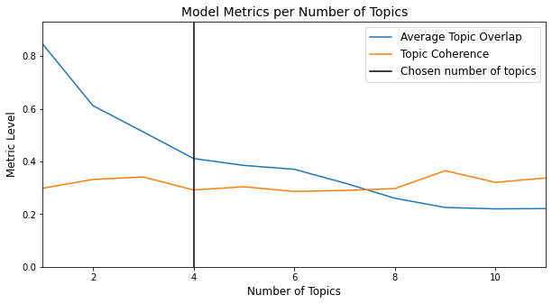
Fig. 13. A comparison between overlap and coherence for different numbers of topics.
The coherence remains approximately constant while the average Topic overlaps continuously decay. There is also a reduction in the gradient ("elbow") of the Topic overlap for two or four Topics and after nine Topics. Considering the problematic interpretability of many Topics and the significant reduction of Topic overlap from two to four Topics, the authors opted to use four topics. The preprocessed versions of each document's abstract, title, and keywords were then utilized to construct a corpus, which was then subjected to LDA.
The weights of the top ten terms discovered in the four topics are shown in Fig. 14. Topic 0 was characterized by a higher weight attributed to the 'explainabl' token. It means that documents more likely to be associated with topic 0 are possibly related to the explainability of models' outcomes.
Topic 1 was associated with case-based reasoning. Still, the prevalence of general terms such as 'legal' and 'law' associated the Topic with the legal sector while hampering more specific intuitions. Topic 2 most important word was 'syst', and the top ten words included 'legal', 'decision', and 'support', indicating some association with decision support systems in the legal environment. Finally, Topic 3 most essential words included 'product', 'complianc', 'algorithm', 'explanation', 'explaining', 'classification', and 'application'. It indicated some degree of overlapping with Topic 0.
The abstracts of the documents were then checked to validate these initial hypotheses. Topic 3, for instance, included papers on electric motor compliance verification, new product development, and the prediction of case-based legal arguments. Topic 2, in turn, included the paper treated as a referential work authored by Mandal et al. (2021). As a result, the highest probability associated with Topic 2, the Topic with the most explicit link with the research subject, was chosen as the eligibility criterion for each document. It resulted in forty eligible documents.
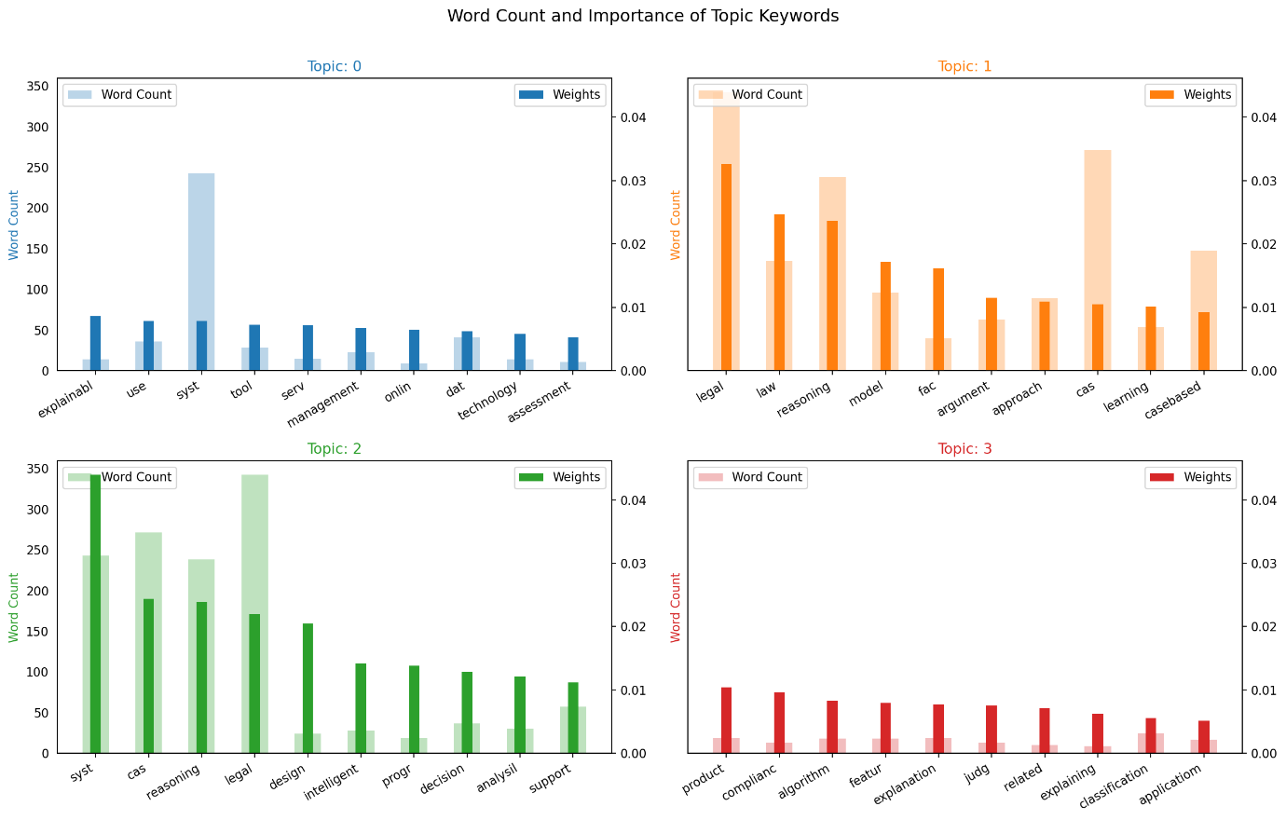
Fig. 14. Word count and importance of keywords for each Topic.

Appendix C – Publications excluded during the full-text screening phase

Reference | Year | Research Topic
(Calderon et al., 2021) | 2021 | This paper proposed a formal model that derived factors from linguistic terms and expert knowledge and used a neutrosophic pairwise matrix of factors for determining case similarity.
(Fungwacharakorn et al., 2021) | 2021 | This paper defined Legal Debugging and used logic programming to anticipate unexpected consequences in the legal domain.
(Mohan & Nair, 2021) | 2021 | This paper proposed an approach to classify legal documents employing Convolutional Neural Networks (CNNs).
(Atkinson et al., 2021) | 2021 | This conference paper proposed a model for predicting and explaining European Court of Human Rights (ECHR) application admissibility results based on a set of questions.
(Lefoane et al., 2019) | 2019 | Instead of retrieving precedents, this conference paper concentrated on retrieving legal statutes from existing cases.
(Morris, 2019) | 2019 | This conference paper presented a web-based platform for developing legal case-based reasoners.
(Yuan, 2016) | 2016 | This proceedings paper presented a model for an automotive design system based on CBR.
(Araszkiewicz, 2014) | 2014 | This paper outlined a model to assess the constitutional admissibility of legal changes.
(Nagata et al., 2014) | 2014 | This conference paper reported preliminary results of a CBR system designed to support decision-making on the sustainable development of regions.
(Wah & Muniandy, 2014) | 2014 | This proceedings paper provided a prototype for using decision support approaches to function as a "virtual courtroom" for plaintiffs and defendants to resolve their legal cases without a trial.
(Fan & Li, 2013) | 2013 | This paper proposed a method for retrieving similar construction accident cases for dispute resolution.
(Wyner & Peters, 2010) | 2010 | This proceedings paper proposed a method to produce an annotated text that supports information extraction.
(Forbes et al., 2010) | 2010 | This paper presented a framework to suggest techniques for solving risk management problems. The proposal involved matching new cases to similar previous cases based on their attributes.
(Wyner et al., 2010) | 2010 | This paper examined text mining algorithms for automating profiling and extracting arguments from court cases.
(Aha, 2005) | 2005 | This conference paper introduced the conversational case-based reasoning (CCBR) methodology, described its evolution, examined its various manifestations and motivations, highlighted recent work, and described unsolved issues that could be the dissertations' focus.
('5th International Conference on Case-Based Reasoning, ICCBR 2003', 2003) | 2003 | This review summarized the conference content without further details on the studies.
(Hoeschl et al., 2003) | 2003 | The entire text of this conference paper could not be accessed from electronic databases.
(Ashley & Rissland, 2003) | 2003 | This conference paper evaluated the lazy learning implemented by the HIPO family of legal expert systems in helping courts' decision-making.
(Zeleznikow, 2002) | 2002 | This paper discussed the evolution of a system to support court decisions and its transition to a hybrid system (based on rules and cases), evolving from a system based solely on rules.

Appendix D – Eligibility Screening Method Validation

Although screening resulted in recognizing twenty-one publications eligible for the literature review, we wanted to validate the clustering through topic modeling as an effective method to assess document eligibility.
Thus, the abstracts of documents associated with the other topics were also evaluated to identify false negatives, i.e., publications relevant to the review objectives, which could be considered in a systematic literature review.
Among the sixty-one publications related to Topic 0, Topic 1, or Topic 3, it was possible to identify nine additional publications relevant to clarifying our research questions. They are listed in Appendix E, and Table 4 details the number of publications (relevant or irrelevant) by Topic. The relevant publications in Topic 2 are true positives identified with the clustering method. On the other hand, the relevant publications associated with other topics are considered false negatives.

Table 4. Relevant and irrelevant documents identified in each cluster
Cluster | Type
Cluster | Relevant | Irrelevant | Total
Topic 0 | 2 | 12 | 14
Topic 1 | 6 | 33 | 39
Topic 2 | 21 | 19 | 40
Topic 3 | 1 | 7 | 8

Next, it was possible to formulate the confusion matrix of Table 5 and calculate the Recall value, respectively, 0.70. The Recall was the performance metric because it measures the ability to identify the maximum number of relevant studies. The Recall is the proportion of true positives to all positive samples (sum of true positives and false negatives).

Table 5. Confusion matrix resulting from the eligibility screening method
Eligibility  Screening |  | Identified
 |  | Relevant | Irrelevant
Actual | Relevant | 21 | 9
Actual | Irrelevant | 19 | 52

To maintain consistency with the method used in this rapid semi-automated review, only studies associated with the chosen Topic (Topic 2) were considered when answering the research questions.

Appendix E – Relevant publications excluded during the eligibility screening phase (by topic selection)

LDA Topic | Reference | Year | Research Topic
0 | (Kiryu et al., 2018) | 2018 | This conference paper proposed a precedent retrieval system using ontology. Ontology is a set of concepts and categories in a domain representing their properties and relations.
0 | (Nissan, 2017) | 2017 | This study summarizes technological advancements to law practitioners, including AI and non-AI tools.
1 | (Elhalwany et al., 2015) | 2015 | This paper proposed a system that responded to a user's questions by evaluating semantical similarity with previously answered inquiries.
1 | (Carneiro et al., 2009) | 2009 | This conference paper introduced an agent-based architecture for a tool that provides users with a list of potential case outcomes based on legal precedents.
1 | (Maxwell & Schafer, 2008) | 2008 | This conference paper examined existing approaches to legal information retrieval, namely manual KE and NLP.
1 | (Branting, 2003) | 2003 | This conference paper modeled legal precedents based on their defining properties: the relevance of a precedent is dictated by the legal support under which it was decided.
3 | (C.-L. C. L. Liu et al., 2003) | 2003 | This conference paper used criminal judgments to investigate the efficacy of artificially created criteria for classification problems.
1 | (Xu et al., 2001) | 2001 | This proceedings paper proposed a factor-based similarity measure between legal cases.
1 | (Hirota et al., 2000) | 2000 | This conference paper detailed a CBR system based on fuzzy logic developed for the United Nations (UN) Convention on Contracts for the International Sale of Foods.

Recall is also known as sensitivity or true positive rate.

