Supplementary Figure 1. Protein–protein interaction network of GABBR1-related DEGs
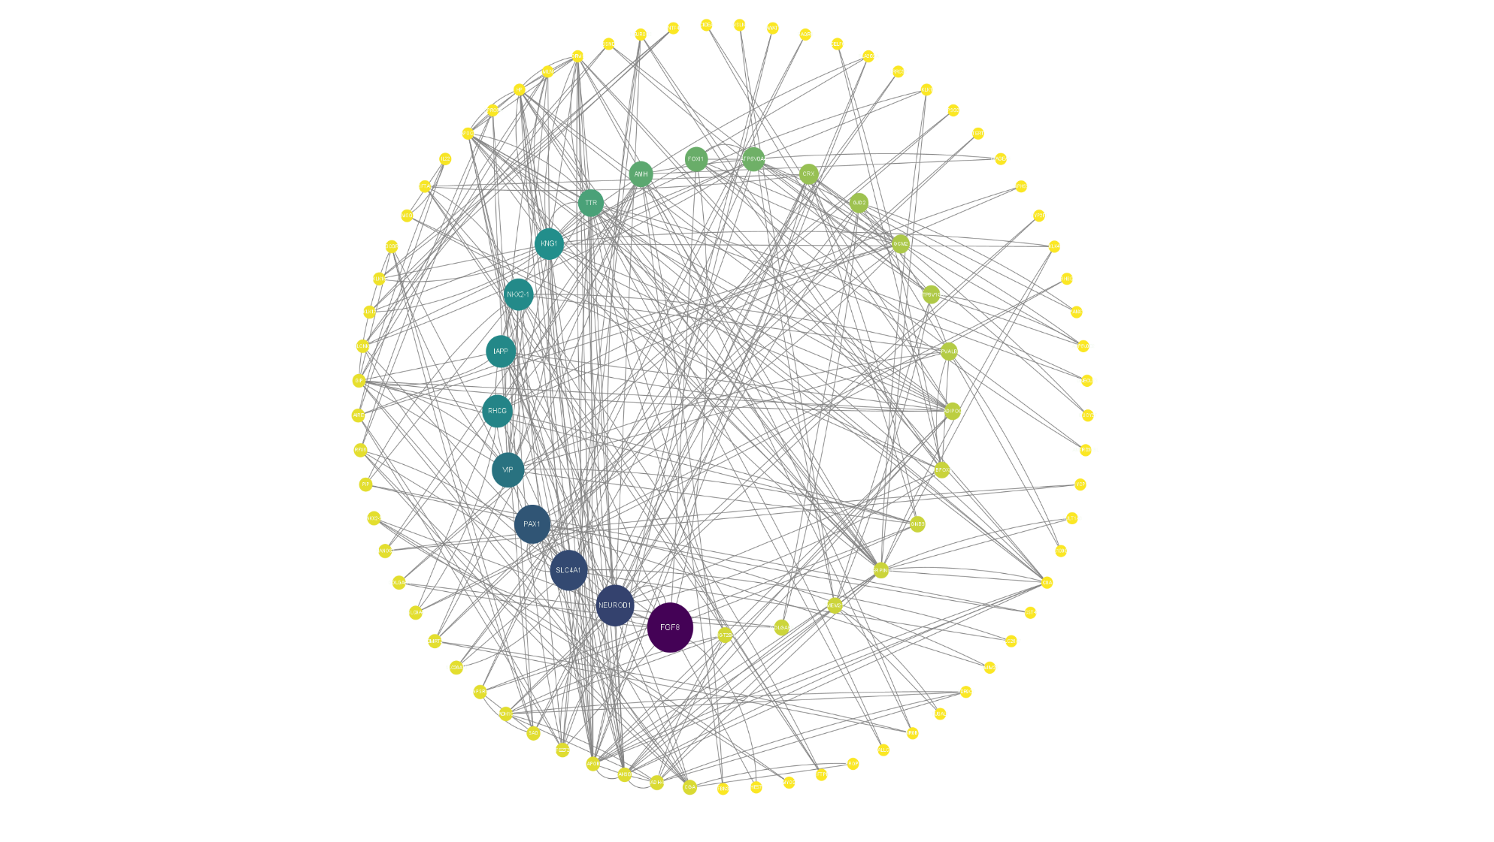
Supplementary Figure 1. Protein–protein interaction network of GABBR1-related DEGs. The score of the inner circle is greater, the score of the outer circle is lower. The lowest point in the inner circle and the darkest hue reflects the gene with the highest score

