Supplemental Information for:
The causal involvement of the BDNF-TrkB pathway in dentate gyrus in early-life stress-induced cognitive deficits
Ya-Xin Sun, Yun-Ai Su, Qi Wang, Ting Wang, Jia-Ya Zheng, Chen-Chen Zhang, Xiao Liu, Yu-Nu Ma, Xue-Xin Li, Xian-Qing Zhang, Xiao-Meng Xie, Ji-Tao Li, Tian-Mei Si

Supplementary Materials and Methods

Behavioral testing

Open field Mice were placed in the open field arena (50 × 50 × 50 cm3) made of gray polyvinyl chloride and evenly illuminated at 60 lux. At the beginning of the test, the mice was placed in the corner of the arena and allowed to freely explore the apparatus for 10 min. The total distance traveled, time spent in the center zone, and the number of entering the center zone were analyzed.

Y-maze spontaneous alternation test The Y-maze apparatus was made of gray polyvinyl chloride with three symmetrical arms (30 × 10 × 15 cm³) and illuminated at 10 lux. During the test, mice were individually placed in the end of one arm and allowed to freely explore the arms for 8 min. The percentage of spontaneous alternations (SA: A→B→C), alternative arm returns (AAR: A→B→A) and same arm returns (SAR: A→A) were recorded manually by investigator. The total number of entries to three arms were also counted.

Immunostaining and image analysis
Mice were anesthetized with sodium pentobarbital (200 mg/kg, i.p.) and transcardially perfused with 0.9% saline followed by 4% buffered paraformaldehyde. Following postfixation and cryoprotection, serial sections were prepared through the dorsal hippocampus (coronal: Bregma -1.46 to -2.18 mm; horizontal: Bregma -3.84 to -5.64 mm) at 30 μm thickness and 180 μm intervals using a cryostat (Leica, Wetzlar, Germany). The following primary antibodies were used for immunostaining: rabbit anti-BDNF (1:1000 for immunohistochemistry, 1:500 for immunofluorescence; ab108319, Abcam, Cambridge, UK), rabbit anti-NGF (NGF; 1:1,000; ab6199, Abcam, Cambridge, UK), rabbit anti-NT-3 (NT-3; 1:1,000; 18084-1-AP, Proteintech, Chicago, USA), rabbit anti-Ki-67 (1:1000; ab15580, Abcam), and rabbit anti-DCX (1:5000; 4604S, Cell Signaling Technology).
For immunohistochemistry, free-floating sections were treated with 3% hydrogen peroxide (10 min) followed by 1% normal goat serum (1 h), and then they were labeled with primary antibodies overnight at 4 °C. The next day, after rinsing, sections were incubated with biotinylated secondary antibody (Zhongshan Golden Bridge Biotechnology, Beijing, China) for 2 h at room temperature. After rinsing, the 3,3’-Diaminobenzidine Horseradish Peroxidase Color Development Kit was used for staining. Finally, sections were transferred onto slides and coverslipped with neutral quick-drying adhesive.
For immunofluorescence, sections were treated with 1% normal donkey serum for 1 h and labeled with the rabbit anti-BDNF antibody overnight at 4 °C. The next day, sections were rinsed and labeled with Alexa Fluor 594-conjugated donkey anti-rabbit secondary antibody (1:500; Invitrogen, Carlsbad, CA, USA) for 2 h at room temperature. After rinsing, sections were transferred onto slides and coverslipped with Vectashield containing 4′,6-diamidino-2-phenylindole (Vector Laboratories, Burlingame, CA, USA).
To quantify the immunoreactivity of BDNF, NGF, and NT-3, images from 3-4 sections per animal were acquired at 100× using the Olympus BX51 microscope and analyzed by ImageJ. Relative protein levels were determined by the differences in optical density values between the region of interest and the corpus callosum, which generally lacks staining and was considered as background. The density of Ki-67 and DCX-positive cells was analyzed using ImageJ. For colocalization analysis, images (1024 × 1024 pixel²) were obtained with an Olympus IX81 laser-scanning confocal microscope (Olympus, Tokyo, Japan) at 200× magnification using the Kalman filter and sequential scanning mode under identical settings for laser power, photomultiplier gain and offset. Images were adjusted for optimal brightness and contrast using the FV10-ASW 1.7 Software (Olympus).

Western Blot
Mice were anesthetized by isoﬂurane-O2 (4–5:100) at 24 h after the last behavioral test. Following the previously reported procedure (Hagihara et al., 2009; Li et al., 2017), we removed animal brains rapidly and dissected DG. DG samples from both hemispheres were homogenized in ice-cold lysis buffer and centrifuged at 12,000 rpm at 4°C (10 min × 2). Protein concentrations were determined using a bicinchoninic acid protein assay kit (Pierce, Rockford, IL, USA). Samples containing 20 µg of protein were resolved by 10% sodium dodecyl sulphate-polyacrylamide gels, and transferred onto polyvinylidene difluoride membranes (Millipore, Bedford, MA, USA). Membranes were labeled with primary antibodies at 4°C (overnight). The following antibodies were used: rabbit anti-BDNF (1:1000, ab108319, Abcam), and rabbit anti-GAPDH (1:20000, 2118, Cell Signaling). After incubation with horseradish peroxidase-conjugated secondary antibodies (1:5000-20000, Zhongshan Gold Bridge Biotechnology, China, diluted in TBST) at room temperature (2 h), bands were visualized using the Amersham Imager 600 (GE Health-care, PA) and analyzed using Quantity One 4.2 (Bio-Rad, Hercules, CA) by an investigator blind to the treatment conditions. The values were corrected based on their corresponding control protein levels. All results were normalized by taking the value of the vehicle group as 100%.

Supplementary Figures
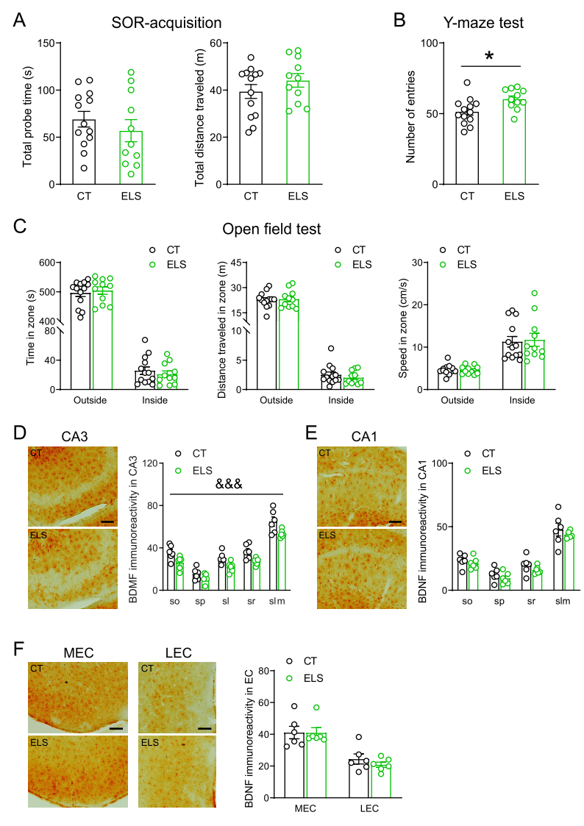
Fig. S1 Additional results of the effects of early-life stress on cognitive and anxiety-like behaviors in adult mice. (A) During the acquision phase of the SOR test, control and stressed mice spent similar time interacting with two objects and traveled similar distance in the box. (B) In the Y-maze test, ELS significantly increased the the number of entries to three arms. (C) In the open field test, ELS did not affect the time, distance traveled, and speed in the outside and inside zones. (D-F) Immunostaining revealed that ELS significantly reduced the protein levels of BDNF in the CA3 (D), not CA1 (E) or EC (F) in adult mice. Scale bar = 100 µm. CT, control; EC, entorhinal cortex; LEC, lateral entorhinal cortex; MEC, medial entorhinal cortex; ELS, early-life stress; sl, stratum lucidum; slm, stratum lacunosum-moleculare; so, stratum oriens; SOR, spatial object recognition; sp, stratum pyramidale; sr, stratum radiatum. *p < 0.05, unpaired t test; &&& p < 0.001, the main effect of stress.

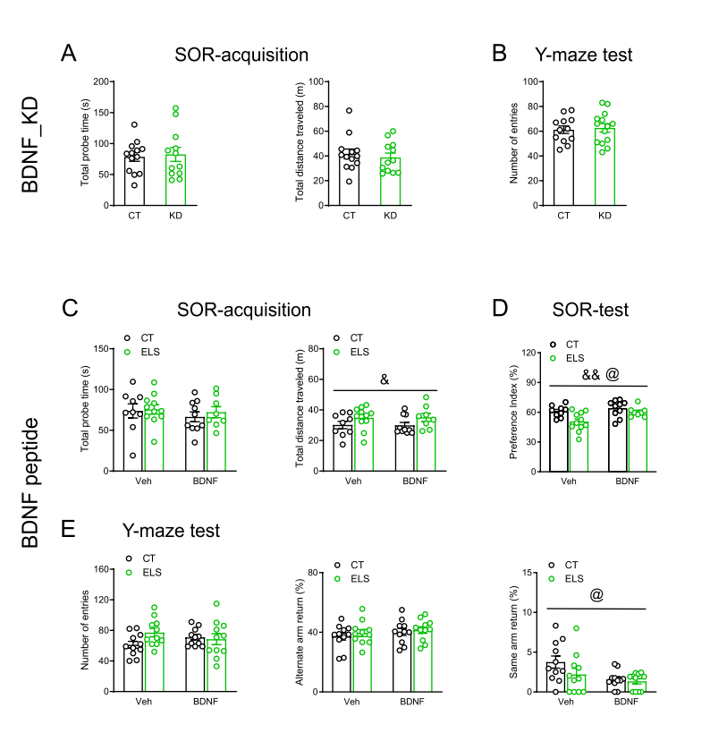
Fig. S2 Additional results of the section “BDNF in the DG mediated early-life stress-induced spatial memory impairment”. (A) During the acquision phase of the SOR test, control and BDNF_KD mice showed comparable time interacting with two objects and traveled distance in the box. (B) In the Y-maze test, BDNF knockdown in the DG did not affect the number of entries to three arms. (C) During the acquision phase of the SOR test, there were no main effects of rhBDNF in the total probe time or total distance traveled, while ELS significantly increased total distance traveled, without affecting the total probe time. (D) During the test phase of the SOR test, preference index was reduced by ELS and increased by rhBDNF, although the ELS × rhBDNF interaction did not approach significance. (E) In the Y-maze test, total number of entries (Left) and AAR ratio (Middle) were not affected by ELS and rhBDNF. SAR ratio (Right) was not significantly altered by ELS and was reduced by rhBDNF reduced. AAR, alternate arm return; BDNF, brain-derived neurotrophic factor; CT, control; ELS, early-life stress; KD, knockdown; SA, spontaneous alternation; SAR, same arm return; SOR, spatial object recognition; Veh, vehicle. & p < 0.05, && p < 0.01, the main effect of stress; @ p < 0.05, the main effect of BDNF.

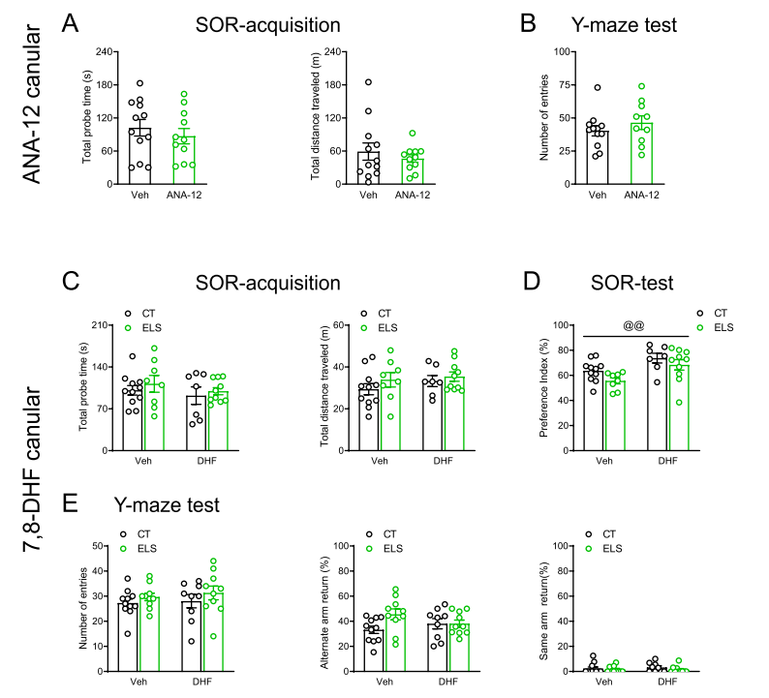
Fig. S3 Additional results of the section “TrkB Receptor in DG Mediated Early-Life Stress-Induced Spatial Memory Loss”. (A) During the acquision phase of the SOR, control and ANA-12-treated mice showed comparable time interacting with two objects and traveled distance in the box. (B) In the Y-maze test, local ANA-12 injection in the DG did not affect the number of entries to three arms. (C) During the acquision phase of the SOR, ELS and local 7,8-DHF injection did not significantly influence the total probe time or total distance traveled. (D) During the test phase of the SOR, local 7,8-DHF injection increased the preference index in adult mice. (E) In the Y-maze test, total number of entries (Left), AAR ratio (Middle), and SAR (Right) were not affected by ELS and 7,8-DHF. AAR, alternate arm return; CT, control; DHF, 7,8-dihydroxyflavone; ELS, early-life stress; SA, spontaneous alternation; SAR, same arm return; SOR, spatial object recognition; Veh, vehicle. @@ p < 0.01, the main effect of drug.

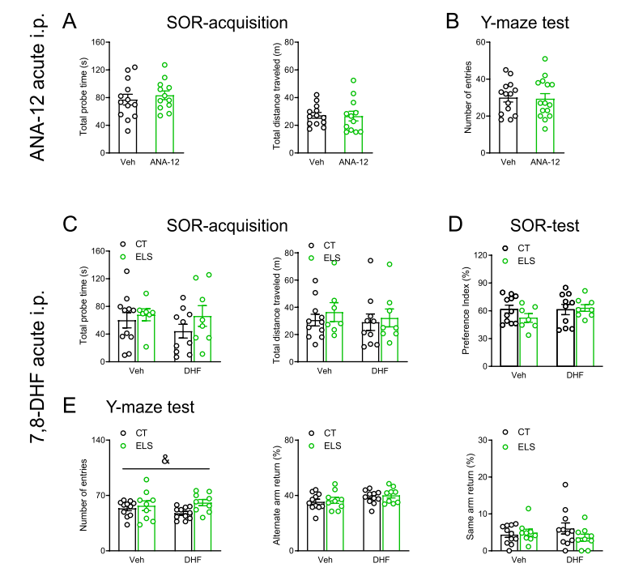
Fig. S4 Additional results of the section “Acute Systemic Administration of 7,8-DHF Reversed Stress-Induced Spatial Memory Loss”. (A) During the acquision phase of the SOR test, control and ANA-12-treated mice showed comparable time interacting with two objects and traveled distance in the box. (B) In the Y-maze test, acute intraperitoneal ANA-12 injection did not affect the number of entries to three arms. (C) During the acquision phase of the SOR test, ELS and acute 7,8-DHF injection (i.p.) did not significantly influence the total probe time or total distance traveled. (D) During the test phase of the SOR test, the main effects of ELS and 7,8-DHF and their interaction on preference index did not approach significance. (E) In the Y-maze test, compared with control mice, stressed mice showed increased number of entries (Left) into three arms, while AAR ratio (Middle), and SAR (Right) were not affected. AAR, alternate arm return; CT, control; DHF, 7,8-dihydroxyflavone; ELS, early-life stress; i.p., intraperitoneal; SA, spontaneous alternation; SAR, same arm return; SOR, spatial object recognition; Veh, vehicle. & p < 0.05, the main effect of stress.

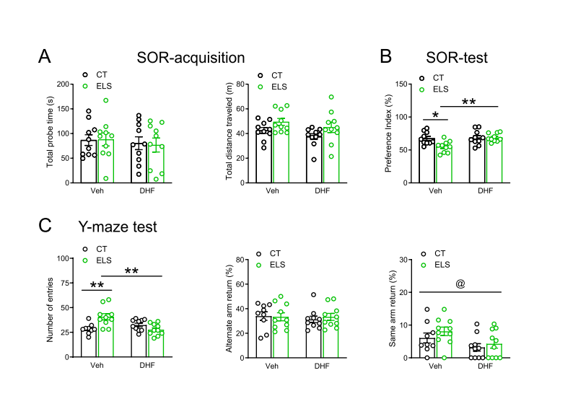
Fig. S5 Additional results of the section “Subchronic Systemic Administration of 7,8-DHF Reversed ELS-induced Spatial Memory Deficits and Adult neurogenesis reduction”. (A) During the acquision phase of the SOR test, ELS and subchronic 7,8-DHF injection (i.p.) did not significantly influence the total probe time or total distance traveled. (B) Subchronic7,8-DHF injection (i.p.) reversed the negative effects of ELS on spatial memory in the SOR test. (C) In the Y-maze test, the increased number of entries (Left) induced by ELS was normalized by subchronic 7,8-DHF injection (i.p.). AAR ratio (Middle) was not affected by ELS or 7,8-DHF, while SAR (Right) was decreased by 7,8-DHF in the Y-maze test. AAR, alternate arm return; CT, control; DHF, 7,8-dihydroxyflavone; ELS, early-life stress; i.p., intraperitoneal; SA, spontaneous alternation; SAR, same arm return; SOR, spatial object recognition; Veh, vehicle. *p < 0.05, **p < 0.01, Tukey’s post hoc test; @ p < 0.05, the main effect of drug.

