Supplementary Information
Figure S1. Multidisciplinary scheme for management of labor and expectant management on COVID-19 in pregnancy
This flow-chart shows the decision-making process for the expectant management for vaginal delivery and/or treatments for COVID-19-infected pregnant women on admission.
This multidisciplinary team consisted of obstetricians, infectious control doctors, midwives, neonatologists, and emergency room (ER) doctors. During isolation, obstetricians checked maternal conditions daily and fetal status biweekly, wearing personal protective equipment (PPE).
When COVID-19-infected pregnant women were admitted to our hospital, we first checked maternal conditions, including vital signs, respiratory conditions, maternal SpO₂, and chest X-ray imaging. If the maternal respiratory condition was not favorable upon admission, a cesarean section was performed immediately to save the mother and fetus. On the other hand, when patients were not in a life-threatening condition, such as the requirement for intubation or resuscitation, we consecutively checked whether patients had a threatened delivery or not by undergoing a non-stress test (NST), transvaginal/abdominal ultrasound imaging, and internal examination. Once patients were categorized as expectant management-available, they were isolated until they tested COVID-19 negative. During isolation, obstetricians checked maternal conditions daily and fetal status biweekly, wearing personal protective equipment (PPE). This follow-up was based on fetal surveillance of high-risk pregnancies, such as pregnancies impacted by severe preeclampsia and diabetes.^{[13, 14]} The severity of COVID-19 was determined on admission by infection control doctors based on the criteria from the Ministry of Health, Labour and Welfare in Japan (Supplementary Table S1).^{[15]} As soon as COVID-19 tests were negative for two consecutive days, patients at term gestation were immediately moved to the obstetrics ward, with easing isolation, to undergo induction of labor. Patients easing isolation in preterm gestation continued a general maternal check-up at our outpatient clinic.
When delivery was threatened on admission or spontaneous labor and ROM occurred during isolation, obstetricians assessed the progress of labor based on obstetrical examination and maternal conditions. If the maternal condition is not favorable or obstetrically available for labor, a cesarean section should be performed immediately. If not, patients were transferred to an isolated labor-delivery room (LDR) and underwent vaginal delivery. The inside of isolated LDR was categorized as a “red zone”. Just three medical staff members, including an obstetrician, midwife, and neonatologist, were allowed to manage vaginal delivery inside of the red zone. Outside of the red zone (i.e., yellow and green zone), midwives and obstetric residents helped to provide the equipment for labor and sample collection.
*Decision was based on a stable maternal and fetal status without features of threatened delivery.
**Management of labor and/or cesarean section was decided by the features of delivery and labor including rupture of membrane, uterine contraction, Bishop score, and obstetrical indications.
Abbreviations: COVID-19, coronavirus disease 2019; LDR; labor and delivery room

Table S1. Criteria for COVID-19 severity in Japan

(Classification) | (Definition)
Mild | Asymptomatic, and/or not necessary to provide oxygen and respiratory support without findings of pneumonia on chest X-ray
Intermediate I | Findings of pneumonia on chest X-ray
Intermediate II | Necessary to provide oxygen regardless of abnormal findings on chest X-ray
Severe | Necessary to undergo respiratory support including intubation and mechanical respiration

The classification and definition of the severity of COVID-19 were provided by the Ministry of Health, Labour, and Welfare (MHLW) in Japan.

Table S2. Details of COVID-19 tests on maternal and neonatal specimens on vaginal delivery.
 | Under isolation (n=17) | Post isolation (n=33)
Maternal nasopharynx | 17 | 0
Amniotic fluid | 0 | 0
Umbilical cord | 0 | 0
Placental surface  (maternal side) | 0 | 0
Placental surface  (fetal side) | 0 | 0
Vaginal discharge | 0 | 0
Milk | 0 | 0
Neonatal nasopharynx | 0 | 0

Details of COVID-19 tests from maternal/neonatal nasopharynx and pregnancy-related tissues on vaginal delivery in the COVID-19 group. COVID-19 antigen tests obtained from amniotic fluid, umbilical cord, placental surfaces, and vaginal discharge, were collected immediately after delivery. COVID-19 antigen test from milk was obtained at the time of the first ejection of milk postpartum. Samples from maternal and neonatal nasopharynx were collected on initiation of labor and post-delivery period at isolated circumstances from COVID-19-infected mother, respectively.

Figure S2. The example of unexpected and sudden-onset tachysystole during labor in COVID-19 women.
(A)
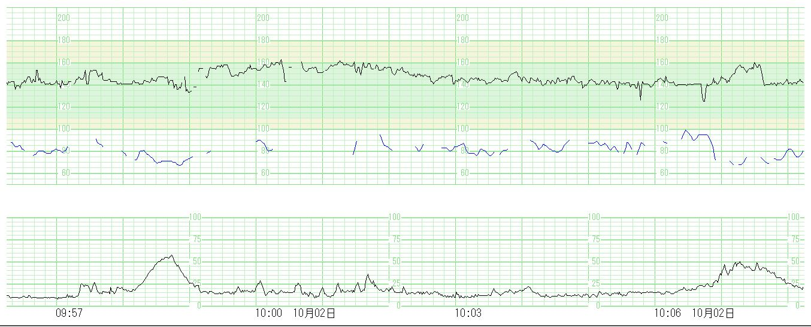
30 minutes later
(B)
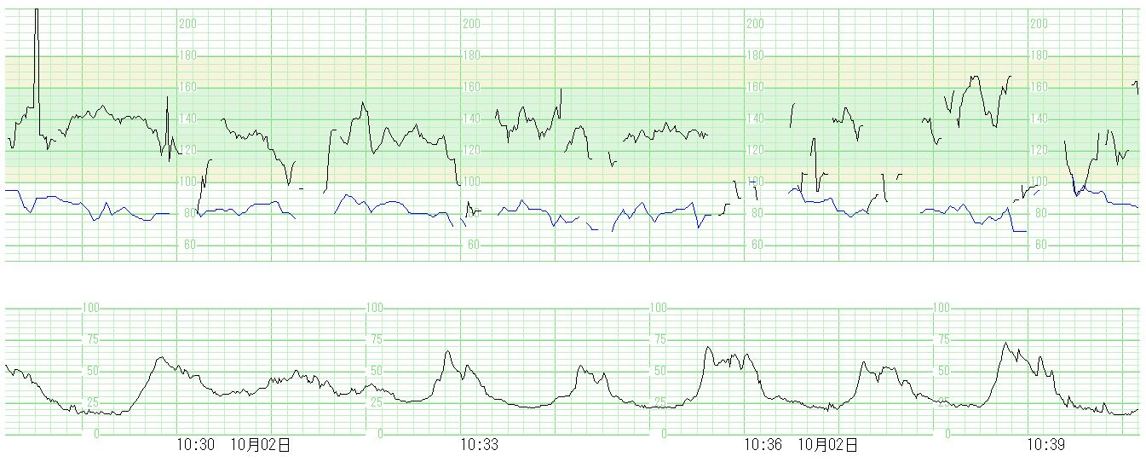
Figure S2 shows NSTs during vaginal labor in COVID-19 women resulting in rapidly progressing delivery with unexplained and sudden-onset tachysystole. (A) At the initiation of labor in latent phase (3cm-opening uterine cervix) with normal contractions. (B) Just 30 minutes later, unexplained tachysystole suddenly occurred, and labor was rapidly progressing to full ripening and resulting in vaginal delivery within one hour.
Abbreviation: COVID-19, coronavirus disease 2019; NST, non-stress test.
Figure S3. Sub-group analysis: estimating the effects of isolation, virus variants, and severity of COVID-19 on labor and uterine cervical ripening.

To evaluate the specific characteristics of labor in COVID-19, sub-group analysis was performed to investigate the effects of under/post isolation during labor due to COVID-19 (A-D), virus variants (E-H), and severity of COVID-19 (I-L) on the progression of labor and ripening of uterine cervix.

1st stage (A) and 2nd stage (B) of labor time, rupture of the membrane to delivery time (C), and Bishop score on initiation of labor (D) comparison between the post isolation and under isolation groups. Post isolation group; n = 33, and under isolation group; n = 17. 1st stage and 2nd stage of labor time (min), ROM to delivery time (min), and Bishop score on initiation of labor were not statistically significant regardless of isolation.

1st stage (E) and 2nd stage (F) of labor time, rupture of the membrane to delivery time (G), and Bishop score on initiation of labor (H) comparing among virus variant types.
1st stage (I) and 2nd stage (J) of labor time, rupture of the membrane to delivery time (K), and Bishop score on initiation of labor (L) comparing the severity of the infection (mild and intermediate I/II & severe). Additionally, we analyzed the effects of virus variants and severity of COVID-19 on the labor and uterine cervical ripening. From the results of Figure S3 E-L, no statistically significant differences between virus variants and severity of COVID-19 were identified in labor time and Bishop score (sub-group analysis on virus variants: P = 0.78, 0.60, 0.43, and 0.22, respectively; on the severity of COVID-19: P = 0.41, 0.12, 0.45, and 0.29, respectively). W; n = 8, N901Y; n = 9, L452R; n = 8, BA.1; n = 24, mild; n = 39, intermediate I/II & severe; n = 11.
*Severity of disease was based on Japanese criteria from the Ministry of Health, Labour and Welfare (MHLW) (see Supplementary Information Table S1.)
Abbreviations: BA.1, omicron variant; COVID-19, coronavirus disease 2019; L452R, delta variant; N501Y, alpha variant; ROM, rupture of membrane, W, wild type of SARS-CoV-2

Figure S4. Endothelial damage markers profiles in the COVID-19 group

These figures show the profiles of endothelial damage markers, reflecting systemic inflammatory response in the COVID-19 group. These figures show the profiles of maternal serum high-sensitive CRP (A), plasma vWF antigen (B), and vWF activity (C) levels obtained from admission period, initiation of labor, postoperative day (PD) 4-5, and PD 1 month (n=38, 45, 33, and 40, respectively). All factors levels presented with higher levels than normal ranges (showing transparent boxes) on admission and initiation of labor. The increases of all markers except for high-sensitive CRP were shown on initiation of labor.

Abbreviations: COVID-19, coronavirus disease 2019; CRP, C-reactive protein; PD 4-5, postpartum day 4-5; PD 1M, postpartum day 1 month; vWF, von Willebrand factor.

