Supplementary Material

Methods and results
1.1 Screening of preparation methods
Three simple one-step methods were selected to prepare polymer lipid nanoparticles, namely nano-precipitation method, improved solvent extraction method and ultrasonic method.
Nano-precipitation method: 45 mg yolk lecithin (PC-98T) and 5 mg DSPE-MPEG₂₀₀₀ were dissolved in 4% ethanol solution containing 1% Tween-80 under magnetic stirring at 75°C to prepare water phase. 10 mg PLGA (Polylactic acid-glycolic acid =50:50, Mw:8000) and 2 mg quercetin (QUE) acetone solution as oil phase, was slowly added to the water phase, which under stirring for 2 h until the polymer and lipid material self-assembly to form core-shell structure nanoparticles, centrifugal filtration to obtain Q-PLNs.
Improved solvent extraction method: 45 mg PC-98T and 5 mg DSPE-MPEG₂₀₀₀ were dissolved in 4% ethanol aqueous solution containing 1% Tween-80. Under the condition of ice bath, ultrasonic solution were mixed by ultrasonic probe to form water phase. Acetone solution dissolved with 10 mg PLGA and 2 mg QUE was used as oil phase. The emulsion was slowly added to the water phase, and then ultrasonic dispersion was prepared under the condition of ice bath. The Q-PLNs were obtained by stirring at room temperature overnight and centrifugation.
Ultrasonic method: 45 mg PC-98T and 5 mg DSPE-MPEG₂₀₀₀ were dissolved in 4% ethanol aqueous solution containing 1% Tween-80 under magnetic stirring at 75°C to form the aqueous phase. Acetone solution dissolved with 10mg PLGA and 2mg QUE was slowly added to the aqueous phase at 75°C. The emulsion was slowly added to the water phase, and then ultrasonic dispersion was prepared under the condition of ice bath. The Q-PLNs were obtained by stirring at room temperature overnight and centrifugation.
The particle size, PDI, potential and encapsulation rate of Q-PLNs prepared by different methods were measured, and the results were shown in Table S1. The particle size and encapsulation rate of Q-PLNs prepared by the improved solvent extraction method were the largest, while Q-PLNs prepared by nano-precipitation method had the smallest particle size and PDI, but the encapsulation rate was smaller. Considering the particle size and encapsulation rate, the relatively simple and widely used nano-precipitation method was selected.
The influence of emulsification temperature of 60, 65, 70, 75 and 80°C on Q-PLNs was investigated. According to Table S2, when the emulsification temperature was 70°C, the prepared Q-PLNs have the smallest PDI, indicating uniform particle size and high encapsulation rate. If the temperature was too low or too high, there will be large PDI, uneven particle size distribution of nanoparticles, and miscellaneous peaks. Therefore, the emulsification temperature was selected as 70°C.
1.2 Screening of emulsifying time
The effects of different emulsification times of 30, 60, 90 and 120 min on Q-PLNs were investigated. According to Table S3, when the emulsifying time was 60 min, the particle size was the smallest, and the prepared Q-PLNs had better particle size dispersion, but the encapsulation rate was slightly lower. Considering the three indexes, the emulsifying time was chosen as 60 min.
1.3 Screening of oil-water ratio
In order to determine the optimal oil-water ratio for the preparation of Q-PLNs, the oil-water ratio of 1:5, 1:10, 1:15, 1:20 and 1:25 were investigated. According to Table S4, when the oil-water ratio is 1:20, the particle size and PDI were smallest, and the prepared Q-PLNs has better particle size dispersion and higher encapsulation rate. Too high or too low oil-water ratio is not conducive to the emulsification and the drug loading capacity, so the oil-water ratio is chosen as 1:20.
1.3 Single factor study on preparation of prescription
1.3.1 Selection of lipid dosage
PC-98T dosage of 20, 30, 40, 50 and 60 mg were selected to investigate the effects of different lipid dosage on Q-PLNs. As can be seen from Table S5, when the dosage of PC-98T is 50 mg, Q-PLNs prepared with uniform particle size and high encapsulation rate. Therefore, the dosage of PC-98T was determined to be 50 mg for subsequent screening.
1.3.2 DSPE-MPEG₂₀₀₀ screening
The effects of DSPE-MPEG₂₀₀₀ dosage of 2.5, 5.0, 7.5, 10.0 and 15.0 mg were investigated. As can be seen from Table S6, the encapsulation rates of Q-PLNs firstly increased and then decreased among 2.5-10.0 mg of DSPE-MPEG₂₀₀₀, while the effect on particle size was small with the increase of dosage. Studies have found that the addition of modified PEG ratio greater than 8% lead to the degradation of PLNs. In order to obtain more stable Q-PLNs, the dosage of DSPE-MPEG₂₀₀₀ was determined to be 5.0 mg.
1.3.3 Selection of PLGA dosage
As the core polymer of Q-PLNs, the amount of PLGA has an important effect on the stability and encapsulation rate of Q-PLNs. PLGA dosage of 5, 10, 15, 20, 25, 30 mg were selected to determine the optimal PLGA dosage for preparation of Q-PLNs. Table S7 showed that when PLGA was 15 mg, Q-PLNs had higher encapsulation rate and smaller particle size. Therefore, the PLGA dosage was determined to be 15 mg.
1.3.4 Screening of emulsifier dosage
The effects of Tween-80 concentration at 0.5%, 0.75%, 1.0%, 1.25% and 1.5% on Q-PLNs were investigated. As can be seen from Table S8, the variation of Tween-80 concentration had little effects on the particle size of Q-PLNs. However, with the increase of Tween-80 concentration, the encapsulation rates first increased and then decreased. When the Tween-80 concentration was 1.0% or 1.25%, the difference between encapsulation rates were small. Therefore, in line with the principle of saving experimental materials, the Tween-80 concentration was determined to be 1.0%.
1.3.5 Screening of QUE dosage
As can be seen from Table S9, the amount of QUE had little effect on particle size. Q-PLNs prepared by adding 1 mg QUE had the smallest encapsulation rate, while adding 2.5 mg QUE, Q-PLNs had the maximum encapsulation rate. Therefore, the amount of QUE was 2.5 mg.
1.4 Optimization of Box-Behnken response surface experiment
1.4.1 Box-Behnken experimental design
The experimental results of preparation prescription screening showed that the composition of preparation prescription had little effect on the particle size of Q-PLNs. Among them, the dosage of PC-98T, PLGA and QUE among prescription factors had a great influence on the encapsulation rate of Q-PLNs. Therefore, the response surface Box-Behnken experiment was designed based on the dosage of PC-98T (A), PLGA (B) and QUE (C), and the encapsulation rate (Y) was used as the evaluation index.
Box-behnken experimental Design was carried out by Design Expert 12.0 software, and the experimental data of encapsulation rate (Y) of prepared Q-PLNs were shown in Table S11.
1.4.2 Establishment of regression equation
According to the experimental results of independent variables (PC-98T dosage, PLGA dosage, QUE dosage) and dependent variables (encapsulation rate), through linear regression, R² and P values were used as indicators to evaluate the fitting effect of the model, and an appropriate model was selected. Finally, the multiple quadratic regression equation was obtained:
Y= -75.51 - 4.26A - 2.14B + 0.7512C + 0.9725AB + 2.58AC - 0.615BC - 3.35A² -3.01B² -5.02C² (R²=0.9620), A², B² and C² were extremely significant (P < 0.01).
Through further analysis by Design-Expert 12.0 software, the response surface three-dimensional map and contour line of the encapsulation rate were obtained. According to Figures S1C and S1D, the curvatures of 3D surfaces of PC-98T and QUE were larger, indicating that the amount of PC-98T and QUE had more obvious interactions in influencing the encapsulation rate of Q-PLNs.
1.5 Process validation
According to the above experimental results, the optimal prescription composition was 42.64 mg PC-98T, 12.67 mg PLGA and 2.46 mg QUE. The encapsulation rate of Q-PLNs prepared with this formula was predicted to be 77.55%. According to three batches of Q-PLNs samples prepared in parallel, the average encapsulation rate was measured to be 77.31%, and the deviation from the predicted value was less than 2%, indicating that the model fitted well and the predicted prescription was accurate and reliable.

Supplementary Figures and Tables

Supplementary Tables
Table S1 Preparation method of Q-PLNs
Preparation Method | Particle size  (nm) | PDI | Potential  (mV) | Encapsulation  rate (%)
Nano-precipitation | 102.6±1.0 | 0.256±0.01 | -19.5±0.7 | 48.08±0.97
Improved solvent  extraction method | 208.4±2.5 | 0.295±0.06 | -20.3±0.4 | 50.34±1.51
Ultrasonic method | 174.0±0.9 | 0.336±0.21 | -17.6±0.3 | 43.24±1.23

Table S2 Influence of emulsification temperature on Q-PLNs（n=3）
Temperature  (°C) | Particle size  (nm) | PDI | Potential  (mV) | Encapsulation  rate (%)
60 | 102.6±1.0 | 0.269±0.01 | -19.5±0.7 | 43.04±1.28
65 | 78.6±0.7 | 0.285±0.02 | -14.4±0.3 | 42.29±0.96
70 | 95.7±0.9 | 0.260±0.05 | -16.1±0.5 | 50.38±1.12
75 | 92.6±3.3 | 0.301±0.09 | -17.6±1.1 | 50.11±1.08
80 | 76.8±1.6 | 0.434±0.38 | -18.1±0.3 | 44.03±1.14

Table S3 Influence of emulsification time on Q-PLNs（n=3）
Time (min) | Particle size  (nm) | PDI | Potential  (mV) | Encapsulation  rate (%)
30 | 99.2±0.9 | 0.284±0.002 | -16.9±0.6 | 43.90±1.09
60 | 98.2±0.8 | 0.238±0.011 | -16.6±0.2 | 51.82±0.56
90 | 117.3±0.5 | 0.225±0.021 | -16.5±0.2 | 52.36±1.24
120 | 114.8±1.0 | 0.223±0.0013 | -23.8±0.2 | 48.78±1.43

Table S4 Influence of oil-water ratio on Q-PLNs（n=3）
Oil-water ratio | Particle size  (nm) | PDI | Potential  (mV) | Encapsulation  rate (%)
1:5 | 136.1±1.36 | 0.214±0.005 | -16.3±0.2 | 45.71±1.05
1:10 | 102.7±0.25 | 0.187±0.006 | -16.5±0.5 | 50.01±0.93
1:15 | 103.7±0.47 | 0.195±0.006 | -17.8±0.9 | 54.23±1.14
1:20 | 89.12±0.94 | 0.181±0.003 | -15.4±0.3 | 53.87±0.64
1:25 | 86.76±1.16 | 0.241±0.003 | -15.4±0.3 | 47.41±1.07

Table S5 Influence of yolk lecithin content on Q-PLNs（n=3）
PC-98T（mg） |  | Particle size  (nm) | PDI | Potential  (mV) | Encapsulation  rate (%)
20 | 102.7±2.03 |  | 0.233±0.004 | -18.5±1.10 | 60.86±1.72
30 | 112.5±1.85 |  | 0.219±0.042 | -18.6±0.74 | 58.47±1.40
40 | 90.98±0.83 |  | 0.255±0.007 | -16.97±0.42 | 54.62±1.74
50 | 93.71±0.50 |  | 0.245±0.044 | -16.3±0.95 | 68.12±1.31
60 | 79.80±0.61 |  | 0.286±0.033 | -15.3±0.12 | 62.65±1.56

Table S6 Influence of DSPE-mPEG₂₀₀₀ dosage on Q-PLNs（n=3）
DSPE-mPEG₂₀₀₀(mg) | Particle size  (nm) |  | PDI | Potential  (mV) | Encapsulation  rate (%)
2.5 | 104.5±0.62 | 0.213±0.009 |  | -17.0±1.01 | 55.34±1.36
5 | 87.06±0.85 | 0.256±0.010 |  | -16.3±0.15 | 67.82±1.02
7.5 | 90.50±0.26 | 0.213±0.017 |  | -17.7±1.40 | 67.17±1.22
10 | 91.56±1.01 | 0.250±0.003 |  | -15.9±0.75 | 64.80±1.48
15 | 99.54±1.00 | 0.237±0.008 |  | -18.0±0.15 | 62.94±1.61

Table S7 Influence of PLGA dosage on Q-PLNs（n=3）
PLGA（mg） |  | Particle size  (nm) | PDI | Potential  (mV) | Encapsulation  rate (%)
5 | 76.61±0.41 |  | 0.335±0.011 | -16.2±0.40 | 55.87±1.62
10 | 120.8±1.72 |  | 0.162±0.014 | -18.8±0.38 | 62.41±1.54
15 | 100.7±0.94 |  | 0.234±0.009 | -17.2±0.23 | 71.62±1.11
20 | 129.4±2.89 |  | 0.150±0.009 | -18.8±0.44 | 72.13±2.01
25 | 126.1.1±0.9 |  | 0.148±0.010 | -18.4±0.46 | 67.65±1.28
30 | 148.1±2.30 |  | 0.119±0.011 | -19.8±0.21 | 59.63±1.05

Table S8 Influence of Tween-80 content on Q-PLNs（n=3）
Tween-80（%） | Particle size  (nm) | PDI | Potential  (mV) | Encapsulation  rate (%)
0.5 | 101.6±0.40 | 0.183±0.010 | -17.1±0.10 | 65.54±1.02
0.75 | 102.1±1.27 | 0.194±0.005 | -16.1±0.35 | 69.98±1.33
1.0 | 102.0±0.95 | 0.221±0.008 | -23.2±0.35 | 72.33±1.39
1.25 | 103.6±0.46 | 0.185±0.008 | -16.2±0.49 | 72.28±1.15
1.5 | 108.6±0.67 | 0.207±0.018 | -15.3±0.40 | 71.31±1.21

Table S9 Influence of QUE dosage on Q-PLNs（n=3）
QUE（mg） | Particle size  (nm) |  | PDI | Potential  (mV) | Encapsulation  rate (%)
1.0 | 106.3±0.55 | 0.217±0.051 |  | -14.6±0.40 | 68.65±0.98
1.5 | 104.4±1.93 | 0.185±0.009 |  | -14.3±0.38 | 70.33±1.08
2.0 | 102.5±1.46 | 0.186±0.002 |  | -15.7±0.32 | 72.52±1.47
2.5 | 106.2±1.10 | 0.212±0.006 |  | -14.6±0.17 | 74.92±1.15
3.0 | 119.9±2.03 | 0.178±0.009 |  | -19.8±2.11 | 71.46±1.08

Table S10 Levels and factors of response surface design
Levels | Factors
Levels | PC-98T dosage (mg) | PLGA dosage  (mg) | QUE dosage  (mg)
-1 | 40 | 10 | 2.0
0 | 50 | 15 | 2.5
1 | 60 | 20 | 3.0

Table S11 Design and response values of Box-Behnken
Order | Factors |  |  | Y (%)
Order | A (mg) | B (mg) | C (mg) | Y (%)
1 | 60 | 15 | 2 | 59.37
2 | 50 | 20 | 2 | 64.18
3 | 60 | 15 | 3 | 64.52
4 | 60 | 20 | 2.5 | 64.92
5 | 50 | 20 | 3 | 65.96
6 | 60 | 10 | 2.5 | 66.71
7 | 50 | 10 | 2 | 67.77
8 | 40 | 20 | 2.5 | 69.65
9 | 40 | 15 | 3 | 69.74
10 | 50 | 10 | 3 | 72.01
11 | 50 | 15 | 2.5 | 74.37
12 | 50 | 15 | 2.5 | 74.64
13 | 40 | 15 | 2 | 74.90
14 | 50 | 15 | 2.5 | 75.19
15 | 40 | 10 | 2.5 | 75.33
16 | 50 | 15 | 2.5 | 76.39
17 | 50 | 15 | 2.5 | 76.96

Table S12 Validation of formulation optimized by Box-Behnken
Index | Predicted value (%) | Measured value | Mean value |  | RSD(%)
 |  | 78.41
Encapsulation rate (%) | 77.55 | 76.83 |  | 77.31 ± 0.95 | 0.306
 |  | 76.70

Supplementary Figures
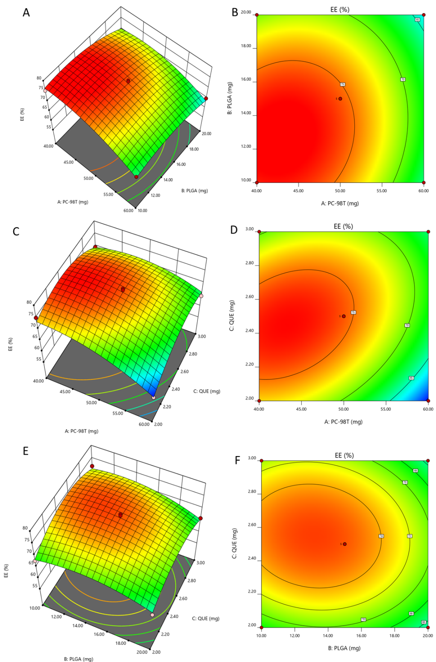
Figure S1 Response surfaces of entrapment efficiency of Q-PLNs

