Figure. 3a
Experiment 1 (the right group was cropped)
IRAK-M
P-JNK
JNK

P-P38
P38
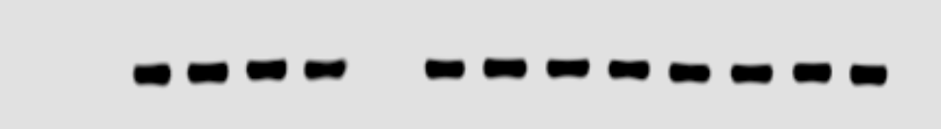
GAPDH

Si-control（0 10 30 60 min）Si-IRAK-M（0 10 30 60 min）
Experiment 2
IRAK-M
P-JNK
JNK
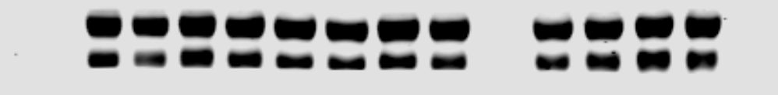
P-P38
P38

GAPDH
Si-control（0 10 30 60 min）Si-IRAK-M（0 10 30 60 min）
Experiment 3
IRAK-M
P-JNK

JNK
P-P38

P38
GAPDH

Si-control（0 10 30 60 min）Si-IRAK-M（0 10 30 60 min）

Figure. 3b
Experiment 1 (the right group was cropped)
IRAK-M
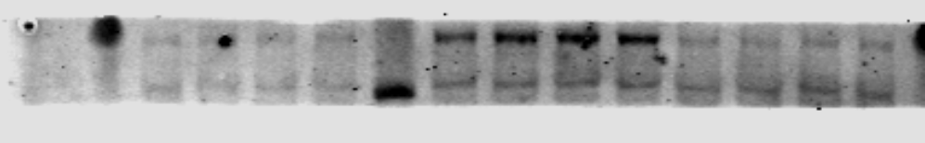
P-JNK
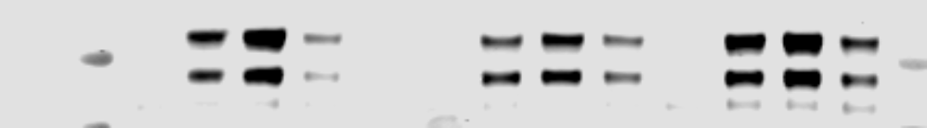
JNK
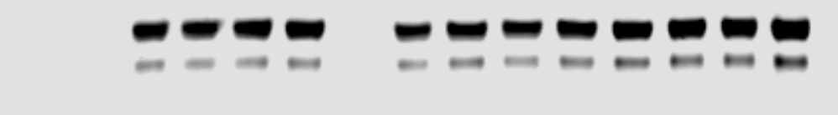
P-P38
P38
GAPDH
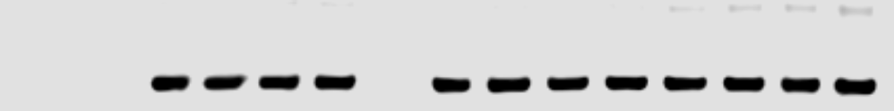
Si-control（0 10 30 60 min）Si-IRAK-M（0 10 30 60 min）

Experiment 2
IRAK-M
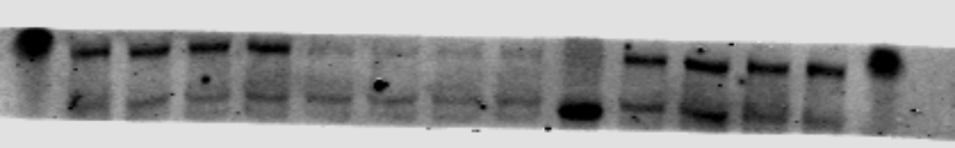
P-JNK
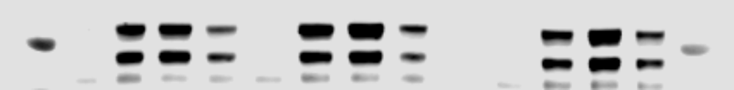
JNK

P-P38
P38
GAPDH
Si-control（0 10 30 60 min）Si-IRAK-M（0 10 30 60 min）

Experiment 3
IRAK-M
P-JNK
JNK
P-P38
P38
GAPDH
Si-control（0 10 30 60 min）Si-IRAK-M（0 10 30 60 min）
Figure. 3c
Experiment 1 (the right group was cropped)
IRAK-M 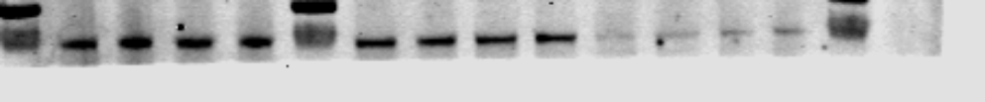
P-JNK
JNK
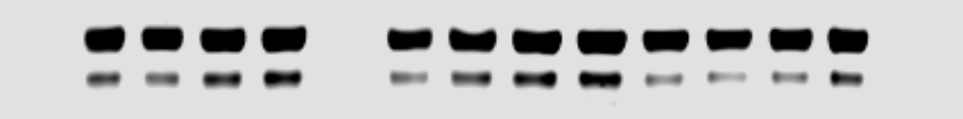
P-P38
P38
GAPDH
Si-control（0 10 30 60 min）Si-IRAK-M（0 10 30 60 min）

Experiment 2
IRAK-M
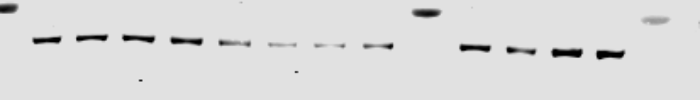
P-JNK
JNK

P-P38
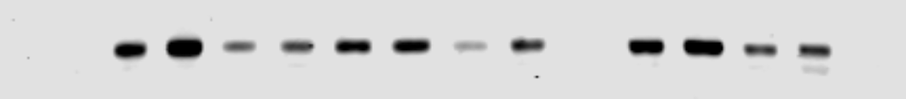
P38
GAPDH

Si-control（0 10 30 60 min）Si-IRAK-M（0 10 30 60 min）

Experiment 3
IRAK-M
P-JNK
JNK
P-P38

P38
GAPDH
Si-control（0 10 30 60 min）Si-IRAK-M（0 10 30 60 min）

Figure. 3d
Experiment 1 (cropped)
IRAK-M
P-JNK
JNK
P-P38

P38

GAPDH
Si-control（0 10 30 60 min）Si-IRAK-M（0 10 30 60 min）

Experiment 2
IRAK-M
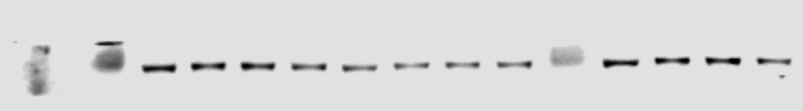
P-JNK
JNK
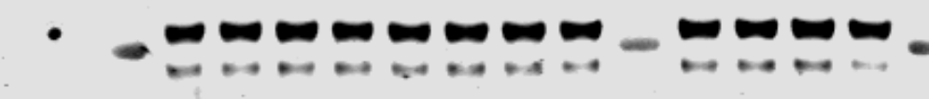
P-P38
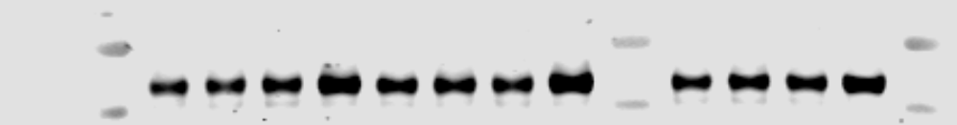
P38
GAPDH
Si-control（0 10 30 60 min）Si-IRAK-M（0 10 30 60 min）

Experiment 3
IRAK-M
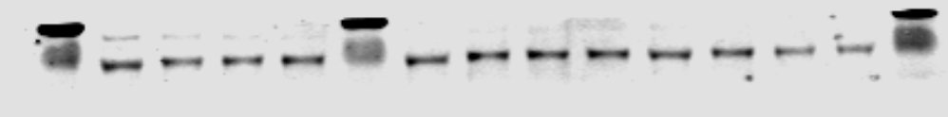
P-JNK
JNK
P-P38
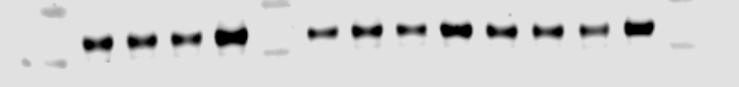
P38
GAPDH
Si-control（0 10 30 60 min）Si-IRAK-M（0 10 30 60 min）

Figure. 4a
Experiment 1 (the left group was cropped)
IRAK-M
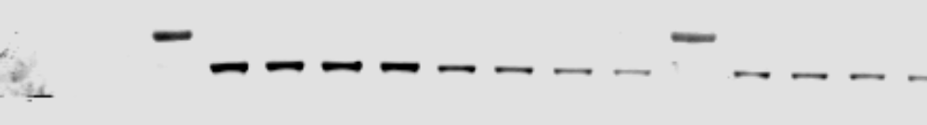
P-JNK
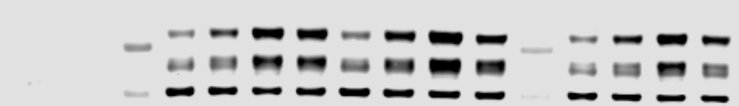
JNK
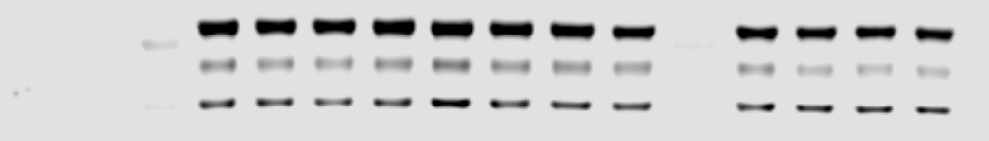
P-P38
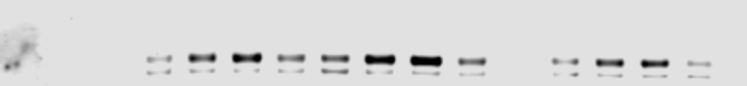
P38
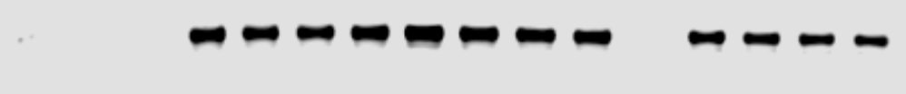
GAPDH
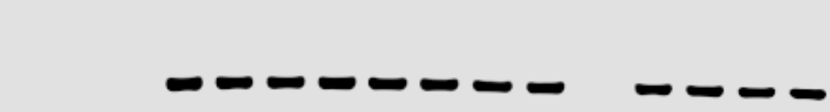Si-control（0 10 30 60 min）Si-IRAK-M（0 10 30 60 min）

Experiment 2
IRAK-M
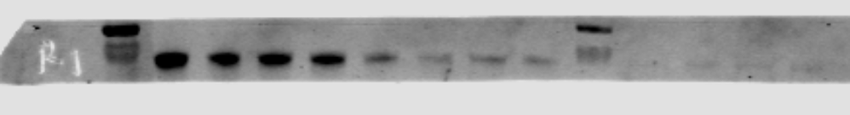
P-JNK
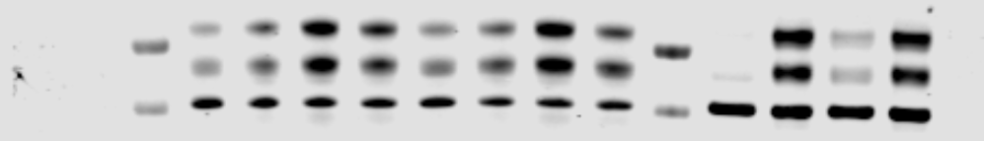
JNK
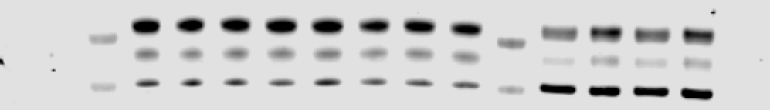
P-P38
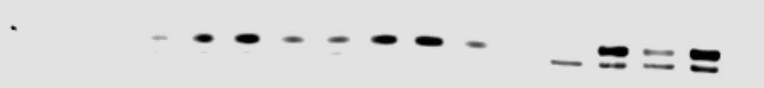
P38
GAPDH
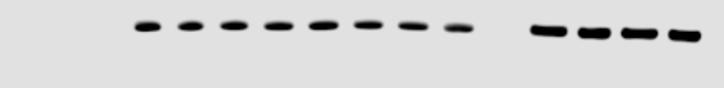
Si-control（0 10 30 60 min）Si-IRAK-M（0 10 30 60 min）

Experiment 3
IRAK-M

P-JNK
JNK
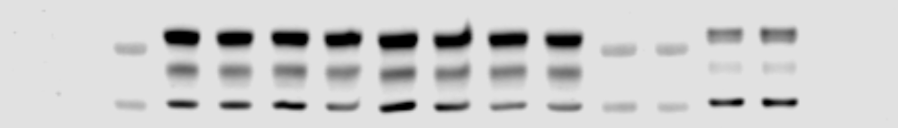
P-P38
P38
GAPDH
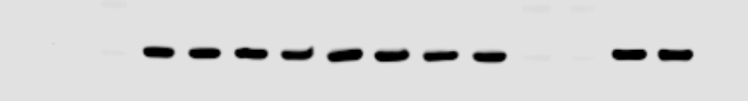
Si-control（0 10 30 60 min）Si-IRAK-M（0 10 30 60 min）

Figure. 4b
Experiment 1 (the left group was cropped)
IRAK-M
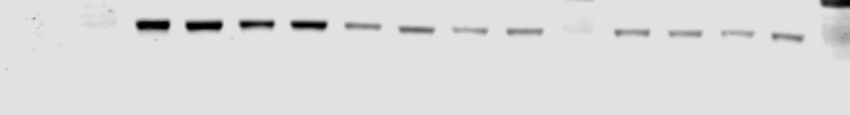
P-JNK
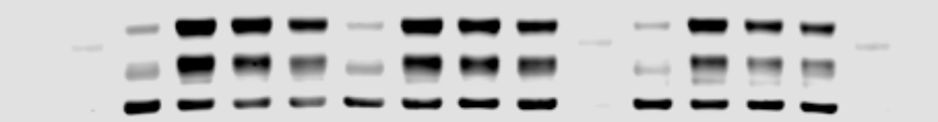
JNK
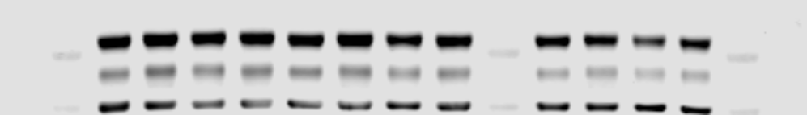
P-P38
P38

GAPDH

Si-control（0 10 30 60 min）Si-IRAK-M（0 10 30 60 min）

Experiment 2
IRAK-M
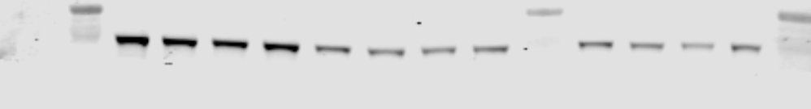
P-JNK
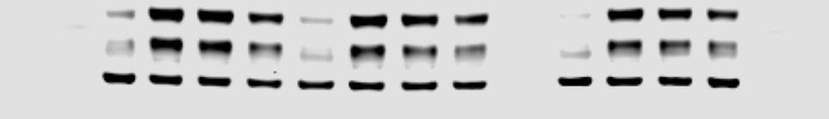
JNK
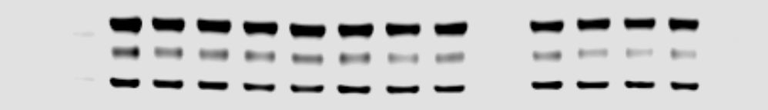
P-P38
P38

GAPDH

Si-control（0 10 30 60 min）Si-IRAK-M（0 10 30 60 min）

Experiment 3
IRAK-M

P-JNK
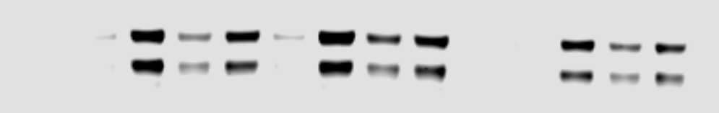
JNK
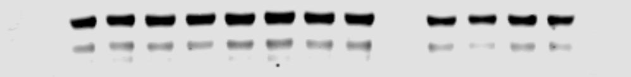
P-P38

P38

GAPDH
Si-control（0 10 30 60 min）Si-IRAK-M（0 10 30 60 min）

Figure. 4c
Experiment 1 (the right group was cropped)
IRAK-M
P-JNK
JNK
P-P38
P38
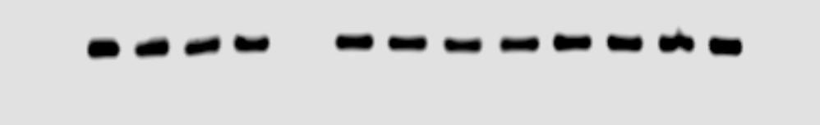
GAPDH

Si-control（0 10 30 60 min）Si-IRAK-M（0 10 30 60 min）

Experiment 2
IRAK-M
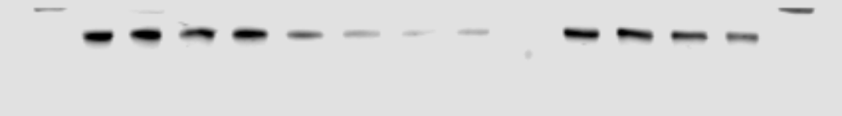
P-JNK
JNK
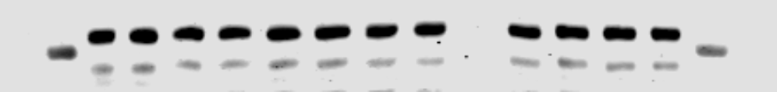
P-P38

P38
GAPDH
Si-control（0 10 30 60 min）Si-IRAK-M（0 10 30 60 min）

Experiment 3
IRAK-M
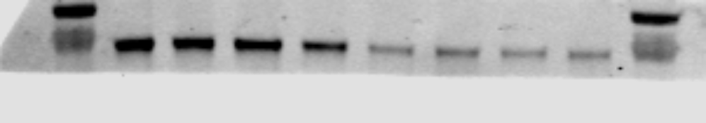
P-JNK
JNK
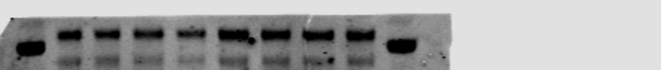
P-P38
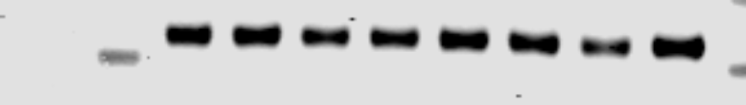
P38
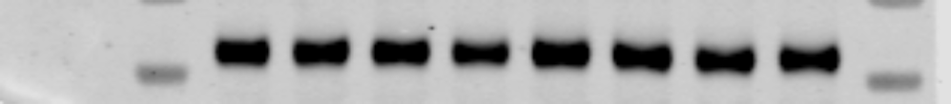
GAPDH
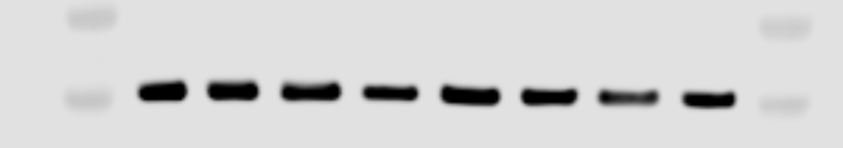
Si-control（0 10 30 60 min）Si-IRAK-M（0 10 30 60 min）

Figure. 4d
Experiment 1 (the right group was cropped)
IRAK-M
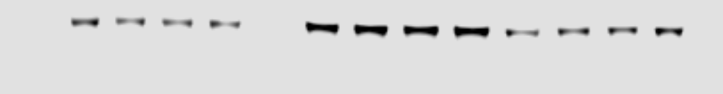
P-JNK
JNK
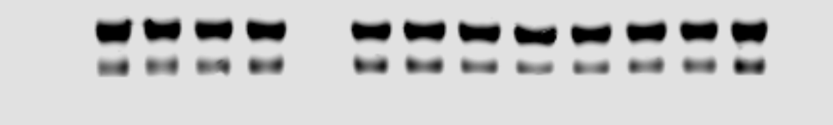
P-P38
P38
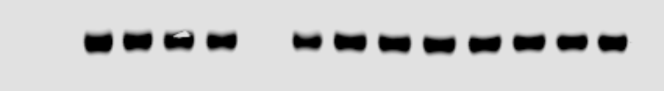
GAPDH
Si-control（0 10 30 60 min）Si-IRAK-M（0 10 30 60 min）

Experiment 2
IRAK-M
P-JNK
JNK
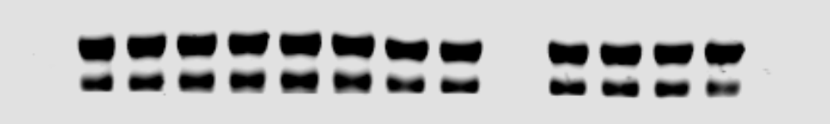
P-P38
P38
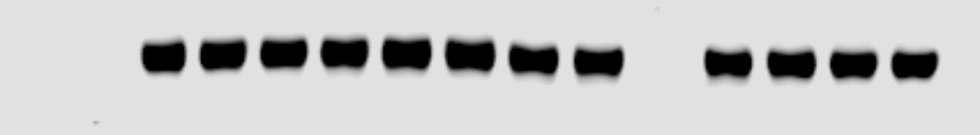
GAPDH

Si-control（0 10 30 60 min）Si-IRAK-M（0 10 30 60 min）

Experiment 3
IRAK-M
P-JNK
JNK
GAPDH
Si-control（0 10 30 60 min）Si-IRAK-M（0 10 30 60 min）
IRAK-M

P-P38

P38

GAPDH

Si-control（0 10 30 60 min）Si-IRAK-M（0 10 30 60 min）

Figure. 5a
Experiment 1、2、3 (the middle group was cropped)
P-JNK
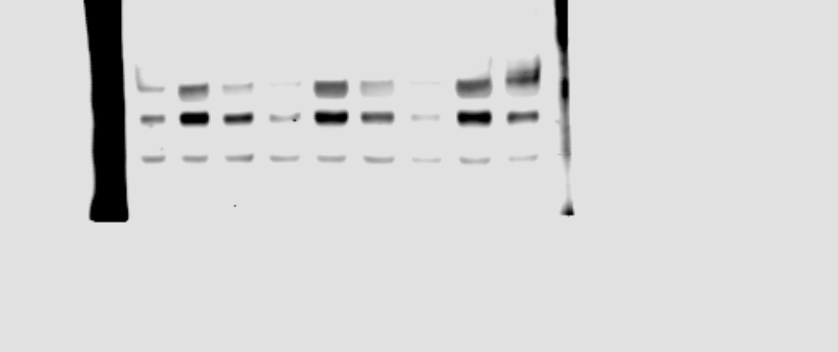
JNK
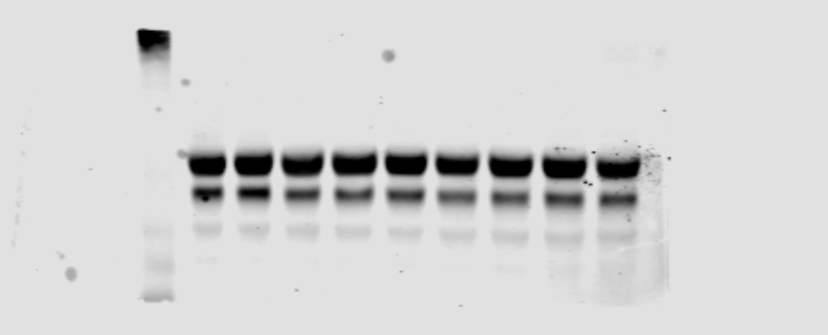
GAPDH

IL-1β IL-1β+SP IL-1β IL-1β+SP IL-1β IL-1β+SP

Figure. 5b
Experiment 1、2、3 (the middle group was cropped)
P-P38

P38

GAPDH
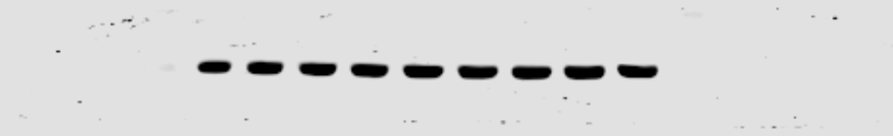IL-1β IL-1β+SB IL-1β IL-1β+SB IL-1β IL-1β+SB

Figure. 5c
Experiment 1、2、3（the middle group was cropped）
P-JNK
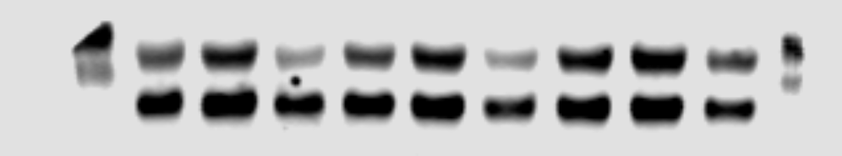
JNK

GAPDH

IL-1β IL-1β+SP IL-1β IL-1β+SP IL-1β IL-1β+SP

Figure. 5d
Experiment 1、2、3（the right group was cropped）
P-P38

P38

GAPDH

IL-1β IL-1β+SB IL-1β IL-1β+SB IL-1β IL-1β+SB

Figure. S1a
Experiment 1 、2、3(the left group was cropped)
IRAK-M
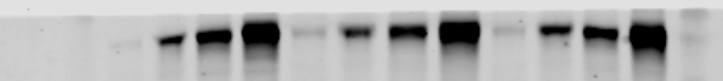
GAPDH
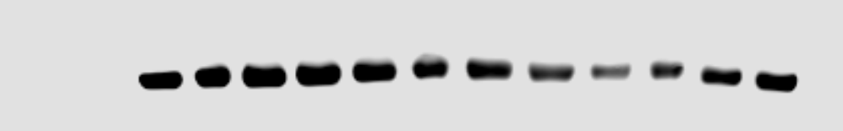
0 6 12 24 0 6 12 24 0 6 12 24 h

Figure. S1b
Experiment 1、2、3 (the middle group was cropped)
IRAK-M
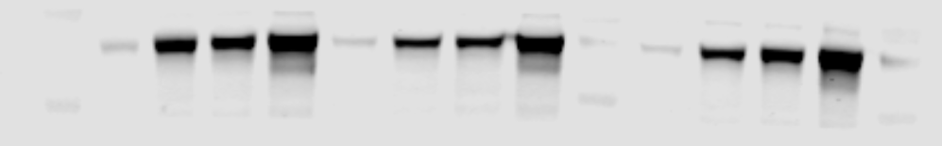
GAPDH

0 6 12 24 0 6 12 24 0 6 12 24 h

Figure. S1c
Experiment 1、2、3 (the left group was cropped)
IRAK-M
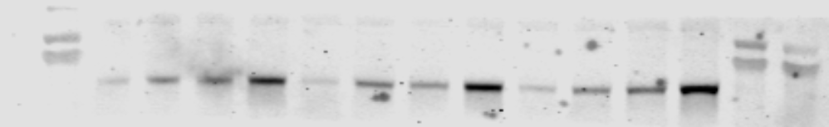
GAPDH
0 6 12 24 0 6 12 24 0 6 12 24 h

Figure. S1d
Experiment 1、2、3 (the left group was cropped)
IRAK-M
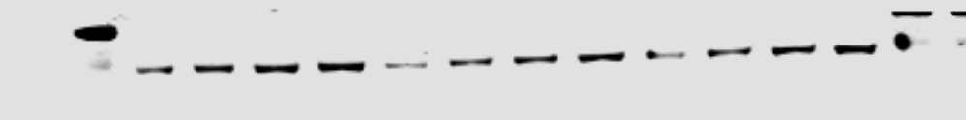
GAPDH
0 6 12 24 0 6 12 24 0 6 12 24 h

Figure. S1e
Experiment 1、2、3 (the right group was cropped)
IRAK-M

GAPDH
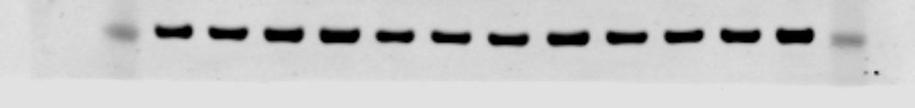
0 6 12 24 0 6 12 24 0 6 12 24 h

Figure. S1f
Experiment 1、2、3 (the left group was cropped)
IRAK-M

GAPDH
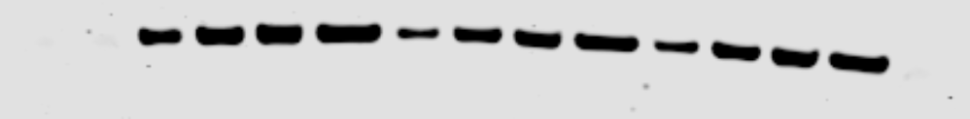
0 6 12 24 0 6 12 24 0 6 12 24 h

Figure. S1g
Experiment 1、2、3 (the left group was cropped)
IRAK-M
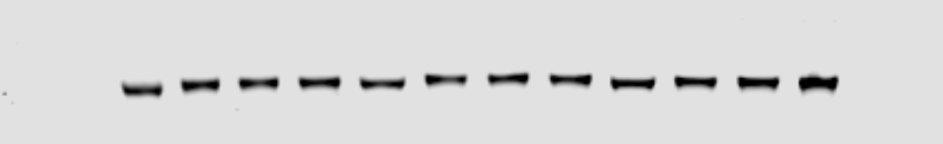
GAPDH
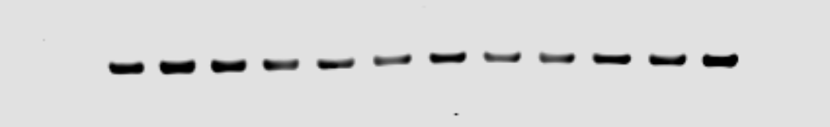
0 6 12 24 0 6 12 24 0 6 12 24 h

Figure. S1h
Experiment 1 、2、3(the left group was cropped)
IRAK-M

GAPDH

0 6 12 24 0 6 12 24 0 6 12 24 h

Figure. S2a
Experiment 1、2、3、4 (the left group was cropped)
IRAK-M
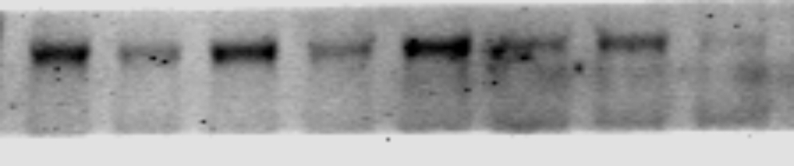
GAPDH

Si-control si-IRAK-M Si-control si-IRAK-M Si-control si-IRAK-M Si-control si-IRAK-M

Figure. S2b
Experiment 1、2、3 (the left group was cropped)
IRAK-M
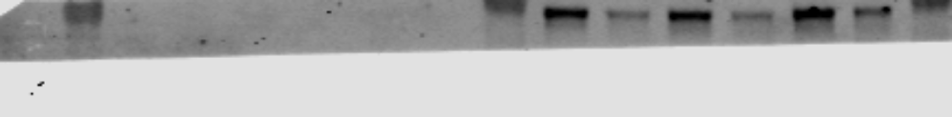
GAPDH
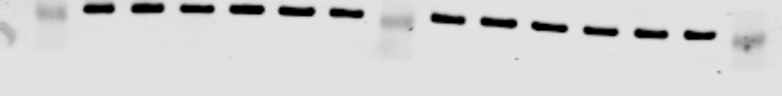
Si-control si-IRAK-M Si-control si-IRAK-M Si-control si-IRAK-M

