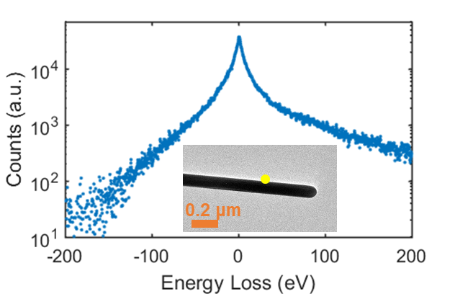
Fig. S1 | The electron spectrum from a single nanowire pumped by 190 fs laser with fluence about 35 mJ/cm². For a single silver nanowire with diameter of about 100 nm, the highest electron energy-gain can be up to 150 eV. The inset shows the bright- field image of the nanowire. The yellow dot represents the detection position.

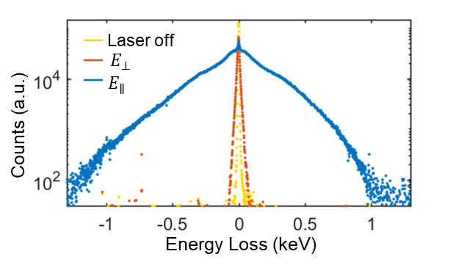
Fig. S2 | Three typical electron spectra of MLA. Strong electron-photon interaction happens on the MLA when the laser polarization is parallel to the electron beam, while the interaction becomes much weaker when the laser polarization is perpendicular to the electron beam.

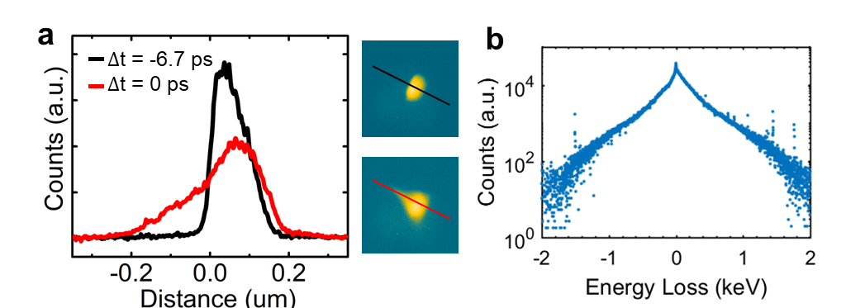
Fig. S3 | a, Intensity line profiles at different time delays along the lines indicated in the right panel. b, The corresponding electron spectrum.

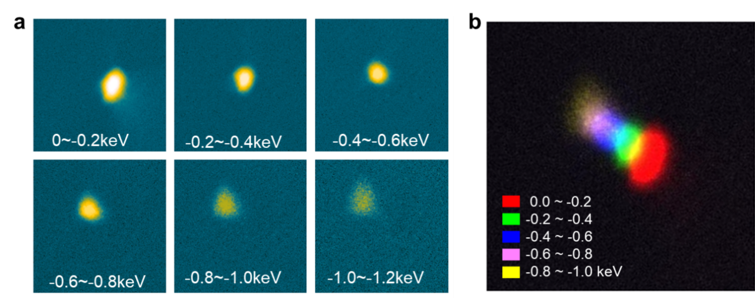
Fig. S4 | Energy filtered images of stretched electron spot. a, A series of energy filtered images under the same experimental conditions in fig. 3a at ∆t = 0. Energy windows used for imaging are indicated in the legends. b, A superimposition of images in a.

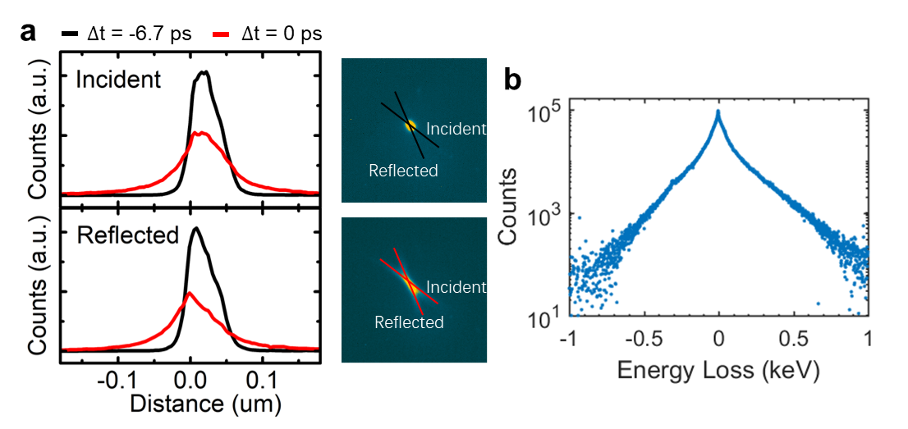
Fig. S5 | a, Intensity line profiles along the incident and reflection directions at different time delays. Positions are indicated by the lines in the right panel. b, The corresponding electron spectrum.

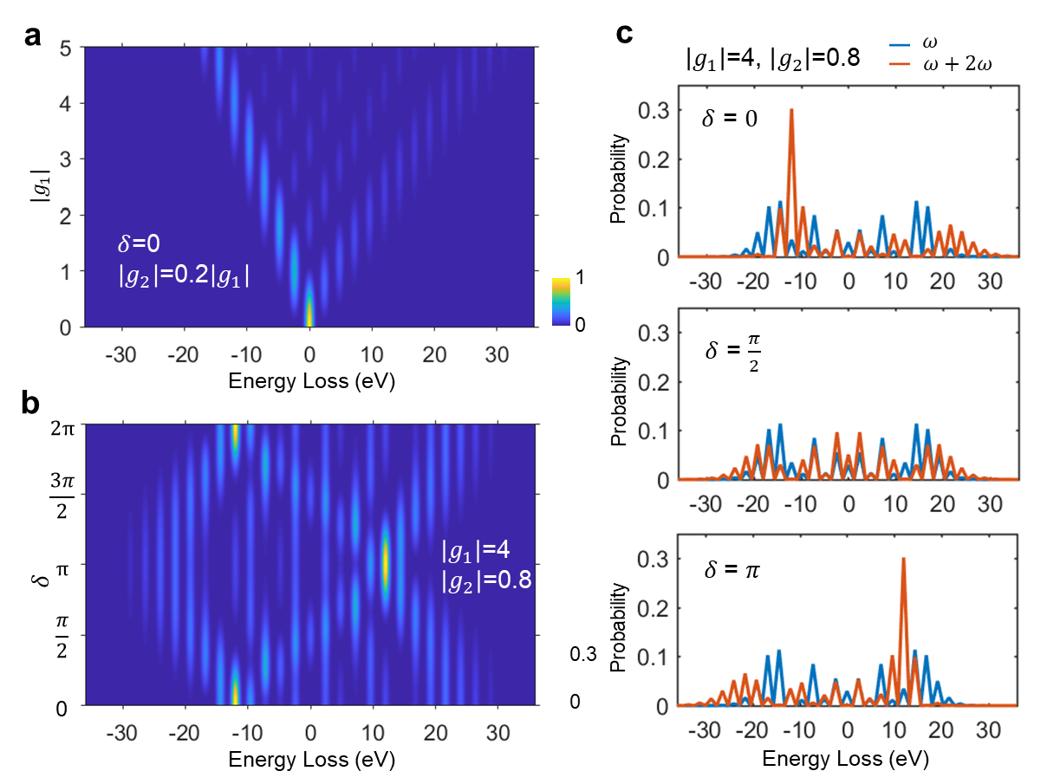
Fig. S6 | A typical Electron density distribution while both fundamental and SHG fields exist. a, Probabilities of electron in each energy state varied with near field intensity. b, Probabilities of electron in each energy state varied with relative phase. c, Three sections of b and the corresponding spectrum with only fundamental field.

Table S1 | A comparison of MLA with DLA. In our experiments, interaction length is 7.16 μm, and fluence is 25.5 mJ/cm² (corresponding to intensity of 1.27×10¹¹ W/cm²). Because the laser size (diameter ~50 μm) is much larger than the interaction area, the acceleration gradient formula provided in reference⁵⁰ doesn’t apply.
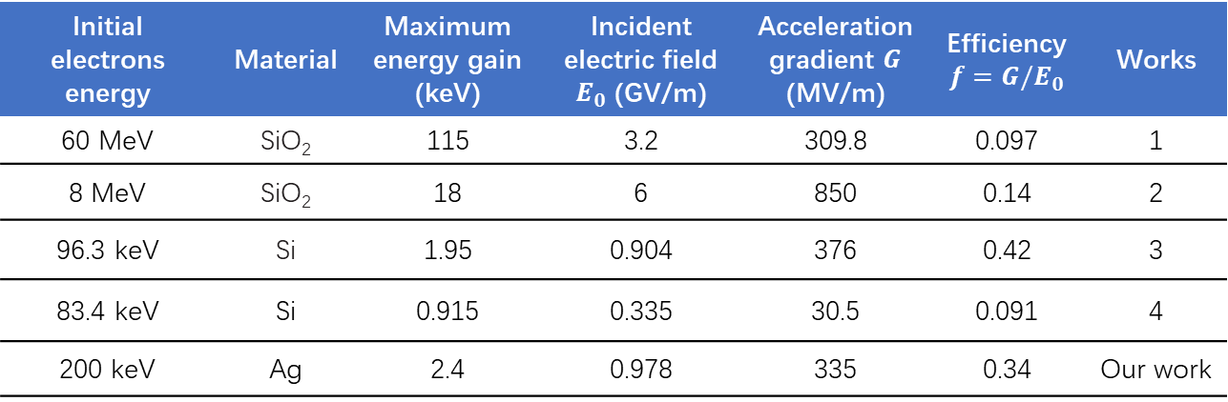
Features: 1. Proof-of-principle experiment⁶. 2. Highest record for relativistic electrons⁴³. 3. Highest record for subrelativistic electrons⁹. 4. On-Chip Integrated waveguide-integrated⁴⁴.

