Supplementary File
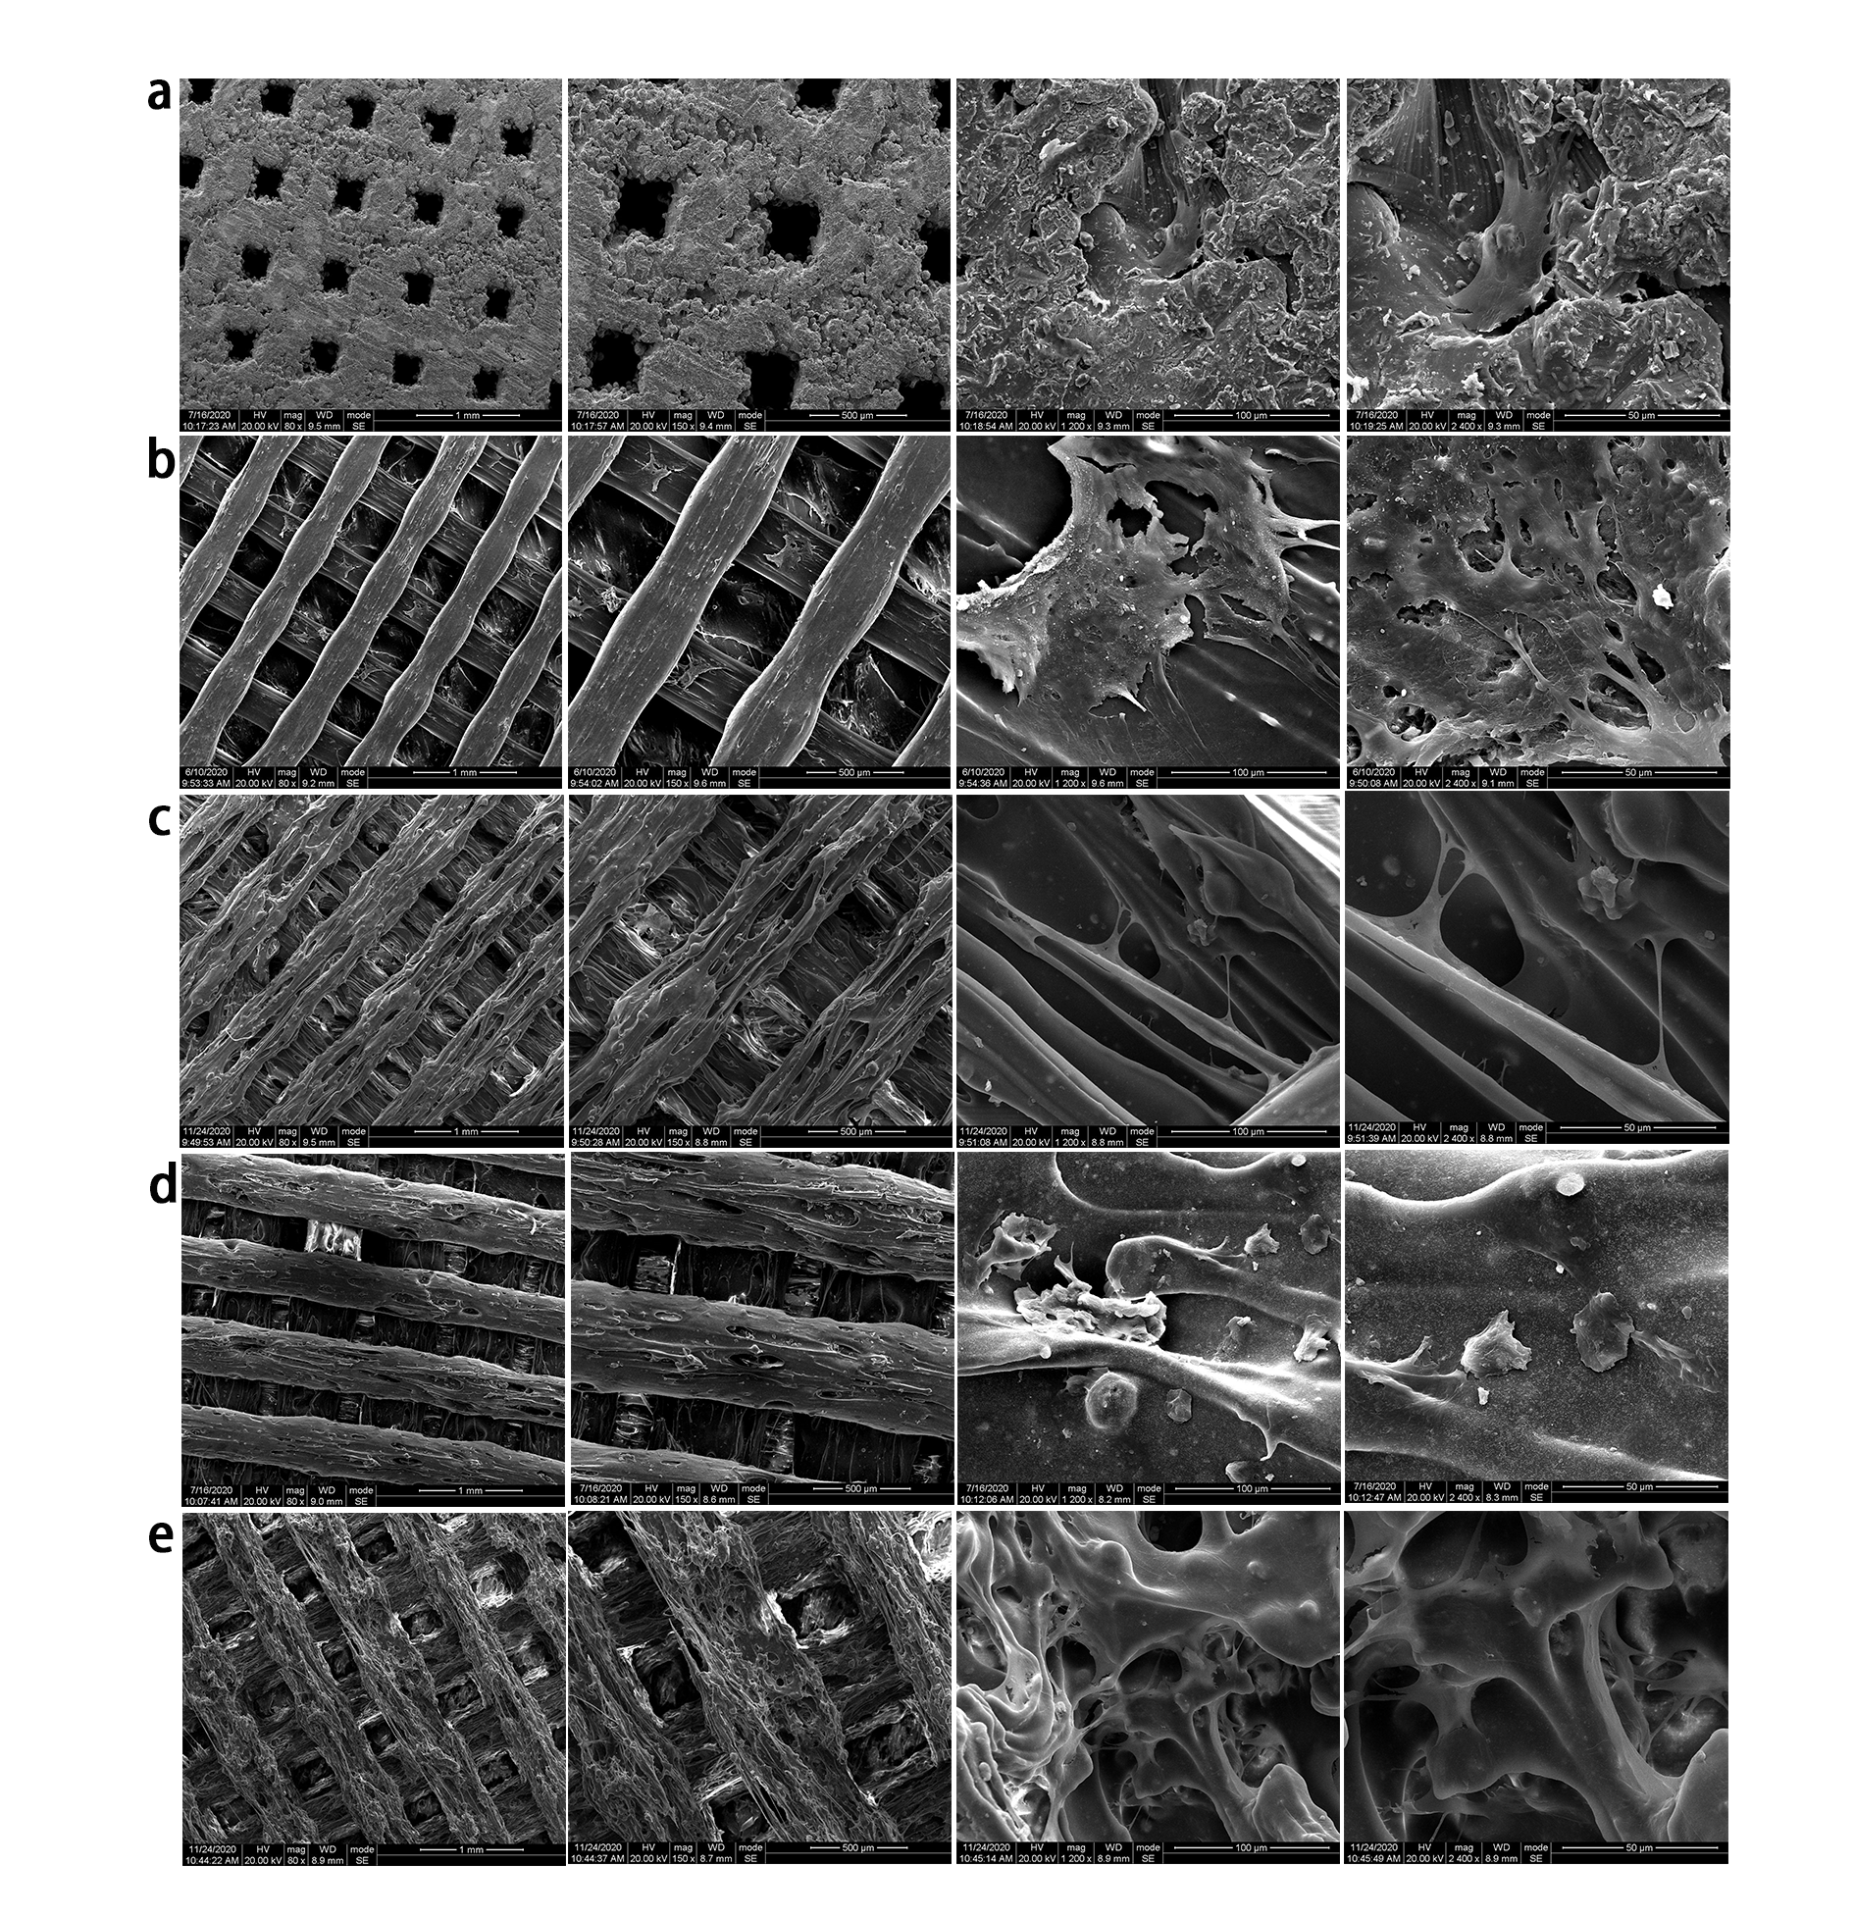
Figure S1. Scanning electron microscope （SEM） image of BMMSCs growing on scaffolds for 24 hours. SEM images of cells on Ti (a), PEEK (b), 10%HA/PEEK (c), 20%HA/PEEK (d) and 30%HA/PEEK (e) with low crystallinity. Observed under 80×, 150×, 1200×, 2400× magnifications (from left to right) respectively.
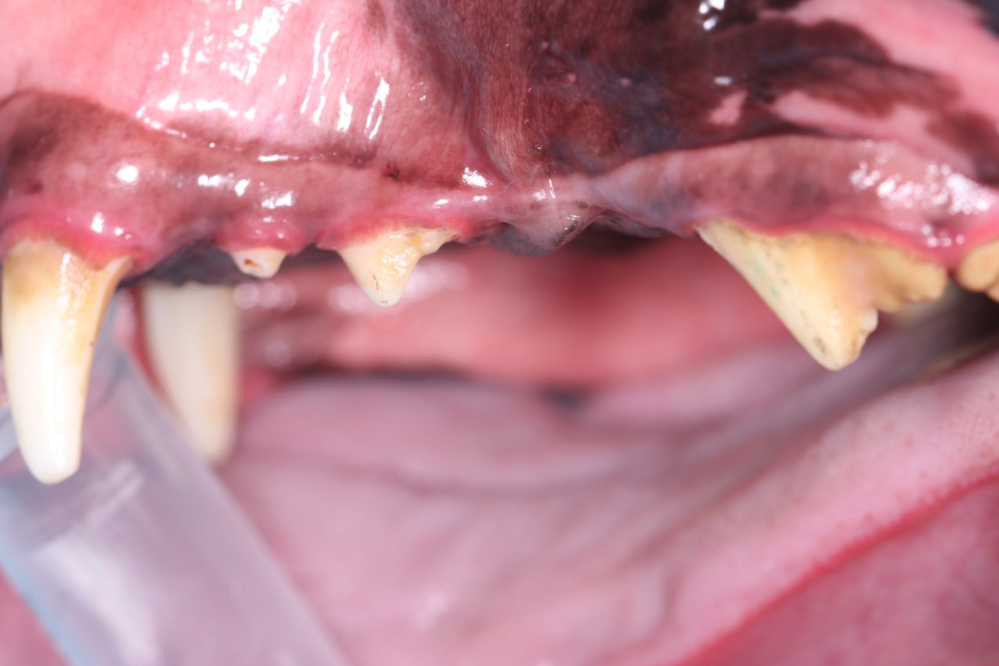
Figure S2. Ti scaffold extruded out of the gingiva after 8 weeks implanted in the alveolar socket of Beagles.

