Additional file 1：Supplementary Information of “Subclassification of Breast Cancer through Comprehensive Multi-omics Data to Benefit Distinct Survival Outcomes”
  - Three heatmaps overlapped features from RNA-seq, Exon expression and DNA methylation
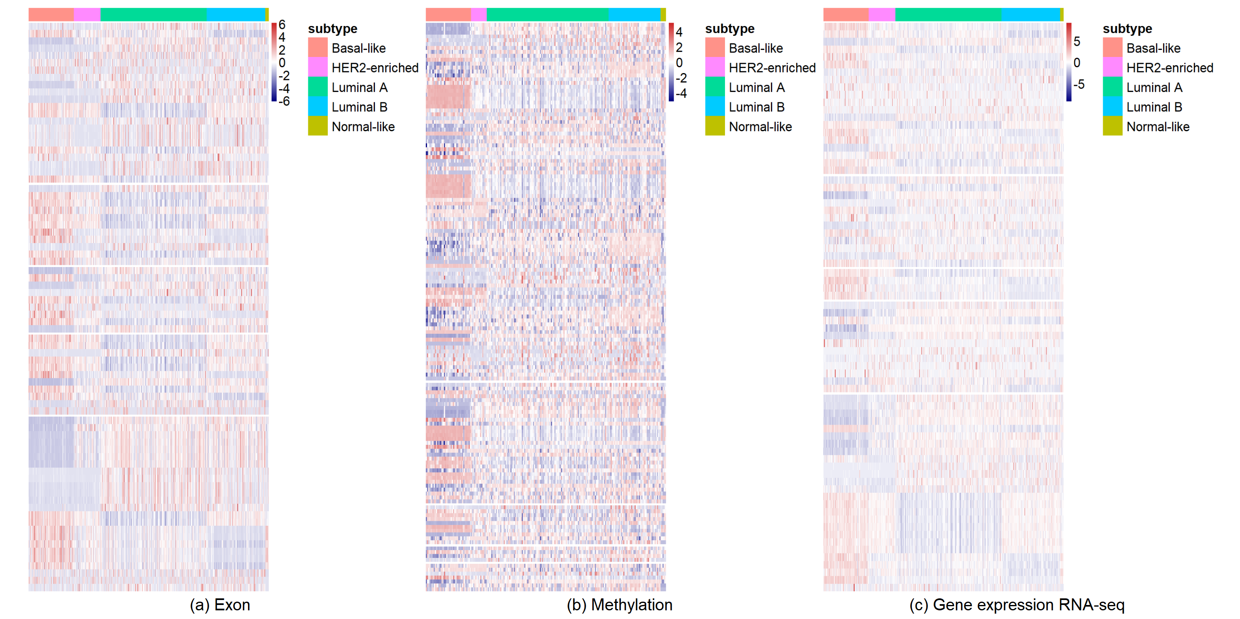

Fig. A-1. Heatmaps of exons(a), CpG islands(b), genes(c) respectively from three datasets. The overlapped features were chosen and sorted by number of repetition. Features more distinctly expressed in five subtypes with the increase of repeat count. It can be observed that the subtypes of breast cancer can be more precisely distinguished in exon expression RNA-seq data and gene expression RNA-seq data.

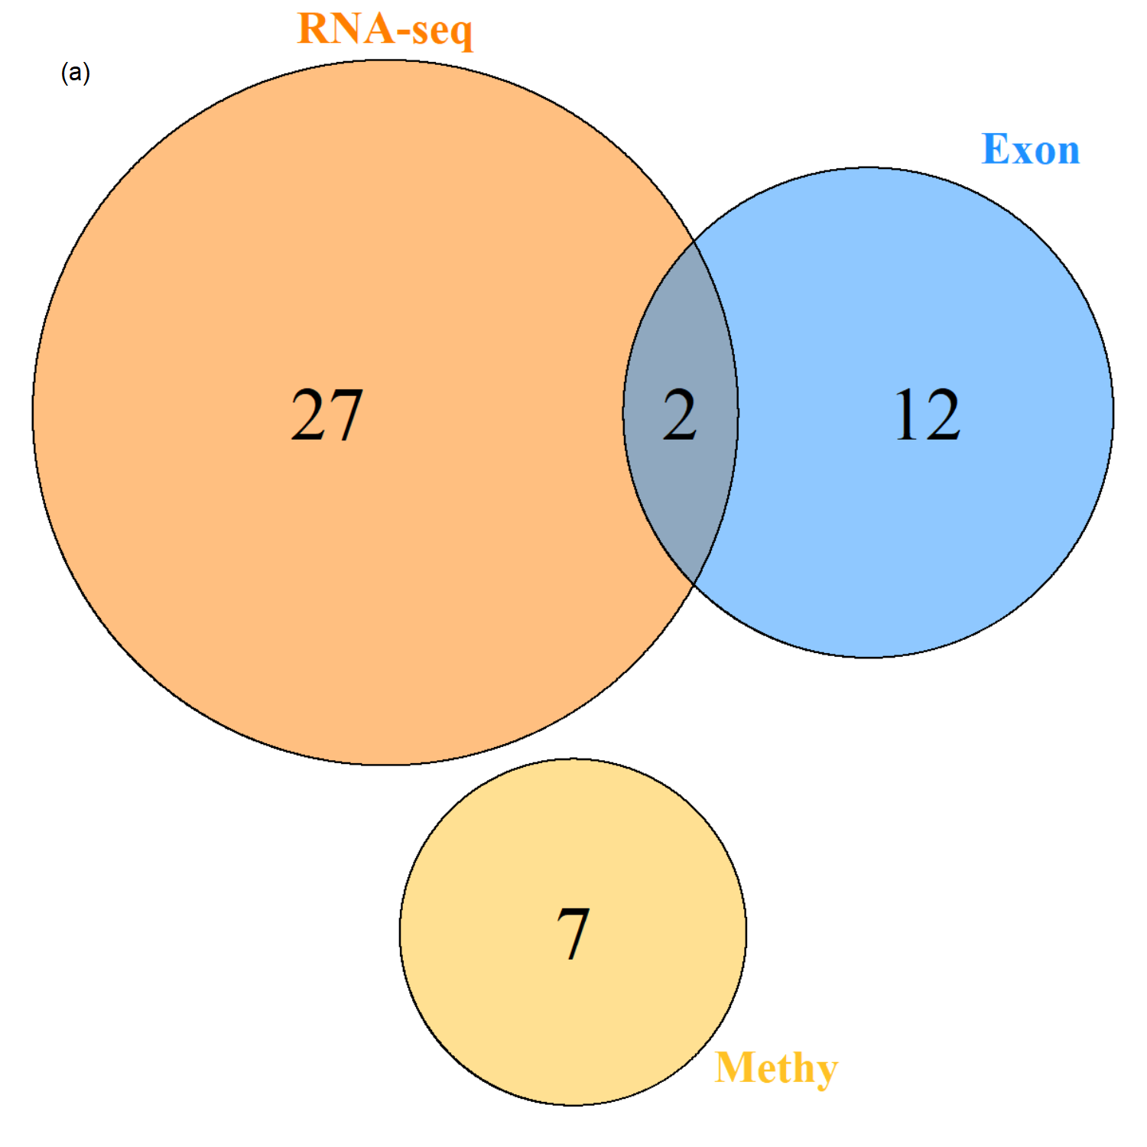
  - Overlaps and heatmaps of corresponding genes from selected significant features from three datasets
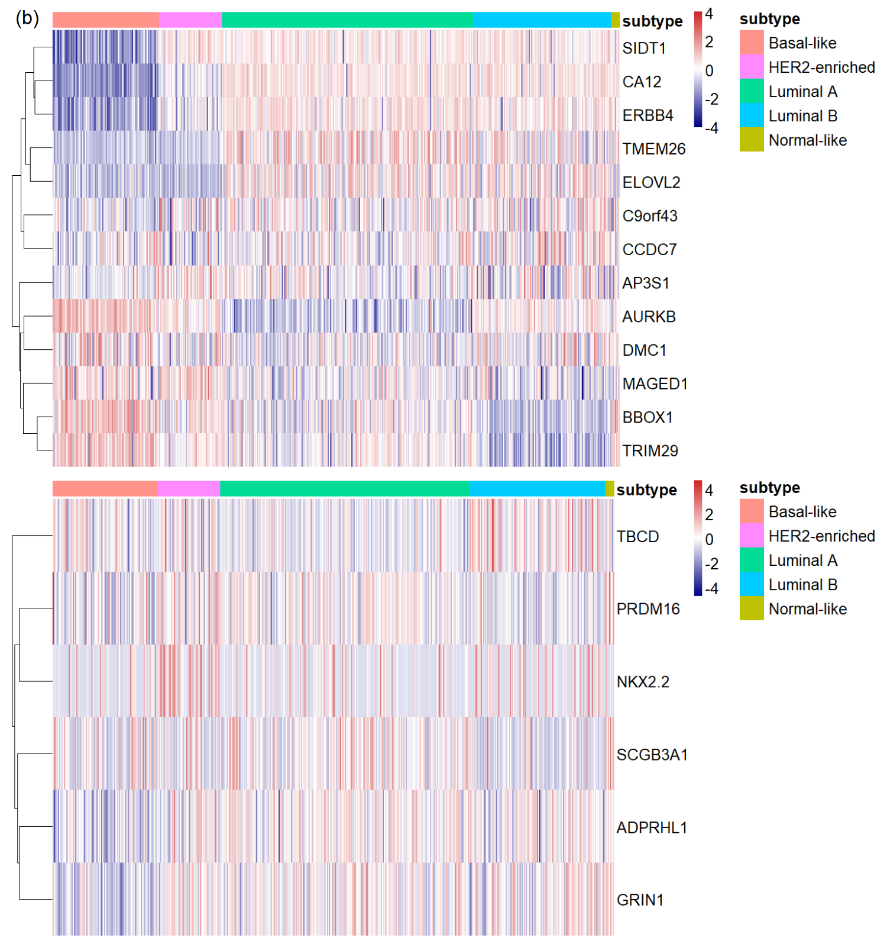
Fig. A-2. Venn diagram (a) of mapped genes of selected features from three datasets and heatmaps (b) of the corresponding genes derived from exon data and methylation data. (a) two genes (AURKB, BBOX1) are shared by RNA-seq data and exon data. (b) The heatmaps based on those genes showed more or less regularity in different subtypes. This indicates that integrating multi-omics datasets can provide supplementary information from the other side.

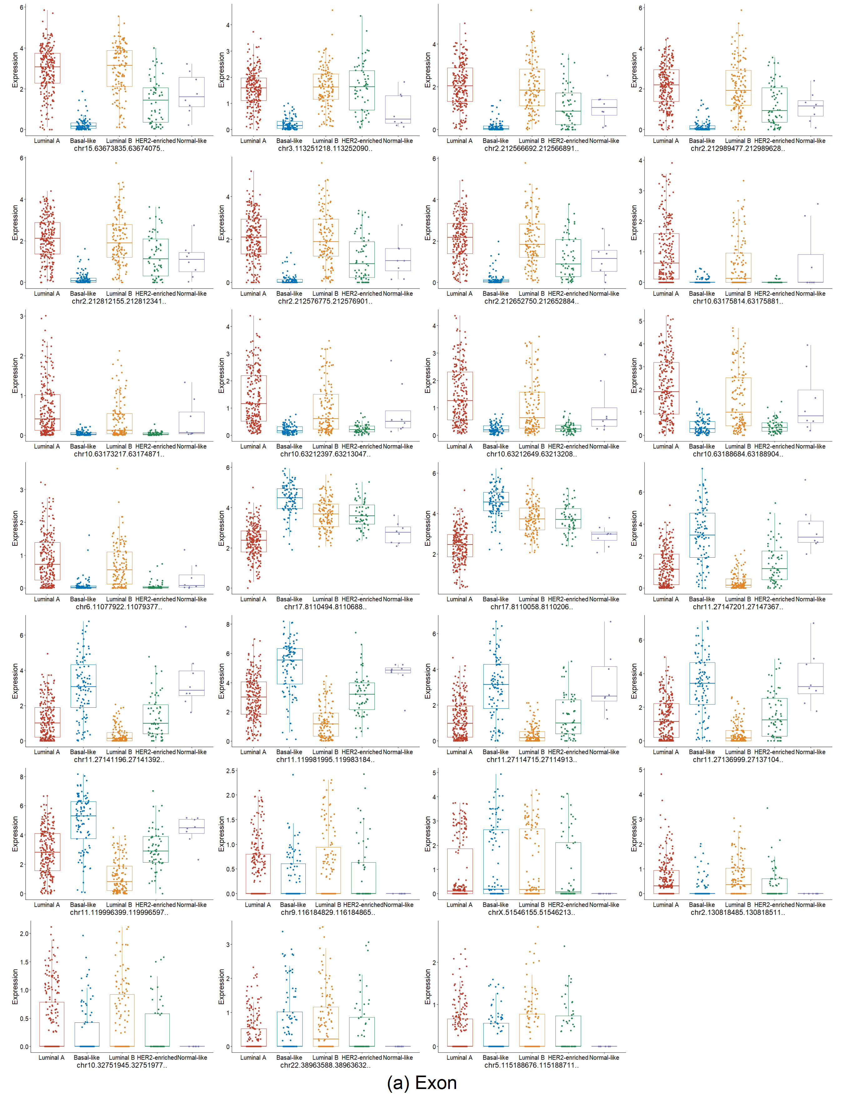
  - Expression levels of Exon (a), methylation levels (b) and RNA-seq (c) of selected significant features

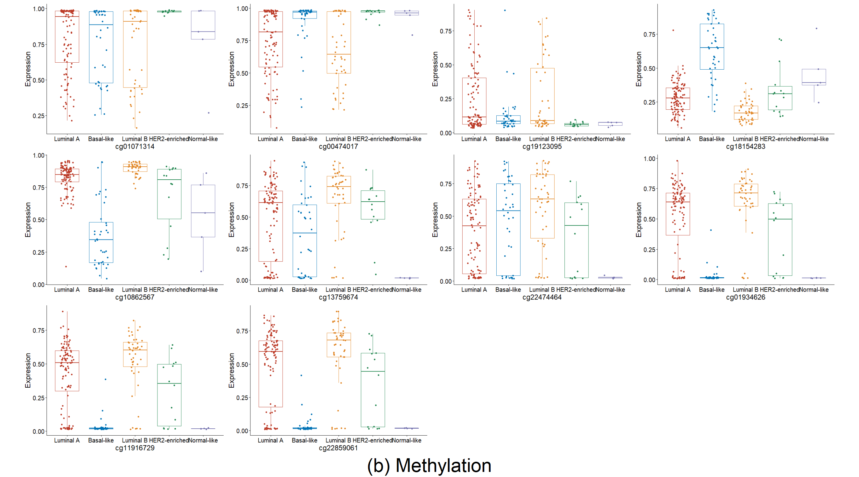

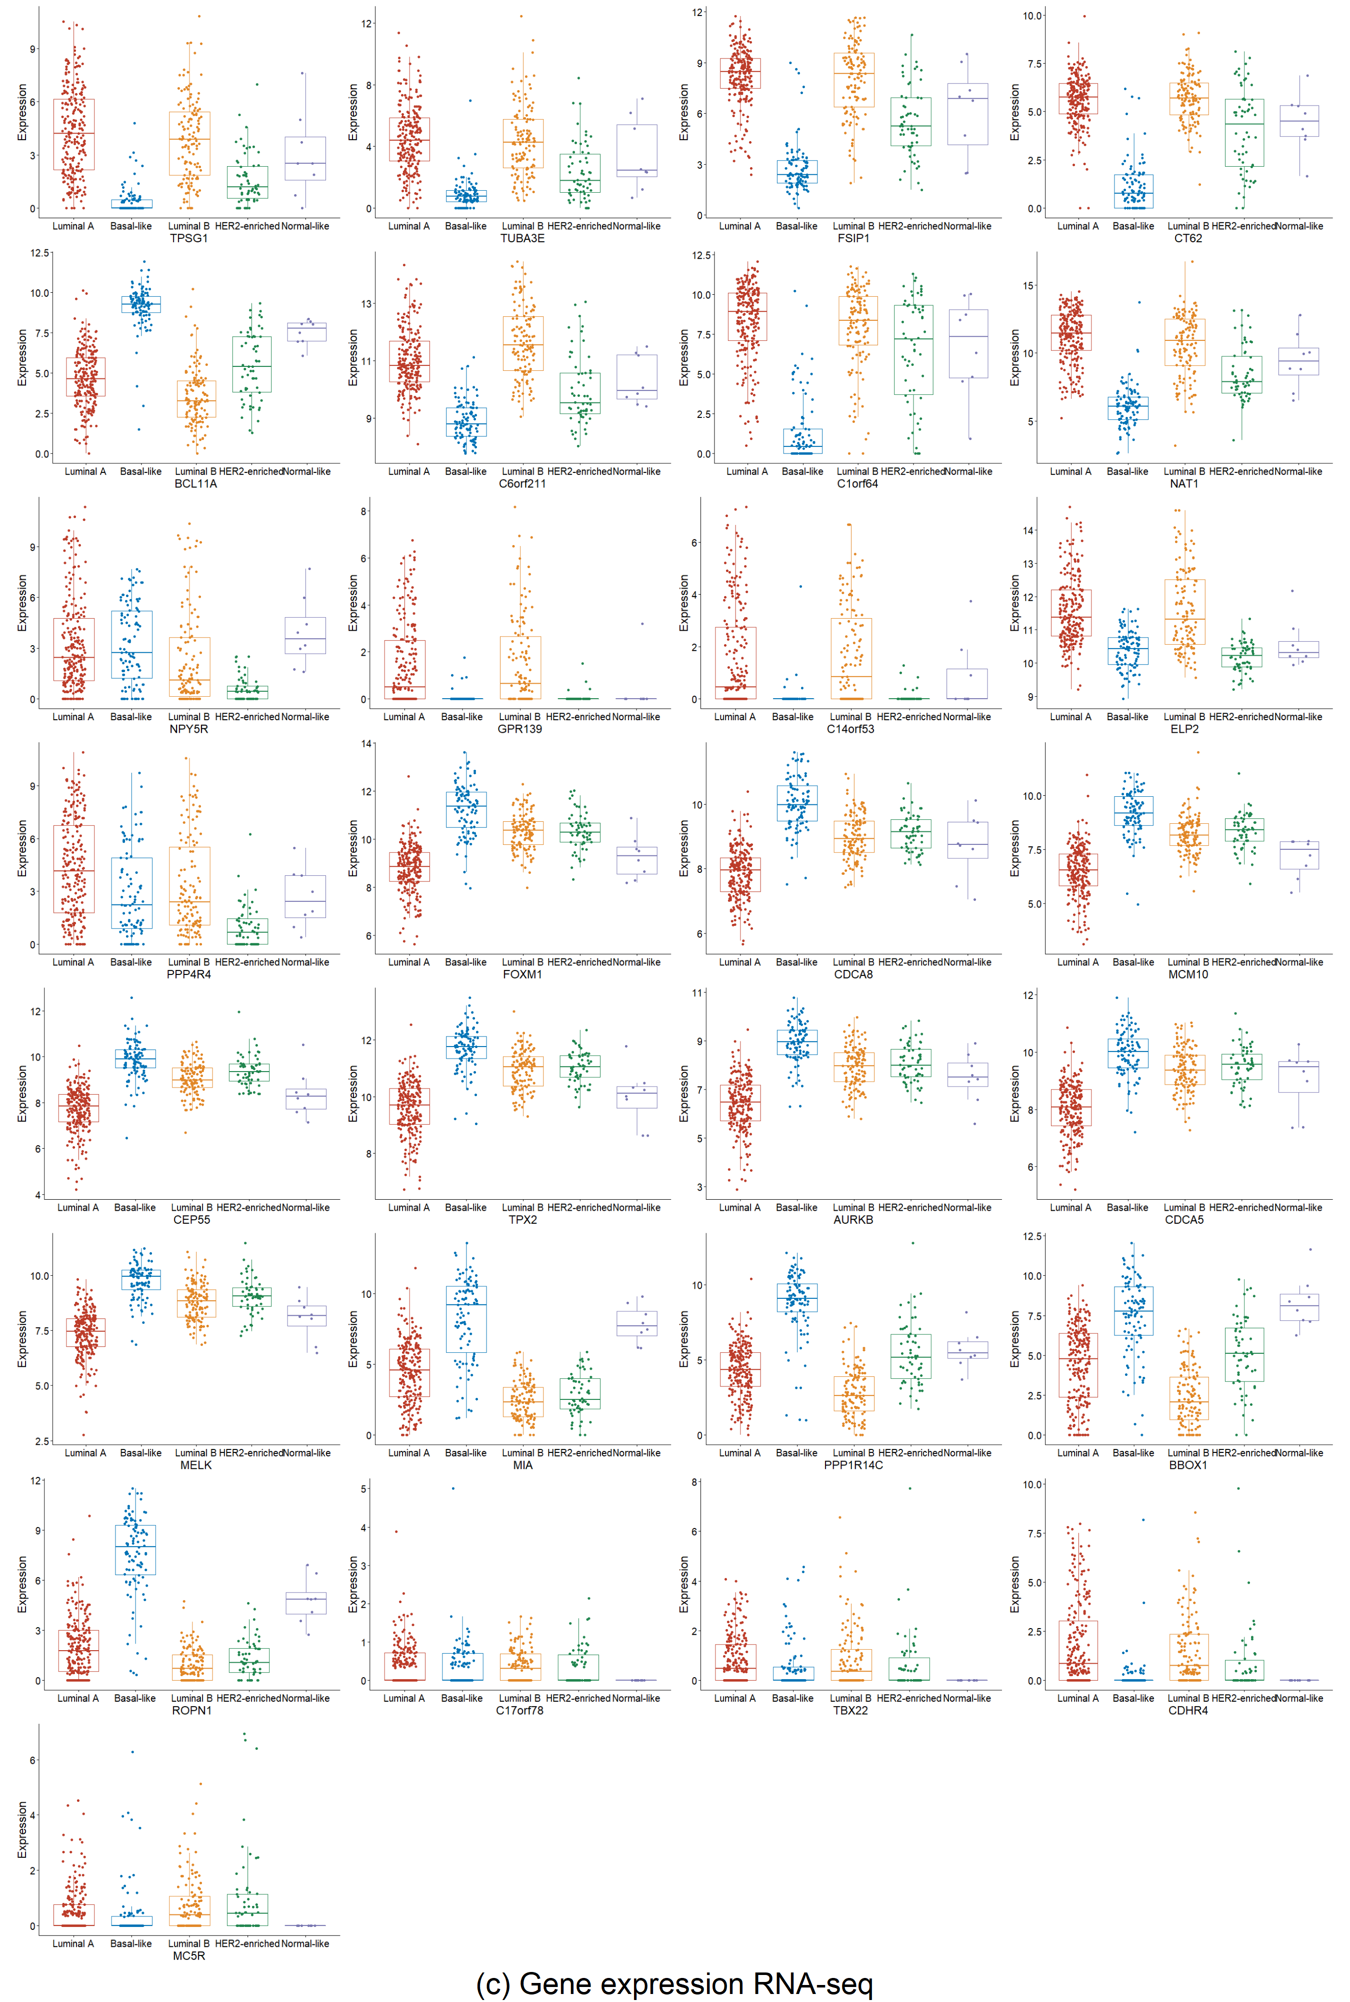

Fig. A-3. Box plots on the selected sets of overlapped features form exon expression RNA-seq (a), methylation (b) and RNA-seq datasets (c). The box plots depict that the expression levels of 29 genes, 27 exons and 10 methylation CpG islands identified from all five cross-validations among different subtypes. As expected, most of selected features were the relevant markers to tumorigenesis, especially breast tumors.

Table A-1. The corresponding mapped genes of significant features based on UCSC Genome Browser on Human (GRCh37/hg19)
Significant Features | Mapped Genes | Significant Features | Mapped Genes
chr15:63673835-63674075 | CA12 | chr11:27147201-27147367 | BBOX1
chr3：113251218-113252090 | SIDT1 | chr11:27136999-27137104 | BBOX1
chr2:212566692-212566891 | ERBB4 | chr11:119996399-119996597 | TRIM29
chr2:212989477-212989628 | ERBB4 | chr9:116184829-116184865 | C9orf43
chr2:212812155-212812341 | ERBB4 | chrX:51546155-51546213 | MAGED1
chr2:212576775-212576901 | ERBB4 | chr10:32751945-32751977 | CCDC7
chr2:212652750-212652884 | ERBB4 | chr22:38963588-38963632 | DMC1
chr10:63175814-63175881 | TMEM26 | chr5:115188676-115188711 | AP3S1
chr10:63173217-63174871 | TMEM26 | cg01071314 | PRDM16
chr10:63212397-63213047 | TMEM26 | cg00474017 | ADPRHL1
chr10:63212649-63213208 | TMEM26 | cg19123095 | SPRY1
chr10:63188684-63188904 | TMEM26 | cg10862567 | TBCD
chr6:11077922-11079377 | ELOVL2-AS1 | cg13759674 | GRIN1
chr17:8110494-8110688 | AURKB | cg22474464 | NKX2-2
chr17:8110058-8110206 | AURKB | cg22859061 | SCGB3A1

  - The performance of machine learning multi-classification
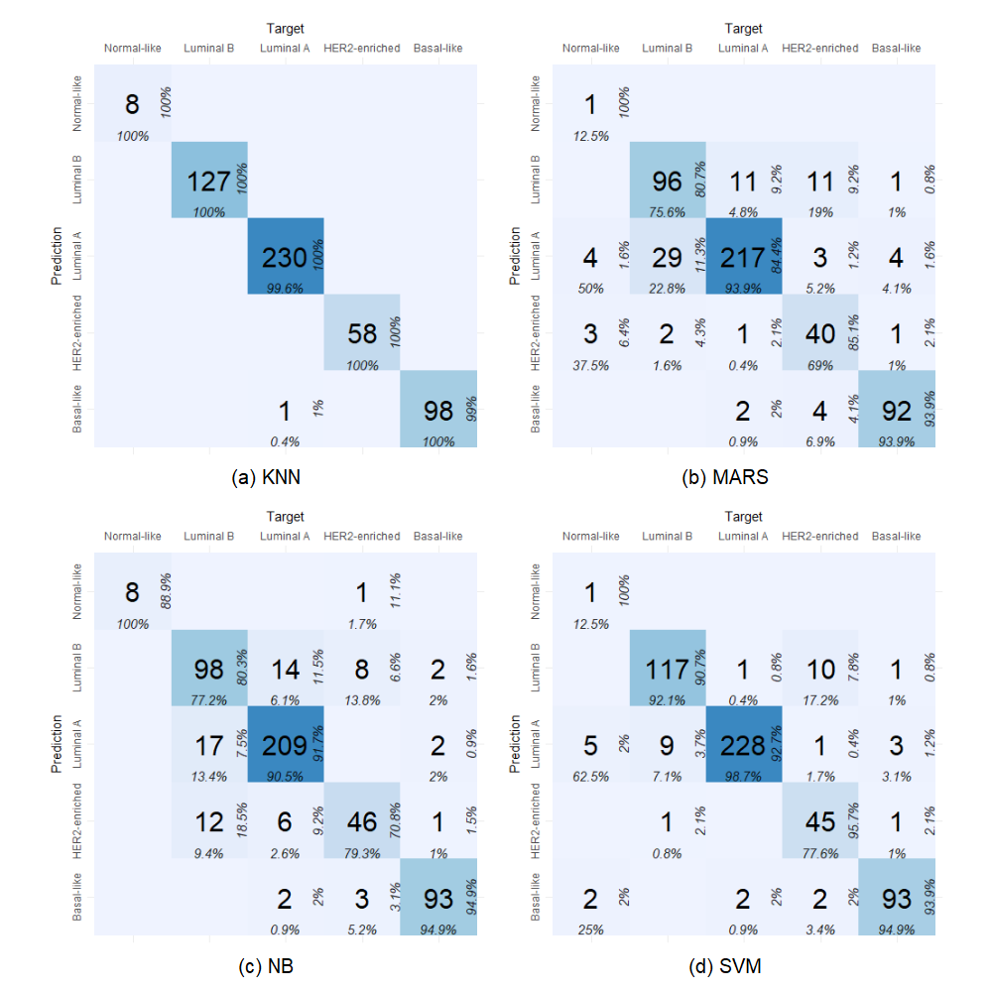
Fig. A-4. The confusion matrices of different approaches. NB and MARS can effectively distinguish luminal breast cancer from other breast cancer subtypes, but could not perfectly distinguish different luminal breast cancer subtypes. For example, by checking the confusion matrix yielded by MARS, among 231 LumA samples, 14 samples were misclassified, where 11 samples were classified to LumB; for 127 LumB samples, 31 samples were not correctly classified and 29 samples were assigned to LumA. All these indicated that LumA and LumB samples were quite similar, inducing difficulties to identify LumB samples from LumA samples.

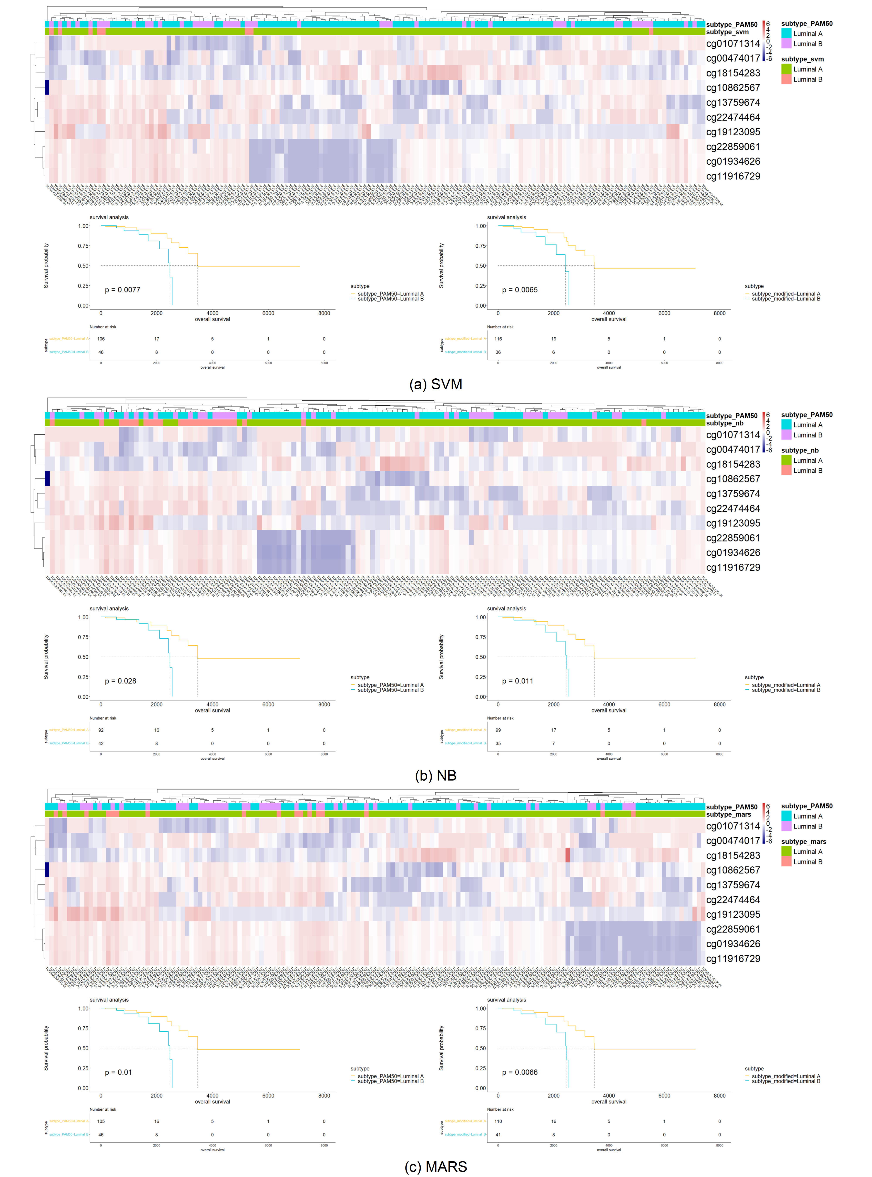
  - Research on methylation Data
Fig. A-5. Picking isolated samples by three heatmaps of methylation data to through comparing PAM50 labels and labels derived from only epigenetic data. The luminal subtypes predicted from clusters of heatmap based on methylation levels of significant methylation CpG islands showed improved survival curve (based on SVM (a), NB (b), MARS (c)).

