Effects of extreme temperature events on behaviour and survival after reproductive in Rana dybowskii

Running title: Effects of temperature on frogs.

Qing Tong ^{a, b*}, Wen-jing Dong ª, Ming-da Xu ª, Xin-zhou Long ª, Zong-fu Hu ^{b}, Xiao-yun Han ª, Li-yong Cui ^{c*}
ª College of Biology and Agriculture, Jiamusi University, Jiamusi, 154007, China
^{b} Northeast Agricultural University, Harbin, 150030, China
^{c} Jiamusi Branch of Heilongjiang Academy of Forestry Sciences, Jiamusi, 154002, China
Corresponding Authors
Qing Tong (lxixl@126.com) and Li-yong Cui (cuiliy@163.com)
Email address: lxixl@126.com, cuiliy@163.com

Supporting information
Figure S1. The temperature and humidity of dormant environment of R. dybowskii.
The upper curve indicates the relative humidity in the air, corresponding to the right side of Y-axis. The lower curve shows the land surface temperature, corresponding to the left side of Y-axis.

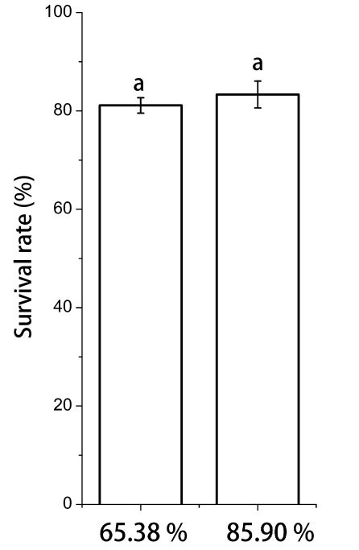
Figure S2. Effects of air humidity on the survival of R. dybowskii.
Data are displayed as the average ± SD. Treatments with different letters are significantly different (P < 0.05).

