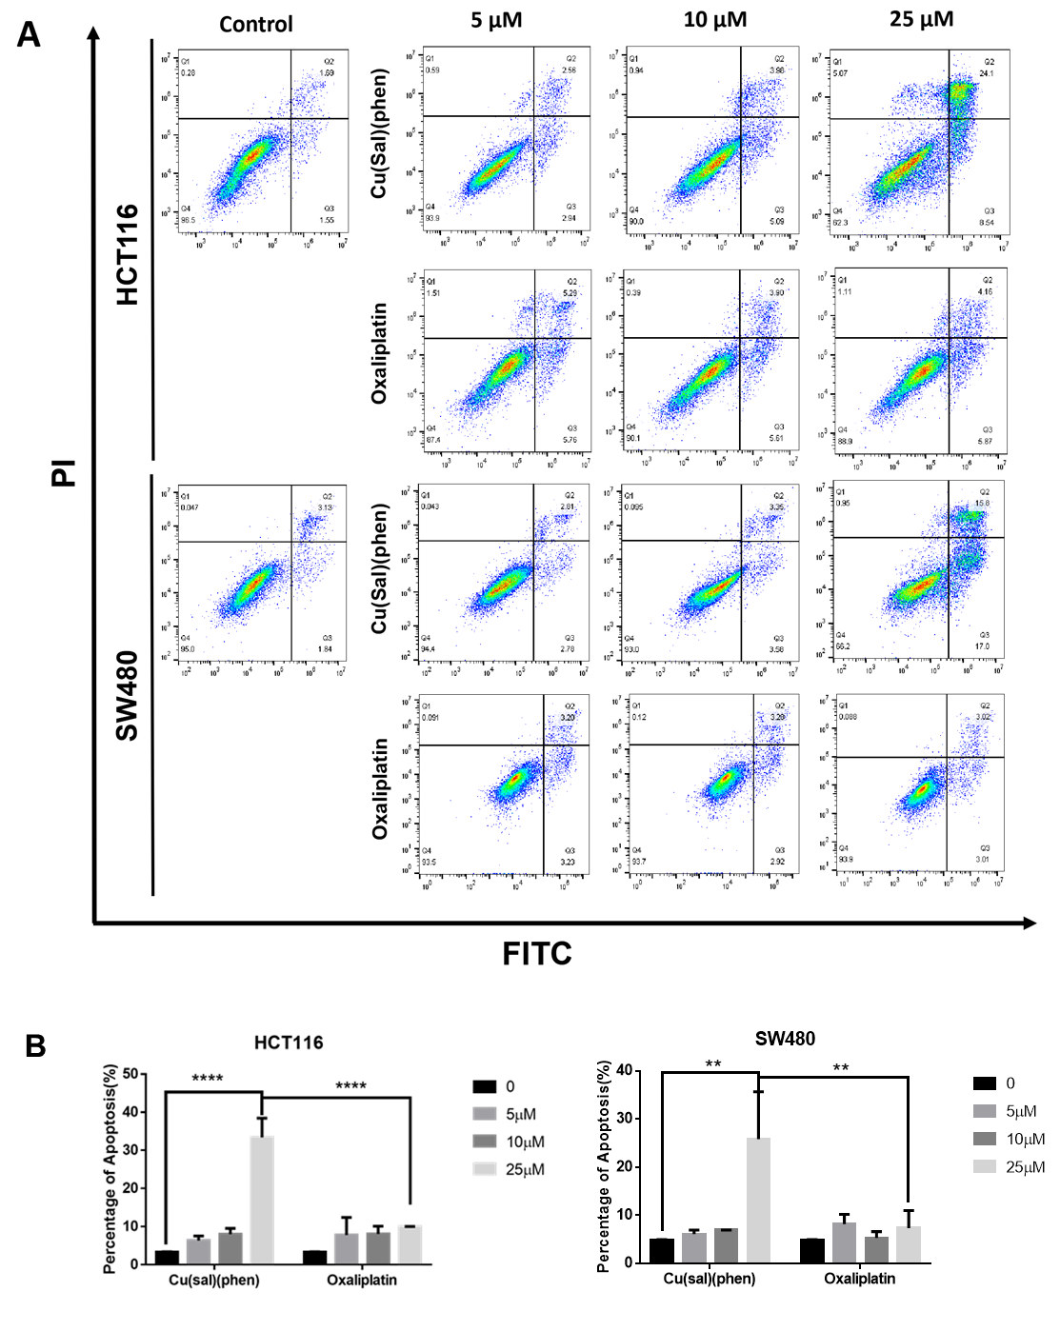
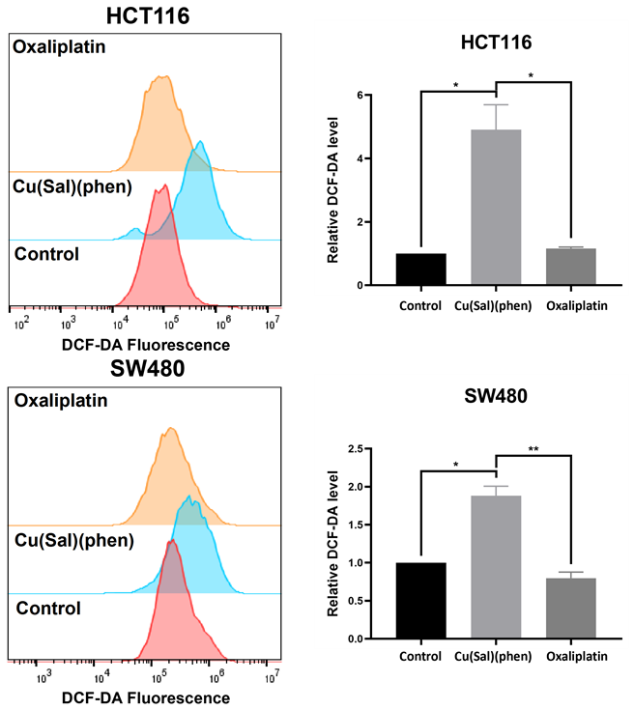

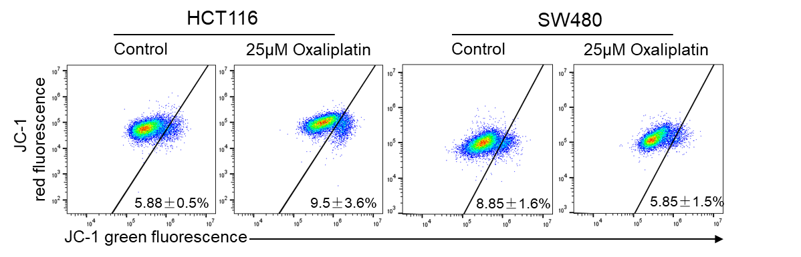
Figure legends
Figure S1 Cu(sal)(phen) induces more apoptosis of CRC cells than oxaliplatin.
A). HCT116 and SW480 were treated with 0, 5, 10 and 25 µM of Cu(sal)(phen) or Oxaliplatin for 24 hrs, and apoptosis was assessed with the flow cytometry after Annexin V/PI double staining.
B&C). Quantitative analysis of A. **p< 0.01; ****p<0.0001.
Figure S2 Cu(sal)(phen) induces more ROS than Oxaliplatin
The level of ROS was detected by flow cytometry in HCT116 and SW480 cells treated with Cu(sal)(phen) or Oxaliplatin. The fold change in DCFH-DA intensity was shown in the right. * p<0.05; ** p<0.01.
Figure S3 Effect of Oxalipatin on Mitocondria membrane potential of HCT116 and SW480. MMP was analyzed with JC1 staining and flow cytometry after treating with Oxaliplatin.

