Endophytic bacteria from diseased plant leaves as potential biocontrol agents of cucumber Fusarium wilt
Yinqing Tan¹, Changxia Du^{1*}, Li Xu¹, Cong Yue, Xingchen Liu, Huaifu Fan*
Collaborative Innovation Center for Efficient and Green Production of Agriculture in Mountainous Areas of Zhejiang Province, College of Horticulture Science, Zhejiang A & F University, Hangzhou, Zhejiang 311300, China
1 These authors have contributed equally to this work.
*Correspondence author’s email:
Huaifu Fan (fanhf@zafu.edu.cn)
Changxia Du (changxiadu@zafu.edu.cn)
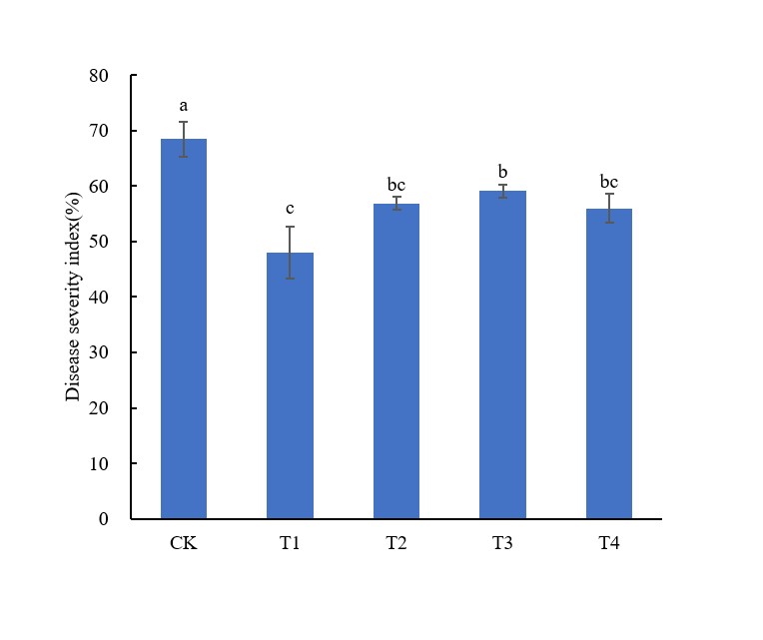
Fig. S1 Antagonistic efficacy against cucumber Fusarium wilt. Where, CK: single Fusarium wilt treatment, T1: Y-4+FOC, T2: Y-6+FOC, T3: Y-9+FOC, T4: Y-14+FOC. For combined inoculation treatment, each plant was treated with antagonist strain culture solution for 24 h, and then inoculated with FOC. Different letters (a, b) indicate significant differences among treatments (one-way ANOVA, P <0.05) according to Duncan's multiple range tests.

