2.4 Spatial distribution, Temporal distribution and Speciation of NMVOCs and PM_{2.5}
For the spatial distribution of open burning of straw, the land type area weighting method was used (Zheng et al., 2012), that is, using the area of cropland in Henan Province as the characterization data for spatial allocation. Rural population weighting method is adopted for spatial distribution of straw and firewood combustion, biogas combustion and biomass briquette fuel combustion. The population weighting method uses population data as a weighting factor for the spatial distribution of pollutants emitted from pollutant emission sources.
The temporal allocation coefficients for the relevant inventories (biogas combustion, biomass briquette fuel combustion and residual open burning of straw) in the control scenarios in this study are uniformly applied to RB sources. The monthly allocation coefficients for their 15 categories of anthropogenic source are based on the results of Zhang et al (Zhang et al., 2007) and Streets et al (Streets et al., 2003), the weekly allocation coefficients for their 15 categories of anthropogenic source are based on the results of Chinkin et al. (Chinkin et al., 2003) and the daily allocation coefficients are based on the results of Wang et al (Wang et al., 2010). The monthly allocation coefficients for OB and RB are shown in Fig.A.4.
The emission inventories generated for OB and RB could not be directly used for CMAQ model since the lumped NMVOCs and PM_{2.5} yet to be speciated into the explicit model species. The source composition profiles were used to convert the emission rates of lumped species into the rates of chemical components that are recognizable by CMAQ model. Due to the differences in industrial institutions, industrial processes and geography, there are certain differences in the source composition profiles of different periods and different locations, so the selection of the source composition profiles of local emission characteristics of sources can reduce the uncertainty of the model simulation (Borge et al., 2008). In terms of the data selection, we prioritized domestic measurement for the species as much as possible. Therefore, for open burning of straw, residential combustion of straw and firewood plus biomass briquette fuel combustion, the NMVOC source profile of mainly refers to data from Liu et al(Liu et al., 2008) and Akagi et al (Akagi et al., 2011), the PM_{2.5} source profile data are cited from the work of Li et al. (Li et al.,2007). For biogas, the NMVOC source profile and the PM_{2.5} source profile mainly refers to the US SPECIATE database (US EPA.,2019) due to the lack of relevant species genealogy studies in China.
3.2 Source contribution of open burning of straw plus residential combustion of straw and firewood.
Table A.13 shows the monthly average concentration values of NH₄⁺, NO₃– and SO₄^{2–} produced by open burning of straw plus residential combustion of straw and firewood in Henan Province. Among them, ANH4_X1 represents the concentration of NH₄⁺ ions produced by open burning of straw in Henan Province, ANH4_X2 represents the concentration of NH₄⁺ ions produced by residential combustion of straw and firewood in Henan Province, and ANH4_X3 represents the concentration of NH₄⁺ ions from remaining anthropogenic emission source in Henan Province. As can be seen from the Table A.13, the concentration of secondary particulate matter from both open burning of straw and residential combustion of straw and firewood is below 0.1µg/m³. Fig.A.5 shows the monthly average proportion of secondary particulate matter generated by open burning of straw plus residential burning of straw and firewood in Henan Province to total amount of secondary particulate matter in Henan Province. it can be seen from Fig.A.5 that the secondary particulate matter of NH₄⁺, NO₃– and SO₄^{2–} ions produced by open burning of straw plus residents burning straw and firewood in Henan Province accounts for a small percentage of the corresponding secondary particulate matter emission concentration in Henan Province, and most of the values of proportion are below 2%, which indicates that open burning of straw plus residential combustion of straw and firewood produces little secondary particulate matter precursor emissions.

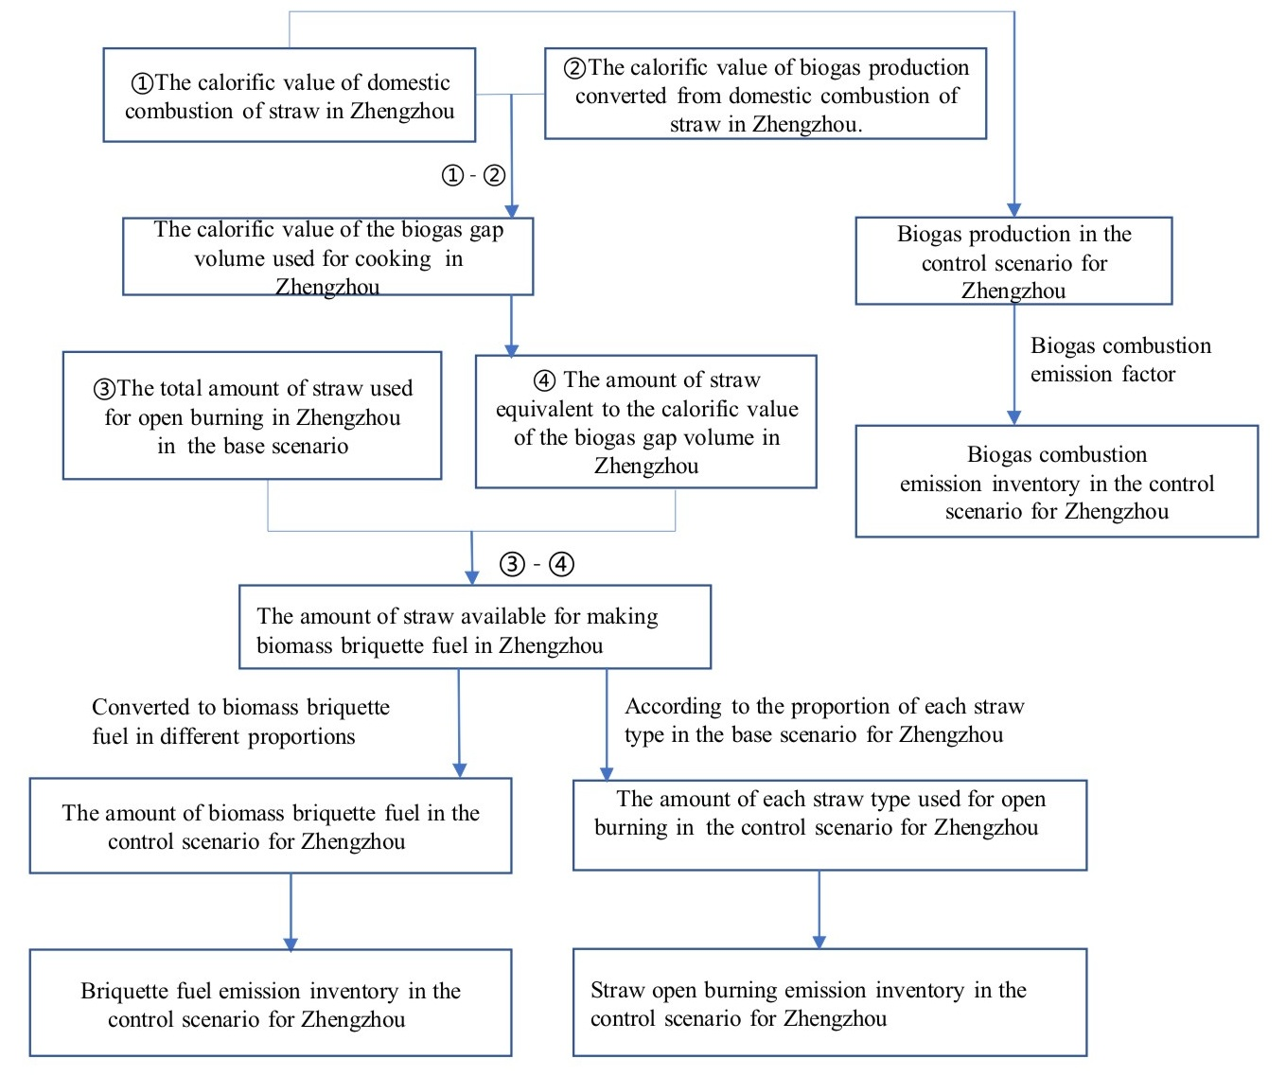
Fig.A.1 Calculation method of emission inventory for control scenarios (Take the rural areas of Zhengzhou as an example).

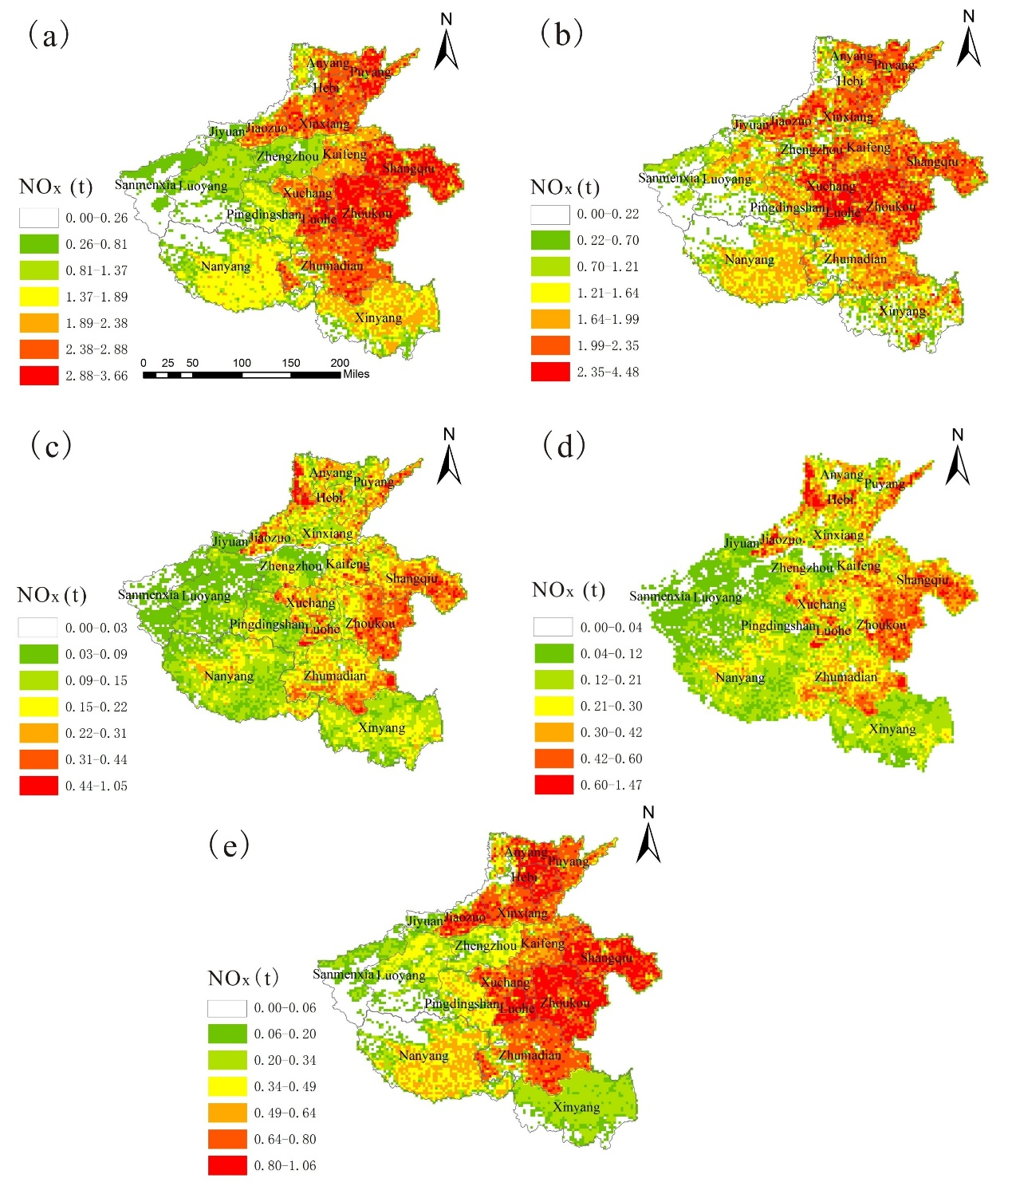
Fig.A.2 (a) Spatial distribution for open burning of straw in base scenario (b) Spatial distribution of straw and firewood combustion in base scenario (c) Spatial distribution of biogas combustion in control scenarios (d) Spatial distribution of biomass briquette fuel combustion in control scenarios (e) Spatial distribution of open burning of residual straw in control scenarios

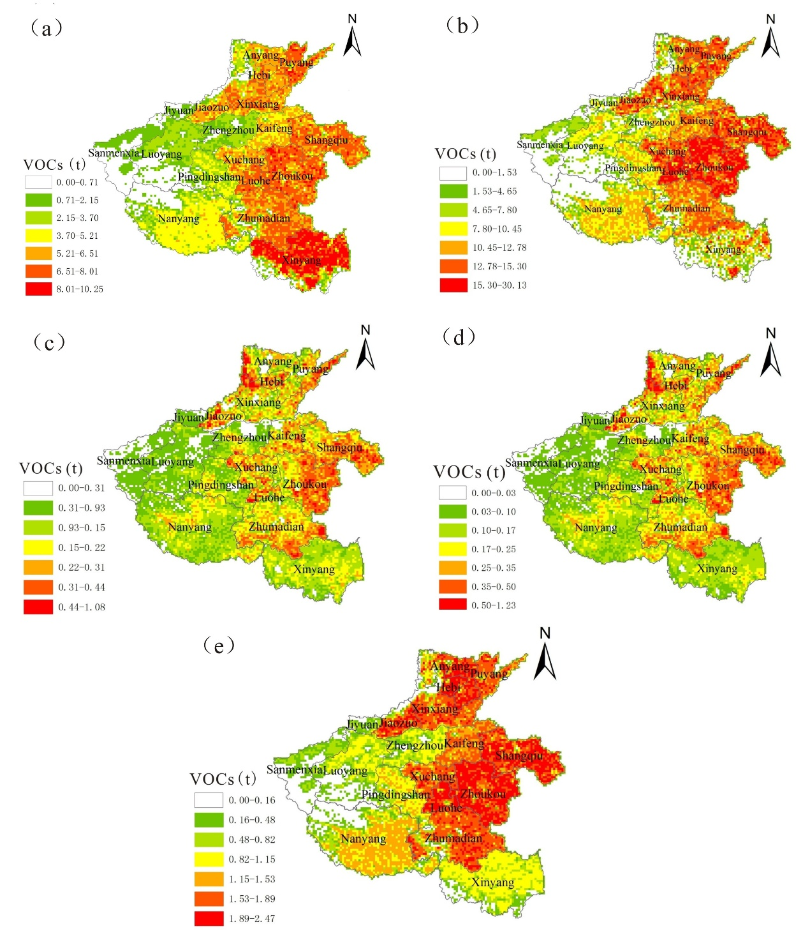
Fig.A.3 (a) Spatial distribution for open burning of straw in base scenario (b) Spatial distribution of straw and firewood combustion in base scenario (c) Spatial distribution of biogas combustion in control scenarios (d) Spatial distribution of biomass briquette fuel combustion in control scenarios (e) Spatial distribution of open burning of residual straw in control scenarios

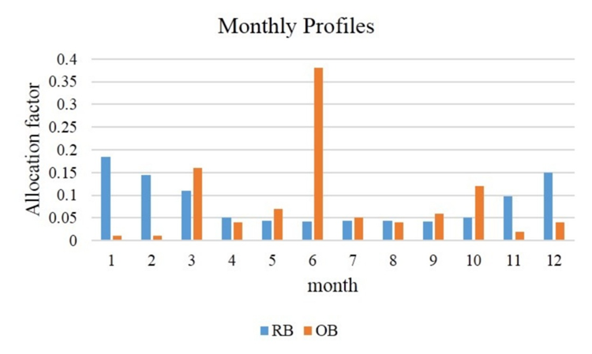
Fig.A.4 Monthly temporal distribution for open burning of straw and residential combustion of straw and firewood

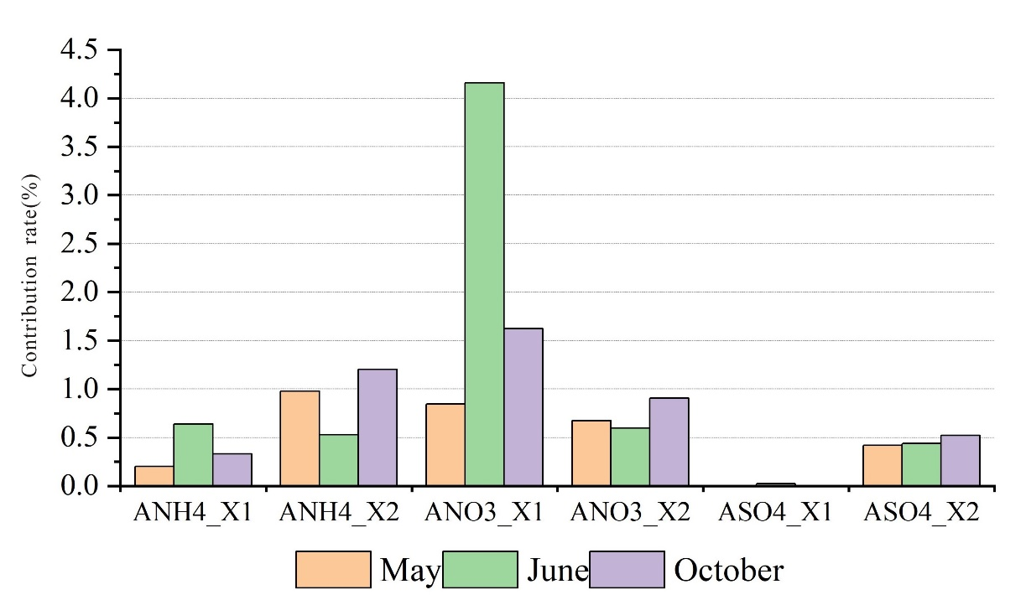
Fig.A.5. The monthly average proportion of secondary particulate matter generated by open burning of straw plus residential burning of straw and firewood in Henan Province to total amount of secondary particulate matter in Henan Province (%)

Table A.1 Some corresponding values in Fig.A.1
 | ③: The total amount of straw used for open burning in base scenario（million tons） | ④: The amount of straw equivalent to the calorific value of the biogas gap volume（million tons） | ③-④: The amount of straw available for making biomass briquette fuel（million tons） | Biogas production in the control scenario（million cubic meters）
Zhengzhou | 13.35 | 7.34 | 6.00 | 7.13
Kaifeng | 29.40 | 14.85 | 14.54 | 14.08
Luoyang | 19.71 | 10.52 | 9.19 | 10.02
Pingdingshan | 19.69 | 10.21 | 9.48 | 9.55
Anyang | 31.92 | 15.62 | 16.30 | 15.50
Hebi | 9.75 | 4.79 | 4.96 | 4.82
Xinxiang | 40.51 | 18.31 | 22.20 | 17.47
Jiaozhuo | 17.89 | 8.67 | 9.22 | 8.51
Puyang | 27.40 | 11.30 | 16.10 | 10.58
Xuchang | 25.15 | 12.38 | 12.77 | 11.80
Luohuo | 16.19 | 8.05 | 8.14 | 7.73
Sanmenxia | 6.07 | 4.26 | 1.82 | 3.76
Nanyang | 73.03 | 37.19 | 35.84 | 33.12
Shangqiu | 65.10 | 32.42 | 32.68 | 30.74
Xinyang | 119.38 | 30.86 | 88.52 | 22.74
Zhoukou | 77.10 | 40.50 | 36.61 | 37.47
Zhumadian | 79.66 | 37.62 | 42.04 | 34.49
Jiyuan | 1.78 | 0.97 | 0.81 | 0.96

Table A.2 Emission factors used in the estimation of different emission inventories (g/kg)
 |  | SO₂ | NOx | PM₁₀ | PM_{2.5} | VOCs | NH₃ | CO
Open burning | Wheat | 0.85ª | 3.3ª | 7.73ª | 7.58ª | 7.5ª | 0.37ª | 55.8ª
 | Corn | 0.44ª | 4.3ª | 11.95ª | 11.7ª | 10ª | 0.68ª | 53ª
 | Rice | 0.53ª | 1.42ª | 5.78ª | 5.73ª | 7.25ª | 0.53ª | 46.03ª
 | Cotton | 0.53ª | 3.16ª | 6.93ª | 6.79ª | 9.5ª | 1.3ª | 66.1ª
 | Peanut | 0.53ª | 3.16ª | 6.93ª | 6.79ª | 9.5ª | 0.53ª | 66.1ª
 | Rapeseed | 0.53ª | 1.12ª | 6.93ª | 6.79ª | 9.5ª | 0.53ª | 34.3ª
 | Beans | 0.53ª | 1.08ª | 6.93ª | 6.79ª | 9.5ª | 0.53ª | 32.3ª
Staw residential combustion | Wheat | 1.2ª | 1.19ª | 8.86ª | 8.24ª | 9.37ª | 0.37ª | 136.46ª
 | Corn | 1.33ª | 1.86ª | 7.39ª | 6.87ª | 7.34ª | 0.68ª | 82.37ª
 | Rice | 0.48ª | 1.92ª | 6.88ª | 6.4ª | 8.4ª | 0.52ª | 79.7ª
 | Cotton | 0.53ª | 2.49ª | 7.69ª | 7.15ª | 8.82ª | 1.3ª | 121.7ª
 | Peanut | 0.53ª | 1.12ª | 7.69ª | 7.15ª | 8.82ª | 1.3ª | 121.7ª
 | Rapeseed | 1.36ª | 1.36ª | 13.73ª | 12.77ª | 7.97ª | 0.52ª | 133.5ª
 | Beans | 0.53ª | 1.12ª | 7.69ª | 7.15ª | 8.82ª | 1.3ª | 80.7ª
Firewood residential combustion |  | 0.40^{b} | 0.97^{b} | 29.00^{b} | 3.13^{b} | 3.48^{b} | 3.24^{b} | 1.30^{b}
Biomass briquette fuel |  | 0.05^{b} | 1.35^{b} | 0.24^{b} | 0.67^{b} | 1.13^{b} | 1.30^{b} | 27.60^{b}
Biogas |  | 0.46^{d} | 0.04^{c} | 0.003^{b} | 0.003^{b} | 0.0004^{c} | 0 | 0.05^{c}
ªYing et al.(2016).^{b}MEP, (2015).^{c}Colin et al,(2010).^{d}Cai et al.(2018).

Table A.3 Inventory of air pollutant emissions from open burning of straw in Henan Province in 2016 (tons/year)
 | SO2 | NOx | CO | PM10 | PM2.5 | VOCs | NH3
Zhengzhou | 86.58 | 351.43 | 6097.19 | 864.61 | 847.65 | 847.21 | 43.7
Kaifeng | 193.56 | 766.66 | 13376.51 | 1865.3 | 1829.29 | 1841.26 | 94.49
Luoyang | 125.27 | 495.82 | 9007.31 | 1255.92 | 1231.39 | 1254.14 | 65.11
Pingdingshan | 123.68 | 484.29 | 9032.77 | 1246.56 | 1222.16 | 1258.12 | 65.38
Anyang | 211.65 | 861.21 | 14548.35 | 2074.46 | 2033.88 | 2009.43 | 102.81
Hebi | 64.93 | 267.44 | 4432.24 | 640.27 | 627.74 | 613.89 | 31.47
Xinxiang | 264.61 | 1051.09 | 18272.55 | 2572.44 | 2523.56 | 2532.42 | 132.24
Jiaozhuo | 117.6 | 477.36 | 8088.4 | 1156.26 | 1134 | 1122.99 | 58.35
Puyang | 174.52 | 676.09 | 12146.29 | 1695.81 | 1665.01 | 1699.43 | 91.91
Xuchang | 164.62 | 658.74 | 11477 | 1619.52 | 1587.8 | 1587.94 | 81.37
Lohe | 106.83 | 428.07 | 7378.01 | 1043.63 | 1023.21 | 1018.89 | 52.04
Sanmenxia | 37.67 | 145.85 | 2778.48 | 381.83 | 374.33 | 388.95 | 20.21
Nanyang | 450.98 | 1713.38 | 33282.89 | 4489.21 | 4403.82 | 4638.32 | 245.21
Shangqiu | 433.67 | 1734.23 | 29649.12 | 4185.99 | 4104.22 | 4079.02 | 207.26
Xinyang | 565.87 | 1643.8 | 50034.51 | 6150.05 | 6066.62 | 7486.6 | 484.48
Zhoukou | 515.18 | 2060.09 | 35066.91 | 4957.05 | 4860.25 | 4823.74 | 244.67
Zhuandian | 510.91 | 1998.57 | 36302.37 | 5008.16 | 4911.85 | 5025.41 | 261.17
Jiyuan | 11.81 | 48.59 | 806.52 | 116.67 | 114.38 | 111.95 | 5.75

Table A.4 Inventory of air pollutant emissions from residential combustion of straw in Henan Province in 2016 (tons/year)
 | SO2 | NOx | CO | PM10 | PM2.5 | VOCs | NH3
Zhengzhou | 578.85 | 633.11 | 17527.91 | 1401.07 | 1302.74 | 1408.65 | 94.61
Kaifeng | 1182.74 | 237.1 | 37969.81 | 2811.7 | 2614.46 | 2874.87 | 175.83
Luoyang | 816.71 | 182.13 | 25310.09 | 2018.26 | 1876.65 | 2001.56 | 132.3
Pingdingshan | 786.45 | 178.41 | 24609.32 | 1964.15 | 1826.35 | 1924.64 | 126.75
Anyang | 1287.77 | 261.93 | 39289.33 | 3009.03 | 2797.87 | 3063.31 | 200.59
Hebi | 398.02 | 81.24 | 11845.05 | 922.68 | 857.92 | 941.88 | 63.57
Xinxiang | 1475.58 | 290.97 | 46534.01 | 3457.07 | 3214.56 | 3549.14 | 223.13
Jiaozhuo | 703.15 | 142.95 | 21358.44 | 1646.51 | 1530.96 | 1686.98 | 111.42
Puyang | 884.3 | 170.78 | 28608.54 | 2095.5 | 1948.55 | 2181.87 | 134.08
Xuchang | 995 | 207.2 | 30819.78 | 2363.85 | 2197.99 | 2375.89 | 154.09
Lohe | 650.74 | 133.34 | 20232.5 | 1536.81 | 1428.99 | 1554.92 | 99.74
Sanmenxia | 302.89 | 72.09 | 9529.99 | 783.83 | 728.83 | 772.9 | 50.71
Nanyang | 2751.65 | 615.46 | 90392.5 | 6994.87 | 6504.33 | 6906.09 | 428.56
Shangqiu | 2620.35 | 521.32 | 82632.33 | 6135.3 | 5704.87 | 6258.32 | 390.36
Xinyang | 1368.2 | 474.37 | 63082.9 | 5537.98 | 5150.84 | 5258.8 | 314.35
Zhoukou | 3207.42 | 638.96 | 101348.8 | 7532.52 | 7004.06 | 7709.31 | 478.8
Zhuandian | 2939.12 | 610.59 | 94568.94 | 7103.6 | 6605.37 | 7128.72 | 442.88
Jiyuan | 78.09 | 16.34 | 2328.53 | 184.18 | 171.25 | 188.19 | 12.71

Table A.5 Inventory of air pollutant emissions from residential combustion of firewood in Henan Province in 2016 (tons/year)
 | SO2 | NOx | CO | PM10 | PM2.5 | VOCs | NH3
Zhengzhou | 209.1 | 507.08 | 15160.1 | 1819.21 | 1693.75 | 1636.25 | 679.59
Kaifeng | 174.25 | 422.57 | 12633.42 | 1516.01 | 1411.46 | 1363.54 | 566.33
Luoyang | 209.1 | 507.08 | 15160.1 | 1819.21 | 1693.75 | 1636.25 | 679.59
Pingdingshan | 174.25 | 422.57 | 12633.42 | 1516.01 | 1411.46 | 1363.54 | 566.33
Anyang | 174.25 | 422.57 | 12633.42 | 1516.01 | 1411.46 | 1363.54 | 566.33
Hebi | 34.85 | 84.51 | 2526.68 | 303.2 | 282.29 | 272.71 | 113.27
Xinxiang | 209.1 | 507.08 | 15160.1 | 1819.21 | 1693.75 | 1636.25 | 679.59
Jiaozhuo | 104.55 | 253.54 | 7580.05 | 909.61 | 846.87 | 818.12 | 339.8
Puyang | 139.4 | 338.05 | 10106.73 | 1212.81 | 1129.17 | 1090.83 | 453.06
Xuchang | 174.25 | 422.57 | 12633.42 | 1516.01 | 1411.46 | 1363.54 | 566.33
Lohe | 104.55 | 253.54 | 7580.05 | 909.61 | 846.87 | 818.12 | 339.8
Sanmenxia | 69.7 | 169.03 | 5053.37 | 606.4 | 564.58 | 545.42 | 226.53
Nanyang | 418.21 | 1014.16 | 30320.2 | 3638.42 | 3387.5 | 3272.49 | 1359.18
Shangqiu | 313.66 | 760.62 | 22740.15 | 2728.82 | 2540.62 | 2454.37 | 1019.39
Xinyang | 243.96 | 591.59 | 17686.78 | 2122.41 | 1976.04 | 1908.95 | 792.86
Zhoukou | 383.36 | 929.65 | 27793.51 | 3335.22 | 3105.21 | 2999.78 | 1245.92
Zhuandian | 313.66 | 760.62 | 22740.15 | 2728.82 | 2540.62 | 2454.37 | 1019.39
Jiyuan | 34.85 | 84.51 | 2526.68 | 303.2 | 282.29 | 272.71 | 113.27

Table A.6 Inventory of air pollutant emissions from biogas combustion in control scenario (tons/year)
 | SO2 | NOx | CO | PM10 | PM2.5 | VOCs
Zhengzhou | 39.85 | 49.5 | 61.88 | 3.71 | 3.71 | 49.5
Kaifeng | 79.5 | 98.76 | 123.45 | 7.41 | 7.41 | 98.76
Luoyang | 56.45 | 70.12 | 87.65 | 5.26 | 5.26 | 70.12
Pingdingshan | 54.23 | 67.36 | 84.21 | 5.05 | 5.05 | 67.36
Anyang | 85.83 | 106.62 | 133.28 | 8 | 8 | 106.62
Hebi | 26.56 | 32.99 | 41.24 | 2.47 | 2.47 | 32.99
Xinxiang | 98.37 | 122.2 | 152.75 | 9.16 | 9.16 | 122.2
Jiaozhuo | 47.34 | 58.81 | 73.51 | 4.41 | 4.41 | 58.81
Puyang | 60.05 | 74.6 | 93.25 | 5.6 | 5.6 | 74.6
Xuchang | 66.47 | 82.57 | 103.21 | 6.19 | 6.19 | 82.57
Lohe | 43.4 | 53.91 | 67.39 | 4.04 | 4.04 | 53.91
Sanmenxia | 21.91 | 3.21 | 34.02 | 2.04 | 2.04 | 27.21
Nanyang | 192.18 | 238.73 | 298.41 | 17.9 | 17.9 | 238.73
Shangqiu | 173.55 | 215.59 | 269.49 | 16.17 | 16.17 | 215.59
Xinyang | 144.21 | 179.14 | 223.93 | 13.44 | 13.44 | 179.14
Zhoukou | 213.81 | 265.6 | 332.01 | 19.92 | 19.92 | 265.6
Zhuandian | 197.59 | 245.46 | 306.82 | 18.41 | 18.41 | 245.46
Jiyuan | 5.32 | 6.61 | 8.26 | 0.5 | 0.5 | 6.61

Table A.7 Inventory of air pollutant emissions from biomass briquette fuel combustion in control scenario No. 1 (tons/year)
 | SO2 | NOx | CO | PM10 | PM2.5 | VOCs | NH3
Zhengzhou | 0.9 | 24.32 | 497.19 | 22.34 | 12.07 | 20.36 | 23.42
Kaifeng | 2.18 | 58.89 | 1204.02 | 54.09 | 29.23 | 49.29 | 56.71
Luoyang | 1.38 | 37.2 | 760.59 | 34.17 | 18.46 | 31.14 | 35.82
Pingdingshan | 1.42 | 38.39 | 784.82 | 35.26 | 19.05 | 32.13 | 36.97
Anyang | 2.44 | 66 | 1349.29 | 60.62 | 32.75 | 55.24 | 63.55
Hebi | 0.74 | 20.09 | 410.64 | 18.45 | 9.97 | 16.81 | 19.34
Xinxiang | 3.33 | 89.92 | 1838.39 | 82.59 | 44.63 | 75.27 | 86.59
Jiaozhuo | 1.38 | 37.33 | 763.26 | 34.29 | 18.53 | 31.25 | 35.95
Puyang | 2.42 | 65.22 | 1333.38 | 59.91 | 32.37 | 54.59 | 62.8
Xuchang | 1.92 | 51.74 | 1057.7 | 47.52 | 25.68 | 43.3 | 49.82
Lohe | 1.22 | 32.97 | 674.08 | 30.28 | 16.36 | 27.6 | 31.75
Sanmenxia | 0.27 | 7.35 | 150.36 | 6.76 | 3.65 | 6.16 | 7.08
Nanyang | 5.38 | 145.16 | 2967.76 | 133.33 | 72.04 | 121.51 | 139.79
Shangqiu | 4.9 | 132.35 | 2705.9 | 121.57 | 65.69 | 110.79 | 127.45
Xinyang | 13.28 | 358.49 | 7329.13 | 329.28 | 177.92 | 300.07 | 345.21
Zhoukou | 5.49 | 148.25 | 3030.93 | 136.17 | 73.58 | 124.09 | 142.76
Zhuandian | 6.31 | 170.27 | 3480.98 | 156.39 | 84.50 | 142.52 | 163.96
Jiyuan | 0.12 | 3.29 | 67.28 | 3.02 | 1.63 | 2.75 | 3.17

Table A.8 Inventory of air pollutant emissions from open burning of straw in control scenario No. 1 (tons/year)
 | SO2 | NOx | CO | PM10 | PM2.5 | VOCs | NH3
Zhengzhou | 23.02 | 122.16 | 1881.73 | 308.82 | 302.6 | 289.53 | 16.69
Kaifeng | 58.64 | 281.16 | 4620.07 | 691.55 | 677.83 | 680.61 | 37.9
Luoyang | 35.79 | 184.23 | 2849.71 | 469.69 | 460.27 | 438.45 | 25.18
Pingdingshan | 36.98 | 189.3 | 2945.45 | 482.69 | 473 | 452.09 | 25.85
Anyang | 64.28 | 331.79 | 5123.22 | 831.7 | 815 | 778.19 | 44.41
Hebi | 19.4 | 102.86 | 1544.61 | 260.61 | 255.36 | 238.34 | 13.75
Xinxiang | 89.15 | 437.11 | 6965.33 | 1094.33 | 1072.68 | 1043.37 | 58.88
Jiaozhuo | 36.1 | 186.89 | 2882.01 | 471.73 | 462.3 | 440.29 | 25.26
Puyang | 65.18 | 306.37 | 4998.92 | 775.59 | 760.57 | 745.9 | 42.29
Xuchang | 51.16 | 257.78 | 3957.51 | 653.34 | 640.23 | 604.34 | 34.28
Lohe | 32.88 | 163.61 | 2521.5 | 413.5 | 405.21 | 383.46 | 21.69
Sanmenxia | 6.99 | 34.93 | 547.38 | 91 | 89.17 | 85.85 | 4.91
Nanyang | 140.82 | 673.85 | 11346.52 | 1682.65 | 1649.47 | 1682.92 | 94.15
Shangqiu | 133.56 | 646.9 | 10184.32 | 1617.68 | 1585.37 | 1527.35 | 85.33
Xinyang | 312.91 | 1062.68 | 25806.27 | 3350.66 | 3303.45 | 3859.1 | 247.18
Zhoukou | 149.78 | 718.41 | 11354.69 | 1799.22 | 1763.3 | 1704.9 | 94.77
Zhuandian | 167.6 | 815.32 | 13329.43 | 2024.11 | 1983.94 | 1978.3 | 110.41
Jiyuan | 3.17 | 16.75 | 250.98 | 42.71 | 41.85 | 39.00 | 2.26

Table A.9 Inventory of air pollutant emissions from biomass briquette fuel combustion in control scenario No. 2 (tons/year)
 | SO2 | NOx | CO | PM10 | PM2.5 | VOCs | NH3
Zhengzhou | 1.50 | 40.53 | 828.65 | 37.23 | 20.12 | 33.93 | 39.03
Kaifeng | 3.64 | 98.15 | 2006.69 | 90.16 | 48.71 | 82.16 | 94.52
Luoyang | 2.30 | 62.00 | 1267.65 | 56.95 | 30.77 | 51.90 | 59.71
Pingdingshan | 2.37 | 63.98 | 1308.03 | 58.77 | 31.75 | 53.55 | 61.61
Anyang | 4.07 | 110.00 | 2248.82 | 101.03 | 54.59 | 92.07 | 105.92
Hebi | 1.24 | 33.48 | 684.39 | 30.75 | 16.61 | 28.02 | 32.24
Xinxiang | 5.55 | 149.87 | 3063.98 | 137.66 | 74.38 | 125.45 | 144.32
Jiaozhuo | 2.30 | 62.22 | 1272.09 | 57.15 | 30.88 | 52.08 | 59.92
Puyang | 4.03 | 108.70 | 2222.30 | 99.84 | 53.95 | 90.99 | 104.67
Xuchang | 3.19 | 86.23 | 1762.84 | 79.20 | 42.79 | 72.17 | 83.03
Lohe | 2.04 | 54.95 | 1123.47 | 50.47 | 27.27 | 46.00 | 52.92
Sanmenxia | 0.45 | 12.26 | 250.59 | 11.26 | 6.08 | 10.26 | 11.80
Nanyang | 8.96 | 241.94 | 4946.26 | 222.22 | 120.07 | 202.51 | 232.98
Shangqiu | 8.17 | 220.59 | 4509.84 | 202.62 | 109.48 | 184.64 | 212.42
Xinyang | 22.13 | 597.48 | 12215.21 | 548.80 | 296.53 | 500.12 | 575.35
Zhoukou | 9.15 | 247.09 | 5051.55 | 226.95 | 122.63 | 206.82 | 237.94
Zhuandian | 10.51 | 283.78 | 5801.63 | 260.65 | 140.84 | 237.53 | 273.27
Jiyuan | 0.20 | 5.48 | 112.13 | 5.04 | 2.72 | 4.59 | 5.28

Table A.10 Inventory of air pollutant emissions from open burning of straw in control scenarios in control scenario No. 2 (tons/year)
 | SO2 | NOx | CO | PM10 | PM2.5 | VOC | NH₃
Zhengzhou | 16.45 | 87.26 | 1344.09 | 220.59 | 216.14 | 206.81 | 11.92
Kaifeng | 41.89 | 200.83 | 3300.05 | 493.97 | 484.16 | 486.15 | 27.07
Luoyang | 25.56 | 131.59 | 2035.50 | 335.50 | 328.76 | 313.18 | 17.99
Pingdingshan | 26.41 | 135.21 | 2103.89 | 344.78 | 337.86 | 322.92 | 18.46
Anyang | 45.92 | 236.99 | 3659.44 | 594.07 | 582.14 | 555.85 | 31.72
Hebi | 13.86 | 73.47 | 1103.30 | 186.15 | 182.40 | 170.24 | 9.82
Xinxiang | 63.68 | 312.22 | 4975.24 | 781.67 | 766.20 | 745.27 | 42.06
Jiaozhuo | 25.79 | 133.49 | 2058.58 | 336.95 | 330.21 | 314.49 | 18.04
Puyang | 46.56 | 218.84 | 3570.65 | 553.99 | 543.27 | 532.78 | 30.20
Xuchang | 36.55 | 184.13 | 2826.79 | 466.67 | 457.31 | 431.67 | 24.49
Lohe | 23.48 | 116.86 | 1801.07 | 295.36 | 289.44 | 273.90 | 15.50
Sanmenxia | 4.99 | 24.95 | 390.99 | 65.00 | 63.70 | 61.32 | 3.50
Nanyang | 100.59 | 481.32 | 8104.66 | 1201.89 | 1178.20 | 1202.08 | 67.25
Shangqiu | 95.40 | 462.07 | 7274.51 | 1155.49 | 1132.41 | 1090.96 | 60.95
Xinyang | 223.51 | 759.05 | 18433.05 | 2393.33 | 2359.61 | 2756.50 | 176.56
Zhoukou | 106.99 | 513.15 | 8110.49 | 1285.15 | 1259.50 | 1217.79 | 67.69
Zhuandian | 119.72 | 582.37 | 9521.02 | 1445.79 | 1417.10 | 1413.07 | 78.86
Jiyuan | 2.26 | 11.97 | 179.27 | 30.51 | 29.89 | 27.86 | 1.61

TableA.11 Inventory of air pollutant emissions from biomass briquette fuel combustion (tons) in control scenario No. 3 (tons/year)
 | SO₂ | NOx | CO | PM₁₀ | PM_{2.5} | VOCs | NH₃
Zhengzhou | 2.10 | 56.74 | 1160.11 | 52.12 | 28.16 | 47.50 | 54.64
Kaifeng | 5.09 | 137.41 | 2809.37 | 126.22 | 68.20 | 115.02 | 132.33
Luoyang | 3.22 | 86.81 | 1774.71 | 79.73 | 43.08 | 72.66 | 83.59
Pingdingshan | 3.32 | 89.57 | 1831.24 | 82.27 | 44.45 | 74.97 | 86.25
Anyang | 5.70 | 154.00 | 3148.35 | 141.45 | 76.43 | 128.90 | 148.29
Hebi | 1.74 | 46.87 | 958.15 | 43.05 | 23.26 | 39.23 | 45.13
Xinxiang | 7.77 | 209.82 | 4289.57 | 192.72 | 104.13 | 175.62 | 202.05
Jiaozhuo | 3.23 | 87.11 | 1780.93 | 80.01 | 43.23 | 72.91 | 83.88
Puyang | 5.64 | 152.18 | 3111.22 | 139.78 | 75.53 | 127.38 | 146.54
Xuchang | 4.47 | 120.72 | 2467.98 | 110.88 | 59.91 | 101.04 | 116.25
Lohe | 2.85 | 76.93 | 1572.85 | 70.66 | 38.18 | 64.40 | 74.08
Sanmenxia | 0.64 | 17.16 | 350.83 | 15.76 | 8.52 | 14.36 | 16.52
Nanyang | 12.54 | 338.71 | 6924.76 | 311.11 | 168.10 | 283.51 | 326.17
Shangqiu | 11.44 | 308.83 | 6313.77 | 283.66 | 153.27 | 258.50 | 297.39
Xinyang | 30.98 | 836.48 | 17101.30 | 768.32 | 415.14 | 700.16 | 805.50
Zhoukou | 12.81 | 345.92 | 7072.17 | 317.74 | 171.68 | 289.55 | 333.11
Zhuandian | 14.71 | 397.29 | 8122.29 | 364.91 | 197.17 | 332.54 | 382.57
Jiyuan | 0.28 | 7.68 | 156.99 | 7.05 | 3.81 | 6.43 | 7.39

Table A.12 Inventory of air pollutant emissions from open burning of straw in control scenario No. 3 (tons/year)
 | SO₂ | NOx | CO | PM₁₀ | PM_{2.5} | VOCs | NH₃
Zhengzhou | 9.87 | 52.35 | 806.46 | 132.35 | 129.69 | 124.08 | 7.15
Kaifeng | 25.13 | 120.5 | 1980.03 | 296.38 | 290.50 | 291.69 | 16.24
Luoyang | 15.34 | 78.95 | 1221.30 | 201.30 | 197.26 | 187.91 | 10.79
Pingdingshan | 15.85 | 81.13 | 1262.33 | 206.87 | 202.71 | 193.75 | 11.08
Anyang | 27.55 | 142.20 | 2195.67 | 356.44 | 349.29 | 333.51 | 19.03
Hebi | 8.31 | 44.08 | 661.98 | 111.69 | 109.44 | 102.15 | 5.89
Xinxiang | 38.21 | 187.33 | 2985.14 | 469.00 | 459.72 | 447.16 | 25.24
Jiaozhuo | 15.47 | 80.09 | 1235.15 | 202.17 | 198.13 | 188.70 | 10.83
Puyang | 27.93 | 131.30 | 2142.39 | 332.39 | 325.96 | 319.67 | 18.12
Xuchang | 21.93 | 110.48 | 1696.08 | 280.00 | 274.38 | 259.00 | 14.69
Lohe | 14.09 | 70.12 | 1080.64 | 177.21 | 173.66 | 164.34 | 9.30
Sanmenxia | 2.99 | 14.97 | 234.59 | 39.00 | 38.22 | 36.79 | 2.10
Nanyang | 60.35 | 288.79 | 4862.80 | 721.13 | 706.92 | 721.25 | 40.35
Shangqiu | 57.24 | 277.24 | 4364.71 | 693.29 | 679.44 | 654.58 | 36.57
Xinyang | 134.10 | 455.43 | 11059.83 | 1436.00 | 1415.77 | 1653.90 | 105.94
Zhoukou | 64.19 | 307.89 | 4866.29 | 771.09 | 755.70 | 730.67 | 40.62
Zhuandian | 71.83 | 349.42 | 5712.61 | 867.47 | 850.26 | 847.84 | 47.32
Jiyuan | 1.36 | 7.18 | 107.56 | 18.31 | 17.94 | 16.71 | 0.97

Table A.13 The monthly average concentration values of NH₄⁺, NO₃– and SO₄^{2–} secondary ions in the atmosphere above Henan Province emitted by open burning of straw plus residential combustion of straw and firewood in Henan Province（µg/m³）
 | May |  | June |  | October
ANH4_X1 |  | 0.0027 | 0.0053 | 0.0105
ANH4_X2 |  | 0.0132 | 0.0044 | 0.0382
ANH4_X3 |  | 1.3358 | 0.8219 | 3.1248
ANO3_X1 |  | 0.0178 | 0.0368 | 0.0747
ANO3_X2 |  | 0.0142 | 0.0053 | 0.0418
ANO3_X3 |  | 2.0711 | 0.8426 | 4.4893
ASO4_X1 |  | 0.0001 | 0.0005 | 0.0001
ASO4_X2 |  | 0.0106 | 0.0094 | 0.0195
ASO4_X3 |  | 2.5207 | 2.1410 | 3.7239

