SUPPLEMENTARY INFORMATION

Pregnancy-induced differential expression of SARS-CoV-2 and influenza A viral entry factors in the lower respiratory tract

Tusar Giri¹, Santosh Panda², Arvind Palanisamy^{1,3*}

¹Department of Anesthesiology, Washington University School of Medicine, St. Louis, MO
²Department of Pathology, Washington University School of Medicine, St. Louis, MO
³Department of Obstetrics and Gynecology, Washington University School of Medicine, St. Louis, MO

*Corresponding author

Arvind Palanisamy, MD, FRCA
Department of Anesthesiology
Department of Obstetrics and Gynecology
Washington University School of Medicine
660 S Euclid Ave
St. Louis, MO, 63110
Telephone: 314-362-2628
Email: arvind.palanisamy@wustl.edu

Fig S1. Uncropped western blot files for ACE2 protein

rat intestine
hACE2
MW
Pregnant
Non-pregnant

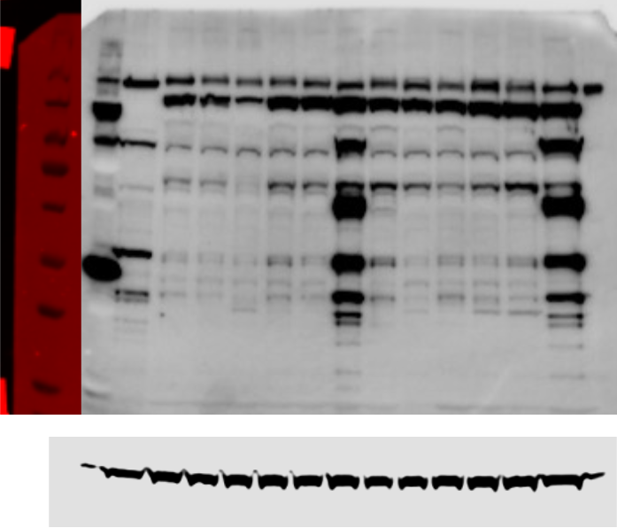
β-actin
ACE2 (119 kD)
119 kD
199 kD
84 kD
57 kD
39 kD
50 kD
28 kD
22 kD
15 kD

Fig S1. Uncropped western blot files for ACE2 protein. Please note that the order of samples is reversed in the full-length blot (pregnant followed by non-pregnant samples). Molecular weights indicated on the left. Lane 1: molecular weight marker, Lane 2: rat intestinal lysate as positive control, Lanes 3-8: pregnant lung homogenates, Lanes 9-14: non-pregnant lung homogenates, Lane 15: hACE2 positive control. β-actin (below) was used as loading control.

Fig S2. Uncropped western blot files for TMPRSS2 protein

+ control TMPRSS2
rat intestine
MW
Non-pregnant
Pregnant
84 kD
57 kD
22 kD
119 kD
28 kD
199 kD
50 kD
39 kD
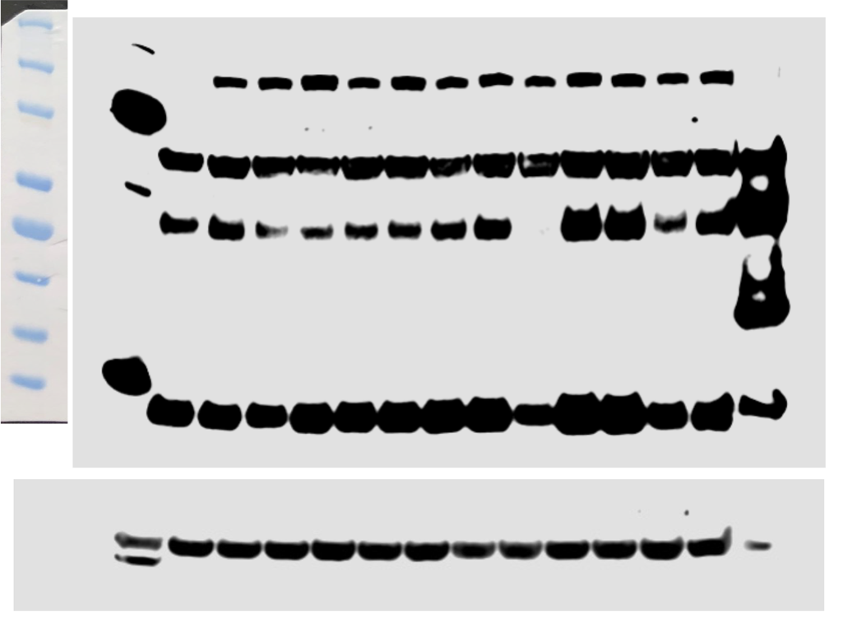
β-actin
TMPRSS2
(70 kD)

Fig S2. Uncropped western blot files for TMPRSS2 protein. Please note that the order of samples is reversed in the full-length blot (pregnant followed by non-pregnant samples). Molecular weights indicated on the right. Lane 1: molecular weight marker, Lane 2: rat intestinal lysate as positive control, Lanes 3-8: pregnant lung homogenates, Lanes 9-14: non-pregnant lung homogenates, Lane 15: TMPRSS2 expressed in HEK293 cells as positive control. β-actin (below) was used as loading control.

Fig S3. Uncropped western blot files for ST3GAL4

+ control
(rat intestine)
ST3GAL4 (38 kD)
Pregnant
Non-pregnant

11 kD
15 kD
50 kD
40 kD
60 kD
85 kD
120 kD
MW

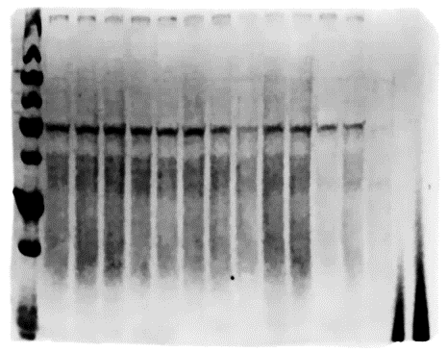
24 kD
28 kD

β-actin

Fig S3. Uncropped western blot files for ST3GAL4 protein. Please note that the order of samples is reversed in the full-length blot (pregnant followed by non-pregnant samples). Molecular weights indicated on the left. Lane 1: molecular weight marker, Lanes 2-7: pregnant lung homogenates, Lanes 8-13: non-pregnant lung homogenates, Lanes 14-15: technical difficulties with gel electrophoresis for rat intestinal lysate as positive control. β-actin (below) was used as loading control. Please note missing β-actin bands in lanes 14-15 indicating technical problems.

Fig S4. Uncropped western blot files for ST6GAL1

rat intestine
MW
Non-pregnant
Pregnant

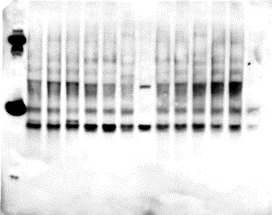

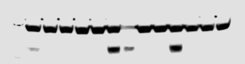
ST6GAL1 (21 kD)
199 kD
119 kD
84 kD
57 kD
50 kD
39 kD
28 kD
22 kD
15 kD
10 kD
β-actin

Fig S4. Uncropped western blot files for ST6GAL1 protein. Please note that the order of samples is reversed in the full-length blot (pregnant followed by non-pregnant samples). Molecular weights indicated on the left. Lane 1: molecular weight marker, Lanes 2-7: pregnant lung homogenates, Lane 8: rat intestinal lysate as positive control, Lanes 9-14: non-pregnant lung homogenates. β-actin (below) was used as loading control.

