Supplementary Materials for

The largest fully protected marine area in North America does not harm industrial fishing
Fabio Favoretto^{1,2}*, Catalina López-Sagastegui³, Enric Sala⁴, Octavio Aburto-Oropeza².

Correspondence to: ffavoretto@ucsd.edu

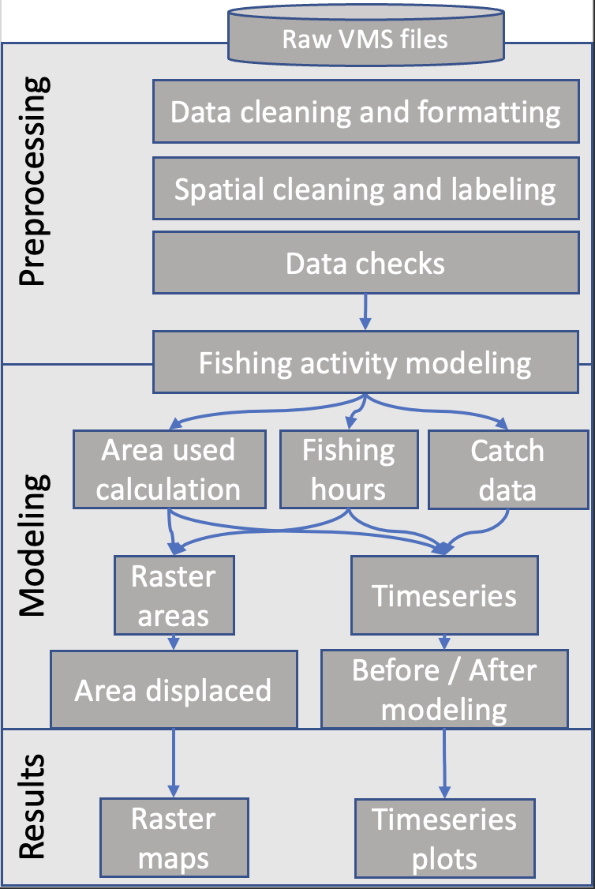

Fig. S1.
Workflow diagram representing the steps of the data analysis.

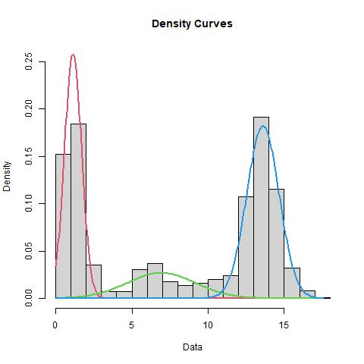

Fig. S2.
Example of Gaussian mixture models using an expectation-maximization algorithm (6) to estimate the parameters of the multimodal speed distribution using the mixtools R package (7). We assumed three univariate normal distributions corresponding to three states of a vessel: fishing, deploying gear, and steaming. The starting values for the mean and standard deviation for each underlying distribution are estimated visually using this histogram showing the multimodal distribution of speed.

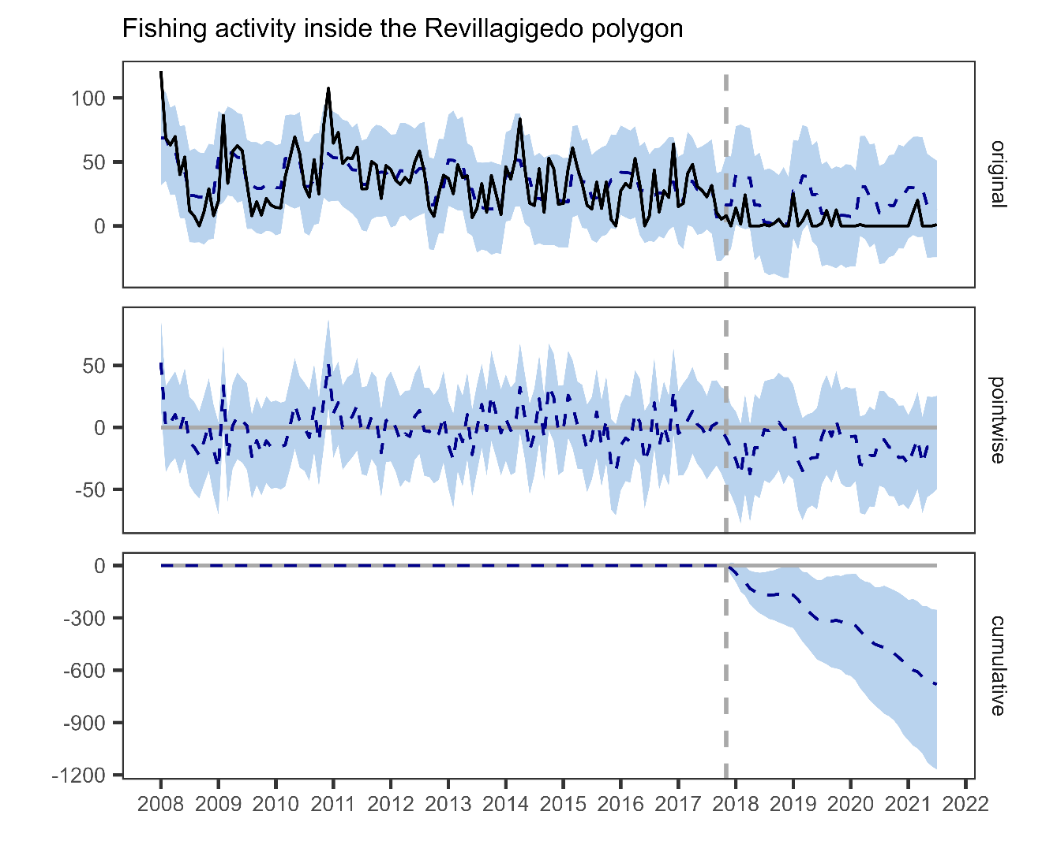

Fig. S3.
Graph of the Causal Impact modeling on the timeseries of fishing activity relative to Fig. 1A in main text. Original plot represents the changes of the variables as observed (black line) and modeled (dashed line) with the confidence intervals for the prediction (blue shade). The pointwise plot represents the difference between each point in time of the observed and modeled trend. The cumulative plot represents the sum of the pointwise differences after the establishment period. The vertical dashed line is the date of MPA implementation that the model takes as temporal threshold to calculate post-intervention differences.

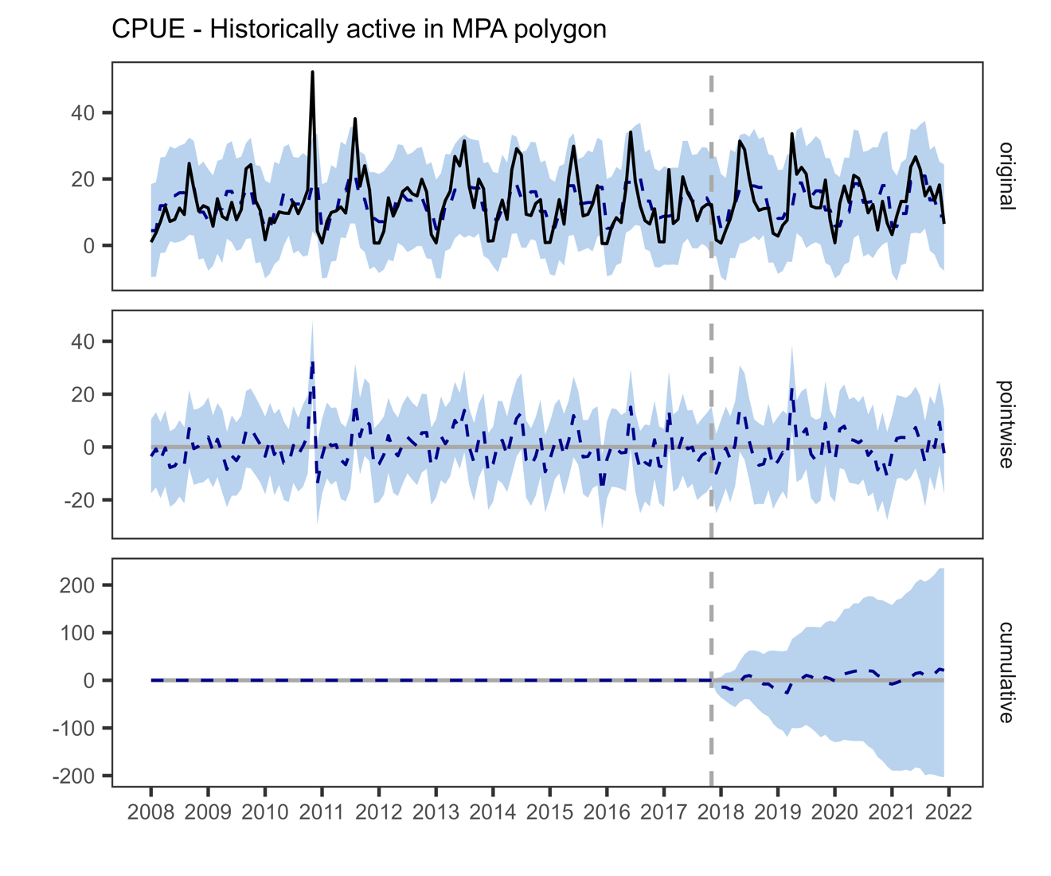

Fig. S4.
Graph of the Causal Impact modeling on the timeseries of Catch Per Unit of Effort (CPUE) of the vessels that were historically active in the MPA polygon before implementation, relative to the blue colored timeseries in Fig. 1B of the main text. Original plot represents the changes of the variables as observed (black line) and modeled (dashed line) with the confidence intervals for the prediction (blue shade). The pointwise plot represents the difference between each point in time of the observed and modeled trend. The cumulative plot represents the sum of the pointwise differences after the establishment period. The vertical dashed line is the date of MPA implementation that the model takes as temporal threshold to calculate post-intervention differences.

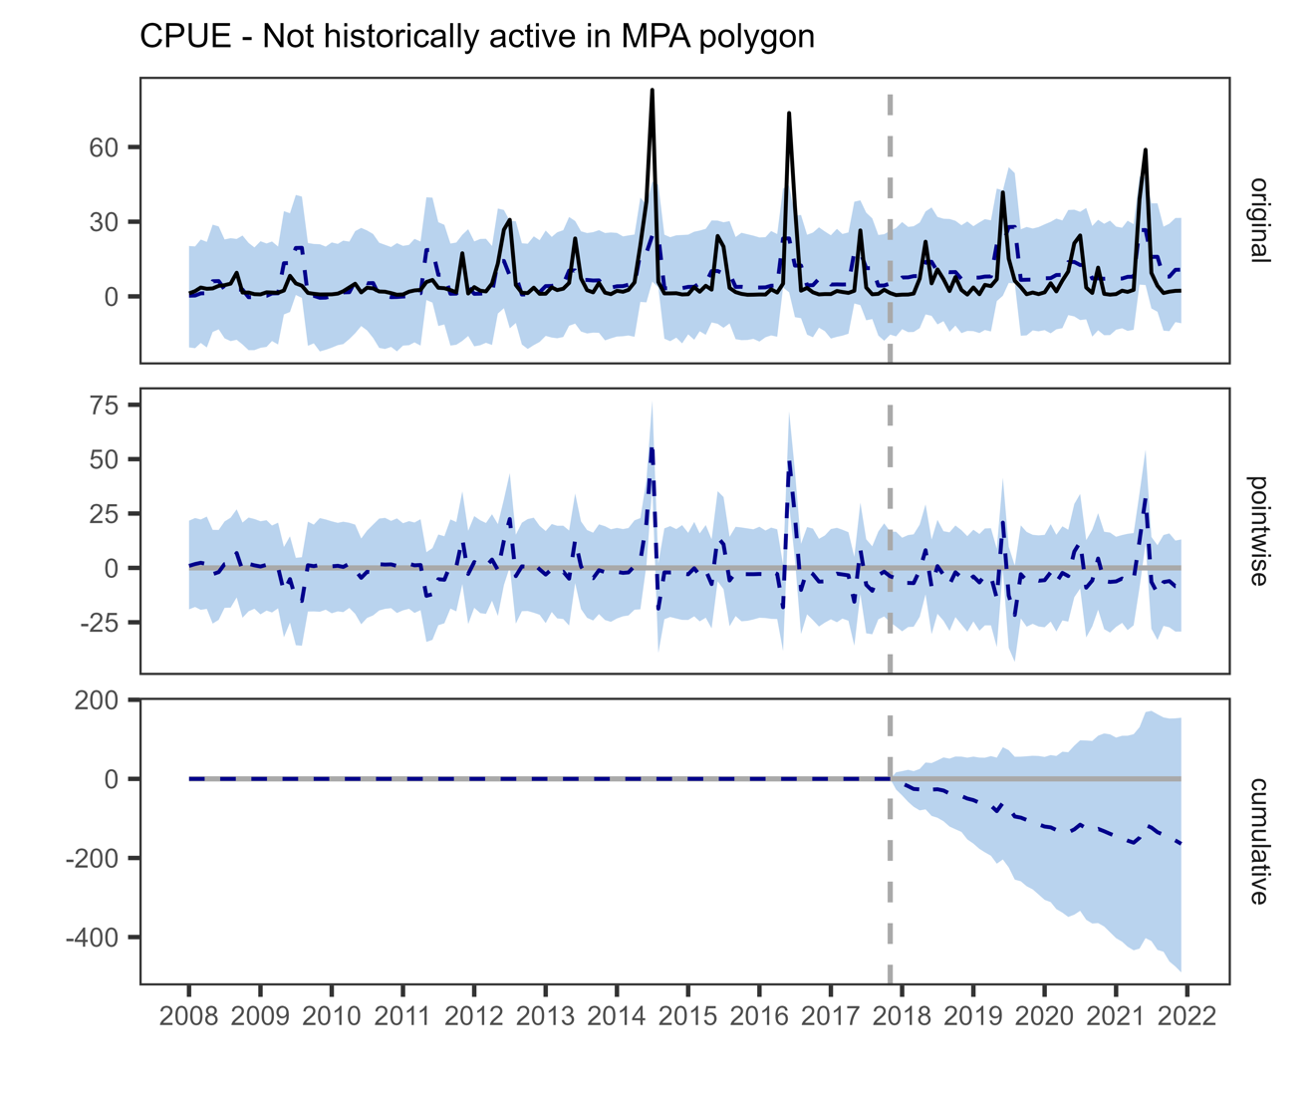\

Fig. S5.
Graph of the Causal Impact modeling on the timeseries of Catch Per Unit of Effort (CPUE) of the vessels that were never active in the MPA polygon before implementation, relative to the orange colored timeseries in Fig. 1B of the main text. Original plot represents the changes of the variables as observed (black line) and modeled (dashed line) with the confidence intervals for the prediction (blue shade). The pointwise plot represents the difference between each point in time of the observed and modeled trend. The cumulative plot represents the sum of the pointwise differences after the establishment period. The vertical dashed line is the date of MPA implementation that the model takes as temporal threshold to calculate post-intervention differences.

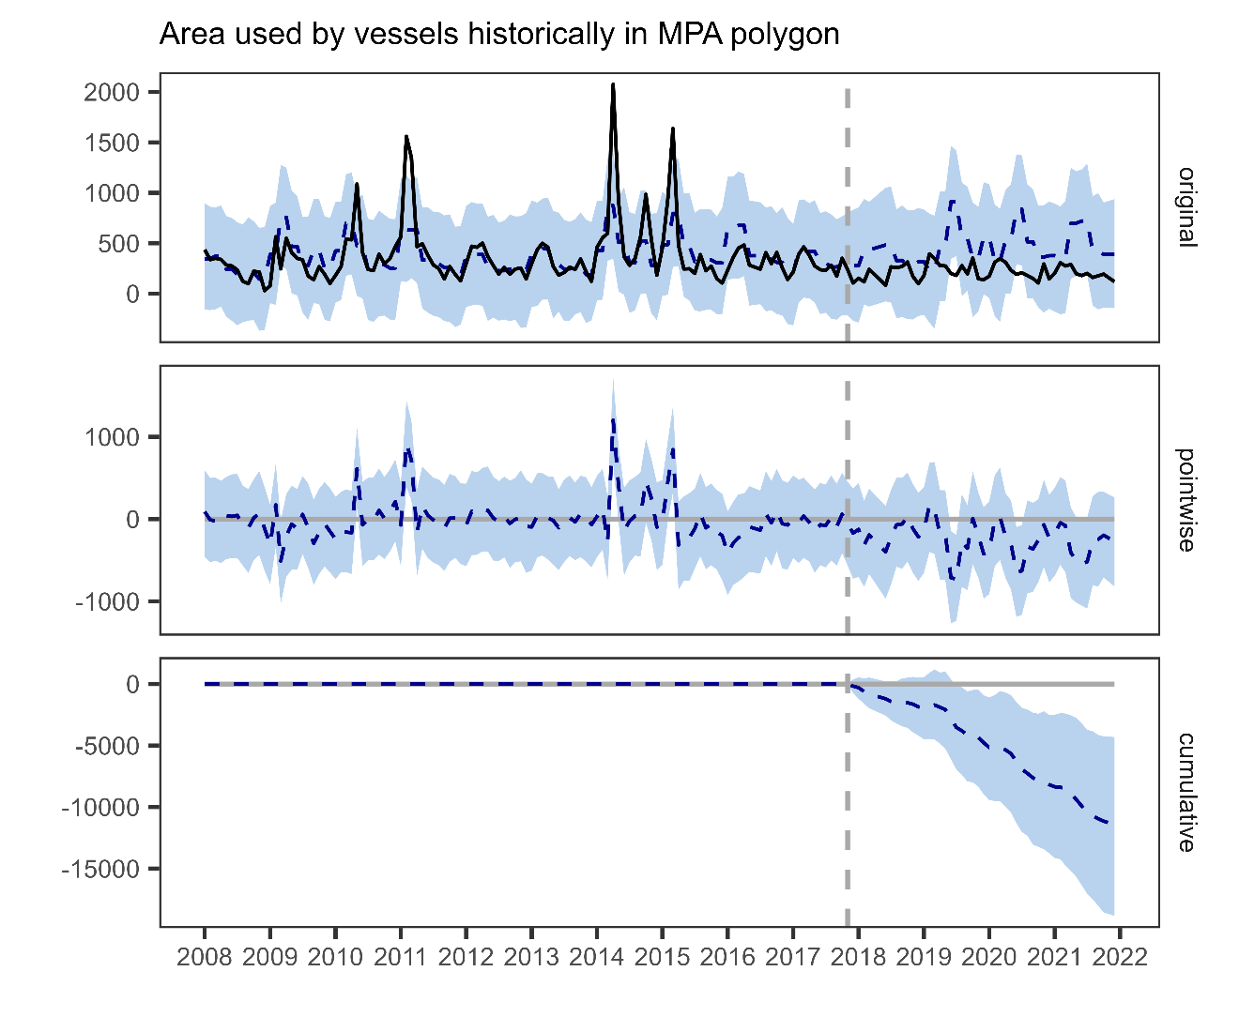

Fig. S6.
Graph of the Causal Impact modeling on the timeseries of monthly area used by the vessels that were historically active in the MPA polygon before implementation, relative to the blue colored timeseries in Fig. 1C of the main text. Original plot represents the changes of the variables as observed (black line) and modeled (dashed line) with the confidence intervals for the prediction (blue shade). The pointwise plot represents the difference between each point in time of the observed and modeled trend. The cumulative plot represents the sum of the pointwise differences after the establishment period. The vertical dashed line is the date of MPA implementation that the model takes as temporal threshold to calculate post-intervention differences.

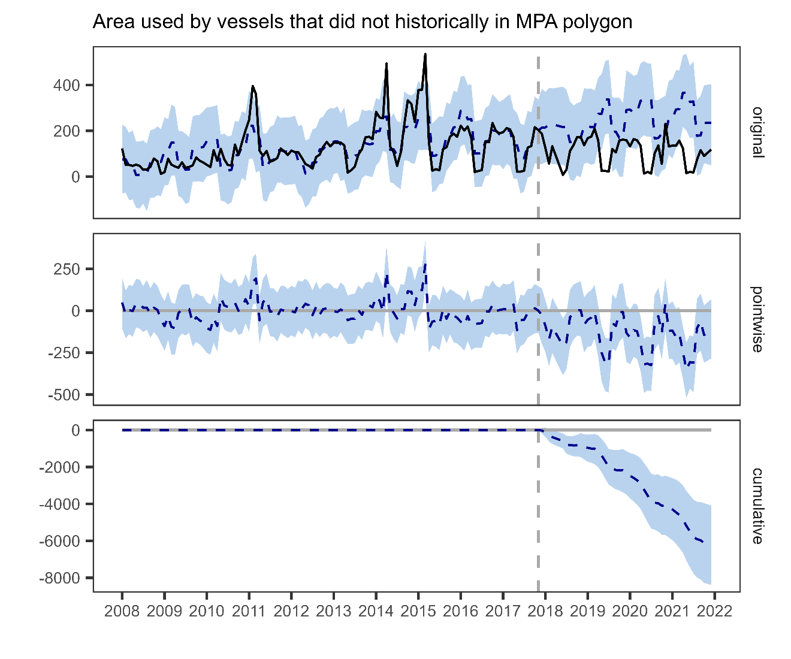

Fig. S7.
Graph of the Causal Impact modeling on the timeseries of monthly area used by the vessels that were never active in the MPA polygon before implementation, relative to the orange colored timeseries in Fig. 1C of the main text. Original plot represents the changes of the variables as observed (black line) and modeled (dashed line) with the confidence intervals for the prediction (blue shade). The pointwise plot represents the difference between each point in time of the observed and modeled trend. The cumulative plot represents the sum of the pointwise differences after the establishment period. The vertical dashed line is the date of MPA implementation that the model takes as temporal threshold to calculate post-intervention differences.

Before After Control Impact model approach compared to Causal Impact approach

The Before After Control Impact design was structured as following:
- Fleet that was “Historically active in Revillagigedo” was considered as “Impact”, while the fleet that was “Not historically active in Revillagigedo” was considered our “control”.
- Time was used as Before/After factor considering the years before implementation (2008-2017) and after (2018-2021).
The goal of the analysis is to consider the two fleets as fixed factor (Control and Impact) and constrain variation to measure significant differences in the Before and After comparison.
It is assumed that the Control is independent from the Impact, an assumption that it is not necessarily met in this case, furthermore, it is should represent the same statistical population, which we have clear indication that it is not the case. Vessels who did not historically fished in Revillagigedo have a much limited fishing range (see Fig. 1D,E in main text) despite targeting the same species. Therefore, the comparison might bring confounding effects to the results which could be spurious. In the following paragraphs we discuss these caveats and the solutions we used to overcome these limitations.

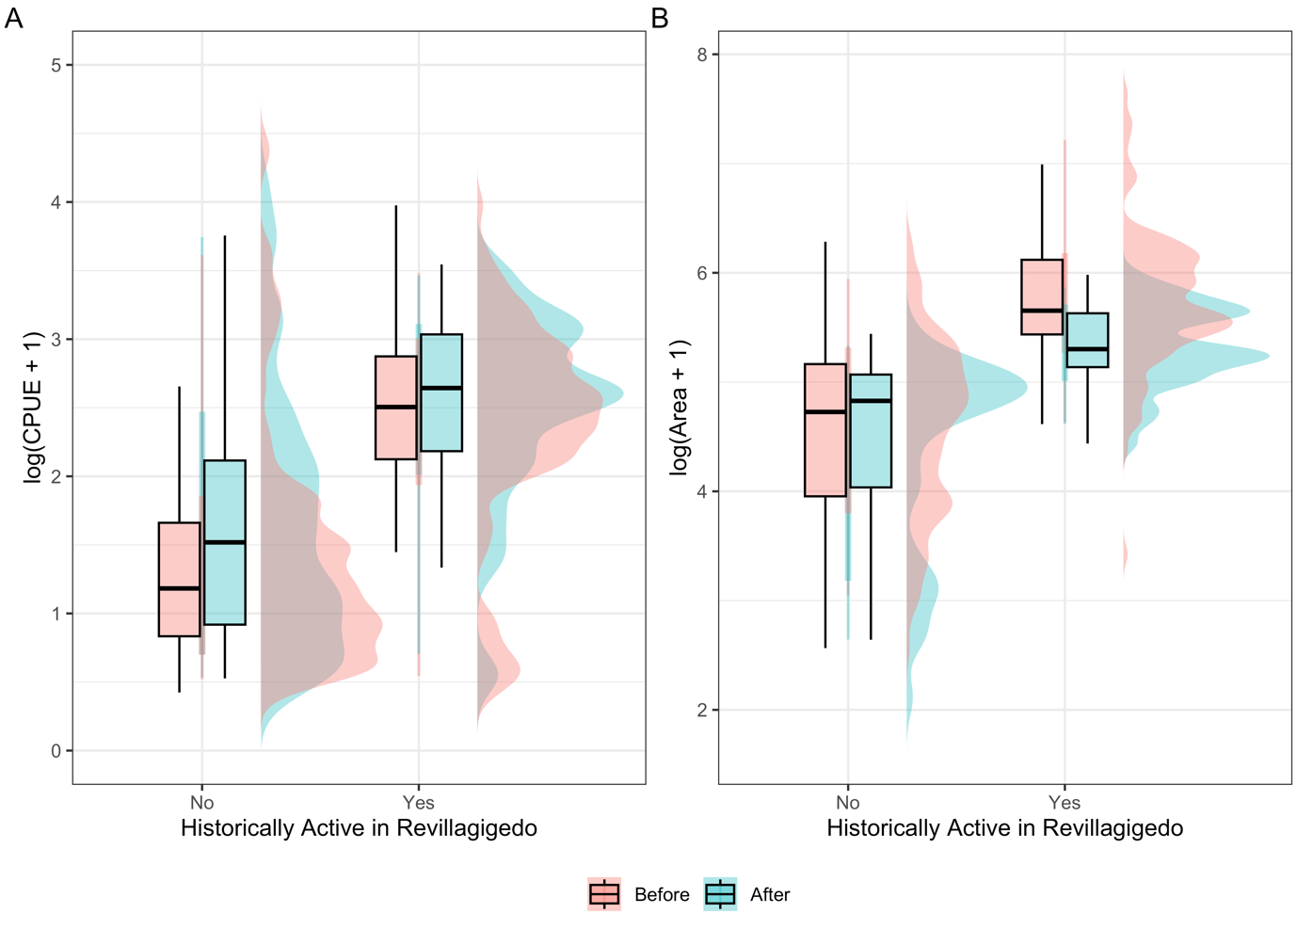
Figure S1. Comparison between historically active vessels in Revillagigedo and those who never fished there before after the park implementation. We compared A) CPUE (Catch per Unit of Effort in Ton/days) and B) Area (km²) used by the fleet. Both variables were log(x+1) transformed to improve visual comparison as raw distribution are highly skewed.

The response variables (CPUE and Area use) were not normal, in the Figure S1 we used a log(x+1) transformation to reduce skewness and improve visual data comparisons. In the model, we used a Gamma distribution with a log-link for the generalized linear model estimated using maximum likelihood.

For the CPUE (Figure S1A) the log-transformed model's intercept, corresponding to before implementation, is at 1.77 (95% CI [1.53, 2.03], t(332) = 13.70, p < 0.001). Within this model:
- The effect of Before and After is statistically non-significant and positive (beta = 0.28, 95% CI [-0.17, 0.78], t(332) = 1.18, p = 0.238; Std. beta = 0.28, 95% CI [-0.17, 0.78])
- The effect of Historically Active in Revillagigedo [Yes/No] is statistically significant and positive (beta = 0.75, 95% CI [0.39, 1.11], t(332) = 4.12, p < .001; Std. beta = 0.75, 95% CI [0.39, 1.11])
- The interaction effect of Historically active in Revillagigedo [Yes] and Before/After is statistically non-significant and negative (beta = -0.18, 95% CI [-0.85, 0.50], t(332) = -0.52, p = 0.605; Std. beta = -0.18, 95% CI [-0.85, 0.50])

Standardized parameters were obtained by fitting the model on a standardized version
of the dataset. 95% Confidence Intervals (CIs) and p-values were computed using a Wald t-distribution approximation.

For the area used (Figure S1B) the log-transformed model's intercept, corresponding to before implementation, is at 1.77 (95% CI [1.53, 2.03], t(332) = 13.70, p < 0.001). Within this
model:
- The effect of Before/After is statistically non-significant and negative (beta = -0.18, 95% CI [-0.42, 0.07], t(324) = -1.47, p = 0.142; Std. beta = -0.18, 95% CI [-0.42, 0.07])
- The effect of Historically Active in Revillagigedo [Yes/No] is statistically significant and positive (beta = 1.07, 95% CI [0.88, 1.25], t(324) = 11.54, p < .001; Std. beta = 1.07, 95% CI [0.88, 1.25])
- The interaction effect of Historically active in Revillagigedo [Yes] and Before/After is statistically significant and negative (beta = -0.35, 95% CI [-0.70, -8.54e-03], t(324) = -2.01, p = 0.044; Std. beta = -0.35, 95% CI [-0.70, -8.54e-03])

Standardized parameters were obtained by fitting the model on a standardized version
of the dataset. 95% Confidence Intervals (CIs) and p-values were computed using a
Wald t-distribution approximation.

Comment on the BACI analysis and caveats
Results from the BACI crossed design using generalized linear models are like the ones obtained with the Causal Impact model presented in the main text. There are no significative differences in CPUE from before/after implementation and there is a significant but negative before/after effect in the area used (i.e., fleet is using less are than before).
However, we found consistently significative differences between control and impact, which should not be the case for the “before” scenario. Meaning that the two populations are not comparable in the first place invalidating the possibility of a proper BACI design. This is the main reason why we decided to use Causal Impact models that have several advantages in cases like ours when an unplanned experiment is to be used.
Another limitation of a traditional BACI approach is that the time component is not explicitly considered in the model, or better, it is only qualitatively represented. While time could be added as a random factor in a generalized linear model, it would still give approximate returns as the variation of both CPUE and Area used is clearly not linear, violating basic linear models’ assumptions.
Therefore, in contrast to classical difference-in-differences schemes, state-space models like the Causal Impact model that we used in this manuscript, make it possible to infer the temporal evolution of attributable impact and flexibly to accommodate multiple sources of variation, including seasonality, and the time-varying influence of contemporaneous covariates.
The model uses a Markov chain Monte Carlo algorithm to generate inference for the after effects and generates a counterfactual scenario that can be used to properly assess the amount of the “effect”. Given a response time series (e.g., CPUE) the package constructs a Bayesian structural time-series model. This model is then used to try and predict the counterfactual, i.e., how the response metric would have evolved after the intervention (MPA implementation) if the intervention had never occurred. Once constructed a model to determine how the time series evolved in the before scenario, it then compares the variability of the observed variation in the “after” scenario against the counterfactual one. This allows to directly estimate the size of the effect the impact had on the target variable with a confidence interval, and of course its significance. This is the analog of analyzing the variance of the interaction in the BACI design. However, it considers time variation and seasonality as well that is lost in the classic approach and it solves the problem of incomparability of the Control vs Impact population and their independence.

