Fig. S1: Identification of novel cell/tissue specific promoters from the nmur-3 promoter region.
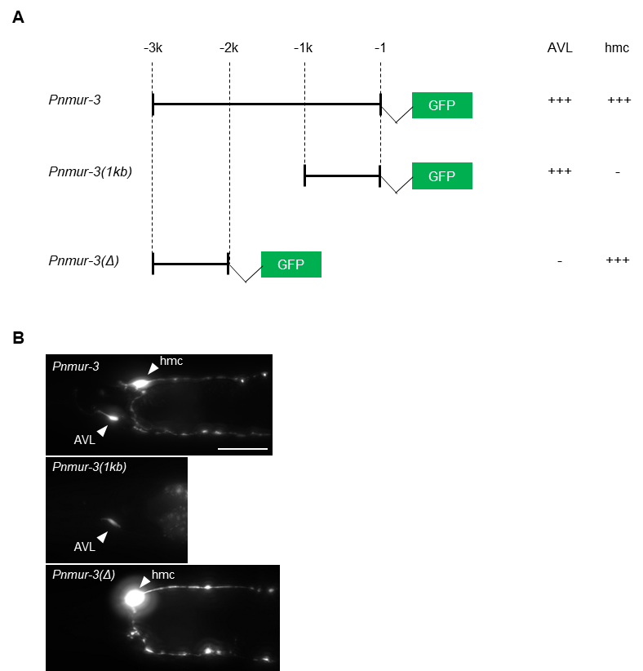

(A) Schematic of the nmur-3 promoter. The 3kb nmur-3 promoter extends from -1bp to -2956bp relative to the ATG codon of nmur-3, and drives expression of GFP in both AVL and hmc. The Pnmur-3(1kb) promoter fragment extends from -1bp to -1053 bp relative to the ATG codon of nmur-3, and drives GFP expression in AVL but not in hmc. The Pnmur-3(Δ) promoter fragment extends from -2026 bp to -2956 bp and drives GFP expression in hmc but not in AVL. +++ indicates that 80-100% of animals exhibited fluorescence in the indicated cell, and – indicates that 0% of animals exhibited fluorescence in the indicated cell.
(B) Representative images showing fluorescence of AVL or hmc in adults expressing transcriptional GFP reporters under control of either the Pnmur-3, Pnmur-3(1kb), and Pnmur-3(Δ) promoter fragments, scale bar, 40 μm.

Fig. S2: flp-22 and frpr-17 mutants show decreased aBoc contraction frequency and extent.
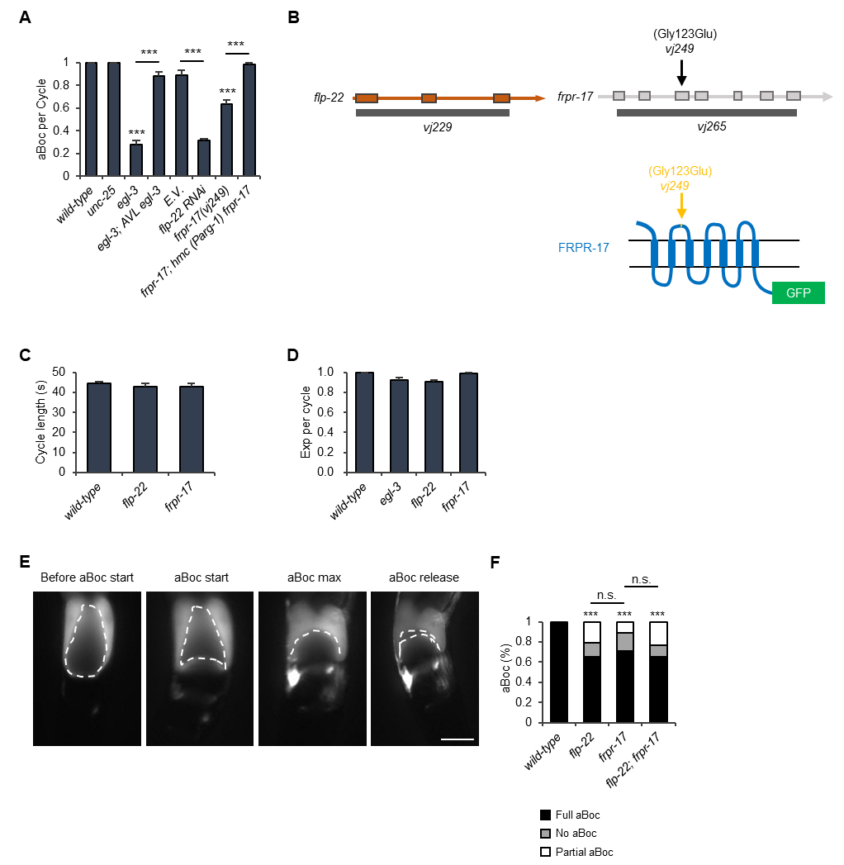
(A) Quantification of the number of aBoc per defecation cycle in adult animals of the indicated genotypes. “AVL egl-3” denotes egl-3 cDNA expressed in AVL using the nmur-3(1kb) promoter. “hmc (Parg-1) frpr-17” denotes frpr-17 cDNA expressed in hmc using arg-1 promoter. Means and standard errors are shown. *** P<0.001 and * P<0.05 in Student’s t test; n.s., not significant.
(B) Top, left, genomic organization of the flp-22 locus showing the location and lesion of vj229 allele. Top, right, genomic organization of the frpr-17 locus showing the locations and the lesions of the vj249 and vj265 alleles. vj249 is a glycine to glutamic acid substitution in exon 3. Bottom, diagram showing structure of FRPR-17 protein and the position of the amino acid substitution in vj249 allele.
(C and D) Quantification of the DMP cycle length and expulsion (Exp) frequency in adult animals with the indicated genotypes.
(E) Representative images from the live calcium imaging showing contraction states of the neck muscle, scale bar, 40 μm. The lumen of the anterior intestine is outlined with a white dotted line. The lumen of the intestine begins to displace posteriorly at the initiation of aBoc and reaches maximum displacement after about one second before beginning to relax. In wild-type animals, the duration of the maximal aBoc contraction is at least 500ms. In the indicated mutants, the maximal displacement is not reached or it is less than 500 ms in about 40% of cycles. Posterior is up and dorsal is to the left in these images.
(F) Quantification of the number aBoc observed in the live calcium imaging records. *** P<0.001 in Fisher’s exact test; n.s., not significant.

Fig. S3: flp-22 and frpr-17 mutants do not alter the calcium dynamics in AVL.
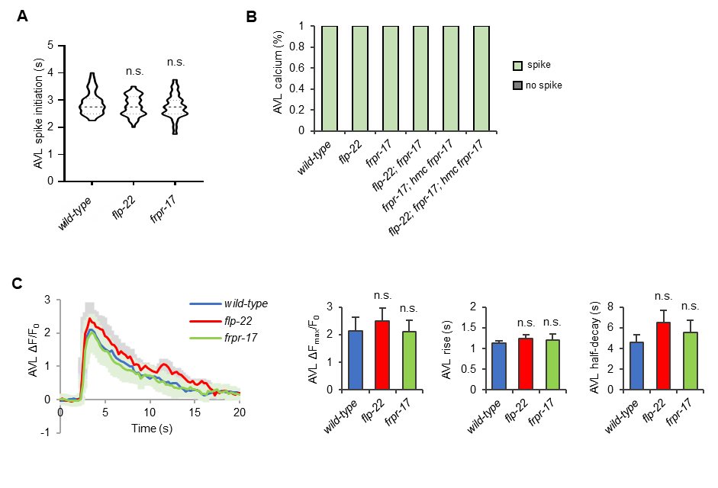
(A) Violin plots of calcium spike initiation time in AVL after the end of intestinal calcium oscillation. Dashed line refers median and dotted lines refer quartiles. ANOVA with Dunnett's correction for multiple comparisons; n.s., not significant.
(B) Quantification of the number of calcium spikes observed in AVL during DMP in adult animals of the indicated genotypes. “hmc frpr-17” denotes expressing frpr-17 cDNA under the nmur-3(Δ) promoter. Wild-type: 33 cycles in 8 animals, flp-22: 49 cycles in 9 animals, frpr-17: 55 cycles in 13 animals, flp-22; frpr-17: 43 cycles in 9 animals, frpr-17; hmc frpr-17: 20 cycles in 7 animals, flp-22; frpr-17; hmc frpr-17: 42 cycles in 9 animals.
(C) Traces of calcium dynamics in AVL aligned to the calcium spike initiation time. Solid lines indicate average fold change in GCaMP intensity and shades indicate SEM. Quantification of the average peak amplitude, rise time, and half-decay time. Strains used for live calcium imaging contain lite-1 gur-3 background to limit light stimulated movement. Means and standard errors are shown. ANOVA with Dunnett's correction for multiple comparisons; n.s., not significant.
Figure. S4: FLP-22 secreted from AVL can reach hmc.
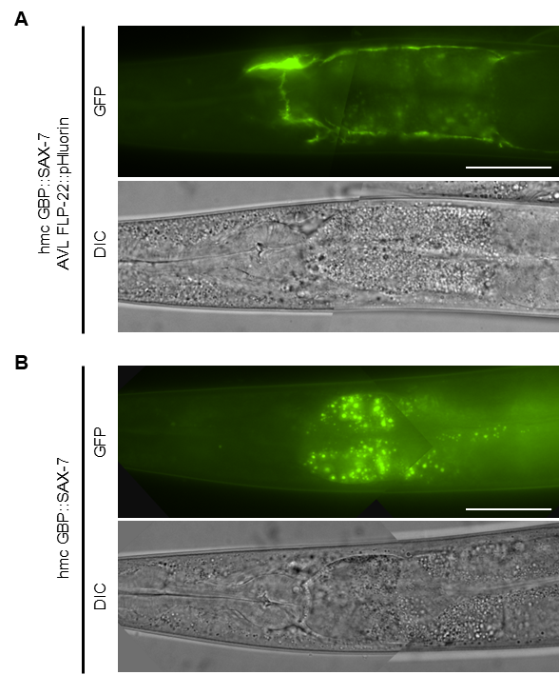

(A) Representative image showing FLP-22::pHluorin trapped to GBP::SAX-7 on hmc, scale bar, 40 μm.
(B) Representative image showing an adult expressing only GBP::SAX-7 in hmc, scale bar, 40 μm.

Fig. S5: aBoc frequency of innexins expressed in hmc and muscles and calcium dynamics in unc-9 mutants.
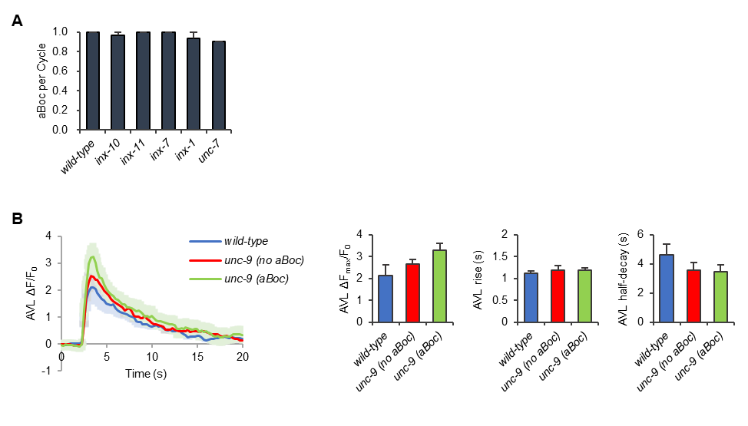
(A) Quantification of the number of aBoc per defecation cycle in adult animals of the indicated genotypes.
(B) Traces of calcium dynamics in AVL aligned to the calcium spike initiation time. Solid lines indicate average fold change in GCaMP intensity and shades indicate SEM. Quantification of the average peak amplitude, rise time, and half-decay time. unc-9 (no aBoc) refers to cycles with calcium spike followed by no aBoc and unc-9 (aBoc) refers to cycles with calcium spike followed by aBoc. Strains used for live calcium imaging contain lite-1 gur-3 background to limit light stimulated movement.

Fig. S6: frpr-21 signaling does not impact the calcium dynamics in AVL
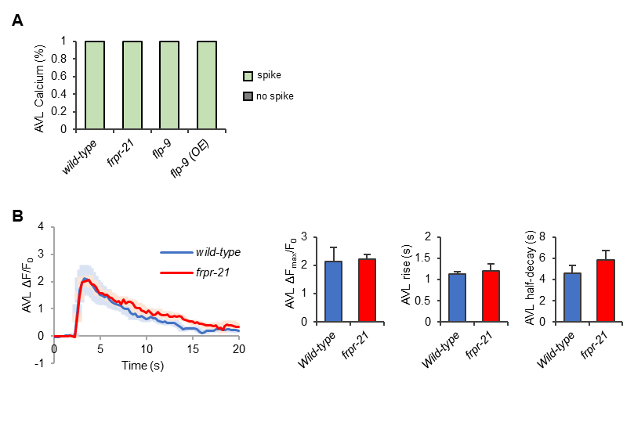
(A) Quantification of the number of calcium spikes observed in AVL during DMP in adult animals of the indicated genotypes. “flp-9 (OE)” denotes expressing flp-9 cDNA under GABAergic-specific unc-47 promoter. Wild-type: 33 cycles in 8 animals, frpr-21: 23 cycles in 9 animals, flp-9: 27 cycles in 8 animals, flp-9 (OE): 27 cycles in 5 animals.
(B) Traces of calcium dynamics in AVL aligned to the calcium spike initiation time. Solid lines indicate average fold change in GCaMP intensity and shades indicate SEM. Quantification of the average peak amplitude, rise time, and half-decay time. Strains used for live calcium imaging contain lite-1 gur-3 background to limit light stimulated movement.

Fig. S7: aBoc frequency and calcium dynamics of receptors highly expressed in hmc.
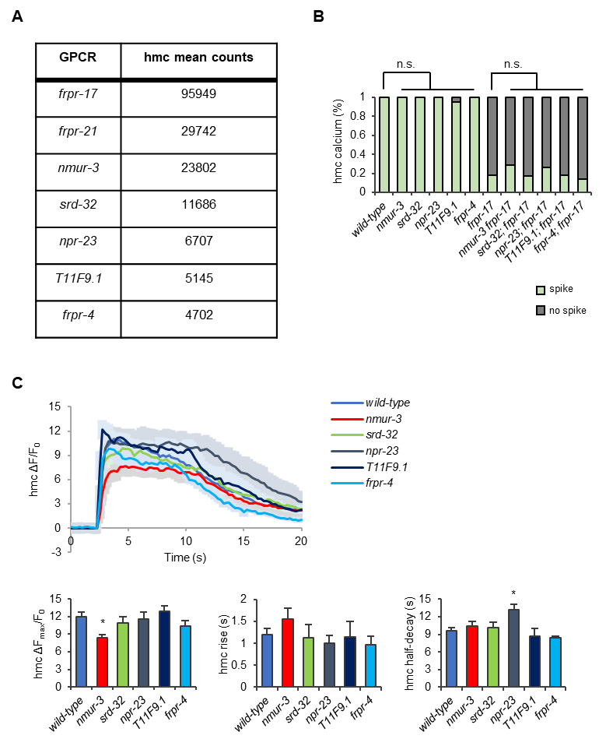
(A) Table of the GPCRs highly expressed in hmc (adapted from (Mathies et al., 2019)).
(B) Quantification of the number of calcium spikes observed in hmc during DMP in adult animals of the indicated genotypes. Wild-type: 33 cycles in 8 animals, nmur-3: 21 cycles in 7 animals srd-32: 25 cycles in 9 animals, npr-23: 23 cycles in 6 animals, T11F9.1: 20 cycles in 9 animals, frpr-17: 55 cycles in 13 animals, nmur-3 frpr-17: 49 cycles in 9 animals, srd-32; frpr-17: 47 cycles in 10 animals, npr-32; frpr-17: 27 cycles in 7 animals, T11F9.1; frpr-17: 49 cycles in 9 animals, frpr-4; frpr-17: 43 cycles in 9 animals. Fisher’s exact test; n.s., not significant.
(C) Traces of calcium dynamics in hmc aligned to the calcium spike initiation time. Solid lines indicate average fold change in GCaMP intensity and shades indicate standard errors. Quantification of the average peak amplitude, rise time, and half-decay time. Strains used for live calcium imaging contain lite-1 gur-3 background to limit light stimulated movement. Means and standard errors are shown. Asterisks indicate significant differences: * P<0.05 in ANOVA with Dunnett's correction for multiple comparisons.

Table S1. Strains, transgenic lines, and plasmids used in this study
Strain | Genotype | Figures | Source
N2 | Wild-type Bristol strain | Fig. 1, Fig. S2A, C, D, Fig. 3A, Fig. 4B, Fig. S5A, Fig. 5A, D
OJ794 | nlp-40(tm4085) I | Fig. 1B | (Wang et al., 2013)
OJ6846 | aex-2(vj304) X | Fig. 1B | This paper
OJ3271 | flp-22(vj229) I | Fig. 1C, Fig. S2C, D, Fig. 5A | This paper
OJ6057 | frpr-17(vj265) X | Fig. 1C, Fig. S2B-D | This paper
OJ6754 | hlh-8(nr2061) X | Fig. 1D | This paper
OJ7173 | flp-22(vj229) I; hlh-8(nr2061) X | Fig. 1D | This paper
OJ1218 | unc-25(e156) III | Fig. S2A | This paper
OJ2424 | egl-3(nr2090) V | Fig. S2A, D | This paper
OJ5308 | frpr-17(vj249) X | Fig. S2A | This paper
OJ3584 | egl-30(ad806) I | Fig. 3A | This paper
OJ8203 | unc-9(e101) X | Fig. 4B | This paper
OJ2451 | inx-10(ok2714) V | Fig. S5A | This paper
OJ4154 | inx-11(ok2783) V | Fig. S5A | This paper
OJ9407 | inx-7(ok2319) IV | Fig. S5A | This paper
OJ2446 | inx-1(tm3524) X | Fig. S5A | (Choi et al., 2021)
OJ3650 | unc-7(e5) X | Fig. S5A | This paper
OJ7399 | frpr-21(tm4669) II | Fig. 5A | This paper
OJ3844 | flp-9(yn36) IV | Fig. 5A | This paper
OJ6524 | flp-22(vj229) I; frpr-21(tm4669) II | Fig. 5A | This paper
OJ1626 | nlp-40(tm4085) I; vjEx368 [pHW61 (Pges-1::nlp-40 cDNA), 25 ng/μL] | Fig. 1B | (Wang et al., 2013)
OJ9177 | aex-2(vj304) X; vjEx3004 [pDS728 (Pnmur-3(1kb)::aex-2 cDNA), 10 ng/μL] | Fig. 1B | This paper
OJ7009 | vjEx2445 [pMH569 (Pnmur-3(1kb)::ICE), 10 ng/μL] | Fig. 1B | This paper
OJ7011 | vjEx2447 [pDS729 (Pnmur-3(1kb)::TeTx), 10 ng/μL] | Fig. 1B | This paper
OJ9314 | flp-22(vj229) I; vjEx1837 [pHM363 (Punc-47::flp-22 cDNA), 25 ng/μL] | Fig. 1C | This paper
OJ5082 | flp-22(vj229) I; vjEx1534 [pHM184 (Punc-129::flp-22 cDNA), 25 ng/μL] | Fig. 1C | This paper
OJ7439 | flp-22(vj229) I; vjEx2466 [pDS747 (Pnmur-3(1kb)::flp-22 cDNA), 10 ng/μL] | Fig. 1C | This paper
OJ9395 | frpr-17(vj249) X; vjEx1596 [pDS573 (Prab-3::frpr-17 cDNA), 5 ng/μL] | Fig. 1C | This paper
OJ5372 | frpr-17(vj249) X; vjEx1580 [pDS567 (Pmyo-3::frpr-17 cDNA) 10 ng/μL] | Fig. 1C | This paper
OJ9396 | frpr-17(vj265) X; vjEx2830 [pUC259 (Pnmur-3(Δ)::frpr-17 cDNA) 25 ng/μL] | Fig. 1C | This paper
OJ6607 | vjEx2174 [pUC168 (Pnmur-3::GFP) 50 ng/μL] | Fig. 1D, Fig. S1 | This paper
OJ7656 | vjEx2651 [pUC246 (Pnmur-3(Δ)::PH domain::miniSOG::SL2::mCherry), 25 ng/μL] | Fig. 1D | This paper
OJ7659 | vjEx2653 [pUC249 (Pnmur-3(Δ)::ICE), 25 ng/μL] | Fig. 1D | This paper
OJ7716 | frpr-17(vj265) X; vjEx2653 [pUC249 (Pnmur-3(Δ)::ICE), 25 ng/μL] | Fig. 1D | This paper
OJ6889 | otIs348; vjEx2349 [pUC214 (Pnmur-3(1kb)::GFP) 2 ng/μL] | Fig. S1 | This paper
OJ7018 | vjEx2454 [pUC218 (Pnmur-3(Δ)::GFP) 50 ng/μL] | Fig. S1 | This paper
OJ7149 | egl-3(nr2090) V; vjEx2535 [pMH576 (Pnmur-3(1kb)::egl-3::Venus) 5 ng/μL] | Fig. S2A | This paper
OJ6220 | frpr-17(vj265); vjEx1926 [pUC163 (Parg-1::Pegl-18::frpr-17 cDNA::mCherry) 50 ng/μL] | Fig. S2A | This paper
OJ8149 | lite-1(ce314) gur-3(ok2245) X; vjEx2548 [pUC191 (Pnmur-3::GCaMP6) 12 ng/μL + pHW107 (Pnlp-40::GCaMP3) 10 ng/μL] | Fig. 2, Fig. S2E, F, Fig. S3, Fig. 3B-E, Fig. 4F, Fig. 5B, C, E, Fig. S6, Fig. S7B, C | This paper
OJ9397 | lite-1(ce314) gur-3(ok2245) aex-2(vj302) X; vjEx2548 | Fig. 2C | This paper
OJ9398 | lite-1(ce314) gur-3(ok2245) aex-2(vj302) X; vjEx2548; vjEx2985 [pDS728 (Pnmur-3(1kb)::aex-2 cDNA) 7 ng/μL] | Fig. 2C, D | This paper
OJ9089 | lite-1(ce314) gur-3(ok2245) X; vjEx2548; vjEx2957 [pMH569 (Pnmur-3(1kb)::ICE) 10 ng/μL] | Fig. 2D | This paper
OJ8231 | flp-22(vj229) I; lite-1(ce314) gur-3(ok2245) X; vjEx2548 | Fig. 2E-G, Fig. S2F, Fig. S3 | This paper
OJ8229 | lite-1(ce314) gur-3(ok2245) frpr-17(vj265) X; vjEx2548 | Fig. 2E-G, Fig. S2F, Fig. S3, Fig. 3B-D, Fig. 5B, Fig. S7B, C | This paper
OJ9399 | flp-22(vj229) I; lite-1(ce314) gur-3(ok2245) frpr-17(vj265) X; vjEx2548 | Fig. 2E, Fig. S2F, Fig. S3B | This paper
OJ8725 | lite-1(ce314) gur-3(ok2245) frpr-17(vj265) X; vjEx2548; vjEx2830 [pUC259 (Pnmur-3(Δ)::frpr-17 cDNA) 25 ng/μL] | Fig. 2E, Fig. S3B | This paper
OJ8783 | flp-22(vj229) I; lite-1(ce314) gur-3(ok2245) frpr-17(vj265) X; vjEx2548; vjEx2830 [pUC259 (Pnmur-3(Δ)::frpr-17 cDNA) 25 ng/μL] | Fig. 2E, Fig. S3B | This paper
OJ9320 | vjEx2589 [pDS788 (Pnmur-3(1kb)::flp-22::pHluorin::flp-22) 5 ng/μL]; vjEx3038 [pDS834 (Pnmur-3(Δ)::GBP::sax-7) 20 ng/μL] | Fig. S4 | This paper
OJ9150 | lite-1(ce314) gur-3(ok2245) X; vjEx2548; vjEx2987 [pUC247 (Pnmur-3(Δ)::kin-2a(G310D)) 50 ng/μL] | Fig. 3B-E | This paper
OJ8824 | lite-1(ce314) gur-3(ok2245) frpr-17(vj265) X; vjEx2548; vjEx2871 [pUC273 (Pnmur-3(Δ)::kin-1a(H96Q,W205R)) 25 ng/μL] | Fig. 3B-E | This paper
OJ8442 | unc-9(e101) X; vjEx2796 [pUC290 (Pnmur-3(Δ)::unc-9 cDNA::GFP) 25 ng/μL] | Fig. 4B | This paper
OJ9148 | unc-9(e101) X; vjEx3000 [pUC258 (Pmyo-3::unc-9 cDNA) 10 ng/μL] | Fig. 4B | This paper
OJ9356 | vjEx3049 [pUC265 (Pnmur-3(Δ)::frpr-17 cDNA::Venus) 20 ng/μL + pUC291 (Pnmur-3(Δ)::unc-9 cDNA::linker::mTurquoise2) 20 ng/μL + pDS833 (Pnmur-3(Δ)::wdr-23b NLS::mCherry) 20 ng/μL] | Fig. 4C | This paper
OJ8578 | lite-1(ce314) gur-3(ok2245) unc-9(e101) X; vjEx2548 | Fig. 4D-F, Fig. S5B | This paper
OJ8615 | frpr-21(tm4669) II; lite-1(ce314) gur-3(ok2245) X; vjEx2548 | Fig. 5B, C, Fig. S6 | This paper
OJ8635 | frpr-21(tm4669) II; lite-1(ce314) gur-3(ok2245) frpr-17(vj265) X; vjEx2548 | Fig. 5B | This paper
OJ8740 | frpr-21(tm4669) II; lite-1(ce314) gur-3(ok2245) frpr-17(vj265) X; vjEx2548; vjEx2838 [pUC276 (Pnmur-3(Δ)::frpr-21 cDNA) 25 ng/μL] | Fig. 5B | This paper
OJ8976 | flp-9(yn36) IV; lite-1(ce314) gur-3(ok2245) frpr-17(vj265) X; vjEx2548 | Fig. 5B | This paper
OJ8977 | frpr-21(tm4669) II; flp-9(yn36) IV; lite-1(ce314) gur-3(ok2245) frpr-17(vj265) X; vjEx2548 | Fig. 5B | This paper
OJ5929 | vjEx1785 [pMH351 (Punc-47::flp-9 cDNA) 25 ng/μL] | Fig. 5D | This paper
OJ6572 | frpr-21(tm4669) II; vjEx1785 [pMH351 (Punc-47::flp-9 cDNA) 25 ng/μL] | Fig. 5D | This paper
OJ8975 | flp-9(yn36) IV; lite-1(ce314) gur-3(ok2245) X; vjEx2548 | Fig. 5E, Fig. S6A | This paper
OJ8856 | lite-1(ce314) gur-3(ok2245) X; vjEx2548; vjEx2867 [pMH351 (Punc-47::flp-9 cDNA) 25 ng/μL] | Fig. 5E, Fig. S6A | This paper
OJ8857 | frpr-21(tm4669) II; lite-1(ce314) gur-3(ok2245) X; vjEx2548; vjEx2867 [pMH351 (Punc-47::flp-9 cDNA) 25 ng/μL] | Fig. 5E | This paper
OJ9400 | lite-1(ce314) gur-3(ok2245) X; vjEx2548; vjEx2838 [pUC276 (Pnmur-3(Δ)::frpr-21 cDNA) 25 ng/μL] | Fig. 5E | This paper
OJ9017 | frpr-21(tm4669) II; lite-1(ce314) gur-3(ok2245) X; vjEx2548; vjEx2838 [pUC276 (Pnmur-3(Δ)::frpr-21 cDNA) 25 ng/μL] | Fig. 5E | This paper
OJ8875 | vjEx2899 [pUC281 (Pnmur-3(Δ)::frpr-21 cDNA::GFP) 25 ng/μL] | Fig. 5F | This paper
OJ8202 | lite-1(ce314) gur-3(ok2245) nmur-3(vj353) X; vjEx2548 | Fig. S7B, C | This paper
OJ8579 | lite-1(ce314) gur-3(ok2245) nmur-3(vj353) frpr-17(vj265) X; vjEx2548 | Fig. S7B | This paper
OJ8617 | srd-32(vj308) V; lite-1(ce314) gur-3(ok2245) X; vjEx2548 | Fig. S7B, C | This paper
OJ9403 | srd-32(vj308) V; lite-1(ce314) gur-3(ok2245) frpr-17(vj265) X; vjEx2548 | Fig. S7B | This paper
OJ8618 | npr-23(vj298) I; lite-1(ce314) gur-3(ok2245) X; vjEx2548 | Fig. S7B, C | This paper
OJ8637 | npr-23(vj298) I; lite-1(ce314) gur-3(ok2245) frpr-17(vj265) X; vjEx2548 | Fig. S7B | This paper
OJ8616 | T11F9.1(ok2284) V; lite-1(ce314) gur-3(ok2245) X; vjEx2548 | Fig. S7B, C | This paper
OJ8636 | T11F9.1(ok2284) V; lite-1(ce314) gur-3(ok2245) frpr-17(vj265) X; vjEx2548 | Fig. S7B | This paper
OJ8638 | frpr-4(ok2376) II; lite-1(ce314) gur-3(ok2245) X; vjEx2548 | Fig. S7B, C | This paper
OJ8639 | frpr-4(ok2376) II; lite-1(ce314) gur-3(ok2245) frpr-17(vj265) X; vjEx2548 | Fig. S7B | This paper
Table S2. Oligonucleotides used in this study
Sequence |  | Oligos | Source
nmur-3 promoter | forward | ccccccGCATGCctgtttcaagattcgggaca | (Choi et al., 2021)
nmur-3 promoter | reverse | ccccccCCCGGGATCCggcttcaattagttgtgtca | (Choi et al., 2021)
nmur-3(1kb) promoter | forward | ccccccGCATGCgcgtgagcaaaatctatgttg | This paper
nmur-3(1kb) promoter | reverse | ccccccCCCGGGATCCggcttcaattagttgtgtca | This paper
nmur-3(Δ) promoter | forward | ccccccGCATGCctgtttcaagattcgggaca | This paper
nmur-3(Δ) promoter | reverse | ccccccCCCGGGATCCcaacgagttgaacgtgtgtt | This paper
arg-1 promoter | forward | ccccGCATGCaagagtttaagacgtcgca | This paper
arg-1 promoter | reverse | ccccGGATCCctttaatgatgtctagtag | This paper
egl-18 basal promoter | forward | ccccccGGATCCctccatagtagtacattttaaggt | (Choi et al., 2021)
egl-18 basal promoter | reverse | ccccccCCCGGGatagactgtgtggagacac | (Choi et al., 2021)
ICE | forward | CCCCCCgctagcAAAAatggccgacaaggtcctg | This paper
ICE | reverse | CCCCCCggtaccttaatgtcctgggaagaggtag | This paper
TeTx | forward | CCCCCCGCTAGCAAAAatgccgatcaccatcaacaac | This paper
TeTx | reverse | ccccccGCGGCCGCttaagcggtacggttgtacagg | This paper
flp-22 cDNA | forward | CCCCCCgctagcAAAAATGAACCGTTCCATGATTG | This paper
flp-22 cDNA | reverse | ccccGGTACCttaATAATCCTGTTCAGAAACTG | This paper
frpr-17 cDNA | forward | ccccgctagcaaaaATGGATGATTCCGTGGATATTTATG | This paper
frpr-17 cDNA | reverse | ccccggtaccTCAAATAAGTACCTCTGGTTG | This paper
PH domain::miniSOG | forward | ccccccGCTAGCAAAAATGGACTCGG | This paper
PH domain::miniSOG | reverse | ccccccGCGGCCGCttatccggaagatcctccatc | This paper
SL2::mCherry | forward | CCCCCCgcggccgcGCTGTCTCATCCTACTTTCAC | This paper
SL2::mCherry | reverse | CCCCCggtaccTTACTTGTACAGCTCGTCCA | This paper
frpr-21 cDNA | forward | ccccGCTAGCaaaaATGGATCAAATAACAAGCAC | This paper
frpr-21 cDNA | reverse | ccccGGTACCTTACGAGCTGTTCGTCTCG | This paper
flp-9 cDNA | forward | ccccGCTAGCaaaaATGAATCAATTTTATGC | This paper
flp-9 cDNA | reverse | ccccGGTACCctaCTTTCTTCCAAATCGAAC | This paper
For 3’ terminal fusion with Venus, GFP, mCherry, or linker::mTurquoise2
wdr-23b NLS | forward | CTAGCAAAAatgccttacaaaagacattcctcttcaaatctgaaaaggA | This paper
wdr-23b NLS | reverse | CCGGTccttttcagatttgaagaggaatgtcttttgtaaggcatTTTTG | This paper
frpr-17 cDNA | forward | ccccgctagcaaaaATGGATGATTCCGTGGATATTTATG | This paper
frpr-17 cDNA | reverse | ccccaccggtAATAAGTACCTCTGGTTGAG | This paper
unc-9 cDNA | forward | CCCCCCgctagcaaaaATGAGTATGCTATTGTATTATTTCGCG | This paper
unc-9 cDNA | reverse | CCCCCCaccggtCACGTCGTGCATTTTTCCTTC | This paper
frpr-21 cDNA | forward | ccccGCTAGCaaaaATGGATCAAATAACAAGCAC | This paper
frpr-21 cDNA | reverse | ccccACCGGTCGAGCTGTTCGTCTCGATG | This paper
For flp-22 cDNA::pHluorin::flp-22 cDNA
flp-22 5’ fragment | forward | CCCCCCgctagcAAAAATGAACCGTTCCATGATTG | This paper
flp-22 5’ fragment | reverse | GACGGGGAcctaggcttACCGGTACCGAATCGCATCCATTTGG | This paper
flp-22 3’ fragment | forward | GATTCGGTACCGGTaagcctaggTCCCCGTCAGCCAAATGG | This paper
flp-22 3’ fragment | reverse | ccccGGTACCttaATAATCCTGTTCAGAAACTG | This paper
pHluorin | forward | ccccccACCGGTAGTAAAGGAGAAGAACTTTTC | This paper
pHluorin | reverse | CCCCCCcctaggTTTGTATAGTTCATCCATGCC | This paper

Movie S1. Calcium imaging of freely moving wild-type day 1 adults co-expressing GCaMP6 in AVL and hmc (under the nmur-3 promoter) and GCaMP3 in intestine (under the nlp-40 promoter). Movie shows one cycle of the DMP in which a calcium spike in the AVL cell body (including the axon) and in the hmc cell body (including the processes) were observed at the same time (within 250ms of the calcium spike initiation in AVL) about 3 seconds after the intestinal calcium oscillation.

Movie S2. Calcium imaging of freely moving frpr-17 mutant day 1 adults co-expressing GCaMP6 in AVL and hmc (under the nmur-3 promoter) and GCaMP3 in intestine (under the nlp-40 promoter). Movie shows one cycle of the DMP in which a calcium spike only occurred in the AVL cell body (including the axon) but not in hmc about 3 seconds after the intestinal calcium oscillation.

Movie S3. Calcium imaging of freely moving unc-9 mutant day 1 adults co-expressing GCaMP6 in AVL and hmc (under the nmur-3 promoter) and GCaMP3 in intestine (under the nlp-40 promoter). Movie shows one cycle of the DMP in which a calcium spike occurred in the AVL cell body (including the axon) and in the hmc cell body (including the processes) were observed at the same time (within 250ms of the calcium spike initiation in AVL) about 3 seconds after the intestinal calcium oscillation but not followed by aBoc.

