Supplementary materials
Neuroanatomical dimensions in medication-free individuals with major depressive disorder and treatment response to SSRI antidepressant medications or placebo

Cynthia H.Y. Fu* 1, 2, Mathilde Antoniades* 3, Guray Erus 3, Jose A. Garcia 3, Yong Fan 3, Danilo Arnone 2, 4, Stephen R. Arnott 5, Taolin Chen 6, 7, Ki Sueng Choi 8, Cherise Chin Fatt 9, Benicio N. Frey 10, 11, Vibe G. Frokjaer 12, 13, 14, Melanie Ganz 12,15, Beata R. Godlewska 16, 17, Stefanie Hassel 18,19, Keith Ho 20, Andrew M. McIntosh 21, Kun Qin 6, 7, Susan Rotzinger 20, 22, Matthew D. Sacchet 23, Jonathan Savitz 24, Haochang Shou 3, 25, Ashish Singh 3, Aleks Stolicyn 21, Irina Strigo 26, Stephen C. Strother 5,27, Duygu Tosun 26, Teresa A. Victor 24, Dongtao Wei 28, Toby Wise 2, Roland Zahn 2, Ian M. Anderson 29, J.F. William Deakin 29, Boadie W. Dunlop 30, Rebecca Elliott 29, Qiyong Gong 6, 7, Ian H. Gotlib 31, Catherine Harmer 16, Sidney H. Kennedy 20, 22, Gitte M. Knudsen 12,13, Helen S. Mayberg 8, Martin P. Paulus 24, Jiang Qiu 28, Madhukar H. Trivedi 9, Heather C. Whalley 21, Chao-Gan Yan 32, Allan H. Young 2, 33, Christos Davatzikos 3

Table of Contents
Supplementary Method 1. Description of main datasets in this study 2
Supplementary Method 2. Estimation of years of education 4
Supplementary Figure 1. 5
Supplementary Figure 2. 6
Supplementary Figure 3 7
Supplementary Figure 4 8
Supplementary Table 1. Scanner protocols 9
Supplementary Table 2. Demographic information by site in healthy controls 10
Supplementary Table 3. Demographic information by site in MDD 10
Supplementary Table 4. List of structural MUSE regions of interest used in the HYDRA model 11
Supplementary References 18

Supplementary Method 1. Description of main datasets in this study

Full descriptions of the datasets are available in: Fu CHY, Erus G, Fan Y, Antoniades M, et al., AI-based dimensional neuroimaging system for characterizing heterogeneity in brain structure and function in major depressive disorder: COORDINATE-MDD consortium design and rationale.
Main datasets in this study are as follows:
- Canadian Biomarker Integration Network in Depression (CAN-BIND) is a national depression program with recruitment from 7 centers (MacQueen et al., 2019). Treatment protocol is 8-week trial with SSRI antidepressant (escitalopram) followed by an augmentation trial if there is poor treatment response (i.e., less than 50% improvement in depressive symptoms). MRI scans have been acquired at baseline, weeks 2 and 8 in both MDD and healthy participants.
- Establishing Moderators and Biosignatures of Antidepressant Response in Clinical Care (EMBARC) is a multisite, randomized, placebo-controlled clinical trial with recruitment from 4 centers (Trivedi et al., 2016). Treatment protocol is an 8-week double-blind randomized allocation to SSRI (escitalopram) or placebo, with double-blind cross over switch to another antidepressant if there is poor treatment response. MRI scans have been acquired in MDD and healthy participants at baseline.
- Huaxi MR Research Center at Sichuan University (SCU) cohort consists of medication-naïve first episode MDD and matched healthy participants (Qiu et al., 2018; Zhao et al., 2020; Zhao et al., 2021).
- King’s College London cohort consists of 4 studies (Green et al., 2012; Nouretdinov et al., 2011; Sankar et al., 2016; Wise et al., 2017, 2018). MRI scans have been acquired in MDD and healthy participants, and the treatment study is an 8-week selective serotonin and norepinephrine reuptake inhibitor (SNRI) antidepressant (duloxetine) with MRI scans at baseline, weeks 2 and 8 in both MDD and healthy participants.
- Laureate Institute for Brain Research (LIBR) cohort consists of MRI data in first episode and recurrent MDD and matched healthy controls from 2 studies (Ford et al., 2019; Misaki et al., 2016; Zheng et al., 2021).
- Manchester cohort consists of 3 studies (Arnone et al., 2012, 2013; Dutta et al., 2019). All participants have a baseline MRI scan, and the treatment study is 8-week SSRI (citalopram) with MRI scans at baseline and week 8 (Arnone et al., 2012).
- Oxford cohort consists of 6-week SSRI (escitalopram) treatment with MRI scans at baseline and week 6 (Godlewska et al., 2014, 2018).
- Predictors of Remission in Depression to Individual and Combined Treatments (PReDICT) study is a 12-week randomized clinical trial of treatment-naïve MDD participants with 3 treatment arms: SSRI (escitalopram), SNRI (duloxetine), or CBT, with an augmentation trial if is there no remission. MRI scans were acquired at baseline (Dunlop et al., 2012).
- Southwest University (SWU) cohort consists of a community-based recruitment which includes first episode and recurrent MDD and healthy control participant (Liu et al., 2017, 2021; Hu et al., 2021).
- Stanford (SNAP) cohort consists of first episode and recurrent MDD and healthy participants (Sacchet & Gotlib, 2017; Sacchet et al., 2019).
- Stratifying Resilience and Depression Longitudinally (STRADL) is a community-based cohort from the Generation Scotland Scottish Family Health Study with detailed clinical, cognitive and neuroimaging assessments (Habota et al., 2019). Single session MRI scans were acquired.
All patients are adults with a primary diagnosis of MDD that is first episode or recurrent, in a current episode of a moderate to severe severity, that is non-psychotic. MDD diagnosis was based on DSM-IV (SCU, Manchester, Oxford) or DSM-IV-TR (CAN-BIND, EMBARC, KCL, LIBR, Stanford SNAP, STRADL) using the Structured Clinical Interview for DSM (SCID) (EMBARC, SCU, KCL, Manchester, Oxford, Stanford SNAP, STRADL) or Mini International Neuropsychiatric Interview (MINI) (CAN-BIND, KCL).
Depressive severity was measured with standardized clinician-rated scales: 17-item Hamilton Rating Scale for Depression (HRSD, (Hamilton, 1960) (EMBARC, SCU, KCL, Oxford, PREDICT, Stanford SNAP), Montgomery-Åsberg Depression Rating Scale (MADRS) (Montgomery & Asberg, 1979)(CAN-BIND, LIBR, Manchester), or Quick Inventory of Depressive Symptomatology (QIDS) (Rush et al., 2003; Trivedi et al., 2004)(STRADL). The rating scales show high correlation in summed scores and percentage score improvements (Leucht et al., 2018; Rush et al., 2003; Uher et al., 2008).

Supplementary Method 2. Estimation of years of education

Wherever raw text was provided, it was converted into years of education. Unless indicated we assumed that the degree was completed and allocated the maximum number of years associated with completing the degree or diploma. The calculation assumed that participants started school at the age of 5.
Raw text | Years of education attributed
No education | 0
Primary school | 6
Middle school | 8
Some high school (10th, 11th) | 11
High school | 12
GED or alternative credential | 12
12th grade, no diploma | 12
Some college credit, but less than 1 year of college credit | 12.5
1 or more years of college credit, no degree | 13
Some college, no degree | 13
Some college | 14
Tech school | 14
Associate's degree (for example: AA, AS) | 14
Trade school | 14
College and above | 16
Four-year college | 16
Junior College | 16
Bachelor's degree | 16
Some graduate school | 17
Grad or Prof Degree | 18
Master's degree | 18
Doctorate | 23

Supplementary Figure 1.

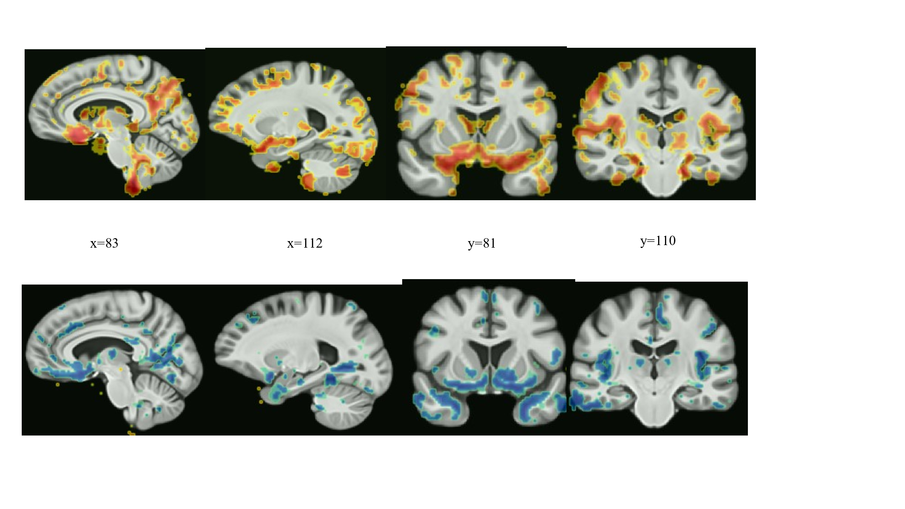
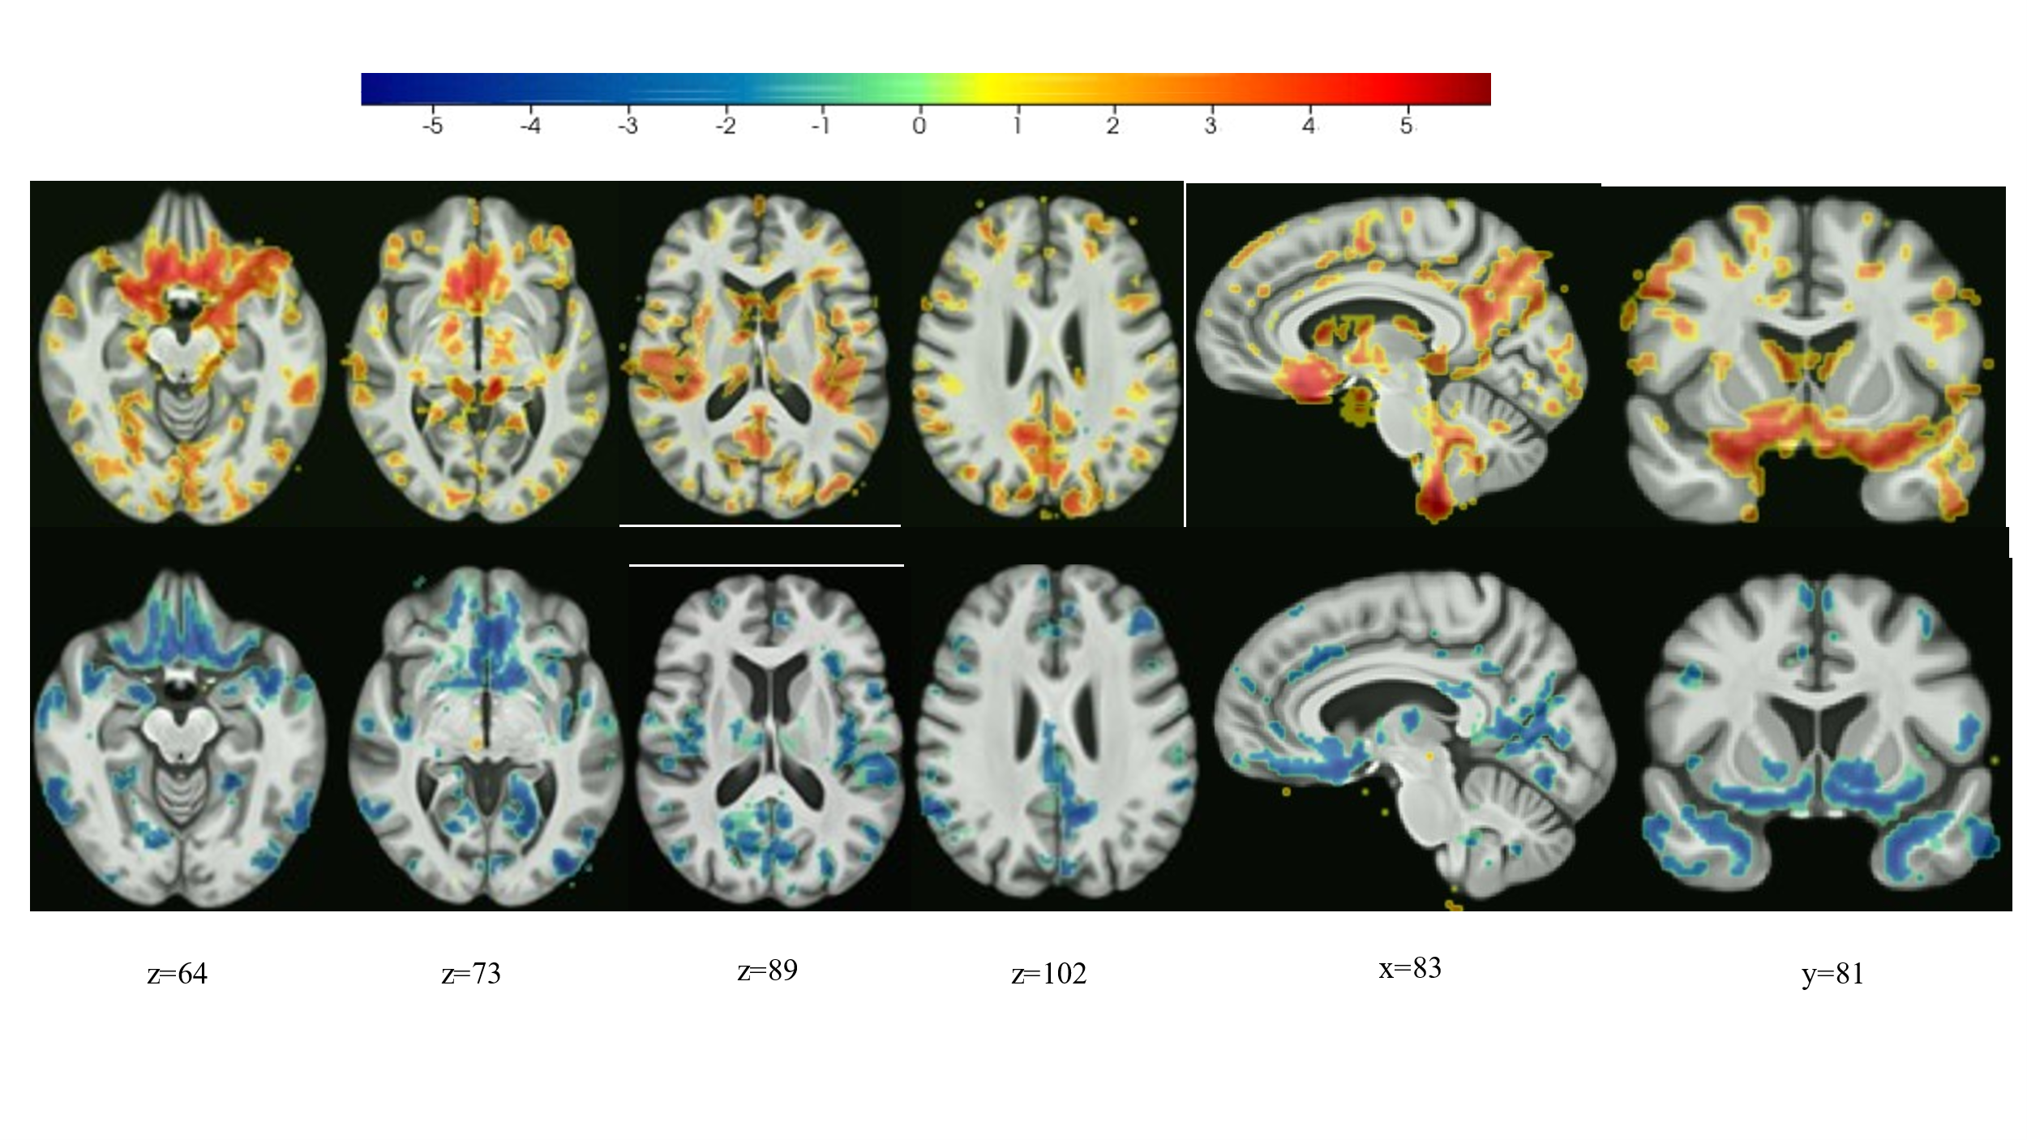

Additional coronal and sagittal views for dimensions 1 and 2 (top and bottom rows respectively), indicating areas with significant differences from controls. Colour represents direction and strength of group differences as indicated by the colour bar.

Supplementary Figure 2.
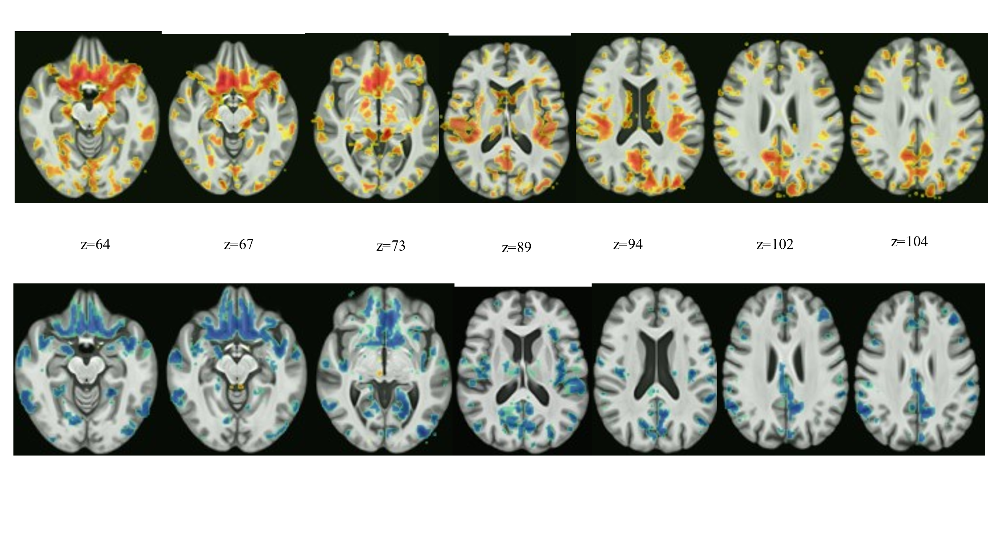

Additional transverse views for dimensions 1 and 2 (top and bottom rows respectively), indicating areas with significant differences from controls. Colour represents direction and strength of group differences as indicated by the colour bar.

Supplementary Figure 3

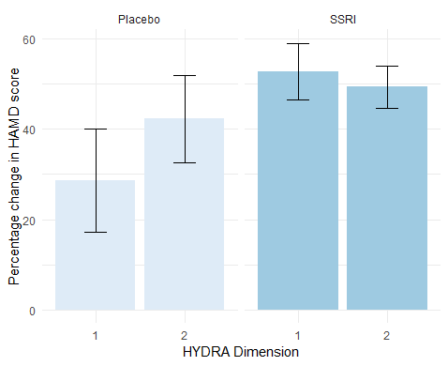

Bar plot showing the mean percentage change (95th percentile error bars) in HAMD scores in the Dimensions and binary treatment groups following treatment with SSRI or placebo medication (PLA).

Supplementary Figure 4

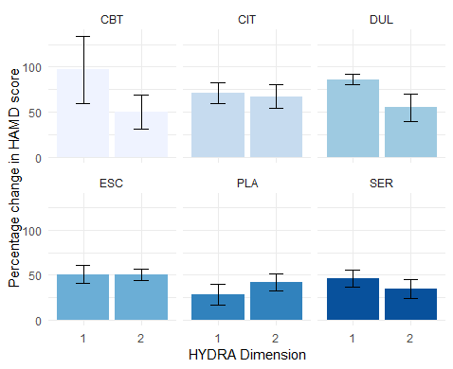
Bar plot showing the mean percentage change (95th percentile error bars) in HAMD scores in the Dimensions and 6 different treatment groups following treatment with cognitive behavioral therapy (CBT), placebo medication (PLA), citalopram medication (CIT), duloxetine medication (DUL), escitalopram medication (ESC), sertraline medication (SER).

Supplementary Table 1. Scanner protocols

 | CANBIND | EMBARC | HMRRC | Manchester | LIBR | Oxford | PReDICT | Stanford | STRADL
Scanner model | GE 3T Signa HDxt | All 3T: GE Signa HDx; Siemens TrioTim, Philips Ingenia | 3T Siemens Trio | Philips Intera 1.5T | GE 3T Discovery MR750 | 3T Siemens TIM Trio | 3T Siemens Magnetom TIM Trio | 1.5T GE Signa Excite | 3T Philips Achieva TX; Siemens 3T Prisma fit
T1 Resolution (mm³) | 1x1x1 | 1x1x1 | 0.94x0.94x1 | 0.875x0.875x1 | 0.9375x0.9375x0.9 | 1x1x1 | 1x1x1 | 0.86x0.86 | 1x1x1
TR/TE (ms) | 7.5/2.86 | 5.9-8.2/2.4-3.7 | 1900/2.26 | 8.99/4.2 | 5.0/2.0 | 20040/  4.68 | 2300/2-4 | 8.3-10.1/  1.7-3.0 | 8.2/3.8
Number of volumes | 176 | 160 | 176 | 160 | 120 |  |  | 116 | 160

Supplementary Table 2. Demographic information by site in healthy controls

Site | Sample size | Age (mean) | F/M (n) | Years of education (mean) | HAMD | MADRS | QIDS
CAN-BIND | 23 | 33.3 | 12/11 | 15.1 |  | 0.6
EMBARC | 39 | 37.1 | 24/15 | 15.1 | 0.6
HMRRC | 139 | 30.9 | 71/68 | 12.9 | NA
KCL-Blame | 46 | 33.4 | 29/17 | 17.3 |  | 0.7
KCL-BUD | 20 | 30.1 | 18/2 | 17.5 |  | 1.0
LIBR-B | 81 | 30.5 | 44/37 | 15.0 | 1.9
LIBR-S | 60 | 32.0 | 39/21 | 14.6 | 1.8
Manchester | 30 | 33.3 | 21/9 | NA |  | 0.1
Oxford | 31 | 30.3 | 18/13 | NA | 0.4
PReDICT | 0 | NA | NA | NA
Stanford | 50 | 32.6 | 33/17 | 16.0 | 2.0
STRADL | 180 | 56.8 | 95/85 | 16.0 |  |  | 2.7
Total | 699 | 38.4 | 404/295 | 15.3 | 1.5 | 0.6 | 2.7

Supplementary Table 3. Demographic information by site in MDD

Site | Sample size | Dimension 1/2 | Age (mean) | F/M  (n) | FE/RC | Years of education (mean) | Age of onset (mean, std) | HAMD | MADRS | QIDS
CAN-BIND | 92 | 27/65 | 36.0 | 61/31 | 14/49 | 13.9 | 22.0 (10.9) |  | 29.7
EMBARC | 257 | 134/123 | 36.6 | 166/91 | 1/253 | 15.1 |  | 19.5
HMRRC | 111 | 53/58 | 31.7 | 65/46 | 81/0 | 13.2 |  | 25.2
KCL-BUD | 20 | 10/10 | 29.6 | 18/2 |  | 15.1 | 22.8 (7.8) |  | 27.3
LIBR-B | 32 | 14/18 | 35.3 | 21/11 |  | 14.0 |  | 18.5
LIBR-S | 22 | 12/10 | 35.2 | 15/7 |  | 14.0 |  | 19.6
Manchester | 40 | 19/21 | 36.4 | 27/13 | 3/37 |  | 22.0 (8.1) |  | 27.3
Oxford | 39 | 14/25 | 29.9 | 24/15 | 25/14 |  | 25.4 (9.1) | 22.7
PReDICT | 63 | 5/58 | 39.3 | 36/27 |  | 15.0 | 29.7 (12.2) | 18.3
Stanford | 8 | 2/6 | 34.0 | 5/3 | 4/2 | 15.0 |  | 17.5
STRADL | 1 | 0/1 | 59.0 | 1/0 |  | 16.0 |  |  |  | 16
Total | 685 | 290/395 | 35.3 | 439/246 | 128/355 | 14.5 | 24.5 (10.8) | 21.2 | 29.0 | 16

Supplementary Table 4. List of structural MUSE regions of interest used in the HYDRA model

ROI index | ROI Name | ROI Resolution
4 | 3rd Ventricle | Single
11 | 4th Ventricle | Single
23 | Right Accumbens Area | Single
30 | Left Accumbens Area | Single
31 | Right Amygdala | Single
32 | Left Amygdala | Single
35 | Brain Stem | Single
36 | Right Caudate | Single
37 | Left Caudate | Single
38 | Right Cerebellum Exterior | Single
39 | Left Cerebellum Exterior | Single
40 | Right Cerebellum White Matter | Single
41 | Left Cerebellum White Matter | Single
47 | Right Hippocampus | Single
48 | Left Hippocampus | Single
49 | Right Inferior Lateral Ventricle | Single
50 | Left Inferior Lateral Ventricle | Single
51 | Right Lateral Ventricle | Single
52 | Left Lateral Ventricle | Single
55 | Right Pallidum | Single
56 | Left Pallidum | Single
57 | Right Putamen | Single
58 | Left Putamen | Single
59 | Right Thalamus Proper | Single
60 | Left Thalamus Proper | Single
61 | Right Ventral DC | Single
62 | Left Ventral DC | Single
71 | Cerebellar Vermal Lobules I-V | Single
72 | Cerebellar Vermal Lobules VI-VII | Single
73 | Cerebellar Vermal Lobules VIII-X | Single
75 | Left Basal Forebrain | Single
76 | Right Basal Forebrain | Single
81 | Frontal lobe white matter right | Single
82 | Frontal lobe white matter left | Single
83 | Occipital lobe white matter right | Single
84 | Occipital lobe white matter left | Single
85 | Parietal lobe white matter right | Single
86 | Parietal lobe white matter left | Single
87 | Temporal lobe white matter right | Single
88 | Temporal lobe white matter left | Single
89 | Right fornix | Single
90 | Left fornix | Single
91 | Anterior limb of internal capsule right | Single
92 | Anterior limb of internal capsule left | Single
93 | Posterior limb of internal capsule inc. cerebral peduncle right | Single
94 | Posterior limb of internal capsule inc. cerebral peduncle left | Single
95 | Corpus callosum | Single
100 | Right anterior cingulate gyrus | Single
101 | Left anterior cingulate gyrus | Single
102 | Right anterior insula | Single
103 | Left anterior insula | Single
104 | Right anterior orbital gyrus | Single
105 | Left anterior orbital gyrus | Single
106 | Right angular gyrus | Single
107 | Left angular gyrus | Single
108 | Right calcarine cortex | Single
109 | Left calcarine cortex | Single
112 | Right central operculum | Single
113 | Left central operculum | Single
114 | Right cuneus | Single
115 | Left cuneus | Single
116 | Right entorhinal area | Single
117 | Left entorhinal area | Single
118 | Right frontal operculum | Single
119 | Left frontal operculum | Single
120 | Right frontal pole | Single
121 | Left frontal pole | Single
122 | Right fusiform gyrus | Single
123 | Left fusiform gyrus | Single
124 | Right gyrus rectus | Single
125 | Left gyrus rectus | Single
128 | Right inferior occipital gyrus | Single
129 | Left inferior occipital gyrus | Single
132 | Right inferior temporal gyrus | Single
133 | Left inferior temporal gyrus | Single
134 | Right lingual gyrus | Single
135 | Left lingual gyrus | Single
136 | Right lateral orbital gyrus | Single
137 | Left lateral orbital gyrus | Single
138 | Right middle cingulate gyrus | Single
139 | Left middle cingulate gyrus | Single
140 | Right medial frontal cortex | Single
141 | Left medial frontal cortex | Single
142 | Right middle frontal gyrus | Single
143 | Left middle frontal gyrus | Single
144 | Right middle occipital gyrus | Single
145 | Left middle occipital gyrus | Single
146 | Right medial orbital gyrus | Single
147 | Left medial orbital gyrus | Single
148 | Right postcentral gyrus medial segment | Single
149 | Left postcentral gyrus medial segment | Single
150 | Right precentral gyrus medial segment | Single
151 | Left precentral gyrus medial segment | Single
152 | Right superior frontal gyrus medial segment | Single
153 | Left superior frontal gyrus medial segment | Single
154 | Right middle temporal gyrus | Single
155 | Left middle temporal gyrus | Single
156 | Right occipital pole | Single
157 | Left occipital pole | Single
160 | Right occipital fusiform gyrus | Single
161 | Left occipital fusiform gyrus | Single
162 | Right opercular part of the inferior frontal gyrus | Single
163 | Left opercular part of the inferior frontal gyrus | Single
164 | Right orbital part of the inferior frontal gyrus | Single
165 | Left orbital part of the inferior frontal gyrus | Single
166 | Right posterior cingulate gyrus | Single
167 | Left posterior cingulate gyrus | Single
168 | Right precuneus | Single
169 | Left precuneus | Single
170 | Right parahippocampal gyrus | Single
171 | Left parahippocampal gyrus | Single
172 | Right posterior insula | Single
173 | Left posterior insula | Single
174 | Right parietal operculum | Single
175 | Left parietal operculum | Single
176 | Right postcentral gyrus | Single
177 | Left postcentral gyrus | Single
178 | Right posterior orbital gyrus | Single
179 | Left posterior orbital gyrus | Single
180 | Right planum polare | Single
181 | Left planum polare | Single
182 | Right precentral gyrus | Single
183 | Left precentral gyrus | Single
184 | Right planum temporale | Single
185 | Left planum temporale | Single
186 | Right subcallosal area | Single
187 | Left subcallosal area | Single
190 | Right superior frontal gyrus | Single
191 | Left superior frontal gyrus | Single
192 | Right supplementary motor cortex | Single
193 | Left supplementary motor cortex | Single
194 | Right supramarginal gyrus | Single
195 | Left supramarginal gyrus | Single
196 | Right superior occipital gyrus | Single
197 | Left superior occipital gyrus | Single
198 | Right superior parietal lobule | Single
199 | Left superior parietal lobule | Single
200 | Right superior temporal gyrus | Single
201 | Left superior temporal gyrus | Single
202 | Right temporal pole | Single
203 | Left temporal pole | Single
204 | Right triangular part of the inferior frontal gyrus | Single
205 | Left triangular part of the inferior frontal gyrus | Single
206 | Right transverse temporal gyrus | Single
207 | Left transverse temporal gyrus | Single
301 | FRONTAL_INFERIOR_GM | Composite
302 | FRONTAL_INSULAR_GM | Composite
303 | FRONTAL_LATERAL_GM | Composite
304 | FRONTAL_MEDIAL_GM | Composite
305 | FRONTAL_OPERCULAR_GM | Composite
306 | LIMBIC_CINGULATE_GM | Composite
307 | LIMBIC_MEDIALTEMPORAL_GM | Composite
308 | OCCIPITAL_INFERIOR_GM | Composite
309 | OCCIPITAL_LATERAL_GM | Composite
310 | OCCIPITAL_MEDIAL_GM | Composite
311 | PARIETAL_LATERAL_GM | Composite
312 | PARIETAL_MEDIAL_GM | Composite
313 | TEMPORAL_INFERIOR_GM | Composite
314 | TEMPORAL_LATERAL_GM | Composite
315 | TEMPORAL_SUPRATEMPORAL_GM | Composite
316 | FRONTAL_INFERIOR_GM_L | Composite
317 | FRONTAL_INSULAR_GM_L | Composite
318 | FRONTAL_LATERAL_GM_L | Composite
319 | FRONTAL_MEDIAL_GM_L | Composite
320 | FRONTAL_OPERCULAR_GM_L | Composite
321 | LIMBIC_CINGULATE_GM_L | Composite
322 | LIMBIC_MEDIALTEMPORAL_GM_L | Composite
323 | OCCIPITAL_INFERIOR_GM_L | Composite
324 | OCCIPITAL_LATERAL_GM_L | Composite
325 | OCCIPITAL_MEDIAL_GM_L | Composite
326 | PARIETAL_LATERAL_GM_L | Composite
327 | PARIETAL_MEDIAL_GM_L | Composite
328 | TEMPORAL_INFERIOR_GM_L | Composite
329 | TEMPORAL_LATERAL_GM_L | Composite
330 | TEMPORAL_SUPRATEMPORAL_GM_L | Composite
331 | FRONTAL_INFERIOR_GM_R | Composite
332 | FRONTAL_INSULAR_GM_R | Composite
333 | FRONTAL_LATERAL_GM_R | Composite
334 | FRONTAL_MEDIAL_GM_R | Composite
335 | FRONTAL_OPERCULAR_GM_R | Composite
336 | LIMBIC_CINGULATE_GM_R | Composite
337 | LIMBIC_MEDIALTEMPORAL_GM_R | Composite
338 | OCCIPITAL_INFERIOR_GM_R | Composite
339 | OCCIPITAL_LATERAL_GM_R | Composite
340 | OCCIPITAL_MEDIAL_GM_R | Composite
341 | PARIETAL_LATERAL_GM_R | Composite
342 | PARIETAL_MEDIAL_GM_R | Composite
343 | TEMPORAL_INFERIOR_GM_R | Composite
344 | TEMPORAL_LATERAL_GM_R | Composite
345 | TEMPORAL_SUPRATEMPORAL_GM_R | Composite
401 | BASAL_GANGLIA | Composite
402 | DEEP_GM | Composite
403 | DEEP_WM | Composite
404 | FRONTAL_GM | Composite
405 | FRONTAL_WM | Composite
406 | LIMBIC_GM | Composite
407 | OCCIPITAL_GM | Composite
408 | OCCIPITAL_WM | Composite
409 | PARIETAL_GM | Composite
410 | PARIETAL_WM | Composite
411 | TEMPORAL_GM | Composite
412 | TEMPORAL_WM | Composite
413 | BASAL_GANGLIA_L | Composite
414 | DEEP_GM_L | Composite
415 | DEEP_WM_L | Composite
416 | FRONTAL_GM_L | Composite
417 | FRONTAL_WM_L | Composite
418 | LIMBIC_GM_L | Composite
419 | OCCIPITAL_GM_L | Composite
420 | OCCIPITAL_WM_L | Composite
421 | PARIETAL_GM_L | Composite
422 | PARIETAL_WM_L | Composite
423 | TEMPORAL_GM_L | Composite
424 | TEMPORAL_WM_L | Composite
425 | BASAL_GANGLIA_R | Composite
426 | DEEP_GM_R | Composite
427 | DEEP_WM_R | Composite
428 | FRONTAL_GM_R | Composite
429 | FRONTAL_WM_R | Composite
430 | LIMBIC_GM_R | Composite
431 | OCCIPITAL_GM_R | Composite
432 | OCCIPITAL_WM_R | Composite
433 | PARIETAL_GM_R | Composite
434 | PARIETAL_WM_R | Composite
435 | TEMPORAL_GM_R | Composite
436 | TEMPORAL_WM_R | Composite
501 | CORPUS_CALLOSUM | Composite
502 | CEREBELLUM | Composite
503 | DEEP_WM_GM | Composite
504 | FRONTAL | Composite
505 | LIMBIC | Composite
506 | OCCIPITAL | Composite
507 | PARIETAL | Composite
508 | TEMPORAL | Composite
509 | VENTRICLE | Composite
510 | CEREBELLUM_L | Composite
511 | DEEP_WM_GM_L | Composite
512 | FRONTAL_L | Composite
513 | LIMBIC_L | Composite
514 | OCCIPITAL_L | Composite
515 | PARIETAL_L | Composite
516 | TEMPORAL_L | Composite
517 | VENTRICLE_L | Composite
518 | CEREBELLUM_R | Composite
519 | DEEP_WM_GM_R | Composite
520 | FRONTAL_R | Composite
521 | LIMBIC_R | Composite
522 | OCCIPITAL_R | Composite
523 | PARIETAL_R | Composite
524 | TEMPORAL_R | Composite
525 | VENTRICLE_R | Composite
601 | GM | Composite
604 | WM | Composite
606 | GM_L | Composite
607 | WM_L | Composite
613 | GM_R | Composite
614 | WM_R | Composite
701 | TOTALBRAIN | Composite
702 | ICV | Composite

Supplementary References

Arnone, D., McKie, S., Elliott, R., Juhasz, G., Thomas, E. J., Downey, D., . . . Anderson, I. M. (2013). State-dependent changes in hippocampal grey matter in depression. Mol Psychiatry, 18(12), 1265-1272. doi:10.1038/mp.2012.150
Arnone, D., McKie, S., Elliott, R., Thomas, E. J., Downey, D., Juhasz, G., . . . Anderson, I. M. (2012). Increased amygdala responses to sad but not fearful faces in major depression: relation to mood state and pharmacological treatment. Am J Psychiatry, 169(8), 841-850. doi:10.1176/appi.ajp.2012.11121774
Dunlop, B. W., Binder, E. B., Cubells, J. F., Goodman, M. M., Kelley, M. E., Kinkead, B., . . . Mayberg, H. S. (2012). Predictors of remission in depression to individual and combined treatments (PReDICT): study protocol for a randomized controlled trial. Trials, 13, 106. doi:10.1186/1745-6215-13-106
Dutta, A., McKie, S., Downey, D., Thomas, E., Juhasz, G., Arnone, D., . . . Anderson, I. M. (2019). Regional default mode network connectivity in major depressive disorder: modulation by acute intravenous citalopram. Transl Psychiatry, 9(1), 116. doi:10.1038/s41398-019-0447-0
Ford, B. N., Yolken, R. H., Aupperle, R. L., Teague, T. K., Irwin, M. R., Paulus, M. P., & Savitz, J. (2019). Association of Early-Life Stress With Cytomegalovirus Infection in Adults With Major Depressive Disorder. JAMA Psychiatry, 76(5), 545-547. doi:10.1001/jamapsychiatry.2018.4543
Godlewska, B. R., Browning, M., Norbury, R., Igoumenou, A., Cowen, P. J., & Harmer, C. J. (2018). Predicting Treatment Response in Depression: The Role of Anterior Cingulate Cortex. International Journal of Neuropsychopharmacology, 21(11), 988-996. doi:10.1093/ijnp/pyy069
Godlewska, B. R., Hasselmann, H. W., Igoumenou, A., Norbury, R., & Cowen, P. J. (2014). Short-term escitalopram treatment and hippocampal volume. Psychopharmacology (Berl), 231(23), 4579-4581. doi:10.1007/s00213-014-3771-3
Green, S., Lambon Ralph, M. A., Moll, J., Deakin, J. F., & Zahn, R. (2012). Guilt-selective functional disconnection of anterior temporal and subgenual cortices in major depressive disorder. Arch Gen Psychiatry, 69(10), 1014-1021. doi:10.1001/archgenpsychiatry.2012.135
Habota, T., Sandu, A. L., Waiter, G. D., McNeil, C. J., Steele, J. D., Macfarlane, J. A., . . . McIntosh, A. M. (2019). Cohort profile for the STratifying Resilience and Depression Longitudinally (STRADL) study: A depression-focused investigation of Generation Scotland, using detailed clinical, cognitive, and neuroimaging assessments. Wellcome Open Res, 4, 185. doi:10.12688/wellcomeopenres.15538.2
Hamilton, M. (1960). A rating scale for depression. J Neurol Neurosurg Psychiatry, 23(1), 56-62. doi:10.1136/jnnp.23.1.56
Leucht, S., Fennema, H., Engel, R. R., Kaspers-Janssen, M., & Szegedi, A. (2018). Translating the HAM-D into the MADRS and vice versa with equipercentile linking. J Affect Disord, 226, 326-331. doi:10.1016/j.jad.2017.09.042
MacQueen, G. M., Hassel, S., Arnott, S. R., Jean, A., Bowie, C. R., Bray, S. L., . . . Kennedy, S. H. (2019). The Canadian Biomarker Integration Network in Depression (CAN-BIND): magnetic resonance imaging protocols. J Psychiatry Neurosci, 44(4), 223-236. doi:10.1503/jpn.180036
Misaki, M., Suzuki, H., Savitz, J., Drevets, W. C., & Bodurka, J. (2016). Individual Variations in Nucleus Accumbens Responses Associated with Major Depressive Disorder Symptoms. Sci Rep, 6, 21227. doi:10.1038/srep21227
Montgomery, S. A., & Asberg, M. (1979). A new depression scale designed to be sensitive to change. Br J Psychiatry, 134, 382-389. doi:10.1192/bjp.134.4.382
Nouretdinov, I., Costafreda, S. G., Gammerman, A., Chervonenkis, A., Vovk, V., Vapnik, V., & Fu, C. H. (2011). Machine learning classification with confidence: application of transductive conformal predictors to MRI-based diagnostic and prognostic markers in depression. Neuroimage, 56(2), 809-813. doi:10.1016/j.neuroimage.2010.05.023
Qiu, L., Xia, M., Cheng, B., Yuan, L., Kuang, W., Bi, F., . . . Gong, Q. (2018). Abnormal dynamic functional connectivity of amygdalar subregions in untreated patients with first-episode major depressive disorder. J Psychiatry Neurosci, 43(4), 262-272. doi:10.1503/jpn.170112
Rush, A. J., Trivedi, M. H., Ibrahim, H. M., Carmody, T. J., Arnow, B., Klein, D. N., . . . Keller, M. B. (2003). The 16-Item Quick Inventory of Depressive Symptomatology (QIDS), clinician rating (QIDS-C), and self-report (QIDS-SR): a psychometric evaluation in patients with chronic major depression. Biol Psychiatry, 54(5), 573-583. doi:10.1016/s0006-3223(02)01866-8
Sacchet, M. D., & Gotlib, I. H. (2017). Myelination of the brain in Major Depressive Disorder: An in vivo quantitative magnetic resonance imaging study. Sci Rep, 7(1), 2200. doi:10.1038/s41598-017-02062-y
Sacchet, M. D., Livermore, E. E., Iglesias, J. E., Glover, G. H., & Gotlib, I. H. (2015). Subcortical volumes differentiate Major Depressive Disorder, Bipolar Disorder, and remitted Major Depressive Disorder. Journal of Psychiatric Research, 68, 91-98. doi:https://doi.org/10.1016/j.jpsychires.2015.06.002
Sankar, A., Zhang, T., Gaonkar, B., Doshi, J., Erus, G., Costafreda, S. G., . . . Fu, C. H. (2016). Diagnostic potential of structural neuroimaging for depression from a multi-ethnic community sample. BJPsych Open, 2(4), 247-254. doi:10.1192/bjpo.bp.115.002493
Schwartz, J., Ordaz, S. J., Kircanski, K., Ho, T. C., Davis, E. G., Camacho, M. C., & Gotlib, I. H. (2019). Resting-state functional connectivity and inflexibility of daily emotions in major depression. J Affect Disord, 249, 26-34. doi:10.1016/j.jad.2019.01.040
Trivedi, M. H., McGrath, P. J., Fava, M., Parsey, R. V., Kurian, B. T., Phillips, M. L., . . . Weissman, M. M. (2016). Establishing moderators and biosignatures of antidepressant response in clinical care (EMBARC): Rationale and design. Journal of Psychiatric Research, 78, 11-23. doi:https://doi.org/10.1016/j.jpsychires.2016.03.001
Trivedi, M. H., Rush, A. J., Ibrahim, H. M., Carmody, T. J., Biggs, M. M., Suppes, T., . . . Kashner, T. M. (2004). The Inventory of Depressive Symptomatology, Clinician Rating (IDS-C) and Self-Report (IDS-SR), and the Quick Inventory of Depressive Symptomatology, Clinician Rating (QIDS-C) and Self-Report (QIDS-SR) in public sector patients with mood disorders: a psychometric evaluation. Psychol Med, 34(1), 73-82. doi:10.1017/s0033291703001107
Uher, R., Farmer, A., Maier, W., Rietschel, M., Hauser, J., Marusic, A., . . . Aitchison, K. J. (2008). Measuring depression: comparison and integration of three scales in the GENDEP study. Psychol Med, 38(2), 289-300. doi:10.1017/s0033291707001730
Wise, T., Marwood, L., Perkins, A. M., Herane-Vives, A., Joules, R., Lythgoe, D. J., . . . Arnone, D. (2017). Instability of default mode network connectivity in major depression: a two-sample confirmation study. Transl Psychiatry, 7(4), e1105. doi:10.1038/tp.2017.40
Wise, T., Marwood, L., Perkins, A. M., Herane-Vives, A., Williams, S. C. R., Young, A. H., . . . Arnone, D. (2018). A morphometric signature of depressive symptoms in unmedicated patients with mood disorders. Acta Psychiatr Scand, 138(1), 73-82. doi:10.1111/acps.12887
Zhao, Y., Niu, R., Lei, D., Shah, C., Xiao, Y., Zhang, W., . . . Gong, Q. (2020). Aberrant Gray Matter Networks in Non-comorbid Medication-Naive Patients With Major Depressive Disorder and Those With Social Anxiety Disorder. Front Hum Neurosci, 14, 172. doi:10.3389/fnhum.2020.00172
Zhao, Y., Zhang, F., Zhang, W., Chen, L., Chen, Z., Lui, S., & Gong, Q. (2021). Decoupling of Gray and White Matter Functional Networks in Medication-Naïve Patients With Major Depressive Disorder. J Magn Reson Imaging, 53(3), 742-752. doi:10.1002/jmri.27392
Zheng, H., Ford, B. N., Bergamino, M., Kuplicki, R., Hunt, P. W., Bodurka, J., . . . Savitz, J. (2021). A hidden menace? Cytomegalovirus infection is associated with reduced cortical gray matter volume in major depressive disorder. Mol Psychiatry, 26(8), 4234-4244. doi:10.1038/s41380-020-00932-y

