Supporting Information
Atomic-Scale Observation of stacking domain structures in a semiconducting van der Waals ferrovalley material VAgP₂Se₆
Leixin Miao†, Seng Huat Lee†, Jingyang He, Venkatraman Gopalan, Zhiqiang Mao*, and Nasim Alem*
† These authors contributed equally: Leixin Miao, Seng Huat Lee
*These authors jointly supervised this work: Zhiqiang Mao, Nasim Alem

Optical bandgap measurement
To examine the optical transition of VAgP₂Se₆ single crystal, UV-vis transmittance spectrum was collected on an exfoliated thin flake of VAgP₂Se₆, as shown in Figure S2. The transmitted intensity started to drop rapidly when excited energy is greater than 2 eV. Using a Tauc analysis by plotting (αhυ)², where α and hυ are the absorption coefficient of the material and the photon energy respectively, versus the energy of the incident light E, for direct bandgap, one can find the optical bandgap is 2.31 eV, as shown in Supplementary Figure 1. The obtained optical bandgap agrees with the dark yellow color of the exfoliated thin flakes (~5 μm) and is comparable to the previously measured bandgap of 2.14 eV. Note that this value is larger than the predicted monolayer bandgap of 1.65eV by density functional theory (DFT). In general, the bandgap is increased by decreasing its thickness; thus, a small bandgap is expected for bulk crystal, which is contradicted with our experiment observation. One explanation is that different hybrid functions used in the calculation can provide different bandgap values, e.g., the Heyd–Scuseria–Ernzerhof (HSE) functional used to predict the bandgap typically yields an underestimated value. In our resistivity measurement (Supplementary Figure 2), we found that the resistivity increases as the temperature decreases, which is a typical semiconductor behavior that possesses a small bandgap and is consistent with the previous resistivity study.
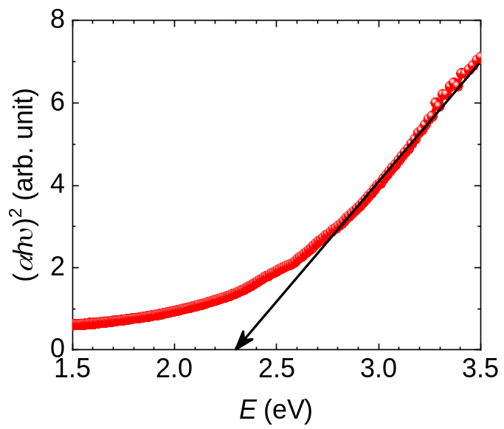
Supplementary Figure 1. (αhν)² as a function of photon energy for VAgP₂Se₆.

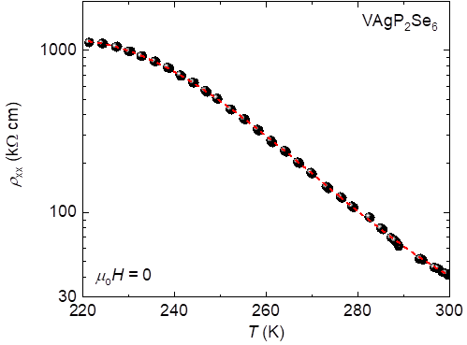
Supplementary Figure 2. Resistivity measurement on VAgP₂Se₆, plotted as the resistivity as a function of temperature.

Supplementary Figure 3. The schematics of the VAgP2Se6 unit cell and its mirror image that demonstrate its chiral structure. In general, a chiral crystal refers to the crystal that has a non-superimposable mirror image under rotation and translation operation. The dashed rectangles highlight trigonal pyramids formed by the P atoms are bonded to three Se atoms with different bond lengths, and the three bonds are labeled with red (2.160 Å), blue (2.199 Å), and green (2.243 Å), respectively. These trigonal pyramids in the original unit cell and its mirrored image cannot be superimposed as shown in the top view images on the right.
Supplementary Table 1: Transformation Matrix of each domain variant
Variant | Coset | Transformation Matrix
V₁ | $$C2$$ | $$\left[\begin{matrix}-1 & 1 & 0 \\ -1 & -1 & 0 \\ 0 & 0 & 1\end{matrix}\right]$$
V₂ | $$3^{+}\left[001\right]C2$$ | $$\left[\begin{matrix}1 & 1 & 0 \\ 0 & 2 & 0 \\ 0 & 0 & 1\end{matrix}\right]$$
V₃ | $$3^{-}\left[001\right]C2$$ | $$\left[\begin{matrix}0 & -2 & 0 \\ 1 & -1 & 0 \\ 0 & 0 & 1\end{matrix}\right]$$
V_{1’} | $$m(120)C2$$ | $$\left[\begin{matrix}-1 & -1 & 0 \\ -1 & 1 & 0 \\ 0 & 0 & 1\end{matrix}\right]$$
V_{2’} | $$m(210)C2$$ | $$\left[\begin{matrix}1 & -1 & 0 \\ 0 & -2 & 0 \\ 0 & 0 & 1\end{matrix}\right]$$
V_{3’} | $$m(1\overline{1}0)C2$$ | $$\left[\begin{matrix}0 & 2 & 0 \\ 1 & 1 & 0 \\ 0 & 0 & 1\end{matrix}\right]$$

Supplementary Figure 4: The schematics of six domain variants, V₁ – V_{3’}, are plotted. Based on the group theory analysis and the coset decomposition, three types of boundaries are identified. The first type is the boundaries between V₁/V₂ and V₁/V₃, which is characterized by the 120° rotation of the [100]_{m} and [010]_{m} (m stands for monoclinic C2) axis around the [001]_{m} axis across the boundary. The second type is the boundaries between V₁/V_{1’}. Across the second type of boundary, the [100]_{m} and [001]_{m} stay in the same direction for two domains but the [010]_{m} directions in adjacent domains are opposite to each other. Lastly, the third type of boundaries are between V₁/V_{2’} and V₁/V_{3’}. The transformation combines the 120° rotation of the [100]_{m} and [010]_{m} axis around the [001]_{m} axis and a reverse of [100]_{m} axis across the boundary.

Supplementary Figure 5. SAED simulations on the superlattice formed by orientational domains. (a-c)The crystal models have the superlattice periodicity of 2, 3 and 4 unit cells, respectively. (d-f)The corresponding simulated SAED patterns show that the distance between the superlattice reflections and Bragg relections is inversely proportional to the size of the superlattices formed by the orientational domains.
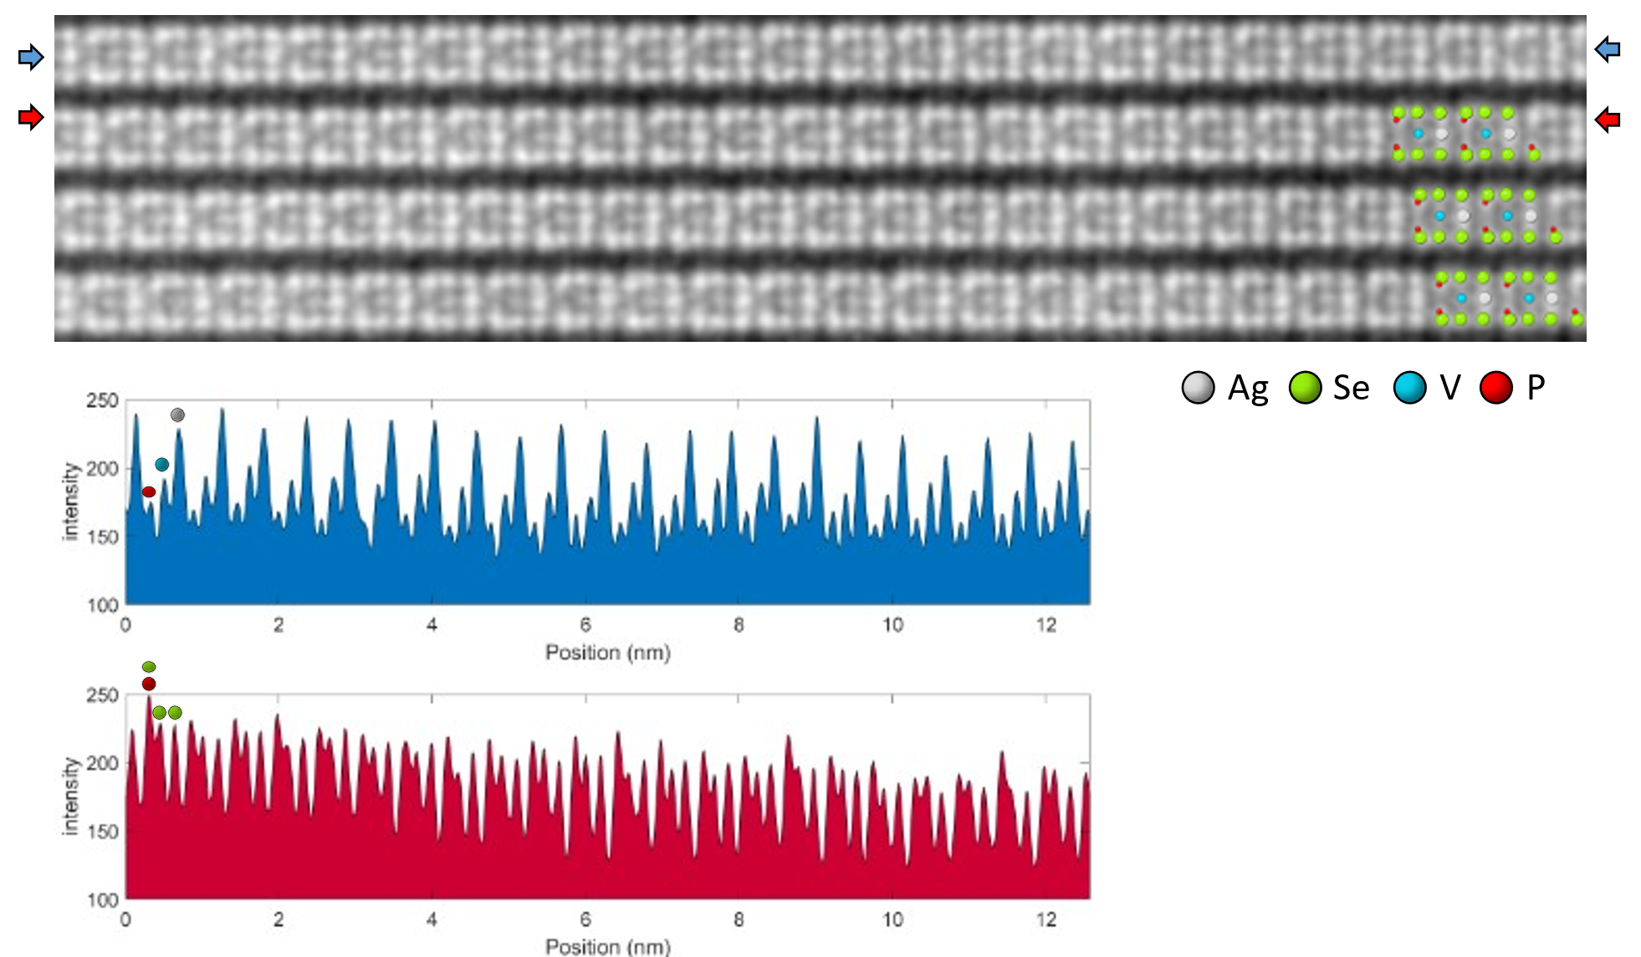
Supplementary Figure 6. The atomic resolution ADF-STEM images of VAgP2Se6 crystal with overlaying crystal structure schematics. The intensity line profile of the atomic columns along the directions indicated by the blue and red arrows are shown. No clear evidence of the V-vacancy within the atomic column or antisite defect of Ag on V-site can be observed from the STEM images and the intensity profiles.

