Search Strategy

Growth prevalence of unruptured aneurysms and coiled unruptured aneurysms

Embase.com
('growth rate'/exp OR growth/de OR 'disease course'/de OR (growth OR course OR progress* OR (increase* NEAR/3 size)):ab,ti) AND ('coil embolization'/exp OR 'embolization coil'/exp OR (coil*):ab,ti) AND ('intracranial aneurysm'/exp OR ('brain artery'/exp AND aneurysm/de) OR ((intracran* OR brain* OR cerebral*) NEAR/6 (aneurysm* OR aneurism*)):ab,ti) NOT ([animals]/lim NOT [humans]/lim)
Medline Ovid
("Growth and Development"/ OR "Growth and Development".xs. OR growth/ OR "Disease Progression"/ OR (growth OR course OR progress* OR (increase* ADJ3 size)).ab,ti.) AND ((coil*).ab,ti.) AND ("Intracranial Aneurysm"/ OR ((intracran* OR brain* OR cerebral*) ADJ6 (aneurysm* OR aneurism*)).ab,ti.) NOT (exp animals/ NOT humans/)
Cochrane
((growth OR course OR progress* OR (increase* NEAR/3 size)):ab,ti) AND ((coil*):ab,ti) AND (((intracran* OR brain* OR cerebral*) NEAR/6 (aneurysm* OR aneurism*)):ab,ti)
Web-of-science
TS=(((growth OR course OR progress* OR (increase* NEAR/2 size))) AND ((coil*)) AND (((intracran* OR brain* OR cerebral*) NEAR/5 (aneurysm* OR aneurism*))) )
Pubmed publisher
("Growth and Development"[mh] OR "Growth and Development"[sh] OR growth[mh] OR "Disease Progression"[mh] OR (growth OR course OR progress*[tiab] OR (increase*[tiab] AND size))) AND ((coil*[tiab])) AND ("Intracranial Aneurysm"[mh] OR ((intracran*[tiab] OR brain*[tiab] OR cerebral*[tiab]) AND (aneurysm*[tiab] OR aneurism*[tiab]))) NOT (animals[mh] NOT humans[mh]) AND publisher[sb]
Google Scholar
growth|course|progress|"increase|increased * size" coil|coiled|coiling "intracranial|brain|cerebral aneurysm|aneurysms"

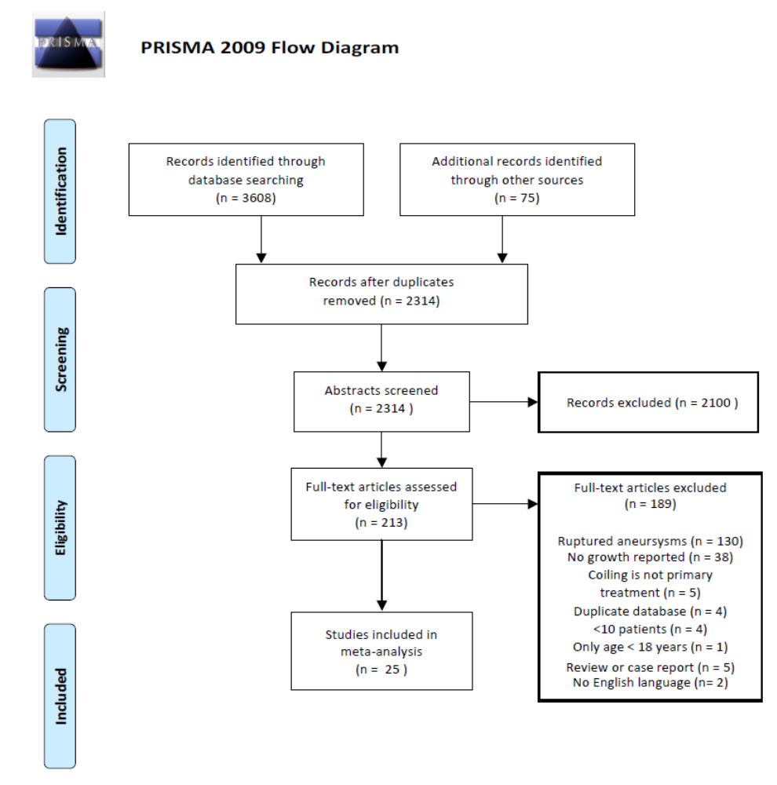
Supplementary Figure 1 - PRISMA Flowchart of included studies

Included studies
Natural history¹⁻¹⁰ and intervention¹¹⁻²⁵ (coiling, stent-assisted coiling)

1. Bor ASE, Groenestege ATT, terBrugge KG, Agid R. Clinical, radiological, and flow-related risk factors for growth of untreated, unruptured intracranial aneurysms. Stroke. 2015.
2. Choi HH, Cho YD, Jeon JP, et al. Growth of Untreated Unruptured Small-sized Aneurysms (≺7mm): Incidence and Related Factors. Clin Neurorad. 2018;28(2):183-189.
3. Giordan E, Brinjikji W, Vine RL, Lanzino G. Risk of de novo aneurysm formation in patients with unruptured intracranial aneurysms. Acta Neurochir (Wien). 2018;160(4):747-751.
4. Inoue T, Shimizu H, Fujimura M, Saito A. Annual rupture risk of growing unruptured cerebral aneurysms detected by magnetic resonance angiography. Journal of …. 2012.
5. Leemans EL, Cornelissen BMW, Said M, et al. Intracranial aneurysm growth: consistency of morphological changes. Neurosurgical Focus. 2019;47(1).
6. Matsumoto K, Oshino S, Sasaki M, Tsuruzono K, Taketsuna S, Yoshimine T. Incidence of growth and rupture of unruptured intracranial aneurysms followed by serial MRA. Acta Neurochir (Wien). 2013;155(2):211-216.
7. Park S, Lee DH, Ryu CW, et al. Incidental Saccular Aneurysms on Head MR Angiography: 5 Years' Experience at a Single Large-Volume Center. J Stroke. 2014;16(3):189-194.
8. Sonobe M, Yamazaki T, Yonekura M, Kikuchi H. Small unruptured intracranial aneurysm verification study: SUAVe study, Japan. Stroke. 2010;41(9):1969-1977.
9. Villablanca JP, Duckwiler GR, Jahan R, Tateshima S. Natural history of asymptomatic unruptured cerebral aneurysms evaluated at CT angiography: growth and rupture incidence and correlation with epidemiologic risk …. Radiology. 2013.
10. Chien A, Callender RA, Yokota H, et al. Unruptured intracranial aneurysm growth trajectory: occurrence and rate of enlargement in 520 longitudinally followed cases. Journal of neurosurgery. 2019:1-11.
11. Abecassis IJ, Sen RD, Barber J, et al. Predictors of recurrence, progression, and retreatment in basilar tip aneurysms: A location-controlled analysis. Oper Neurosurg. 2019;16(4):435-444.
12. Cho YD, Jeon JP, Yoo DH, et al. Growth-Related Major Recanalization of Coiled Aneurysms: Incidence and Risk Factors. Neurosurgery. 2018;82(2):185-191.
13. Cognard C, Weill A, Spelle L, et al. Long-term angiographic follow-up of 169 intracranial berry aneurysms occluded with detachable coils. Radiology. 1999;212(2):348-356.
14. Feng X, Wang L, Guo E, et al. Progressive Occlusion and Recanalization After Endovascular Treatment for 287 Unruptured Small Aneurysms (<5mm): A Single-Center 6-Year Experience. World Neurosurg. 2017;103:576-583.
15. Gao BL, Zhang XJ, Fan QY, Hao WL, Li CH, Yang ST. Long-term outcome of the enterprise stent in the treatment of wide-necked cerebral aneurysms. Acta Med Mediterr. 2018;34(1).
16. Gentric JC, Biondi A, Piotin M, et al. Safety and efficacy of neuroform for treatment of intracranial aneurysms: a prospective, consecutive, French multicentric study. AJNR Am J Neuroradiol. 2013;34(6):1203-1208.
17. Iijima A, Piotin M, Mounayer C, Spelle L, Weill A, Moret J. Endovascular treatment with coils of 149 middle cerebral artery berry aneurysms. Radiology. 2005;237(2):611-619.
18. Im SH, Han MH, Kwon OK, et al. Endovascular coil embolization of 435 small asymptomatic unruptured intracranial aneurysms: procedural morbidity and patient outcome. AJNR Am J Neuroradiol. 2009;30(1):79-84.
19. Jeon JP, Cho YD, Yoo DH, et al. Risk factor analysis of recanalization timing in coiled aneurysms: Early versus late recanalization. Am J Neuroradiol. 2017;38(9):1765-1770.
20. Kim SY, Park DS, Park HY, Chun YI, Moon CT, Roh HG. Simple Coiling versus Stent-Assisted Coiling of Paraclinoid Aneurysms: Radiological Outcome in a Single Center Study. J Korean Neurosurg Soc. 2017;60(6):644-653.
21. Maldonado IL, Machi P, Costalat V, Mura T, Bonafe A. Neuroform stent-assisted coiling of unruptured intracranial aneurysms: short- and midterm results from a single-center experience with 68 patients. AJNR Am J Neuroradiol. 2011;32(1):131-136.
22. Oishi H, Yamamoto M, Shimizu T, Yoshida K, Arai H. Endovascular therapy of 500 small asymptomatic unruptured intracranial aneurysms. AJNR Am J Neuroradiol. 2012;33(5):958-964.
23. Soeda A, Sakai N, Sakai H, Iihara K, Nagata I. Endovascular treatment of asymptomatic cerebral aneurysms: anatomic and technical factors related to ischemic events and coil stabilization. Neurol Med Chir (Tokyo). 2004;44(9):456-465; discussion 466.
24. Teramoto S, Oishi H, Arai H. Comparative Analysis of Long-Term Effect of Stent-Assisted Coiling in Unruptured Sidewall-Type and Terminal-Type Aneurysms. World Neurosurg. 2019;126:e753-e757.
25. Van Eijck M, Bechan RS, Sluzewski M, Peluso JP, Roks G, Van Rooij WJ. Clinical and imaging follow-Up of patients with coiled basilar tip aneurysms Up to 20 years. Am J Neuroradiol. 2015;36(11):2108-2113.

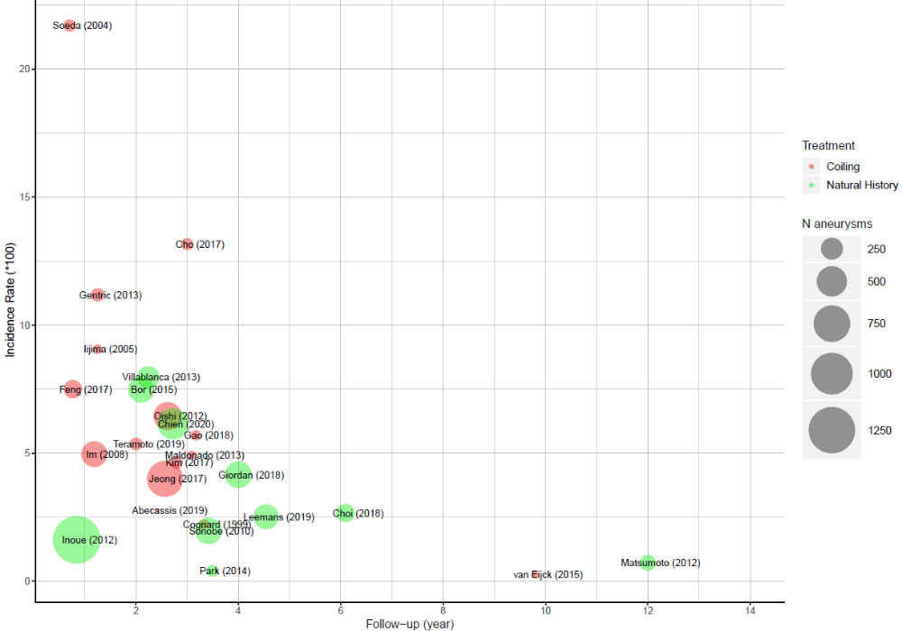
Supplementary Figure 2 – Bubble plot of included studies. The x-axis reflects the numbers of years of follow-up, the y-axis the incidence rate, the size of the bubble the number of included aneurysms. Red studies depict endovascular studies, whereas green ones natural history studies.

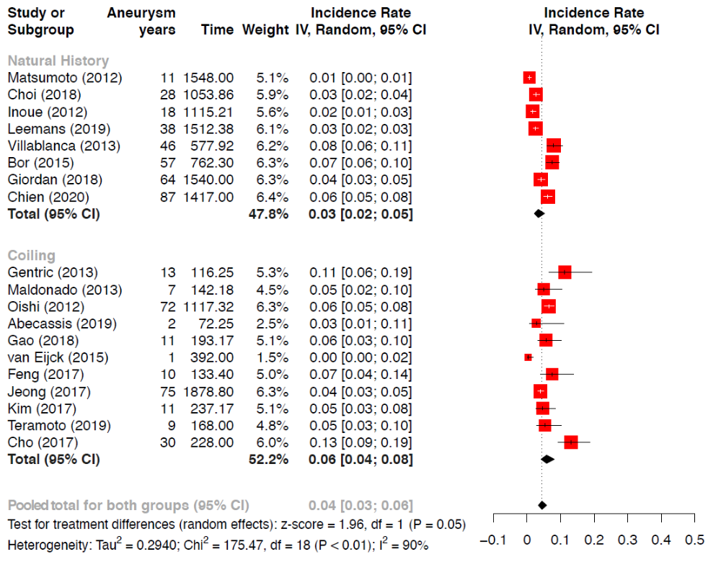
Supplementary Figure 3-Sensitivity analysis: Analysis including only studies published after 2010

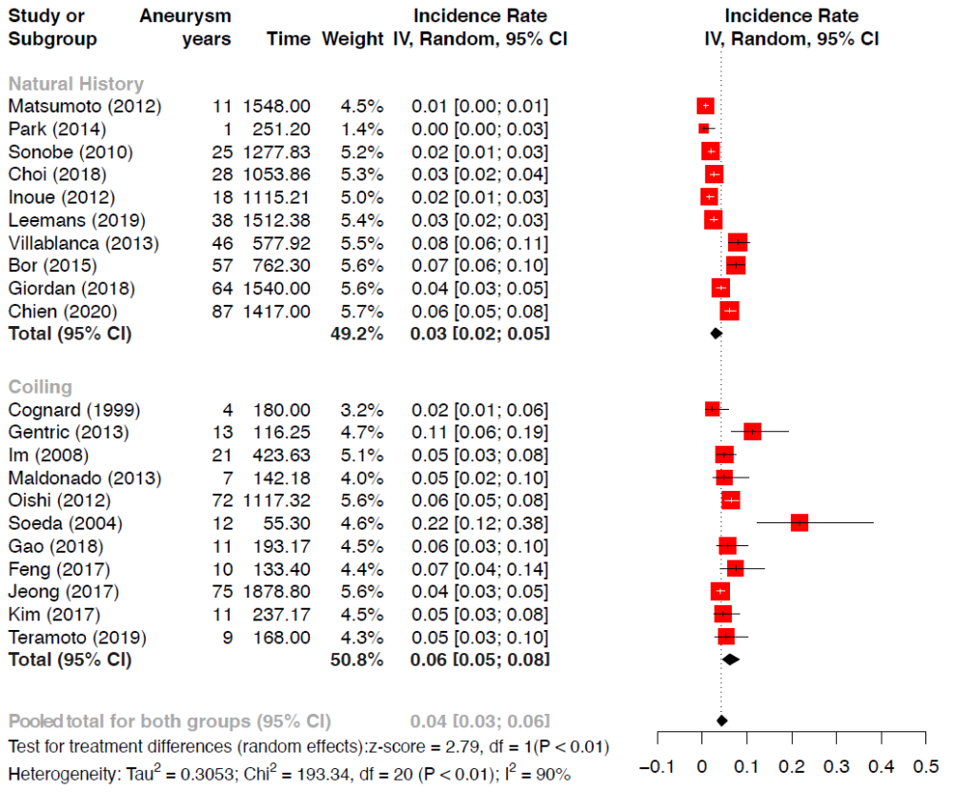
Supplementary Figure 4 - Sensitivity analysis: The 3 studies identified as outliers were excluded from the analysis.

