Table 1. Represents the top hits their structure and binding energies.

S Compound 2D Docking
NO Name Structure Score
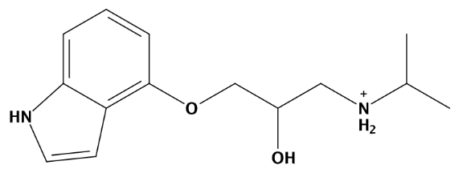
1 Reference compound

-4.2

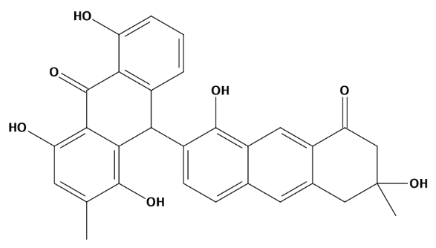

2 (10R)-3',4'-dihydro-1,4,8,3',8',9'-hexahydroxy-3,3
-dimethyl-[10,7'-bianthracene]-9,1'(10H,2'H)-dione -7.1

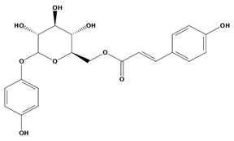

-6.9 3 6'-(4''-hydroxy cinnamoyl) arbutin

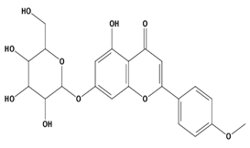

4 Acacetin 7-glucoside -6.5

Ligand | PAINS Filter |  | Structure | SMILE ID
Ref | Passed | 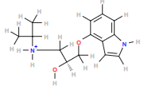 |  | O(C[C@@H](O)C[NH2+]C(C)C)c1c2c([nH]cc2)ccc1
C1 | Passed | 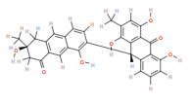 |  | O=C1C[C@@](C)(O)Cc2c1cc1c(c2)ccc(c1O)[C@H]1c2cccc(c2C(=O)c2c1c(O)c(C)cc2O)O
C2 | Passed | 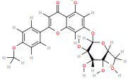 |  | OC[C@H]1O[C@H](Oc2cc(O)c3c(c2)oc(cc3=O)c2ccc(cc2)OC)[C@@H]([C@H]([C@@H]1O)O)O
C3 | Passed | 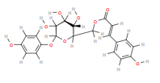 |  | O=C(OC[C@H]1O[C@H](Oc2ccc(cc2)O)[C@@H]([C@H]([C@@H]1O)O)O)/C=C/c1ccc(cc1)O

Table 4 The areas enclosed and red color parts make these chemistries as artefacts.
PAINS | Reason of being PAINS
 | TOXOFLAVIN Redox cycler: can produce hydrogen peroxide, which can activate or inactivate different proteins.
 | ISOTHIAZOLONES Covalent modifier: reacts chemically with proteins in non-specific, non-drug-like ways.
 | CURCUMIN Covalent modifier, membrane disruptor: muddles response of membrane receptors.
 | HYDROXYPHENYL HYDRAZONES Covalent modifier, metal complexer: sequesters metal ions that inactivate proteins.
 | ENE-RHODANINE Covalent modifier, metal complexer.
 | PHENOL-SULPHONAMIDES Redox cycler, covalent modifier, unstable compound: breaks down into molecules that give false signals.

