Supplementary Material for
Seasonal variation in landcover estimates reveals sensitivities and opportunities for environmental models

Daniel T. Myers^{1*} (ORCID 0000-0002-1932-5775), David Jones² (0000-0002-5373-8290), Diana Oviedo-Vargas¹ (0000-0001-9333-0962), John Paul Schmit² (0000-0003-3781-2750), Darren L. Ficklin³ (0000-0003-3736-7407), Xuesong Zhang⁴ (0000-0003-4711-7751)

¹ Stroud Water Research Center, 970 Spencer Road, Avondale, Pennsylvania 19311, USA
² National Park Service National Capital Region Network, 4598 MacArthur Blvd. NW, Washington, DC 20007, USA
³ Department of Geography, Indiana University Bloomington, Student Building 120, 701 E. Kirkwood Avenue, Bloomington, IN 47405, USA
⁴ Hydrology and Remote Sensing Laboratory, United States Department of Agriculture Agricultural Research Service, Bldg. 007, Rm. 104, BARC-West, Beltsville, MD 20705-2350, USA
* Corresponding author (dmyers@stroudcenter.org)

Contents:
Figure S1
Figure S2
Figure S3
Figure S4
Figure S5
Table S1
Table S2
Table S3
Table S4
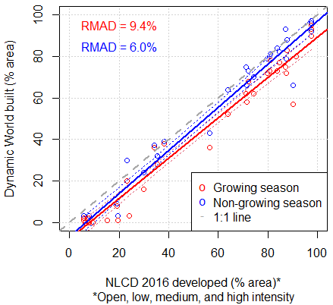
Figure S1. Comparison of Dynamic World 2016 built class and National Landcover Database (NLCD) developed classes as proportions of watershed area for the 37 currently monitored study watersheds, with 95% confidence intervals as dotted lines. RMAD: Relative mean absolute difference.

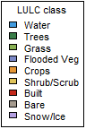
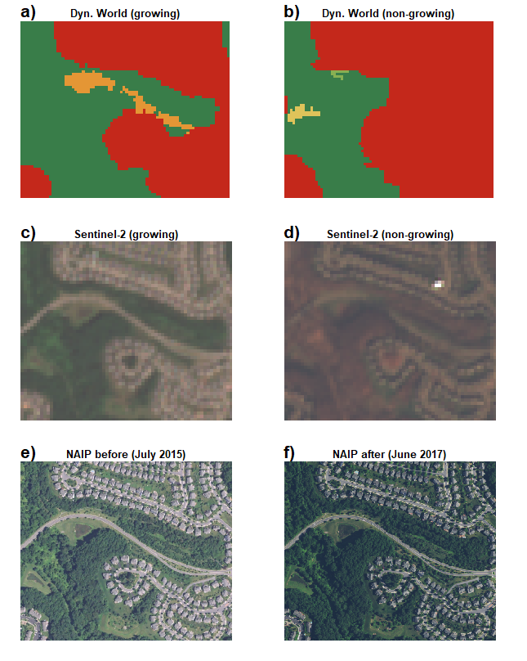
Figure S2. Visual comparison of LULC classification in a mixed landuse area showing (a,b) differences in Dynamic World data between growing (spring equinox 2016 to autumn equinox 2016) and non-growing (autumn equinox 2015 to spring equinox 2016) seasons. (c,d) Sentinel-2 imagery examples for growing (20 July, 2016) and non-growing (23 November, 2015) seasons. And, (e,f) before-and-after images from the National Agriculture Imagery Program (NAIP).

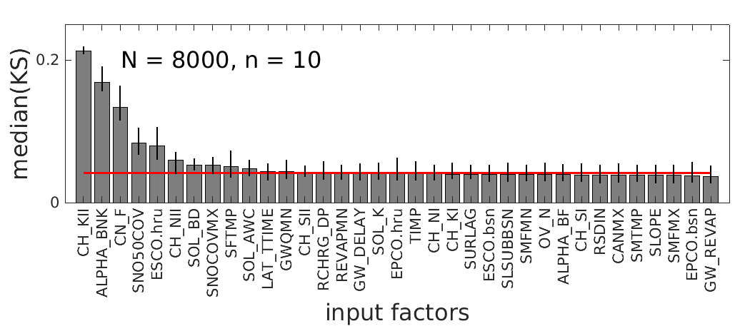
Figure S3. PAWN sensitivity analysis results ranking the SWAT parameters from most to least sensitive, using 8,000 samples (N) and conditioning intervals (n) of 10. The red line is the “dummy” parameter and bars are 95% confidence intervals. KS: Kolmogorov-Smirnov statistic. Higher median KS indicates higher sensitivity of SWAT model streamflow output to the parameter.

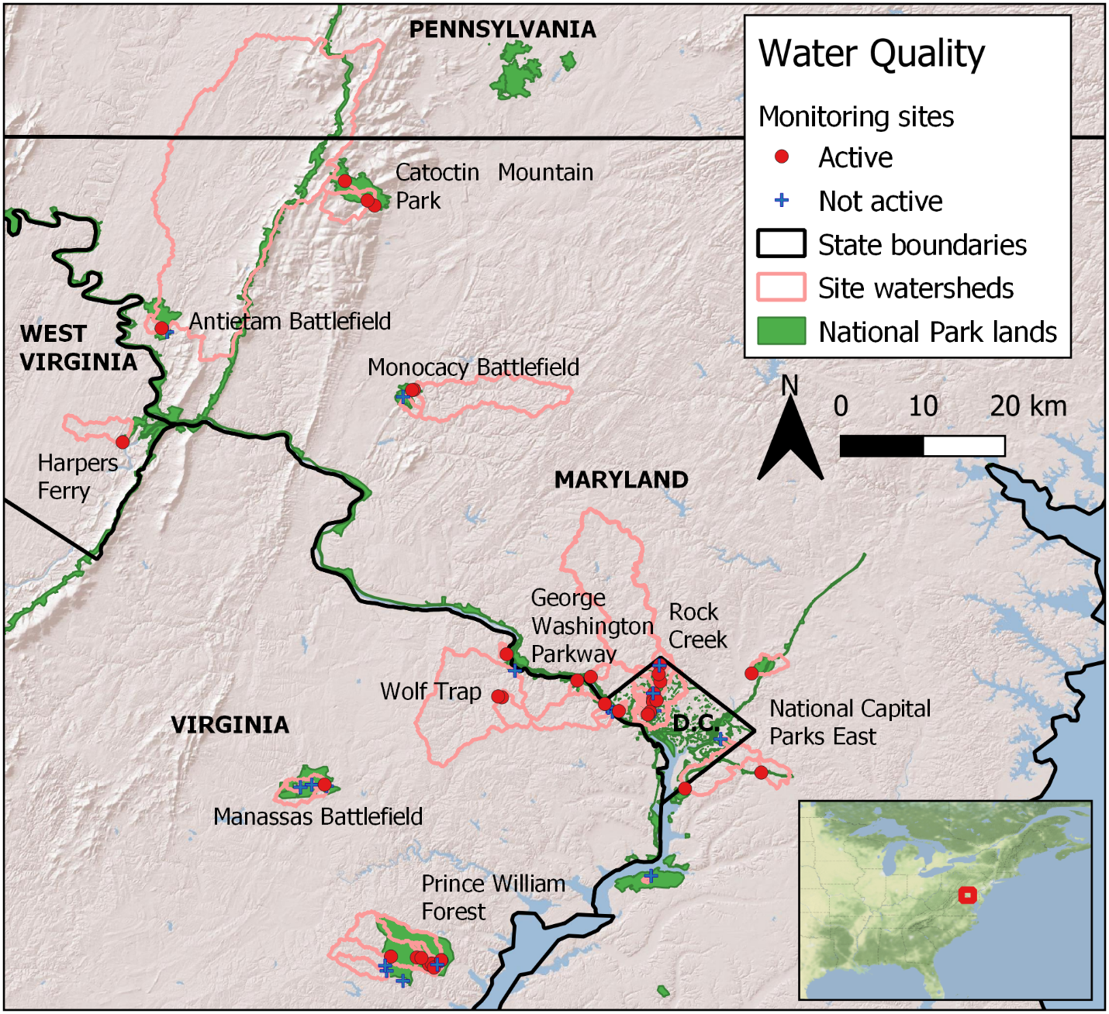
Figure S4. Study area map of National Park Service stream water quality monitoring sites in the National Capital Region Network, USA.

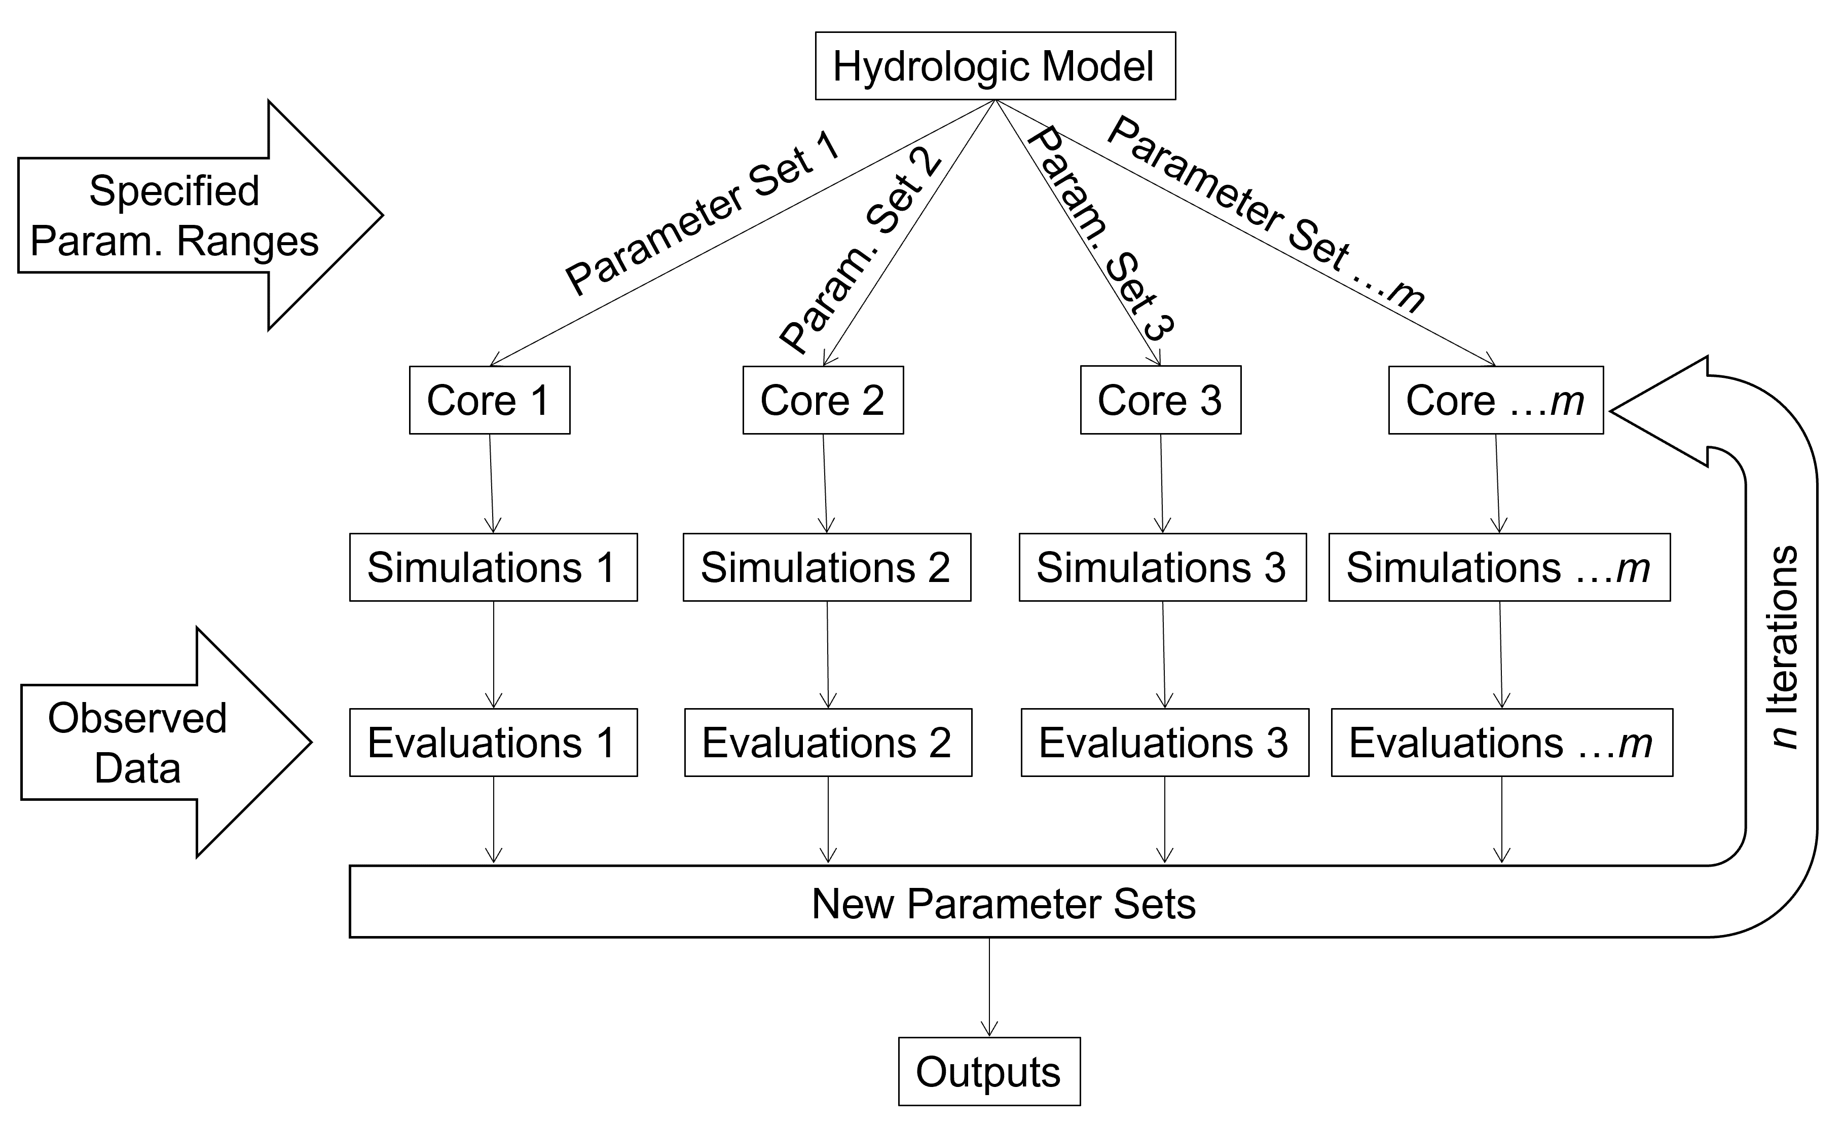
Figure S5. Flowchart of the AMALGAM calibration approach used in this study. Parameter sets are randomly generated within specified reasonable ranges of parameter values. Then, hydrologic models are distributed among multiple computer processing cores, simulations are run, and outputs are evaluated for performance against observed streamflow data. The algorithm learns from these outputs and generates new sets of parameter values. This process is iterated and optimal parameter sets are identified based on model evaluations.

Table S1. Proportions of watershed area that were urban (built or developed), agricultural (crops or pasture/hay), or forested LULC categories for the Bush Creek watershed (Case #2) and Difficult Run watershed (Case #3).
LULC type | Bush Creek (% area) | Difficult Run (% area)
Dyn. World growing season built | 16 | 44
Dyn. World non-growing season built | 24 | 54
NLCD 2016 open space developed | 18 | 30
NLCD 2016 low intensity developed | 7 | 17
NLCD 2016 medium intensity developed | 4 | 8
NLCD 2016 high intensity developed | 1 | 3
Dyn. World growing season crops | 14 | 0
Dyn. World non-growing season crops | 11 | 1
NLCD 2016 cultivated crops | 12 | 0
NLCD 2016 pasture/hay | 24 | 2
Dyn. World growing season trees | 56 | 54
Dyn. World non-growing season trees | 40 | 42
NLCD 2016 deciduous forest | 28 | 27
NLCD 2016 evergreen forest | 0 | 0
NLCD 2016 mixed forest | 3 | 8

Table S2. Regression models for specific conductance for the growing vs. non-growing seasons of Dynamic World 2016 built data and the NLCD 2016 developed classes model (df=35). LCI and UCI: upper and lower 95% confidence intervals of slope.
LULC | Intercept | Slope | R² | F | p-value | LCI | UCI | AIC
Dyn. World growing season | 154.71 | 6.39 | 0.65 | 66.19 | <0.001 | 4.80 | 7.99 | 486
Dyn. World non-growing season | 141.88 | 6.06 | 0.67 | 71.38 | <0.001 | 4.60 | 7.51 | 484
NLCD 2016 | 103.58 | 6.23 | 0.64 | 61.16 | <0.001 | 4.62 | 7.85 | 488

Table S3. Parameters used in SWAT model streamflow calibration for Difficult Run watershed, Virginia, USA, for models input with growing and non-growing season Dynamic World 2016 data, as well as the model with NLCD 2016 input.
Symbol | Definition † | Lower Limit | Upper Limit | Calibrated  Growing | Calibrated Non-growing | Calibrated NLCD 2016
CH_KII.rte | Channel hydraulic conductivity (mm/hour) (v) | 0.1 | 150 | 0.11 | 3.86 | 0.10
ALPHA_BNK.rte | Bank flow recession constant (v) | 0.01 | 1 | 0.14 | 0.27 | 1.00
CN_F.mgt | Runoff curve number (r) | -0.2 | 0.2 | -0.17 | -0.20 | -0.12
SNO50COV.bsn | Fraction of SNOCOVMX for 50% cover (v) | 0.01 | 0.8 | 0.03 | 0.03 | 0.02
ESCO.hru | Soil evaporation compensation coef. (v) | 0.01 | 1 | 0.01 | 0.03 | 0.20
CH_NII.rte | Manning's n value for main channel (v) | 0.01 | 0.30 | 0.30 | 0.30 | 0.30
SOL_BD.sol | Soil moist bulk density (r) | -0.2 | 0.2 | -0.19 | -0.01 | -0.19
SNOCOVMX.bsn | Snow depth above which is 100% cover (mm) (v) | 0 | 500 | 471 | 496 | 453
SFTMP.bsn | Snowfall temperature threshold (°C) (v) | 0 | 3 | 0.95 | 0.98 | 0.98
SOL_AWC.sol | Available Water Capacity (r) | -0.25 | 0.25 | -0.23 | -0.25 | -0.22
† A ‘v’ indicates that the original parameter from QSWAT was replaced by the calibrated value, in the same unit. An ‘r’ indicates that the original parameter was modified relatively, multiplying it by 1 + the calibrated value (e.g. a value of -0.2 reduces the original parameter by 20%).

Table S4. This LULC lookup table can be read into the QSWAT model so that SWAT uses the Dynamic World LULC image as the LULC input.
LANDUSE_ID | SWAT_CODE
0 | WATR
1 | FRST
2 | RNGE
3 | WETL
4 | AGRL
5 | RNGB
6 | UCOM
7 | SWRN
8 | WATR

