Supplemental Table S1: RT-PCR primer list
Gene name | Species | Forward Sequence | Reverse Sequence
Gapdh | Mouse | ACAACTTTGGCATTGTGGAA | GATGCAGGGATGATGTTCTG
Ubr5 | Mouse | CAATCACGCCGCGTTTCTT | GTCCTTCCTGGCCTAGAGGT
Cdc73 | Mouse | GGGGAAGCATCAACATCAGCA | GCTCTTTTGACTTGAGTAGACCG
Parp-1 | Mouse | ACACCACAAAACCTCAGCCA | ACAAACCACAAACAACCGGC
Pdgfrb | Mouse | TGTGCAGTTGCCTTACGACT | CGCTACTTCTGGCTGTCGAT
Lama3 | Mouse | GGCTACAGCAAGTCAGTCCA | CCGATCACCACACTGTCGAT
Areg | Mouse | GCCATCATCCTCGCAGCTAT | ATGTCATTTCCGGTGTGGCT
Itga2 | Mouse | TTAGATTCCCCAGCGCAGAC | TCACTTGAAGGCCCGGAAAA
Mylk | Mouse | CTGGGTTTCCAAGAGAGCCTTTA | CCTTCTTTGACGCAGAGGTTC
Ecm1 | Mouse | GAACAAAGAGAAGTGCAGCCCC | GGCAGGCGGGTCTATTTCCT
Vimentin | Mouse | TCCACACGCACCTACAGTCT | CCGAGGACCGGGTCACATA
GAPDH | Human | GAAGGTGAAGGTCGGAGTCA | TGGAATCATATTGGAACATGT
UBR5 | Human | CACCTTAGGAAGCCGCTGGA | CGATCCCGTCCTCTCCGAAT

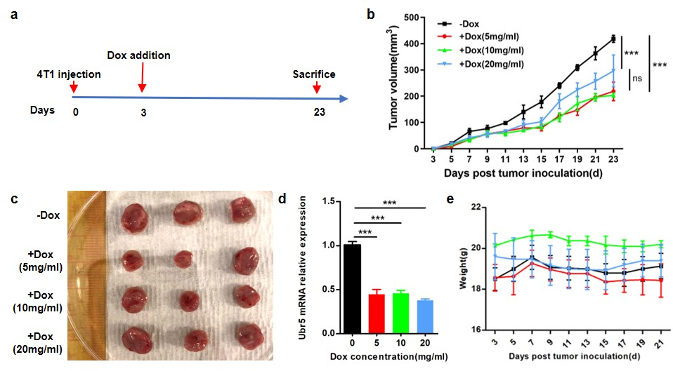
Supplementary Fig. S1: The effect of different concentration of doxycycline in downregulating the expression of the protein of Ubr5 in vivo. a. Schematic for knocking down Ubr5 expression with doxycycline. The BALB/c mice that injected with 5×10⁵ 4T1/Tet-shUbr5 cells into mammary pad were treated with 200ul different concentration of doxycycline(5mg/ml, 10mg/ml, 20mg/ml) daily by gavage from D3 and sacrificed on D23 for analyze. b. Tumor growth curve of four groups. Tumor size was measured every 2 days. c. Tumors from orthotopic model were resected on D23. d. The Ubr5 mRNA expression in 4T1 tumors bearing mice treated with different concentration of doxycycline was detected by real-time quantitative PCR and expressed as relative expression to that of GAPDH. e. The weight curve after doxycycline addition. Data represent mean ± SEM; *P <0.05; **P <0.01; ***P < 0.001.

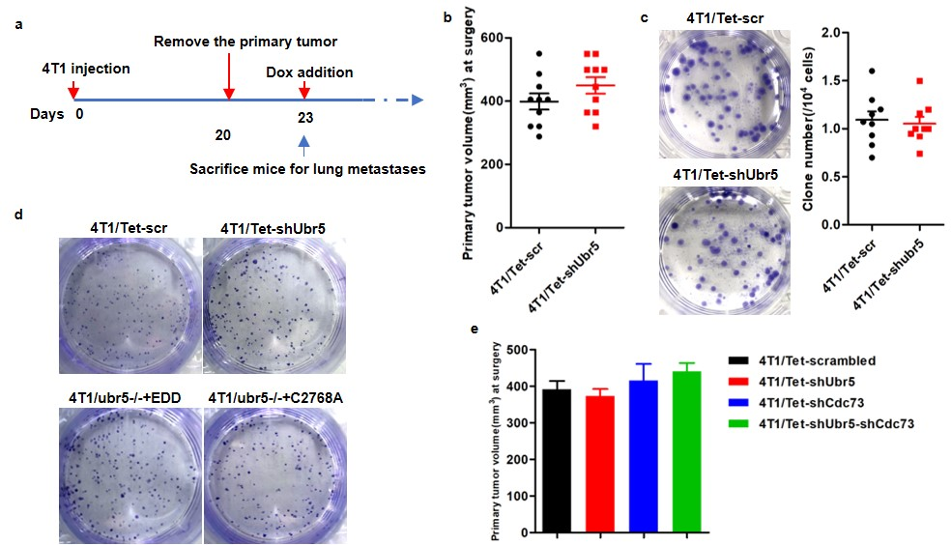
Supplementary Figure S2: The tumor volume and lung metastases before primary tumor removal surgery. a. Schematic for removing primary tumor and sacrificing mice for spontaneous metastases analyze. 5×10⁵ 4T1/Tet-scrambled, 4T1/Tet-shUbr5, 4T1/Ubr5-/-+EDD, 4T1/Ubr5-/-+EDD-C2768A, 4T1/Tet-shCdc73, 4T1/Tet-shUbr5-shCdc73 cells were s.c. injected into the mammary pad of BALB/c mice. The mice were sacrificed for 6-thioguanine clonogenicity assay on D23. b. Primary tumor volume were measured on the day of primary tumor removal surgery. c. The micro-metastases in the lung of mice bearing 4T1/Tet-scrambled and 4T1/Tet-shUbr5 cells before Dox addition were visualized and quantitated by the 6-thioguanine clonogenicity assay. d. The micro-metastases in the lung of mice were quantitated by the 6-thioguanine clonogenicity assay. e. The primary tumor volume was measured on D20 after tumor cells inoculation.

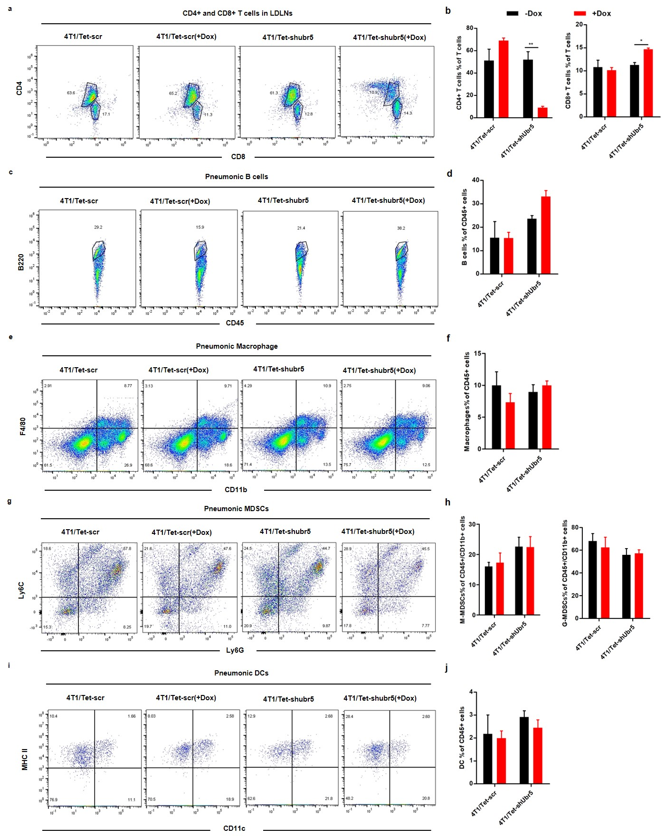
Supplementary Figure S3: Immunological alterations in mice with inducible knock-down Ubr5 expression by Tet-on system. 4T1 tumor cells were s.c. injected into the mammary pad of BALB/c mice and on day 35, mice were sacrificed and organs were harvest for FACS analysis after tumor removal on day 20. a, b. Representative FACS images(a) and quantification(b) of CD4 T cells and CD8 T cells in lung draining lymph nodes(LDLN). Representative FACS images of pneumonic B cells(c), macrophage(e), MDSCs(g) and DCs(i). Quantification of pneumonic B cells(d), macrophage(f), MDSCs(h) and DCs(j). In all cases, data are representative of at least three independent experiments using three to four mice per group. Data represent mean ± SEM; * P < 0.05; **P <0.01.

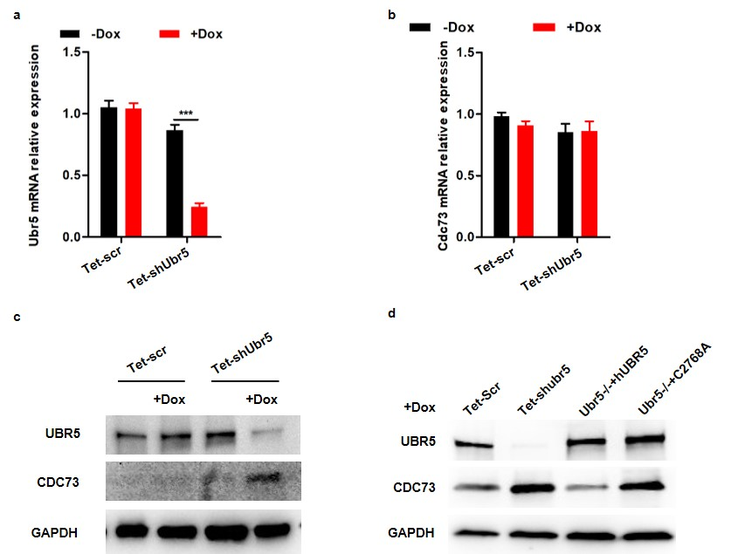
Supplementary Figure S4: The UBR5 and CDC73 mRNA and protein expression in 4T1 cells. a, b. Ubr5 mRNA(a) and cdc73 mRNA(b) expression of 4T1/Tet-scrambled(±Dox) and 4T1/Tet-shUbr5 (±Dox) cells was detected by real-time quantitative PCR. c. Protein expression of UBR5 and CDC73 in 4T1/Tet-scrambled(±Dox) and 4T1/Tet-shUbr5 (±Dox) cells analyzed by Western blot. d. Protein expression of UBR5 and CDC73 in 4T1/Tet-scrambled(+Dox), 4T1/Tet-shUbr5 (+Dox), 4T1/ubr5-/-+EDD (+Dox), 4T1/ubr5-/-+C2768A (+Dox). Data represent mean ± SEM; *P <0.05; **P <0.01; ***P < 0.001.

