Supplementary information

Effects of P limitation on the bioavailability of DOM released by marine heterotrophic prokaryotes.

Nawal Bouchachi^{1*}, Ingrid Obernosterer¹, Cécile Carpaneto Bastos¹, Franck Li¹, Lorenzo Scenna^{1,2}, Barbara Marie¹, Olivier Crispi¹, Philippe Catala¹, Eva Ortega-Retuerta^{1*}

¹CNRS/Sorbonne Université, UMR7621 Laboratoire d’Océanographie Microbienne, Banyuls sur Mer, France.
² Università Politecnica delle Marche, Ancona, Italy.

*Correspondence: nawal.bouchachi@obs-banyuls.fr, ortegaretuerta@obs-banyuls.fr

Supporting Material and methods

Samples for inorganic nutrients (11 ml, PO₄³⁻ ) were stored at -20 °C until analysis. Quantification was done using segmented flow analyzer (Bran+Luebbe) with colorimetric detection using methods described in [1]. The accuracy of the method was assessed 3 using reference material (Certipur, Merck). The precisions were in the range of 1–4%, and the detection limit was of 0.01 µmol L⁻¹.
NH₄ ⁺ (7 mL) samples were collected into pre-rinsed tubes and analyzed freshly by fluorometry using a DeNovix QFX Fluorometer.

1. Aminot A, Kérouel R (2007) Dosage automatique des nutriments dans les eaux marines. Méthodes en flux continu, Ifremer-Quae

Supporting figures and tables

Table S1 Summary of the biodegradation experiments: Date, treatments, DOM and inoculum sources, performed analyses
Experiment | Treatment | DOM source (90 % vol) | Inocula (10 % vol) | Abundance, DOC, FDOM, nutrients | 16s
S. alaskensis DOM biodegradation
S. alaskensis DOM biodegradation | B-DOM | DOM released by S. alaskensis growing under P-repletion | Surface Med Sea collected on Feb 2nd, 2021 filtered through 0.8 µm and concentrated from 2000 mL to 200 mL onto 0.2 µm filter
S. alaskensis DOM biodegradation | U-DOM | DOM released by S. alaskensis growing under P-limitation
S. alaskensis DOM biodegradation | IS-DOM | Surface Med Sea collected at the same date
S. alaskensis DOM biodegradation | G-DOM | IS-DOM + glucose (20 µM final concentration)
SOLA-fall DOM biodegradation
SOLA-fall DOM biodegradation | B-DOM | DOM released by SOLA-fall HP community growing under P-repletion | Surface Med Sea collected on Nov 24th, 2020 filtered through 0.8 µm and concentrated from 3000 mL to 250 mL onto 0.2 µm filter
SOLA-fall DOM biodegradation | U-DOM | DOM released by SOLA-fall HP community growing under P-limitation
SOLA-fall DOM biodegradation | IS-DOM | Surface Med Sea collected at the same date
SOLA-fall DOM biodegradation | G-DOM | IS-DOM + glucose (20 µM final concentration)
SOLA-Spring DOM biodegradation
SOLA-Spring DOM biodegradation | B-DOM | DOM released by SOLA-spring HP community growing under P-repletion | Surface Med Sea collected on may 18th, 2021 filtered through 0.8 µm and concentrated from 2000 mL to 200 mL onto 0.2 µm filter
SOLA-Spring DOM biodegradation | U-DOM | DOM released by SOLA-spring HP community growing under P-limitation
SOLA-Spring DOM biodegradation | IS-DOM | Surface Med Sea collected at the same date
SOLA-Spring DOM biodegradation | G-DOM | IS-DOM + glucose (20 µM final concentration)

Table S2 Inorganic nutrients values at T₀ and T_{f} expressed in µmole L⁻¹: means and standards deviation of the triplicates (at T₀ there was only one replicate measured)
DOM source | Treatment | PO₄³⁻ |  | NH₄⁺
DOM source | Treatment | T₀ | T_{f} | T₀ | T_{f}
S. alaskensis | B-DOM | 4.69 | 4.08 ± 0.11 | 20.68 | 17.26 ± 1.78
S. alaskensis | U-DOM | 2.29 | 1.75 ± 0.05 | 23.81 | 19.03 ± 0.83
S. alaskensis | G-DOM | 2.37 | 2.06 ± 0.02 | 14.55 | 13.43 ± 0.47
S. alaskensis | IS-DOM | 2.4 | 2.18 ± 0.01 | 16.59 | 14.6 ± 0.22
SOLA-fall | B-DOM | 3.53 | 3.73 ± 0.08 | 21.54 | 18.47 ± 0.24
SOLA-fall | U-DOM | 1.87 | 1.85 ± 0.54 | 15.91 | 20.35 ± 0.2
SOLA-fall | G-DOM | 2.12 | 1.83 ± 0.03 | 18.36 | 13.76 ± 0.32
SOLA-fall | IS-DOM | 2.08 | 1.99 ± 0.04 | 14.39 | 14.24 ± 0.68
SOLA-spring | B-DOM | 4.37 | 3.93 ± 0.04 | 30.22 | 22.92 ± 0.46
SOLA-spring | U-DOM | 2.15 | 1.7 ± 0.02 | 32.65 | 27.5 ± 0.62
SOLA-spring | G-DOM | 2.31 | 1.77 ± 0.04 | 15.18 | 10.55 ± 0.66
SOLA-spring | IS-DOM | 2.2 | 1.95 ± 0.04 | 14.13 | 11.59 ± 0.55

Table S3 Repeated two ways anova results, DFn Degrees of Freedom in the numerator, DFd Degrees of Freedom in the denominator, SSn Sum of Squares in the numerator, SSd Sum of Squares in the denominator, F F-value, p p-value (probability of the data given the null hypothesis), p<0.05 Highlights p-values less than the traditional alpha level of 0.05, ges Generalized Eta-Squared measure of effect size
Effect | DFn | DFd | F | p | p<0.05 | ges
 | S. alaskensis
Treatment | 3 | 6 | 11.941 | 0.006 | * | 0.769
time | 5 | 10 | 150.076 | 4.54E-09 | * | 0.763
Treatment:time | 15 | 30 | 8.276 | 5.75E-07 | * | 0.560
 | SOLA-fall
Treatment | 3 | 6 | 552.913 | 1.02E-07 | * | 0.978
time | 5 | 10 | 39.762 | 2.78E-06 | * | 0.795
Treatment:time | 15 | 30 | 26.566 | 2.98E-13 | * | 0.884
 | SOLA-spring
Treatment | 3 | 6 | 1326.765 | 7.46E-09 | * | 0.975
time | 2 | 4 | 1416.377 | 1.99E-06 | * | 0.984
Treatment:time | 6 | 12 | 47.867 | 1.09E-07 | * | 0.95

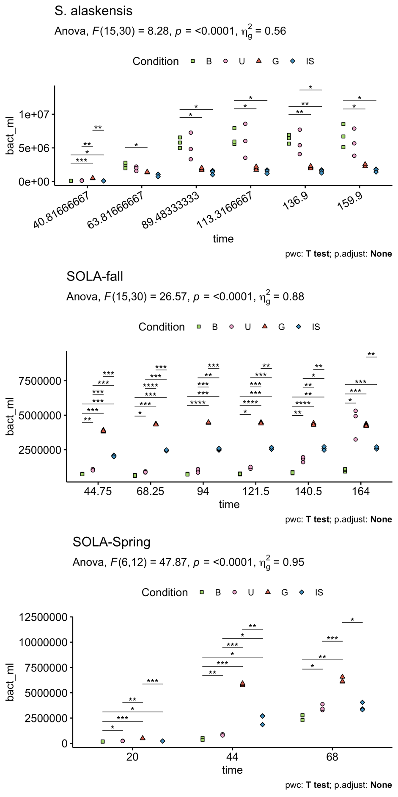
Fig. S1 pairwise t-test post hoc results on HP cell abundance

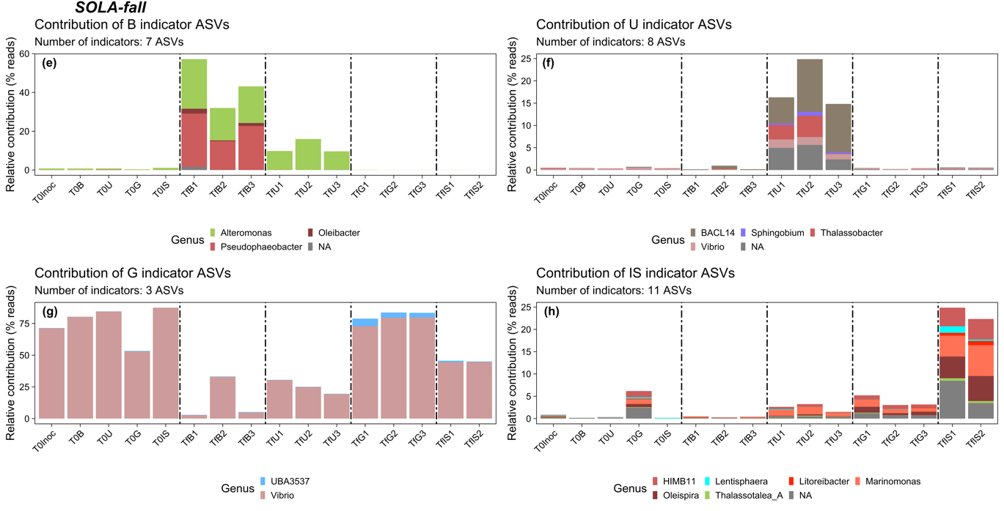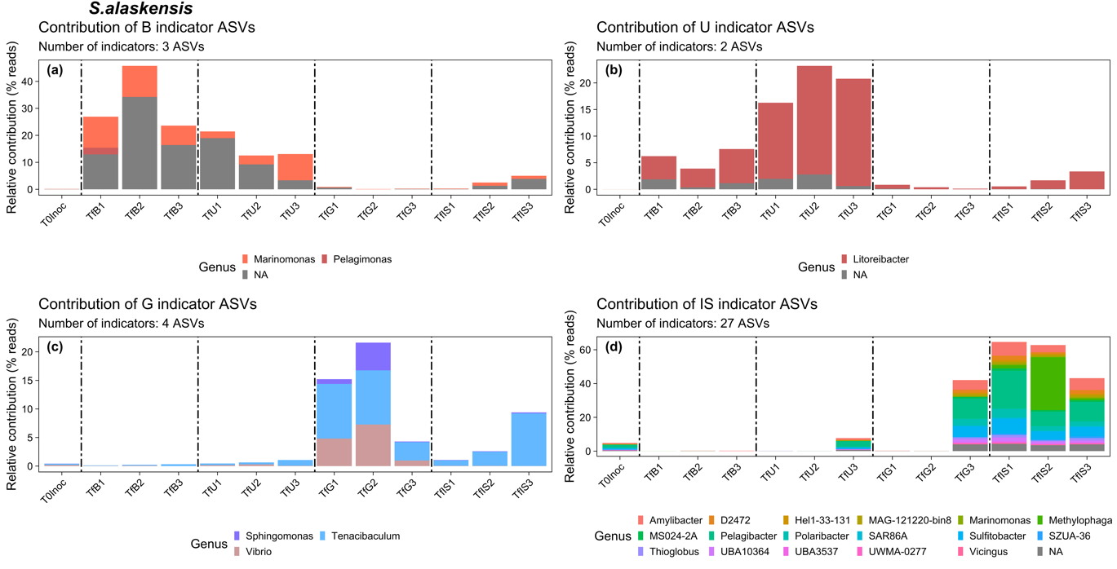
Fig. S2 Contribution of B-DOM, U-DOM, G-DOM and IS-DOM indicator ASVs to T₀ and T_{f} communities composition of the different treatments and their taxonomy at the genus level, in S. alaskensis DOM degradation experiment (a-d) and SOLA-fall DOM degradation experiment (e-h)

