Supporting Information
Neutrophil-targeted Mn₃O₄ nanozyme treats myocardial ischemia reperfusion injury by scavenging reactive oxygen species
Fu-hang Wang^{1#}, Dong-jian Han^{1#}, Zhen-tao Qiao², Yuan-song Zhuang¹, Yi Zhang¹, Qing-jiao Jiang¹, Miao-miao Liu¹, Quan-xu An¹, De-liang Shen¹()

¹Department of Cardiology, The First Affiliated Hospital of Zhengzhou University, Zhengzhou, 450052, China.
²Department of Vascular and Endovascular Surgery, The First Affiliated Hospital of Zhengzhou University, Zhengzhou, 450052, China.

#These authors contributed equally to this work.
()Corresponding author. E-mail address: dlshen@zzu.edu.cn (DL. Shen)

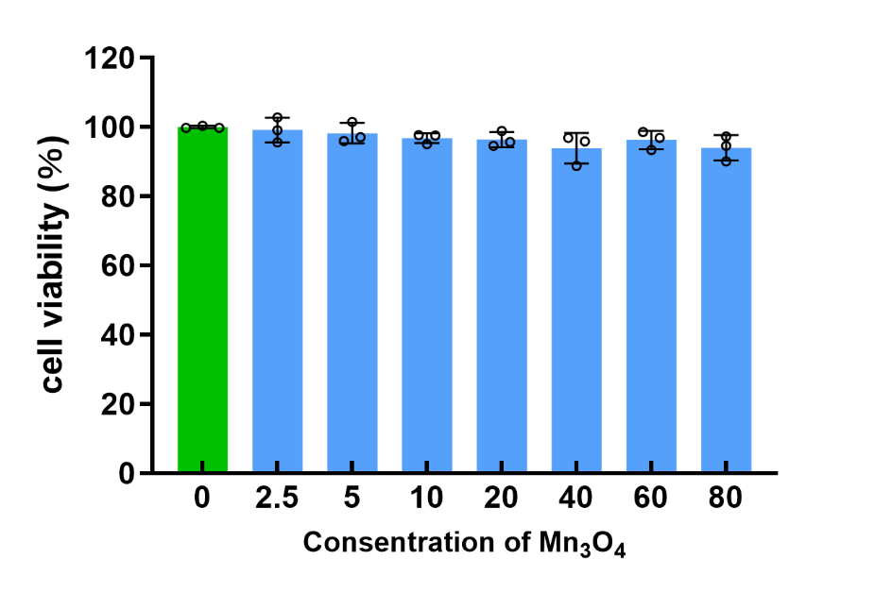
Figure S1. The cytotoxicity of Mn₃O₄ was assessed by CCK-8.
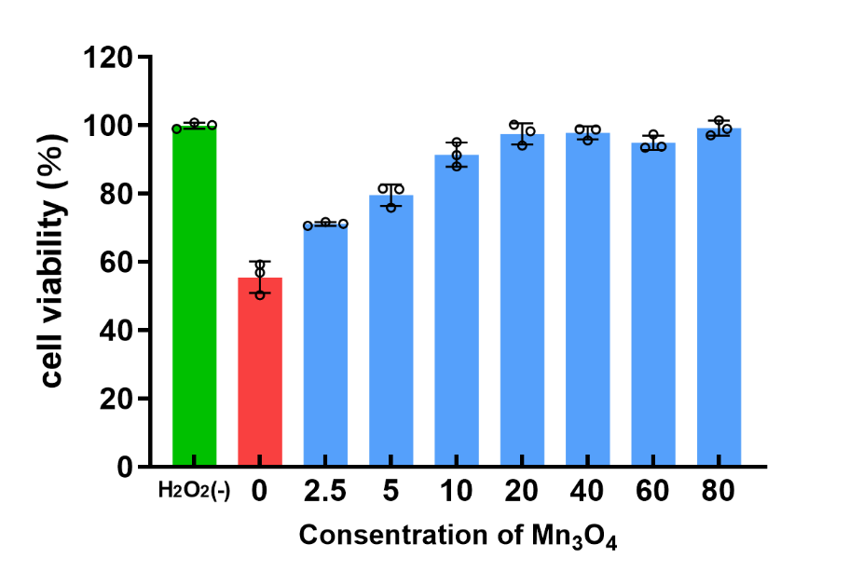
Figure S2. The protective effect of Mn₃O₄ to H₉C₂ cell.
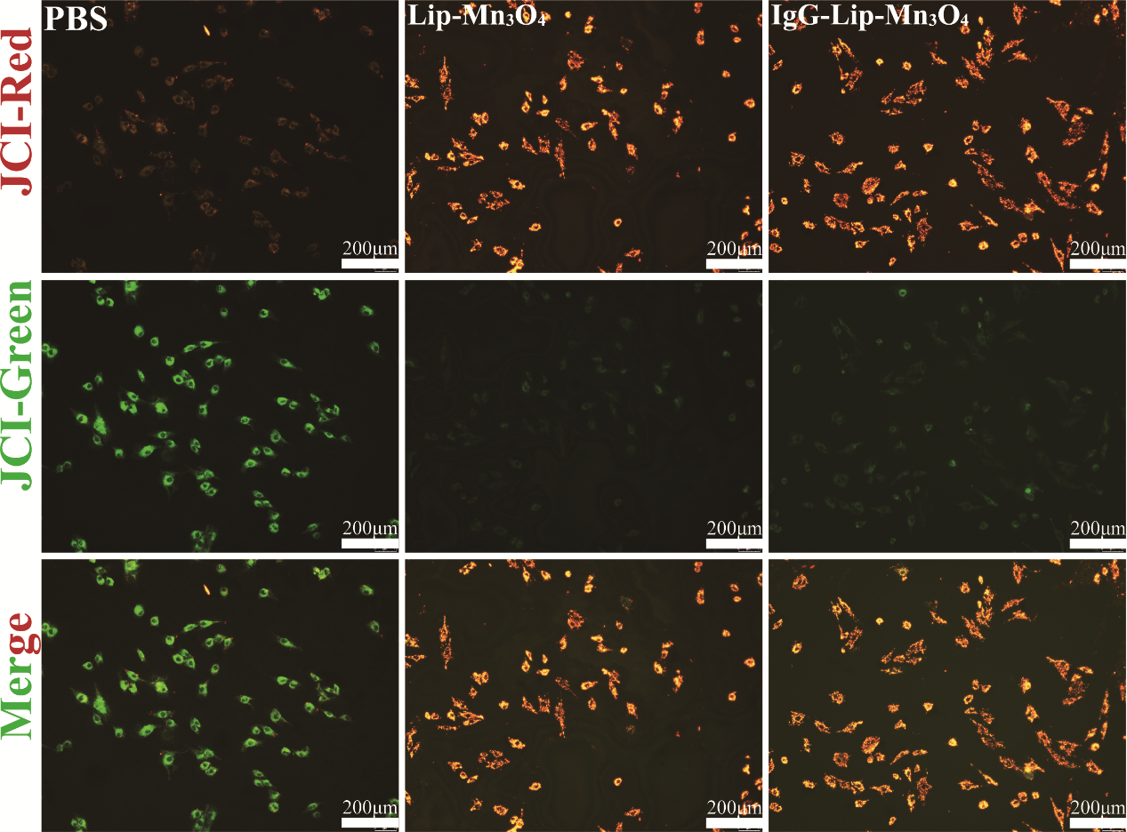
Figure S3. Mitochondrial membrane potential was detected by JC-1 kit. scale bar: 200 μm n=6
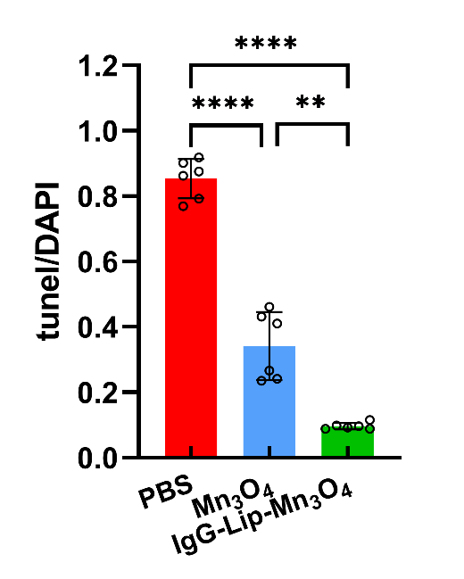
Figure S4. Quantification analysis of apoptosis ratio of myocardial tissue with different treatments.
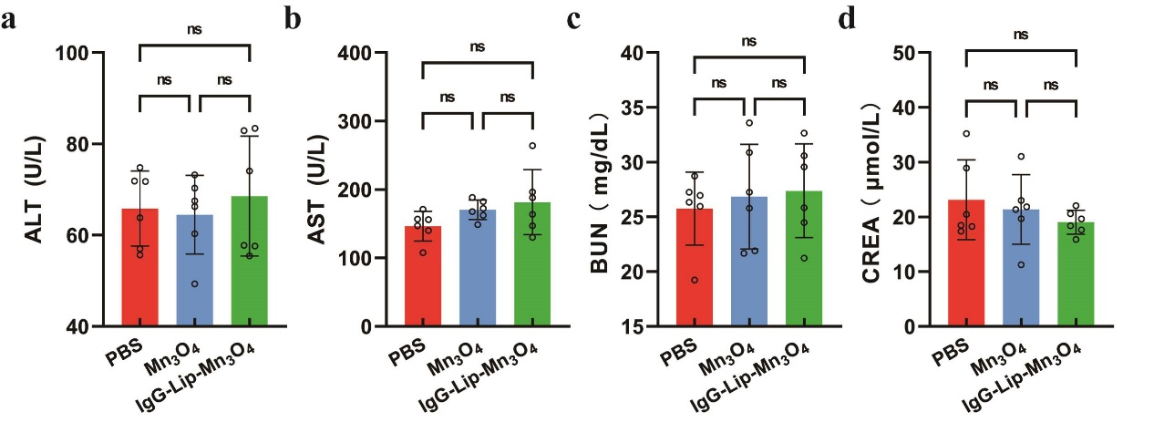
Figure S5. Quantification analysis of liver and kidney function of mice with different treatments in 24 h.
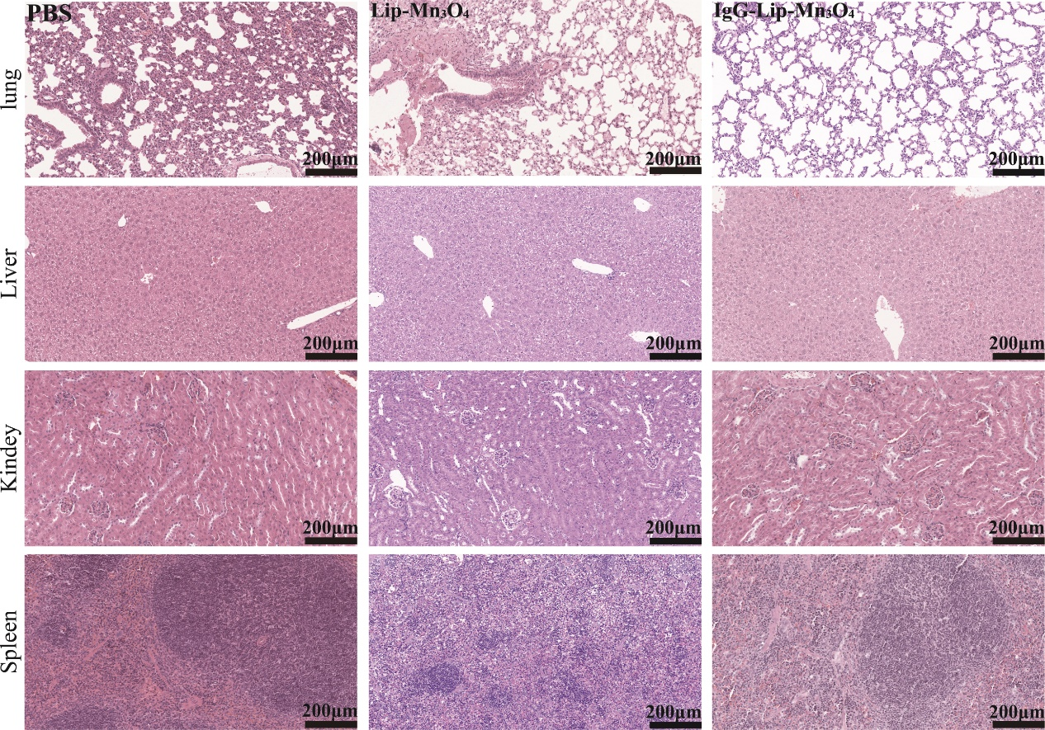
Figure S6. HE staining of major organs of mice 24 h after injection with PBS, Mn₃O₄ or IgG-Lip-Mn₃O₄.

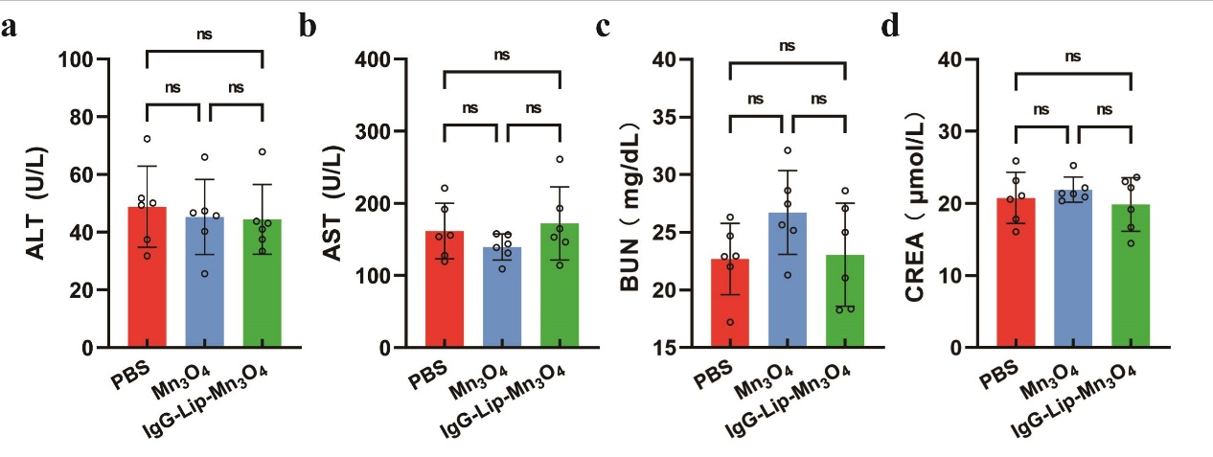
Figure S7. Quantification analysis of liver and kidney function of mice with different treatments in 28 d.
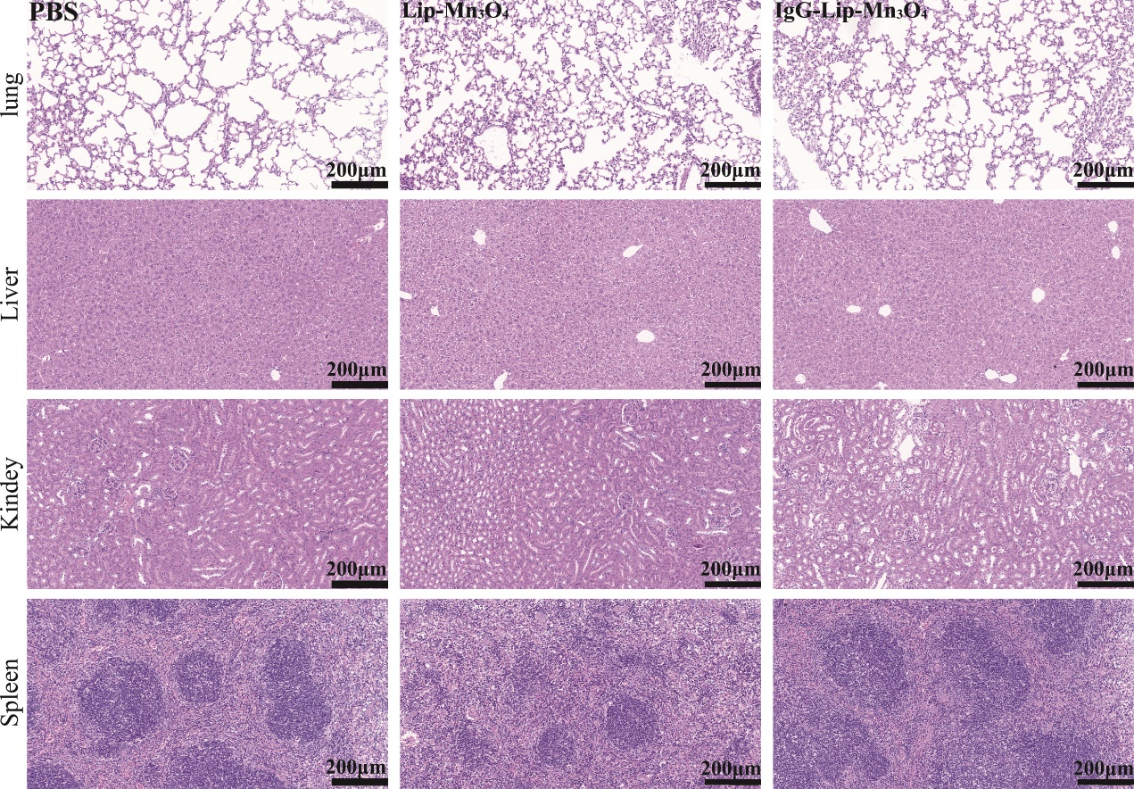
Figure S8. HE staining of major organs of mice 28 d after injection with PBS, Mn₃O₄ or Lip-Mn₃

