Supplementary Information

- Geographical settings
The Madang profile (E116°39′44″，N29°59′29″) is located in Madang Town, Pengze County, Jiujiang City, Jiangxi Province, about 850 km from the Loess Plateau in the northwest and 340 km from the Xiashu profile in the northeast. The Hukou-Tongling reach of the lower Yangtze River, located between the Dabie Mountain and the mountains in southern Anhui, forms a southwest-northeast oriented valley, about 200 km long and 60 km wide ( Fig. S1a). Pengze County is located on the south bank of the Yangtze River in this reach, and the terrain rises gradually from northwest to southeast. The northwestern zone is an alluvial plain along the river, with an average elevation of ~20 m. Sand hills are distributed in some areas along the river. In the central zone, there are hills and basins with low topographic relief, and loess is accumulated in the piedmont and basins, and lakes are formed in the depression of the basins. In the southeast zone, there are low and middle mountains, with more gullies and river valleys, and eluvium is widely distributed (Fig. S1b).
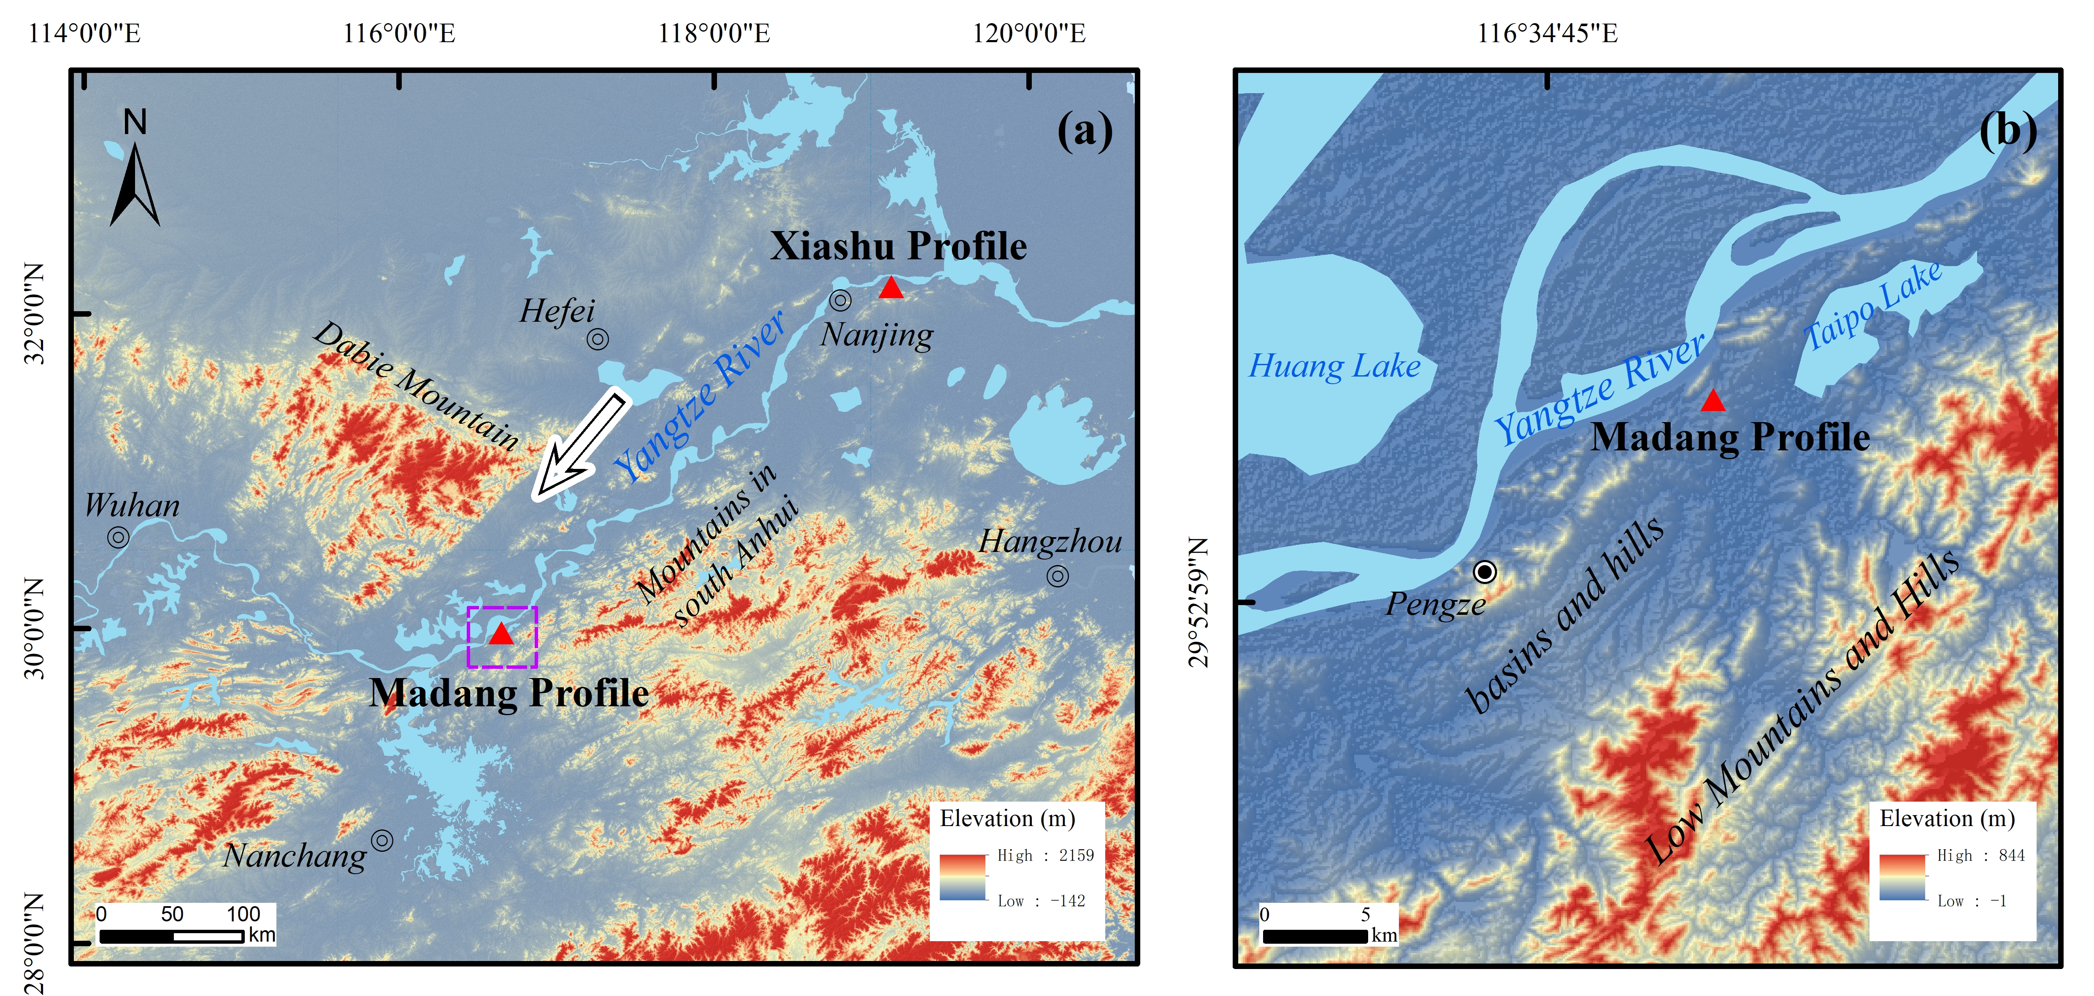
Fig. S1 Terrain in the lower reaches of Yangtze River (a) and nearby Madang profile (b). The arrow indicates the direction of the dominant wind. The purple rectangle in (a) designates the range of (b).

The intermittently distributed hills along the Yangtze River in Pengze County are about 100-300 m high, surrounding a basin about 5 km wide and 20 km long to its southeast, and the Madang profile is located within this basin. To the northwest of the profile is Huang Mountain (about 100 m a.s.l.), which is about 2 km long and 0.5 km wide, and to the northeast of the profile is Beng Mountain (about 100 m a.s.l.), which is about 3 km long and 1.5 km wide, and the two mountains are about 0.8 km apart. Madang profile is located to the southeastern of Huang Mountain, about 0.3 km away, 2 km away from Huang Mountain, and 1 km away from the Yangtze River, with an elevation of about 30 m at the top of this profile. The upper part of the profile is 13.2 m thick, being exposed in a burrow pit, and the lower part is a 2.7 m long drilling core, with a total thickness of 15.9 m.
This region has a subtropical monsoon climate, which is influenced by the East Asian monsoon circulation and the subtropical high pressure zone in summer and by the cold high pressure of Mongolia and Siberia in winter. Influenced by the Yangtze River valley extending northeastward, northeasterly prevails near the surface. The mean annual temperature is 14-17°C, the mean annual precipitation is 1100-1500 mm, the mean annual sunshine duration is 1917 hours, and the annual solar radiation is 113 kcal/cm². The ratio of precipitation during summer half year (April to September) to annual precipitation is 67% (Fig. S2).
Fig. S2 Monthly mean temperature and precipitation (1981-2000) at meteorological station of Pengze (http://data.cma.cn/)

- Section and sampling
The eolian sediments in Madang profile are mainly characterised by brownish-yellow in color, massive structure and vertical joints developed on outcrops, which are typical characteristics of loess. According to the sedimentary characteristics, the strata of Madang profile can be divided into eight layers from top to bottom, which roughly correspond to the stratigraphic unit L1, S1, L2, S2, L3, S3, L4 of the Loess Plateau (Fig. S3). The loess unit is generally brownish yellow, and the paleosol unit is yellowish brown, forming a typical loess-paleosol sequence (Tab. S1).
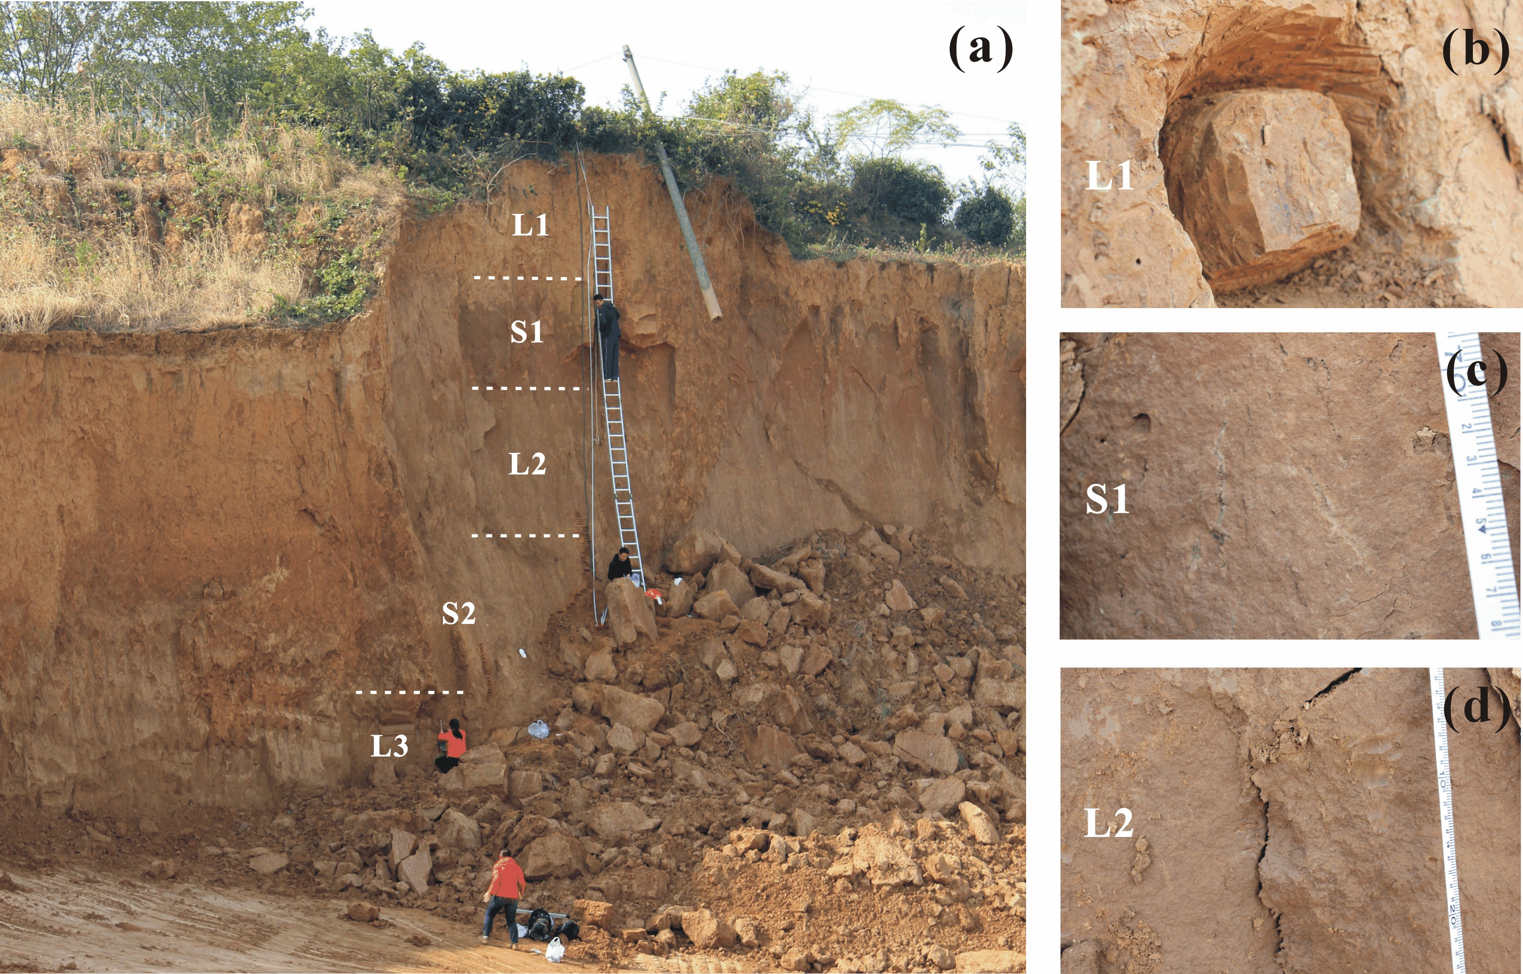
Fig. S3 Outcrops of Madang profile and lithology of aeolian sediments. (a) Stratigraphic subdivision following the scheme used in the Loess Plateau. The white dashed line represents the stratigraphic boundary. The visible strata thickness is 13.2 m; (b)-(d) the close-up photos of unit L1, S1 and L2, respectively.

Tab. S1 Stratigraphic subdivision and lithological description of Madang profile
Depth (m) | Unit | Colour | Description
0.0-2.5 | L1 | Grayish yellow | Silt, loose, massive, plant root
2.5-4.75 | S1 | Slight yellowish brown | Silt, hard and dense, massive, worm boring
4.8-7.6 | L2 | Slight brownish yellow | Silt, massive, unobvious Fe-Mn coating
7.65-8.95 | S2 | Slight yellowish brown | Silt, massive, unobvious Fe-Mn coating
9.0-10.1 | L3 | Slight brownish yellow | Silt, massive, few caesious mottle, unobvious Fe-Mn coating
10.15-11.1 | S3 | Slight brownish red | Silt, massive, obvious Fe-Mn coating in the middle part, few grey mottle in the middle and lower part
11.15-15.9 | L4 | Slight brownish yellow | Silt, loose, massive, few grey mottle

The sampling interval is 5 cm for the upper part (<13.2 m) and 10 cm for the lower part (>13.2 m), and each sample is ~2 cm thick. A total of 291 bulk samples were collected for measurements of particle size, magnetic susceptibility (MS), DCB-extractable iron (FeD), redness and hematite content. In addition, 5 samples were collected for Optically Stimulated Luminescence (OSL) dating.

Methods
  - Grain size analysis
2 g of loess sample is placed in a beaker, 10 ml of 10% H₂O₂ is added and heated, 10 ml of 10% HCl is further added and boiled. The beaker is filled with water and set for 12 hours before the supernatant is decanted. 10 ml of 0.05 ml/L (NaPO₃)₆ dispersant is added, the sample is shaken with an ultrasonic cleaner for 15 minutes before it is tested on Mastersizer2000 laser particle sizer manufactured by Malvern Panalytical. The particle size measurements were done at the Laboratory of Surface Processes and Environment Evolution, Nanjing University.

  - Redness measurement
The redness of the sample was tested using a Konica-Minolta CM-700D spectrophotometer with a wavelength range of 400-700 nm and a test interval of 10 nm. The test steps were: (1) the sample was dried naturally and ground to less than 200 mesh; (2) the spectrophotometer was calibrated with a standard calibration white plate (CM-A177, standard deviation of spectral reflectance <0.1% and standard deviation of chromaticity ΔE*ab <0.04); (3) an appropriate amount of sample was placed on the glass disc and flatten; (4) the redness (a*) value of the sample is obtained by three random measurements on the sample surface with the instrument. The redness is masured in Institute of Geology, Chinese Academy of Geological Sciences.

  - Hematite measurement
The hematite content is measured by Diffuse Reflectance Spectroscopy (DRS) method (Ji et al., 2002). Before performing DRS tests on the samples, the interference of matrix effects needs to be eliminated, and we use the DCB dissolution method to pretreat the samples. The DCB treatment is performed as follows: (1) a total of 21 samples of different depths are mixed and ground to 200 mesh and placed in a centrifuge cup; (2) heat the samples to 75°C, add 45 ml of 0.3 N citrate and 1 N bicarbonate 5 ml and stir well; (3) add excess sodium dithionite and stir for 10 min; (4) centrifuge the cup at 2000 r/min for 5 min; (5) repeat the steps of (2)-(4); (6) add 70 ml of distilled water to ultrasonically disperse the sample and centrifuge at 5000 r/min for 30 min; (7) regrind the sample to 200 mesh to obtain the natural matrix.
Synthetic hematite and geothite standard minerals are added to the natural matrix in different proportions to produce a total of 26 standard samples, including one pure matrix sample, eight pure hematite samples, eight pure geothite samples, and nine mixed hematite and geothite samples (Tab. S2). The hematite standard mineral is pure red nanoscale hematite (R4399) from Bayferrox, and the geothite standard mineral is pure yellow nanoscale geothite (SY610) from Hover Color.
The samples are first ground to less than 200 mesh using an agate mortar, placed on glass slides, diluted with distilled water into a slurry and spread evenly, dried at low temperature (<40°C), and scanned spectroscopically using a Lambd 900 UV/VIS/NIR spectrophotometer from Perkin-Elmer, with a measurement interval of 2 nm, the measured band is 400-700 nm, and the visible band is divided into six different color bands, violet = 400-450 nm, blue = 450-490 nm, green = 490-560 nm, yellow = 560-590 nm, orange = 590-630 nm, red = 630-700 nm.
Stepwise multiple linear regression analysis is performed on the added hematite content and reflectance of each color band (Tab. S2), which results in a calibration equation: Hematite%= 8.88-0.329×green-0.055×red. Sample pretreatment and measurements are done at the Ministry-of-Education Key Laboratory of Supergene Geochemistry, Nanjing University.

Tab. S2 Percent reflectance in standard color bands of calibration samples
Sample | violet | blue | green | yellow | orange | red | Goethite (%) | Hematite (%)
BY 01 | 10.32 | 8.51 | 16.85 | 10.78 | 18.64 | 34.90 | 0.20 | 1.80
BY 02 | 9.95 | 8.45 | 17.19 | 10.97 | 18.69 | 34.76 | 0.40 | 1.60
BY 03 | 9.68 | 8.49 | 17.85 | 11.25 | 18.59 | 34.14 | 0.60 | 1.40
BY 04 | 9.46 | 8.48 | 18.29 | 11.44 | 18.54 | 33.78 | 0.80 | 1.20
BY 05 | 9.08 | 8.36 | 18.73 | 11.72 | 18.57 | 33.53 | 1.00 | 1.00
BY 06 | 8.92 | 8.35 | 19.34 | 11.97 | 18.47 | 32.96 | 1.20 | 0.80
BY 07 | 8.66 | 8.33 | 20.15 | 12.27 | 18.29 | 32.30 | 1.40 | 0.60
BY 08 | 8.36 | 8.23 | 20.85 | 12.60 | 18.18 | 31.77 | 1.60 | 0.40
BY 09 | 7.95 | 8.07 | 21.76 | 13.04 | 18.04 | 31.15 | 1.80 | 0.20
BY 10 | 12.92 | 12.04 | 24.34 | 11.02 | 14.59 | 25.10 | 0.10 | 0.00
BY 11 | 12.38 | 11.66 | 24.35 | 11.24 | 14.85 | 25.51 | 0.20 | 0.00
BY 12 | 11.33 | 10.98 | 24.32 | 11.65 | 15.37 | 26.34 | 0.40 | 0.00
BY 13 | 10.44 | 10.32 | 24.17 | 12.04 | 15.87 | 27.16 | 0.60 | 0.00
BY 14 | 9.81 | 9.80 | 23.98 | 12.34 | 16.26 | 27.81 | 0.80 | 0.00
BY 15 | 9.43 | 9.49 | 23.86 | 12.54 | 16.51 | 28.18 | 1.00 | 0.00
BY 16 | 8.55 | 8.71 | 23.40 | 13.01 | 17.13 | 29.20 | 1.50 | 0.00
BY 17 | 8.10 | 8.18 | 22.93 | 13.33 | 17.56 | 29.89 | 2.00 | 0.00
BY 18 | 13.55 | 12.09 | 23.38 | 10.81 | 14.70 | 25.47 | 0.00 | 0.10
BY 19 | 13.35 | 11.72 | 22.57 | 10.84 | 15.13 | 26.39 | 0.00 | 0.20
BY 20 | 12.96 | 11.07 | 21.24 | 10.86 | 15.86 | 28.01 | 0.00 | 0.40
BY 21 | 12.36 | 10.44 | 20.12 | 10.90 | 16.56 | 29.63 | 0.00 | 0.60
BY 22 | 11.91 | 9.95 | 19.25 | 10.90 | 17.10 | 30.89 | 0.00 | 0.80
BY 23 | 11.73 | 9.69 | 18.69 | 10.82 | 17.39 | 31.68 | 0.00 | 1.00
BY 24 | 11.10 | 9.00 | 17.31 | 10.65 | 18.14 | 33.79 | 0.00 | 1.50
BY 25 | 10.81 | 8.65 | 16.50 | 10.42 | 18.51 | 35.12 | 0.00 | 2.00
BY 26 | 13.81 | 12.60 | 24.39 | 10.70 | 14.14 | 24.37 | 0.00 | 0.00

- Results
  - Grain size distribution
The representative particle size frequency distribution curves from each unit of Madang profile are relatively consistent, and all show a morphological asymmetric distribution, with silts as the main component, and none of them show a coarse tail.
The particle size frequency distribution curves of Madang samples show there exist three peaks, corresponding mode size is ~0.9 μm, ~7 μm, ~30 μm respectively. Each peak represents one component which corresponds to a different dynamic process. The <1 μm particles may be the pedogenic component (Sun, 2006), the 1-10 μm particles are the distal component, and the 16-32 μm particles are the proximal component (Fig. S4). Therefore, the Madang loess has typical characteristics of dust sediments, in accordance with the typical loess of the Loess Plateau.
Fig. S4 Grain size frequency curve of samples from different units of Madang profile

  - OSL ages
Tab. S3 OSL dating results of quartz of Madang profile
Sample | Depth (cm) | Grain size (μm) | Water content (%) | U (ppm) | Th (ppm) | K (%) | Dose rate (Gy/ka) | De (Gy) | Age (ka) | Aliqout number
MD-P-1.5 | 245 | 4-11 | 17.4 | 3.21±0.12 | 13.90±0.38 | 1.71±0.05 | 3.56±0.25 | 271±5 | 76.3±5.5 | 6
MD-P-4.5 | 350 | 4-11 | 17.6 | 2.44±0.10 | 15.40±0.42 | 1.96±0.06 | 3.65±0.25 | 313±7 | 85.6±6.0 | 6

  - Time scale and proxy indicators

Tab. S4 Tie points between the depth of Madang profile and the age of Luochuan profile (Lu et al., 1999)
Depth (cm) | 100 | 260 | 460 | 755 | 820 | 945 | 1020 | 1320 | 1540
Age (ka) | 56 | 78 | 128 | 186 | 195 | 233 | 242 | 281 | 334

Tab. S5 Ages and proxy indicators for samples at different depth
Depth  (cm) | Age  (ka) | MS  (10⁻⁸m³kg⁻¹) | FeD  (%) | Hm  (%) | Mean grain size  (μm） | a*
5 | 42.9 | 29.2 | 1.60 | 0.23 | 12.9 | 6.82
10 | 43.6 | 27.9 | 1.82 | 0.27 | 13.1
15 | 44.3 | 29.4 | 2.08 | 0.28 | 13.0
20 | 45.0 | 25.8 | 1.34 | 0.34 | 12.5 | 8.18
25 | 45.7 | 33.6 | 2.24 | 0.43 | 12.3
30 | 46.4 | 31.9 | 2.17 | 0.42 | 11.6
35 | 47.1 | 33.1 | 2.76 | 0.43 | 11.3
40 | 47.8 | 40.2 | 2.51 | 0.41 | 11.2
45 | 48.4 | 40.7 | 2.78 | 0.44 | 10.7
50 | 49.1 | 40.0 | 2.02 | 0.47 | 10.8 | 9.08
55 | 49.8 | 43.1 | 2.16 | 0.52 | 10.7
60 | 50.5 | 38.2 | 2.26 | 0.53 | 11.0
65 | 51.2 | 37.3 | 1.80 | 0.49 | 11.1
70 | 51.9 | 48.3 | 2.34 | 0.56 | 11.7
75 | 52.6 | 41.0 | 2.52 | 0.46 | 10.6
80 | 53.3 | 39.9 | 2.49 | 0.41 | 11.1 | 8.35
85 | 53.9 | 45.0 | 2.77 | 0.44 | 11.1
90 | 54.6 | 46.1 | 1.89 | 0.45 | 11.5
95 | 55.3 | 39.3 | 2.13 | 0.45 | 11.5
100 | 56.0 | 48.8 | 2.26 | 0.50 | 10.9 | 9.1
105 | 56.7 | 42.4 | 1.87 | 0.50 | 11.2
110 | 57.4 | 36.1 | 1.86 | 0.30 | 11.1
115 | 58.1 | 43.7 | 2.76 | 0.45 | 11.1
120 | 58.8 | 40.2 | 2.97 | 0.44 | 11.5
125 | 59.4 | 39.5 | 2.17 | 0.30 | 11.3
130 | 60.1 | 37.8 | 2.35 | 0.35 | 11.0 | 8.12
135 | 60.8 | 42.4 | 2.54 | 0.31 | 10.6
140 | 61.5 | 35.4 | 2.28 | 0.27 | 11.5
145 | 62.2 | 35.8 | 1.92 | 0.23 | 11.3
150 | 62.9 | 30.6 | 1.81 | 0.20 | 11.6
155 | 63.6 | 37.4 | 1.82 | 0.23 | 12.0
160 | 64.3 | 34.4 | 1.80 | 0.27 | 11.9
165 | 64.9 | 38.5 | 1.71 | 0.28 | 11.4
170 | 65.6 | 34.7 | 1.51 | 0.19 | 11.6
175 | 66.3 | 32.0 | 1.91 | 0.22 | 12.0
180 | 67.0 | 32.1 | 2.12 | 0.22 | 11.9
185 | 67.7 | 34.7 | 1.81 | 0.23 | 12.0
190 | 68.4 | 31.3 | 2.08 | 0.20 | 12.0
195 | 69.1 | 31.6 | 2.17 | 0.22 | 11.4 | 7.19
200 | 69.8 | 34.0 | 1.98 | 0.24 | 12.2
205 | 70.4 | 33.4 | 1.59 | 0.22 | 13.0
210 | 71.1 | 34.3 | 2.02 | 0.25 | 12.8
215 | 71.8 | 39.3 | 1.61 | 0.28 | 12.7 | 7.51
220 | 72.5 | 37.6 | 2.58 | 0.27 | 12.9
225 | 73.2 | 36.9 | 2.13 | 0.24 | 12.9 | 7.33
230 | 73.9 | 37.1 | 1.91 | 0.23 | 12.9
235 | 74.6 | 38.1 | 1.36 | 0.28 | 12.6
240 | 75.3 | 37.8 | 2.42 | 0.23 | 12.8
245 | 75.9 | 38.4 | 2.28 | 0.30 | 12.6
250 | 76.6 | 37.1 | 2.36 | 0.29 | 12.3
255 | 77.3 | 60.3 | 2.92 | 0.47 | 13.1
260 | 78.0 | 117.4 | 2.44 | 0.60 | 13.0 | 8.96
265 | 79.3 | 83.5 | 2.86 | 0.59 | 12.9 | 9.57
270 | 80.5 | 88.0 | 2.75 | 0.63 | 13.0
275 | 81.8 | 106.7 | 2.38 | 0.54 | 12.3
280 | 83.0 | 85.8 | 2.98 | 0.50 | 12.9
285 | 84.3 | 83.2 | 3.05 | 0.58 | 12.4
290 | 85.5 | 109.3 | 2.46 | 0.57 | 12.9 | 9.27
295 | 86.8 | 99.2 | 2.67 | 0.51 | 13.0
300 | 88.0 | 90.6 | 2.89 | 0.54 | 13.1
305 | 89.3 | 111.9 | 2.89 | 0.57 | 13.5
310 | 90.5 | 96.0 | 3.41 | 0.58 | 13.4
315 | 91.8 | 78.3 | 3.25 | 0.54 | 13.0 | 8.6
320 | 93.0 | 100.3 | 3.07 | 0.55 | 12.4 | 9.15
325 | 94.3 | 92.5 | 2.91 | 0.56 | 12.8
330 | 95.5 | 99.6 | 2.33 | 0.59 | 13.0
335 | 96.8 | 106.3 | 2.61 | 0.60 | 12.9
340 | 98.0 | 88.4 | 2.87 | 0.61 | 12.7 | 9.34
345 | 99.3 | 98.1 | 2.75 | 0.59 | 12.9
350 | 100.5 | 99.4 | 3.03 | 0.59 | 13.2
355 | 101.8 | 98.3 | 2.55 | 0.64 | 13.0
360 | 103.0 | 99.5 | 2.73 | 0.58 | 12.5
365 | 104.3 | 100.7 | 2.71 | 0.61 | 12.6
370 | 105.5 | 86.4 | 2.67 | 0.63 | 13.3
375 | 106.8 | 108.2 | 2.11 | 0.60 | 12.5
380 | 108.0 | 99.2 | 1.67 | 0.55 | 13.2
385 | 109.3 | 118.3 | 1.48 | 0.48 | 13.0 | 9.26
390 | 110.5 | 88.6 | 1.53 | 0.60 | 12.7
395 | 111.8 | 102.2 | 1.21 | 0.63 | 13.0
400 | 113.0 | 110.3 | 1.37 | 0.54 | 13.0
405 | 114.3 | 97.4 | 1.20 | 0.72 | 13.3 | 9.46
410 | 115.5 | 97.1 | 1.97 | 0.64 | 13.2
415 | 116.8 | 104.2 | 1.68 | 0.58 | 12.6
420 | 118.0 | 113.4 | 2.05 | 0.63 | 12.5
425 | 119.3 | 116.2 | 2.17 | 0.63 | 12.7
430 | 120.5 | 119.3 | 2.59 | 0.63 | 13.0 | 9.36
435 | 121.8 | 112.3 | 2.31 | 0.62 | 12.8
440 | 123.0 | 110.2 | 2.82 | 0.68 | 12.4
445 | 124.3 | 118.3 | 2.39 | 0.70 | 12.7
450 | 125.5 | 108.1 | 1.80 | 0.49 | 12.5 | 8.4
455 | 126.8 | 97.9 | 1.64 | 0.63 | 12.6
460 | 128.0 | 99.5 | 1.90 | 0.70 | 11.8
465 | 129.0 | 94.2 | 1.82 | 0.64 | 12.2
470 | 130.0 | 87.6 | 1.81 | 0.64 | 12.1 | 9.36
475 | 130.9 | 76.5 | 1.50 | 0.58 | 12.1
480 | 131.9 | 67.5 | 1.71 | 0.52 | 12.1
485 | 132.9 | 62.1 | 1.44 | 0.56 | 12.1
490 | 133.9 | 53.3 | 1.38 | 0.51 | 12.5
495 | 134.9 | 40.3 | 2.20 | 0.51 | 12.0
500 | 135.9 | 42.5 | 1.95 | 0.51 | 12.2
505 | 136.8 | 40.7 | 2.05 | 0.51 | 12.0
510 | 137.8 | 34.6 | 1.17 | 0.52 | 11.9 | 8.33
515 | 138.8 | 36.8 | 1.29 | 0.56 | 12.2
520 | 139.8 | 37.1 | 2.64 | 0.49 | 11.9 | 8.25
525 | 140.8 | 36.5 | 2.07 | 0.52 | 12.2
530 | 141.8 | 31.7 | 2.70 | 0.51 | 12.1
535 | 142.7 | 32.1 | 2.42 | 0.49 | 12.0 | 8.28
540 | 143.7 | 34.5 | 2.60 | 0.51 | 11.8
545 | 144.7 | 22.5 | 2.92 | 0.51 | 12.0 | 8.06
550 | 145.7 | 30.9 | 3.13 | 0.61 | 11.9
555 | 146.7 | 20.7 | 2.44 | 0.56 | 11.6
560 | 147.7 | 21.7 | 2.98 | 0.55 | 11.8
565 | 148.6 | 31.9 | 2.74 | 0.49 | 11.9 | 8.26
570 | 149.6 | 27.0 | 1.35 | 0.52 | 11.8
575 | 150.6 | 27.8 | 2.68 | 0.49 | 11.9
580 | 151.6 | 24.1 | 1.58 | 0.49 | 11.7
585 | 152.6 | 24.0 | 1.80 | 0.45 | 11.9 | 7.93
590 | 153.6 | 21.9 | 1.16 | 0.46 | 12.2
595 | 154.5 | 20.4 | 1.37 | 0.47 | 11.6
600 | 155.5 | 20.8 | 2.92 | 0.48 | 11.7
605 | 156.5 | 20.6 | 2.74 | 0.47 | 11.7 | 8.1
610 | 157.5 | 16.9 | 2.60 | 0.46 | 11.9
615 | 158.5 | 13.1 | 2.14 | 0.47 | 11.9 | 8.11
620 | 159.5 | 22.3 | 3.24 | 0.52 | 12.1
625 | 160.4 | 14.1 | 3.61 | 0.54 | 12.2
630 | 161.4 | 30.5 | 3.41 | 0.52 | 12.3 | 8.34
635 | 162.4 | 26.7 | 3.14 | 0.47 | 12.2
640 | 163.4 | 28.8 | 2.70 | 0.47 | 12.4
645 | 164.4 | 26.7 | 2.38 | 0.52 | 12.3
650 | 165.4 | 24.8 | 2.39 | 0.52 | 12.4 | 8.72
655 | 166.3 | 27.3 | 2.35 | 0.56 | 12.6
660 | 167.3 | 30.1 | 2.35 | 0.57 | 12.5 | 8.74
665 | 168.3 | 26.0 | 2.11 | 0.59 | 12.8
670 | 169.3 | 24.3 | 1.75 | 0.56 | 12.6
675 | 170.3 | 23.9 | 1.38 | 0.47 | 12.5
680 | 171.3 | 25.1 | 1.60 | 0.55 | 12.9
685 | 172.2 | 24.0 | 1.83 | 0.47 | 13.2
690 | 173.2 | 25.0 | 2.12 | 0.55 | 12.7
695 | 174.2 | 25.0 | 2.20 | 0.56 | 12.8
700 | 175.2 | 21.0 | 2.00 | 0.54 | 12.4
705 | 176.2 | 24.5 | 1.72 | 0.59 | 12.2
710 | 177.2 | 24.6 | 1.55 | 0.60 | 11.9
715 | 178.1 | 21.9 | 1.70 | 0.51 | 12.0
720 | 179.1 | 21.9 | 2.16 | 0.60 | 11.7
725 | 180.1 | 23.8 | 2.22 | 0.58 | 11.7
730 | 181.1 | 21.7 | 2.09 | 0.59 | 11.9
735 | 182.1 | 23.4 | 1.90 | 0.55 | 11.7
740 | 183.1 | 21.4 | 1.23 | 0.58 | 11.9 | 8.8
745 | 184.0 | 21.0 | 1.65 | 0.54 | 12.1
750 | 185.0 | 21.4 | 1.46 | 0.57 | 12.2
755 | 186.0 | 19.0 | 1.48 | 0.59 | 12.5
760 | 186.7 | 22.3 | 1.55 | 0.66 | 12.2
765 | 187.4 | 26.9 | 1.28 | 0.67 | 12.6 | 9.42
770 | 188.1 | 37.8 | 1.88 | 0.72 | 11.7 | 10.09
775 | 188.8 | 44.4 | 2.17 | 0.77 | 11.7
780 | 189.5 | 53.7 | 2.49 | 0.72 | 11.6 | 10.11
785 | 190.2 | 51.6 | 1.72 | 0.78 | 11.7
790 | 190.8 | 66.0 | 2.30 | 0.74 | 11.4
795 | 191.5 | 68.4 | 1.92 | 0.81 | 11.3 | 10.38
800 | 192.2 | 70.7 | 2.23 | 0.76 | 11.6
805 | 192.9 | 73.0 | 2.33 | 0.78 | 12.2
810 | 193.6 | 76.4 | 1.88 | 0.77 | 11.5
815 | 194.3 | 75.8 | 1.95 | 0.81 | 11.6
820 | 195.0 | 81.0 | 1.83 | 0.74 | 12.7 | 10.03
825 | 196.5 | 79.0 | 1.86 | 0.76 | 12.7
830 | 198.0 | 79.0 | 2.43 | 0.73 | 12.1
835 | 199.6 | 67.2 | 3.12 | 0.66 | 12.6 | 9.87
840 | 201.1 | 66.8 | 2.45 | 0.76 | 12.1
845 | 202.6 | 68.2 | 2.74 | 0.73 | 11.9
850 | 204.1 | 68.8 | 2.74 | 0.73 | 11.9
855 | 205.6 | 88.2 | 2.72 | 0.74 | 11.9
860 | 207.2 | 98.9 | 2.53 | 0.69 | 12.1 | 9.99
865 | 208.7 | 90.0 | 2.82 | 0.69 | 12.0
870 | 210.2 | 82.3 | 2.55 | 0.69 | 12.5
875 | 211.7 | 71.2 | 2.28 | 0.70 | 11.6 | 9.92
880 | 213.2 | 47.9 | 1.60 | 0.68 | 11.8 | 9.99
885 | 214.8 | 76.7 | 1.44 | 0.67 | 12.4
890 | 216.3 | 72.4 | 2.13 | 0.48 | 12.6 | 9.74
895 | 217.8 | 50.3 | 3.14 | 0.70 | 12.5
900 | 219.3 | 71.3 | 2.69 | 0.69 | 12.2
905 | 220.8 | 41.9 | 2.91 | 0.56 | 11.9 | 9.02
910 | 222.4 | 35.0 | 2.41 | 0.56 | 11.7 | 8.8
915 | 223.9 | 38.8 | 2.66 | 0.54 | 11.4 | 8.96
920 | 225.4 | 30.2 | 1.95 | 0.55 | 11.4
925 | 226.9 | 33.4 | 1.61 | 0.53 | 11.5
930 | 228.4 | 34.7 | 2.13 | 0.59 | 11.1
935 | 230.0 | 32.0 | 2.13 | 0.61 | 11.2
940 | 231.5 | 26.6 | 1.58 | 0.64 | 11.1
945 | 233.0 | 26.0 | 1.37 | 0.58 | 11.5 | 8.78
950 | 233.6 | 28.6 | 1.92 | 0.61 | 11.3
955 | 234.2 | 27.9 | 1.79 | 0.59 | 11.3
960 | 234.8 | 33.4 | 2.21 | 0.57 | 11.2
965 | 235.4 | 42.1 | 1.82 | 0.54 | 11.7
970 | 236.0 | 46.8 | 1.68 | 0.49 | 11.7 | 8.63
975 | 236.6 | 49.6 | 1.80 | 0.47 | 11.7
980 | 237.2 | 48.0 | 2.90 | 0.50 | 11.7
985 | 237.8 | 49.3 | 2.37 | 0.49 | 12.1 | 8.68
990 | 238.4 | 42.3 | 2.10 | 0.49 | 13.1
995 | 239.0 | 63.1 | 1.87 | 0.63 | 12.6 | 9.35
1000 | 239.6 | 48.8 | 3.04 | 0.56 | 12.5
1005 | 240.2 | 51.5 | 1.51 | 0.60 | 11.9 | 9.05
1010 | 240.8 | 76.4 | 3.13 | 0.62 | 12.8
1015 | 241.4 | 71.7 | 1.66 | 0.61 | 12.0
1020 | 242.0 | 88.9 | 1.65 | 0.63 | 12.4 | 9.48
1025 | 242.7 | 68.9 | 1.86 | 0.61 | 12.3 | 9.43
1030 | 243.3 | 71.7 | 1.62 | 0.60 | 12.5
1035 | 244.0 | 60.0 | 1.75 | 0.60 | 12.3
1040 | 244.6 | 49.9 | 2.89 | 0.55 | 12.5 | 9.11
1045 | 245.3 | 52.6 | 1.50 | 0.59 | 13.3
1050 | 245.9 | 46.3 | 4.27 | 0.53 | 12.2
1055 | 246.6 | 36.2 | 4.04 | 0.52 | 12.0
1060 | 247.2 | 38.9 | 4.25 | 0.51 | 12.5
1065 | 247.9 | 30.8 | 4.63 | 0.50 | 12.8
1070 | 248.5 | 29.9 | 3.26 | 0.37 | 13.2
1075 | 249.2 | 30.2 | 4.24 | 0.44 | 12.8 | 8.4
1080 | 249.8 | 31.9 | 3.56 | 0.44 | 12.3
1085 | 250.5 | 29.9 | 3.13 | 0.48 | 12.7
1090 | 251.1 | 36.5 | 3.05 | 0.51 | 13.1
1095 | 251.8 | 40.0 | 2.55 | 0.47 | 13.0 | 8.27
1100 | 252.4 | 26.1 | 2.50 | 0.49 | 12.6 | 8.7
1105 | 253.1 | 32.8 | 1.95 | 0.48 | 13.0
1110 | 253.7 | 25.4 | 2.20 | 0.48 | 13.5
1115 | 254.4 | 37.0 | 2.42 | 0.45 | 13.0
1120 | 255.0 | 29.5 | 2.60 | 0.48 | 12.6
1125 | 255.7 | 34.8 | 4.04 | 0.48 | 13.3
1130 | 256.3 | 38.8 | 3.58 | 0.49 | 13.0 | 8.76
1135 | 257.0 | 30.0 | 3.17 | 0.50 | 13.3
1140 | 257.6 | 30.0 | 3.34 | 0.41 | 13.1
1145 | 258.3 | 38.3 | 3.48 | 0.46 | 13.4
1150 | 258.9 | 38.2 | 2.85 | 0.48 | 13.0
1155 | 259.6 | 35.5 | 3.20 | 0.47 | 12.8
1160 | 260.2 | 33.8 | 3.15 | 0.48 | 13.2
1165 | 260.9 | 32.7 | 2.86 | 0.42 | 13.0 | 7.98
1170 | 261.5 | 35.8 | 3.15 | 0.42 | 13.0
1175 | 262.2 | 36.8 | 3.37 | 0.43 | 13.1
1180 | 262.8 | 29.5 | 2.73 | 0.42 | 13.0
1185 | 263.5 | 31.5 | 2.98 | 0.47 | 13.3
1190 | 264.1 | 34.1 | 2.94 | 0.50 | 13.0
1195 | 264.8 | 35.8 | 3.46 | 0.49 | 12.9 | 8.46
1200 | 265.4 | 33.8 | 3.12 | 0.50 | 12.9
1205 | 266.1 | 32.4 | 2.72 | 0.50 | 12.8
1210 | 266.7 | 33.3 | 3.33 | 0.48 | 13.0
1215 | 267.4 | 34.4 | 3.66 | 0.47 | 13.1
1220 | 268.0 | 33.5 | 2.89 | 0.47 | 13.0
1225 | 268.7 | 33.7 | 2.57 | 0.44 | 12.8
1230 | 269.3 | 32.8 | 2.43 | 0.45 | 12.9
1235 | 270.0 | 29.8 | 3.12 | 0.49 | 13.3 | 8.61
1240 | 270.6 | 33.0 | 2.73 | 0.46 | 13.3
1245 | 271.3 | 33.0 | 2.99 | 0.45 | 13.1
1250 | 271.9 | 33.0 | 2.89 | 0.45 | 13.1
1255 | 272.6 | 29.0 | 2.74 | 0.42 | 13.0
1260 | 273.2 | 31.7 | 3.51 | 0.47 | 13.5
1265 | 273.9 | 32.5 | 3.34 | 0.47 | 13.5 | 8.38
1270 | 274.5 | 30.5 | 2.59 | 0.41 | 13.2
1275 | 275.1 | 32.9 | 1.94 | 0.44 | 13.5
1280 | 275.8 | 31.1 | 1.69 | 0.47 | 12.9
1285 | 276.4 | 31.4 | 1.97 | 0.43 | 13.4
1290 | 277.1 | 28.9 | 1.54 | 0.46 | 13.0 | 8.35
1295 | 277.7 | 32.9 | 2.39 | 0.47 | 13.0
1300 | 278.4 | 33.3 | 3.08 | 0.46 | 13.0
1305 | 279.0 | 28.7 | 2.93 | 0.44 | 12.9
1310 | 279.7 | 32.6 | 3.38 | 0.47 | 13.2
1315 | 280.3 | 30.0 | 3.21 | 0.44 | 13.2
1320 | 281.0 | 32.9 | 2.92 | 0.47 | 12.9
1330 | 283.4 | 131.9 | 3.66 | 0.83 | 11.4 | 10.34
1340 | 285.8 | 142.8 | 3.58 | 0.84 | 11.9 | 10.65
1350 | 288.2 | 130.9 | 3.75 | 0.88 | 11.9 | 10.71
1360 | 290.6 | 125.8 | 3.03 | 0.81 | 12.2 | 10.38
1370 | 293.0 | 131.8 | 3.65 | 0.83 | 12.1 | 10.77
1380 | 295.5 | 127.9 | 2.55 | 0.81 | 12.8 | 10.55
1390 | 297.9 | 141.7 | 2.72 | 0.81 | 12.6 | 10.77
1400 | 300.3 | 137.9 | 3.51 | 0.79 | 12.6
1410 | 302.7 | 100.2 | 2.94 | 0.68 | 11.9 | 9.7
1420 | 305.1 | 104.9 | 2.32 | 0.71 | 12.2
1430 | 307.5 | 106.3 | 2.92 | 0.72 | 11.9
1440 | 309.9 | 114.6 | 2.30 | 0.76 | 12.2 | 10.15
1450 | 312.3 | 145.7 | 2.59 | 0.82 | 12.4 | 10.68
1460 | 314.7 | 150.2 | 2.82 | 0.83 | 12.9 | 10.75
1470 | 317.1 | 135.0 | 2.37 | 0.79 | 12.8 | 10.62
1480 | 319.5 | 143.7 | 2.54 | 0.82 | 13.2 | 10.77
1490 | 322.0 | 123.9 | 3.06 | 0.77 | 12.9 | 10.46
1500 | 324.4 | 144.1 | 2.86 | 0.81 | 12.8 | 10.48
1510 | 326.8 | 125.2 | 3.20 | 0.76 | 12.5 | 10.36
1520 | 329.2 | 129.9 | 3.28 | 0.75 | 12.5
1530 | 331.6 | 124.3 | 2.86 | 0.76 | 12.7
1540 | 334.0 | 125.6 | 3.09 | 0.74 | 12.7
1550 | 336.4 | 34.4 | 2.68 | 0.57 | 11.8 | 8.81
1560 | 338.8 | 27.7 | 2.42 | 0.59 | 11.8
1570 | 341.2 | 30.9 | 3.04 | 0.53 | 11.7
1580 | 343.6 | 26.8 | 2.31 | 0.55 | 11.3 | 8.65
1590 | 346.0 | 28.2 | 1.75 | 0.52 | 11.8

Fig. S5 Down-profile variation of proxy indicators. The band in light orange represents the paleosol units. The paleosol units generally have relatively high value of magnetic susceptibility (MS), hematite (Hm) content and redness (a*). This trend is not seen in curves of mean grain size (Mz) and DCB-extractable iron (FeD).

Fig. S6 Temporal sequence of proxy indicators of Madang profile. The sequences of magnetic susceptibility (MS), hematite (Hm) content and redness (a*) exhibit ~100-kyr cycle. The sequence of DCB-extractable iron (FeD) exhibits a quasi-20-kyr cycle. The sequence of mean grain size (Mz) shows no cycle.

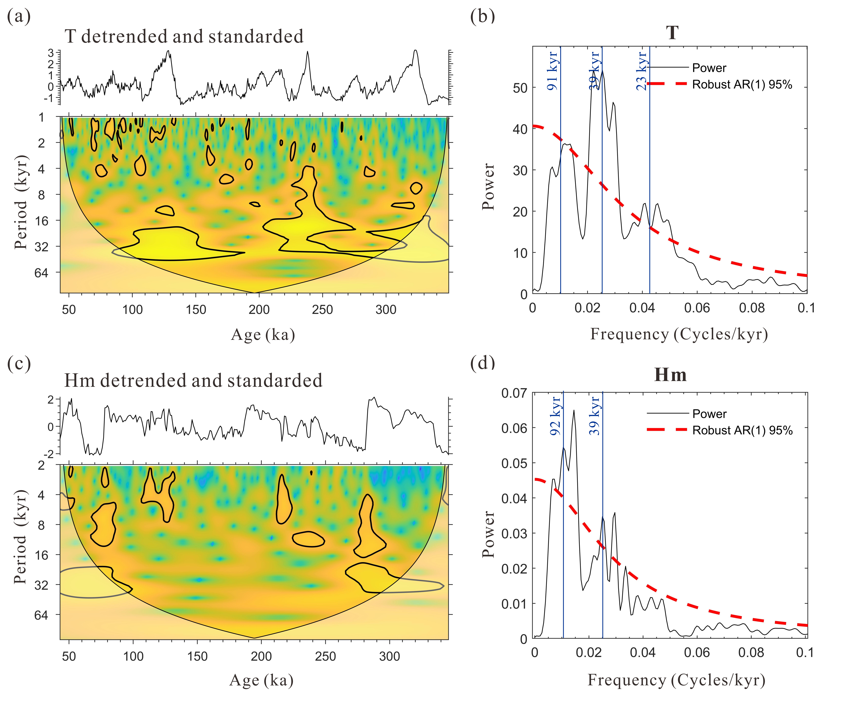Fig. S7 Wavelet and spectral analysis of the isotopic temperature (T) of the atmosphere of Vostok (Petit et al., 1999) (a, b) and the hematite (Hm) content of Madang (c, d). Both records show 40-kyr and 100-kyr cycles. The central axis of the peak (blue line) and the corresponding cycle (blue font) are shown in c and d.

- Cited studies of FeD

Fig. S8 Dependence of DCB-extractable iron (FeD) in modern soil on the mean annual precipitation (MAP) and mean annual temperature (MAT) (Peng et al., 2022). The increase of FeD is negligible when MAP is lower than ~700 mm or MAT is lower than ~14°C (marked with light blue band).

Fig. S9 Dependence of DCB-extractable iron (FeD) in modern soil on the mean annual precipitation (MAP) (Long et al., 2016). The soil samples were taken from Hainan Island, South China. The FeD generally increases with MAP up to ~1800 mm. A decrease of FeD is seen for more MAP (marked with light orange band).

References
- Ji J，Balsam W，Chen J U，et al. Rapid and quantitative measurement of hematite and goethite in the Chinese loess-paleosol sequence by diffuse reflectance spectroscopy[J]. Clays and Clay minerals，2002，50(2): 208-216.
- Long X., Ji J., Barrón V., Torrent J. Climatic thresholds for pedogenic iron oxides under aerobic conditions: Processes and their significance in paleoclimate reconstruction, Quaternary Science Reviews, Volume 150, 2016, Pages 264-277, ISSN 0277-3791, https://doi.org/10.1016/j.quascirev.2016.08.031.
- Lu H., Liu X., Zhang F., An Z., Dodson J. Astronomical calibration of loess–paleosol deposits at Luochuan, central Chinese Loess Plateau, Palaeogeography, Palaeoclimatology, Palaeoecology, Volume 154, Issue 3, 1999, Pages 237-246, https://doi.org/10.1016/S0031-0182(99)00113-3.
- Peng J., Wu X., Ni S., Wang J., Song Y., Cai C. Investigating intra-aggregate microstructure characteristics and influencing factors of six soil types along a climatic gradient, CATENA, Volume 210, 2022, 105867, ISSN 0341-8162, https://doi.org/10.1016/j.catena.2021.105867.
- Petit, J.R., J. Jouzel, D. Raynaud, N.I. Barkov, J.-M. Barnola, I. Basile, M. Bender, J. Chappellaz, M. Davis, G. Delayque, M. Delmotte, V.M. Kotlyakov, M. Legrand, V.Y. Lipenkov, C. Lorius, L. Pépin, C. Ritz, E. Saltzman, and M. Stievenard. 1999. Climate and atmospheric history of the past 420,000 years from the Vostok ice core, Antarctica. Nature 399: 429-436.

