Supplementary Materials for

Eco-friendly and Recyclable Evaporator Based on Discarded Cigarette Filters for High-eﬃciency and Stable Solar Desalination

Haoran Gong ^{‡a}, Ze Chen ^{‡a}, Can Ge ^{‡b}, Yingcun Liu ^{b}, Wan Li ^{c}, Pengtao Le ^{d}, Weilin Xu *ª, Duo Xu *^{b}, Keshuai Liu *ª

*Corresponding author. E-mail: weilin_xu0@163.com (W.X.); xuduo_96@163.com (X. D.); liukeshuai89@163.com (L. K.)

This PDF file includes:

Supplementary Materials

Figure S1 to S13.

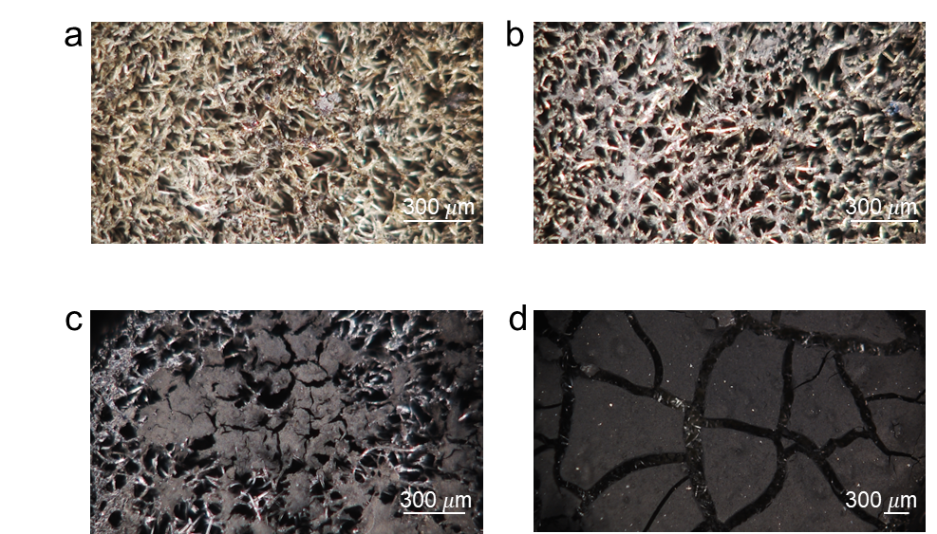 Fig. S1 Optical images a, b, c, d showing the features of 0.1-AC-CF, 0.3-AC-CF, 1.0-AC-CF, and 1.5-AC-CF.

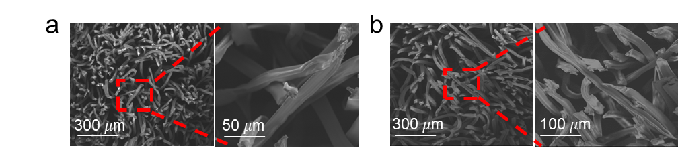
Fig. S2 Scanning electron microscopy images a and b of the clean cigarette filter (Clean-CF) and cigarette filter (CF) at different magnifications.

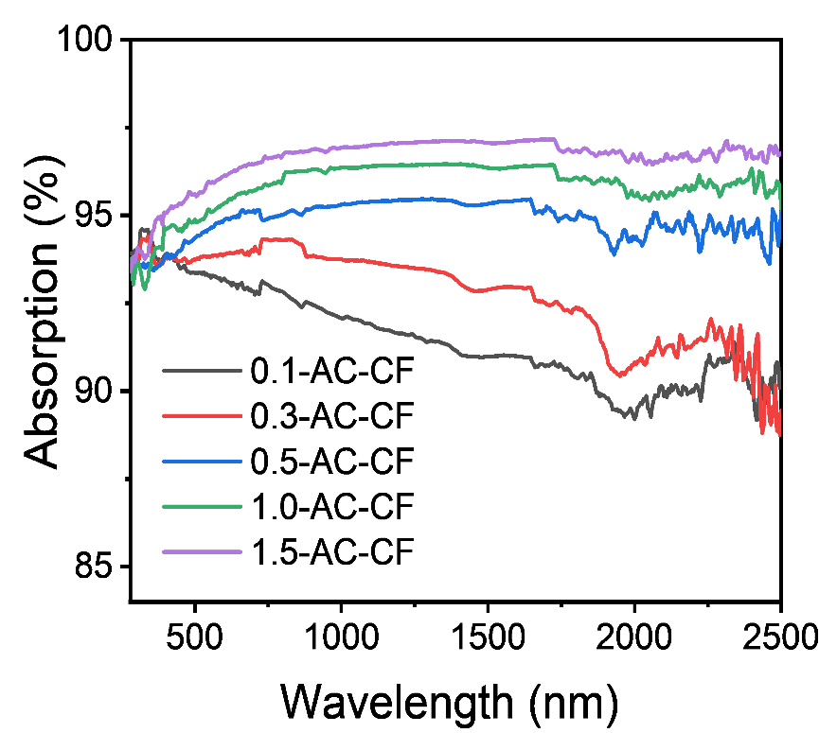
Fig. S3 Absorption spectra of the AC-CFs in the wavelength range of 280–2500 nm.

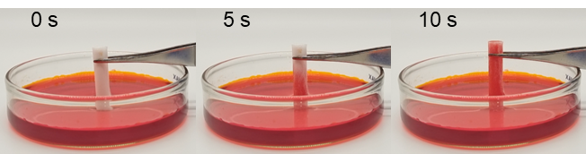
Fig. S4 A single Clean-CF wicking test.

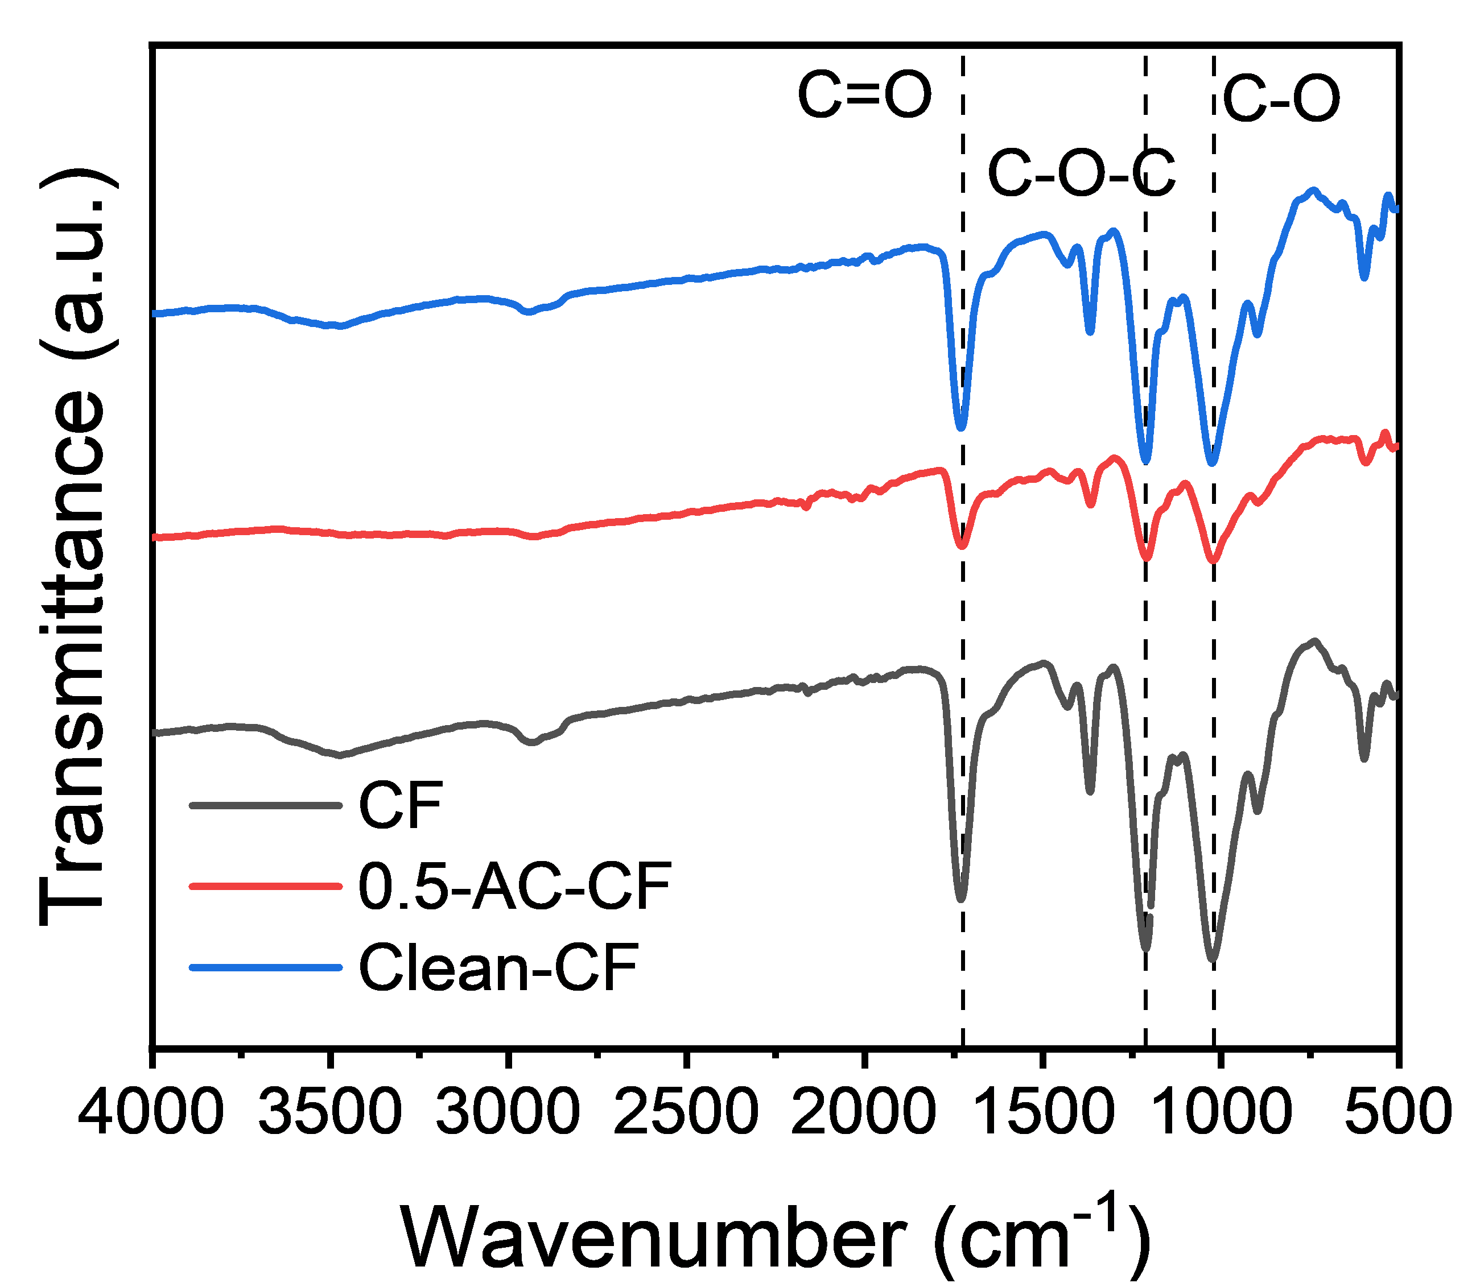
Fig. S5 Fourier transform infrared (FTIR) spectra of CF, 0.5-AC-CF, and Clean-CF

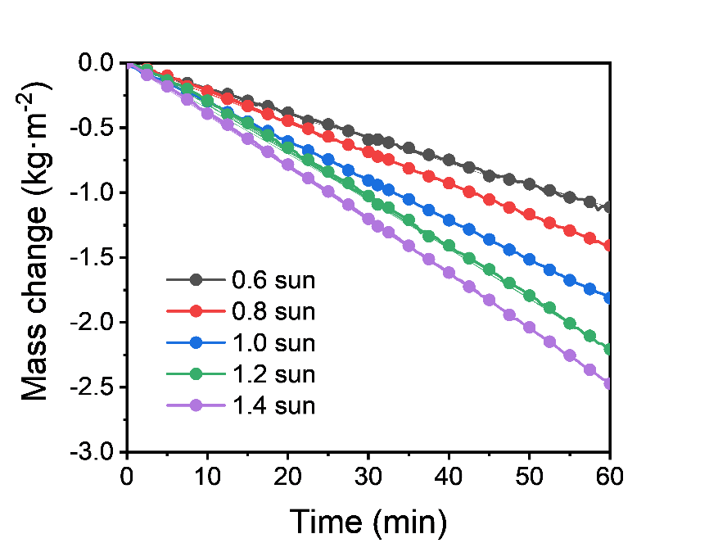
Fig. S6 Mass change of water using 0.5-AC-CF under different solar intensities.

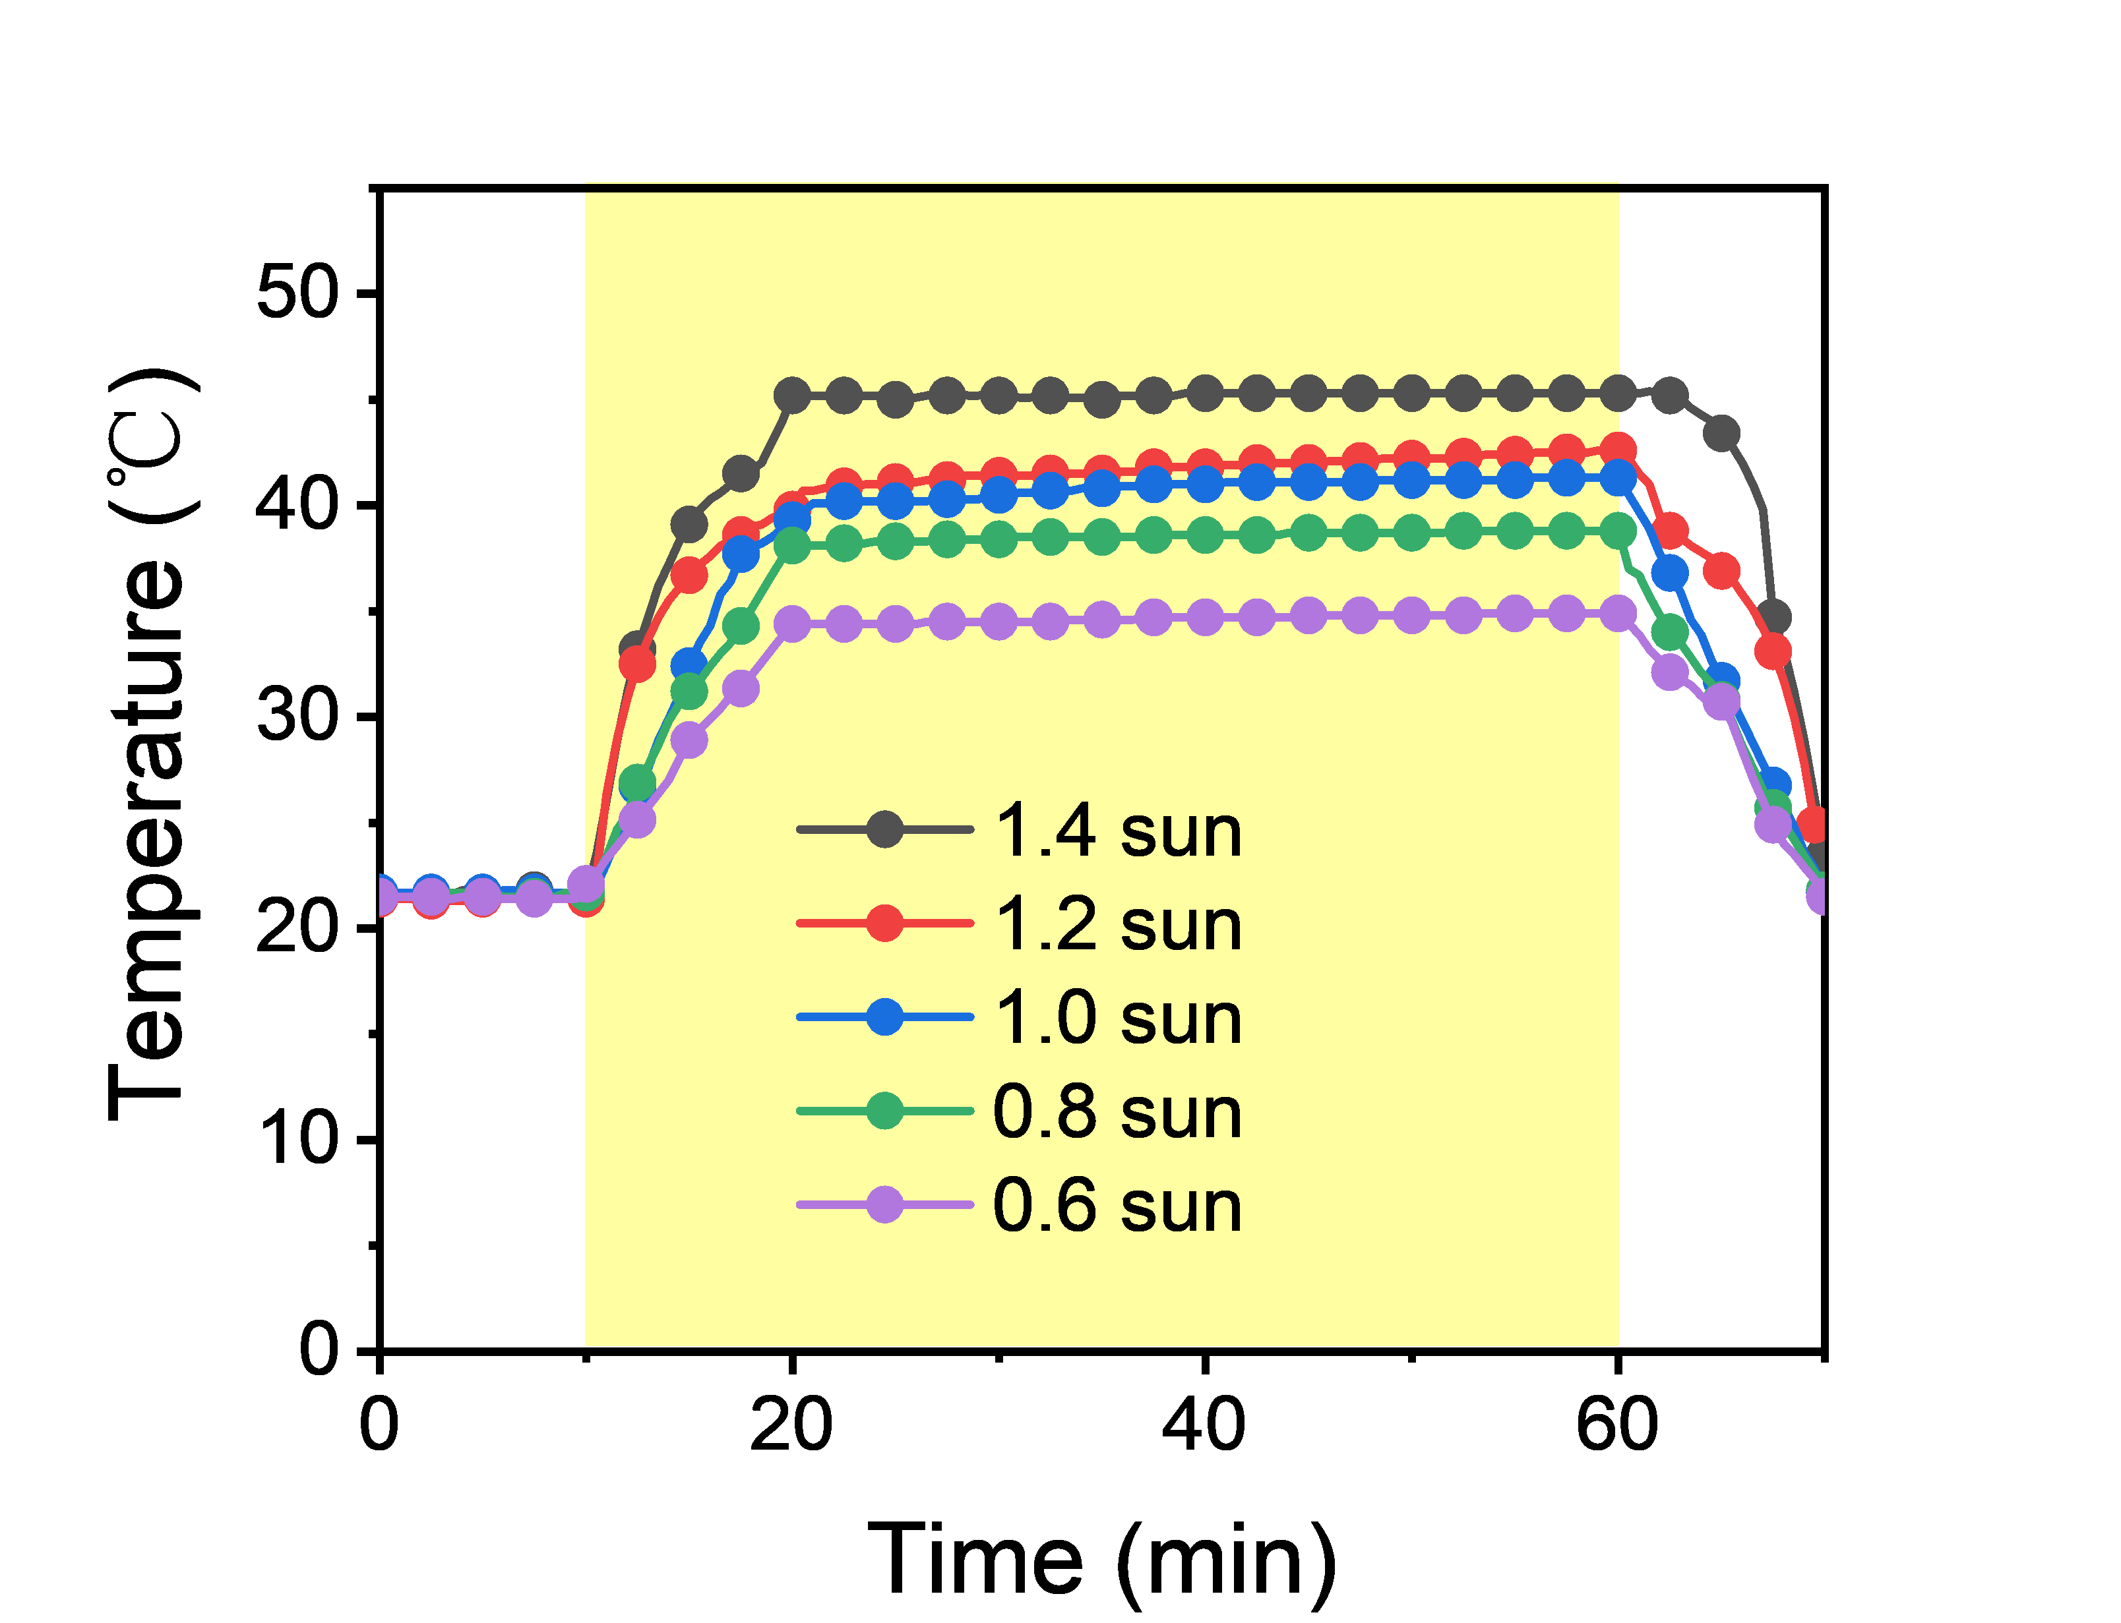
Fig. S7 Time-dependent temperature change of 0.5-AC-CF under different solar intensities.

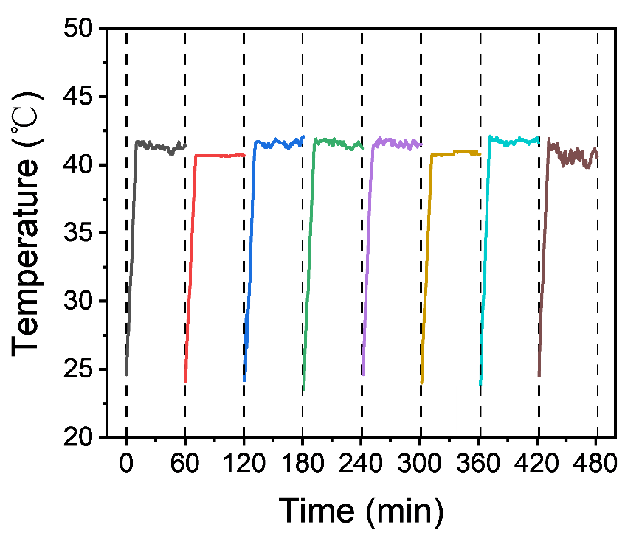
Fig. S8 Cycling stability of the time-dependent temperature change of 0.5-AC-CF under 1 sun illumination.

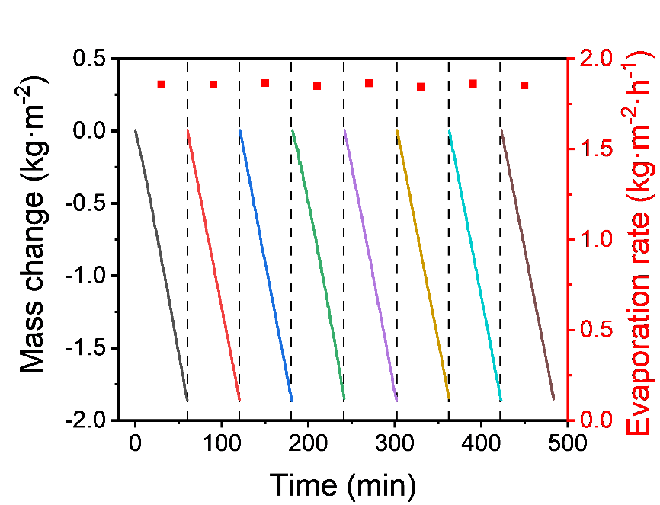
Fig. S9 Cycling performance of the net evaporation rate of 0.5-AC-CF under 1 sun illumination, where each cycle lasted 1 hour.

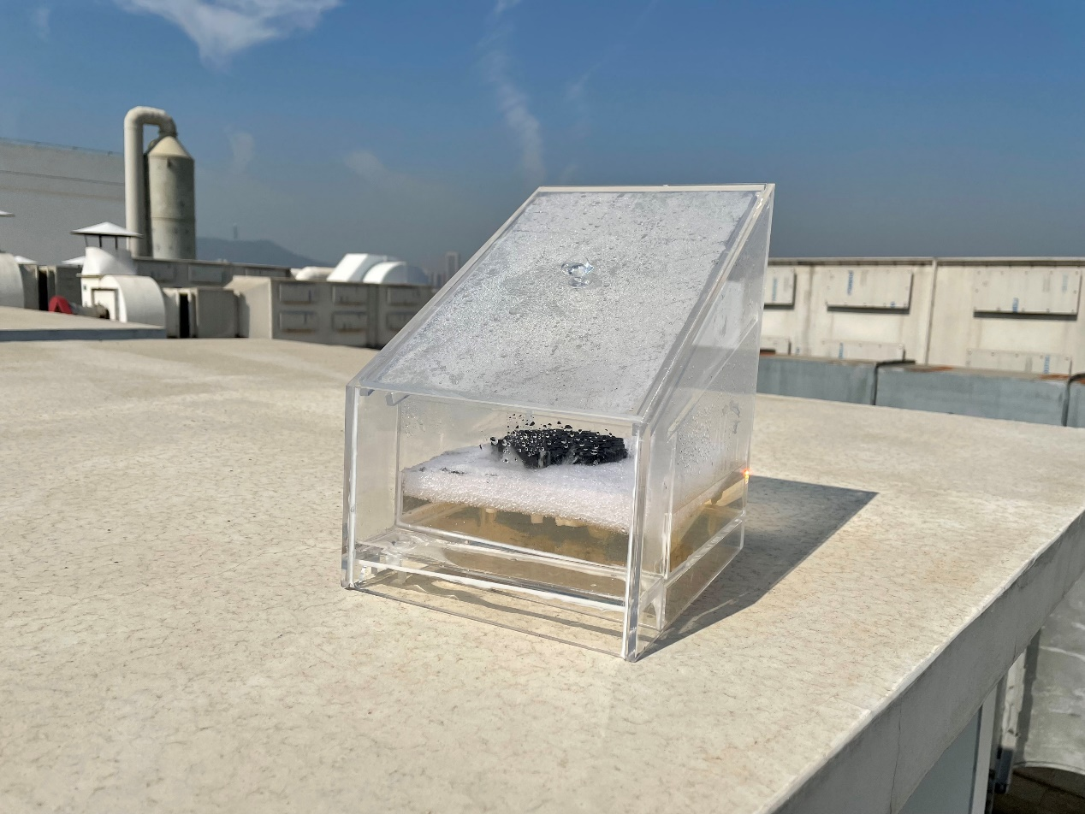
Fig. S10 Photograph of the evaporation device during the outdoor test

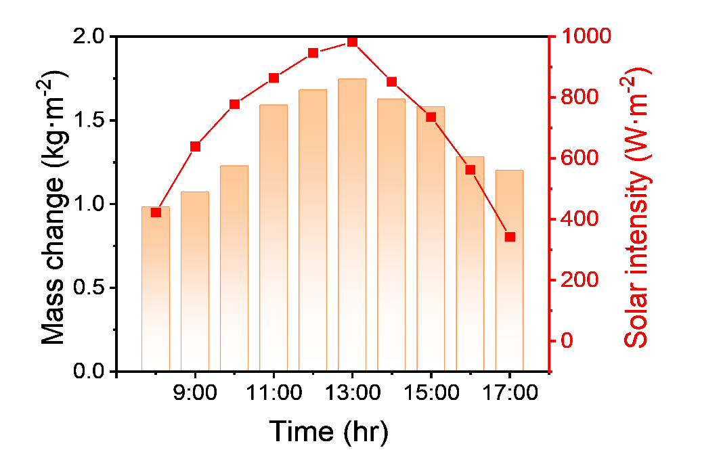
Fig. S11 The varying mass change and solar intensities from 8 a.m. to 5 p.m. on September 26, 2022 in Wuhan, China.

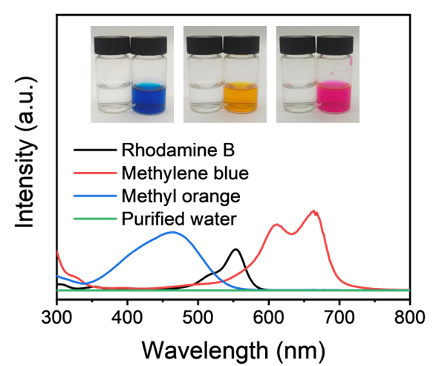
Fig. S12 UV-Vis spectra of rhodamine B, methyl orange, and methylene blue before and after purification.

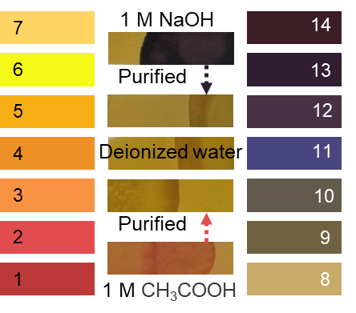
Fig. S13 pH values before and after acidic and alkaline solutions were purified using 0.5-AC-CF.

