Supplemental Figure Legends
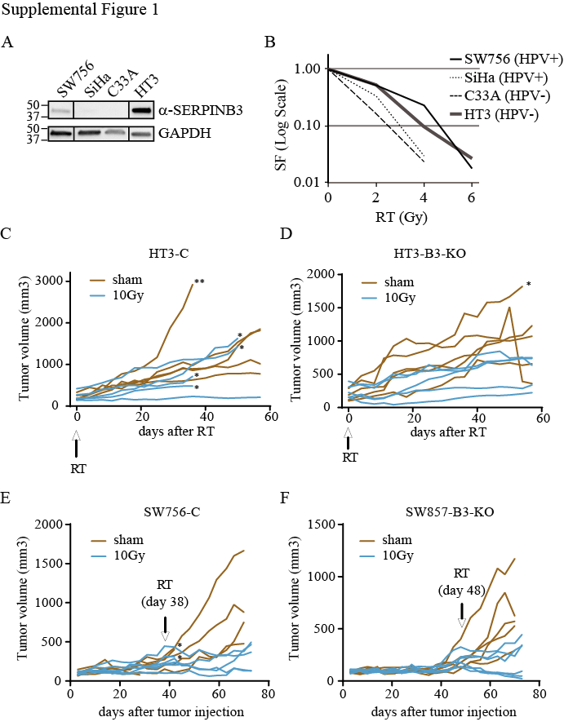
Supplemental Figure 1. A) Western blot showing steady state total cell lysate SERPINB3 protein levels in untreated SW756, SiHa, C33A and HT3 cells. B) Clonogenic survival of the four cell lines, two HPV+ and two HPV-). C-F) Spider plots of ellipsoid tumor volume in mm³ measured at 3-4 day intervals after subcutaneous injection of HT3-C (C) or –B3-KO (D) or SW756-C (D) or –B3-KO (F) cells. Tumors were treated at the indicated day with sham or 10Gy RT. * = mouse sacked for development of skin ulcer, ** = mouse sacked for tumor size criteria, all other mice sacked in bulk at end of the lines.
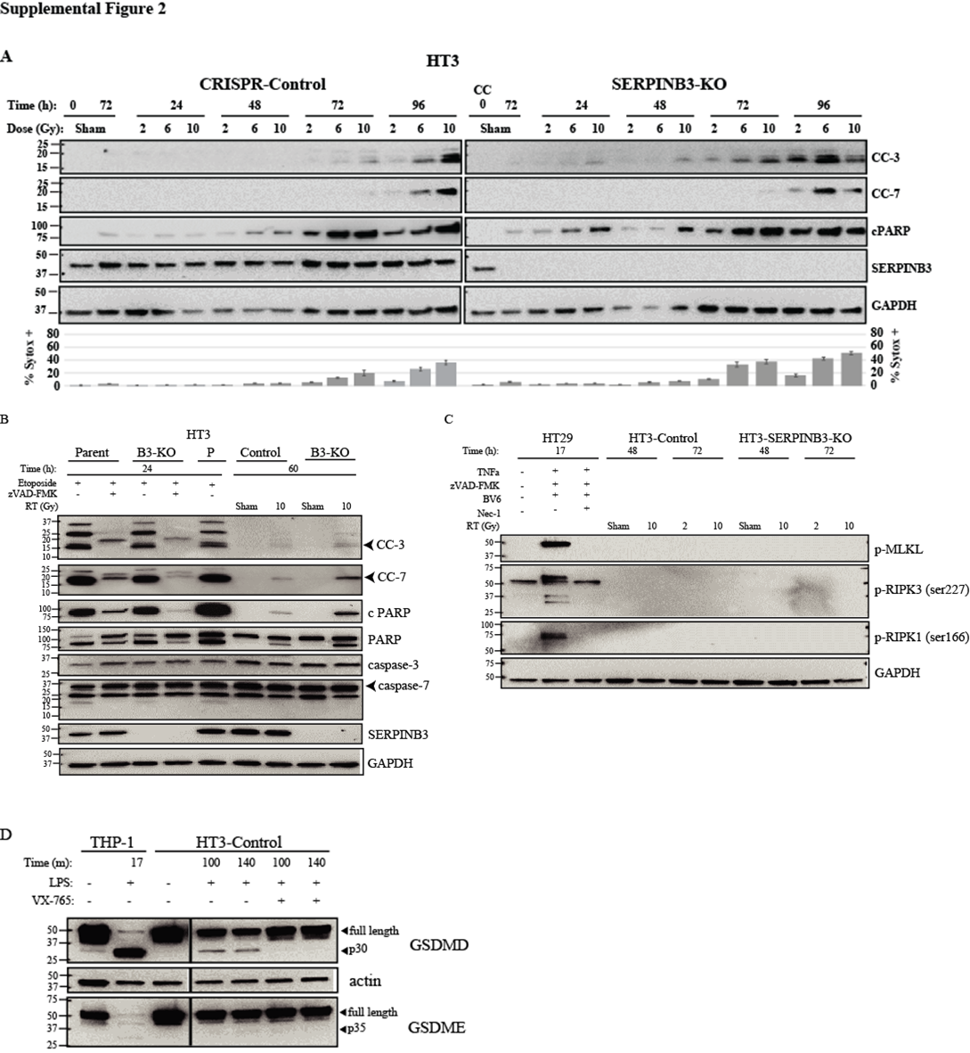
Supplemental Figure 2. A) Full Western blot of all dose levels and time points abbreviated in Figure 4A. % Sytox positive cells for each condition is shown beneath the Western blot. B) Control Western blot for markers of apoptosis, cleaved caspase-3 (CC-3), cleaved caspase-7 (CC-7) and PARP cleavage (cPARP). HT3 cells treated with etoposide to induce apoptosis, with or without zVAD-FMK pre-treatment to inhibit pan-caspase activity. Sham and 10Gy RT samples from HT3-C and –B3-KO cells are shown for reference. C) Control Western blot for markers of necroptosis, p-RIPK3, p-RIPK1 and p-MLKL. HT29 cells were treated with TNFα + zVAD-FMK + SMAC mimetic BV6 to induce necroptosis with or without necrostatin-1 (Nec-1). Sham and radiated HT3-C and –B3-KO cells are shown as reference. D) Control Western blot for markers of pyroptosis, GSDMD cleavage. THP-1 cells or HT3-C cells were treated with LPS for the indicated times to induce pyroptosis, with or without caspase-1 inhibitor VX-765.

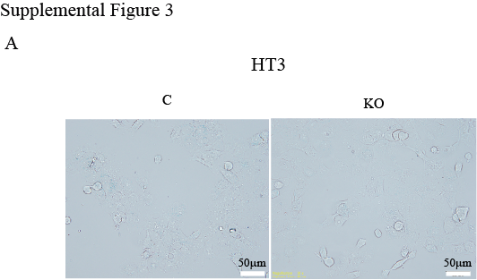
Supplemental Figure 3. Representative light microscope image of SA-βgal staining of HT3 cells.

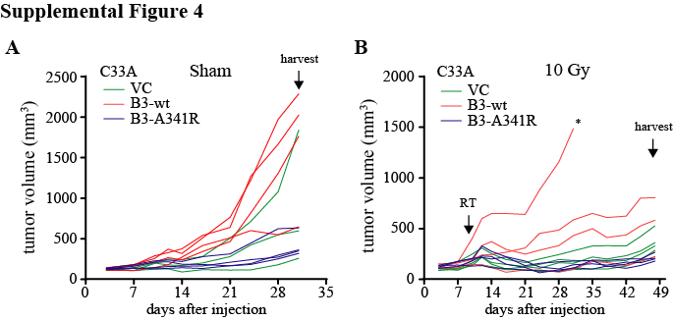
Supplemental Figure 4. Spider plots of absolute spheroid tumor volumes of C33A-VC, -B3, and –A341R tumors over time after injection. Time of radiation is indicated by the arrow (RT). * = mouse harvested for ulcer formation. All other mice were sacked and tumors harvested at the indicated time point.

