Supplementary Information
The hUCMSCs exerts excellent anti-inflammation effect which is different from TCZ IL-6 antagonist by inducing high IL-6 secretion

Short Title: High IL-6 involved hUCMSCs immunomodulation

Huei-Yu Lo^{1,2,3}, Shun-Ping Cheng^{2,3}, Jing-Long Huang⁴, Kuo-Ting Chang³, Yu-Lung Chang^{3,5,6}, Chien-Hsun Huang⁷, Chia-Jen Chang^{3,8}, Chien-Hua Chiu³, *Yui Whei Chen-Yang², *Chin-Kan Chan^{3,9,10}

¹Department of Rehabilitation, Taoyuan General Hospital, Ministry of Health and Welfare, Taoyuan, Taiwan
²Department of Chemistry, Chung Yuan Christian University, Taoyuan, Taiwan
³Translational Medicine Center, Taoyuan General Hospital, Ministry of Health and Welfare, Taoyuan, Taiwan
⁴Division of Allergy, Asthma and Rheumatology, Department of Pediatrics, Chang Gung Memorial Hospital, Taoyuan, Taiwan
⁵Department of Urology, Taoyuan General Hospital, Ministry of Health and Welfare, Taoyuan, Taiwan
⁶Department of Urology, School of Medicine, National Yang-Ming University, Taipei, Taiwan
⁷Department of Obstetrics & Gynecology, Taoyuan General Hospital, Ministry of Health and Welfare, Taoyuan, Taiwan
⁸Department of Food Science, Fu Jen Catholic University, New Taipei City, Taiwan
⁹Department of Pediatrics, Taoyuan General Hospital, Ministry of Health and Welfare, Taoyuan, Taiwan
¹⁰Department of Biotechnology, Ming Chuan University, Taoyuan, Taiwan

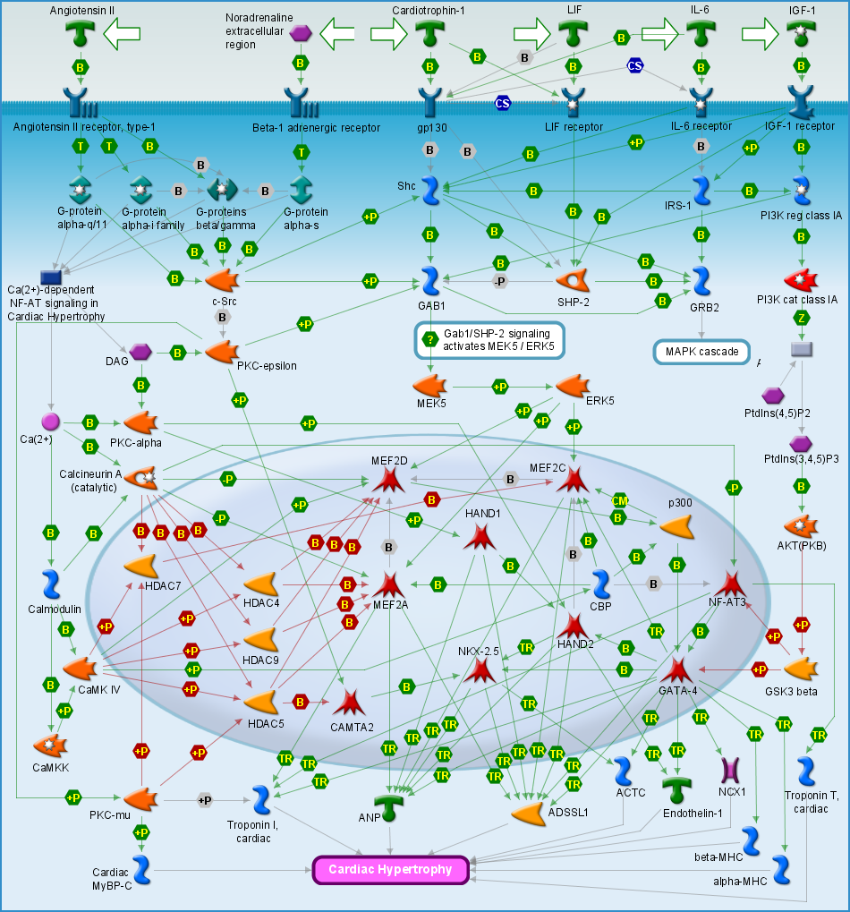
Supplementary Fig. 1 The possible downstream pathway that L-6 activates on PBMC suppression assay in co-culture with hUCMSCs
After Microarray analysis and Functional network analysis showed that IL-6 may activate the mRNA expression of genes in the MAPK pathway, including leukemia inhibitory factor (LIF), IL-6, insulin receptor substrate 2 (IRS2), and growth factor receptor-bound protein 14 (GRB14), suggesting that IL-6 activates its downstream pathways by binding to different receptors or stimulating relevant factors.

Table 1 IL-6 may activate the mRNA expression of genes in the MAPK pathway
 | Name | Cell line 1 | Cell line 2 | Cell line 3 | Cell line 4 | Cell line 5
LIF | Homo sapiens leukemia inhibitory factor (cholinergic differentiation factor) (LIF), mRNA [NM_002309] | 0.860 | 2.367 | 2.485 | 2.540 | 2.157
LIF | Homo sapiens leukemia inhibitory factor (cholinergic differentiation factor) (LIF), mRNA [NM_002309] | 1.154 | 1.511 | 1.345 | 1.624 | 1.519
IL-6 | Homo sapiens interleukin 6 (interferon, beta 2) (IL6), mRNA [NM_000600] | 0.882 | 2.036 | 3.549 | 3.207 | 1.146
IL-6 | Homo sapiens interleukin 6 (interferon, beta 2) (IL6), mRNA [NM_000600] | 0.885 | 2.023 | 3.549 | 3.243 | 1.154
IL-6 | Homo sapiens interleukin 6 (interferon, beta 2) (IL6), mRNA [NM_000600] | 0.862 | 2.074 | 3.246 | 3.142 | 1.152
IRS2 | Homo sapiens insulin receptor substrate 2 (IRS2), mRNA [NM_003749] | 0.571 | 1.874 | 1.969 | 2.016 | 1.763
GRB14 | Homo sapiens growth factor receptor-bound protein 14 (GRB14), mRNA [NM_004490] | 1.658 | 3.702 | 2.948 | 0.804 | 0.855

