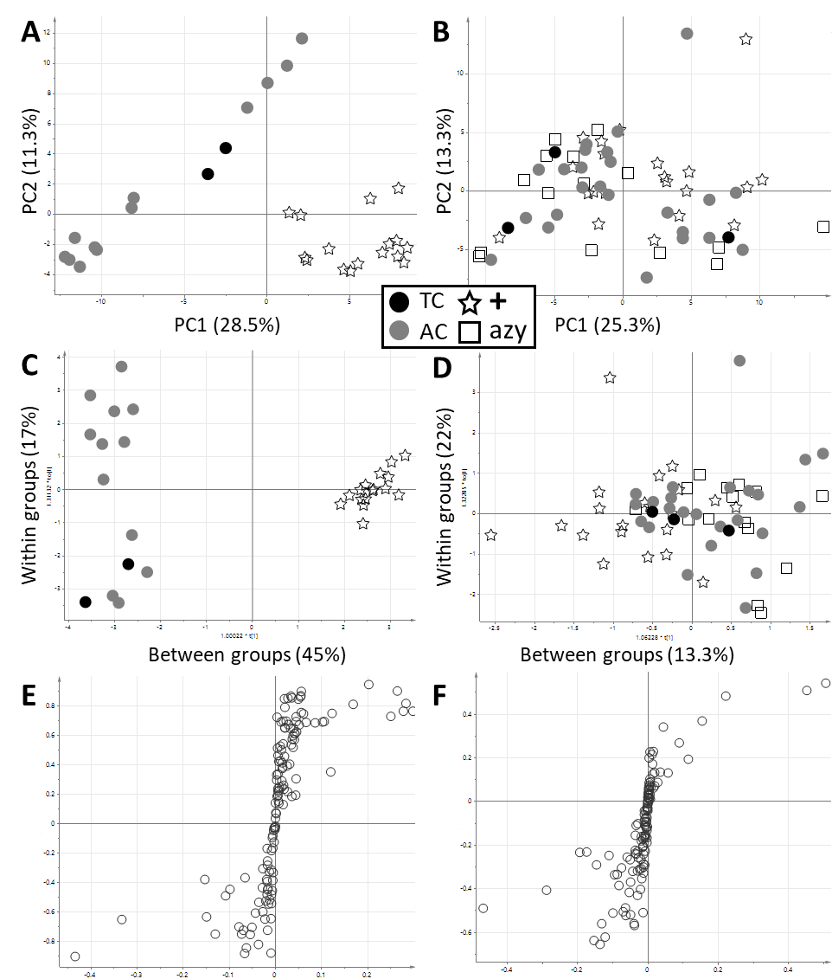
Supplementary Figure S1. Statistical modelling of GC-MS analysis of tobacco transformed with and without CRISPR/Cas9 construct. Sample groups include tissue culture control (TC), plants treated with agrobacteria without vector (AC) and plants tested positive (+) or negative (azy) for the CRISPR/Cas9 construct by PCR (see legend). PCA scatter plots are displayed for generation T₀ (A) and T₁ (B). OPLS-DA scatter plots and associated S-plot are displayed for generation T₀ (C, E) and T₁ (D, F).
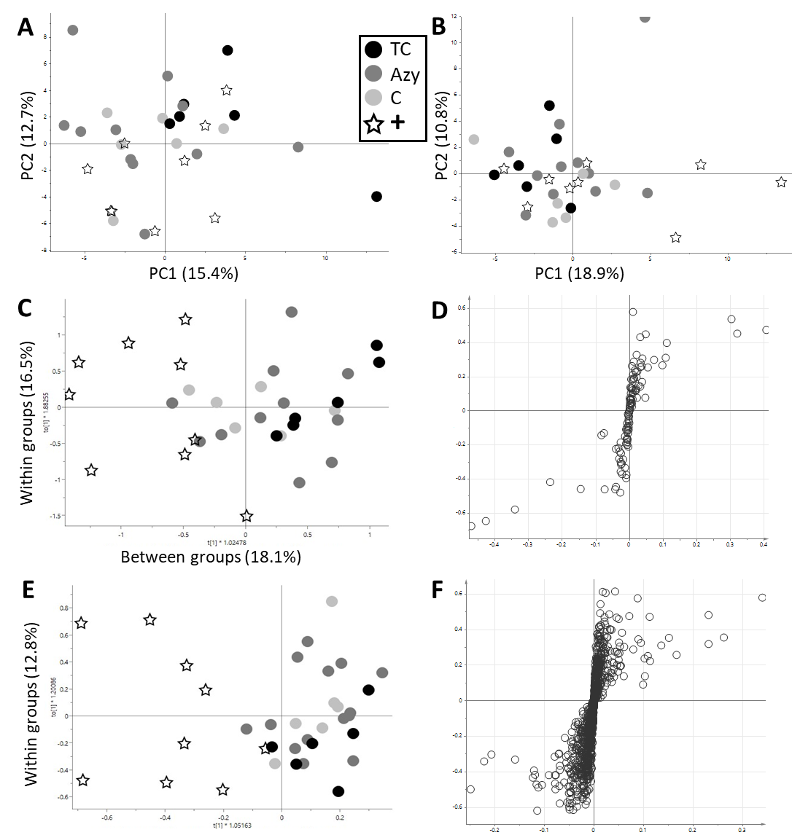
Supplementary Figure S2. Statistical modelling of GC-MS analysis of leaf and fruit of tomato transformed with and without CRISPR/Cas9. Sample groups include tissue culture control (TC), nptII-only vector control (C), non-edited azygous plants (Azy) and plants tested positive (+) for Cas9 by PCR (see legend). PCA scatter plots are displayed for leaf (A) and fruit (B). OPLS-DA scatter plot and associated S-plot are displayed for GC-MS analysis of leaf (C, D). OPLS-DA scatter plot and associated S-plot are displayed for LC-HRMS analysis of fruit (E, F). OPLS-DA separation for GC-MS analysis for fruit and LC-HRMS analysis for leaf could not be performed, due to the strong similarity of the groups.

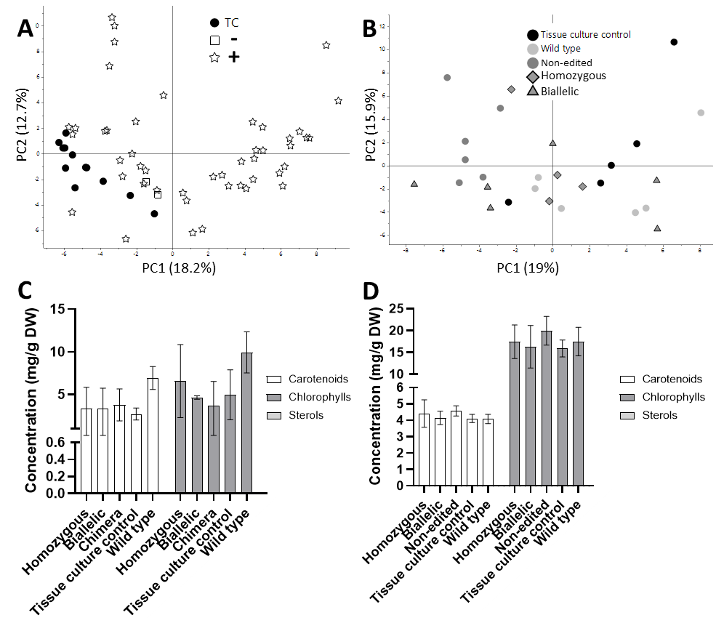
Supplementary Figure S3. Statistical modelling of GC-MS analysis of tobacco with downregulated DET1 by CRISPR/Cas9. PCA score plots are displayed for generation T₀ (A) and T₁ (B). Carotenoid, chlorophyll and sterol concentrations were measured for selected plants of generation T₀ (C) and their T₁ progeny (D). Plants of the T₀ generation were screened for Cas9 by PCR and are indicated as tested positive (+) or negative (-), see legend. T₀ plants were analysed as duplicate technical replicates. T₁ plants included four to six biological replicates per genotype.

