Efficient adsorption of methyl orange and methylene blue dyes by a novel carbazole-based hyper-crosslinked porous polymer
Yan He^{a*}, Zhulei Guoª, Mingfan Chen ª, Sicheng Wan ª, Nan Peng ª, Xiaolei Fuª, Dingzhong Yuanª, Bing Naª
ª Jiangxi Province Key Laboratory of Polymer Micro/Nano Manufacturing and Devices, School of Chemistry, Biology and Materials Science, East China University of Technology, Nanchang, 330013, China.

1.Figures:

Fig. S1 the TEM image of porous polymer HCP-CP

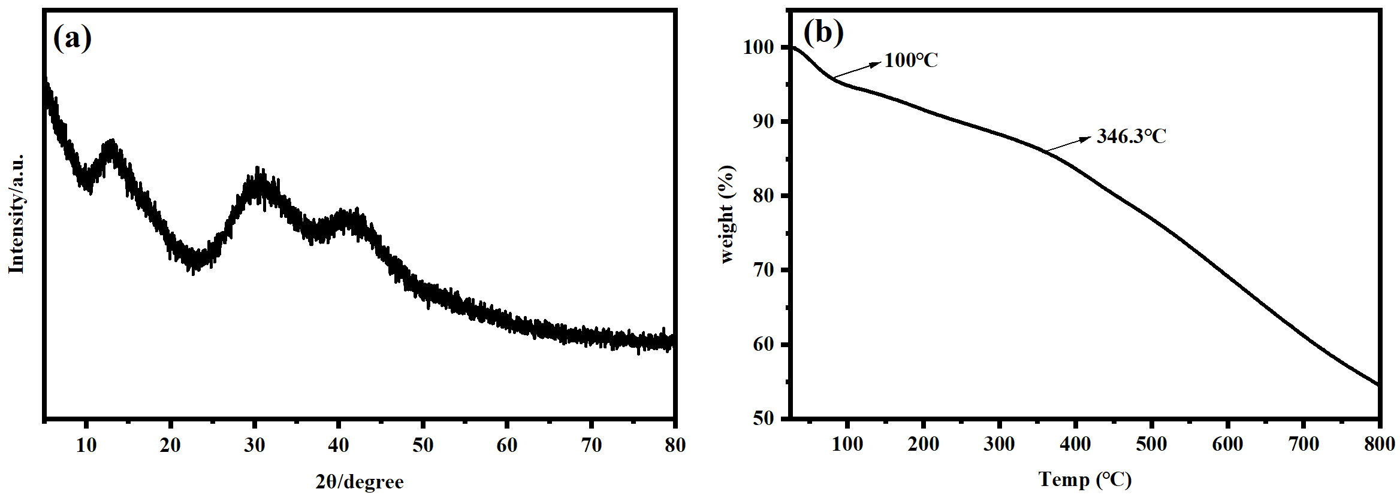
Fig. S2 (a)XRD of HCP-CP, TG curve of HCP-CP (b)

Fig. S3 Langmuir(a) and Freundlich(b) isotherms of MO and MB adsorption by HCP-CP

Fig. S4 The selectivity of HCP-CP at different dyes concertation

Fig. S5 The maximum adsorption capacity of different dyes by the polymer HCP-CP

2.Tables:

Table S1 The property of porosity of microporous HCP-CP
Polymer | SA_{BET}ª  (m² g⁻¹) | SA_{L}^{b}  (m² g⁻¹) | Vt^{c}  (cm³ g⁻¹)^{c} | Vm^{d}  (cm³ g⁻¹)^{c} | %Vm/Vt
HCP-CP | 486.7 | 491.8 | 0.323 | 0.183 | 57

Table S2 The parameters of pseudo-first-order kinetic models and pseudo-second-order kinetic models
kinetic parameter | pseudo-first-order kinetic models |  |  | pseudo-second-order kinetic models
MO | k₁/(min⁻¹) | q_{e}(mg/g) | R² | k₂/(g·mg⁻¹·min⁻¹) | q_{e}(mg/g) | R²
MO | 0.03243 | 93.57 | 0.975 | 0.00142 | 96.15 | 0.999
MB | 0.02346 | 185.68 | 0.813 | 0.00062 | 192.31 | 0.998

Table S3 The parameters of isotherm adsorption Langmuir and Freundlich model
Dyes | Temperature | q_{e,exp}  (mg·g⁻¹) | Langmuir |  |  | Freundlich
Dyes | Temperature | q_{e,exp}  (mg·g⁻¹) | q_{m}  (mg·g⁻¹) | K_{L} | R² | K_{F} | n | R²
MB | 25℃ | 751.88 | 731.76 | 0.059 | 0.996 | 149.24 | 3.66 | 0.966
MB | 35℃ | 787.41 | 771.38 | 0.093 | 0.998 | 204.09 | 4.32 | 0.938
MB | 45℃ | 884.96 | 868.54 | 0.099 | 0.998 | 206.81 | 3.89 | 0.953
MO | 25℃ | 274.73 | 253.79 | 0.036 | 0.998 | 52.79 | 3.57 | 0.971
MO | 35℃ | 303.03 | 276.52 | 0.033 | 0.994 | 56.77 | 3.64 | 0.968
MO | 45℃ | 349.65 | 315.91 | 0.033 | 0.995 | 59.56 | 3.35 | 0.917

