Supporting information
Figure A1: The XRD pattern of 800CCRM.
Figure A2: The XRD pattern of 900CCRM.
Figure A3: The XRD pattern of 1000CCRM.
Figure A4: The XRD pattern of 1100CCRM.
Figure A5: The XRD pattern of 1200CCRM.

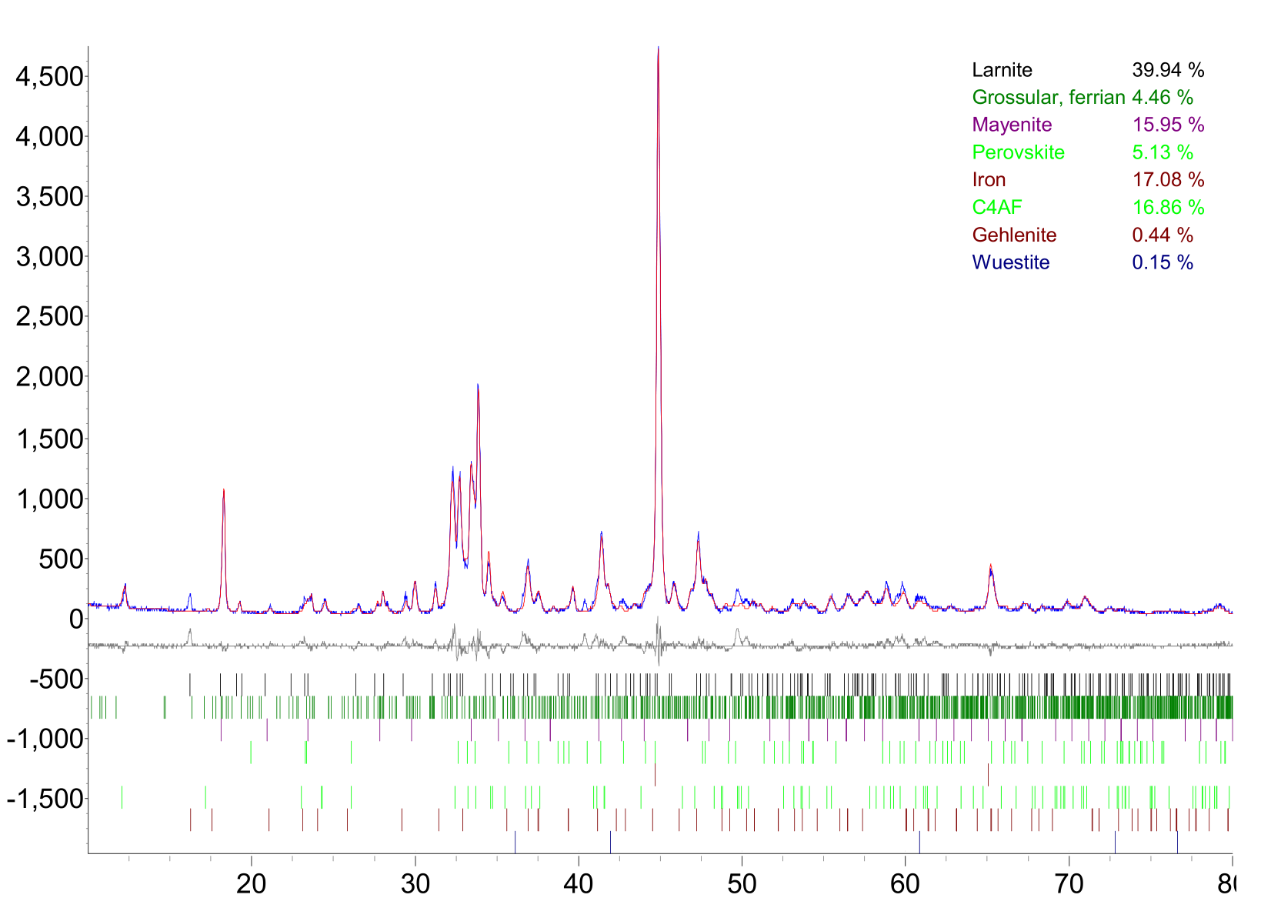
Figure A6: Quantitative results of 1000-5 CCRM.

