Supplementary Information for
Versatile optical manipulation of trions, dark excitons and biexcitons through contrasting exciton-photon coupling
Zhe Li^{1#}, Xin-Yuan Zhang^{1#}, Rundong Ma¹, Tong Fu¹, Yan Zeng¹, Yufeng Cheng¹, Cheng Wang¹, Yun Wang², Yuhua Feng², Takashi Taniguchi³, Kenji Watanabe⁴, Ti Wang^{1*}, Xiaoze Liu^{1,5*}, Hongxing Xu^{1,5,6*}

¹ School of Physics and Technology, Center for Nanoscience and Nanotechnology, and Key Laboratory of Artificial Micro- and Nanostructures of Ministry of Education, Wuhan University, Wuhan, 430072, China
² Institute of Advanced Synthesis, School of Chemistry and Molecular Engineering, Nanjing Tech University, Nanjing 211816, China
³ International Center for Materials Nanoarchitectonics, National Institute for Materials Science, 1-1 Namiki, Tsukuba 305-0044, Japan
⁴ Research Center for Functional Materials, National Institute for Materials Science, 1-1 Namiki, Tsukuba 305-0044, Japan
⁵ Wuhan Institute of Quantum Technology, Wuhan 430206, China
⁶ School of Microelectronics, Wuhan University, Wuhan 430072, China

# These authors contributed equally to this work
* Corresponding emails: wangti@whu.edu.cn, xiaozeliu@whu.edu.cn, hxxu@whu.edu.cn

Contents
S1 Sample characterization 2
S2 Photoluminescence (PL) spectral analysis and fitting 3
S3 Power-law fitting for different exciton species 4
S4 Helicity-resolved PL spectra with σ⁻ excitation 5
S5 Electric field distributions of the SPP mode 6
S6 Power-dependent PL spectra from left end of the Ag NW 7
S7 Position-dependent PL spectra from the left end 8
S8 Details for the extraction of diffusion lengths 9
S9 Schematic diagram of experimental setup 10
S10 Polarization dependent directionality of ${\text{X}}_{\text{D}}$ and ${\text{X}}_{\text{D}}^{\text{-}}$ 11
S11 Simulation for linear dipoles in xz plane 12
S12 Simulated coupling strength with various gap distance 13
S13 Simulated coupling strength varying the diameters of the NW 14
References 15

S1 Sample characterization

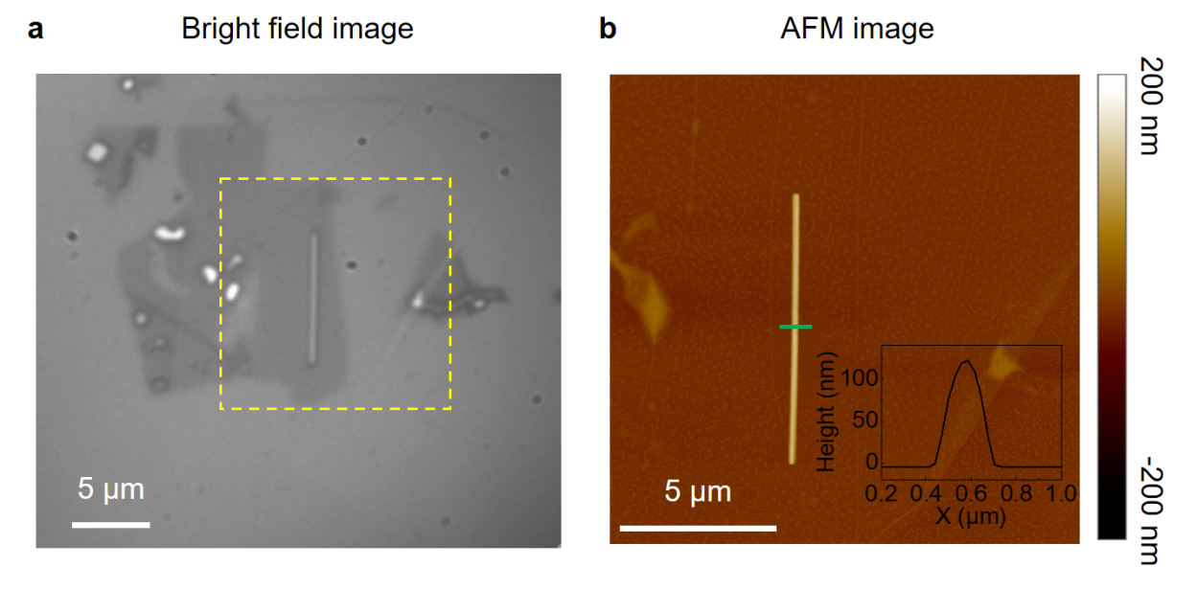
Fig. S1 a, Bright filed image of the Ag NW-WSe₂ hybrid structure. b, Atomic force microscopy (AFM) image of the sample. The AFM scanning area is marked as the yellow dashed square in a. The height of Ag NW along the green line is shown in the inset. The diameter of Ag NW is determined to be ~140 nm from the AFM.

S2 Photoluminescence (PL) spectral analysis and fitting

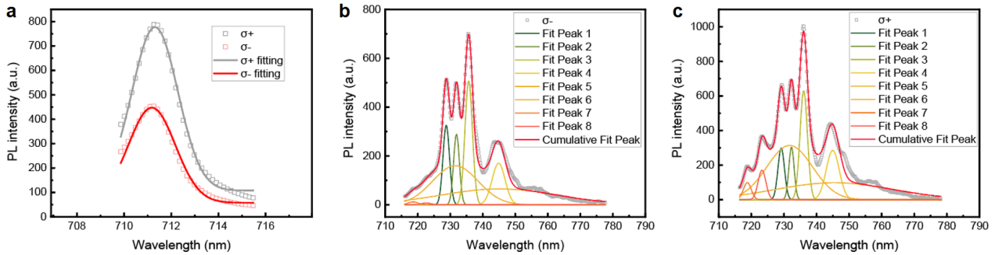
Fig. S2 a, Helicity-resolved PL spectra of the neutral exciton ($\text{X}\text{0}$) by σ⁺ pump at 685nm CW laser in Fig. 1c. The fitted results for σ⁺ and σ⁻ detections are shown as gray and red lines. b and c are the fitted results of other exciton species of σ⁻ and σ⁺ detection, respectively.

 | $$\text{X}\text{0}$$ | $$\text{XX}\text{0}$$ | $${\text{X}}^{\text{-}}$$ | $${\text{X}}_{\text{D}}$$ | $$\text{XX}\text{-}$$ | $${\text{X}}_{\text{D}}^{\text{-}}$$
$$ρ$$ | 27% | 79% | 92% | -4% | 3% | 11%

Table S2 The degree of circular polarization for different exciton species calculated from Fig. S2. The degree of circular polarization of X⁻ is the highest, with a value of 92%. X_{D}, XX⁻ and X_{D}⁻ shows negligible values of ρ. The degree of polarization and peak position for these excitons are consistent with previous reports ¹⁻⁴.

S3 Power-law fitting for different exciton species

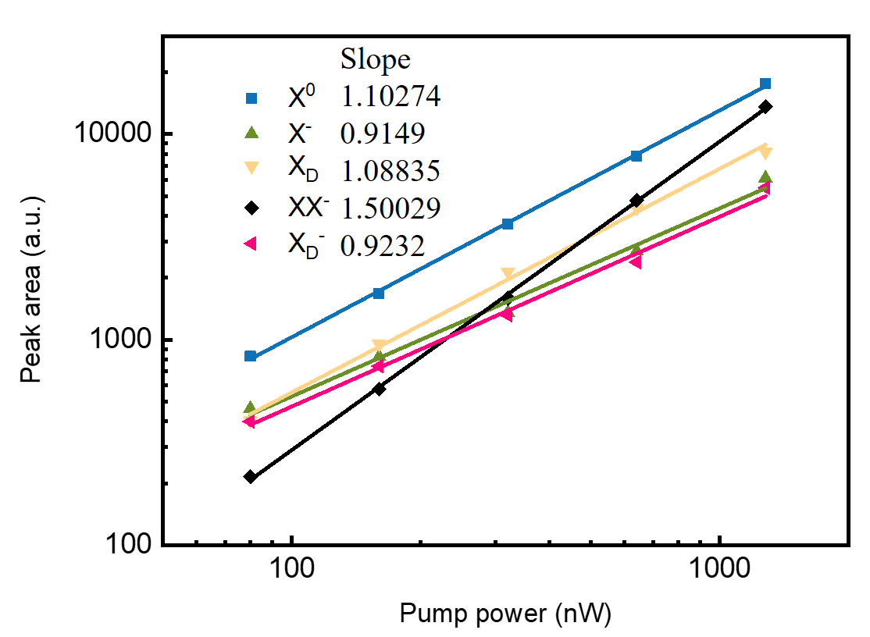
Fig. S3 Power-law fitting for different exciton species of WSe₂ without Ag NWs. The power-law fitting gives exponents of 1.10, 0.91, 1.09, 0.92 for $\text{X}\text{0}$, $\text{X}\text{-}$, ${\text{X}}_{\text{D}}$ and ${\text{X}}_{\text{D}}^{\text{-}}$, respectively. The exponents of $\text{XX}\text{-}$ deviated from 2 was attributed to the partial equilibrium between the biexciton and the constituent exciton. The power-law results for different exciton species are consistent with previous reports ¹⁻⁴.

S4 Helicity-resolved PL spectra with σ⁻ excitation
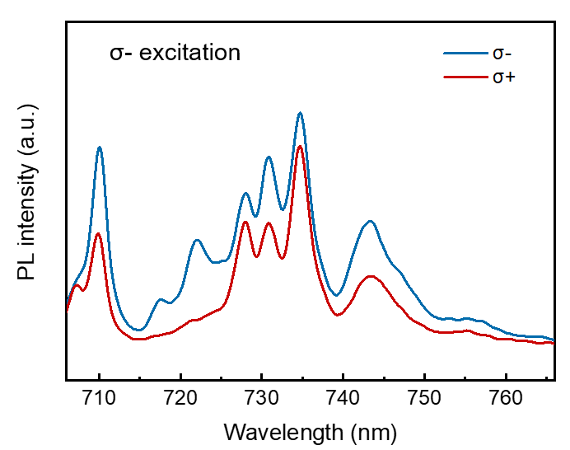
Fig. S4 PL spectra of monolayer WSe₂ far away from Ag NW at 4 K. The blue and red lines are the PL signal with σ⁻ and σ⁺ detection when excited by a σ⁻ polarized laser of 685nm. The helicity-resolved PL spectra are consistent with the results shown in Fig. 1b.

S5 Electric field distributions of the SPP mode
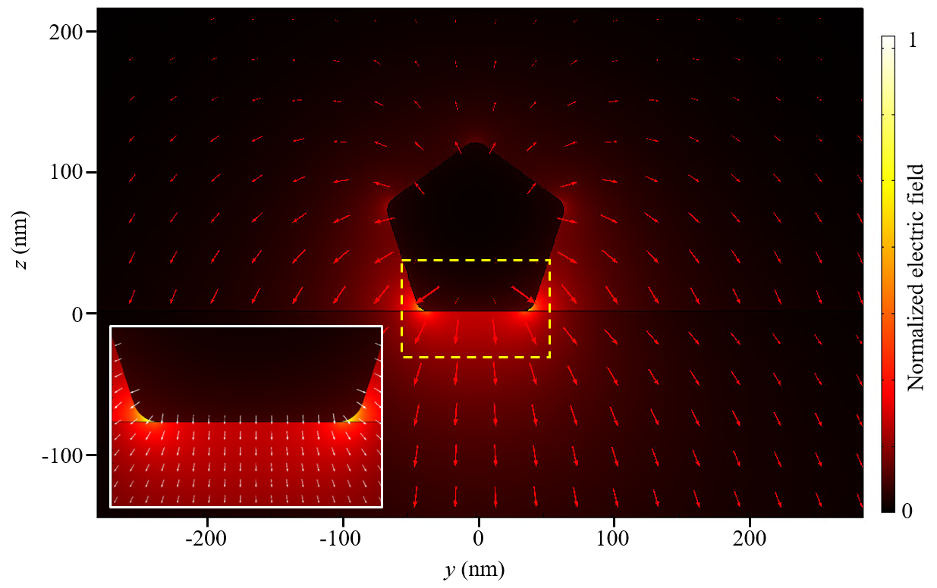Fig. S5 Electric field distribution of the propagating mode for Ag NW with a diameter of 140 nm. The inset is an enlarged view of the yellow dashed square area. The z component of the electric field underneath the Ag NW is much stronger than the y component, resulting in a larger coupling strength with an out-of-plane dipole. Here the arrows represent the electric field directions.
S6 Power-dependent PL spectra from left end of the Ag NW

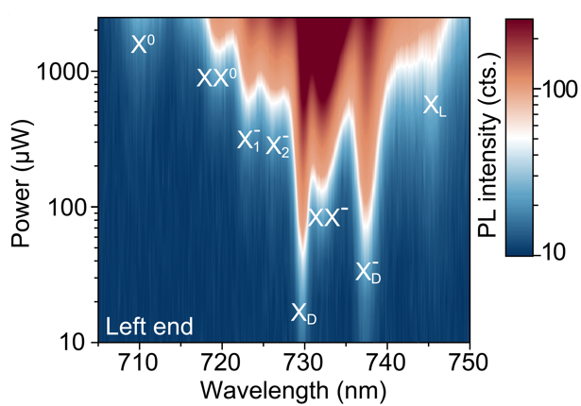
Fig. S6 The PL spectra from left end of the Ag NW. The data were obtained with the same excitation of Fig. 2b and 2d in the main text. The PL spectrum from left end also reveals the differences from the in-situ spectra, such as the narrower excitonic linewidths and stronger dark exciton intensity.

S7 Position-dependent PL spectra from the left end

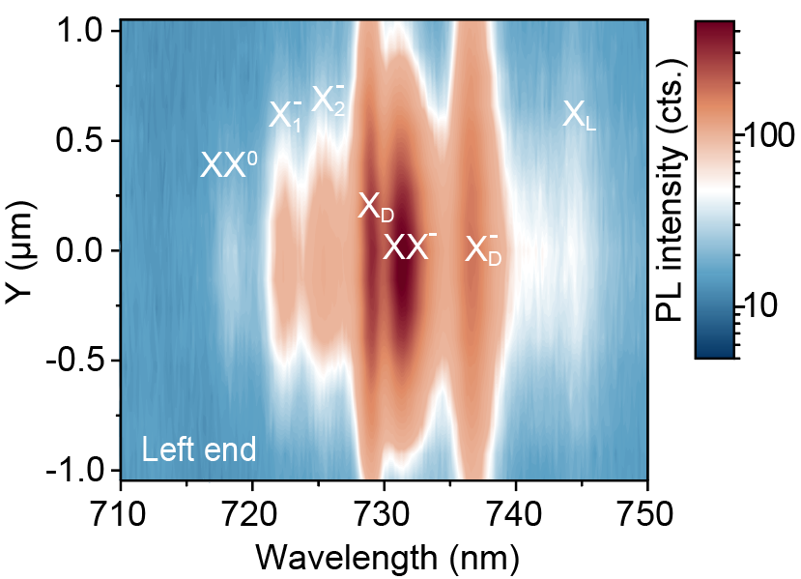
Fig. S7 Color map of PL spectra as a function of the distance y from the left end. The variable y represents the distance from the laser spot to the Ag NW. As the absolute value of y increases, the PL intensity decreases.

S8 Details for the extraction of diffusion lengths

Note. S8
As discussed in the main text, the steady state exciton distribution can be described by the following formula:
$$\begin{aligned} \text{n}\text{(}\text{r}\text{) }∝ \int_{\text{-∞}}^{\text{∞}}{ }{\text{K}}_{\text{0}}\text{(}{\text{r}}^{\text{'}}\text{/}{\text{L}}_{\text{X}}\text{)}{\text{e}}^{{\text{-(}\text{r} \text{-}{ \text{r}}^{\text{'}}\text{)}}^{\text{2}}\text{/}{\text{w}}^{\text{2}}}\text{d}{\text{r}}^{\text{'}}\#\text{(S1)}\end{aligned}$$
where ${\text{L}}_{\text{X}} \text{= }\sqrt{{\text{D}}_{\text{X}}{\text{τ}}_{\text{X}}}$ is the diffusion length. While the diffusion constants ${\text{D}}_{\text{X}}$ for these exciton species are similar (around 1 ~ 10 cm²/s) ^{5,6}, the lifetimes ${\text{τ}}_{\text{X}}$ differ a lot ^{7,8}. Due to the spin-forbidden transition, the ${\text{τ}}_{\text{X}}$ for ${\text{X}}_{\text{D}}$ and ${\text{X}}_{\text{D}}^{\text{-}}$ are more than ten times longer than the bright excitons, leading to much longer diffusion lengths.
Based on previous reports, we estimate the ${\text{L}}_{\text{X}}$ for ${\text{X}}_{\text{D}}$ and ${\text{X}}_{\text{D}}^{\text{-}}$ to be a few hundred nanometers and the ${\text{L}}_{\text{X}}$ for ${\text{X}}_{\text{1}}^{\text{-}}$, ${\text{X}}_{\text{2}}^{\text{-}}$ and $\text{XX}\text{-}$ to be tens of nanometers. The ${\text{L}}_{\text{X}}$ for ${\text{X}}_{\text{1}}^{\text{-}}$, ${\text{X}}_{\text{2}}^{\text{-}}$ and $\text{XX}\text{-}$ are too small to be quantified considering the relatively big beam spot (diameter ~ 1 μm). Meanwhile, as $\text{XX}\text{-}$ has a higher power-law exponent (Fig. S3), its initial exciton distribution is more concentrated in the beam spot center area, which leads to a narrower distribution.
To extract the ${\text{L}}_{\text{X}}$ for ${\text{X}}_{\text{D}}$ and ${\text{X}}_{\text{D}}^{\text{-}}$, we use the exciton distribution of ${\text{X}}_{\text{1}}^{\text{-}}$ as the initial excitation condition as ${\text{X}}_{\text{1}}^{\text{-}}$ have very short ${\text{L}}_{\text{X}}$ and similar power-law exponents with the two dark excitons (Fig. S3). By fitting the distribution of ${\text{X}}_{\text{1}}^{\text{-}}$ with the Gaussian function, we get a $\text{w}$ value of 0.89 μm. Then Eq. (S1) is employed to obtain the only remaining variable ${\text{L}}_{\text{X}}$ for ${\text{X}}_{\text{D}}$ and ${\text{X}}_{\text{D}}^{\text{-}}$. The extracted ${\text{L}}_{\text{X}}$ for ${\text{X}}_{\text{D}}$ and ${\text{X}}_{\text{D}}^{\text{-}}$ are 0.59 ± 0.10 μm and 0.84 ± 0.13 μm, respectively.

S9 Schematic diagram of experimental setup
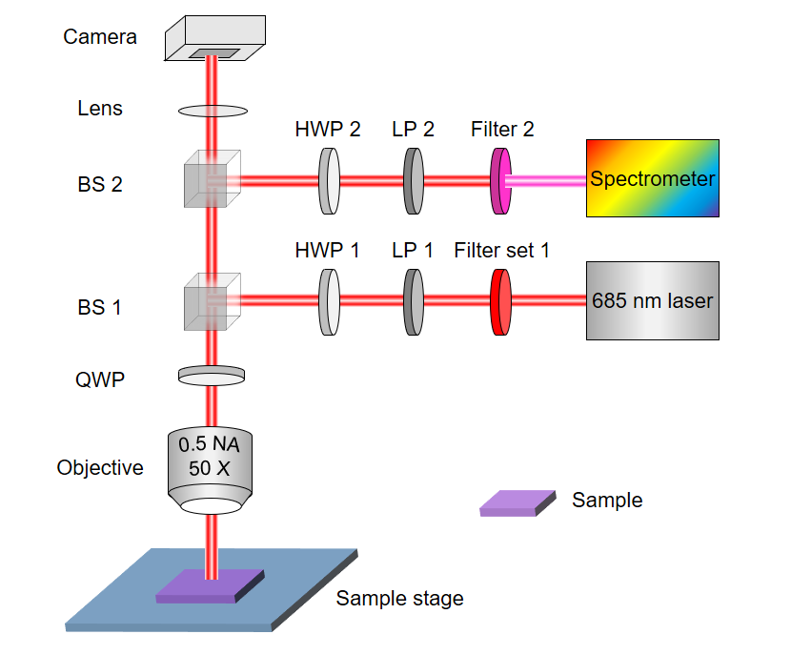
Fig. S9 schematic diagram the optical setup for spectral measurement. Filter set 1 contains two filters: 700 nm short pass and 690 $±$ 5 nm band pass. Filter 2: 700 nm long pass filter. LP (linear polarizer), HWP (half-wave plate) and QWP (quarter-wave plate) are used to alter the polarization of the excitation and collection. BS: non-polarized beam splitter.

S10 Polarization dependent directionality of ${\text{X}}_{\text{D}}$ and ${\text{X}}_{\text{D}}^{\text{-}}$

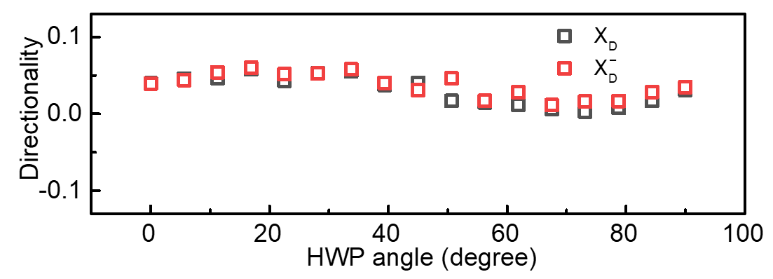
Fig. S10 Polarization dependent directionality of ${\text{X}}_{\text{D}}$ and ${\text{X}}_{\text{D}}^{\text{-}}$, the polarization of the laser is modified by a half wave-plate (HWP). Compared with ${\text{X}}_{\text{1}}^{\text{-}}$ and ${\text{X}}_{\text{2}}^{\text{-}}$, the two dark excitons show negligible polarization dependence. The slight polarization dependence may come from the background change from other excitons.

S11 Simulation for linear dipoles in xz plane

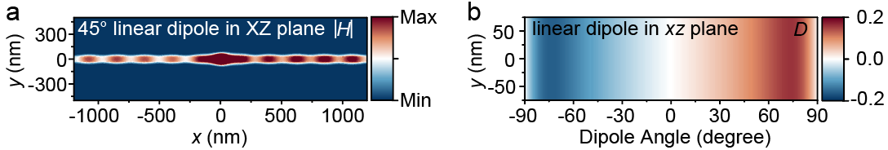
Fig. S11 COMSOL Multiphysics modeling of the directionality for dipoles in xz plane. a, Magnetic field distribution of SPPs excited by the 45$°$tilted linear dipole. b is the simulated dipole angle dependent directionality (D) for linear dipole in xz plane. The directionality keeps increase as the angle increase and reaches its maximum at around 70$°$.

S12 Simulated coupling strength with various gap distance
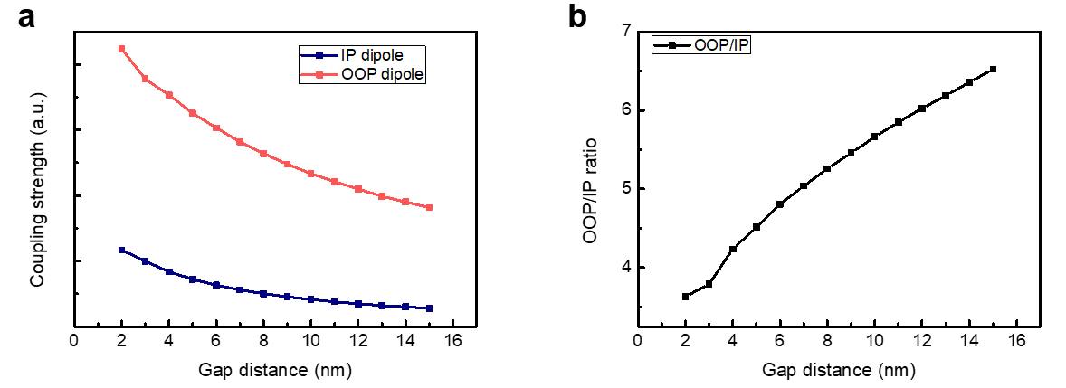
Fig. S12 The simulation of coupling strength between dipoles and Ag NW with various gaps. a, the simulated coupling strength of in-plane (IP) and out-of-plane (OOP) dipoles at the edge of a 110 nm diameter Ag NW as a function of gap distance. The coupling strength for both OOP and IP dipoles decays with distance, and the strength for OOP keeps higher than that of IP. b is the ratio of coupling strength between OOP and IP dipoles with increase of gap distance. The ratio of the two is positively correlated with the gap distance. The ratio between the two can be effectively modulated by adjusting the value of the gap distance.

S13 Simulated coupling strength varying the diameters of the NW
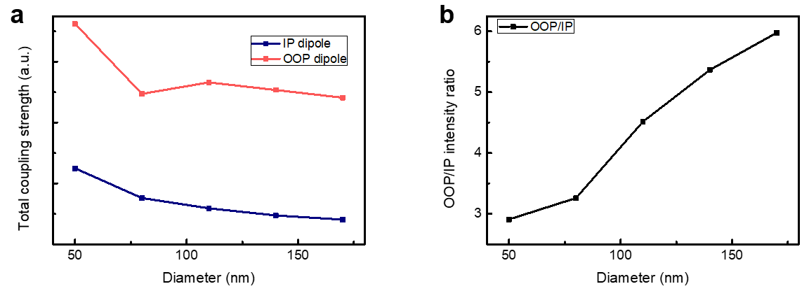
Fig. S13 The simulated coupling strength between dipoles and Ag NW with various diameters of NWs. a, the simulated coupling strength between OOP(IP) dipole and Ag NWs with different diameters. The coupling strength of the OOP (IP) dipoles decreases with increasing diameter of the NW. b is the coupling strength ratio of OOP and IP with various diameters. The ratio of the two is positively correlated with the diameter, which provides another tool to modulate the ratio between them.

References
1 Li, Z. et al. Revealing the biexciton and trion-exciton complexes in BN encapsulated WSe₂. Nat. Commun. 9, 3719 (2018).
2 Liu, E. et al. Landau-quantized excitonic absorption and luminescence in a monolayer valley semiconductor. Phys. Rev. Lett. 124, 097401 (2020).
3 Steinhoff, A. et al. Biexciton fine structure in monolayer transition metal dichalcogenides. Nat. Phys. 14, 1199-1204 (2018).
4 Ye, Z. et al. Efficient generation of neutral and charged biexcitons in encapsulated WSe₂ monolayers. Nat. Commun. 9, 3718 (2018).
5 Wagner, K. et al. Nonclassical exciton diffusion in monolayer WSe₂. Phys. Rev. Lett. 127, 076801 (2021).
6 Zipfel, J. et al. Exciton diffusion in monolayer semiconductors with suppressed disorder. Phys. Rev. B 101, 115430 (2020).
7 Robert, C. et al. Fine structure and lifetime of dark excitons in transition metal dichalcogenide monolayers. Phys. Rev. B 96, 155423 (2017).
8 Zhang, X. X. et al. Magnetic brightening and control of dark excitons in monolayer WSe₂. Nat. Nanotechnol. 12, 883-888 (2017).

