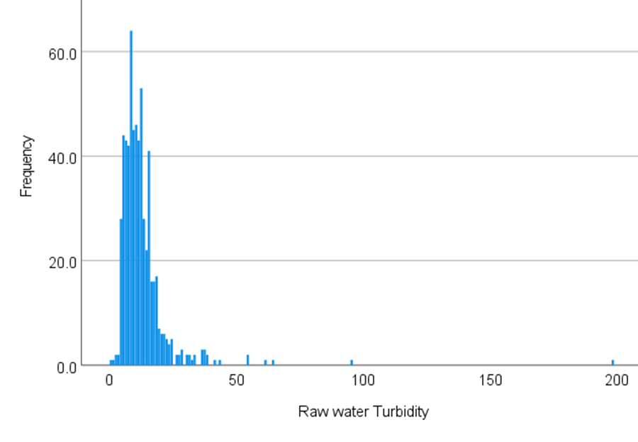
Figure SI-1 – frequency distribution of raw water turbidity (NTU)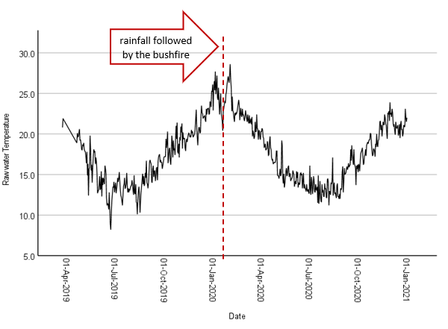
Figure SI-2 variation of raw water temperature (before and after the bushfire event)

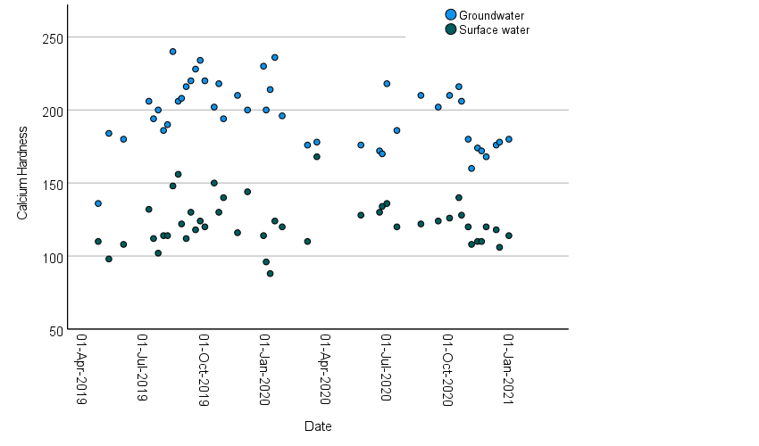
Figure SI-3- Variation of calcium hardness in groundwater and surface water

Table SI -4 (Treated Water Quality Targets & Guideline Values)
Parameter | Units | ADWG |  | Common Industry Treated Water Targets | Current Theodore Treated Water Target
Parameter | Units | Health | Aesthetic | Common Industry Treated Water Targets | Current Theodore Treated Water Target
Turbidity | NTU | 1 | 5 | < 0.1 | < 0.15
Colour | HU |  | 15 | ≤ 5 | ≤ 5
pH |  |  | 6.5 – 8.5 | 7.5 – 8.3 | 7.5-7.6
Chlorine | mg/L | 5 |  | Depends on system | 1.0 – 1.5
Total Aluminum | mg/L | 0.2 |  | ≤ 0.2 | -
Total Manganese | mg/L | 0.5 | 0.1 | ≤ 0.05 | -
Total Iron | mg/L |  | 0.3 | ≤ 0.3 | -
Total Alkalinity | mg/L as CaCO₃ |  |  | ³ 40 | -
Total Dissolved Solids (TDS) | mg/L |  | < 600 | < 500 | -
CCPP |  |  |  | -1 to -5 | -
Total Trihalomethanes | mg/L | 0.25 |  | 0.15 | -

