Supplementary material
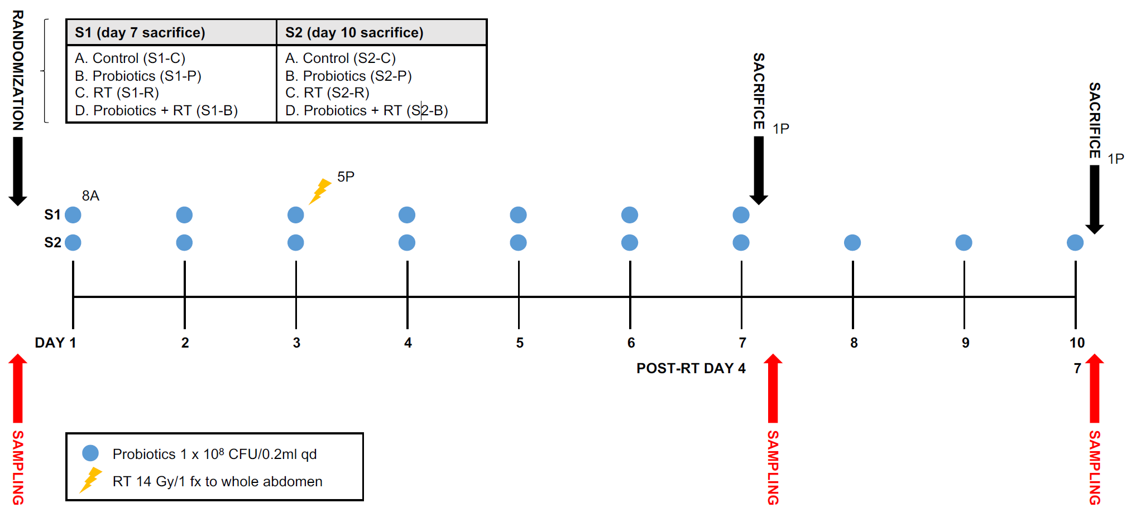
Supplementary Fig. 1. Experimental scheme

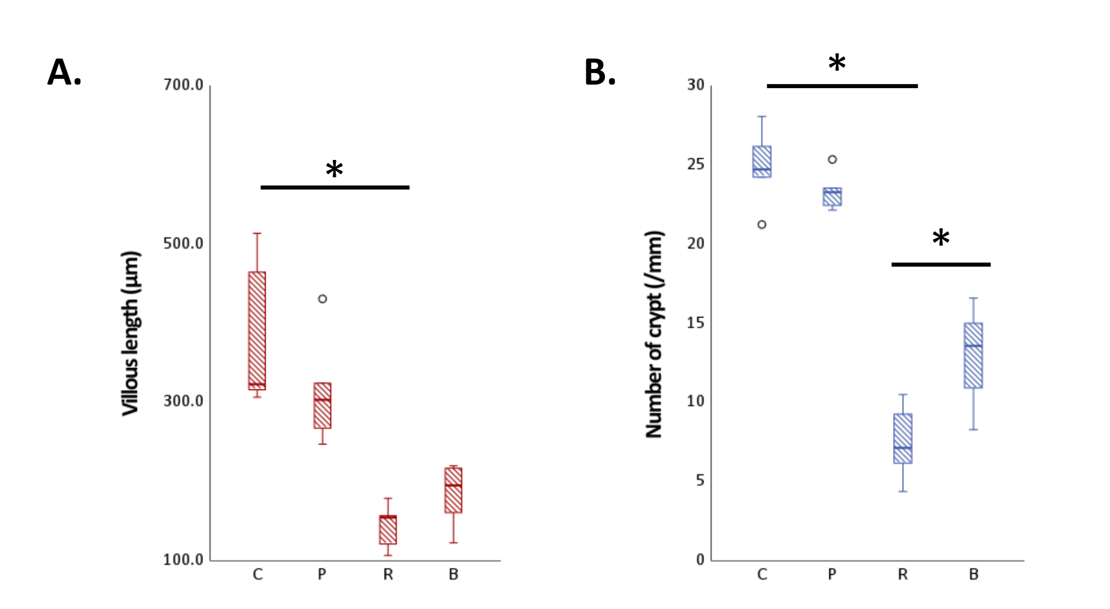
Supplementary Fig. 2. Histomorphologic evaluation for radiation enteritis mouse model. A. villous height, B. number of crypts. Significant differences were observed between irradiated and non-irradiated groups.
Abbreviations: C, control; P, probiotics only; R, radiation only; B, both radiation and probiotics. Asterisk represents p-value <0.05 by T-test.

