Facile synthesis of N-doped carbon dots (N-CDs) for effective corrosion inhibition of mild steel in 1 M HCl solution

E. A. Matterª, G. A. El-Naggarª, F. Nasrª and Gaber Hashem Gaber Ahmed^{a,b*}
ª Chemistry department, Faculty of Science, Damanhour University, Damanhour, 22511, Egypt
^{b} Science department, Rustaq college of Education, University of technology and applied sciences at Rustaq, Rustaq, 318, Sultanate of Oman


Fig. S1. The photo of mild steel working electrodes utilized in the study

Fig. S2. (a) UV-Vis. absorption spectrum; (b) Photoluminescence excitation (PLE) spectra (λ_{ex} = 253 and 337 nm); and (c) Excitation-independent emission spectra (λ_{em} = 410 nm) of the N-CDs nanoparticles.

Fig. S3 Open circuit potential- time curve for the MS electrode immersed 1M HCl solution in the absence and presence of the different concentrations of the N-CDs inhibitors at 298 K.

Fig. S4. Potentiodynamic polarization plots for MS substrates in molar hydrochloric acid in the temperature range (298 – 328 K); (a) in the absence and (b) presence of 200 mg/L N-CDs inhibitors.

Table S1. Electrochemical corrosion parameters obtained from potentiodynamic polarization curves for MS substrates in molar hydrochloric acid in the absence and presence of 200 mg/L N-CDs in the temperature range from 298 to 328 K.

Medium | Temp.  (K) | E_{corr}  (V vs. Ag/Ag/Cl) | i_{corr}  (µA.cm⁻²) | β_{a}  (mV.dec⁻¹) | -β_{c}  (mV.dec⁻¹) | CR  (mm/year) | R_{p}  (Ω .cm²) | η %
1 M HCl | 298 | -0.469 | 1761.2 | 129.65 | 123.49 | 20.465 | 40.508 | -
1 M HCl | 308 | -0.466 | 2256.9 | 137.25 | 134.10 | 26.225 | 33.901 | -
1 M HCl | 318 | -0.468 | 2807.5 | 139.16 | 135.83 | 32.623 | 28.565 | -
1 M HCl | 328 | -0.467 | 4503.6 | 139.63 | 133.34 | 52.332 | 18.908 | -
200 mg/L N-CDs | 298 | -0.478 | 57.56 | 125.03 | 118.48 | 0.668 | 1192.2 | 96.73 %
200 mg/L N-CDs | 308 | -0.479 | 79.649 | 126.71 | 126.57 | 0.926 | 896.75 | 96.47 %
200 mg/L N-CDs | 318 | -0.465 | 103.09 | 131.57 | 133.54 | 1.198 | 666.88 | 96.33 %
200 mg/L N-CDs | 328 | -0.465 | 207.35 | 138.96 | 136.67 | 2.409 | 360.50 | 95.39 %

Table S2. The electrochemical impedance parameters of the MS electrodes in 1 M HCl solution without and with 200 mg/L N-CDs at different immersion times.
C _{N-CDs}  (mg/L) | Time  (h) | CPE_{dl}  ( µΩ⁻¹.s^{n}.cm⁻²) |  | C_{dl}  (µΩ.cm⁻²) | R_{ct}  (Ω. cm²)
C _{N-CDs}  (mg/L) | Time  (h) | Y_{o} | n | C_{dl}  (µΩ.cm⁻²) | R_{ct}  (Ω. cm²)
Blank | 0.5 | 419.21 | 0.830 | 176.47 | 34.91
Blank | 2 | 979.25 | 0.790 | 375.36 | 27.70
Blank | 5 | 1001.80 | 0.803 | 384.28 | 20.09
Blank | 24 | 1654.80 | 0.771 | 511.35 | 11.59
Blank | 48 | 5334.90 | 0.727 | 1716.54 | 9.15
200 mg/L  N-CDs | 0.5 | 42.95 | 0.873 | 26.57 | 856.53
200 mg/L  N-CDs | 2 | 41.08 | 0.874 | 25.91 | 997.40
200 mg/L  N-CDs | 5 | 38.93 | 0.879 | 25.87 | 1320.40
200 mg/L  N-CDs | 24 | 37.18 | 0.880 | 24.99 | 1458.80
200 mg/L  N-CDs | 48 | 34.65 | 0.880 | 24.17 | 2058.20

Table S3. Corrosion parameters for the MS samples vs. time of exposure to 1 M HCl corrosive medium in the absence and presence of 200 mg /L of N-CDs at 298 K.

Parameters |  | CR (mm/year) | 𝜼% | Parameters |  | CR (mm/year) | 𝜼%
Blank | 0.5 h | 20.465 | - | N-CDs | 0.5 h | 0.668 | 96.73 %
Blank | 2 h | 34.978 | - | N-CDs | 2 h | 0.589 | 98.31 %
Blank | 5 h | 45.472 | - | N-CDs | 5 h | 0.405 | 99.10 %
Blank | 24 h | 87.267 | - | N-CDs | 24 h | 0.362 | 99.58 %
Blank | 48 h | 11.44 | - | N-CDs | 48 h | 0.306 | 99.73 %

Table S4. Potentiodynamic polarization parameters of MS samples after exposure to 1 M HCl with different mixtures of the studied corrosion inhibitors.
Condition | i_{corr}  (µA.cm⁻²) | CR  (mm/year) | R_{p}  (Ω.cm²) | η (%)
200 mg/L Ce (III) | 1662.2 | 19.31 | 49.78 | 5.62 %
200 mg/L 8-HQ | 1562.3 | 18.15 | 56.13 | 11.29 %
200 mg/L N-CDs | 57.56 | 0.668 | 1192.2 | 96.73 %
200 mg/L ( N-CDs + Ce(III)) | 65.48 | 0.761 | 990.18 | 96.28 %
200 mg/L ( N-CDs + 8-HQ) | 51.44 | 0.598 | 1219.5 | 97.08 %
200 mg/L ( N-CDs + Ce (III) + 8-HQ) | 40.69 | 0.473 | 1539.7 | 97.69 %

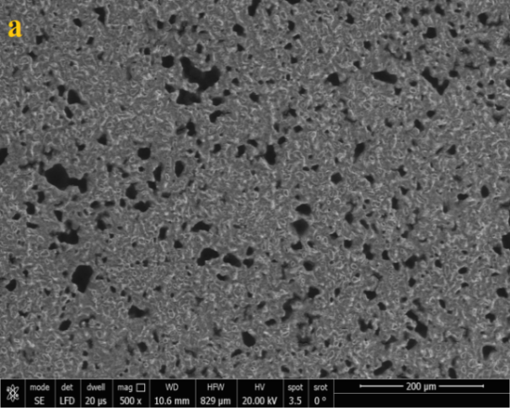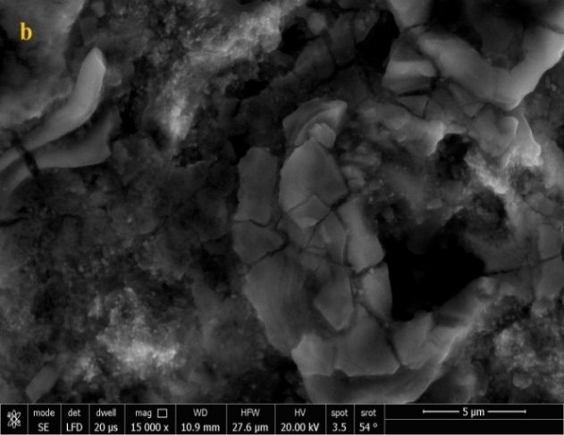
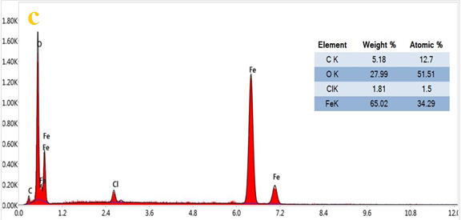
Fig. S5. (a) Low, (b) high magnification scanning electron micrographs of MS sample after 6 hours of exposure to 1 M HCl solution, and (c) their corresponding energy dispersive X-ray (EDX) spectrum and table for distribution of the elements on the surface.

UV–Vis. spectroscopy analysis
The UV-visible test was performed to judge the possibility of complex formation between Fe and N-CDs [1]. Figure S6 show the corresponding UV-Vis absorption spectra of 1 M HCl solution containing 200 mg/L of N-CDs before and after 24 h immersion of mild steel. The maximum absorption was raised from 0.108 and 0.046 to 0.143 and 0.085 for the N-CDs inhibitors after immersion. The obtained differences revealed that these N-CDs could interact with iron and form Fe-inhibitor complexes.

Fig. S6. UV -Vis spectra of 1 M HCl solution containing 200 mg/L of N-CDs; (I) pre-immersion and (II) post-immersion of MS for 24 h.

References:
1. Berrissoul, A., Ouarhach, A., Benhiba, F., Romane, A., Guenbour, A., Outada, H., ... & Zarrouk, A. (2022). Exploitation of a new green inhibitor against mild steel corrosion in HCl: Experimental, DFT and MD simulation approach. Journal of Molecular Liquids, 349, 118102.

