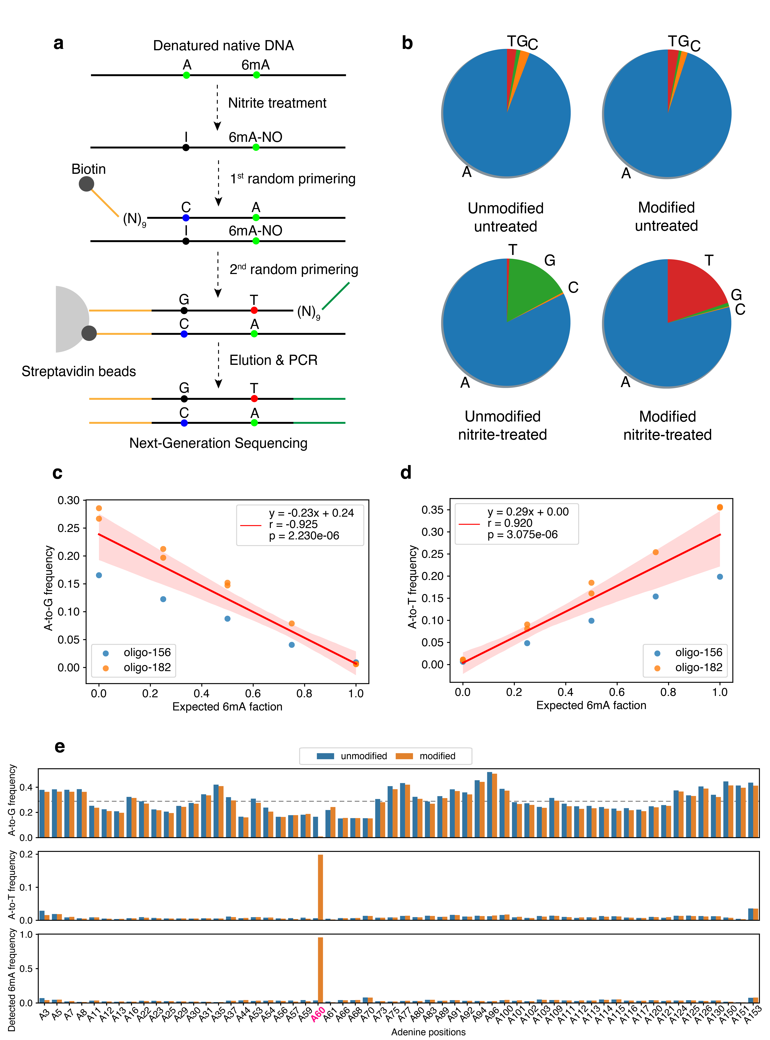
Supplementary Figure 1: Additional information for 6mA detection in oligonucleotides using NAME-seq. a, The workflow of NAME-seq. b, ﻿The base composition of unmodified/6mA oligo with/without nitrite treatment. c-d, Correlation of expected 6mA percentage of oligo and A-to-G frequency (c) or A-to-T frequency (d). e, The A-to-G frequency, A-to-T frequency, and detected 6mA frequency of all adenine positions in oligo-156 (6mA position at A60).

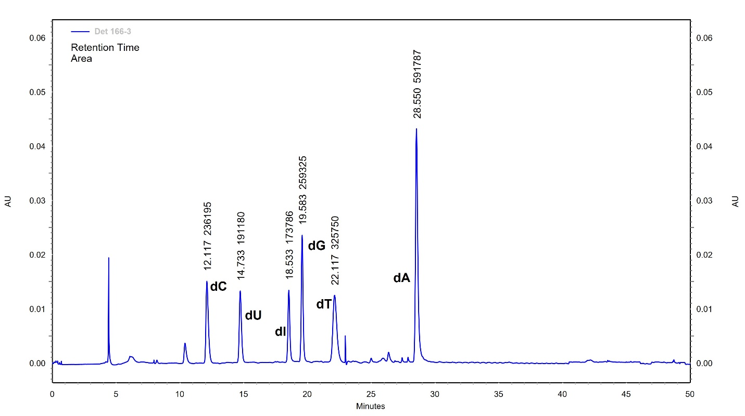Supplementary Figure 2. A representative HPLC trace for the separation of nucleosides from the digestion mixture of unmodified oligodeoxynucleotide with sodium nitrite treatment.

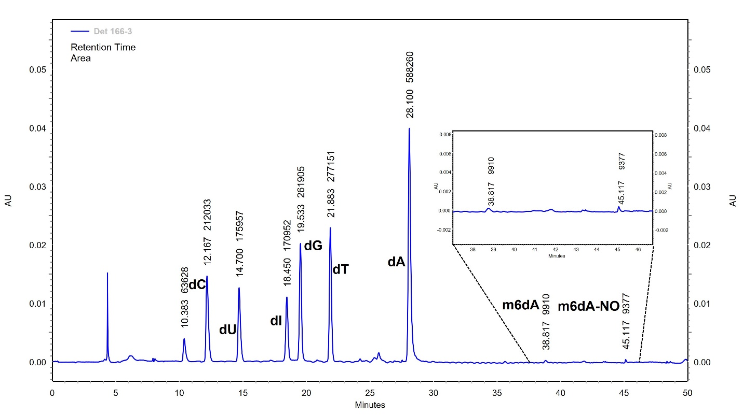Supplementary Figure 3. A representative HPLC trace for the separation of nucleosides from the digestion mixture of modified oligodeoxynucleotide with sodium nitrite treatment.

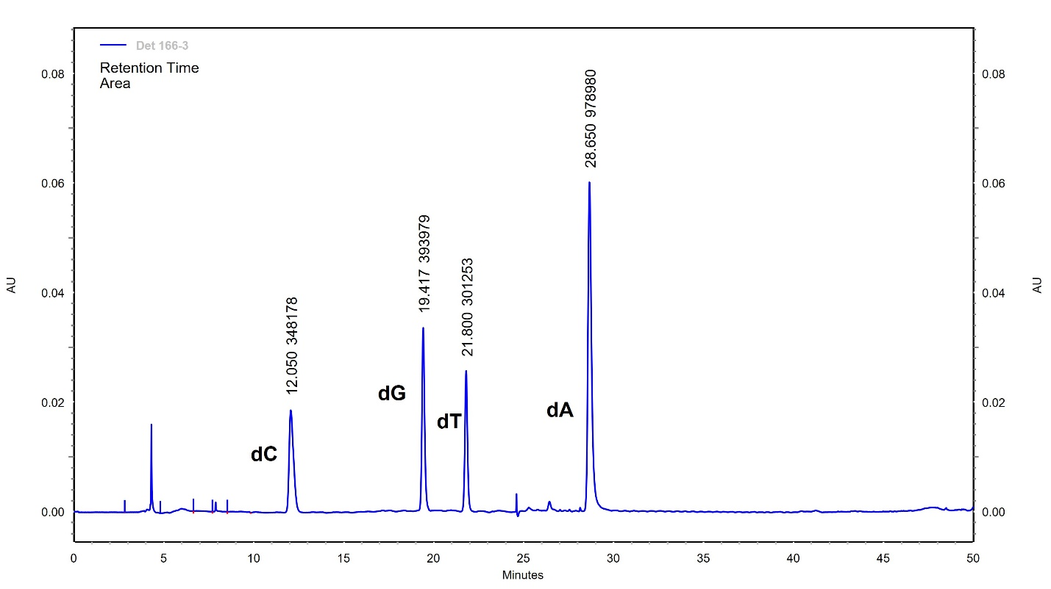Supplementary Figure 4. A representative HPLC trace for the separation of nucleosides from the digestion mixture of unmodified oligodeoxynucleotide without sodium nitrite treatment.

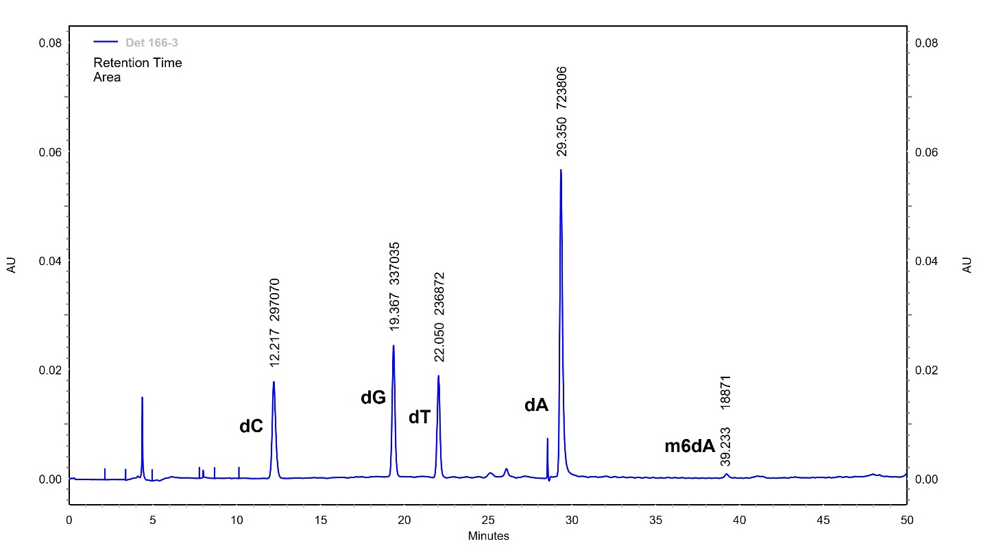Supplementary Figure 5. A representative HPLC trace for the separation of nucleosides from the digestion mixture of modified oligodeoxynucleotide without sodium nitrite treatment.

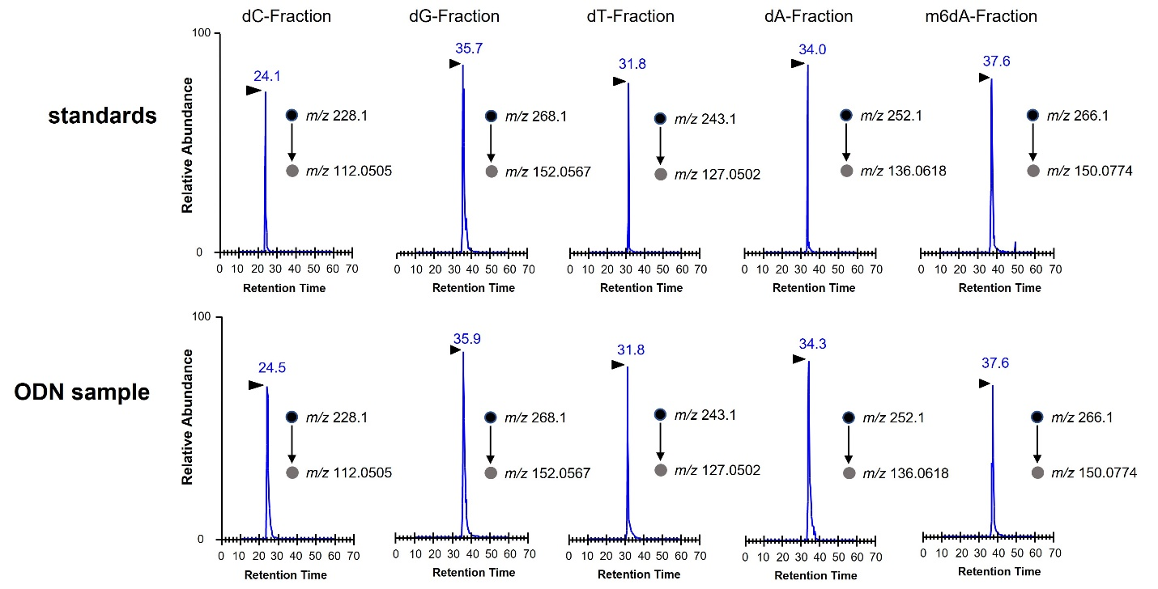Supplementary Figure 6. Representative selected-ion chromatograms (SICs) for monitoring the transitions of dC, dG, dT, dA and 6mdA in the corresponding HPLC fractions from the standards (top) and the digestion mixture of ODN samples (bottom).

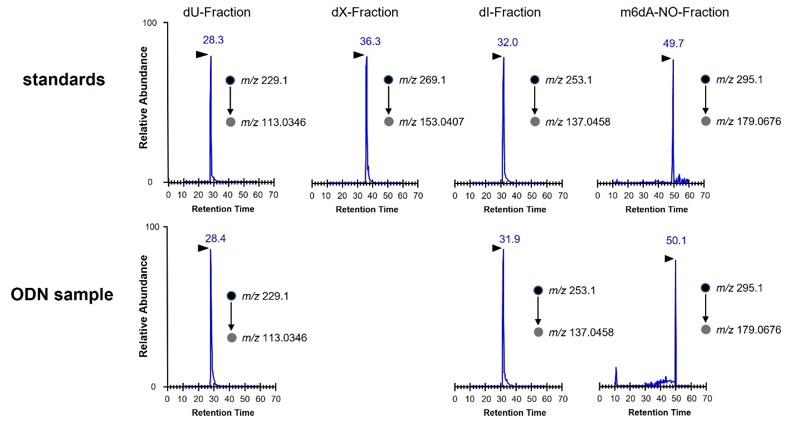Supplementary Figure 7. Representative selected-ion chromatograms (SICs) for monitoring the transitions of dU, dX, dI and 6mdA-NO in the corresponding HPLC fractions from the standards (top) and the digestion mixture of ODN samples (bottom).

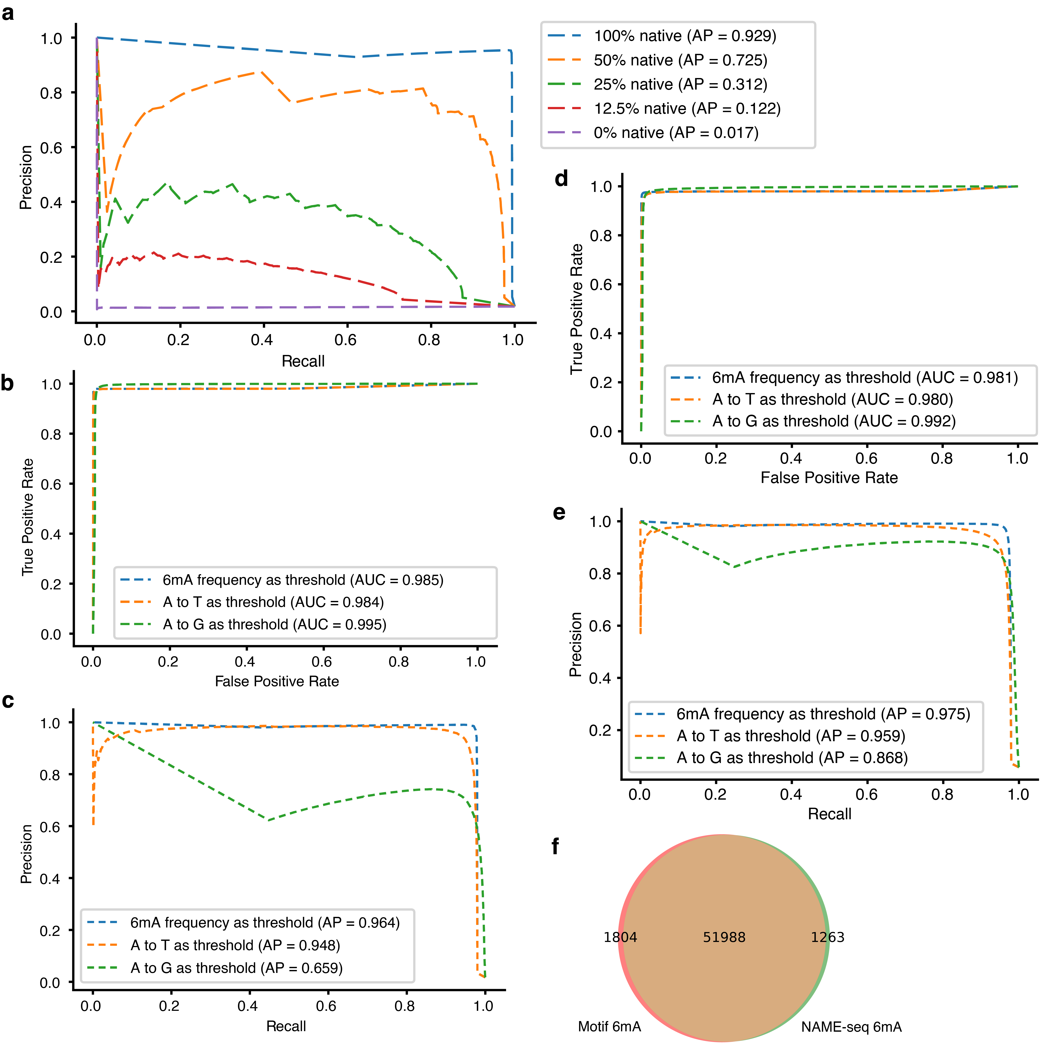
Supplementary Figure 8: Additional information of detecting 6mA in bacteria using NAME-seq. a, PR curve of NAME-seq in detecting 6mA at different dilution of native E. coli DNA. b-c, ROC (b) and P-R (c) curve of NAME-seq detected 6mA in E. coli strain MG1655. The AP values indicate that combining A-to-G and A-to-T to 6mA frequency provides the best performance (AP = 0.964). d-e, ROC(d) and P-R (e) curves of NAME-seq detected 6mA in H. pylori strain JP26. f, Venn diagrams of NAME-seq detected 6mA and methylation motif 6mA in H. pylori strain JP26.
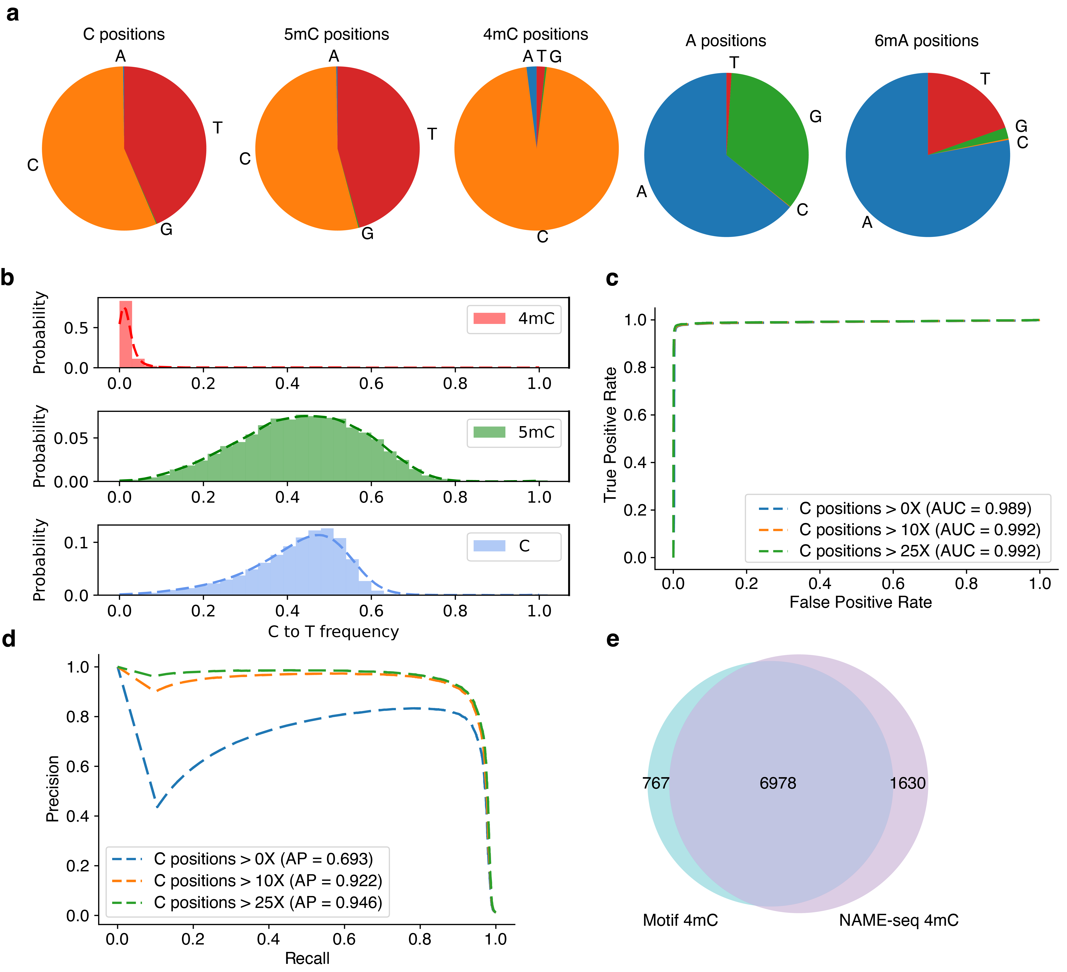
Supplementary Figure 9: Detection of 4mC in H. pylori using NAME-seq. a, Pie charts of base composition of C, 5mC, 4mC, A, and 6mA. b, The C-to-T frequency of 4mC, 5mC, and unmethylated cytosine positions in H. pylori genome. c, ROC curve of 4mC detection in H. pylori strain JP26 using NAME-seq. d, P-R curve of 4mC detection in H. pylori strain JP26 using NAME-seq. e, The overlap of known 4mC and NAME-seq detected 4mC (No depth filtering) in H. pylori.
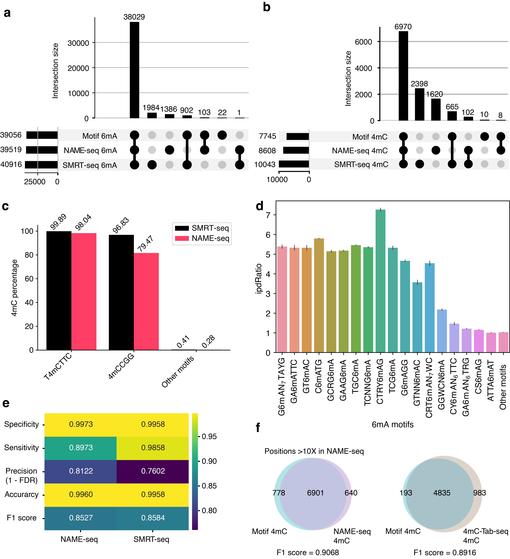
Supplementary Figure 10: Additional information of comparison of NAME-seq and SMRT-seq. a, Comparison of NAME-seq and SMRT-seq in detecting 6mA at single-base resolution level in E. coli. b, Comparison of NAME-seq and SMRT-seq in detecting 4mC at single-base resolution level in H. pylori. c, Comparison of NAME-seq and SMRT-seq in detecting 4mC at motif level in H. pylori. d, The SMRT-seq average IPD-Ratio of 6mA motif sites in H.pylori. e, Heatmap of 4mC detection performance metrics in H. pylori by NAME-seq and SMRT-seq indicating a comparable performance of NAME-seq and SMRT-seq in detecting 4mC. f, Comparison of NAME-seq (H. pylori) and 4mC-Tab-seq (Caldicellulosiruptor kristjanssonii) in detecting 4mC at single-base resolution.

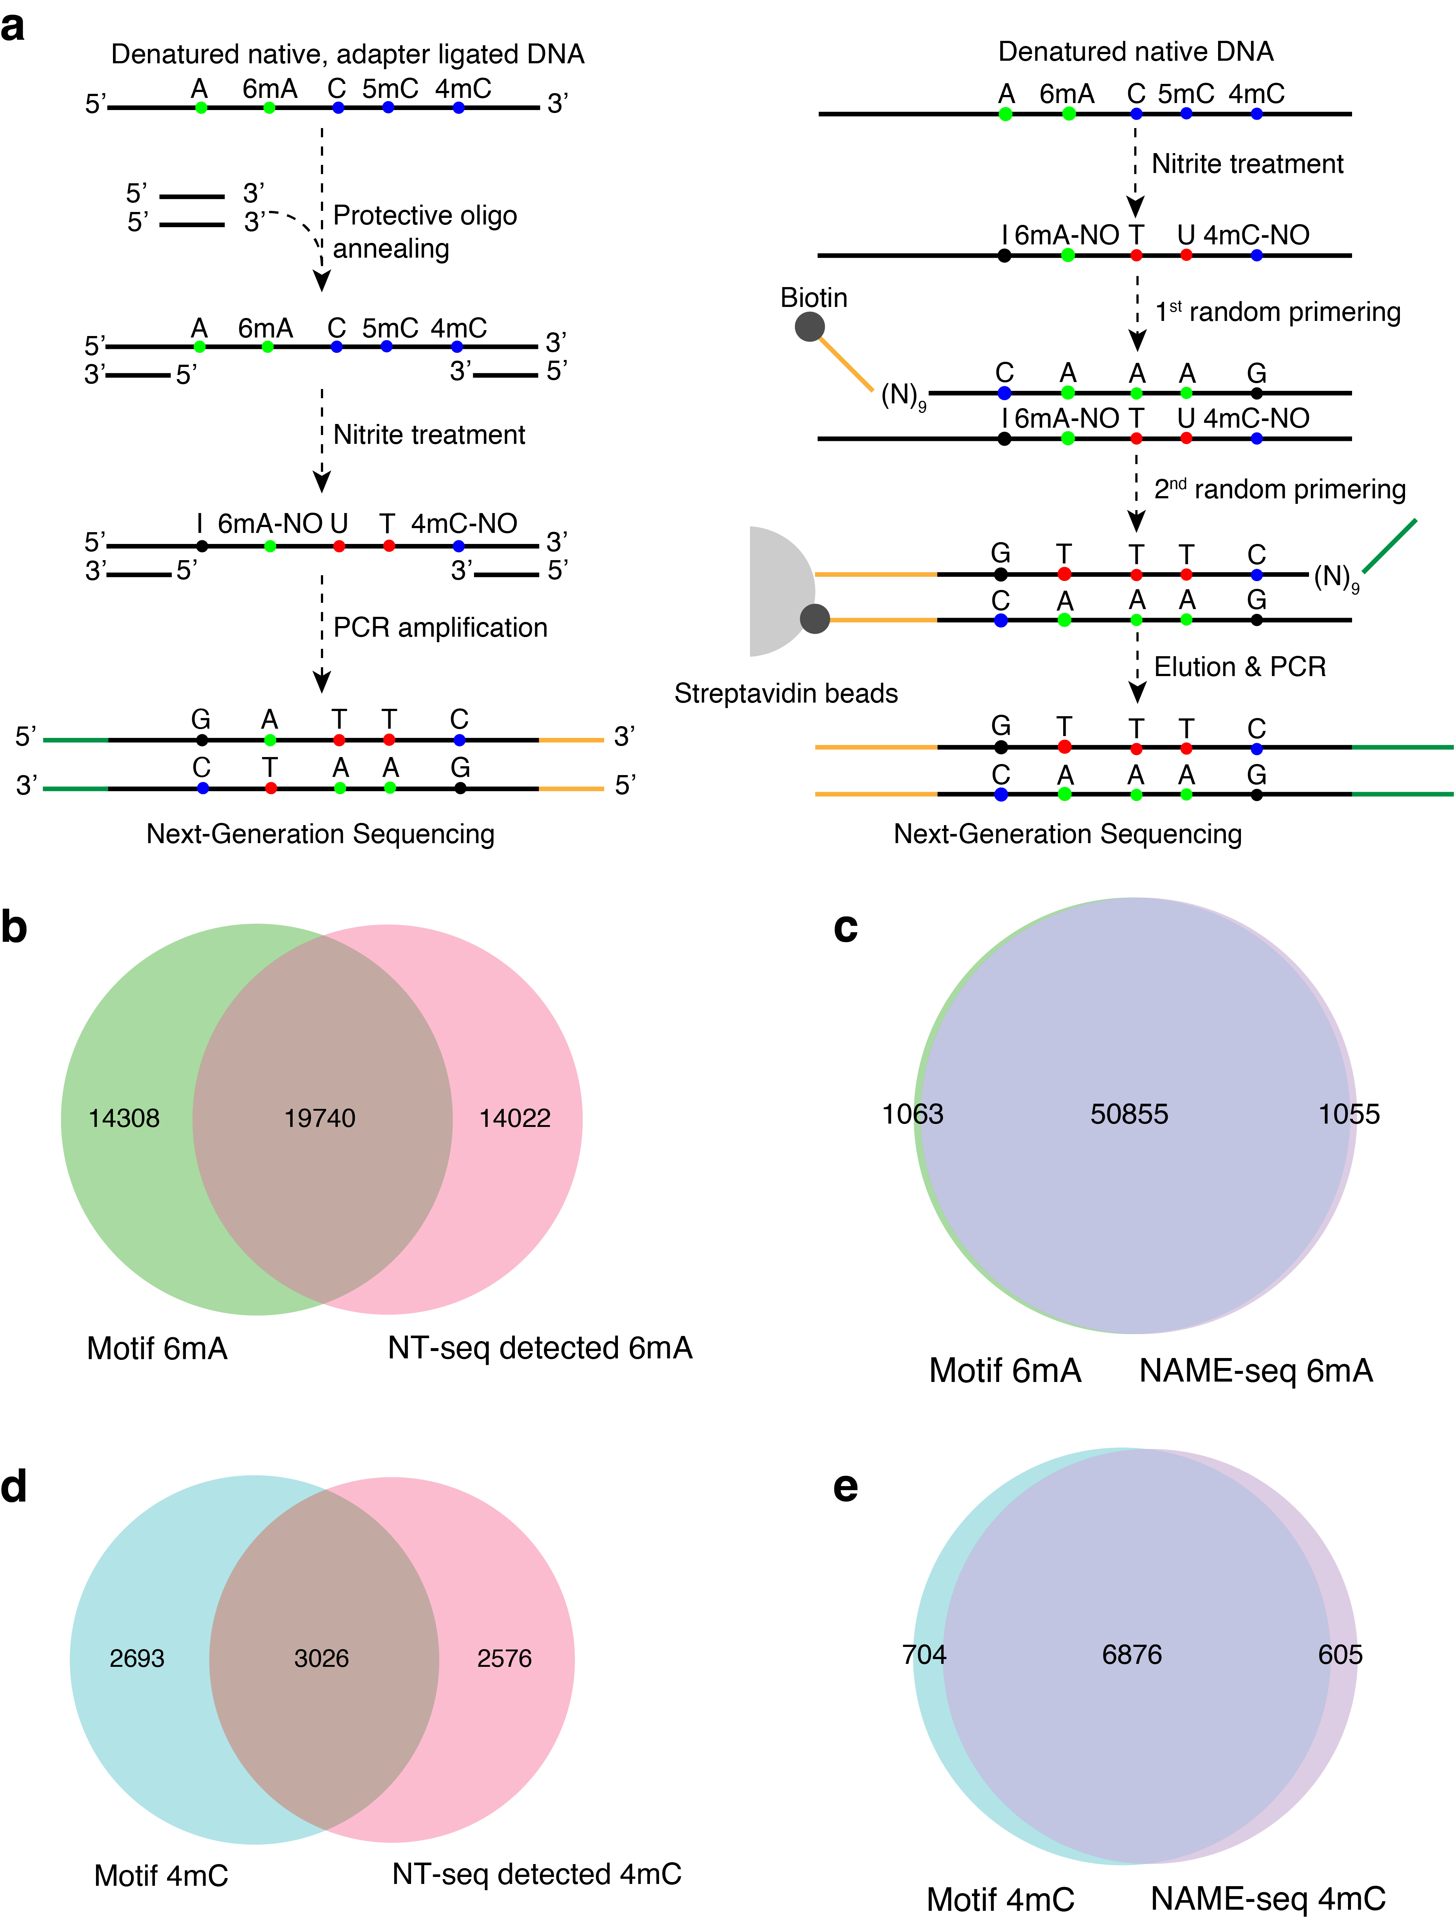
Supplementary Figure 11: Comparison of NAME-seq with previous NT-seq. a, Experimental workflow comparison between NT-seq (left) and NAME-seq (right). b-c, Comparison of NT-seq (b) and NAME-seq (c) in detecting H. pylori 6mA. d-e, Comparison of NT-seq (d) and NAME-seq (e) in detecting H. pylori 4mC.

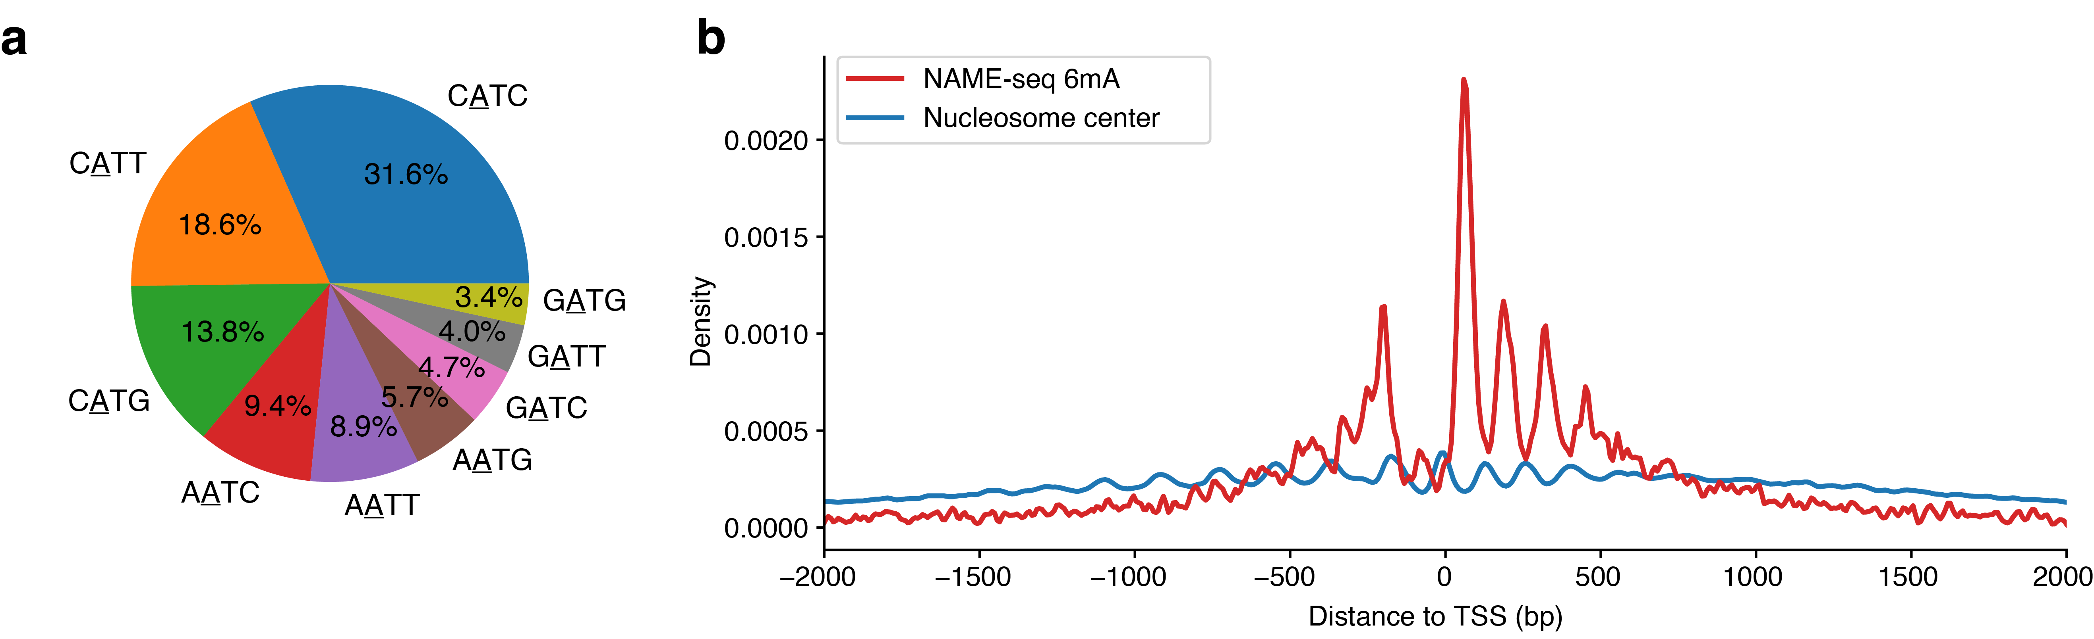
Supplementary Figure 12: Additional information for 6mA detection in C. reinhardtii genome using NAME-seq. a, Distribution of NAME-seq detected 6mA across different sub-motifs of VATB. b, The periodic distribution of NAME-seq detected 6mA (anti-correlated to nucleosome positioning) around transcription start sites (TSS) in C. reinhardtii.

 | no 6mdA context
 | dC/dT | dG/dT | dA/dT
sodium nitrite treated | 0.76 | 0.83 | 2.01
untreated | 1.20 | 1.33 | 3.23
treated/untreated | 0.63 | 0.63 | 0.62
Supplementary Table 1. The abundance change of dC/dG/dA in unmodified ODN samples before and after sodium nitrite treatment. (Values represent the average from three independent replicates.)

 | 6mdA containing context
 | dC | dG | dA
sodium nitrite treated | 0.82 | 0.92 | 2.17
untreated | 1.24 | 1.39 | 3.16
treated/untreated | 0.66 | 0.66 | 0.69
Supplementary Table 2. The abundance changes of dC/dG/dA in modified ODN samples before and after sodium nitrite treatment. (Values represent the average from three independent replicates.)

Name | dA to dI | 6mdA to 6mdA-NO | dC to dU
Unmodified-nitrite-treated-rep1 | 0.38 |  | 0.38
Unmodified-nitrite-treated-rep2 | 0.34 |  | 0.37
Unmodified-nitrite-treated-rep3 | 0.35 |  | 0.37
Modified-nitrite-treated-rep1 | 0.37 | 0.49 | 0.38
Modified-nitrite-treated-rep2 | 0.36 | 0.51 | 0.39
Modified-nitrite-treated-rep3 | 0.35 | 0.44 | 0.36
Mean | 0.36 | 0.48 | 0.37
Standard deviation | 0.014 | 0.039 | 0.012
Supplementary Table 3. Conversion rates of dA to dI, 6mdA to 6mdA-NO and dC to dU with sodium nitrite treatment.

Methylated and unmethylated oligos (5'-3')
6mA-156- modified | GGACACAATGAAAGCATTTCTAAGAGGGAAACCCATAGCTCTGAGTGCCTCCAAGAAGA[6mA]ACGGGAGAGAGCACATACTA  GCAGCTTGACAACACATCTAAAAGCTCTAGAAAAAAAGGAAGCAAATTCACCCCCCGTTCTTCTCTGCTAACACCC
6mA-156-unmodified | GGACACAATGAAAGCATTTCTAAGAGGGAAACCCATAGCTCTGAGTGCCTCCAAGAAGAAACGGGAGAGAGCACATACTA GCAGCTTGACAACACATCTAAAAGCTCTAGAAAAAAAGGAAGCAAATTCACCCCCCGTTCTTCTCTGCTAACACCC
6mA-182- modified | GTTCTGTGACTCCTGAAAATGCACATGCACACGCACATGCACACACACCCACACACGCACACAGA[6mA]CTTTTAAGGGTGGAGTCACCCACAGTATGGTGGCATCTCTCAAATCATTAATTCAAGAAAATGGGTCCTATAACCTTCCACCAACTGAAAAATCATAAGCCCAGTTTCAGGCACTC
6mA-182-unmodified | GTTCTGTGACTCCTGAAAATGCACATGCACACGCACATGCACACACACCCACACACGCACACAGAACTTTTAAGGGTGGAGTCACCCACAGTATGGTGGCATCTCTCAAATCATTAATTCAAGAAAATGGGTCCTATAACCTTCCACCAACTGAAAAATCATAAGCCCAGTTTCAGGCACTC
Library preparation oligos (5'-3')
Biotin-R2-N9 | [Btn]CAGACGTGTGCTCTTCCGATCTNNNNNNNNN
R1-N9 | CTACACGACGCTCTTCCGATCTNNNNNNNNN
R2-22nt | CAGACGTGTGCTCTTCCGATCT
R1-22nt | CTACACGACGCTCTTCCGATCT
Supplementary Table 4: Oligos and primers used in this study.

Organism name | Reference genome
E. coli MG1655 | Escherichia coli str. K-12 substr. MG1655, complete genome
H. pylori JP26 | Helicobacter pylori strain HPJP26 chromosome, complete genome
C. reinhardtii | Chlamydomonas reinhardtii v5.0 (JGI)
H. sapiens | Genome sequence, primary assembly (GRCh38, Gencode)
Supplementary Table 5: Reference genome used in this study

