Extended Data
GPe Astrocytes and Prototypic Neurons Selectively Represent Routine Formation

Minsu Abel Yang^{1,2,#}, Sa-Ik Hong^{3,#}, Shinwoo Kang^{4,#}, Jeyeon Lee⁵, Minryung Song¹, Sang Wan Lee^{1,2,6,7,†} and Doo-Sup Choi^{4,8,9,†}

¹Department of Bio and Brain Engineering; ²Program of Brain and Cognitive Engineering, Korea Advanced Institute of Science and Technology (KAIST), 34141, Daejeon, Republic of Korea, ³Department of Pharmacy, Dongguk University Gyeongju Hospital, 38067, Gyeongju, Republic of Korea, ⁴Department of Molecular Pharmacology and Experimental Therapeutics; ⁵Department of Radiology, Mayo Clinic, 55905, Rochester, Minnesota, United States, ⁶Korea Advanced Institute of Science and Technology (KAIST) for Health Science Technology; ⁷KAIST for Artificial Intelligence, Korea Advanced Institute of Science and Technology (KAIST), 34141, Daejeon, Republic of Korea, ⁸Department of Psychiatry and Psychology; ⁹Neuroscience Program, Mayo Clinic College of Medicine and Science, 55905, Rochester, Minnesota, United States.

# Contributed equally to this work as the first author.
† Corresponding author. E-mail: choids@mayo.edu; sangwan@kaist.ac.kr

Methods
Animals. All experimental procedures were approved by the Mayo Clinic Institutional Animal Care and Use Committee and performed following NIH guidelines. C57BL/6J, GFAP-Cre (Stock No. 024098), PV-Cre (Stock No. 017320), and GCaMP6s (Stock No. 028866) mice were purchased from Jackson Laboratory (Bar Harbor, ME). Mice were housed in standard Plexiglas cages. The colony room was maintained at a constant temperature (24 ± 1°C) and humidity (60 ± 2%) with a 12 h light/dark cycle (lights on at 07:00 A.M.). We used 8- to 10-week-old male mice for all experiments. Mice were allowed ad libitum access to food and water. For the operant conditioning tests, mice were food restricted to 85% of their baseline weight, at which time they were maintained for the duration of experimental procedures.

Stereotaxic surgery and virus injection. Mice were anesthetized with isoflurane (1.5% in oxygen gas) with the VetFloTM vaporizer with a single-channel anesthesia stand (Kent Scientific Corporation, Torrington, CT) and placed on the digital stereotaxic alignment system (Model 1900; David Kopf Instruments, Tujunga, CA). Hair was trimmed, and the skull was exposed using an 8-gauge electrosurgical skin cutter (KLS Martin, Jacksonville, FL). The skull was leveled using a dual tilt measurement tool. Holes were drilled in the skull at the appropriate stereotaxic coordinates. For in vivo Ca²⁺ imaging of GPe neurons, the virus was infused unilaterally to the DLS (AP +0.6 mm, ML +2.4 mm, DV -3.1 mm from bregma) at 100 nL/min for 5 min through a 33-gauge injection needle using a micro-syringe pump. The injection needle remained in place for an additional 6 min following the end of the injection. Following stereotaxic surgery, we injected buprenorphine sustained-release LAB (1 mg/kg, s.c.; ZooPharm, Laramie, WY, USA) to alleviate post-surgery pain. Mice were utilized for the experiments 4-5 weeks after the virus injection. Next, we implanted an optic cannula (200/240 µm diameter, 200 µm end fiber) and fixed it into the GPe (AP -0.46 mm, ML +2.0 mm, DV -3.0 mm from bregma) of the cell-type, specifically GCaMP6s-expressing mice by stereotaxic surgery.

Behavioral experiments. 1) Operant conditioning. The operant chamber consisted of an active hole, an inactive hole, a magazine, a house light, a speaker, and a cue light at each nose port. Reward (20% sucrose solution) was presented to the liquid receptacle in the magazine once per reward signal by a syringe pump. The nose-poking behavior of mice was followed by two contradicting results in some cases. One is the case of rewarded nose-poke. When the mice did a nose-poke in the active hole, the chamber presented tone, light from the nose port, and one reward from the magazine. On the other hand, in the case of non-rewarded nose-poke, the chamber did not present anything, no matter how nose-poke the mice did (Fig. 1a). The operant conditioning schedule is as follows.

On the first day, magazine training was performed for 30 minutes to let the mice learn the magazine’s space. After that, the fixed ratio of 1 (FR1) was performed for 4 sessions and 60 minutes. Furthermore, if mice obtained 60 rewards, the session was terminated regardless of the remaining time. For rapid learning of operant behavior, 10 uL of 20% sucrose was placed in the active hole as bait before starting the FR1 session. Moreover, in two consecutive sessions, when the average latency time from nose-poke to the magazine was less than 2 seconds, no bait was placed in the active hole from the next session. In the last, fourth session of the FR1 task, all mice performed operant behavior without prior bait presentations. Until the fourth session of the FR1 task, if the average latency time from nose-poke to the magazine was more than 2 s, we planned to discard that mice data, but none was excluded. The nose-poke and magazine entry time points, session duration, latency time from nose-poke to magazine approach, time spent in the magazine, and the number of nose-pokes and magazine entries were recorded using the Med-PC IV software, and the time resolution was 10 ms.

In vivo calcium imaging with fiber-photometry. We recorded the cellular calcium transients in real-time in vivo by fiber photometry described previously ¹⁵. The optic fiber was linked to a patch cord, allowing the light-emitting diode intensity at the interface of the fiber tip to rage at 80 µW consistently. These output signals were projected onto a photodetector by the same optical fiber passed through a GFP filter. Data analysis was performed using the CineLyzer software (Ver. 4.4, Plexon), and light intensities were measured as relative fluorescence change (∆F/F0). ∆F/F0 (%) was calculated relative to the signal (F0) averaged in the 3 s preceding the time alignment. The camera for observing the mice’s performance and the camera for observing the fluorescence change of GCaMP6s were synchronized and recorded at 30 frames per second. In operant conditioning, we recorded Ca²⁺ imaging in the GPe of mice during the last sessions of FR1. For preprocessing, all Ca²⁺ activity traces were normalized to the range [0,1] based on the minimum and maximum of ∆F/F0 individually.

Definition of block and cycle. To dissect animal behavior systematically and investigate it under the minimal effect due to different motor events, we divided the entire behavior into blocks, the transitions between two adjacent action events. There are three possible action events in this task; nose-poke (NP), magazine entry (ME), and magazine exit (MX). By definition, there are five blocks. The extensive descriptions of each block are listed in Extended Data Table 3.

Furthermore, we classified them into two categories based on whether the block consists of a closed-loop to receive a reward, which length is longer than 1. We referred to the blocks required and optional to satisfy the reward condition as routine blocks (NP-ME, ME-MX, MX-NP) and non-routine blocks (NP-NP, MX-ME), respectively (Fig. 1d).

Next, in terms of achieving consistent rewards, we can view the entire behavior as the repetition of "nose-poke, then receive a reward." Consistently, we defined the chain of blocks "NP-ME, ME-MX, MX-NP, NP-ME" as a cycle. We rejected the behavioral and photometry data in the cycle where the latency of block NP-ME is more than 2 seconds. If the rejection rate was higher than 20%, we planned to discard that mouse data, but none was excluded.

Definition of the routine index. To quantify how close the subject is to the routine simultaneously, we defined the routine index of one cycle as the function of the time spent to complete the current cycle. Here, we assumed that the subject, which behaves more routinely, spends less time finishing one cycle. Suppose that there is a subject’s $k$^{th} cycle $C_{k}$. Then, mathematically, its routine index $d_{R}\left(C_{k}\right)$ is

$$d_{R}\left(C_{k}\right)=f\left(\frac{N_{F}}{N\left(C_{k}\right)}\right),$$

where $N_{F}$ is the number of frames per minute (1800 frames for 30 Hz measurement) for rescaling the index within the countable range, $N$ is the function that returns the number of frames occupied by the corresponding cycle, and $f$ is a transformation function, which guides the distribution of routine indices toward the normal distribution. After testing various transformation functions, we fixed $f$ to the square root function, which is the most effective among candidates (Extended Data Fig. 3).

Block alignment. We delineated two alignment methods for visualization and further analyses within a single block type. In head-fixed alignment, blocks were aligned to the timestamp when the initial action event of each block occurred to focus on the cellular activity during the initial period inside the block. In tail-fixed alignment, blocks were aligned to the timestamp when the terminal action event of each block occurred to focus on the cellular activity during the terminal period inside the block. We determined the window length of both head-fixed and tail-fixed alignments for each block type as half of the average block length to prevent overlap between different alignments.
Tensor component analysis. We utilized the nonnegative TCA ¹⁶ to approximate cellular activities with respect to common bases across the blocks. Let $X$ denote a $K×T$ matrix dataset containing $K$ blocks with identical block type, where the population activity is recorded over $T$ frames. The tensor representation requires that the number of frames within each block be identical for all blocks, whereas the mice took a variable amount of time to complete each block. Hence, we fixed $T$ to the 50th percentile of block length distribution for each block type. Blocks whose lengths are shorter than $T$ were discarded during TCA analyses. The exact values of $T$ for every block type are listed in Extended Data Tables 4.

Here, TCA factorizes the original matrix $X$ and approximates it as the product of two matrices, $B∈R^{K×R}$ and $A∈R^{T×R}$, where $BA^{T}≅X$. Specifically, $r$^{th} columns of $B$ and $A$, $b^{r}$ and $a^{r}$, are the trial factors (within-session factors) and the temporal factors (within-block factors) of the $r$^{th} tensor component, respectively. To determine the order between the tensor components, we computed $λ_{r}$ by rescaling the columns of $B$ and $A$ to unit length and merging these scalings into the constant $λ_{r}$ for each tensor component. The descending order of $λ_{r}$ determines the order between tensor components. Then the estimate of the data becomes:

$${\hat{x}}_{kt}=\sum_{r=1}^{R}{λ_{r}b_{k}^{r}a_{t}^{r}}.$$

The criterion for determining the number of tensor components. To determine the number of components $R$ for each analysis employing TCA, we utilized the cross-validation procedure, configuring model error and similarity plots (Extended Data Fig. 6-7). For scalable model selection, we determined the removal probability $p_{CV}$ using the conjecture of how TCA becomes robust to overfitting ¹⁶. Roughly, the probability of overfitting depends on $F(R)$, the ratio between the number of entities in the training matrix and the tensor components,

$$F\left(R\right)=\frac{\left(1-p_{CV}\right)KT}{R\left(K+T-1\right)}.$$

To identify the optimal number of components $R^{*}$ by the cross-validation, the model should show overfitting when $R>R^{*}$. Since $F(R)$ is a decreasing function to $R$, we can satisfy such conditions by increasing $p_{CV}$. However, if $p_{CV}$ reaches too high, TCA cannot extract valuable information because the amount of training data shown becomes incomparably tiny than the original data. Especially if $F(R)<1$, it indicates that the model owns more parameters than the number of data it should encode, so much more prone to overfitting. Thus, we set the lower bound on $p_{CV}$ to guarantee that $F(R)≥1$ for every candidate $R$ in predefined set $R=[1, 12]⊂N^{+}$.
In conclusion, we set the removal probability $p_{CV}$ to $p_{CV}^{*}$ for each block type, the lowest value satisfying the above statement. It was computed by using the principles that $F(R)$ is decreasing function and $F(R_{M})=1$, where $R_{M}$ is the maximum (12) of the set $R$,

$$p_{CV}^{*}=1-\frac{R_{M}\left(K+T-1\right)}{KT}.$$

For the dataset $X∈R^{K×T}$, Monte Carlo cross-validation was conducted 100 rounds. For each round, we generated a masking matrix $M∈R^{K×T}$ where $m_{kt}=0$ with probability $p_{CV}^{*}$ and $m_{kt}=1$ with probability $1-p_{CV}^{*}$. From $M$, we constructed the training set $X^{tr}$ and test set $X^{te}$ by following rules;

$$x_{kt}^{tr}=\left\{\begin{aligned}NaN, &m_{kt}=0 \\ x_{kt}, &m_{kt}=1\end{aligned}\right., x_{kt}^{te}=\left\{\begin{aligned}x_{kt}, &m_{kt}=0 \\ NaN, &m_{kt}=1\end{aligned}\right.,$$

where $NaN$ indicates a missing value. Using $X^{tr}$, we trained the TCA model $\{B^{tr},A^{tr}\}$ and measured normalized reconstruction error from both $X^{tr}$ and $X^{te}$. After the entire cross-validation was completed, the pairwise similarity scores ¹⁶ were also calculated from the set containing 100 TCA models. Consequently, we determined the number of tensor components $R^{*}$ for the analysis of $X$ based on two criteria; (1) whether $R^{*}$ is included within the region of local minima of normalized reconstruction error from the test set, and (2) whether the pairwise similarity score at ${R=R}^{*}$ is higher than 0.8, which is the recommended option in the previous study ¹⁶.

Modulation of cellular activity during the routine and non-routine block with respect to the routine index. To identify whether the block type subject is conducting can affect the Ca²⁺ activity around one action event and investigate the tendency of its modulation with respect to the routine index, we designed the following test. For pair of blocks, one for routine and another for non-routine block, in which initial or terminal action events were matched (For example, NP-ME and NP-NP), we first collected the matrix containing the Ca²⁺ activity during a routine block $X_{R}∈R^{K_{R}×T_{R}}$ and the matrix during non-routine block $X_{N}∈R^{K_{N}×T_{N}}$. For preprocessing, we matched the number of columns (the number of frames) of two matrices by trimming additional columns of one matrix. To represent Ca²⁺ activity during different blocks within common grids, we concatenated two matrices and decomposed it by tensor component analysis (TCA),

$$X^{'}=\left[\begin{matrix}X_{R}^{'} \\ X_{N}^{'}\end{matrix}\right]=BA^{T}, B=\left[\begin{matrix}B_{R} \\ B_{N}\end{matrix}\right],$$

where $X_{R}^{'}$ and $X_{N}^{'}$ are trimmed versions of $X_{R}$ and $X_{N}$, respectively. Consequently, the matrix $B∈R^{\left(K_{R}+K_{N}\right)×R}$ contains trial factors of routine and non-routine blocks, and the matrix $A∈R^{T_{C}×R}$ consists of temporal factors common to both blocks. Here, $T_{C}$ indicates $min([T_{R}, T_{N}])$.

For each block, there exists a corresponding routine index $d_{R}$. Nonetheless, each block occurs at a different relative timepoint $t_{S}$, thus it needs to be compensated while analyzing how trial factors $B$ change in terms of $d_{R}.$ To do so, for $i$^{th} tensor component and its associated trial factors $b_{R}^{i}$ and $b_{N}^{i}$, we separately computed $ρ(d_{R},b_{R}^{i}|t_{S})$ and $ρ(d_{R},b_{N}^{i}|t_{S})$, the Spearman partial correlation coefficients between $d_{R}$ and $b_{R}^{i}$/$b_{N}^{i}$ while controlling for $t_{S}$. To evaluate whether $ρ(d_{R},b_{R}^{i}|t_{S})$ differs from $ρ(d_{R},b_{N}^{i}|t_{S})$ significantly, we conducted independent-sample permutation tests.

Statistical analyses. All data are represented as mean ± s.e.m. and were analyzed by a one-sample permutation test, paired-sample permutation test, independent-sample permutation test, Spearman correlation, simple linear regression, normality test with one-sample Kolmogorov–Smirnov test using MATLAB R2020b (The Mathworks, Inc., Natick, MA). The statistical significance level was set at p < 0.05. Detailed information about the exact test statistics is listed in Extended Data Tables 1 and 2. The number of permutations for entire permutation-based tests was set at N = 10⁵. In addition, the number of bootstrapped samples to compute the 95% bootstrap confidence interval of Spearman’s rank correlation coefficient and coefficients of logistic regressions was also set at N = 10⁵. For readability, within this article, bCI_{95%}, d indicate 95% bootstrap confidence interval, Cohen’s d used to report the effect size for entire permutation-based tests, individually.

Data availability. All data are available from the authors upon reasonable request.

Code availability. All codes used in this manuscript are available at the public repository https://github.com/brain-machine-intelligence/Yang_2022.

Extended Data Table 1. Results of statistical analyses
Figure | Sample size (n) | Statistical Test | Comparison | Values
1c | 17 | One-sample permutation test | Coefficients from logistic regression vs. 0 | p = 0.0124  d = 0.6862  bCI_{95%} = [0.2262 1.1654]
1d | 17 | One-sample permutation test | Coefficients from logistic regression vs. 0 | p = 1.8000×10⁻⁴  d = 1.0372  bCI_{95%} = [0.6493 1.4025]
1f | 17 | One-sample permutation test | Correlation coefficients between relative timepoint and number of blocks per cycle vs. 0 | p = 0.0011,  d = -0.9318,  bCI_{95%} = [-1.4363 -0.4657]
1f | 17 | One-sample permutation test | Number of blocks per cycle at the last group vs. 4 | p = 0.0331,  d = -0.5819,  bCI_{95%} = [-1.3028 -0.0163]
1g | 17 | One-sample permutation test | Correlation coefficients between relative timepoint and routine index vs. 0 | p = 8.0000×10⁻⁵,  d = 1.4036,  bCI_{95%} = [0.8324 2.0197]
1h | 17 | Paired-sample permutation test | The similarity between the ratio of NP-ME and routine index, Original vs. Shuffled | p = 0.0012,  d = 0.9646,  bCI_{95%} = [0.4820 1.5500]
1h | 17 | Paired-sample permutation test | The similarity between the ratio of MX-NP and routine index, Original vs. Shuffled | p = 6.5000×10⁻⁴,  d = 1.0485,  bCI_{95%} = [0.5887 1.5927]
1h | 17 | Paired-sample permutation test | The similarity between the number of blocks per cycle and routine index, Original vs. Shuffled | p = 8.9000×10⁻⁴,  d = 0.9228,  bCI_{95%} = [0.5176 1.3758]
2c | 437/NP-ME 127/NP-NP | Independent-sample permutation test | Partial correlation coefficient (PCC), NP-ME vs. NP-NP | #1, ∆ρ = 0.1493, p = 0.099 #2, ∆ρ = 0.054, p = 0.549
2e | 427/MX-NP 127/NP-NP | Independent-sample permutation test | PCC, MX-NP vs. NP-NP | #1, ∆ρ = 0.2098, p = 0.029 #2, ∆ρ = 0.1025, p = 0.285
2g | 183/NP-ME 88/NP-NP | Independent-sample permutation test | PCC, NP-ME vs. NP-NP | #1, ∆ρ = 0.2039, p = 0.118 #2, ∆ρ = 0.363, p = 0.006
2i | 182/MX-NP 88/NP-NP | Independent-sample permutation test | PCC, MX-NP vs. NP-NP | #1, ∆ρ = 0.1668, p = 0.205 #2, ∆ρ = -0.0015, p = 0.994
3b | 437/NP-ME 113/MX-ME | Independent-sample permutation test | PCC, NP-ME vs. MX-ME | #1, ∆ρ = -0.2969, p = 0.005 #2, ∆ρ = 0.1563, p = 0.096 #3, ∆ρ = 0.0475, p = 0.603
3d | 427/MX-NP 113/MX-ME | Independent-sample permutation test | PCC, MX-NP vs. MX-ME | #1, ∆ρ = -0.1818, p = 0.047 #2, ∆ρ = 0.0531, p = 0.548 #3, ∆ρ = 0.1045, p = 0.238
3f | 183/NP-ME 58/MX-ME | Independent-sample permutation test | PCC, NP-ME vs. MX-ME | #1, ∆ρ = 0.18, p = 0.174 #2, ∆ρ = 0.162, p = 0.229 #3, ∆ρ = 0.3147, p = 0.014 #4, ∆ρ = 0.2089, p = 0.117
3h | 182/MX-NP 58/MX-ME | Independent-sample permutation test | PCC, MX-NP vs. MX-ME | #1, ∆ρ = 0.0862, p = 0.512 #2, ∆ρ = 0.0119, p = 0.92
Extended Data Table 2. Results of statistical analyses in Extended Data
Figure | Sample size (n) | Statistical Test | Comparison | Values
ED 1a | 17 | One-sample permutation test | Mean latency NP to ME (sec) vs. 2 | p < 1.0000×10⁻⁶  d = -2.2779  bCI_{95%} = [-3.3205 -1.4875]
ED 1a | 11/GFAP+  6/PV+ | Independent-sample permutation test | Mean latency NP to ME (sec). GFAP+ vs. PV+ | p = 0.0614  d = -0.9753  bCI_{95%} = [-2.3000 0.1675]
ED 1b | 11/GFAP+  6/PV+ | Independent-sample permutation test | Mean time spent in the magazine (sec). GFAP+ vs. PV+ | p = 0.1523  d = 0.7255  bCI_{95%} = [-0.1037 1.6284]
ED 1c | 17 | One-sample permutation test | Discrimination ratio vs. 0.5 (chance level) | p < 1.0000×10⁻⁶  d = 56.8954  bCI_{95%} = [42.9109 90.7215]
ED 1c | 11/GFAP+  6/PV+ | Independent-sample permutation test | Discrimination ratio. GFAP+ vs. PV+ | p = 0.2464  d = 0.4904  bCI_{95%} = [-0.6212 2.0838]
ED 1d | 11/GFAP+  6/PV+ | Independent-sample permutation test | Session duration (min). GFAP+ vs. PV+ | p = 0.3878  d = -0.4321  bCI_{95%} = [-1.7479 0.8770]
ED 2a | 17 | Paired-sample permutation test | The ratio of NP-ME,  first group vs. the last group | p = 8.0000×10⁻⁵ ,  d = 1.5183,  bCI_{95%} = [0.5669 2.5353]
ED 2b | 17 | Paired-sample permutation test | The ratio of NP-NP,  first group vs. the last group | p = 0.0058,  d = -0.7473,  bCI_{95%} = [-1.2255 -0.2627]
ED 2d | 17 | Paired-sample permutation test | The ratio of MX-NP,  first group vs. the last group | p < 1.0000×10⁻⁶ ,  d = 1.7464,  bCI_{95%} = [1.2219 2.3453]
ED 2e | 17 | Paired-sample permutation test | The ratio of MX-ME,  first group vs. the last group | p = 6.0000×10⁻⁵,  d = -1.4556,  bCI_{95%} = [-2.2006 -0.6817]
ED 3a | 623 | One-sample Kolmogorov-Smirnov test | Whether the distribution of routine indices using $f(x)=\sqrt{x}$ shows normality | D = 0.0326  p = 0.511
ED 3b | 623 | One-sample Kolmogorov-Smirnov test | Whether the distribution of routine indices using $f(x)=\log{(x)}$ shows normality | D = 0.0877  p = 1.27×10⁻⁴
ED 3c | 623 | One-sample Kolmogorov-Smirnov test | Whether the distribution of routine indices using $f(x)=x$ shows normality | D = 0.0447  p = 0.162

Extended Data Table 3. Definition of Blocks
Type | Definition
NP-ME | The period after the subject nose-pokes and before it enters the magazine
ME-MX | The period after the subject enters and before it leaves the magazine
MX-NP | The period after the subject leaves the magazine and before it nose-pokes
NP-NP | The period between when the subject nose-pokes and then nose-pokes again
MX-ME | The period when the subject returns to the magazine without nose-poke

Extended Data Table 4. Exact Value of $T$ for Block Types
Type | GFAP+ |  | PV+
Block | $T$ (# of frames) | Discarded / Total blocks | $T$ (# of frames) | Discarded / Total blocks
NP-ME | 12 | 9/446 (2.02%) | 15 | 11/194 (5.67%)
ME-MX | 52 | 115/588 (19.56%) | 54 | 76/278 (27.34%)
MX-NP | 18 | 10/437 (2.29%) | 27 | 7/189 (3.70%)
NP-NP | 5 | 13/140 (9.29%) | 5 | 12/100 (12.00%)
MX-ME | 33 | 30/143 (20.98%) | 57 | 28/86 (32.56%)

Extended Data Figures
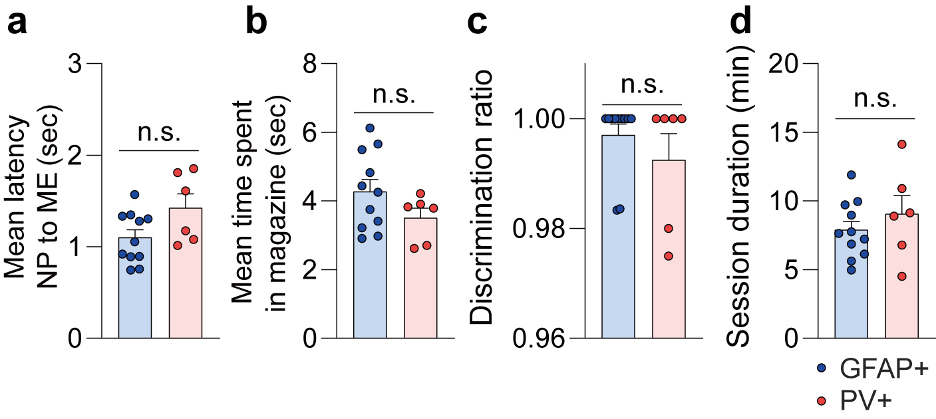
Extended Data Fig. 1. Evaluation of behavioral difference between two groups. a, Mean latency from active nose-poke (NP) to magazine entry (ME) (n = 11 mice/GFAP+ and n = 6 mice/PV+, P = 0.0614). They showed latencies significantly shorter than 2 seconds (n = 17 mice, P < 10⁻⁶). b, Mean time spent inside the magazine (n = 11 mice/GFAP+ and n = 6 mice/PV+, P = 0.1523). c, Discrimination ratio between active and inactive nose-poke (n = 11 mice/GFAP+ and n = 6 mice/PV+, P = 0.2464). They showed discrimination ratios significantly higher than 0.5, the chance level (n = 17 mice, P < 10⁻⁶). d, Session duration (n = 11 mice/GFAP+ and n = 6 mice/PV+, P = 0.3878). Data are shown as individual dot plots. Error bars behind denote mean ± s.e.m. Statistics for a-d, independent-sample permutation test for comparison between two groups. Statistics for a and c, one-sample permutation test to compare the behavioral measurement with constant criterion. *n.s. > 0.05. Detailed information about the exact test statistics is provided in Extended Data Table 2.

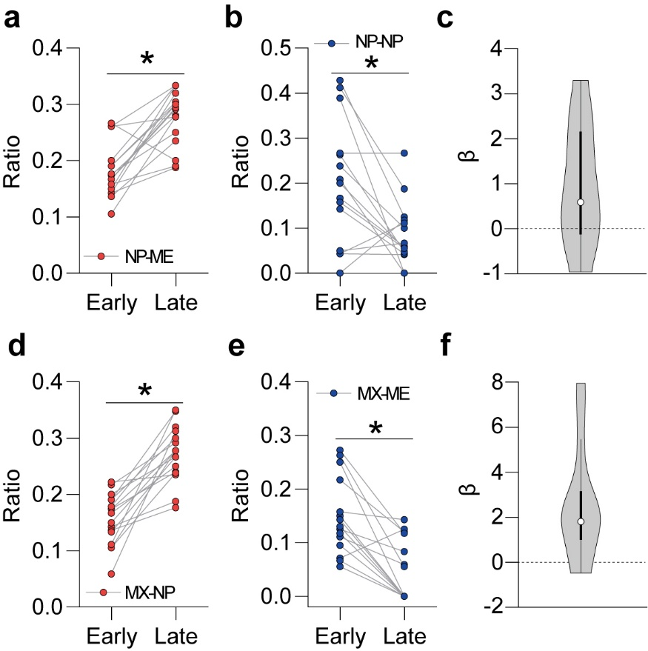
Extended Data Fig. 2. The emergence of routine behavior as the session progresses. a, Comparison between the ratio of NP-ME in the first and the last group (n = 17 mice, P = 8.0000×10⁻⁵). Data are shown as individual dot plots. b, Comparison between the ratio of NP-NP in the first and the last group (n = 17 mice, P = 0.0058). Data are shown as individual dot plots. c, Distribution of regression coefficients for predictor (relative timepoint) in the logistic regression model for Fig. 1c-d. Data are shown as a violin plot. d, Comparison between the ratio of MX-NP in the first and the last group (n = 17 mice, P < 10⁻⁶). Data are shown as individual dot plots. e, Comparison between the ratio of MX-ME in the first and the last group (n = 17 mice, P = 6.0000×10⁻⁵). Data are shown as individual dot plots. f, Distribution of regression coefficients for predictor (relative timepoint) in the logistic regression model for Fig. 1f-g. Data are shown as a violin plot. Statistics for a, b, d, and e, paired-sample permutation test. *P < 0.05. Detailed information about the exact test statistics is provided in Extended Data Table 2.

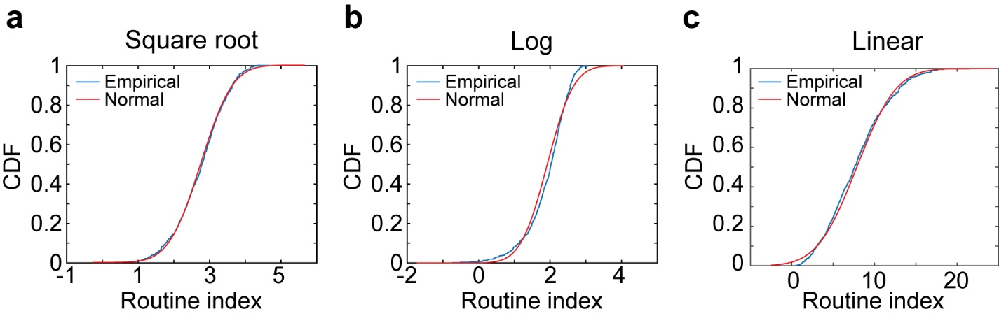
Extended Data Fig. 3. Determination of transformation function for the routine index. a-c, Comparison between the distribution of the routine indices computed under the corresponding transformation function and the normal distribution with matched mean and standard deviation. a, Square root function (n = 623 cycles from 17 mice, P = 0.511). b, Logarithm function (n = 623 cycles from 17 mice, P = 1.27×10⁻⁴). c, Linear function (n = 623 cycles from 17 mice, P = 0.162). Statistics for a-c, one-sample Kolmogorov-Smirnov test. Detailed information about the exact test statistics is provided in Extended Data Table 2.

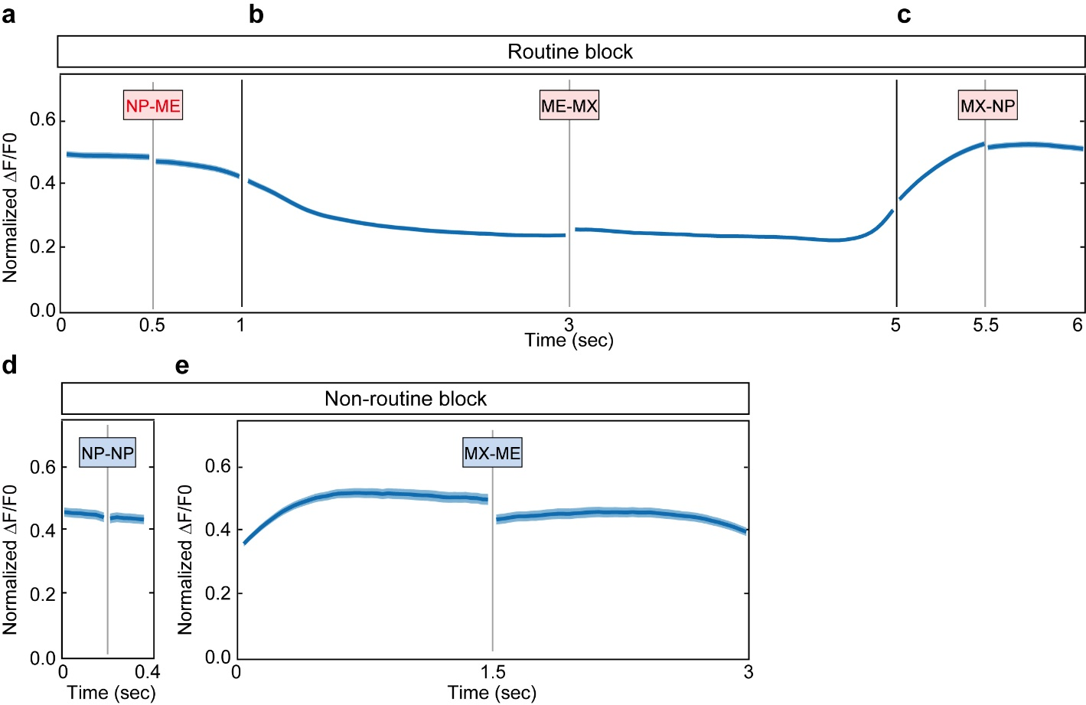
Extended Data Fig. 4. The activity of GFAP+ cells within different blocks. a-c, Routine blocks. a, NP-ME. b, ME-MX. c, MX-NP. d-e, Non-routine blocks. d, NP-NP. e, MX-ME. The solid line and shaded regions represent mean ± s.e.m.

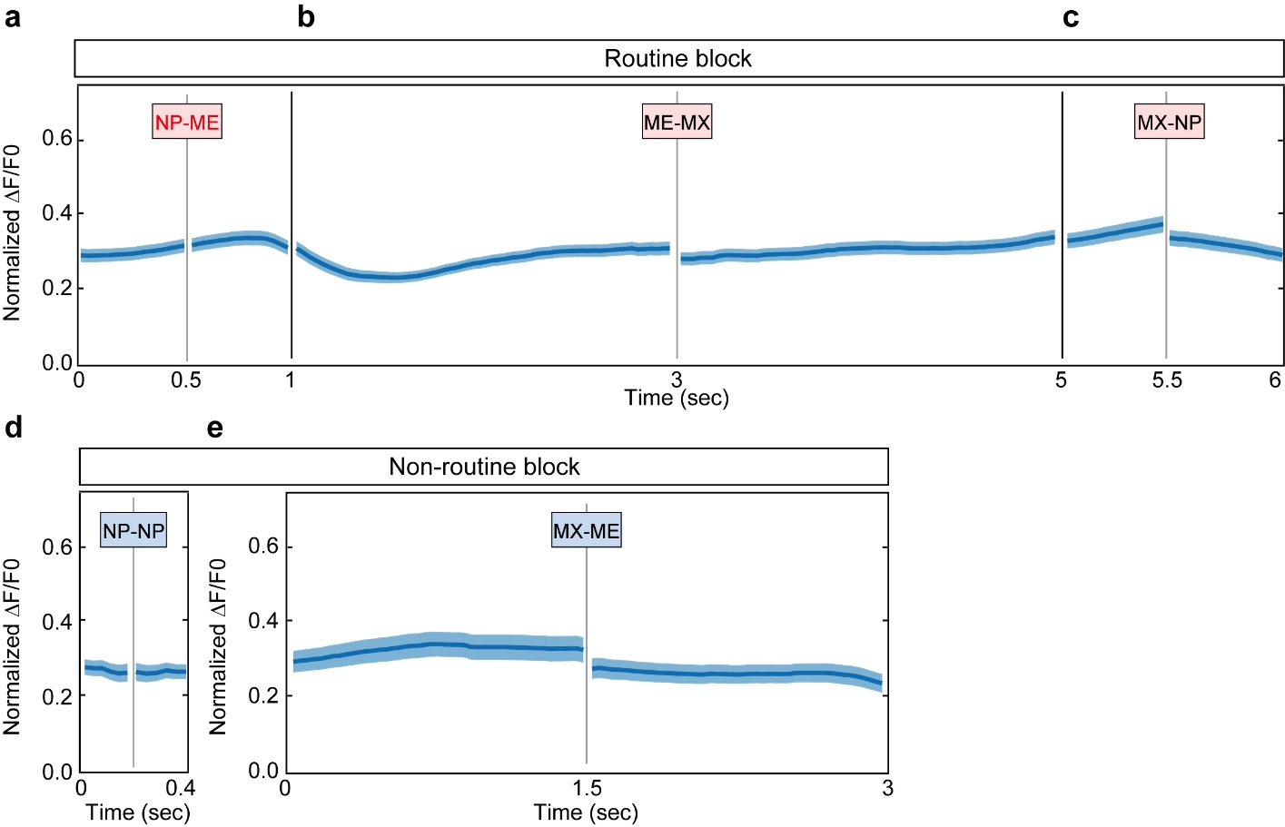
Extended Data Fig. 5. The activity of PV+ cells within different blocks. a-c, Routine blocks. a, NP-ME. b, ME-MX. c, MX-NP. d-e, Non-routine blocks. d, NP-NP. e, MX-ME. The solid line and shaded regions represent mean ± s.e.m.
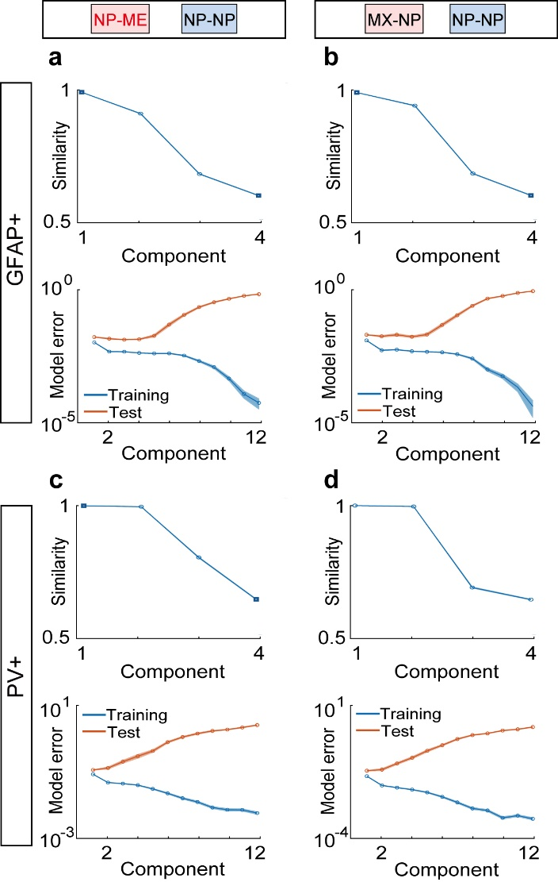
Extended Data Fig. 6. Determination of the number of tensor components for tensor component analyses for Fig. 2. a, Comparison between Ca²⁺ activity of GFAP+ cells during NP-ME and NP-NP. Model similarity plot (top) and model error plot (bottom). b, Comparison between Ca²⁺ activity of GFAP+ cells during MX-NP and NP-NP. Model similarity plot (top) and model error plot (bottom). c, Comparison between Ca²⁺ activity of PV+ cells during NP-ME and NP-NP. Model similarity plot (top) and model error plot (bottom). d, Comparison between Ca²⁺ activity of PV+ cells during MX-NP and NP-NP. Model similarity plot (top) and model error plot (bottom). The solid line and shaded regions represent mean ± s.e.m.
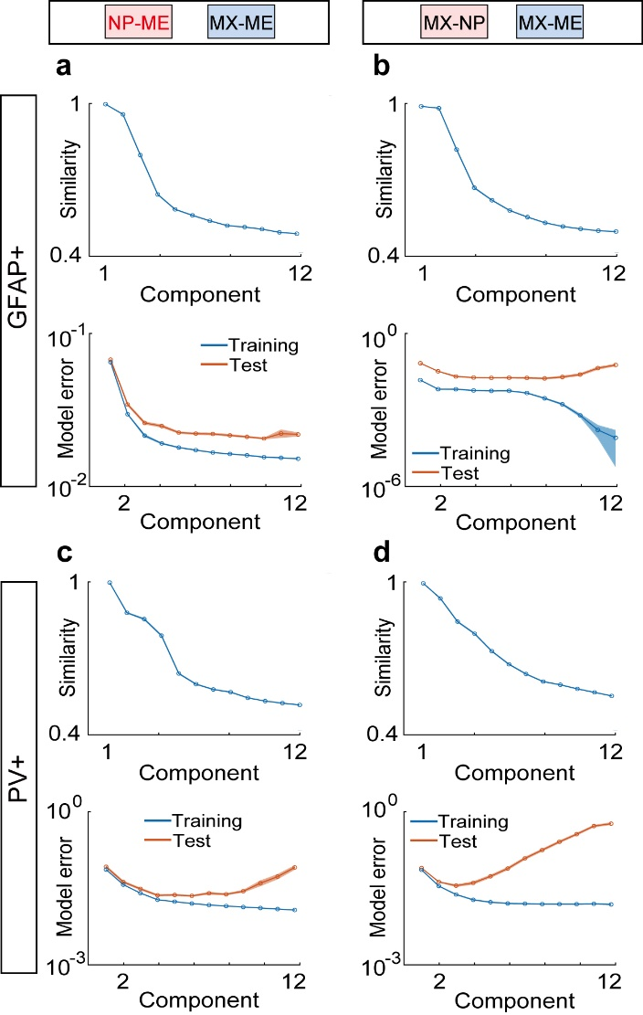
Extended Data Fig. 7. Determination of the number of tensor components for tensor component analyses for Fig. 3. a, Comparison between Ca²⁺ activity of GFAP+ cells during NP-ME and MX-ME. Model similarity plot (top) and model error plot (bottom). b, Comparison between Ca²⁺ activity of GFAP+ cells during MX-NP and MX-ME. Model similarity plot (top) and model error plot (bottom). c, Comparison between Ca²⁺ activity of PV+ cells during NP-ME and MX-ME. Model similarity plot (top) and model error plot (bottom). d, Comparison between Ca²⁺ activity of PV+ cells during MX-NP and MX-ME. Model similarity plot (top) and model error plot (bottom). The solid line and shaded regions represent mean ± s.e.m.

