Supplementary Materials for

A Circulating MicroRNA Panel as a Novel Dynamic Monitor for Oral Squamous Cell Carcinoma

Yudan Piao¹, Seung-Nam Jung², Mi Ae Lim², Chan Oh¹, Yan Li Jin¹, Hae Jong Kim¹, Nguyen Quoc Khanh¹, Jae Won Chang^{1,2}, Ho-Ryun Won^{1,2*}, Bon Seok Koo^{1,2*}

¹Department of Medical Science, Chungnam National University College of Medicine, Daejeon, Republic of Korea
²Department of Otolaryngology-Head and Neck Surgery, Chungnam National University College of Medicine, Daejeon, Republic of Korea

* These authors contributed equally to this work as corresponding authors.

Correspondence Authors:
Bon Seok Koo MD, PhD.
Professor, Department of Otolaryngology-Head and Neck Surgery,
Chungnam National University College of Medicine,
266, Munhwa-ro, Jung-gu, Daejeon, 35015, Republic of Korea
Tel: +82-42-280-7690 Fax: +82-42-253-4059
E-mail: bskoo515@cnuh.co.kr

Ho-Ryun Won MD, PhD.
Professor, Department of Otolaryngology-Head and Neck Surgery,
Chungnam National University College of Medicine,
Chungnam National University Sejong Hospital
20, Bodeum 7-ro, Sejong, 30099, Republic of Korea
Tel: +82-44-995-4756 Fax: +82-44-995-5099
E-mail: hryun83@cnuh.co.kr

Table S1. The clinical information of patients with OSCC in CNUH cohort.

Sex | Age | Main  subsite | T stage | N stage | M stage | ClinicalStage | Pathology
M | 72 | tongue | 1 | 0 | 0 | I | Squamous cell carcinoma
F | 82 | tongue | 2 | 0 | 0 | II | Squamous cell carcinoma
M | 74 | buccal | 1 | 0 | 0 | I | Squamous cell carcinoma
M | 36 | tongue | 2 | 1 | 0 | III | Squamous cell carcinoma
M | 42 | tongue | 4a | 2b | 0 | IVa | Squamous cell carcinoma
M | 77 | tongue | 1 | 0 | 0 | I | Squamous cell carcinoma
M | 77 | tongue | 1 | 0 | 0 | I | Squamous cell carcinoma
M | 74 | tongue | 1 | 0 | 0 | I | Squamous cell carcinoma
M | 87 | RMT | 2 | 0 | 0 | II | Squamous cell carcinoma
M | 65 | RMT | 4a | 2c | 0 | IVa | Squamous cell carcinoma
M | 46 | tongue | 2 | 2b | 0 | III | Squamous cell carcinoma
M | 58 | tongue | 1 | 3 | 0 | IVa | Squamous cell carcinoma
F | 54 | tongue | 1 | 0 | 0 | I | Squamous cell carcinoma
F | 39 | tongue | 2 | 0 | 0 | II | Squamous cell carcinoma
F | 63 | tongue | 2 | 0 | 0 | II | Squamous cell carcinoma
M | 65 | tongue | 1 | 0 | 0 | I | Squamous cell carcinoma
M | 65 | tongue | 1 | 0 | 0 | I | Squamous cell carcinoma
M | 65 | tongue | 1 | 0 | 0 | I | Squamous cell carcinoma
M | 45 | tongue | 1 | 0 | 0 | I | Squamous cell carcinoma
F | 78 | tongue | 2 | 0 | 0 | II | Squamous cell carcinoma
F | 77 | tongue | 2 | 2b | 0 | IIIb | Squamous cell carcinoma
F | 69 | buccal,lip | 2 | 0 | 0 | II | Squamous cell carcinoma
M | 63 | FOM | 4a | 1 | 0 | IIIb | Squamous cell carcinoma
M, male; F, female; RMT, retromolar trigone; FOM, floor of the mouth.

Table S2. The clinical information of patients with OSCC in CNUH cohort for NGS.

Sex | Age | Main  subsite | T stage | N stage | M stage | Clinical stage | Pathology
F | 86 | Tongue | 2 | 0 | 0 | II | Squamous cell carcinoma
M | 66 | Buccal | 1 | 0 | 0 | I | Squamous cell carcinoma
M | 75 | Tongue | 3 | 2a | 0 | IVa | Squamous cell carcinoma
M | 54 | Tongue | 3 | 2a | 0 | IVa | Squamous cell carcinoma
M, male; F, female.
Table S3. microRNA-specific primers.

 |  | ID
hsa-miR-92b-3p | miScript Primer Assay (Cat No.218300) | MS00032144
hsa-miR-423-5p | miScript Primer Assay (Cat No.218300) | MS00009681
hsa-miR-320c | miScript Primer Assay (Cat No.218300) | MS00041867
hsa-miR-183-5p | miScript Primer Assay (Cat No.218300) | MS00031507
hsa-miR-432-5p | miRCURY LNA miRNA PCR Assay (Cat NO. 339306) | YP00204776
hsa-miR-92a-3p | miRCURY LNA miRNA PCR Assay (Cat NO. 339306) | YP00204258
hsa-miR-629-5p | miRCURY LNA miRNA PCR Assay (Cat NO. 339306) | YP00204370
hsa-miR-337-3p | miRCURY LNA miRNA PCR Assay (Cat NO. 339306) | YP00205938
hsa-miR-199a-3p | miRCURY LNA miRNA PCR Assay (Cat NO. 339306) | YP00204536
hsa-miR-199b-3p | 5′‐AACACGTGACAGTAGTCTGCA‐3′
hsa-miR-16 | 5′‐GTAGCAGCACGTAAATATTGG‐3′

Table S4. Differentially expressed miRNA by next-generation sequencing in serum from patients with OSCC and healthy controls
Mature_Accession | Mature_ID | Fold Change | -log10(P value) | Regulation
MIMAT0000092 | hsa-miR-92a-3p | 5.52007 | 5.968 | up
MIMAT0003218 | hsa-miR-92b-3p | 4.69249 | 4.299 | up
MIMAT0000261 | hsa-miR-183-5p | 4.67171 | 3.950 | up
MIMAT0004810 | hsa-miR-629-5p | 4.65223 | 2.272 | up
MIMAT0005793 | hsa-miR-320c | 4.43814 | 2.413 | up
MIMAT0000754 | hsa-miR-337-3p | -5.44630 | 1.795 | down
MIMAT0002814 | hsa-miR-432-5p | -5.11657 | 1.839 | down
MIMAT0000232 | hsa-miR-199a-3p | -3.37685 | 1.600 | down
MIMAT0004563 | hsa-miR-199b-3p | -3.37681 | 1.600 | down
Up, up-regulation; Down, indicates down-regulation.

Appendix Figures and Figure Legends

Figure S1

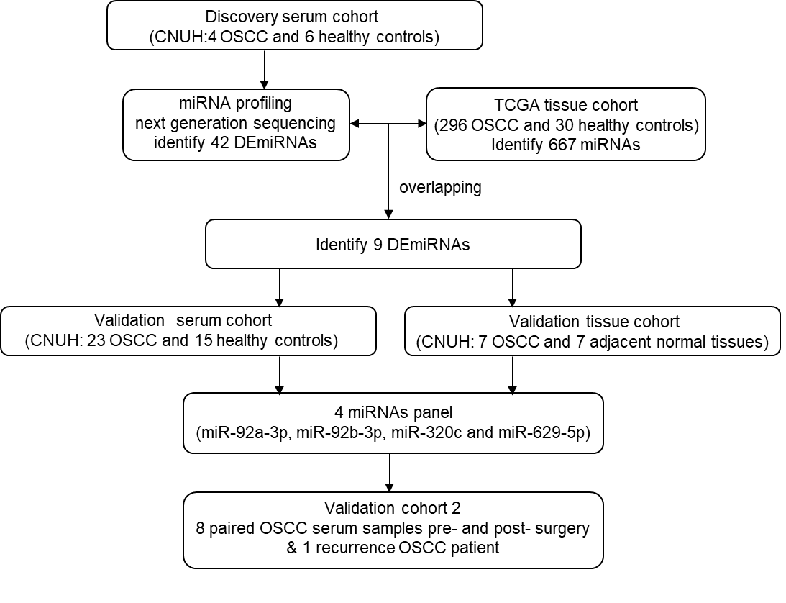
Figure S1. An overview of the workflow of the research design.

Figure S2

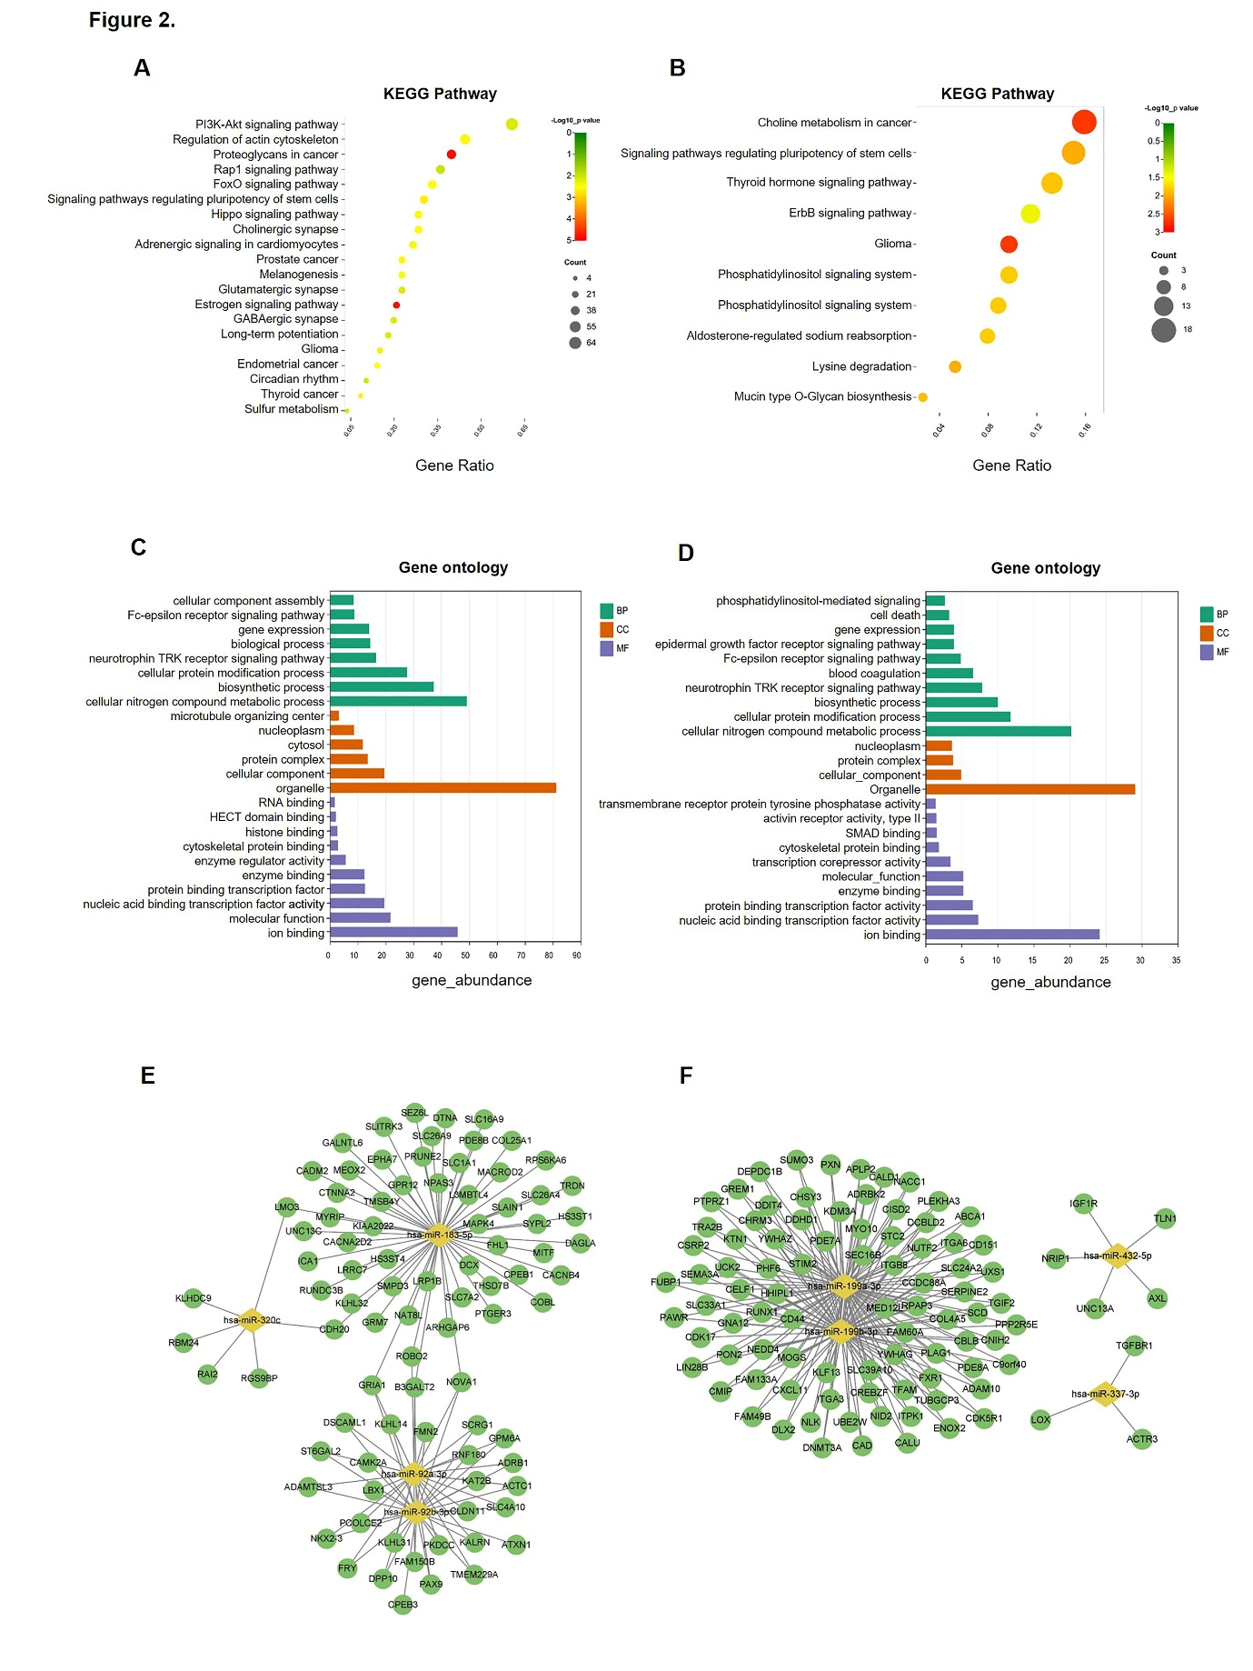
Figure S2. Functional classification and linkage of the target genes of 9 DEmiRNAs.
A-D: Kyoto Encyclopedia of Genes and Genomes (KEGG) pathway enrichment analysis and Gene Ontology (GO) functional annotation for the targeted genes of the 9 differentially expressed miRNAs (DEmiRNAs). The top 20 KEGG pathways affected by up-regulated miRNAs (A) and down-regulated miRNAs (B). The color of each dot denotes the p value, and the size of each dot denotes the number of enrichment target genes. GO functional annotation including biological processes (BP), cellular components (CC), and molecular function (MF), which were affected by up-regulated miRNAs (C) and down-regulated miRNAs (D). The Y-axis indicates the enrichment score (p ≤ 0.05); E-F: miRNA-mRNA regulatory networks in OSCC. Up-regulated (E) and down-regulated (F) miRNA-mRNA network of the 9 differentially expressed miRNAs. Yellow diamonds represent miRNAs and green circles represent target mRNAs.

Figure S3

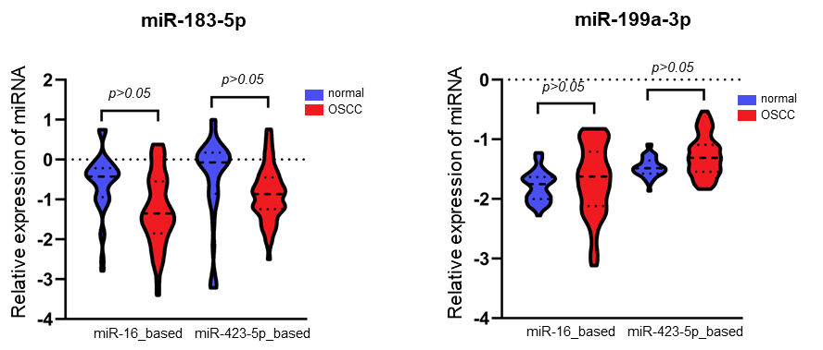
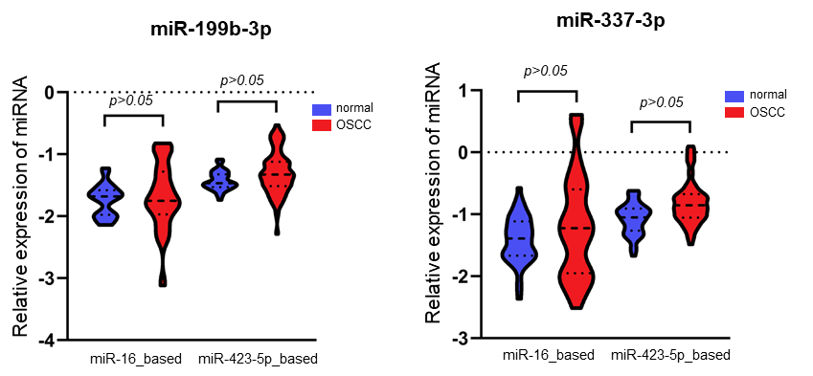
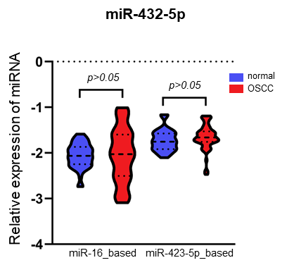

Figure S3. Serum validation for selected DEmiRNAs.
The expression levels of miRNAs were calculated using the 2^{-ΔΔCT} method, and the results are presented as relative log10 fold changes.

Figure S4.

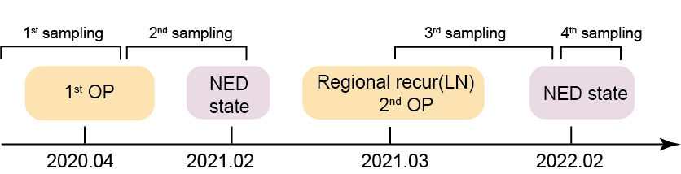

Figure S4. The clinical course of recurrent patients with OSCC in CNUH cohort.

