Supplementary Table 1: The CT image acquisition parameters of the three centers.
 | Parameters | Center 1(The Sixth Affiliated Hospital of Guangzhou Medical University, Qingyuan People’s Hospital) |  | Center 2 (Guangzhou First People's Hospital, School of Medicine, South China University of Technology) | Center 3(The First Affiliated Hospital of University of South China)
CT system information | CT system | 16 -channel multi-detector CT（Toshiba Aquilion） | 64-channel multi-detector  CT（ SOMATOM Force） | 64-channel multi-detector CT (Philips, brilliance) | 64-channel multi-detector CT(Philips, brilliance）
CT scan | tube voltage | 120kVp | 120kVp | 120kVp | 120kVp
 | tube current | 250 mA | Auto | Auto (Avg 300 mA) | 130 mA
 | rotation time | 0.5s | 0.25s | 0.75s | 1.0s
 | detector collimation | 16×0.625 mm | 96×0.5 mm | 64×0.625 mm | 64×0.625 mm
CT image information | image matrix | 512×512 | 512×512 | 512×512 | 512×512
 | field of view | 300×300 mm | 300×300 mm | 300×300 mm | 300×300 mm
 | thickness for coronal reconstruction (MPR) images | 3mm | 3mm | 7mm | 2mm

Supplementary Table 2: Diagnostic performances of three radiologists visual diagnoses in differentiating complicated from uncomplicated AA in 100 cases randomly selected in validation cohorts)
 | AUC (95% CI) | Accuracy | Sensitivity | Specificity | PPV | NPV | P value ª
Radiologist’s diagnosis 1 | 0.700 (0.600 - 0.788) | 0.780 | 0.500 | 0.900 | 0.682 | 0.808 | Ref
Radiologist’s diagnosis 2 | 0.638 (0.536 - 0.732) | 0.720 | 0.433 | 0.843 | 0.542 | 0.776 | 0.165
Radiologist’s diagnosis 3 | 0.657 (0.556 - 0.749) | 0.680 | 0.600 | 0.714 | 0.474 | 0.807 | 0.350
Abbreviations: AUC, area under the receiver operating characteristic curve; CI, confidence interval; PPV, positive predict value; NPV, negative predict value.
ª P value indicates significance of the comparison between radiologist’ s diagnosis 1 and the other radiologist’ s diagnosis.

Supplementary Table 3. Radiomics and clinical feature importance of the selected features of our combined model.
Features | Feature type | Weight | Train cohort (mean ± SD) | Validation cohorts (mean ± SD) | P value
original_glszm_SizeZoneNonUniformity | GLSZM | 0.173 | 1.47 ± 1.28 | 1.85 ± 1.9 | <0.001
wavelet-LLH_glcm_Imc2 | GLCM | -0.752 | 0.4 ± 0.10 | 0.40 ± 0.12 | 0.629
wavelet-LLH_gldm_HighGrayLevelEmphasis | GLDM | 0.292 | 4.67 ± 6.39 | 6.09 ± 8.73 | 0.235
wavelet-LHL_glrlm_LowGrayLevelRunEmphasis | GLRLM | 0.177 | 0.65 ± 0.07 | 0.64 ± 0.11 | <0.001
wavelet-LHH_gldm_DependenceNonUniformityNormalized | GLDM | 0.256 | 0.08 ± 0.01 | 0.08 ± 0.01 | 0.713
wavelet-LHH_gldm_LowGrayLevelEmphasis | GLDM | 0.303 | 0.63 ± 0.03 | 0.62 ± 0.04 | <0.001
wavelet-HLL_glrlm_ShortRunLowGrayLevelEmphasis | GLRLM | 0.006 | 0.37 ± 0.05 | 0.36 ± 0.07 | 0.039
wavelet-HLH_glcm_MaximumProbability | GLCM | 1.210 | 0.30 ± 0.01 | 0.29 ± 0.01 | <0.001
wavelet-HLH_glrlm_LongRunLowGrayLevelEmphasis | GLRLM | 0.330 | 3.28 ± 0.55 | 3.16 ± 0.65 | <0.001
wavelet-HHL_glszm_SizeZoneNonUniformity | GLSZM | 1.3927 | 2.41 ± 1.33 | 2.18 ± 1.20 | 0.001
wavelet-HHL_gldm_LargeDependenceHighGrayLevelEmphasis | GLDM | -0.370 | 332.04 ± 59.80 | 319.56 ± 56.31 | <0.001
wavelet-HHH_glcm_InverseVariance | GLCM | 0.416 | 0.51 ± 0.01 | 0.51 ± 0.01 | 0.002
wavelet-HHH_glrlm_GrayLevelNonUniformity | GLRLM | 0.220 | 1224.74 ± 653.24 | 1246.27 ± 644.83 | 0.429
wavelet-HHH_glrlm_GrayLevelVariance | GLRLM | 0.088 | 0.25 ± 0.00 | 0.25 ± 0.00 | 0.016
wavelet-HHH_glszm_SizeZoneNonUniformityNormalized | GLSZM | 0.090 | 0.32 ± 0.10 | 0.33 ± 0.11 | 0.007
Abbreviations: SD, standard deviation.

Features | Feature type | Weight | Train cohort | Validation cohorts | P value
Age, years, mean ± SD | continuous | 0.435 | 42.6 ± 16.0 | 44.3 ± 16.5 | 0.061
Neutrophilia (≥ 75%), median (IQR) | continuous | 0.331 | 85.2 (80.6 - 89.8) | 80.6 (23.1 - 87.2) | <0.001
White blood cell count (10·0 × 109/L), median (IQR) | continuous | 1.066 | 15.0 (12.0 - 18.7) | 15.6 (10.5 - 53.6) | 0.011
Absolute neutrophil count, median (IQR) | continuous | -0.389 | 12.9 (10.0 - 14.8) | 11.6 (8.3 - 15.2) | 0.023
Appendix maximal coronal diameter, mm, median (IQR) | continuous | 1.244 | 11.6 (10.2 - 13.6) | 11.5 (9.9 - 13.3) | 0.259
Fever (≥ 37.3°C) | categorical | 0.130 | 75 | 91 | <0.001
RLQ tenderness | categorical | -0.029 | 692 | 436 | <0.001
Extraluminal air | categorical | 0.236 | 41 | 31 | 0.574
Intraluminal appendicolith | categorical | 0.171 | 309 | 201 | 0.757
Peri-appendiceal fluid collection | categorical | 0.414 | 142 | 104 | 0.394
Peri-appendiceal abscess | categorical | 0.218 | 13 | 1 | 0.012
Abbreviations: SD, standard deviation; IQR, interquartile range.

Supplementary Table 4: Diagnostic performance of our combined model in appendices with and without appendicoliths. (Supplementary Fig. 2）
Variable | AUC (95% CI) | Accuracy | Sensitivity | Specificity | PPV | NPV | P value
Training Cohort
Intraluminal appendicolith (n = 156, n = 153) ª | 0.818 (0.770 - 0.859) | 0.790 | 0.693 | 0.885 | 0.855 | 0.746 | 0.136
Non-intraluminal appendicolith (n = 308, n = 83) ª | 0.759 (0.713 - 0.800) | 0.662 | 0.795 | 0.627 | 0.365 | 0.919 | Ref
Validation Cohorts
Intraluminal appendicolith (n = 95, n = 106) ª | 0.814 (0.753 - 0.865) | 0.746 | 0.679 | 0.821 | 0.809 | 0.696 | 0.195
Non-intraluminal appendicolith (n = 189, n = 75) ª | 0.757 (0.700 - 0.807) | 0.708 | 0.733 | 0.698 | 0.491 | 0.868 | Ref

Abbreviations: AUC, area under the receiver operating characteristic curve; CI, confidence interval; PPV, positive predict value; NPV, negative predict value.
ª Numbers in parentheses represent the number of specimens with uncomplicated appendicitis and the number of specimens with complicated appendicitis

(Supplementary Fig. 1A–C). Lasso model (Alpha = 0.0005)
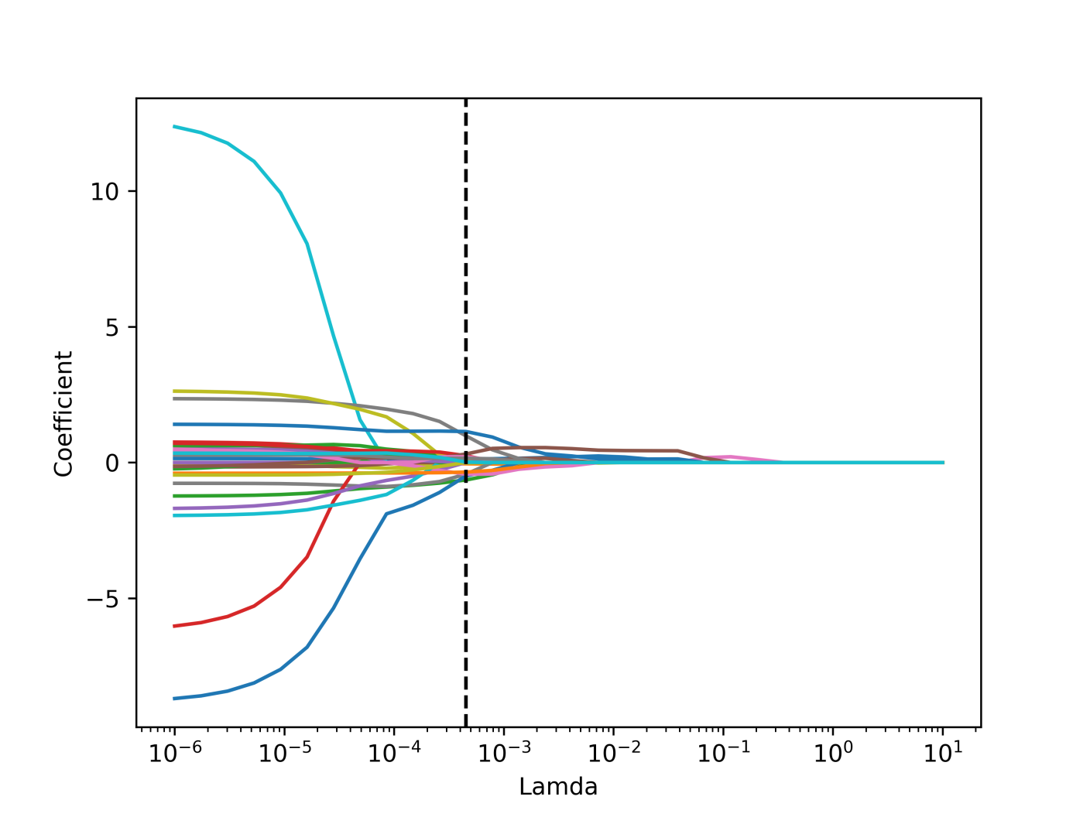
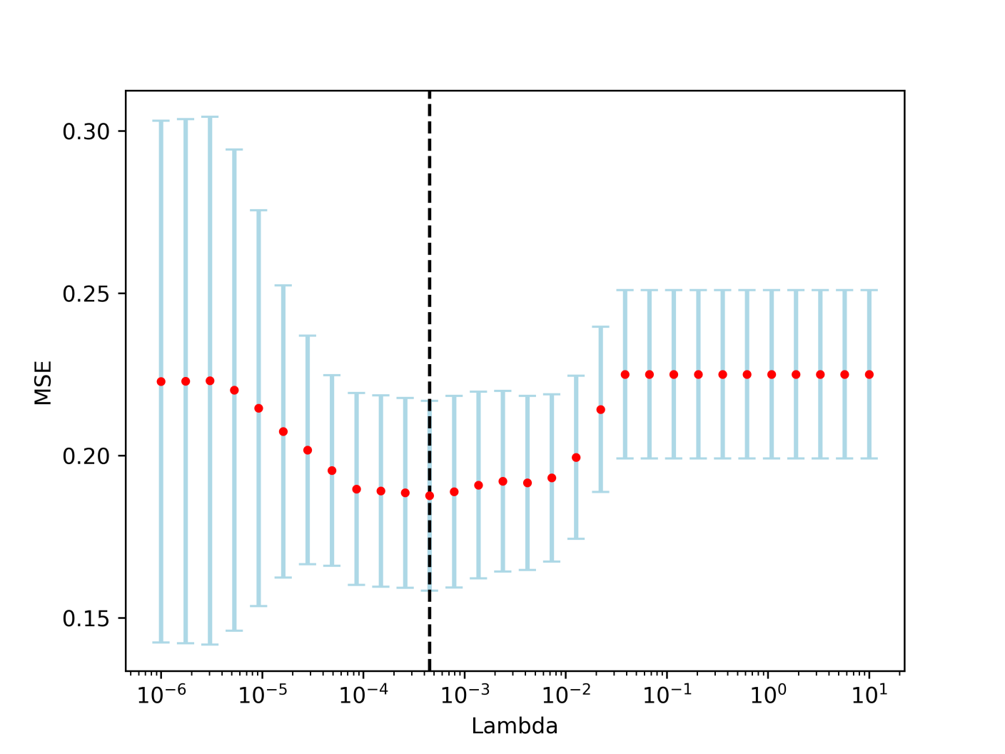

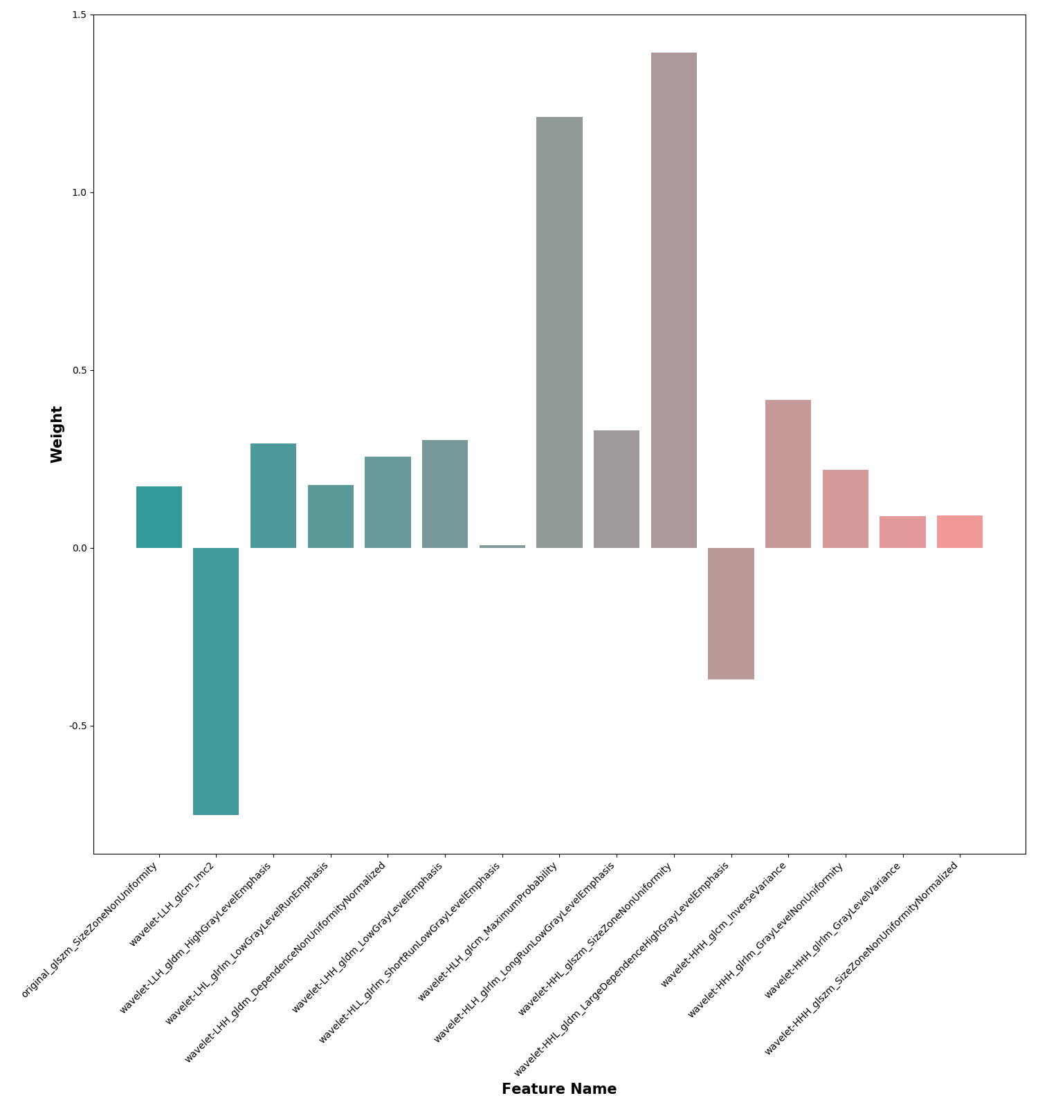

Supplementary Fig2. Diagnostic performances of our combined model in appendix with and without appendicolith.
