Supplementary Information

Uncovering hidden spin polarization of energy bands in antiferromagnets

Lin-Ding Yuan¹, Xiuwen Zhang¹, Carlos Mera², Alex Zunger¹
¹Renewable and Sustainable Energy Institute, University of Colorado, Boulder, Colorado 80309, USA
²Center for Natural and Human Sciences, Federal University of ABC, Santo Andre, São Paulo, Brazil

- Symmetry conditions for SOC-independent hidden spin polarization in collinear AFM
The hidden spin polarization in the absence of SOC arises in AFM, when the bulk symmetry enforces spin degeneracy of the band while the sector symmetry allows spin splitting.
The bulk symmetry of a spin degenerate antiferromagnetic compound needs to preserve either $ΘIT$ or $UT$ symmetry. Depending on the which of the two symmetries $ΘIT$ and $UT$ are preserved spin degenerate bulk AFM can be divided into three prototypes: (1) Bulk AFM compounds that violate $UT$ but preserves $ΘIT$ symmetry which is referred to as spin splitting prototype 1 (SST-1) bulk; (2) Bulk AFM compounds that preserve both $UT$ and $ΘIT$ symmetry which is referred to as SST-2 bulk; (3) Bulk AFM compounds that preserve $UT$ but violate $ΘIT$ symmetry which is referred to as SST-3 bulk.
The sector symmetry of a spin split sector needs to violate both $UT$ and $ΘIT$ symmetry. Depending on the magnetic type of the constitute sector of the bulk AFM the spin split sector can be either (4) AFM sector that violate both $UT$ and $ΘIT$ symmetry which is referred to as SST-4 sector; or (5) FM (also include Ferrimagnets (FiM)) sector that violate both $UT$ and $ΘIT$ symmetry which is referred to as SST-5 sector. The two spin split sector prototypes correspond to the two SOC-independent mechanisms for spin splitting, that is (a) magnetic mechanism that create spin splitting even in the absence of SOC in antiferromagnetic compounds; and (b) Zeeman mechanism of the FM sector with non-zero intrinsic magnetic moment.

- Additional examples of SOC-independent hidden spin polarization in collinear antiferromagnets with DFT results
Figure S1 illustrates the “hidden spin polarization” effect in hexagonal CoBr₂ ¹ being bulk SST-2 class (MSG C_{C}2/c) but made of SST-5 class FM CoBr2 layers ($α$-sector and $β$-sector in Fig. S1a). The crystal is antiferromagnetically ordered with its magnetic moments collinearly aligned in (001) direction. The two FeBr₂ layers are connected by both the $ΘIT$ and the $UT$ symmetry which restores the spin degeneracy of the bulk and results in a compensated net spin polarization (Fig. S1b). However, the corresponding spin polarization for the bottom two conduction bands (C1 and C2) projected onto $α$-sector and $β$-sector (hidden spin polarization), shown in Fig. S1c, are non-zero and compensate each other.

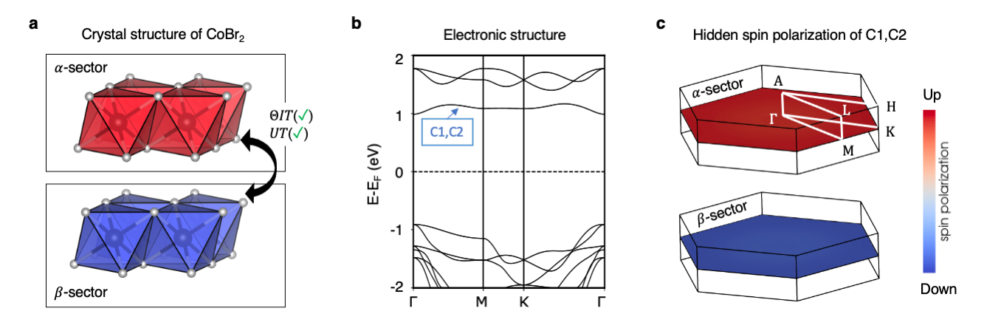
Figure S1: Hidden spin polarization from individual ferromagnetic sectors in bulk hexagonal CoBr₂ (bulk belonging to SST-2 class with sector belonging to SST-5 class). a crystal structure of antiferromagnetic CoBr₂ composed of two ferromagnetic layers with opposite magnetization (indicated by red and blue polynomials) in the unit cell. The two layers are referred as sector-$α$ and sector-$β$, respectively; b spin degenerate bands of CoBr₂; c Hidden spin polarization from each individual sector of the lowest two conduction bands (C1 and C2) on $ΓMK$ k-plane. The up and down spins are mapped to the color from blue to red.

Figure S2 illustrates the “hidden spin polarization” effect in tetragonal Ca₃Ru₂O₇ ² being bulk SST-3 class (MSG P_{C}na2₁) but made of SST-5 class FM RuO₇ sectors ($α$-sector and $β$-sector in Fig. S2a). The crystal is antiferromagnetically ordered with its magnetic moments collinearly aligned in (010) direction. The two ferromagnetically ordered Ru₂O₇ sectors are connected by the $UT$ symmetry which restores the spin degeneracy of the bulk and results in a compensated net spin polarization (Fig. S2b). However, the corresponding spin polarization for the bottom two conduction bands (C1 and C2) projected onto $α$-sector and $β$-sector (hidden spin polarization), shown in Fig. S2c, are nonzero and compensate each other.

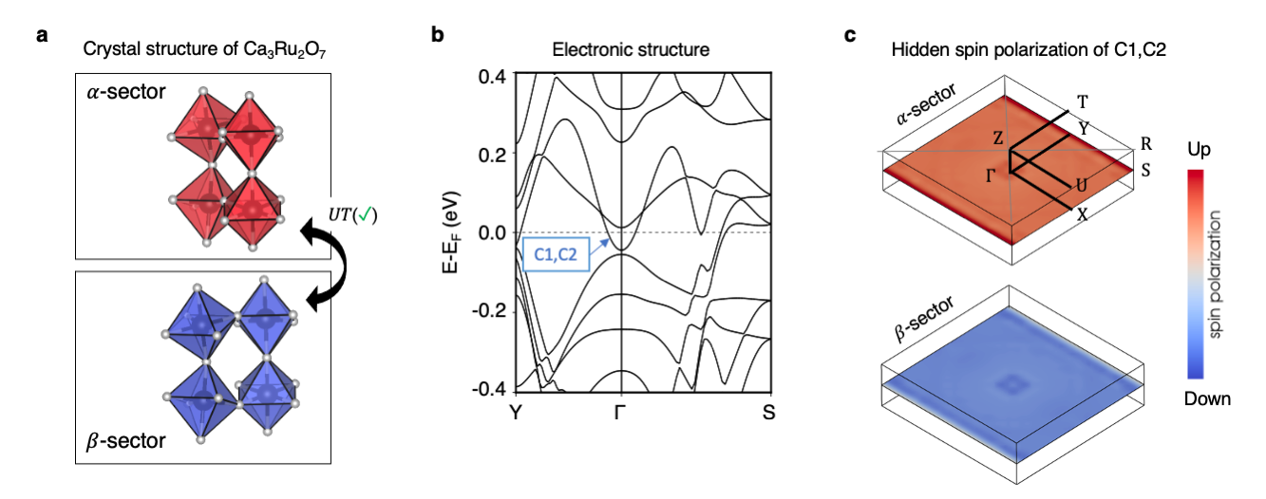
Figure S2: Hidden spin polarization from individual ferromagnetic sectors in bulk Ca₃Ru₂O₇ (bulk belonging to SST-3 class with sector belonging to SST-5 class). a crystal structure of antiferromagnetic Ca₃Ru₂O₇ composed of two ferromagnetic sectors with opposite magnetization (indicated by red and blue polynomials) in the unit cell. The Ca atoms are dismissed. The two sectors are referred as sector-$α$ and sector-$β$, respectively; b spin degenerate bands of Ca₃Ru₂O₇; c Hidden spin polarization from each individual sector of the lowest two conduction bands (C1 and C2) on $ΓXS$ k-plane. The up and down spins are mapped to the color from blue to red.
Figure S3 illustrates the “hidden spin polarization” effect in La₂NiO₄ ³ being bulk SST-2 class (MSG: P_{C}mna) but made of SST-4 class antiferromagnetic NiO₆ layers ($α$-sector and $β$-sector in Fig. S3a). The crystal is antiferromagnetically ordered with its magnetic moments collinearly aligned in (100) direction. The two ferromagnetically ordered Ru₂O₇ sectors are connected by both the $ΘIT$ and $UT$ symmetry which restores the spin degeneracy of the bulk and results in a compensated net spin polarization (Fig. S3b). However, the corresponding spin polarization for the top two valence bands (V1 and V2) projected onto $α$-sector and $β$-sector (hidden spin polarization), shown in Fig. S3c, are nonzero and compensate each other.
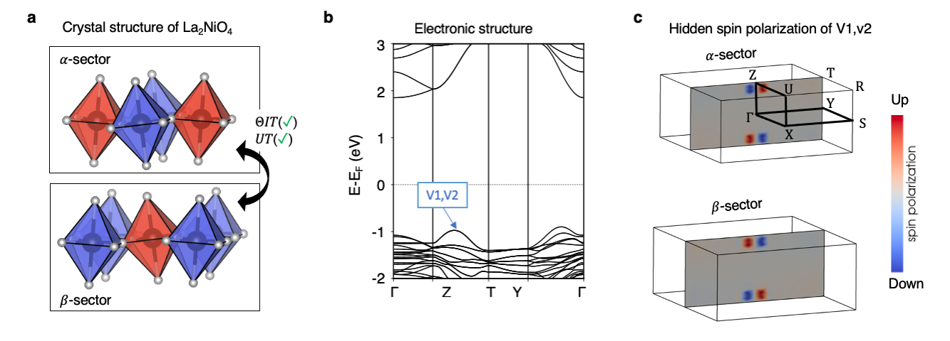
Figure S3: Hidden spin polarization from individual antiferromagnetic sectors in bulk La₂NiO₄ (bulk belonging to SST-2 class with sector belonging to SST-4 class). a crystal structure of antiferromagnetic La₂NiO₄ composed of two antiferromagnetic sectors with opposite magnetic ordering (the magnetic ordering are indicated by red and blue polynomials) in the unit cell. The two layers are referred as sector-$α$ and sector-$β$, respectively; b spin degenerate bands of La₂NiO₄. c Hidden spin polarization from each individual sector of the highest two valence bands (V1 and V2) on $ΓYT$ k-plane. The up and down spins are mapped to the color from blue to red.

Figure S4 illustrates the “hidden spin polarization” effect in MnS₂ ⁴ being bulk SST-3 class (MSG: P_{C}mna) but made of SST-4 class antiferromagnetic MnS₆ layers ($α$-sector and $β$-sector in Fig. S4a). The crystal is antiferromagnetically ordered with its magnetic moments collinearly aligned in (010) direction. The two ferromagnetically ordered Ru₂O₇ sectors are connected by the $UT$ symmetry which restores the spin degeneracy of the bulk and results in a compensated net spin polarization (Fig. S4b). However, the corresponding spin polarization for the top two valence bands (V1 and V2) projected onto $α$-sector and $β$-sector (hidden spin polarization), shown in Fig. S4c, are nonzero and compensate each other.

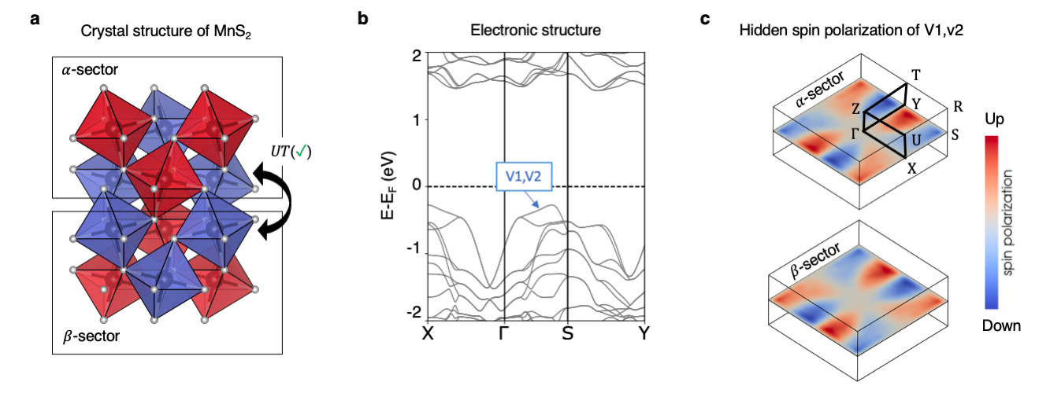
Figure S4: Hidden spin polarization from individual antiferromagnetic sectors in bulk MnS₂ (bulk belonging to SST-3 class with sector belonging to SST-4 class). a crystal structure of antiferromagnetic MnS₂ composed of two antiferromagnetic sectors with opposite magnetic ordering (the magnetic ordering are indicated by red and blue polynomials) in the unit cell. The two layers are referred as sector-$α$ and sector-$β$, respectively; b spin degenerate bands of MnS₂. c Hidden spin polarization from each individual sector of the highest two valence bands (V1 and V2) on $ΓXS$ k-plane. The up and down spins are mapped to the color from blue to red.

- Effect of external electric field on FeSe – a SOC-independent hidden spin polarized antiferromagnetic material constructed from 2D layered magnets

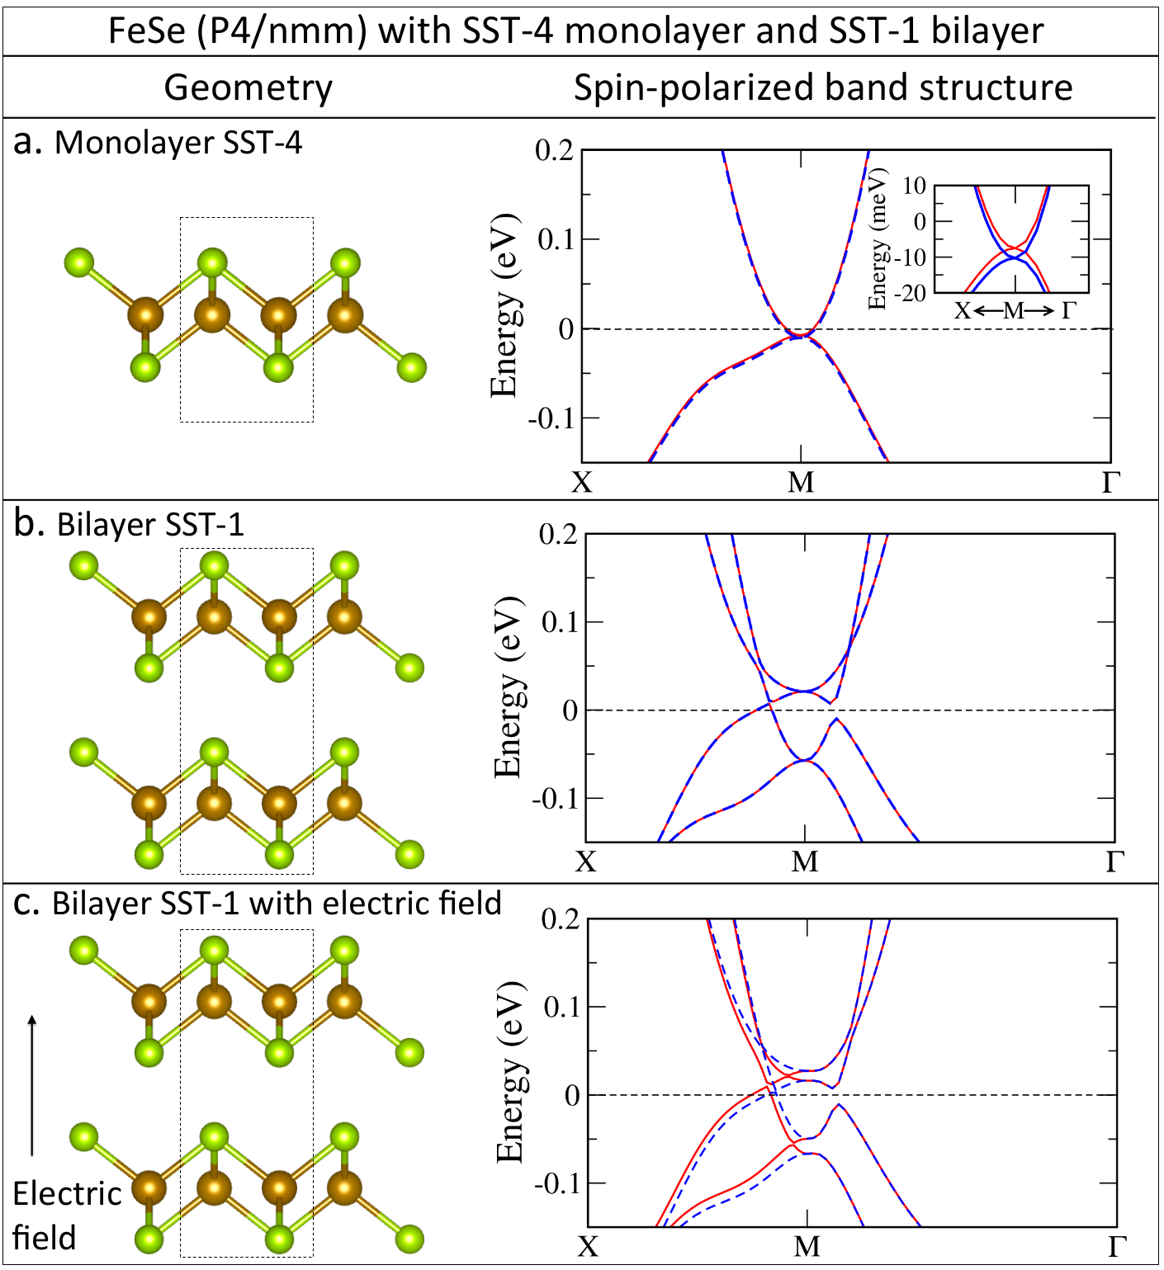

Figure S5: Geometry and DFT band structure calculation for an illustrative example of compensation between SST-4 2D monolayers forming a SST-1 2D bilayer. a SST-4 FeSe monolayer with SS of about 5 meV near the Fermi energy; b SST-1 FeSe bilayer with no SS, and c SST-1 FeSe bilayer with an external electric field of 0.3 eV/Ang. All DFT+U calculations are performed in the absence of SOC and considering only collinear local magnetic moments. While the SS vanishes when the two SST-4 are connected by the $ΘIT$ symmetry in the bilayer, the external effective field breaks the inversion symmetry, and hence, the $ΘIT$ symmetry. Even in the absence of SOC, the electric field induced a non-zero SS along all symmetry paths in the Brillouin zone. Red and blue lines stand for bands with up and down spin, respectively.

Figure S5 illustrates how SST-4 class monolayers (with SS) are $ΘIT$-asymmetric subsets forming an SST-1 class bilayer that is $ΘIT$-symmetric (without SS), i.e., spin polarization at different SST-4 class sectors is mutually compensated by means of the stacking of layers that restores the $ΘIT$ symmetry. The DFT band structure calculations for the SST-4 class FeSe monolayer reveals a spin splitting of about 5 meV near the Fermi energy (Fig. S5a). This spin splitting is the result of the antiferromagnetic configuration with two different local environments in the unit cell (dotted line) breaking the $ΘIT$ and $UT$ symmetries. When FeSe monolayers interact via the Van der Waals potential to form a bilayer with layer exactly equivalent (i.e., connected through the $ΘIT$ symmetry), the FeSe bilayer belongs to the SST-1 class. As a consequence, the band structure is completely spin degenerated (Fig. S5b). The compensation between FeSe layers in the bilayer system explicitly demonstrates the concept of the hidden AFM-SS. Remarkable, the bands in the $ΘIT$-symmetric bilayer have hidden spin-polarization, where spin bands are formed by orbitals spatially localized at different $ΘIT$-asymmetric subsets (Fig. S5b). As expected, an external electric field breaks the $ΘIT$ symmetry, leading then to manifestation of the hidden spin polarization in a bilayer with $ΘIT$-asymmetric subsets that compensate each other. The SS magnitude depends on the intensity of the external electric field. Different from the relativistic Rashba and Dresselhaus SS that require the SOC, the electric field induces in the SST-1 FeSe bilayer a non-zero SS even in the absence of SOC (Fig. S5c).

Table SI. Easily exfoliable 2D magnetic compounds with AFM configuration belonging to SST-4 class ⁵. The formula, space group, 2D structure prototype, DFT-PBE calculated bandgap (E_{g}), and binding energy (E_{b}) are indicated. The last three columns describe for the experimental parent structure: the 3D space group (3D SG), source database (SDB) ⁶, and the ID in the source database (ID SDB).
Formula | SG | Structure Prototype | E_{g} (eV) | E_{b} (meV/Å2) | 3D SG | SDB of 3D | ID SDB
FeSe | P4/nmm | FeSe | 0.0 | 22.6 | Cmme | ICSD | 290411
LaBr | P3m1 | ZrCl | 0.6 | 11.7 | R3m | ICSD | 23354
FeO₂ | Pmmm | FeO2 | 0.0 | 16.3 | Cmcm | COD | 9015156
PrOI | P4mm | PbClF | 0.0 | 14.9 | P4/nmm | COD | 1530611
FeOCl | Pmmn | PeOCl | 0.0 | 14.2 | Pmmn | COD | 1010645
VOBr | Pmmn | FeOCl | 0.0 | 14.7 | Pmmn | ICSD | 27010

Table SII. Easily exfoliable 2D magnetic compounds with FM configuration belonging to SST-5 class ⁵. The formula, space group, 2D structure prototype, DFT-PBE calculated bandgap (E_{g}), and binding energy (E_{b}) are indicated. The last three columns describe for the experimental parent structure: the 3D space group (3D SG), source database (SDB) ⁶, and the ID in the source database (ID SDB).
Formula | SG | Structure Prototype | E_{g} (eV) | E_{b} (meV/Å2) | 3D SG | SDB of 3D | ID SDB
CoBr₂ | P3m1 | CdI₂ | 0.2 | 16.8 | P3m1 | COD | 9016149
CoCl₂ | P3m1 | CdI₂ | 0.2 | 10.7 | P3m1 | COD | 9014719
CoO₂ | P3m1 | CdI₂ | 0.0 | 22.6 | P3m1 | COD | 1522027
FeBr₂ | P3m1 | CdI₂ | 0.0 | 15.5 | P3m1 | COD | 9009102
FeI₂ | P3m1 | CdI₂ | 0.0 | 16.9 | P3m1 | COD | 9009103
NiBr₂ | P3m1 | CdI₂ | 0.8 | 18.1 | R3m | COD | 9008013
NiCl₂ | P3m1 | CdI₂ | 1.1 | 16.3 | R3m | COD | 9009132
NiI₂ | P3m1 | CdI₂ | 0.3 | 21.5 | R3m | COD | 9009133
VS₂ | P3m1 | CdI₂ | 0.0 | 27.7 | P3m1 | ICSD | 651361
VSe₂ | P3m1 | CdI₂ | 0.0 | 25.4 | P3m1 | ICSD | 86520
VTe₂ | P3m1 | CdI₂ | 0.0 | 27.1 | P3m1 | ICSD | 603582
TmI₂ | P3m1 | CdI₂ | 0.0 | 10.5 | P3m1 | ICSD | 43731
LaBr₂ | P6m2 | MoS₂ | 0.6 | 11.2 | P6₃/mmc | ICSD | 65481
FeTe | P4/nmm | FeSe | 0.0 | 26.6 | P4/nmm | ICSD | 169974
LaCl | P3m1 | ZrCl | 0.0 | 11.0 | R3m | ICSD | 24410
ScCl | P3m1 | ZrCl | 0.0 | 13.8 | R3m | COD | 4343683
TbBr | P3m1 | ZrCl | 0.0 | 12.2 | R3m | ICSD | 23353
YCl | P3m1 | ZrCl | 0.0 | 17.6 | R3m | ICSD | 30708
CuCl₂ | C2/m | NbTe₂ | 0.2 | 13.4 | C2/m | COD | 9001506
EuOBr | P4/nmm | PbClF | 0.0 | 17.4 | P4/nmm | ICSD | 28531
EuOI | P4/nmm | PbClF | 0.0 | 14.8 | P4/nmm | ICSD | 27666
PrOBr | P4/nmm | PbClF | 0.0 | 24.1 | P4/nmm | COD | 2232654
NdOBr | C2/m | PbClF | 0.2 | 21.8 | P4/nmm | COD | 9009172
SmOBr | C2/m | PbClF | 0.2 | 18.4 | P4/nmm | COD | 1530050
TmOI | C2/m | PbClF | 0.2 | 15.0 | P4/nmm | COD | 2310429
TbOBr | Cmme | PbClF | 0.0 | 15.2 | P4/nmm | ICSD | 28532
CrOBr | Pmmn | FeOCl | 0.5 | 14.8 | Pmmn | ICSD | 27092
CrOCl | Pmmn | FeOCl | 0.6 | 13.8 | Pmmn | ICSD | 4086
CrSBr | Pmmn | FeOCl | 0.4 | 19.5 | Pmmn | ICSD | 69659
ErSCl | Pmmn | FeOCl | 0.3 | 11.9 | Pmmn | ICSD | 21009
ErSeI | Pmmn | FeOCl | 0.0 | 11.6 | Pmmn | ICSD | 50194
HoSI | Pmmn | FeOCl | 0.5 | 10.9 | Pmmn | ICSD | 425295
ErHCl | P3m1 | SmSI | 0.0 | 10.9 | R3m | COD | 1530725
SmSI | P3m1 | SmSI | 0.0 | 11.4 | R3m | COD | 1008317
YbOCl | P3m1 | SmSI | 0.0 | 11.7 | R3m | ICSD | 6077
CdOCl | P3m1 | BiTeI | 0.3 | 25.6 | P6₃mc | COD | 9016472
Co(OH)₂ | C2/m | Mg(OH)₂ | 0.0 | 18.3 | P3m1 | ICSD | 88940

References

1 Wilkinson, M. K., Cable, J. W., Wollan, E. O. & Koehler, W. C. Neutron Diffraction Investigations of the Magnetic Ordering in FeBr2, CoBr2, FeCl2, and CoCl2. Physical Review 113, 497-507, doi:10.1103/PhysRev.113.497 (1959).
2 Yoshida, Y. et al. Crystal and magnetic structure of Ca3Ru2O7. Physical Review B 72, 054412, doi:10.1103/PhysRevB.72.054412 (2005).
3 Rodriguez-Carvajal, J., Fernandez-Diaz, M. T. & Martinez, J. L. Neutron diffraction study on structural and magnetic properties of La<sub>2</sub>NiO<sub>4</sub>. Journal of Physics: Condensed Matter 3, 3215-3234, doi:10.1088/0953-8984/3/19/002 (1991).
4 Corliss, L. M., Elliott, N. & Hastings, J. M. Antiferromagnetic Structures of MnS2, MnSe2, and MnTe2. Journal of Applied Physics 29, 391-392, doi:10.1063/1.1723149 (1958).
5 Yuan, L.-D., Wang, Z., Luo, J.-W. & Zunger, A. Prediction of low-Z collinear and noncollinear antiferromagnetic compounds having momentum-dependent spin splitting even without spin-orbit coupling. Physical Review Materials 5, 014409, doi:https://doi.org/10.1103/PhysRevMaterials.5.014409 (2021).
6 Mounet, N. et al. Two-dimensional materials from high-throughput computational exfoliation of experimentally known compounds. Nature Nanotechnology 13, 246-252, doi:10.1038/s41565-017-0035-5 (2018).

