Supplementary Information

Journal: Biogeochemistry

Title: Predicting high resolution total phosphorus concentrations for soils of the Upper Mississippi River Basin using machine learning

Author names and affiliations: Christine L. Dolph¹, Se Jong Cho², Jacques C. Finlay¹, Amy T. Hansen³, Brent Dalzell⁴

¹Department of Ecology, Evolution and Behavior, University of Minnesota, 140 Gortner, 1479 Gortner Ave, St. Paul, Minnesota, 55108
²U.S. Geological Survey, Water Resources Mission Area, Earth System Processes Division, Reston, Virginia, 20192
³Civil, Environmental, and Architectural Engineering Department, University of Kansas, 1530 W. 15th St., Lawrence, Kansas, 66045
⁴U.S. Department of Agriculture -ARS Soil and Water Management Research Unit, 439 Borlaug Hall, 1991 Upper Buford Circle, St. Paul, MN 55108

Corresponding author:
Christine Dolph, dolph008@umn.edu, 612-868-1565, 140 Gortner Laboratory, 1479 Gortner Ave, St Paul, MN 55108

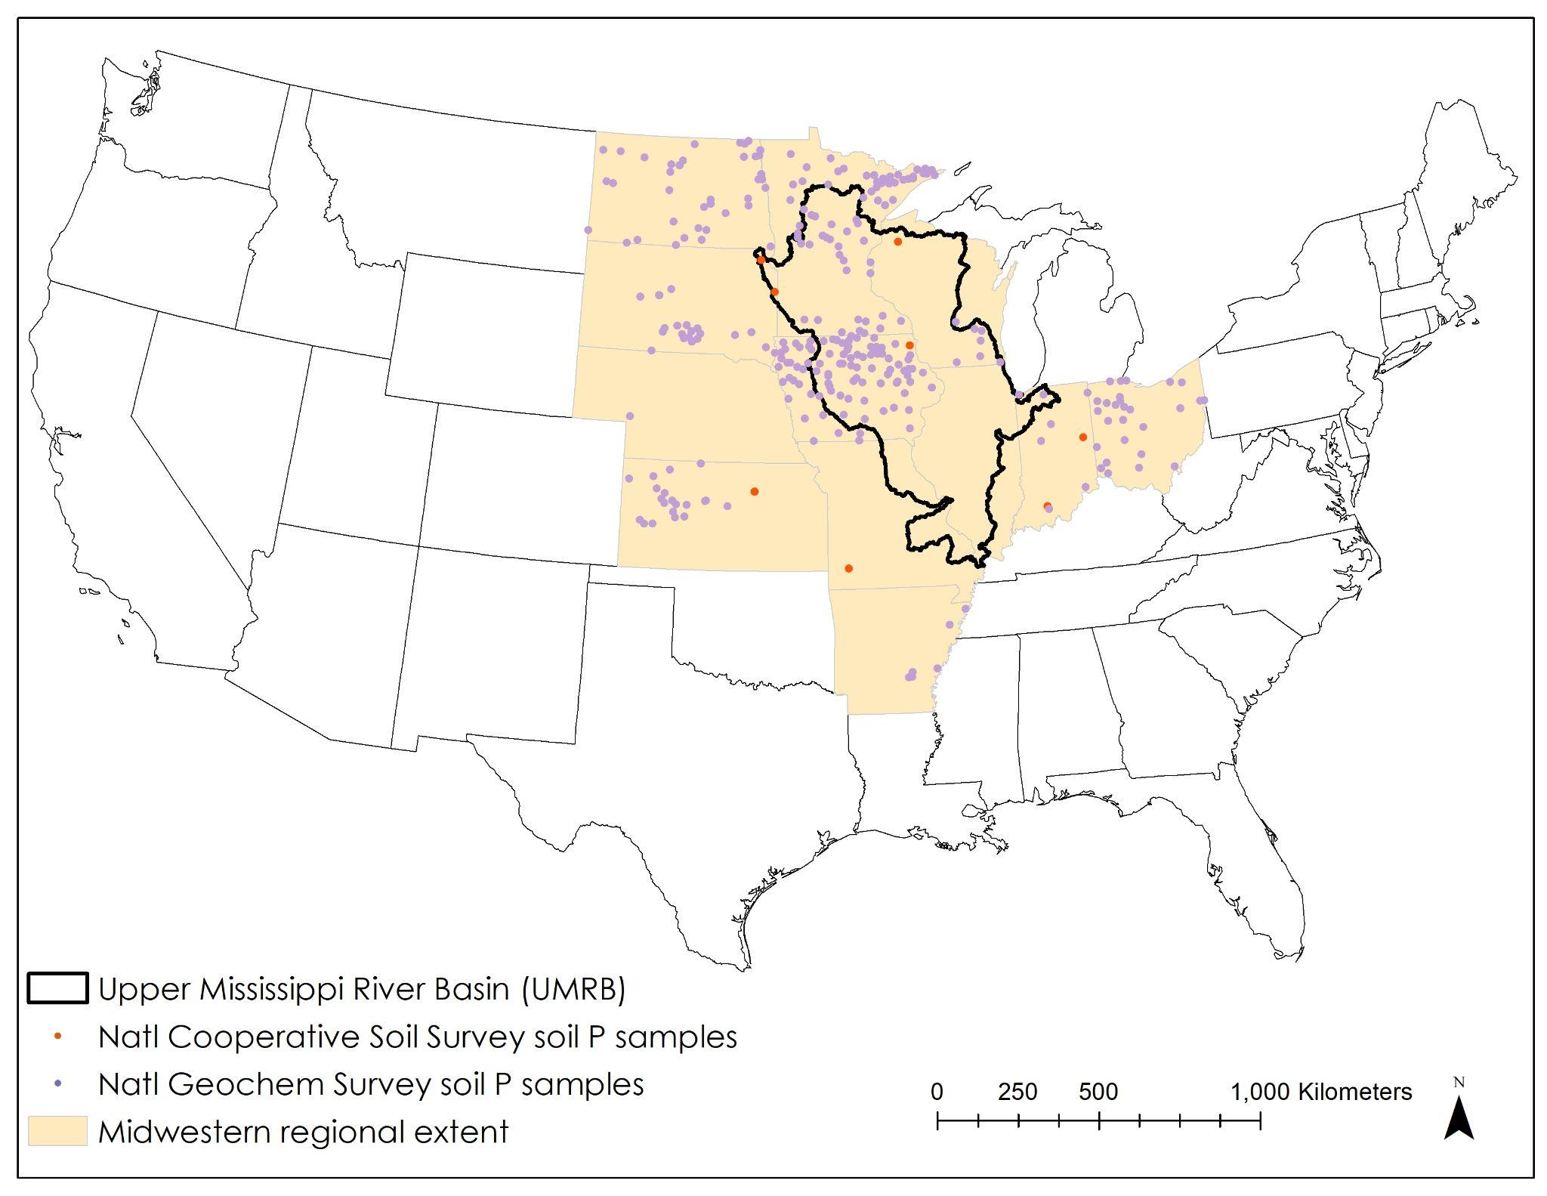
Figure S1. Locations of soil samples with total P > 1000 mg/kg.

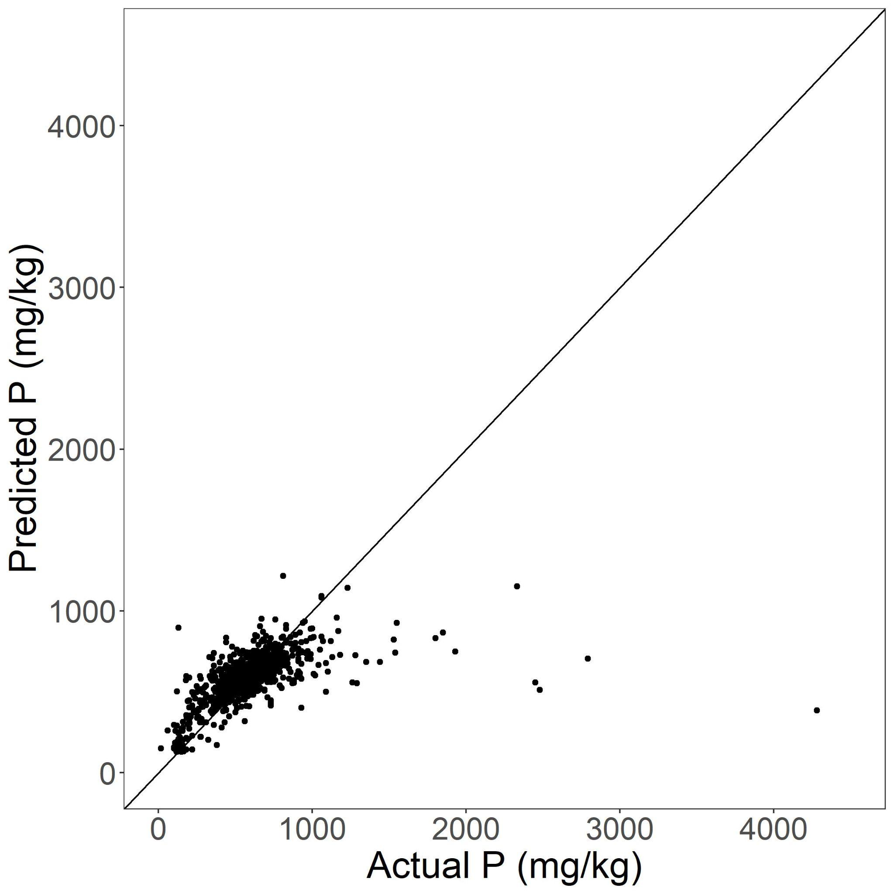
Figure S2. Random forest model performance when all soil samples were included, including samples with total soil P > 1000 mg/kg. Actual vs predicted total soil P (mg/kg) for soil samples in the independent test dataset (i.e., not used to build the model). R²=X, RMSE=X, p =X.Note that the random forest model was run using centered and scaled values of P, but unscaled values are shown here for easier interpretation.

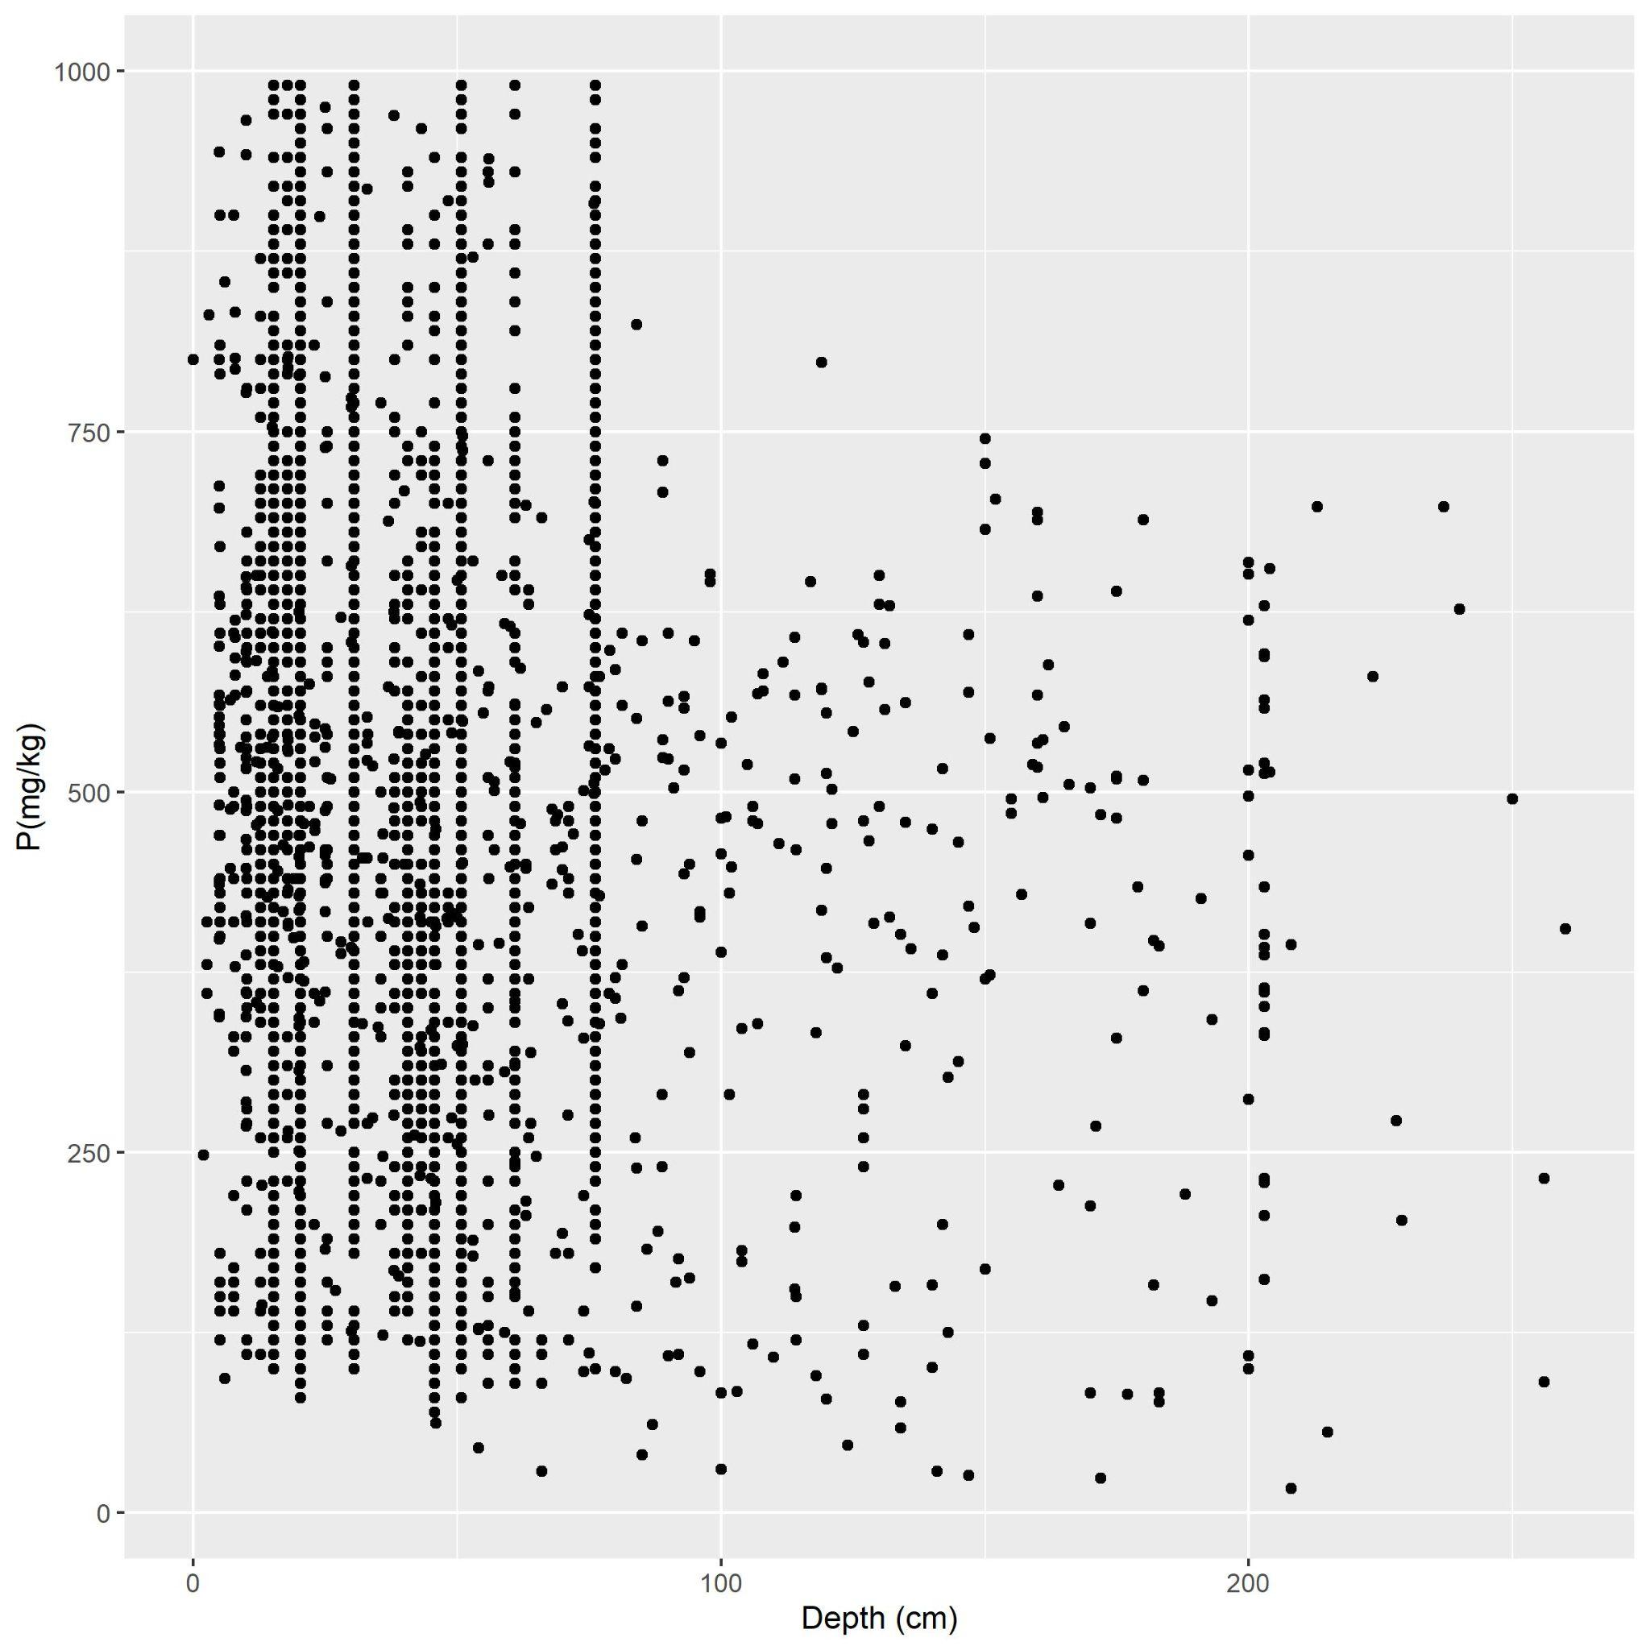
Figure S3. Total soil P (mg/kg) in relation to the depth (cm) at which samples were collected.
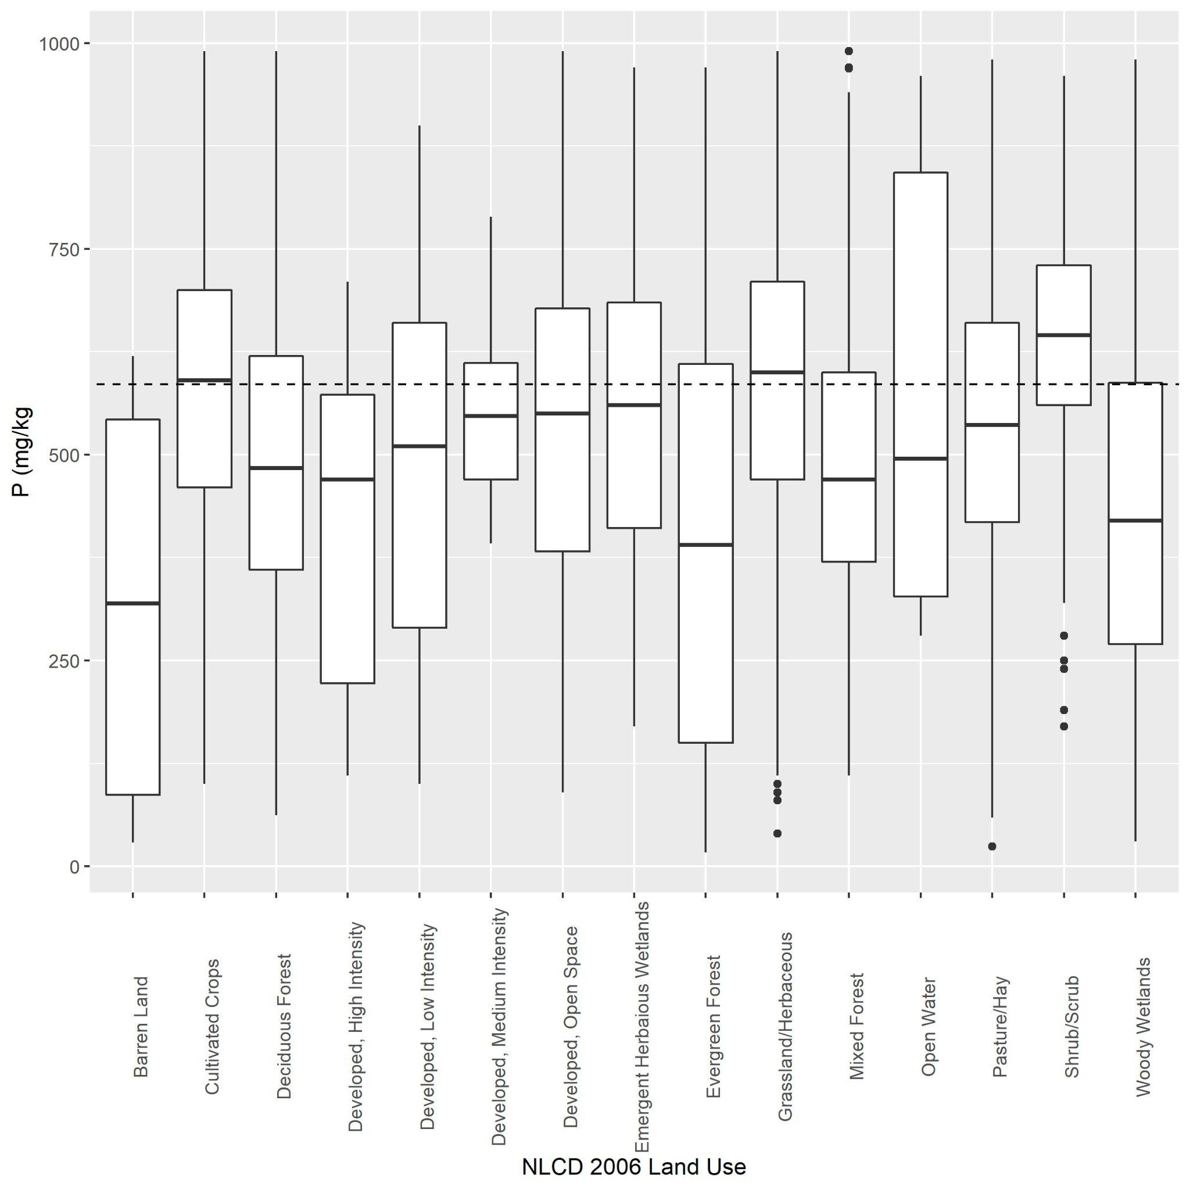
Figure S4. Total soil P (mg/kg) in relation to NLCD 2006 Land Use categories.
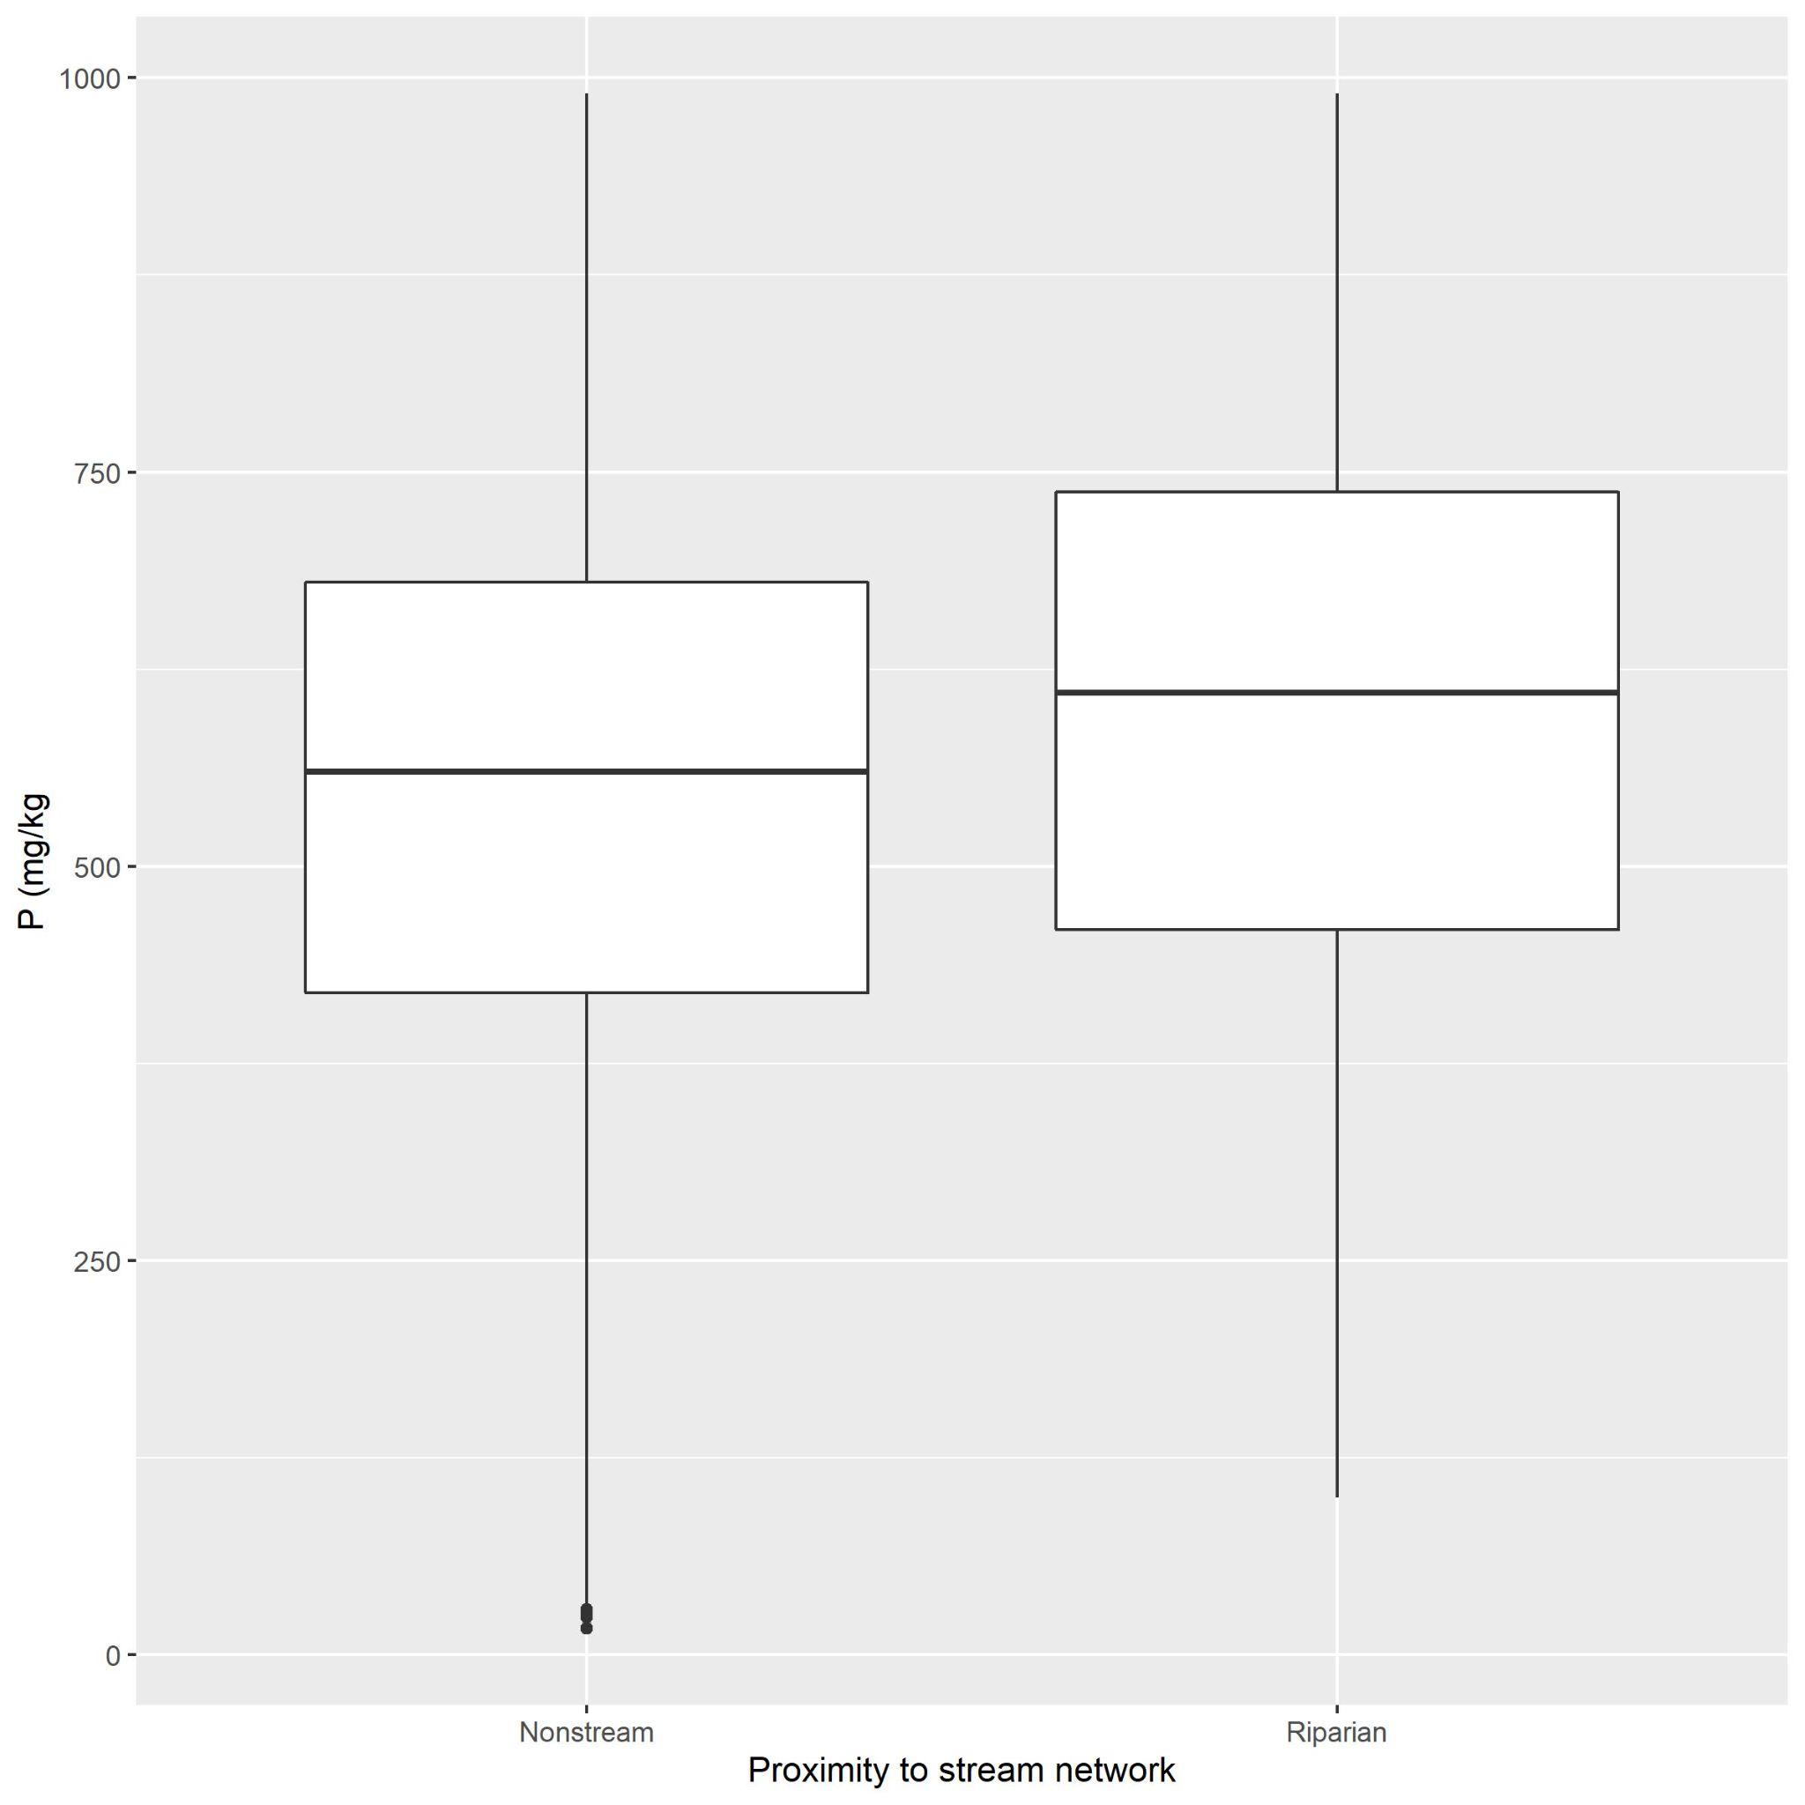
Figure S5. Total soil P (mg/kg) in relation to whether soil samples were collected inside the riparian buffer (‘Riparian’) or outside (‘Nonstream’).

Table S1. Initial list of geospatial attributes considered for the random forest model. Attributes were excluded as covariates from the random forest model if they 1) contained all zeros for the training dataset; 2) if more than 20% of records for the training dataset contained missing values (i.e., ‘NA’); or 3) if the attributes contained category levels for the UMRB grid points (used to predict soil P across the UMRB) that were not included in the training data. All other attributes were included as covariates in the random forest model. Covariate Names are given according to their corresponding Source Layer.

Covariate Name (Abbreviated) | Covariate type | Description | Source layer
airtempa_r | numeric | The arithmetic average of the daily maximum and minimum temperatures for a calendar year taken over the standard "normal" period, 1961 to 1990. | gSSURGO
aws0_100 | numeric | Available water storage (AWS). The volume of water that the soil, to a depth of 100 centimeters, can store that is available to plants. It is reported as the weighted average of all components in the map unit, and is expressed as centimeters of water. AWS is calculated from AWC (available water capacity) which is commonly estimated as the difference between the water contents at 1/10 or 1/3 bar (field capacity) and 15 bars (permanent wilting point) tension, and adjusted for salinity and fragments | gSSURGO
aws0_150 | numeric | Available water storage (AWS). The volume of water that the soil, to a depth of 150 centimeters, can store that is available to plants. It is reported as the weighted average of all components in the map unit, and is expressed as centimeters of water. AWS is calculated from AWC (available water capacity) which is commonly estimated as the difference between the water contents at 1/10 or 1/3 bar (field capacity) and 15 bars (permanent wilting point) tension, and adjusted for salinity and fragments | gSSURGO
aws0_20 | numeric | Available water storage estimate (AWS) in standard zone 2 (0‐20 cm depth), expressed in mm. The volume of plant available water that the soil can store in this zone based on all map unit components (weighted average). NULL values are presented where data are incomplete or not available. | gSSURGO
aws0_30 | numeric | Available water storage estimate (AWS) in standard zone 3 (0‐30 cm depth), expressed in mm. The volume of plant available water that the soil can store in this zone based on all map unit components (weighted average). NULL values are presented where data are incomplete or not available. | gSSURGO
aws0_5 | numeric | Available water storage estimate (AWS) in standard layer 1 or standard zone 1 (0‐5 cm depth), expressed in mm. The volume of plant available water that the soil can store in this layer based on all map unit components (weighted average). NULL values are presented where data are incomplete or not available. | gSSURGO
aws0_999 | numeric | Available water storage estimate (AWS) in total soil profile (0 cm to the reported depth of the soil profile), expressed in mm. The volume of plant available water that the soil can store in this layer based on all map unit components (weighted average). NULL values are presented where data are incomplete or not available. | gSSURGO
aws100_150 | numeric | Available water storage estimate (AWS) in standard layer 5 (100‐150 cm depth), expressed in mm. The volume of plant available water that the soil can store in this layer based on all map unit components (weighted average). NULL values are presented where data are incomplete or not available. | gSSURGO
aws150_999 | numeric | Available water storage estimate (AWS) in standard layer 6 (150 cm to the reported depth of the soil profile), expressed in mm. The volume of plant available water that the soil can store in this layer based on all map unit components (weighted average). NULL values are presented where data are incomplete or not available. | gSSURGO
aws20_50 | numeric | Available water storage estimate (AWS) in standard layer 3 (20‐50 cm depth), expressed in mm. The volume of plant available water that the soil can store in this layer based on all map unit components (weighted average). NULL values are presented where data are incomplete or not available. | gSSURGO
aws5_20 | numeric | Available water storage estimate (AWS) in standard layer 2 (5‐20 cm depth), expressed in mm. The volume of plant available water that the soil can store in this layer based on all map unit components (weighted average). NULL values are presented where data are incomplete or not available. | gSSURGO
aws50_100 | numeric | Available water storage estimate (AWS) in standard layer 4 (50‐100 cm depth), expressed in mm. The volume of plant available water that the soil can store in this layer based on all map unit components (weighted average). NULL values are presented where data are incomplete or not available. | gSSURGO
caco3_r | numeric | The quantity of Carbonate (CO3) in the soil expressed as CaCO3 and as a weight percentage of the less than 2 mm size fraction. | gSSURGO
claytotal_r | numeric | Mineral particles less than 0.002mm in equivalent diameter as a weight percentage of the less than 2.0mm fraction. | gSSURGO
comppct_r | numeric | The percentage of the component of the mapunit. | gSSURGO
Depth_cm | numeric | Deepest depth from which soil P sample was collected | USGS NGS; NCSS
drainagecl | categorical | Identifies the natural drainage conditions of the soil and refers to the frequency and duration of wet periods. An example of a drainage class is well drained. | gSSURGO
droughty | numeric | Droughty Soil Landscapes ‐ earthy major components. Drought vulnerable soil landscapes comprise those map units that have available water  storage within the root zone for commodity crops that is less than or equal to 6 inches (152  mm) expressed as "1" for a drought vulnerable soil landscape map unit or "0" for a non‐  droughty soil landscape map unit or NULL for miscellaneous areas (includes water bodies). It  is computed as a weighted average for major earthy components. Earthy components are  those soil series or higher level taxa components that can support crop growth (Dobos et al.,  2012). Major components are those soil components where the majorcompflag = 'Yes'  (SSURGO component table). NULL values are presented where data are incomplete or not  available | gSSURGO
elev_r | numeric | The vertical distance from mean sea level to a point on the earth's surface | gSSURGO
ffd_r | numeric | The expected number of days between the last freezing temperature (0 degrees Celsius) in spring (Jan-Jul) and the first freezing temperature (0 degrees Celsius) in the fall (Aug-Dec). The number of days is based on the probability that the values for the standard "normal" period of 1961 to 1990 will be exceeded in 5 years out of 10. | gSSURGO
gypsum_r | numeric | The percent by weight of hydrated calcium sulfate in the less than 20 mm fraction of soil | gSSURGO
hydricrating | categorical | A yes/no field that indicates whether or not a map unit component is classified as a "hydric soil". If rated as hydric, the specific criteria met are listed in the Component Hydric Criteria table. | gSSURGO
kffact | numeric | An erodibility factor which quantifies the susceptibility of soil particles to detachment by water. | gSSURGO
ksat_r | numeric | The amount of water that would move vertically through a unit area of saturated soil in unit time under unit hydraulic gradient. | gSSURGO
nccpi3all | numeric | National Commodity Crop Productivity Index that has the highest value among Corn and Soybeans, Small Grains, or Cotton (weighted average) for major earthy components. Values range from .01 (low productivity) to .99 (high productivity). Earthy components are those soil series or higher level taxa components that can support crop growth (Dobos et al., 2012). Major components are those soil components where the majorcompflag = 'Yes' (SSURGO component table). NULL values are presented where data are incomplete or not available | gSSURGO
nccpi3corn | numeric | National Commodity Crop Productivity Index for Corn (weighted average) for major earthy components. Values range from .01 (low productivity) to .99 (high productivity). Earthy components are those soil series or higher level taxa components that can support crop growth (Dobos et al., 2012). Major components are those soil components where the majorcompflag = 'Yes' (SSURGO component table). NULL values are presented where data are incomplete or not available. | gSSURGO
nccpi3cot | numeric | National Commodity Crop Productivity Index for Cotton (weighted average) for major earthy components. Values range from .01 (low productivity) to .99 (high productivity). Earthy components are those soil series or higher level taxa components that can support crop growth (Dobos et al., 2012). Major components are those soil components where the majorcompflag = 'Yes' (SSURGO component table). NULL values are presented where data are incomplete or not available. | gSSURGO
nccpi3sg | numeric | National Commodity Crop Productivity Index for Small Grains (weighted average) for major earthy components. Values range from .01 (low productivity) to .99 (high productivity). Earthy components are those soil series or higher level taxa components that can support crop growth (Dobos et al., 2012). Major components are those soil components where the majorcompflag = 'Yes' (SSURGO component table). NULL values are presented where data are incomplete or not available. | gSSURGO
nccpi3soy | numeric | National Commodity Crop Productivity Index for Soybeans (weighted average) for major earthy components. Values range from .01 (low productivity) to .99 (high productivity). Earthy components are those soil series or higher level taxa components that can support crop growth (Dobos et al., 2012). Major components are those soil components where the majorcompflag = 'Yes' (SSURGO component table). NULL values are presented where data are incomplete or not available. | gSSURGO
om_r | numeric | The amount by weight of decomposed plant and animal residue expressed as a weight percentage of the less than 2 mm soil material. | gSSURGO
pctearthmc | numeric | The National Commodity Crop Productivity Index map unit percent earthy is the map unit summed comppct_r for major earthy components. Earthy components are those soil series or higher level taxa components that can support crop growth (Dobos et al., 2012). Major components are those soil components where the majorcompflag = 'Yes' (SSURGO component table). Useful metadata information. NULL values are presented where data are incomplete or not available. | gSSURGO
pmkind | categorical | A term describing the general physical, chemical and mineralogical composition of the material, mineral or organic, from which the soil develops. Mode of deposition and/or weathering may be implied or implicit. | gSSURGO
rootznaws | numeric | Root zone (commodity crop) available water storage estimate (RZAWS) , expressed in mm, is the volume of plant available water that the soil can store within the root zone based on all map unit earthy major components (weighted average). Earthy components are those soil series or higher level taxa components that can support crop growth (Dobos et al., 2012). Major components are those soil components where the majorcompflag = 'Yes' (SSURGO component table). NULL values are presented where data are incomplete or not available. | gSSURGO
rootznemc | numeric | Root zone depth (cm) is the depth within the soil profile that commodity crop (cc) roots can effectively extract water and nutrients for growth. Root zone depth influences soil productivity significantly. Soil component horizon criteria for root‐limiting depth include: presence of hard bedrock, soft bedrock, a fragipan, a duripan, sulfuric material, a dense layer, a layer having a pH of less than 3.5, or a layer having an electrical conductivity of more than 12 within the component soil profile. If no root‐restricting zone is identified, a depth of 150 cm is used to approximate the root zone depth (Dobos et al., 2012). Root zone depth is computed for all map unit major earthy components (weighted average). Earthy components are those soil series or higher level taxa components that can support crop growth (Dobos et al., 2012). Major components are those soil components where the majorcompflag = 'Yes' (SSURGO component table). NULL values are presented where data are incomplete or not available. | gSSURGO
sandtotal_r | numeric | Mineral particles 0.05mm to 2.0mm in equivalent diameter as a weight percentage of the less than 2 mm fraction. | gSSURGO
sieveno10_r | numeric | Soil fraction passing a number 10 sieve (2.00mm square opening) as a weight percentage of the less than 3 inch (76.4mm) fraction. | gSSURGO
sieveno200_r | numeric | Soil fraction passing a number 200 sieve (0.074mm square opening) as a weight percentage of the less than 3 inch (76.4mm) fraction. | gSSURGO
sieveno4_r | numeric | Soil fraction passing a number 4 sieve (4.70mm square opening) as a weight percentage of the less than 3 inch (76.4mm) fraction. | gSSURGO
sieveno40_r | numeric | Soil fraction passing a number 40 sieve (0.42mm square opening) as a weight percentage of the less than 3 inch (76.4mm) fraction. | gSSURGO
silttotal_r | numeric | Mineral particles 0.002 to 0.05mm in equivalent diameter as a weight percentage of the less than 2.0mm fraction. | gSSURGO
slope_r | numeric | The difference in elevation between two points, expressed as a percentage of the distance between those points. (SSM) | gSSURGO
soc0_100 | numeric | Soil organic carbon stock estimate (SOC, g C per square meter) in standard zone 4 (0‐100 cm depth). The concentration of organic carbon present in the soil expressed in grams C per square meter to a depth of 100 cm. NULL values are presented where data are incomplete or not available | gSSURGO
soc0_150 | numeric | Soil organic carbon stock estimate (SOC, g C per square meter) in standard zone 5 (0‐150 cm depth). The concentration of organic carbon present in the soil expressed in grams C per square meter to a depth of 150 cm. NULL values are presented where data are incomplete or not available. | gSSURGO
soc0_20 | numeric | Soil organic carbon stock estimate (SOC, g C per square meter) in standard zone 2 (0‐20 cm depth). The concentration of organic carbon present in the soil expressed in grams C per square meter to a depth of 20 cm. NULL values are presented where data are incomplete or not available. | gSSURGO
soc0_30 | numeric | Soil organic carbon stock estimate (SOC, g C per square meter) in standard zone 3 (0‐30 cm depth). The concentration of organic carbon present in the soil expressed in grams C per square meter to a depth of 30 cm. NULL values are presented where data are incomplete or not available. | gSSURGO
soc0_5 | numeric | Soil organic carbon stock estimate (SOC, g C per square meter) in standard layer 1 or standard zone 1 (0‐5 cm depth). The concentration of organic carbon present in the soil expressed in grams C per square meter to a depth of 5 cm. NULL values are presented where data are incomplete or not available. | gSSURGO
soc0_999 | numeric | Soil organic carbon stock estimate (SOC, g C per square meter) in total soil profile (0 cm to the reported depth of the soil profile). The concentration of organic carbon present in the soil expressed in grams C per square meter for the total reported soil profile depth. NULL values are presented where data are incomplete or not available. | gSSURGO
soc100_150 | numeric | Soil organic carbon stock estimate (SOC, g C per square meter) in standard layer 5 (100‐150 cm depth). The concentration of organic carbon present in the soil expressed in grams C per square meter for the 100‐150 cm layer. NULL values are presented where data are incomplete or not available. | gSSURGO
soc150_999 | numeric | Soil organic carbon stock estimate (SOC, g C per square meter) in standard layer 6 (150 cm to the reported depth of the soil profile). The concentration of organic carbon present in the soil expressed in grams C per square meter for the 150 cm and greater depth layer. NULL values are presented where data are incomplete or not available. | gSSURGO
soc20_50 | numeric | Soil organic carbon stock estimate (SOC, g C per square meter) in standard layer 3 (20‐50 cm depth). The concentration of organic carbon present in the soil expressed in grams C per square meter for the 20‐50 cm layer. NULL values are presented where data are incomplete or not available. | gSSURGO
soc5_20 | numeric | Soil organic carbon stock estimate (SOC, g C per square meter) in standard layer 2 (5‐20 cm depth). The concentration of organic carbon present in the soil expressed in grams C per square meter for the 5‐20 cm layer. NULL values are presented where data are incomplete or not available. | gSSURGO
soc50_100 | numeric | Soil organic carbon stock estimate (SOC, g C per square meter) in standard layer 4 (50‐100 cm depth). The concentration of organic carbon present in the soil expressed in grams C per square meter for the 50‐100 cm layer. NULL values are presented where data are incomplete or not available. | gSSURGO
taxceactcl | numeric | Cation exchange activity classes are used as family criteria differentiae. It is the relative cation exchange (CEC) activity level of the soil based on the CEC to clay ratio. (Soil Taxonomy) | gSSURGO
taxpartsize | categorical | Particle-size classes are used as family differentiae. Particle-size refers to grain-size distribution of the whole soil and is not the same as texture. (Soil Taxonomy). | gSSURGO
texcl | categorical | An expression, based on the USDA system of particle sizes, for the relative portions of the various size groups of individual mineral grains less than 2mm equivalent diameter in a mass of soil. | gSSURGO
StreamType | categorical | Based on the FCODE attribute of NHDv2Plus; categories are 'NonStream', 'Canal/Ditch', 'Intermittent_Stream', 'Perennial_Stream', 'Artificial_Path', 'Coastline'. | NHDv2Plus
NLCD06Cat | categorical | Land use categories from the NLCD 2006 dataset. | NLCD 2006
WetlandType | categorical | Based on the WETLAND_TYPE attribute of NWI; categories are 'NonWetland','Freshwater Emergent Wetland', 'Freshwater Forested/Shrub Wetland',  'Freshwater Pond', 'Lake', 'Riverine'. | NWI
AgKffactCat | numeric | Mean soil erodibility (Kf) factor (unitless) of soils within catchment on agricultural land. The Kf factor is used in the Universal Soil Loss Equation (USLE) and represents a relative index of susceptibility of bare, cultivated soil to particle detachment and transport by rainfall. | StreamCat
AgKffactWs | numeric | Mean soil erodibility (Kf) factor (unitless) of soils within watershed on agricultural land. The Kf factor is used in the Universal Soil Loss Equation (USLE) and represents a relative index of susceptibility of bare, cultivated soil to particle detachment and transport by rainfall. | StreamCat
Al2O3Cat | numeric | Mean % of lithological aluminum oxide (Al2O3) content in surface or near surface geology within catchment | StreamCat
Al2O3Ws | numeric | Mean % of lithological aluminum oxide (Al2O3) content in surface or near surface geology within watershed | StreamCat
BFICat | numeric | Baseflow is the component of streamflow that can be attributed to ground-water discharge into streams. The Baseflow Index (BFI) is the ratio of baseflow to total flow, expressed as a percentage, within catchment. | StreamCat
BFIWs | numeric | Baseflow is the component of streamflow that can be attributed to ground-water discharge into streams. The Baseflow Index (BFI) is the ratio of baseflow to total flow, expressed as a percentage, within watershed. | StreamCat
CanalDensCat | numeric | Density of NHDPlus line features classified as canal, ditch, or pipeline within the catchment (km/ square km) | StreamCat
CanalDensWs | numeric | Density of NHDPlus line features classified as canal, ditch, or pipeline within the upstream watershed (km/ square km) | StreamCat
CaOCat | numeric | Mean % of lithological calcium oxide (CaO) content in surface or near surface geology within catchment | StreamCat
CaOWs | numeric | Mean % of lithological calcium oxide (CaO) content in surface or near surface geology within watershed | StreamCat
CatAreaSqKm | numeric | Area of local NHDPlus catchment (square km) | StreamCat
CBNFCat | numeric | Mean rate of biological nitrogen fixation from the cultivation of crops in kg N/ha/yr, within catchment | StreamCat
CBNFWs | numeric | Mean rate of biological nitrogen fixation from the cultivation of crops in kg N/ha/yr, within watershed | StreamCat
ClayCat | numeric | Mean % clay content of soils (STATSGO) within catchment | StreamCat
ClayWs | numeric | Mean % sand content of soils (STATSGO) within catchment | StreamCat
CoalMineDensCat | numeric | Density of coal mines sites within catchment (mines/square km) | StreamCat
CoalMineDensWs | numeric | Density of coal mines sites within watershed (mines/square km) | StreamCat
CompStrgthCat | numeric | Mean lithological uniaxial compressive strength (megaPascals) content in surface or near surface geology within catchment | StreamCat
CompStrgthWs | numeric | Mean lithological uniaxial compressive strength (megaPascals) content in surface or near surface geology within watershed | StreamCat
DamDensCat | numeric | Density of georeferenced dams within catchment (dams/ square km) based on the National Inventory of Dams (https://catalog.data.gov/dataset/national-inventory-of-dams) | StreamCat
DamDensWs | numeric | Density of georeferenced dams within watershed (dams/ square km) based on the National Inventory of Dams (https://catalog.data.gov/dataset/national-inventory-of-dams) | StreamCat
DamNIDStorCat | numeric | Total possible volume of all reservoirs (NID_STORA in NID) per unit area of catchment (cubic meters/square km) based on the National Inventory of Dams (https://catalog.data.gov/dataset/national-inventory-of-dams) | StreamCat
DamNIDStorWs | numeric | Total possible volume of all reservoirs (NID_STORA in NID) per unit area of watershed (cubic meters/square km) based on the National Inventory of Dams (https://catalog.data.gov/dataset/national-inventory-of-dams) | StreamCat
DamNrmStorCat | numeric | Normal (most common) volume of all reservoirs (NORM_STORA in NID) per unit area of catchment (cubic meters/square km) based on the National Inventory of Dams (https://catalog.data.gov/dataset/national-inventory-of-dams) | StreamCat
DamNrmStorWs | numeric | Normal (most common) volume of all reservoirs (NORM_STORA in NID) per unit area of watershed (cubic meters/square km) based on the National Inventory of Dams (https://catalog.data.gov/dataset/national-inventory-of-dams) | StreamCat
ElevCat | numeric | Mean catchment elevation (m) | StreamCat
ElevWs | numeric | Mean watershed elevation (m) | StreamCat
Fe2O3Cat | numeric | Mean % of lithological ferric oxide (Fe2O3) content in surface or near surface geology within catchment | StreamCat
Fe2O3Ws | numeric | Mean % of lithological ferric oxide (Fe2O3) content in surface or near surface geology within watershed | StreamCat
FertCat | numeric | Mean rate of synthetic nitrogen fertilizer application to agricultural land in kg N/ha/yr, within the catchment | StreamCat
FertWs | numeric | Mean rate of synthetic nitrogen fertilizer application to agricultural land in kg N/ha/yr, within watershed | StreamCat
HydrlCondCat | numeric | Mean lithological hydraulic conductivity (micrometers per second) content in surface or near surface geology within catchment | StreamCat
HydrlCondWs | numeric | Mean lithological hydraulic conductivity (micrometers per second) content in surface or near surface geology within watershed | StreamCat
InorgNWetDep_2008Cat | numeric | Annual gradient map of precipitation-weighted mean deposition for inorganic nitrogen wet deposition from nitrate and ammonium for 2008 in kg of N/ha/yr, within catchment | StreamCat
InorgNWetDep_2008Ws | numeric | Annual gradient map of precipitation-weighted mean deposition for inorganic nitrogen wet deposition from nitrate and ammonium for 2008 in kg of N/ha/yr, within watershed | StreamCat
K2OCat | numeric | Mean % of lithological potassium oxide (K2O) content in surface or near surface geology within catchment | StreamCat
K2OWs | numeric | Mean % of lithological potassium oxide (K2O) content in surface or near surface geology within watershed | StreamCat
KffactCat | numeric | Mean soil erodibility (Kf) factor (unitless) of soils within catchment. The Kf factor is used in the Universal Soil Loss Equation (USLE) and represents a relative index of susceptibility of bare, cultivated soil to particle detachment and transport by rainfall. | StreamCat
KffactWs | numeric | Mean soil erodibility (Kf) factor (unitless) of soils within watershed. The Kf factor is used in the Universal Soil Loss Equation (USLE) and represents a relative index of susceptibility of bare, cultivated soil to particle detachment and transport by rainfall. | StreamCat
ManureCat | numeric | Mean rate of manure application to agricultural land from confined animal feeding operations in kg N/ha/yr, within catchment | StreamCat
ManureWs | numeric | Mean rate of manure application to agricultural land from confined animal feeding operations in kg N/ha/yr, within watershed | StreamCat
MAST_2008 | numeric | Predicted mean annual stream temperature (Jan-Dec) for year 2008 | StreamCat
MgOCat | numeric | Mean % of lithological magnesium oxide (MgO) content in surface or near surface geology within catchment | StreamCat
MgOWs | numeric | Mean % of lithological magnesium oxide (MgO) content in surface or near surface geology within watershed | StreamCat
MineDensCat | numeric | Density of mine sites within catchment (mines/square km) | StreamCat
MineDensWs | numeric | Density of mine sites within watershed (mines/square km) | StreamCat
MineDensWsRp100 | numeric | Density of mine sites within watershed and within 100-m buffer of NHD stream lines (mines/square km) | StreamCat
MSST_2008 | numeric | Predicted mean summer stream temperature (July-Aug) for year 2008 | StreamCat
Na2OCat | numeric | Mean % of lithological sodium oxide (Na2O) content in surface or near surface geology within catchment | StreamCat
Na2OWs | numeric | Mean % of lithological sodium oxide (Na2O) content in surface or near surface geology within watershed | StreamCat
NABD_DensCat | numeric | Density of georeferenced dams within catchment (dams/ square km) based on the National Anthropogenic Barrier Dataset (https://www.sciencebase.gov/catalog/item/56a7f9dce4b0b28f1184dabd) | StreamCat
NABD_DensWs | numeric | Density of georeferenced dams within watershed (dams/ square km) based on the National Anthropogenic Barrier Dataset (https://www.sciencebase.gov/catalog/item/56a7f9dce4b0b28f1184dabd) | StreamCat
NABD_NIDStorCat | numeric | Total possible volume of all reservoirs (NID_STORA in NID) per unit area of catchment (cubic meters/square km) based on the National Anthropogenic Barrier Dataset (https://www.sciencebase.gov/catalog/item/56a7f9dce4b0b28f1184dabd) | StreamCat
NABD_NIDStorWs | numeric | Total possible volume of all reservoirs (NID_STORA in NID) per unit area of watershed (cubic meters/square km) based on the National Anthropogenic Barrier Dataset (https://www.sciencebase.gov/catalog/item/56a7f9dce4b0b28f1184dabd) | StreamCat
NABD_NrmStorCat | numeric | Normal (most common) volume of all reservoirs (NORM_STORA in NID) per unit area of catchment (cubic meters/square km) based on the National Anthropogenic Barrier Dataset (https://www.sciencebase.gov/catalog/item/56a7f9dce4b0b28f1184dabd) | StreamCat
NABD_NrmStorWs | numeric | Normal (most common) volume of all reservoirs (NORM_STORA in NID) per unit area of watershed (cubic meters/square km) based on the National Anthropogenic Barrier Dataset (https://www.sciencebase.gov/catalog/item/56a7f9dce4b0b28f1184dabd) | StreamCat
NCat | numeric | Mean % of lithological nitrogen (N) content in surface or near surface geology within catchment | StreamCat
NH4_2008Cat | numeric | Annual gradient map of precipitation-weighted mean deposition for ammonium ion concentration wet deposition for 2008 in kg of NH4/ha/yr, within catchment | StreamCat
NH4_2008Ws | numeric | Annual gradient map of precipitation-weighted mean deposition for ammonium ion concentration wet deposition for 2008 in kg of NH4/ha/yr, within watershed | StreamCat
NO3_2008Cat | numeric | Annual gradient map of precipitation-weighted mean deposition for nitrate ion concentration wet deposition for 2008 in kg of NO3/ha/yr, within catchment | StreamCat
NO3_2008Ws | numeric | Annual gradient map of precipitation-weighted mean deposition for nitrate ion concentration wet deposition for 2008 in kg of NO3/ha/yr, within watershed | StreamCat
NPDESDensCat | numeric | Density of permitted NPDES (National Pollutant Discharge Elimination System) sites within catchment (sites/square km) | StreamCat
NPDESDensCatRp100 | numeric | Density of permitted NPDES (National Pollutant Discharge Elimination System) sites within catchment and within a 100-m buffer of NHD stream lines (sites/square km) | StreamCat
NPDESDensWs | numeric | Density of permitted NPDES (National Pollutant Discharge Elimination System) sites within watershed (sites/square km) | StreamCat
NPDESDensWsRp100 | numeric | Density of permitted NPDES (National Pollutant Discharge Elimination System) sites within watershed and within 100-m buffer of NHD stream lines (sites/square km) | StreamCat
NWs | numeric | Mean % of lithological nitrogen (N) content in surface or near surface geology within watershed | StreamCat
OmCat | numeric | Mean organic matter content (% by weight) of soils (STATSGO) within catchment | StreamCat
OmWs | numeric | Mean organic matter content (% by weight) of soils (STATSGO) within watershed | StreamCat
P2O5Cat | numeric | Mean % of lithological phosphorous oxide (P2O5) content in surface or near surface geology within catchment | StreamCat
P2O5Ws | numeric | Mean % of lithological phosphorous oxide (P2O5) content in surface or near surface geology within watershed | StreamCat
PctAg2006Slp10Ws | numeric | % of watershed area classified as ag land cover (NLCD 2006 classes 81-82) occurring on slopes greater than or equal to 10% | StreamCat
PctAlkIntruVolWs | numeric | % of watershed area classified as lithology type: alkaline intrusive volcanic rock | StreamCat
PctAlluvCoastCat | numeric | % of catchment area classified as lithology type: alluvium and fine-textured coastal zone sediment | StreamCat
PctAlluvCoastWs | numeric | % of watershed area classified as lithology type: alluvium and fine-textured coastal zone sediment | StreamCat
PctBl2006Cat | numeric | % of catchment area classified as barren land cover (NLCD 2006 class 31) | StreamCat
PctBl2006CatRp100 | numeric | % of catchment area classified as barren land cover (NLCD 2006 class 31) within a 100-m buffer of NHD streams | StreamCat
PctBl2006Ws | numeric | % of watershed area classified as barren land cover (NLCD 2006 class 31) | StreamCat
PctBl2006WsRp100 | numeric | % of watershed area classified as barren land cover (NLCD 2006 class 31) within a 100-m buffer of NHD streams | StreamCat
PctCarbResidWs | numeric | % of watershed area classified as lithology type: carbonate residual material | StreamCat
PctColluvSedCat | numeric | % of catchment area classified as lithology type: colluvial sediment | StreamCat
PctColluvSedWs | numeric | % of watershed area classified as lithology type: colluvial sediment | StreamCat
PctConif2006Cat | numeric | % of catchment area classified as evergreen forest land cover (NLCD 2006 class 42) | StreamCat
PctConif2006CatRp100 | numeric | % of catchment area classified as evergreen forest land cover (NLCD 2006 class 42) within a 100-m buffer of NHD streams | StreamCat
PctConif2006Ws | numeric | % of watershed area classified as evergreen forest land cover (NLCD 2006 class 42) | StreamCat
PctConif2006WsRp100 | numeric | % of watershed area classified as evergreen forest land cover (NLCD 2006 class 42) within a 100-m buffer of NHD streams | StreamCat
PctCrop2006Cat | numeric | % of catchment area classified as crop land use (NLCD 2006 class 82) | StreamCat
PctCrop2006CatRp100 | numeric | % of catchment area classified as crop land use (NLCD 2006 class 82) within a 100-m buffer of NHD streams | StreamCat
PctCrop2006Ws | numeric | % of watershed area classified as crop land use (NLCD 2006 class 82) | StreamCat
PctCrop2006WsRp100 | numeric | % of watershed area classified as crop land use (NLCD 2006 class 82) within a 100-m buffer of NHD streams | StreamCat
PctDecid2006Cat | numeric | % of catchment area classified as deciduous forest land cover (NLCD 2006 class 41) | StreamCat
PctDecid2006CatRp100 | numeric | % of catchment area classified as deciduous forest land cover (NLCD 2006 class 41) within a 100-m buffer of NHD streams | StreamCat
PctDecid2006Ws | numeric | % of watershed area classified as deciduous forest land cover (NLCD 2006 class 41) | StreamCat
PctDecid2006WsRp100 | numeric | % of watershed area classified as deciduous forest land cover (NLCD 2006 class 41) within a 100-m buffer of NHD streams | StreamCat
PctEolCrsCat | numeric | % of catchment area classified as lithology type: eolian sediment, coarse-textured (sand dunes) | StreamCat
PctEolCrsWs | numeric | % of watershed area classified as lithology type: eolian sediment, coarse-textured (sand dunes) | StreamCat
PctEolFineCat | numeric | % of catchment area classified as lithology type: eolian sediment, fine-textured (glacial loess) | StreamCat
PctEolFineWs | numeric | % of watershed area classified as lithology type: eolian sediment, fine-textured (glacial loess) | StreamCat
PctExtruVolWs | numeric | % of watershed area classified as lithology type: extrusive volcanic rock | StreamCat
PctGlacLakeCrsCat | numeric | % of catchment area classified as lithology type: glacial outwash and glacial lake sediment, coarse-textured | StreamCat
PctGlacLakeCrsWs | numeric | % of watershed area classified as lithology type: glacial outwash and glacial lake sediment, coarse-textured | StreamCat
PctGlacLakeFineCat | numeric | % of catchment area classified as lithology type: glacial lake sediment, fine-textured | StreamCat
PctGlacLakeFineWs | numeric | % of watershed area classified as lithology type: glacial lake sediment, fine-textured | StreamCat
PctGlacTilClayCat | numeric | % of catchment area classified as lithology type: glacial till, clayey | StreamCat
PctGlacTilClayWs | numeric | % of watershed area classified as lithology type: glacial till, clayey | StreamCat
PctGlacTilCrsCat | numeric | % of catchment area classified as lithology type: glacial till, coarse-textured | StreamCat
PctGlacTilCrsWs | numeric | % of watershed area classified as lithology type: glacial till, coarse-textured | StreamCat
PctGlacTilLoamCat | numeric | % of catchment area classified as lithology type: glacial till, loamy | StreamCat
PctGlacTilLoamWs | numeric | % of watershed area classified as lithology type: glacial till, loamy | StreamCat
PctGrs2006Cat | numeric | % of catchment area classified as grassland/herbaceous land cover (NLCD 2006 class 71) | StreamCat
PctGrs2006CatRp100 | numeric | % of catchment area classified as grassland/herbaceous land cover (NLCD 2006 class 71) within a 100-m buffer of NHD streams | StreamCat
PctGrs2006Ws | numeric | % of watershed area classified as grassland/herbaceous land cover (NLCD 2006 class 71) | StreamCat
PctGrs2006WsRp100 | numeric | % of watershed area classified as grassland/herbaceous land cover (NLCD 2006 class 71) within a 100-m buffer of NHD streams | StreamCat
PctHay2006Cat | numeric | % of catchment area classified as hay land use (NLCD 2006 class 81) | StreamCat
PctHay2006CatRp100 | numeric | % of catchment area classified as hay land use (NLCD 2006 class 81) within a 100-m buffer of NHD streams | StreamCat
PctHay2006Ws | numeric | % of watershed area classified as hay land use (NLCD 2006 class 81) | StreamCat
PctHay2006WsRp100 | numeric | % of watershed area classified as hay land use (NLCD 2006 class 81) within a 100-m buffer of NHD streams | StreamCat
PctHbWet2006Cat | numeric | % of catchment area classified as herbaceous wetland land cover (NLCD 2006 class 95) | StreamCat
PctHbWet2006CatRp100 | numeric | % of catchment area classified as herbaceous wetland land cover (NLCD 2006 class 95) within a 100-m buffer of NHD streams | StreamCat
PctHbWet2006Ws | numeric | % of watershed area classified as herbaceous wetland land cover (NLCD 2006 class 95) | StreamCat
PctHbWet2006WsRp100 | numeric | % of watershed area classified as herbaceous wetland land cover (NLCD 2006 class 95) within a 100-m buffer of NHD streams | StreamCat
PctHydricCat | numeric | % of catchment area classified as lithology type: hydric, peat and muck | StreamCat
PctHydricWs | numeric | % of watershed area classified as lithology type: hydric, peat and muck | StreamCat
PctIce2006Ws | numeric |  | StreamCat
PctIce2006WsRp100 | numeric |  | StreamCat
PctImp2006Cat | numeric | Mean imperviousness of anthropogenic surfaces (NLCD 2006) within catchment | StreamCat
PctImp2006CatRp100 | numeric | Mean imperviousness of anthropogenic surfaces (NLCD 2006) within catchment and within a 100-m buffer of NHD stream lines | StreamCat
PctImp2006Ws | numeric | Mean imperviousness of anthropogenic surfaces (NLCD 2006) within watershed | StreamCat
PctMxFst2006Cat | numeric | % of catchment area classified as mixed deciduous/evergreen forest land cover (NLCD 2006 class 43) | StreamCat
PctMxFst2006CatRp100 | numeric | % of catchment area classified as mixed deciduous/evergreen forest land cover (NLCD 2006 class 43) within a 100-m buffer of NHD streams | StreamCat
PctMxFst2006Ws | numeric | % of watershed area classified as mixed deciduous/evergreen forest land cover (NLCD 2006 class 43) | StreamCat
PctMxFst2006WsRp100 | numeric | % of watershed area classified as mixed deciduous/evergreen forest land cover (NLCD 2006 class 43) within a 100-m buffer of NHD streams | StreamCat
PctNonCarbResidCat | numeric | % of catchment area classified as lithology type: non-carbonate residual material | StreamCat
PctNonCarbResidWs | numeric | % of watershed area classified as lithology type: non-carbonate residual material | StreamCat
PctOw2006Cat | numeric | % of catchment area classified as open water land cover (NLCD 2006 class 11) | StreamCat
PctOw2006CatRp100 | numeric | % of catchment area classified as open water land cover (NLCD 2006 class 11) within a 100-m buffer of NHD streams | StreamCat
PctOw2006Ws | numeric | % of watershed area classified as open water land cover (NLCD 2006 class 11) | StreamCat
PctOw2006WsRp100 | numeric | % of watershed area classified as open water land cover (NLCD 2006 class 11) within a 100-m buffer of NHD streams | StreamCat
PctShrb2006Cat | numeric | % of catchment area classified as shrub/scrub land cover (NLCD 2006 class 52) | StreamCat
PctShrb2006CatRp100 | numeric | % of catchment area classified as shrub/scrub land cover (NLCD 2006 class 52) within a 100-m buffer of NHD streams | StreamCat
PctShrb2006Ws | numeric | % of watershed area classified as shrub/scrub land cover (NLCD 2006 class 52) | StreamCat
PctShrb2006WsRp100 | numeric | % of watershed area classified as shrub/scrub land cover (NLCD 2006 class 52) within a 100-m buffer of NHD streams | StreamCat
PctSilicicWs | numeric | % of watershed area classified as lithology type: silicic residual material | StreamCat
PctUrbHi2006Cat | numeric | % of catchment area classified as developed, high-intensity land use (NLCD 2006 class 24) | StreamCat
PctUrbHi2006CatRp100 | numeric | % of catchment area classified as developed, high-intensity land use (NLCD 2006 class 24) within a 100-m buffer of NHD streams | StreamCat
PctUrbHi2006Ws | numeric | % of watershed area classified as developed, high-intensity land use (NLCD 2006 class 24) | StreamCat
PctUrbHi2006WsRp100 | numeric | % of watershed area classified as developed, high-intensity land use (NLCD 2006 class 24) within a 100-m buffer of NHD streams | StreamCat
PctUrbLo2006Cat | numeric | % of catchment area classified as developed, low-intensity land use (NLCD 2006 class 22) | StreamCat
PctUrbLo2006CatRp100 | numeric | % of catchment area classified as developed, low-intensity land use (NLCD 2006 class 22) within a 100-m buffer of NHD streams | StreamCat
PctUrbLo2006Ws | numeric | % of watershed area classified as developed, low-intensity land use (NLCD 2006 class 22) | StreamCat
PctUrbLo2006WsRp100 | numeric | % of watershed area classified as developed, low-intensity land use (NLCD 2006 class 22) within a 100-m buffer of NHD streams | StreamCat
PctUrbMd2006Cat | numeric | % of catchment area classified as developed, medium-intensity land use (NLCD 2006 class 23) | StreamCat
PctUrbMd2006CatRp100 | numeric | % of catchment area classified as developed, medium-intensity land use (NLCD 2006 class 23) within a 100-m buffer of NHD streams | StreamCat
PctUrbMd2006Ws | numeric | % of watershed area classified as developed, medium-intensity land use (NLCD 2006 class 23) | StreamCat
PctUrbMd2006WsRp100 | numeric | % of watershed area classified as developed, medium-intensity land use (NLCD 2006 class 23) within a 100-m buffer of NHD streams | StreamCat
PctUrbOp2006Cat | numeric | % of catchment area classified as developed, open space land use (NLCD 2006 class 21) | StreamCat
PctUrbOp2006CatRp100 | numeric | % of catchment area classified as developed, open space land use (NLCD 2006 class 21) within a 100-m buffer of NHD streams | StreamCat
PctUrbOp2006Ws | numeric | % of watershed area classified as developed, open space land use (NLCD 2006 class 21) | StreamCat
PctUrbOp2006WsRp100 | numeric | % of watershed area classified as developed, open space land use (NLCD 2006 class 21) within a 100-m buffer of NHD streams | StreamCat
PctWaterCat | numeric | % of catchment area classified as lithology type: water | StreamCat
PctWaterWs | numeric | % of watershed area classified as lithology type: water | StreamCat
PctWdWet2006Cat | numeric | % of catchment area classified as woody wetland land cover (NLCD 2006 class 90) | StreamCat
PctWdWet2006CatRp100 | numeric | % of catchment area classified as woody wetland land cover (NLCD 2006 class 90) within a 100-m buffer of NHD streams | StreamCat
PctWdWet2006Ws | numeric | % of watershed area classified as woody wetland land cover (NLCD 2006 class 90) | StreamCat
PctWdWet2006WsRp100 | numeric | % of watershed area classified as woody wetland land cover (NLCD 2006 class 90) within a 100-m buffer of NHD streams | StreamCat
PermCat | numeric | Mean permeability (cm/hour) of soils (STATSGO) within catchment | StreamCat
PermWs | numeric | Mean permeability (cm/hour) of soils (STATSGO) within watershed | StreamCat
Pestic97Cat | numeric | Mean pesticide use (kg/km2) in yr. 1997 within catchment | StreamCat
Pestic97Ws | numeric | Mean pesticide use (kg/km2) in yr. 1997 within watershed | StreamCat
PrecipCat | numeric | PRISM climate data - Mean precipitation (mm) within the catchment. Period: 2008 | StreamCat
PrecipWs | numeric | PRISM climate data - Mean precipitation (mm) within the watershed. Period: 2008 | StreamCat
RckDepCat | numeric | Mean depth (cm) to bedrock of soils (STATSGO) within catchment | StreamCat
RckDepWs | numeric | Mean depth (cm) to bedrock of soils (STATSGO) within watershed | StreamCat
RdCrsCat | numeric | Density of roads-stream intersections (2010 Census Tiger Lines-NHD stream lines) within catchment (crossings/square km) | StreamCat
RdCrsSlpWtdCat | numeric | Density of roads-stream intersections (2010 Census Tiger Lines-NHD stream lines) multiplied by NHDPlusV21 slope within catchment (crossings*slope/square km) | StreamCat
RdCrsSlpWtdWs | numeric | Density of roads-stream intersections (2010 Census Tiger Lines-NHD stream lines) multiplied by NHDPlusV21 slope within watershed (crossings*slope/square km) | StreamCat
RdCrsWs | numeric | Density of roads-stream intersections (2010 Census Tiger Lines-NHD stream lines) within watershed (crossings/square km) | StreamCat
RdDensCat | numeric | Density of roads-stream intersections (2010 Census Tiger Lines-NHD stream lines) within catchment (crossings/square km) | StreamCat
RdDensCatRp100 | numeric | Density of roads (2010 Census Tiger Lines) within catchment and within a 100-m buffer of NHD stream lines (km/square km) | StreamCat
RdDensWs | numeric | Density of roads (2010 Census Tiger Lines) within watershed (km/square km) | StreamCat
RdDensWsRp100 | numeric | Density of roads (2010 Census Tiger Lines) within watershed and within a 100-m buffer of NHD stream lines (km/square km) | StreamCat
RunoffCat | numeric | Mean runoff (mm) within catchment | StreamCat
RunoffWs | numeric | Mean runoff (mm) within watershed | StreamCat
SandCat | numeric | Mean % clay content of soils (STATSGO) within watershed | StreamCat
SandWs | numeric | Mean % sand content of soils (STATSGO) within watershed | StreamCat
SCat | numeric | Mean % of lithological sulfur (S) content in surface or near surface geology within catchment | StreamCat
SiO2Cat | numeric | Mean % of lithological silicon dioxide (SiO2) content in surface or near surface geology within catchment | StreamCat
SiO2Ws | numeric | Mean % of lithological silicon dioxide (SiO2) content in surface or near surface geology within watershed | StreamCat
SN_2008Cat | numeric | Annual gradient map of precipitation-weighted mean deposition for average sulfur & nitrogen wet deposition for 2008 in kg of S+N/ha/yr, within catchment | StreamCat
SN_2008Ws | numeric | Annual gradient map of precipitation-weighted mean deposition for average sulfur & nitrogen wet deposition for 2008 in kg of S+N/ha/yr, within watershed | StreamCat
SuperfundDensCat | numeric | Density of Superfund sites within catchment (sites/square km) | StreamCat
SuperfundDensCatRp100 | numeric | Density of Superfund sites within 100-m buffer of NHD stream lines within the catchment (sites/square km) | StreamCat
SuperfundDensWs | numeric | Density of Superfund sites within watershed (sites/square km) | StreamCat
SuperfundDensWsRp100 | numeric | Density of Superfund sites within watershed and within a 100-m buffer of NHD stream lines (sites/square km) | StreamCat
SWs | numeric | Mean % of lithological sulfur (S) content in surface or near surface geology within watershed | StreamCat
TmaxCat | numeric | PRISM climate data - 30-year normal maximum temperature (°C): Annual period: 1981-2010 within the catchment | StreamCat
TmaxWs | numeric | PRISM climate data - 30-year normal maximum temperature (°C): Annual period: 1981-2010 within the watershed | StreamCat
TmeanCat | numeric | PRISM climate data - Mean temperature (°C) within the catchment. Period: 2008 | StreamCat
TmeanWs | numeric | PRISM climate data - Mean temperature (°C) within the watershed. Period: 2008 | StreamCat
TminCat | numeric | PRISM climate data - 30-year normal minimum temperature (°C): Annual period: 1981-2010 within the catchment | StreamCat
TminWs | numeric | PRISM climate data - 30-year normal minimum temperature (°C): Annual period: 1981-2010 within the watershed | StreamCat
TRIDensCat | numeric | Density of TRI (Toxic Release Inventory) sites within catchment (sites/square km) | StreamCat
TRIDensCatRp100 | numeric | Density of TRI (Toxic Release Inventory) sites within 100-m buffer of NHD stream lines in the catchment (sites/square km) | StreamCat
TRIDensWs | numeric | Density of TRI (Toxic Release Inventory) sites within watershed (sites/square km) | StreamCat
TRIDensWsRp100 | numeric | Density of TRI (Toxic Release Inventory) sites within watershed and within a 100-m buffer of NHD stream lines (sites/square km) | StreamCat
WetIndexCat | numeric | Mean Composite Topographic Index (CTI) [Wetness Index] within catchment | StreamCat
WetIndexWs | numeric | Mean Composite Topographic Index (CTI) [Wetness Index] within watershed | StreamCat
WsAreaSqKm | numeric | Watershed area (square km) at NHDPlus stream segment outlet, i.e., at the most downstream location of the vector line segment | StreamCat
WtDepCat | numeric | Mean seasonal water table depth (cm) of soils (STATSGO) within catchment | StreamCat
WtDepWs | numeric | Mean seasonal water table depth (cm) of soils (STATSGO) within watershed | StreamCat

Table S2. Mean values and unpaired t-test results for covariates that differed significantly for soil samples with soil P > 1000 mg/kg compared to soil samples with soil P < 1000 mg/kg.

Covariate name (abbrev.) | Description | < 1000 mg/kg | > 1000 mg/kg | t | df | p
aws0_5 | Available water storage estimate (AWS) in standard layer 1 or standard zone 1 (0‐5 cm depth), expressed in mm. | 9.24 | 8.88 | 3.01 | 414.52 | 0.003
aws5_20 | Available water storage estimate (AWS) in standard layer 2 or standard zone 2  (5‐20 cm depth), expressed in mm. | 26.83 | 25.87 | 2.53 | 407.05 | 0.012
aws50_100 | Available water storage estimate (AWS) in standard layer 4 (50‐100 cm depth), expressed in mm. | 70.67 | 65.81 | 3.11 | 400.12 | 0.002
aws100_150 | Available water storage estimate (AWS) in standard layer 5 (100‐150 cm depth), expressed in mm. | 60.70 | 60.08 | 2.72 | 404.72 | 0.007
aws0_999 | Available water storage estimate (AWS) in total soil profile (0 cm to the reported depth of the soil profile), expressed in mm. | 270.47 | 256.28 | 2.37 | 402.83 | 0.018
BFICat | Baseflow is the component of streamflow that can be attributed to ground-water discharge into streams. TheBaseflow Index (BFI) is the ratio of baseflow to total flow, expressed as a percentage, within catchment. | 35.98 | 40.10 | -5.25 | 426.68 | <0.001
BFIWs | Baseflow is the component of streamflow that can be attributed to ground-water discharge into streams. TheBaseflow Index (BFI) is the ratio of baseflow to total flow, expressed as a percentage, within watershed. | 36.11 | 40.28 | -5.35 | 427.91 | <0.001
FertWs | Mean rate of synthetic nitrogen fertilizer application to agricultural land in kg N/ha/yr, within watershed. | 32.82 | 40.46 | -4.63 | 399.28 | <0.001
FertCat | Mean rate of synthetic nitrogen fertilizer application to agricultural land in kg N/ha/yr, within catchment. | 31.97 | 39.46 | -4.48 | 398.79 | <0.001
InorgNWetDep_2008Ws | Annual gradient map of precipitation-weighted mean deposition for inorganic nitrogen wet deposition from nitrate and ammonium for 2008 in kg of N/ha/yr, within watershed. | 4.35 | 4.76 | -7.00 | 424.19 | <0.001
InorgNWetDep_2008Cat | Annual gradient map of precipitation-weighted mean deposition for inorganic nitrogen wet deposition from nitrate and ammonium for 2008 in kg of N/ha/yr, within catchment. | 4.38 | 4.77 | -6.72 | 423.63 | <0.001
nccpi3corn | National Commodity Crop Productivity Index for Corn (weighted average) for major earthy components. Values range from .01 (low productivity) to .99 (high productivity). | 0.44 | 0.48 | -2.95 | 404.91 | <0.001
NH4_2008Ws | Annual gradient map of precipitation-weighted mean deposition for ammonium ion concentration wet deposition for 2008 in kg of NH4/ha/yr, within watershed. | 3.50 | 3.89 | -8.21 | 422.52 | <0.001
NH4_2008Cat | Annual gradient map of precipitation-weighted mean deposition for ammonium ion concentration wet deposition for 2008 in kg of NH4/ha/yr, within catchment. | 3.52 | 3.90 | -7.90 | 422.32 | <0.001
NO3_2008Ws | Annual gradient map of precipitation-weighted mean deposition for nitrate ion concentration wet deposition for 2008 in kg of NO3/ha/yr, within watershed. | 7.26 | 7.75 | -3.74 | 426.64 | <0.001
NO3_2008Cat | Annual gradient map of precipitation-weighted mean deposition for nitrate ion concentration wet deposition for 2008 in kg of NO3/ha/yr, within catchment. | 7.30 | 7.76 | -3.56 | 426.06 | <0.001
PctCrop2006Ws | % of watershed area classified as crop land use (NLCD 2006 class 82). | 42.25 | 49.89 | -4.13 | 407.36 | <0.001
PctCrop2006Cat | % of catchment area classified as crop land use (NLCD 2006 class 82). | 40.34 | 47.31 | -3.77 | 407.63 | <0.001
PctCrop2006WsRp100 | % of watershed area classified as crop land use (NLCD 2006 class 82) within a 100-m buffer of NHD streams. | 33.76 | 40.28 | -3.56 | 404.12 | <0.001
PctCrop2006CatRp100 | % of catchment area classified as crop land use (NLCD 2006 class 82) within a 100-m buffer of NHD streams. | 30.01 | 35.92 | -3.20 | 404.11 | <0.001
Pestic97Ws | Mean pesticide use (kg/km2) in yr. 1997 within watershed. | 72.58 | 105.21 | -6.64 | 397.30 | <0.001
Pestic97Cat | Mean pesticide use (kg/km2) in yr. 1997 within catchment. | 70.68 | 102.16 | -6.40 | 396.61 | <0.001
PrecipWs | PRISM climate data - Mean precipitation (mm) within the watershed. Period: 2008. | 718.28 | 740.62 | -2.10 | 444.98 | 0.037
RunoffWs | Mean runoff (mm) within watershed. | 159.13 | 175.77 | -2.43 | 431.00 | 0.016
RunoffCat | Mean runoff (mm) within catchment. | 159.19 | 175.81 | -2.42 | 430.77 | 0.016

Included attributes "taxreaction", "MineDensCatRp100", "PctCarbResidCat", "PctAlkIntruVolCat", "PctSilicicCat", "PctExtruVolCat", "PctSalLakeCat", "PctCoastCrsCat","PctSalLakeWs", "PctCoastCrsWs", "PctIce2006Cat", "PctIce2006CatRp100"
Included attributes "slopelenusle_r", "reannualprecip_r" , "claysizedcarb_r", "partdensity", "runoff", "erocl", "hydricon", "pwsl1pomu", "PctAg2006Slp20Cat”, "PctAg2006Slp10Cat", "PctAg2006Slp20Ws", "PctImp2006WsRp100”, "MWST_2008"
Included attributes “taxpartsize”, “texcl”, “pmkind’

