Supplementary Information
Automatic Detection of Circulating Tumor Cells and
Cancer Associated Fibroblasts using Deep Learning

Cheng Shen¹, Siddarth Rawal², Rebecca Brown², Haowen Zhou¹, Ashutosh Agarwal³, Mark A. Watson², Richard J. Cote^{2*}, Changhuei Yang^{1*}
¹ Department of Electrical Engineering, California Institute of Technology, Pasadena, CA 91125, USA
² Department of Pathology and Immunology, Washington University School of Medicine, St. Louis, MO 63110, USA
³ Department of Biomedical Engineering, DJTMF Biomedical Nanotechnology Institute, University of Miami, Coral Gables, FL 33146, USA
*Co-corresponding authors. Email: chyang@caltech.edu; rcote@wustl.edu

Including:
Supplementary figures 1 to 6
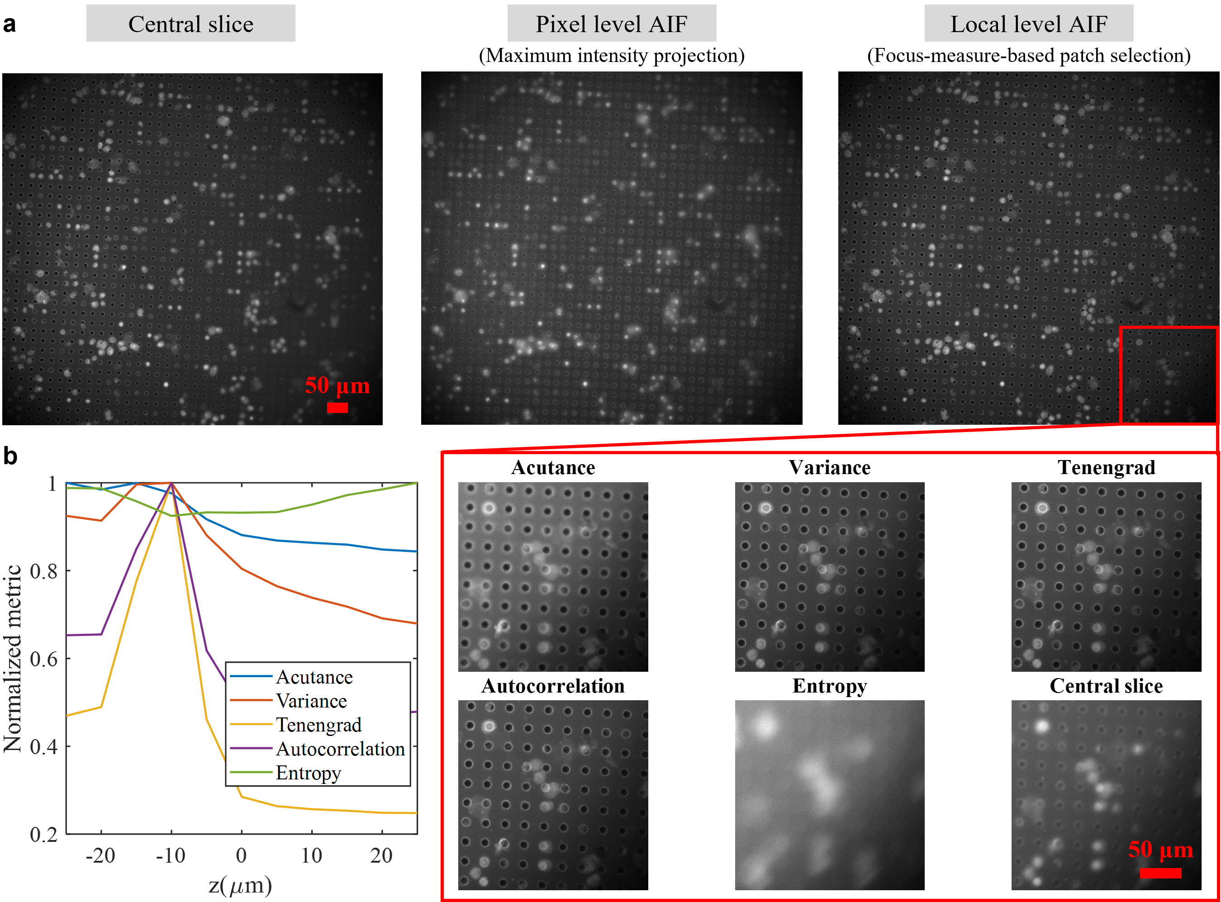

Supplementary Figure 1. Comparison of different all-in-focus (AIF) compression methods.
a. Central slice of a z-stack from DAPI channel, compared with pixel level AIF compression result based on maximum intensity projection and local patch level AIF compression results based on different F-metrics. b. Normalized curve of different focus measures versus z positions.

We can see from the central slice that a single z-slice is not capable of presenting all cells in good focus. Maximum intensity projection, where we project the maximum pixel value along the z-axis, is one possible way to resolve this. However, as can see from the image, this simply creates an image with significant haze artifacts. Local-level patch selection AIF methods can avoid this problem as long as the focus measure is correctly chosen. Here, Tenegrad function is chosen as our metric because it can find the correct focus z position with excellent sensitivity.

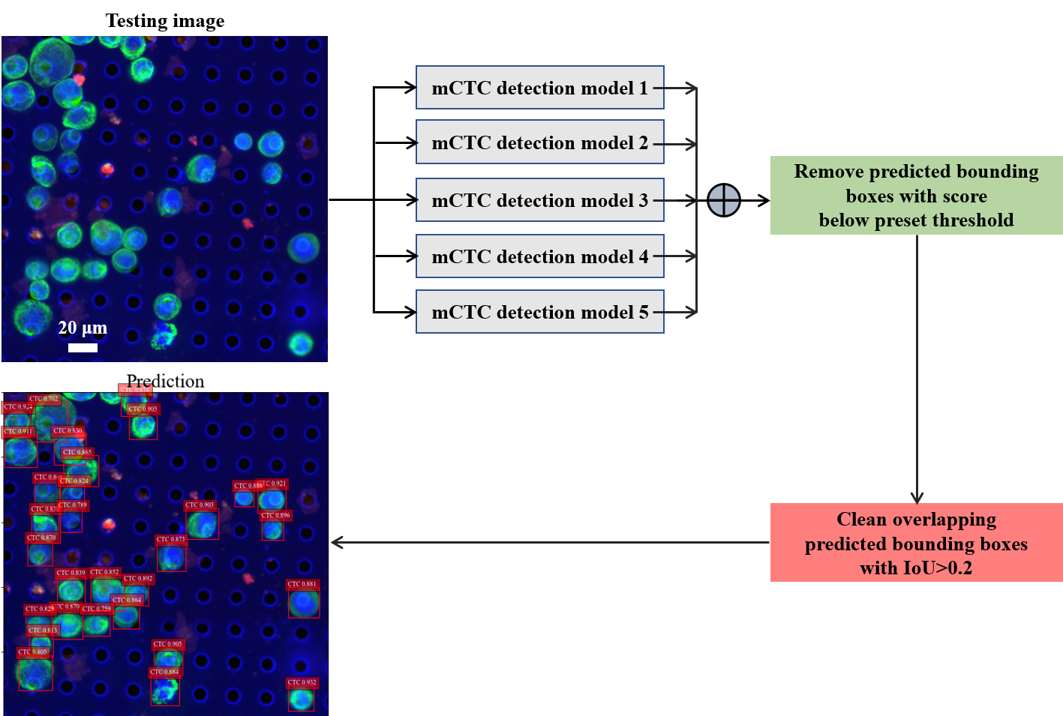

Supplementary Figure 2. Ensemble five object detection models and cleaning of prediction result.
Five cell detection models have the same neural network architecture but are trained on randomized image batches. The ensembled prediction is a set of bounding boxes with confidence score. We first remove the predicted boxes with score lower than a chosen threshold. Then, the repeated boxes predicted for the same cell can be reduced to a single box by quantifying the pairwise overlapping ratio between boxes with intersection-over-union (IoU) metric, finding the clustered boxes and only keeping the one with the highest score.
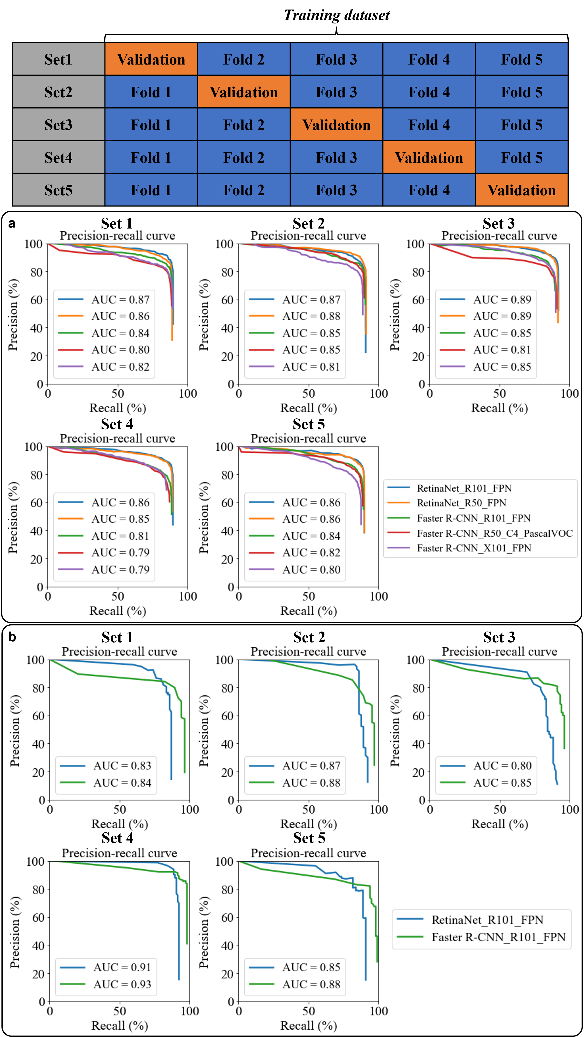

Supplementary Figure 3. Comparison of different object detection baseline models by 5-fold cross validation.
a. mCTC detection by five selected detectors differing in either network architecture, backbone or pretraining benchmark dataset. From the precision-recall curves, RetinaNet and Faster R-CNN with ResNet-101 backbone pretrained on COCO dataset achieved the best area under curve (AUC) in one-stage and two-stage detectors, respectively. b. Only the best one-stage and two-stage models were tested on the CAF detection task. Since the instance number of CAFs used in the experiment was low, the two-stage detector, Faster R-CNN, had better localization and recognition accuracy as indicated by higher AUC.
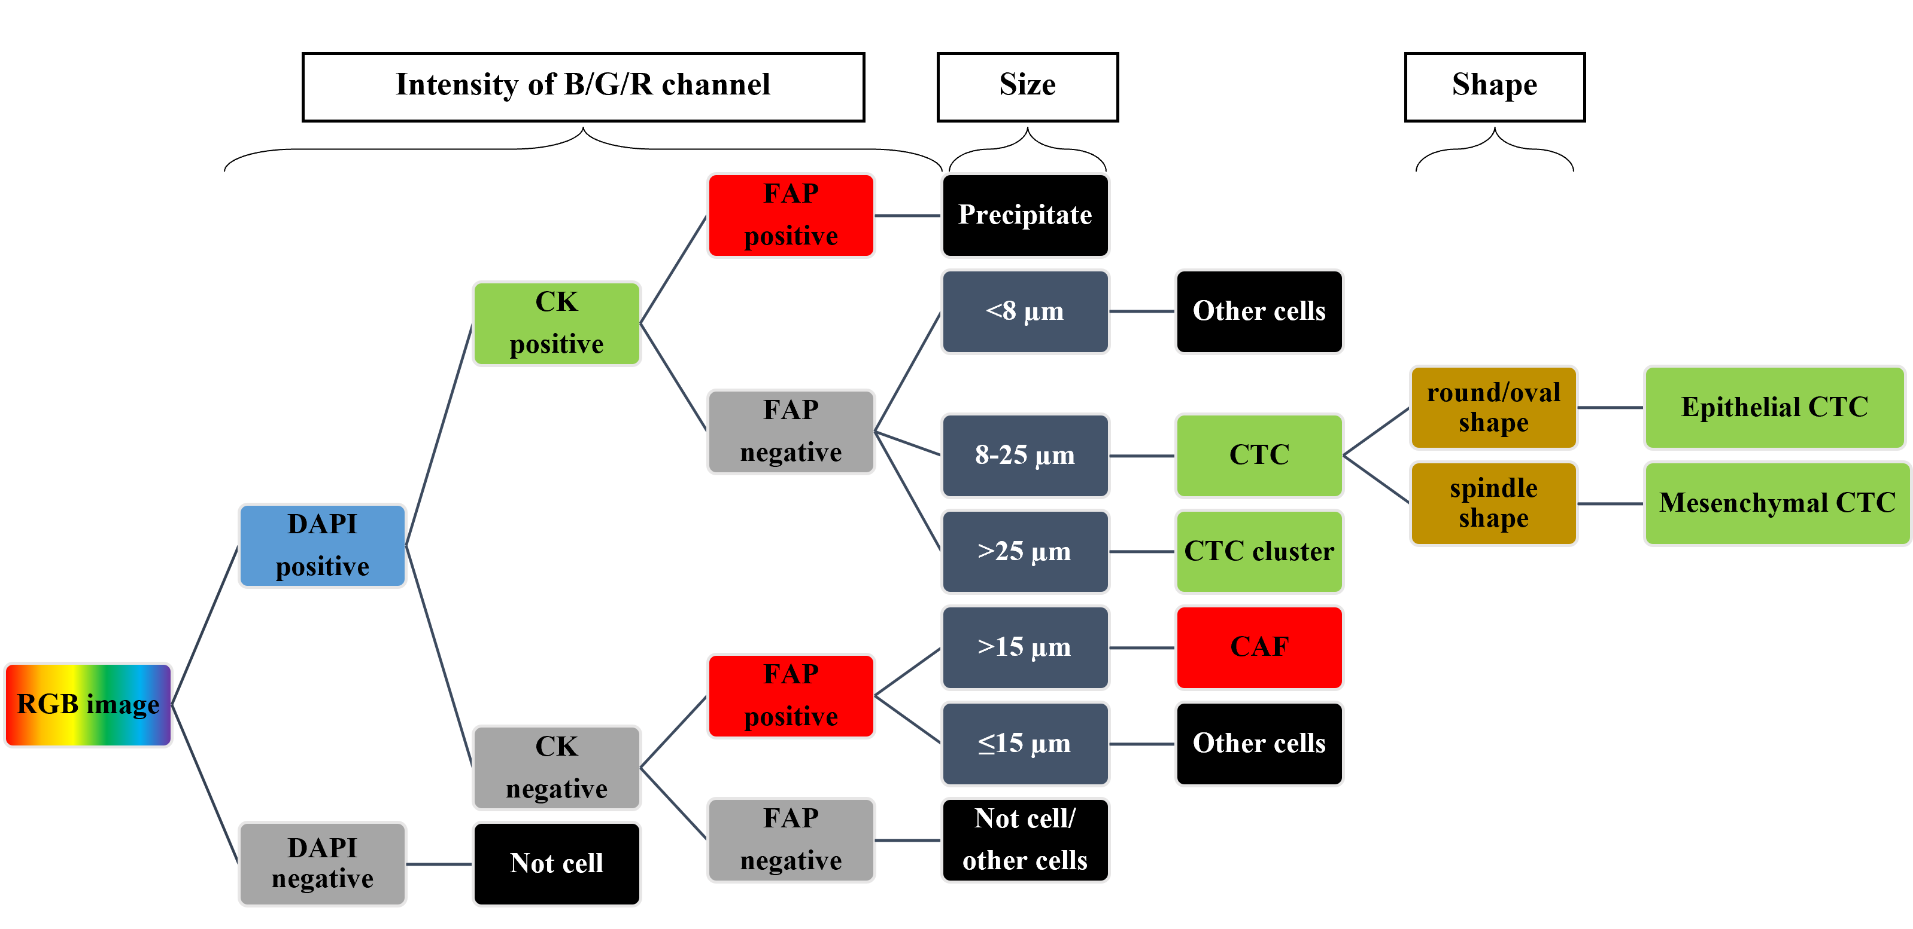

Supplementary Figure 4. Pathology screening decision tree.
The screening of CTCs and CAFs from RGB fluorescence images relies on the fluorescence signal intensity and location as well as cell size and shape. The main goal is to distinguish them from other cells, precipitate, and junk. CTC cluster can be seen as a collection of single CTCs from the perspective of computer vision. Also, single CTCs could be further classified into two subtypes, which could be a future work, based on our current results with excellent mCTC detection accuracy. CK, cytokeratin; FAP, fibroblast activation protein.
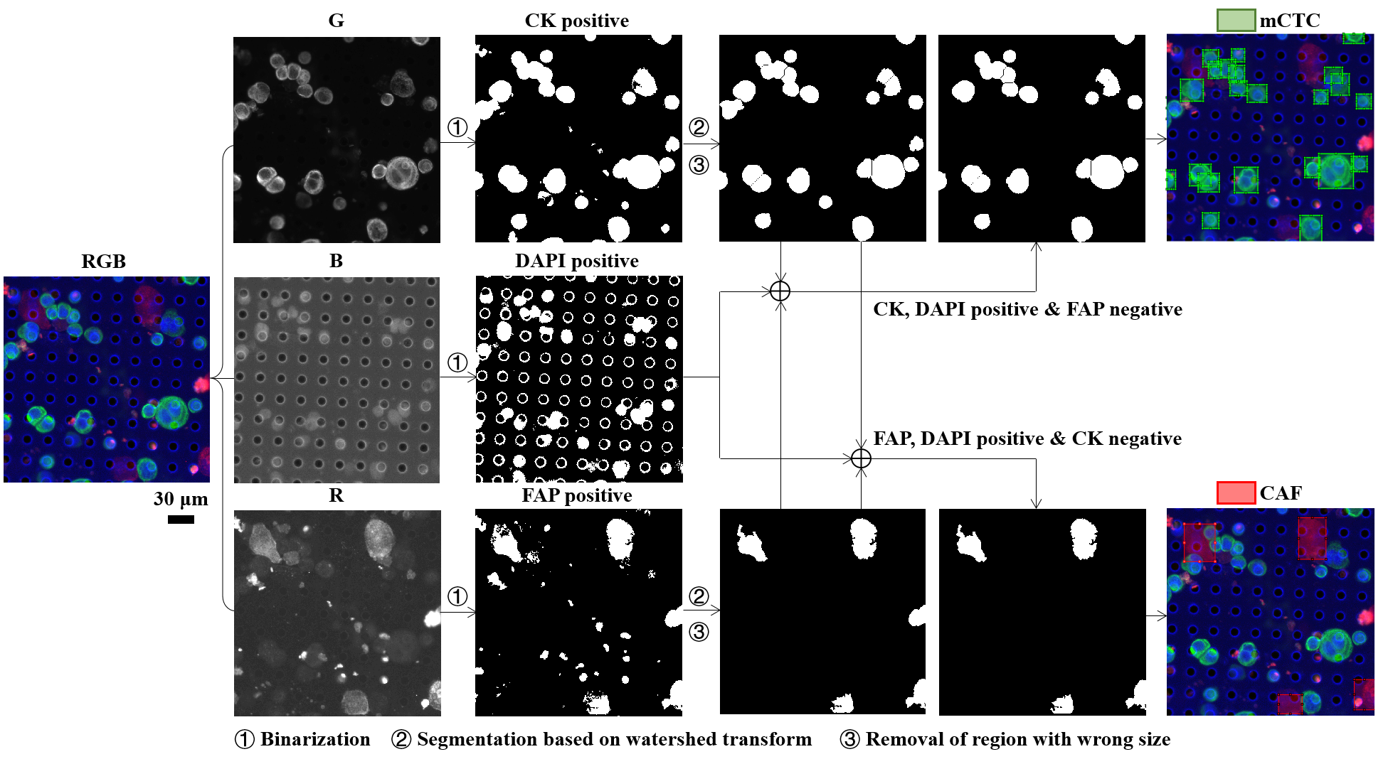

Supplementary Figure 5. Conventional computer vision method for mCTC and CAF detection using image processing algorithms.
The conventional computer vision method to detect mCTCs and CAFs from RGB fluorescence images was designed based on the pathology screening protocol shown in Supplementary Fig. 4. First, three channels were separately binarized to get a bunch of positive events, DAPI positive (blue channel), CK positive (green channel) and FAP positive (red channel). Then, CK and FAP positive events were segmented using watershed transform and cleaned by removing event regions with size below or beyond expectations. Finally, binary images from three channels were cross-checked. The event regions which were DAPI and CK positive but FAP negative were assumed to be mCTCs and those which were DAPI and FAP positive but CK negative were taken as CAFs. During this image processing pipeline, the binarization threshold, segmentation parameters and size threshold were all chosen and optimized by human.
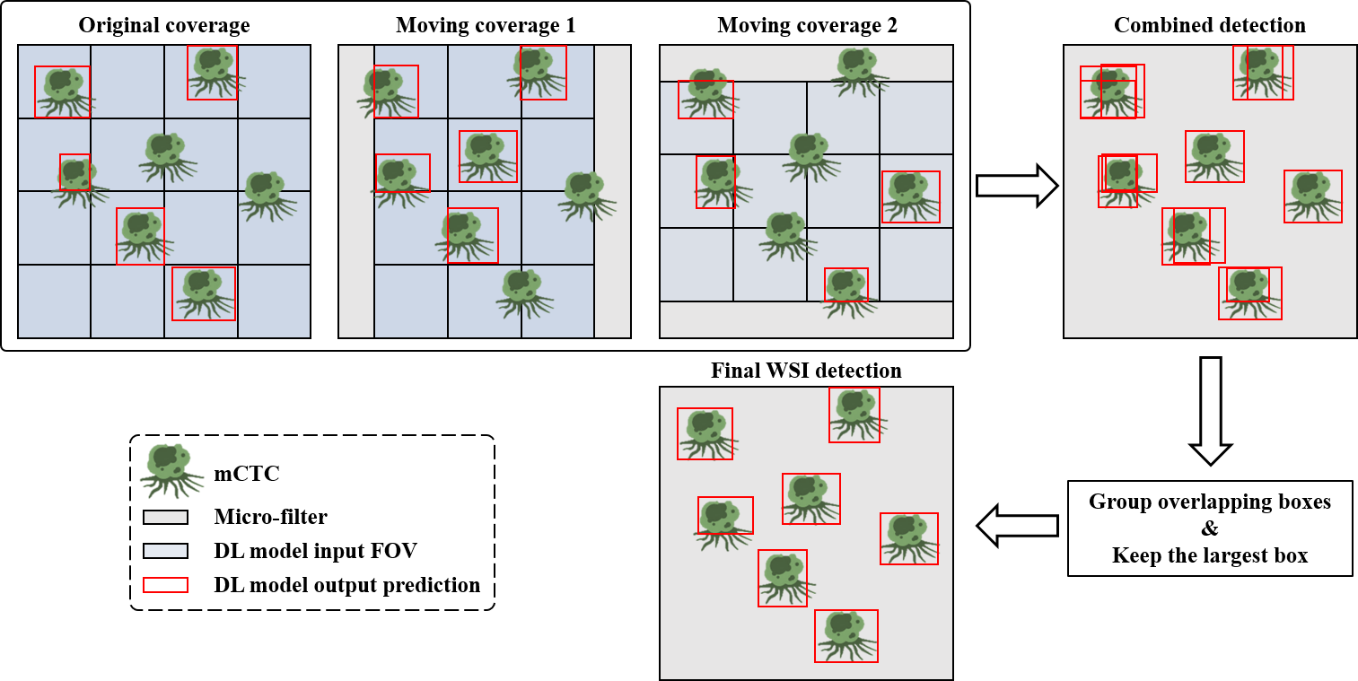

Supplementary Figure 6. Cell detection at the whole slide image level.
Any detector has a limited input field of view (FOV). When cells are located across the boundary between two FOVs, only partial cells are visible, therefore they would likely be ignored by the detectors. To solve this issue, we can move the input FOVs covering the whole slide by half size of FOV side length horizontally and vertically, as shown above. In this way, the cells across the boundary could be fully covered and detected. We then use the same strategy shown in Fig. S2 to eliminate overlapping boxes by calculating pairwise IoU metrics, grouping them and keeping the largest one. Final WSI detection results show good match with the ground truth.

