Title: Development of a novel integrated isothermal amplification system for detection of bacteria-spiked blood samples
Authors: Jin Li^{1#}, Mei-Yun Shang^{1#}, Shao-Li Deng¹, Min Li¹, Ning Su¹, Xiao-Dong Ren¹, Xian-Ge Sun¹, Wen-Man Li¹, Yu-Wei Li¹, Ruo-Xu Li¹, Qing Huang^{1*}, Wei-Ping Lu^{1*}
*Co-corresponding authors:
Wei-Ping Lu, M.D. Ph.D., Email: luweiping19710416@163.com
Qing Huang, M.D. Ph.D., Email: qinghuang@tmm.edu.cn
Tel: +86-23-68746995
Fax: +86-23-68716530
¹Department of Laboratory Medicine, Daping Hospital, Army Medical University, Chongqing, 400042, P.R. China
#These authors contributed equally to this work

SUPPLEMENTARY MATERIALS INDEX
Supplementary Figure 1 Relative positions of the amplicon target genes in bacterial specific target genes of bloodstream infection.
Supplementary Figure 2 Structure diagram of the detection device.
Supplementary Figure 3 Primer screening for basic RPA assays.
Supplementary Figure 4 Sensitivity of the real-time PCR assays.
Supplementary Table 1 Samples for specificity assays.
Supplementary Table 2 Primers and probes of real-time PCR.

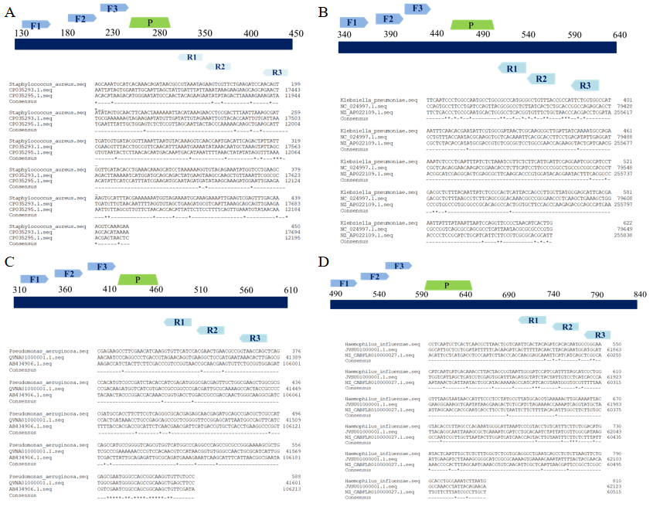
Supplementary Figure 1. Relative positions of the amplicon target genes in bacterial specific target genes of bloodstream infection. (A: S. aureus; B: K. peneumoniae; C: P. aeruginosa; D: H. influenzae).

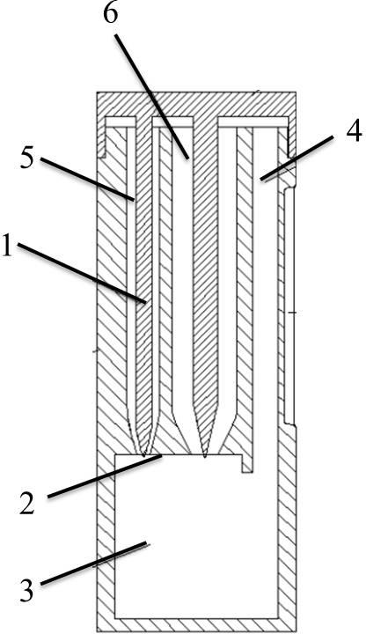
Supplementary Figure 2. Structure diagram of the detection device. This device consists of top cover (1) and bottom container. Bottom pad (2), reaction chamber (3) and inspection window (4) constituted the bottom container. Number 5 and 6 represent the left channel and the right channel respectively.

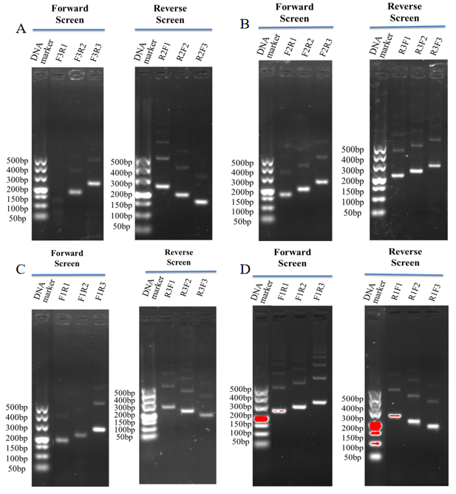
Supplementary Figure 3. Primer screening for basic RPA. Several sets of forward and reverse primer screens were conducted according to the manufacturer’s instructions to obtain best amplification efficacy of four bacteria. (A: S. aureus; B: K. peneumoniae; C: P. aeruginosa; D: H. influenzae).

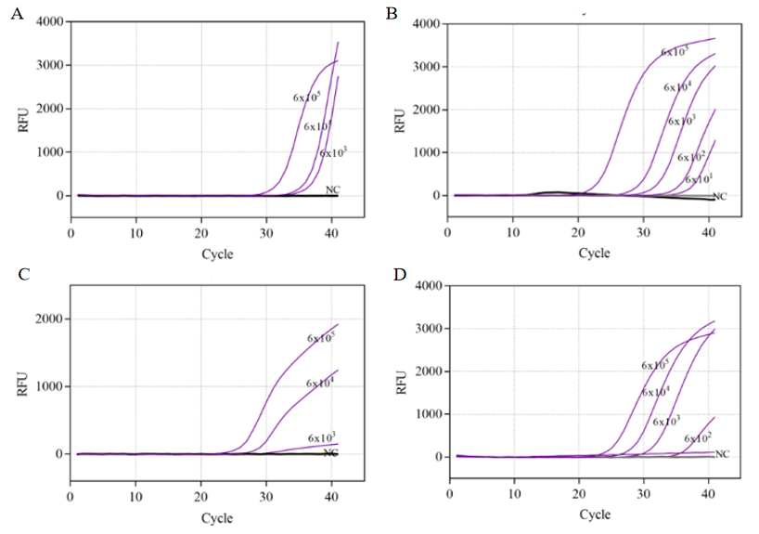

Supplementary Figure 4. Sensitivity of the real-time PCR assays. A, B, C, D and E represent the results of S. aureus, K. peneumoniae, P. aeruginosa, and H. influenza real-time PCR sensitivity assays, respectively. The sensitivity of the real-time PCR assays based on the quantity of genomic DNA of above four bacteria was tested by real-time PCR at 95°C for 2 min, followed by 40 cycles of 95°C for 15 seconds and 60°C for 1 min. NC: negative control.

Supplementary Table 1 Samples for specificity assays

Target bacteria | Non-target bacteria
 | Staphylococcus haemolyticus
 | Staphylococcus cohnii
 | Staphylococcus hominis
Staphylococcus aureus | Staphylococcus caprea
 | Staphylococcus epidermidis
 | Enterococcus faecalis
 | Enterococcus faecium
 | Klebsiella oxytoca
 | Escherichia coli
 | Acinetobacter baumannii
Klebsiella peneumoniae | Pseudomonas aeruginosa
 | Proteus mirabilis
 | Enterobacter cloacae
 | Enterobacter aerogenes
 | Proteus mirabilis
 | Burkholder cepacia
 | Pseudomonas putida
Pseudomonas aeruginosa | Enterobacter cloacae
 | Klebsiella pneumoniae
 | Escherichia coli
 | Acinetobacter baumannii
 | Haemophilus parahaemolyticus
 | Haemophilus parainfluenzae
 | Escherichia coli
Haemophilus influenzae | Acinetobacter baumannii
 | Klebsiella pneumoniae
 | Pseudomonas aeruginosa
 | Stenotrophomonas maltophilia

Supplementary Table 2 Primers and probes of Real-Time PCR.
Target bacteria | Target region | Oligonucleotide | Origin
S. aureus | Nuc | Forward:AGCATCCTAAAAAAGGTGTAGAGA  Reverse:CTTCAATTTTMTTTGCATTTTCTACCA  Probe:TEX-TTTTCGTAAATGCACTTGCTTCAGGACCA-BHQ1 | (1)
K. peneumoniae | CelB | Forward:TTGCCGCCAGCTATCTTCAC  Reverse:GGCAATACGCCAATGACCGT  Probe:FAM-AACCGATGGCTTATGGCGTGCCGCT-BHQ1 | This publishment
P. aeruginosa | Eta | Forward:ACAACGCCCTCAGCATCAC Reverse:AGTTCAGCGACCAACTGCC  Probe:FAM-TCGAAGGTGGCGTCGAGCCGAACAA-BHQ1 | This publishment
H. influenzae | Fuck | Forward:ATGGCGGGAACATCAATGA  Reverse:ACGCATAGGAGGGAAATGGTT Probe:FAM-CGGTAATTGGGATCCAT-MGB | (1)

Reference
1. Gadsby NJ, McHugh MP, Russell CD, Mark H, Conway Morris A, Laurenson IF, et al. Development of two real-time multiplex PCR assays for the detection and quantification of eight key bacterial pathogens in lower respiratory tract infections. Clin Microbiol Infect 2015;21(8):788.e1-788.e13. doi: 10.1016/j.cmi.2015.05.004.

