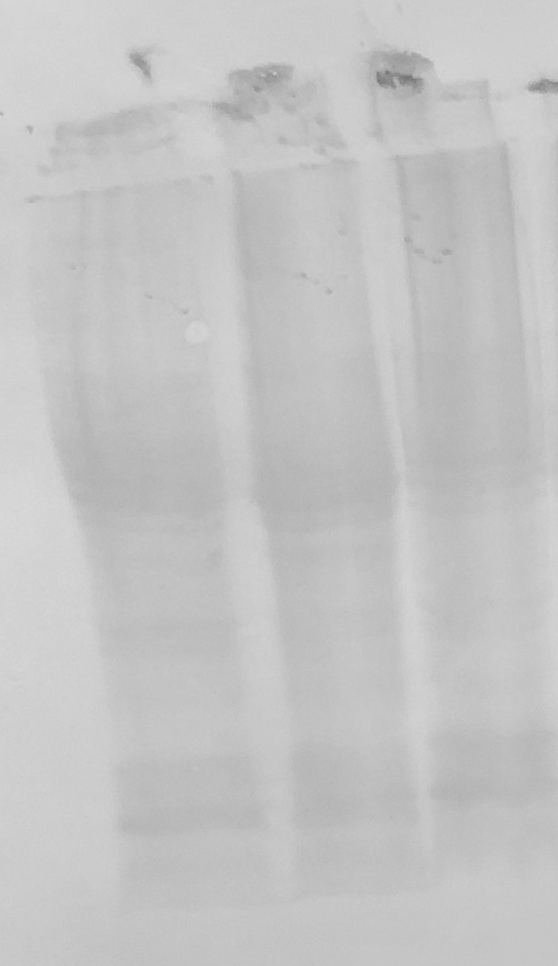
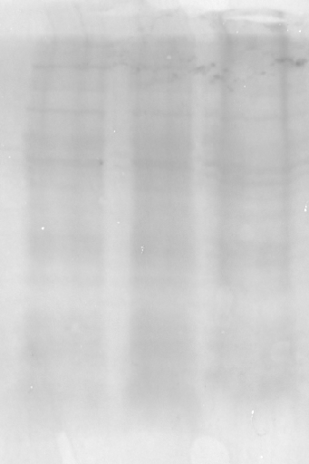
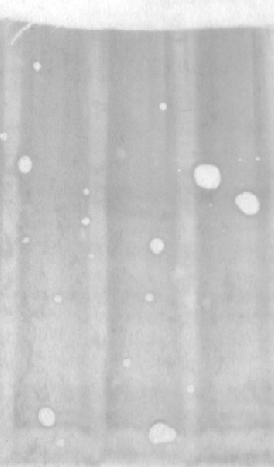
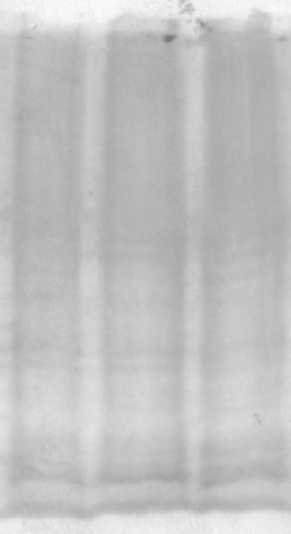
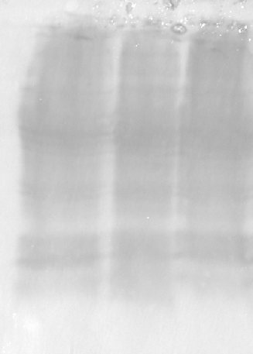
E
A
Loading control of Ponceau S staining taken of gels used for (A) MnSOD (25 kDa), (B) eNOS (133 kDa), (C) eNOS (133 kDa), (D) ATP synthase B (52 kDa), (E) GSK-3B (50 kDa), (F) HSP27 (27 kDa), and (G) GSK-3B (50 kDa).
B
C
D
F
G

