A Cross Sectional Analysis of Physical Activity Engagement in Adults with Mild Cognitive Impairment

Leona Connolly ¹, Joanna McHugh Power ^{1, 2}, Brian Lawlor ^{1,3}
Trinity College Dublin ¹
Maynooth University Ireland ²
St. James`s Hospital, Dublin ³

Appendix 1: NeuroExercise Study summary

NeuroExercise study
The NeuroExercise study (Devenney et al., 2017) was a multi- centre study of a semi- structured 12-month exercise programme designed to prevent the progression of Mild Cognitive Impairment in adults aged 50 + (n=62). The primary outcome of this study was level of cognitive function. Community dwelling adults with Mild Cognitive Impairment were randomised to one of three conditions. These were; a control condition where participants completed physical and neuropsychological testing only at baseline, 6 month and 12 months, and two exercise conditions (stretch & tone and aerobic exercise) where participants took part in structured group exercise sessions on a weekly basis supported by two further unstructured home - based exercise sessions, in addition to physical and neuropsychological testing at baseline, 6 months and 12 months. Both the aerobic and stretch and tone conditions were organised as such; 2 physiotherapist supervised centre based sessions per week and 1 unstructured home – based 60 - minute PA session per week with no direction as to the mode of PA completed (though walking was the most popular activity) for the first 8 weeks, followed by 1 centre based supervised session and 2 home – based session for the remainder of the intervention duration. Participants completed a battery of psychosocial and cognitive assessments at baseline, 6 months and 12 months. This current study is embedded in the NeuroExercise trial and consequently analysed a sub sample of these participants from one study site (Dublin) for this body of research.

Appendix 2: Patient Information Leaflet and consent form for the NeuroExercise study

Patient Information Leaflet

Study Title:
(1) The effects of an extensive exercise program on the progression of Mild Cognitive Impairment (MCI)
(2) The effects of acute exercise on cognitive function in individuals with Mild Cognitive Impairment (MCI)

Sponsor: Health Research Board

Principal Investigators: | Professor Brian Lawlor  Dr Emer Guinan
Research Physiotherapist: | Kate Devenney
Study Doctor: | Professor Brian Lawlor
Site Address: | St James’s Hospital, Dublin

This is a clinical study, a type of research study. The Research Team will explain the clinical study to you. Please take your time to make your decision about taking part. You may discuss your decision with your friends and family. You can also discuss it with your health care team. If you have any questions, you can ask your study doctor for more explanation.

- Why is this study being done?
Mild cognitive impairment is characterised by deficits in memory and thinking skills that does not significantly impact day-to-day function. To help ensure an aging society live enjoyable and productive life, research into treating conditions such as Alzheimer’s disease, and other forms of age-related diseases, is an urgent public health priority. The purpose of this study is to investigate the effect of a 12 month exercise programme in patients who have mild cognitive impairment. The exercise programme is testing the theory that exercise may prevent the progression of cognitive decline (decline in the mental processes of perception, memory, judgement and reasoning) in patients with mild cognitive impairment.

- Why am I being asked to take part?
People who have attended the memory clinic at St. James’s Hospital with a diagnosis of Mild Cognitive Impairment are being asked to participate.

- Do I have to take part?
No, it is up to you to decide whether or not you take part.
If you decide to take part, you will be asked to sign the consent form. You will be given a copy of this information sheet and a signed consent form for you to keep.
You will still be free to leave the study at any time, with or without giving a reason. If you decide to leave the study, this will not affect your future treatment and care.

- How many people will take part in the study?
Approximately 75 people will take part in this study, in St James’s Hospital, Dublin. An additional 150 people will take part in the study which is also being conducted in two other European centres.
The study will last approximately two years and your participation will last for 12 months.

- What will happen to me if I take part?
You will be invited to participate in this programme when your doctor has indicated to the research team that you are medically well and able for the interventions involved and you clear the screening criteria.

There will be 3 different groups involved in the study. If you choose to take part in the study, you will be “randomised” into one of the study groups. Randomisation means that you are put into a group by chance. A computer program will place you in one of the 3 study groups. Neither you nor your doctor can choose the group you will be in. One group will act as the “control group” and will not participate in the exercise programme. If you are selected to be in the “control” group, you will be required to attend for assessments at the Clinical Research Facility at St. James’s Hospital as detailed below.

The exercise groups will both undertake a 12 month supervised and home based exercise programme. One group will complete a stretching and toning programme. The other group will complete an aerobic exercise programme (examples of aerobic exercise include cycling and walking). These interventions will be provided in addition to your usual medical care provided at St. James’s Hospital.

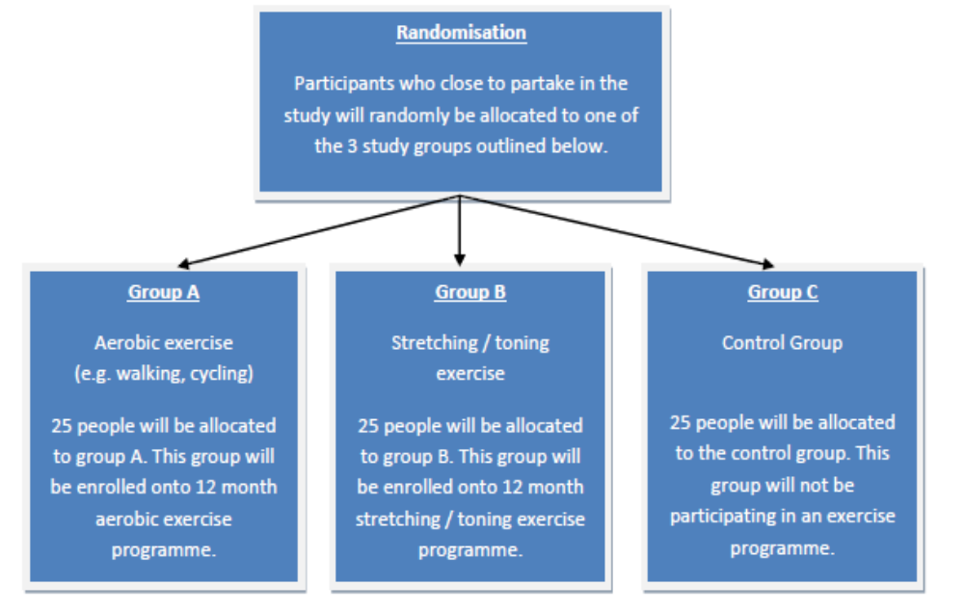

The aim of this study is to deliver a 12 month exercise programme (3 exercise sessions per week. This equals 56 supervised and 88 unsupervised/home based exercise sessions in total) for patients with mild cognitive impairment. The supervised exercise sessions will take place at the Clinical Research Facility in St. James’s Hospital. The unsupervised exercise sessions will be completed at home and you will wear a monitor to record your activity. Each exercise session will last approximately 1 hour.

If you decide to participate in the study, you will be assessed by the research team at three time points:
- prior to commencing the exercise programme (0 months)
- six months into the exercise programme (at 6 months)
- upon completion of the exercise programme (at 12 months)

The second study will examine the effects of single bouts of exercise on cognitive function in individuals with Mild Cognitive Impairment (MCI). Prior to exercise testing, participants will be randomised to group A or B. You will have the similar testing done, in differing order. Blood samples and tests of your cognitive function will be obtained around the exercise testing.
Participants who are randomly selected to one of the exercise groups will have blood tests and tests of their cognitive function during week 1, 6 and 12 of their exercise programme. Blood samples and cognitive tests will be performed on each of these time points prior to the supervised exercise class in the CRF in St. James’s Hospital. The bloods and cognitive tests will then be repeated after the exercise session.
We also aim to assess the factors that are related to exercise participation and adherence, specifically in people who are experiencing mild cognitive decline. The purpose of this is to assess the feasibility of the exercise programme. This sub- study consists of two phases. Phase one is concerned with gathering information on the factors related to exercise participation in people with mild cognitive impairment, and phase two is concerned with gathering information on the factors related to their adherence to the study intervention. In both phases, information will be collected via face- to- face interviews with the participant and one researcher. Therefore you will be asked to participate in two interview sessions, one on entry into the study to take place during your initial assessment and one on exit from the study at 12 months. Each interview will last approximately one hour.

Details of the initial assessments are detailed below.
Vital signs: Heart rate, blood pressure and oxygen saturation will be recorded at the screening visit and prior to commencing all supervised exercise sessions
Body composition: Weight and height will be recorded at initial assessment
Medical examination: all participants will undergo a medical examination by a doctor prior to completing exercise testing

The following assessments will be completed at 0, 6 and 12 months during the study period.
These assessments will take place over a 2 day period. It will take approximately 3 hours on each day to complete assessment.
- Cognitive performance will be measured by a number of tests that test attention, memory and ability to perform certain tasks
- One-to- one participant interview to assess exercise habits and behaviours will take place on entry into the study at 0 months and again on exit from the study at 12 months
- You will be required to complete 7 separate Questionnaires pertaining to:
  - quality of life
  - physical activity
  - ability to carry out activities of daily living
  - depression
  - Sleep quality
  - personality traits
  - behavioural traits
- We will record your Blood pressure when you move from a lying position into sitting and then standing
- An exercise test will be carried out to assess your physical fitness. During the exercise test, you may experience general fatigue and shortness of breath
- You will be given a physical activity monitor to wear at home for a week at the three assessment time points
- A blood sample will be obtained for analysis – about 3 teaspoons of blood every time blood is taken.
- You will be required to complete 3 physical assessments to ascertain your general strength, endurance, mobility and balance

If you exit the study prior to completing the 12 months of exercise, you will be invited to complete an exit assessment with the research team. The exit assessment will be optional; you may choose to decline completing the exit assessment.

- What will I have to do?
If you are in the control group, you will attend the Clinical Research Facility at 0, 6 and 12 month time points to undergo assessments. You will not be involved in the exercise programme detailed below. You will receive a newsletter in the post every 3 months to keep you updated on how the trial is progressing. You will be contacted by phone every 2 months by a member of the research team to check how you are doing.
If you are enrolled in the exercise programme, you will need to attend the Clinical Research Facility at St James’s Hospital for supervised exercise sessions over a 12 month period. Each exercise session will last approximately 1 hour. You will also have to complete exercise sessions at home. Please see diagram below for further details. Where possible, study appointments will be scheduled for a time that is convenient for you to attend.
You will also be asked to take part in a one- to -one interview with a member of the research team on entry into the study, and again on exit from the study at 12 months. These interviews will assess your opinions and behaviour regarding exercise in general and with regard to the study exercise programme. They will last approximately one hour and will be recorded so that they can later be transcribed and analysed.
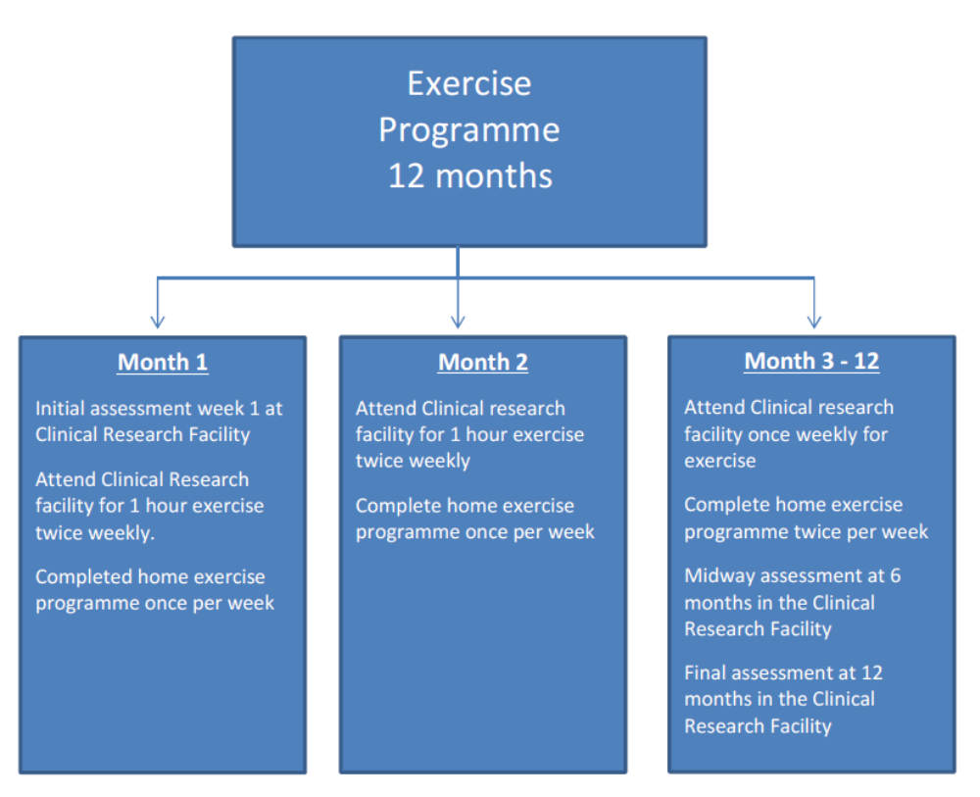
- What are the benefits of taking part?
There may or may not be direct benefits to people taking part in the study. The study aims to examine the effect of different exercise interventions in people with mild cognitive impairment. The results will help us establish if exercise interventions may be of benefit for people with mild cognitive impairment in the future.

- What are the risks of taking part?
We do not anticipate adverse effects during the assessments or participating in the prescribed exercise intervention. The proposed exercise intervention has been designed in line with established protocols, thereby posing minimal risk.
Participation in the exercise intervention will be with the consent of your doctor and will be supervised closely by your physiotherapist. Your risk of adverse events will be minimised through thorough medical screening prior to exercise testing and monitoring during exercise intervention.
While rare, adverse events are possible. Serious adverse events may include: heart attack, stroke, unconsciousness or other serious injury.

You may feel a little tired after the exercise test and during the initial stages of the exercise intervention but we expect that you will recover quickly.
There is a risk of bruising or fainting when taking blood samples. If any results with potentially harmful consequences are discovered your team will be informed immediately.

- Will I receive payment for being part of this study?
You will not be paid for taking part of this study. However, you will receive remuneration for car parking costs incurred while attending study assessments and exercise sessions at the Clinical Research Facility.

- What happens if I get hurt taking part in this study?
All participants and professionals working on the study are covered by clinical indemnity insurance. This insurance covers any damage resulting from the research. For further details please contact Kate Devenney. Contact details are listed at the end of this document.

- Will my information be kept private?
If you decide to take part in the study, you give the researchers permission to collect information about you and share it with the Health Research Board. Any information that identifies you (such as your name and address) will not be shared with the Health Research Board.
Your study data will be identified with a code number which will not include your name or other information that directly identifies you.
As this research project is taking place at 2 other research sites in Europe (Nijmegen, Netherlands and Cologne, Germany), information collected related to the study and some of the blood samples collected will be transferred to these sites to be pooled together centrally for analysis. The additional blood samples will be kept on site in St. James’s Hospital.
Personal and medical information, and interview recordings and transcripts identifying you will be kept confidential. We will keep it in a secured file. At any time, you may ask to see your personal information.
Your study information will be used to determine the effect of a long term exercise programme on patients with mild cognitive impairment. The information gained will help inform the planning of future exercise programmes for people with mild cognitive impairment.
Your information will be kept on file for up to 15 years and will be destroyed securely after that time.
The results of the study may be used in presentations or be published in scientific reports. You will not be identified in any presentation or publication.
To make sure the data collected during the study is correct and accurate, it may be checked by researchers, representatives of Trinity College Dublin or the Health Research Board, external auditors or inspectors or members of the Ethics Committee. They will keep your information confidential. By signing consent, you are agreeing to allow such access.

- Who should I contact if I have any questions?
For more information or answers to your questions about the study please contact any member of our research team, Monday – Friday from 9.00 am to 5.00pm.

Research Team Contact Details
Kate Devenney, Research Physiotherapist | 01-8963613
Dr. Emer Guinan, Principal Investigator | 01-8964809

- Has this study been approved?
Yes, this study has been reviewed and approved by the AMNCH/SJH Research Ethics Committee (Approval reference number 2015/09/04).

Consent Form

Study Title:
1. The effects of an extensive exercise programme on the progression of Mild Cognitive Impairment
2. The effects of acute exercise on cognitive function in individuals with Mild Cognitive Impairment

Sponsor: Health Research Board

Principal Investigator | Professor Brian Lawlor  Dr Emer Guinan
Research Physiotherapist: | Kate Devenney
Study Doctor: | Professor Brian Lawlor
Site Address: | St James’s Hospital, Dublin

Please tick each box to confirm you have read, understood and agreed to each of the points in this form.
- I have read and understood the Patient Information Leaflet, Version __, dated ________. I have had time to consider it and the opportunity to ask questions.

- I understand that my taking part is voluntary and that I am free to withdraw at any time, without giving a reason and without my medical care or legal rights being affected. If I withdraw, I understand that my data can still be used up to when I withdrew, unless I state otherwise.

- I understand that my medical records may be looked at by authorised personnel from Health Research Board, the ethics committee, the regulatory authority, where it is relevant to my taking part in this study. I give my permission for such personnel to have access to my records. I understand that if I withdraw from the study, my records may need to be accessed in order to verify data collected while I was still in the study.

- I understand what will happen to my blood/tissue samples and I consent to the retention of my biological samples for research purposes.

- I consent to the collection and use of personal and sensitive information about me, including medical information, which will not include my name.

- I agree to the use of data collected in this study to be used in future studies without the need for giving consent again.

- I agree to take part in this study

Name of Patient (CAPITALS) |  |  | Signature |  |  |  | Date (Day Month Year)
Investigator Name (CAPITALS) |  |  | Signature |  |  |  | Date (Day Month Year)
Name of Person taking Consent (if different to Investigator)(CAPITALS) |  |  | Signature |  |  |  | Date (Day Month Year)

Appendix 3: LAPAQ Physical Activity questionnaire

LASA Physical Activity Questionnaire (LAPAQ)
1. Do you walk outside?

Explanation : with walking outside we mean walking to go shopping or doing other daily

activities, like visiting someone. We do not mean: a walking tour.

1. no (go to question 5)

2. yes

2. Did you walk during the past two weeks?

1. no (go to question 5)

2. yes

3. How many times did you walk during the past two weeks?

……………….. times

4. How long did you usually walk each time?

……………….. hours

……………….. minutes

5. Do you cycle?

Explanation : with cycling we mean cycling to go shopping or doing other daily activities, like

visiting someone. With cycling we do not mean: a cycling tour.

1. no (go to question 9)

2. yes

6. Did you cycle during the past two weeks?

1. no (go to question 9)

2. yes

7. How many times did you cycle the past two weeks?

……………….. times

8. How long did you usually cycle each time?

……………….. hours

……………….. minutes

9. Do you have a garden (including allotment)?

1. no (go to question 15)

2. yes

10. During how many months per year do you work regularly in your garden?

Explanation : by regularly we mean at least once a week.

……………….. months

11. Did you work in the garden during the past two weeks?

1. no (go to question 15)

2. yes

----------------------- Page 2-----------------------

12. How many times did you work in the garden during the past two weeks?

……………….. times

13. How long did you usually work in your garden each time?

……………….. hours

……………….. minutes

14. Did you dig in the earth in your garden during the past two weeks?

1. no

2. yes

15. Do you do sports?

Explanation : with sports we mean the activities on the list (see question 16).

1. no (go to question 24)

2. yes

16. Which sport did you do most time during the past two weeks?

Sometimes it happens that a respondent does a sport, which is not on the list. This should be

recorded:

1. Distance walking 10. Rowing

2. Distance cycling 11. Sailing

3. Gymnastics 12. Playing billiards

4. Cycling on hometrainer 13. Fishing

5. Swimming 14. Playing soccer/basketball/hockey

6. Dancing 15. Playing volleyball/baseball

7. Bowling 16. Skiing

8. Tennis, badminton 17. Else, ………………………

9. Running, fast walking

17. How many times did you do this sport during the past two weeks?

……………….. times

18. How long did you usually do this sport each time?

……………….. hours

……………….. minutes

19. Do you do another sport?

1. no (go to question 24)

2. yes

20. Which other sport did you do during the past two weeks?

1. Distance walking 10. Rowing

2. Distance cycling 11. Sailing

3. Gymnastics 12. Playing billiards

4. Cycling on hometrainer 13. Fishing

5. Swimming 14. Playing soccer/basketball/hockey

6. Dancing 15. Playing volleyball/baseball

7. Bowling 16. Skiing

8. Tennis, badminton 17. Else, ………………………

9. Running, fast walking

----------------------- Page 3-----------------------

21. How many times did you do this sport during the past two weeks?

……………….. times

22. How long did you usually do this sport each time?

……………….. hours

……………….. minutes

23. How many times did you perspire while sporting during the past two weeks?

……………….. times

24. Do you do light household tasks?

Explanation : with light household tasks we mean washing the dishes, dusting, making the bed,

doing the laundry, hanging out the laundry, ironing, tidying up, and cooking meals.

1. no (go to question 27)

2. yes

25. How many days did you do light household tasks during the past two weeks?

………………..days

26. How long per day did you usually do light household tasks?

……………….. hours

……………….. minutes

27. Do you do heavy household tasks?

Explanation : with heavy household tasks we mean window cleaning, changing the bed, beating

the mat, vacuuming, washing or scrubbing the floor, and chores with sawing, carpeting,

repairing or painting.

1. no (go to question 30)

2. yes

28. How many days did you do heavy household tasks during the past two weeks?

………………..days

29. How long per day did you usually do heavy household tasks?

……………….. hours

……………….. minutes

30. You just told me about your usual activities of the past two weeks.

Were the past two weeks normal as compared to the rest of the past year?

1. no

2. yes (end of questionnaire)

31. Why were the past two weeks not normal?

1. disease

2. depression

3. bad weather

4. family occasion

5. holiday

6. else, …………………………………………………………………..

Appendix 4: Montreal Cognitive Assessment questionnaire (MoCA)

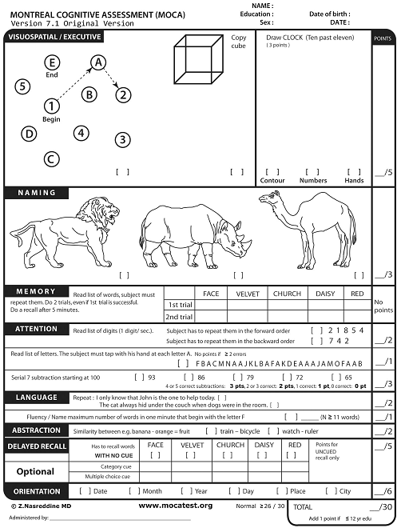

Appendix 5: Quality of life for dementia questionnaire (DemQoL)

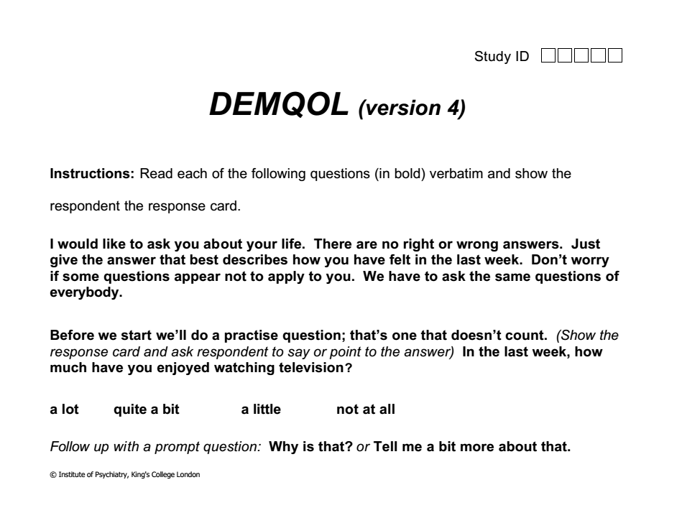

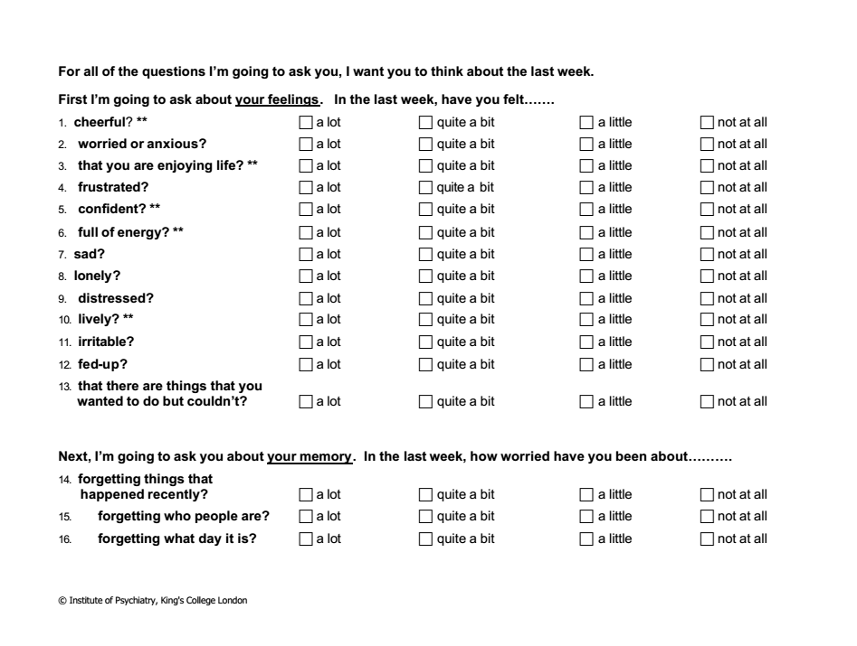
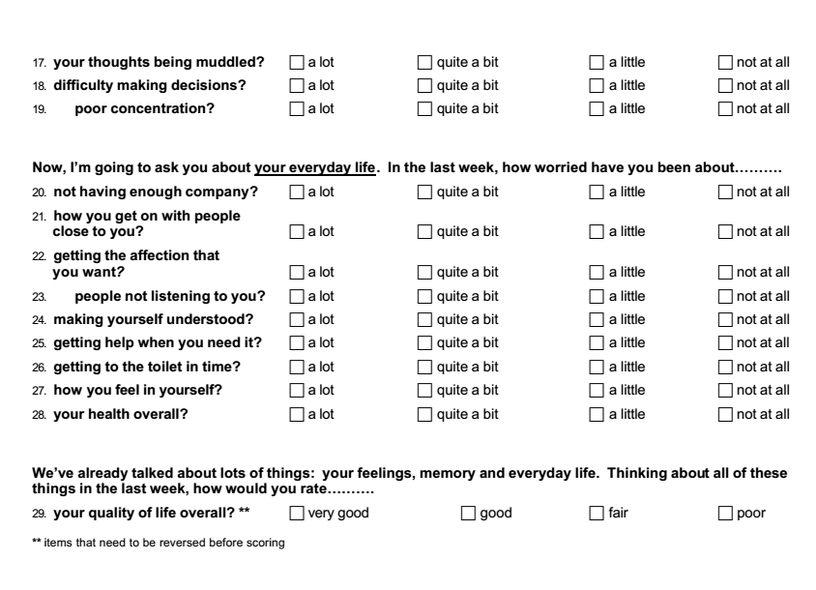
Appendix 6: Centre for Epidemiologic Studies Depression Scale (CES – D)
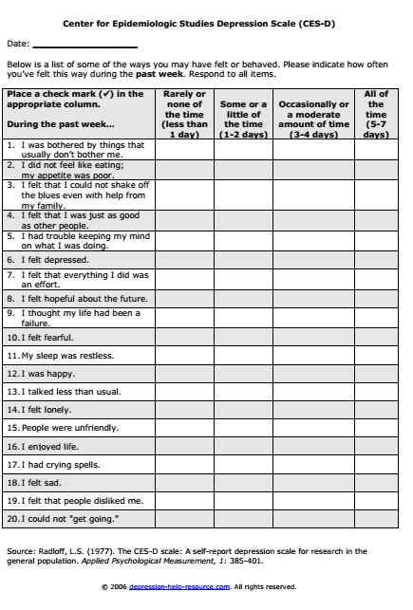

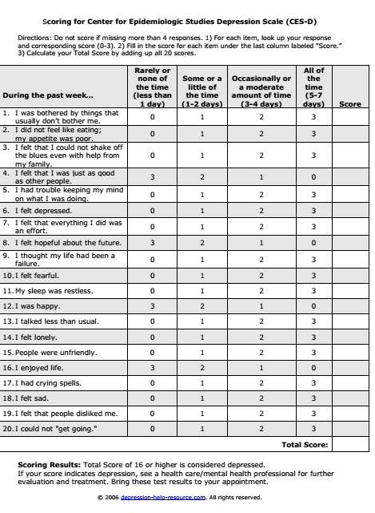

Appendix 7: Assessment of Normality

Table A1.

Summary of Skewness and Kolmogorov- Smirnov values for all variables
Variable | Skewness values | Kolmogorov – Smirnov values
Age screening | 0.112 | .053
Years education | 0.095 | .200
Number of meds | 0.161 | .001*
MoCA | 0.146 | .002*
Handgrip left | 0.113 | .051
Handgrip right | 0.086 | .200
DemQol | 0.103 | .099
CES - D | 0.064 | .200
Actigraph | .169 | .001*
T0_Total_time_Freedson_Bouts0.1690.001LAPAQ | 0.112 | .053
*p < .05 indicates violation of the assumption of normality

Appendix 8: Inspection of outliers; education

Figure A1.

Boxplot of years of education

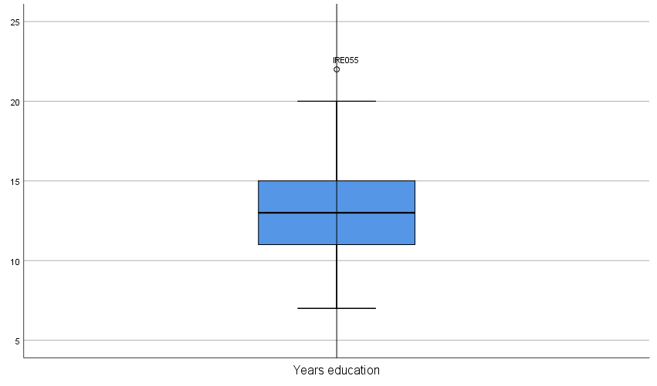

Appendix 9: Inspection of outliers ; number of medications

Figure A2.

Boxplot for number of medications
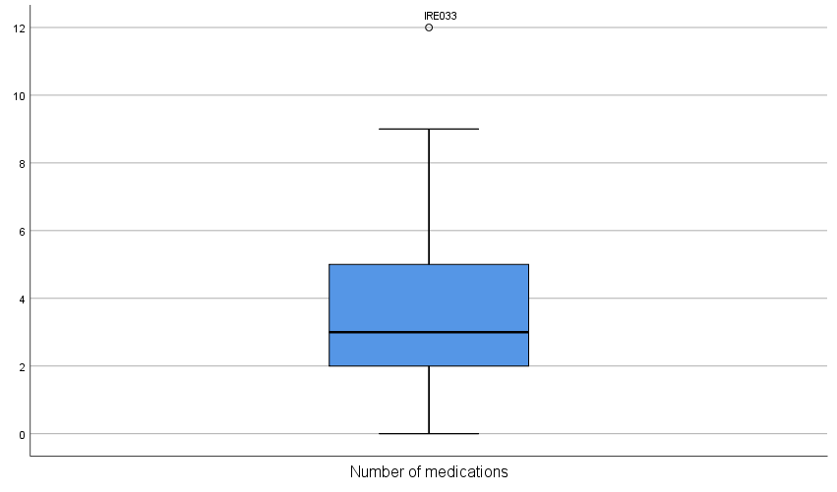

Appendix 10 Inspection of outliers ; LAPAQ physical activity questionnaire

Figure A3.

Boxplot for the LAPAQ physical activity questionnaire

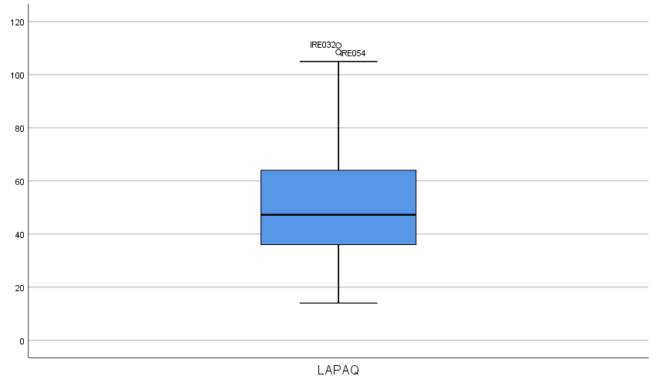

Appendix 11: Inspection of outliers ; age

Figure A4.

Boxplot for age

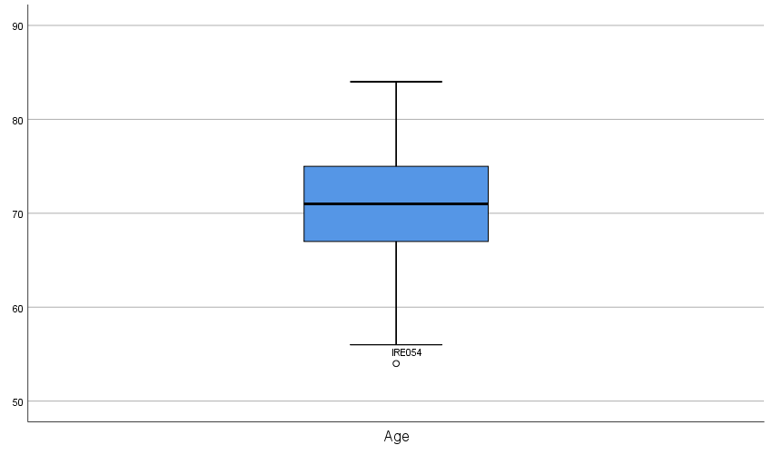

Appendix 12: Scatterplots for all Independent Variables by LAPAQ

Figure A5.

Scatterplot of all independent variables
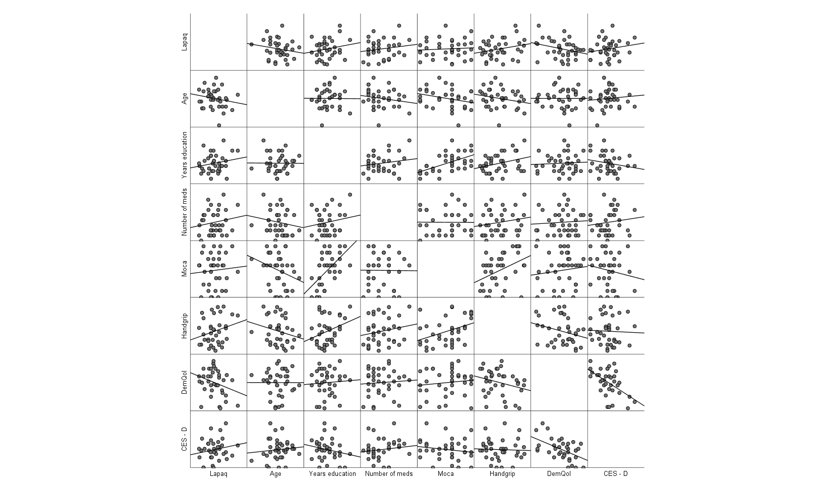

Appendix 13: Scatterplots for all Independent Variables by Actigraph

Figure A6.

Scatterplot of all independent variables by the Actigraph
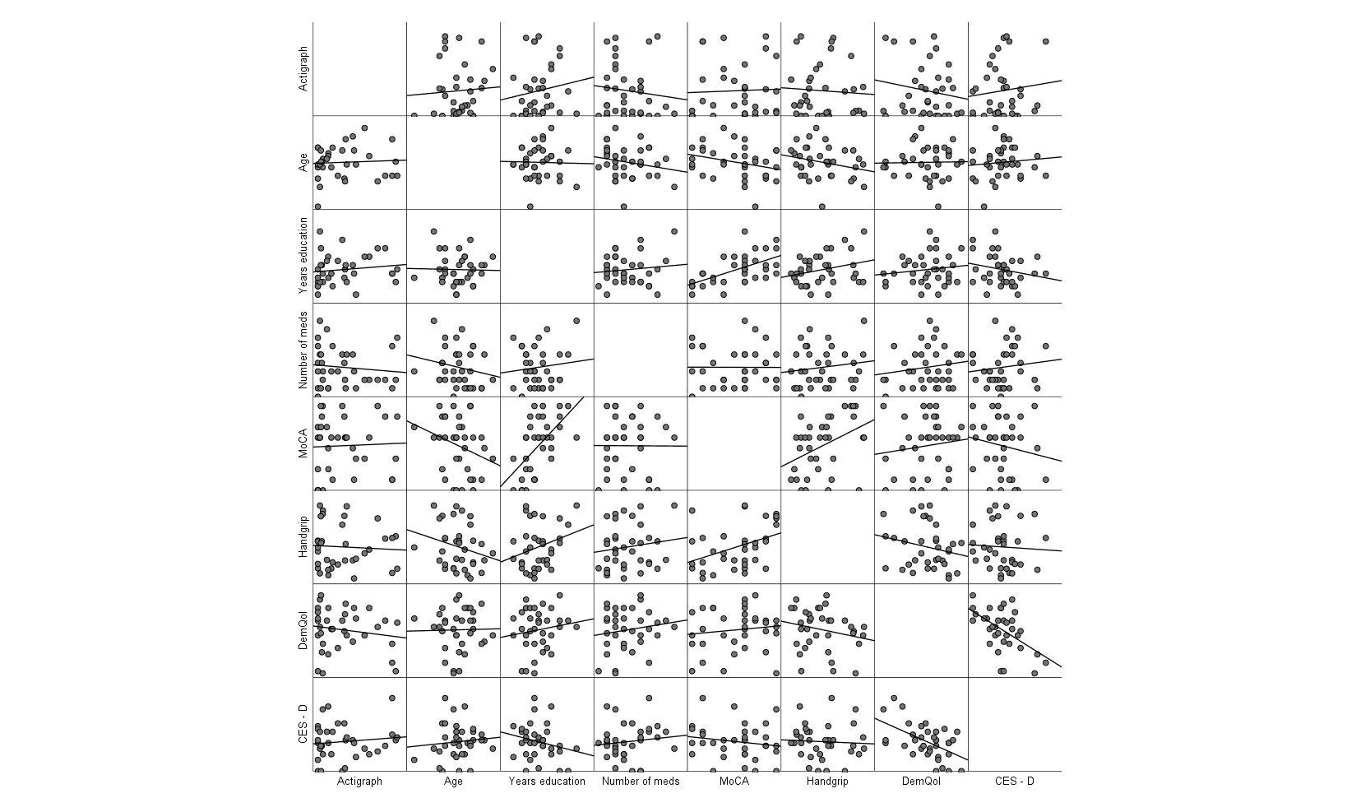

Appendix 14: Barchart of independent variables by recruitment source

Figure A7

Clustered bar chart for mean of independent variables by recruitment source
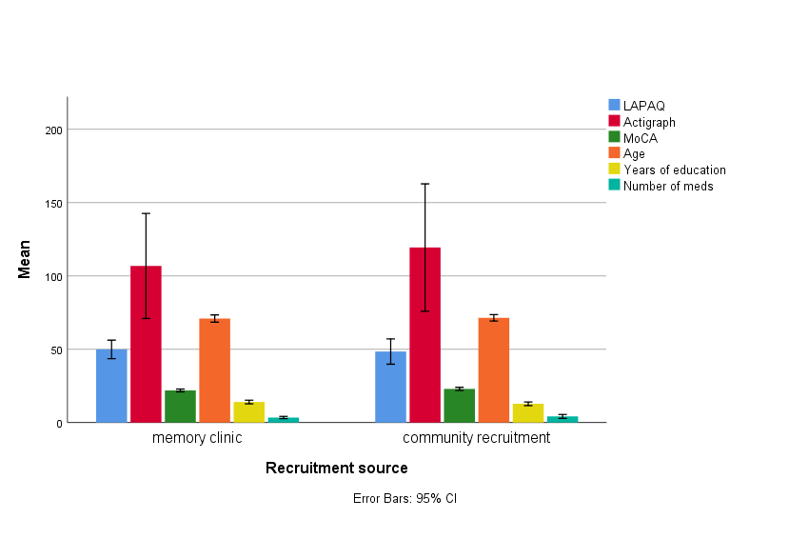

Appendix 15: Means of physical activity engagement by gender

Figure A8.

Clustered bar chart of physical activity by gender
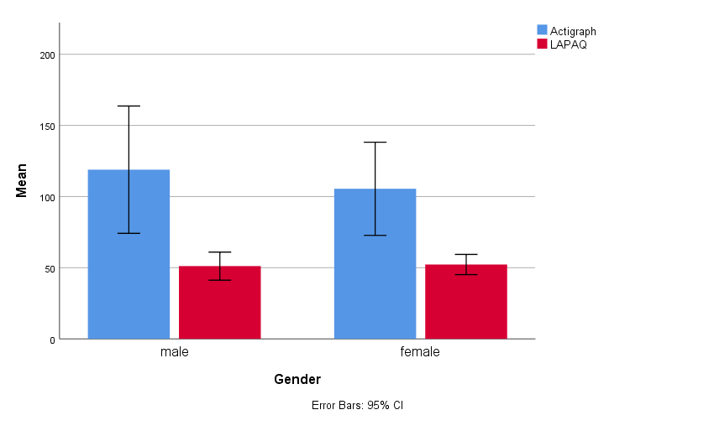

Appendix 16: Frequencies for age

Table A2.

Frequencies for the variable of age
Age | N | %
54 | 1 | 1.6
56 | 1 | 1.6
60 | 3 | 4.8
61 | 1 | 1.6
62 | 1 | 1.6
63 | 2 | 3.2
64 | 1 | 1.6
65 | 3 | 4.8
66 | 2 | 3.2
67 | 5 | 8.1
68 | 1 | 1.6
69 | 1 | 1.6
70 | 7 | 11.3
71 | 5 | 8.1
72 | 4 | 6.5
73 | 3 | 4.8
74 | 5 | 8.1
75 | 2 | 3.2
76 | 3 | 4.8
77 | 5 | 8.1
78 | 1 | 1.6
80 | 2 | 3.2
81 | 1 | 1.6
83 | 1 | 1.6
84 | 1 | 1.6
Total | 62 | 100

Appendix 17: Frequencies for education

Table A3.

Frequencies for years of education
Years of Education | N | %
7 | 2 | 3.2
8 | 1 | 1.6
9 | 3 | 4.8
10 | 7 | 11.3
11 | 5 | 8.1
12 | 7 | 11.3
13 | 9 | 14.5
14 | 8 | 12.9
15 | 5 | 8.1
16 | 4 | 6.5
17 | 3 | 4.8
18 | 6 | 9.7
20 | 1 | 1.6
22 | 1 | 1.6
Total | 62 | 100.0

Appendix 18: Frequencies for the MoCA
Table A4.

Frequencies for MoCA scores
MoCA | N | %
18 | 6 | 9.7
19 | 6 | 9.7
20 | 6 | 9.7
21 | 4 | 6.5
22 | 7 | 11.3
23 | 11 | 17.7
24 | 7 | 11.3
25 | 10 | 16.1
26 | 5 | 8.1
Total | 62 | 100.0

Appendix 19: Frequencies for DemQoL

Table A5.

Frequencies for Dementia Related Quality of Life (DemQol)
DemQol scores | N | %
65 | 1 | 1.6
72 | 1 | 1.6
73 | 2 | 3.2
74 | 1 | 1.6
75 | 1 | 1.6
77 | 2 | 3.2
79 | 1 | 1.6
81 | 1 | 1.6
82 | 1 | 1.6
83 | 1 | 1.6
84 | 2 | 3.2
86 | 2 | 3.2
87 | 2 | 3.2
88 | 1 | 1.6
89 | 2 | 3.2
90 | 3 | 4.8
91 | 2 | 3.2
92 | 1 | 1.6
93 | 2 | 3.2
94 | 3 | 4.8
95 | 1 | 1.6
96 | 2 | 3.2
97 | 4 | 6.5
98 | 4 | 6.5
99 | 3 | 4.8
100 | 1 | 1.6
101 | 3 | 4.8
103 | 5 | 8.1
105 | 2 | 3.2
106 | 1 | 1.6
107 | 2 | 3.2
109 | 1 | 1.6
110 | 1 | 1.6
Total | 62 | 100.0

Appendix 20: Frequencies for CES - D

Table A6.

Frequencies for depression scores (CES- D)
CES - D Score | N | %
0 | 6 | 9.7
1 | 1 | 1.6
3 | 2 | 3.2
4 | 4 | 6.5
5 | 1 | 1.6
6 | 4 | 6.5
7 | 2 | 3.2
8 | 3 | 4.8
9 | 3 | 4.8
10 | 3 | 4.8
11 | 5 | 8.1
12 | 5 | 8.1
13 | 3 | 4.8
14 | 4 | 6.5
15 | 2 | 3.2
16 | 1 | 1.6
17 | 4 | 6.5
18 | 2 | 3.2
20 | 1 | 1.6
22 | 1 | 1.6
23 | 1 | 1.6
26 | 1 | 1.6
Total | 59 | 95.2
Missing | 3 | 4.8
 | 62 | 100.0

Appendix 21: Frequencies for number of medications

Table A7.

Frequencies for number of medications
Number of Medications | N | %
0 | 2 | 3.2
1 | 12 | 19.4
2 | 11 | 17.7
3 | 8 | 12.9
4 | 4 | 6.5
5 | 10 | 16.1
6 | 6 | 9.7
7 | 4 | 6.5
8 | 1 | 1.6
9 | 1 | 1.6
12 | 1 | 1.6
Total | 60 | 96.8
Missing | 2 | 3.2

Appendix 22: Frequencies for handgrip strength (males)

Table A8.

Frequencies for handgrip scores for males in kg
Handgrip males (kg) | N | %
20 | 1 | 3.4
21 | 1 | 3.4
25 | 1 | 3.4
26 | 1 | 3.4
27 | 1 | 3.4
29 | 1 | 3.4
29 | 1 | 3.4
30 | 1 | 3.4
31 | 1 | 3.4
31 | 1 | 3.4
32 | 1 | 3.4
32 | 1 | 3.4
32 | 1 | 3.4
33 | 1 | 3.4
37 | 1 | 3.4
38 | 1 | 3.4
38 | 1 | 3.4
40 | 1 | 3.4
41 | 1 | 3.4
41 | 1 | 3.4
42 | 1 | 3.4
42 | 1 | 3.4
42 | 1 | 3.4
43 | 1 | 3.4
45 | 1 | 3.4
47 | 1 | 3.4
47 | 1 | 3.4
48 | 1 | 3.4
Total | 28 | 96.6
Missing | 1 | 3.4
 | 29 | 100.0

Appendix 23: Frequencies for handgrip strength (females )

Table A9.

Frequencies for handgrip scores for females in kg
Handgrip females (kg) | N | %
9 | 1 | 3.0
13 | 1 | 3.0
14 | 1 | 3.0
15 | 1 | 3.0
15 | 1 | 3.0
15 | 1 | 3.0
17 | 1 | 3.0
17 | 1 | 3.0
17 | 1 | 3.0
17 | 1 | 3.0
17 | 1 | 3.0
18 | 1 | 3.0
19 | 1 | 3.0
19 | 1 | 3.0
20 | 1 | 3.0
21 | 1 | 3.0
21 | 1 | 3.0
21 | 1 | 3.0
22 | 1 | 3.0
22 | 1 | 3.0
23 | 1 | 3.0
23 | 1 | 3.0
24 | 1 | 3.0
25 | 1 | 3.0
25 | 1 | 3.0
26 | 1 | 3.0
28 | 1 | 3.0
29 | 2 | 6.1
29 | 1 | 3.0
30 | 1 | 3.0
32 | 1 | 3.0
Total | 32 | 97.0
Missing | 1 | 3.0
 | 33 | 100.0

