Electronic Supporting Information for

The study of stereoselectivity and mesomeric effect of N-nitrosamins via ¹H NMR spectroscopy
Nahid Yaghmaeiyan,*, Mahdi Mirzaei, Abdolhamid Bamoniri

Department of Organic Chemistry, Faculty of Chemistry, University of Kashan, Kashan, , I.R.Iran
E-mail: nahidyghma@yahoo.com

N,N-dimethyl-nitrosoamine (1): ¹H NMR (CDCl₃, 400 MHz)/δ ppm: δ_{H}= 3.69 (s, 3H), 2.96 (s, 3H).
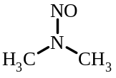
¹H NMR spectrum of compound l (CDCl₃)/ppm

N,N-diethyl-nitrosoamine (2): ¹H NMR (CDCl₃, 400 MHz)/δ ppm: δ_{H}= 3.87 (q, 2H, ³J_{HH} = 7.6 Hz), 3.33 (q, 2H, ³J_{HH} = 7.6 Hz), 1.16 (t, 3H, ³J_{HH} = 7.6 Hz), 0.85(t, 3H, ³J_{HH} = 7.6 Hz).
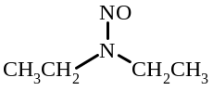
¹H NMR spectrum of compound 2 (CDCl₃)/ppm

N,N-diisopropyl-nitrosoamine (3): ¹H NMR (CDCl₃, 400 MHz)/δ ppm: δ_{H}= 4.99 (sep, 1H, ³J_{HH} = 7.6 Hz), 4.20 (sep, 1H, ³J_{HH} = 7.6 Hz), 1.41 (d, 6H, ³J_{HH} = 7.6 Hz), 1.07 (d, 6H, ³J_{HH} = 7.6 Hz).
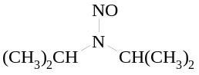
¹H NMR spectrum of compound 3 (CDCl₃)/ppm
N-nitrosopiperidine (4): ¹H NMR (CDCl₃, 400 MHz)/δ ppm: δ_{H}= 4.06 (m, 2H), 3.65 (m, 2H), 1.67 (m, 6H).
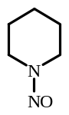
¹H NMR spectrum of compound 4 (CDCl₃)/ppm
N-nitrosoproline (5: a mixture of E and Z isomers): ¹H NMR (CDCl₃, 400 MHz)/δ ppm: E isomer (67%): δ_{H}= 10.83 (s, 1H, COOH), 4.35 (m, 2H), 3.63 (“t”, 1H, ³J_{HH} = 7.2 Hz), 2.13(m, 4H). Z isomer (33%): δ_{H}= 10.83 (s, 1H, COOH), 5.24 (“t”, 1H, ³J_{HH} = 7.2 Hz), 4.35 (m, 2H), 2.13(m, 4H).

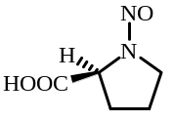
¹H NMR spectrum of compound 5 (CDCl₃)/ppm
N-methyl-N-phenyl nitrosamine (6): ῡ_{max} (KBr)/cm⁻¹: 3053 (=C-H), 2935 (-C-H), 1600-1400 (C=C and N=N), 1396 (CH₃ bending), 1000-1350 (C=O and C-N),760 and 690 (=C-H bending OOP of monosubstituted phenyl ring). ¹H NMR (CDCl₃, 400 MHz)/δ ppm: Z isomer (100%): δ_{H}= 7.54 (d, 2H, ³J_{HH} = 7.6 Hz), 7.48 (“t”, 2H, ³J_{HH} = 7.2 Hz), 7.36 (“t”, 1H, ³J_{HH} = 7.6 Hz), 3.45 (s, 3H).
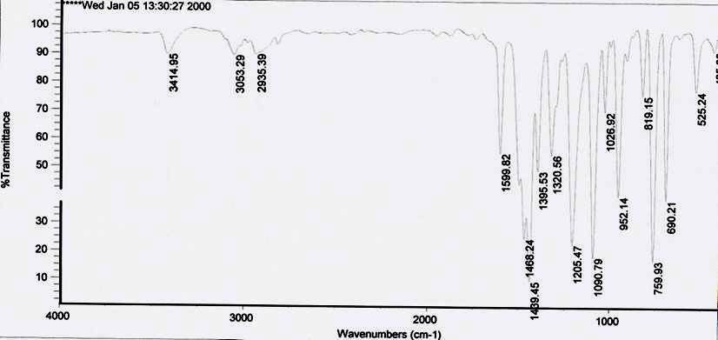
FT–IR spectrum of compound 6
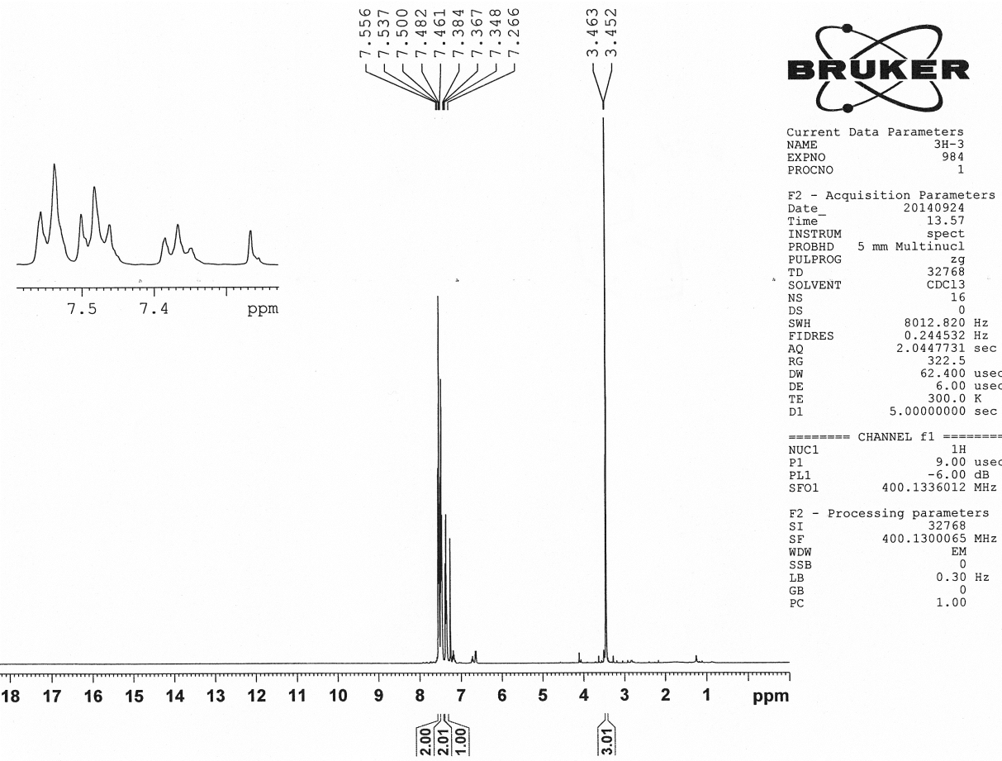
¹H NMR spectrum of compound 6 in low concentration (DMSO-d₆)/ppm
N,N-diphenyl nitrosamine (7): ῡ_{max} (KBr)/cm⁻¹: 3060 (=C-H), 1600-1400 (C=C and N=N), 1000-1350 (C=O and C-N),755 and 692 (=C-H bending OOP of monosubstituted phenyl ring). ¹H NMR (CDCl₃, 400 MHz)/δ ppm: 7.54 (d, 2H, ³J = 7.6 Hz), 7.48 (“t”, 2H, ³J = 7.2 Hz), 7.36 (“t”, 1H, ³J = 7.6 Hz), 3.45 (s, 3H).
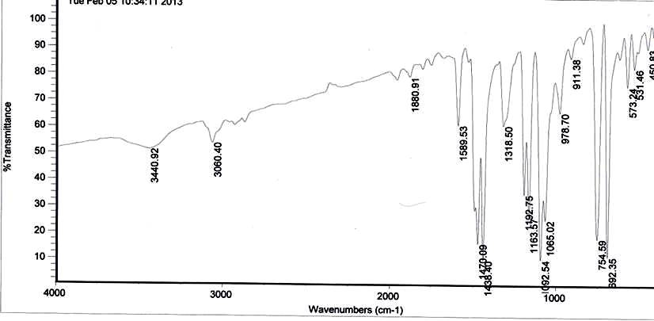
FT–IR spectrum of compound 7
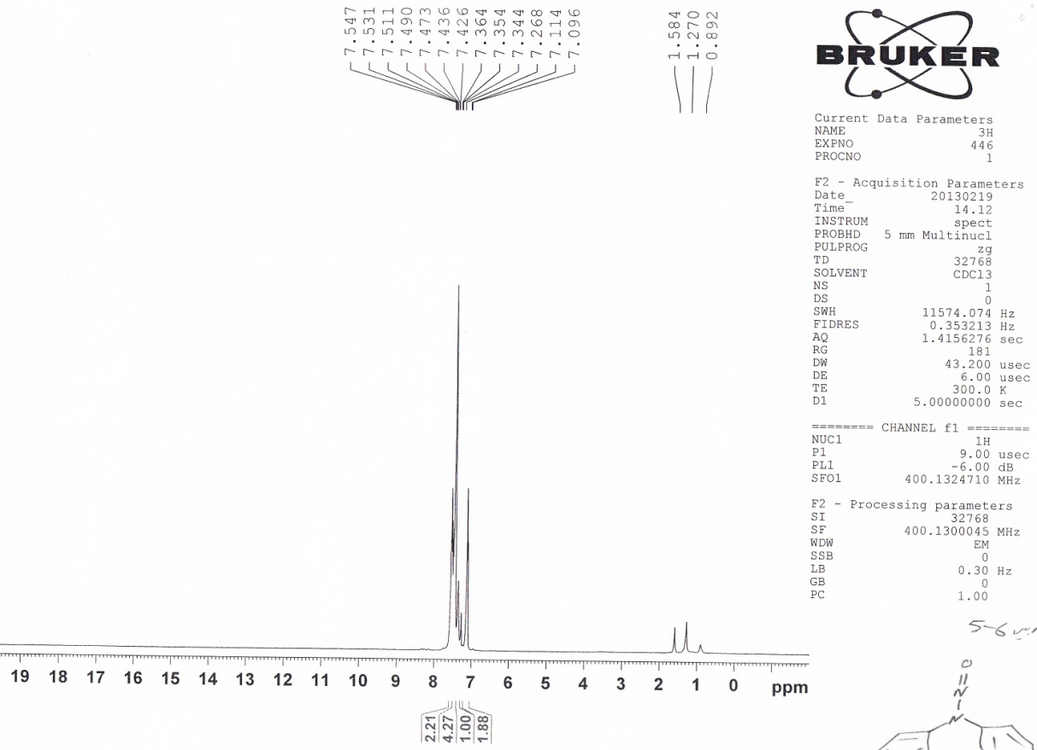
¹H NMR spectrum of compound 7 (CDCl₃)/ppm
N-phenyl-N-(2-naphthyl)-nitrosamine (8: a mixture of E and Z isomers): ῡ_{max} (KBr)/cm⁻¹: 3060 (=C-H), 1600-1400 (C=C and N=N), 1000-1350 (C=O and C-N),753 and 689 (=C-H bending OOP of monosubstituted phenyl ring). ¹H NMR (CDCl₃, 400 MHz)/δ ppm: Z isomer (100%): δ_{H}= 8.14 (d, 1H, ³J_{HH} = 7.6 Hz), 7.9-7.7 (m, 4H), 7.6-7.4 (m, 4H), 7.42 (“t”, 1H, ³J_{HH} = 7.6 Hz), 7.37 (d, 1H, ⁴J_{HH} = 1.6 Hz), 7.34 (d, 1H, ³J_{HH} = 8.0 Hz).
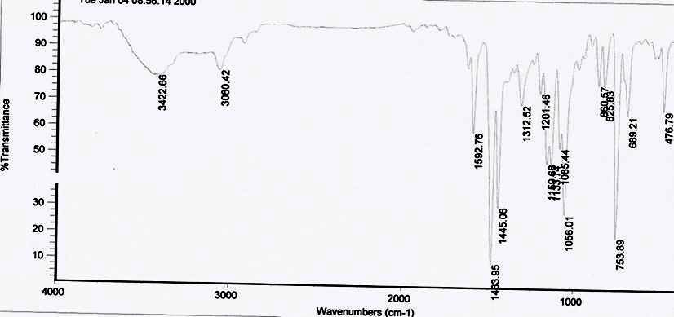
FT–IR spectrum of compound 8
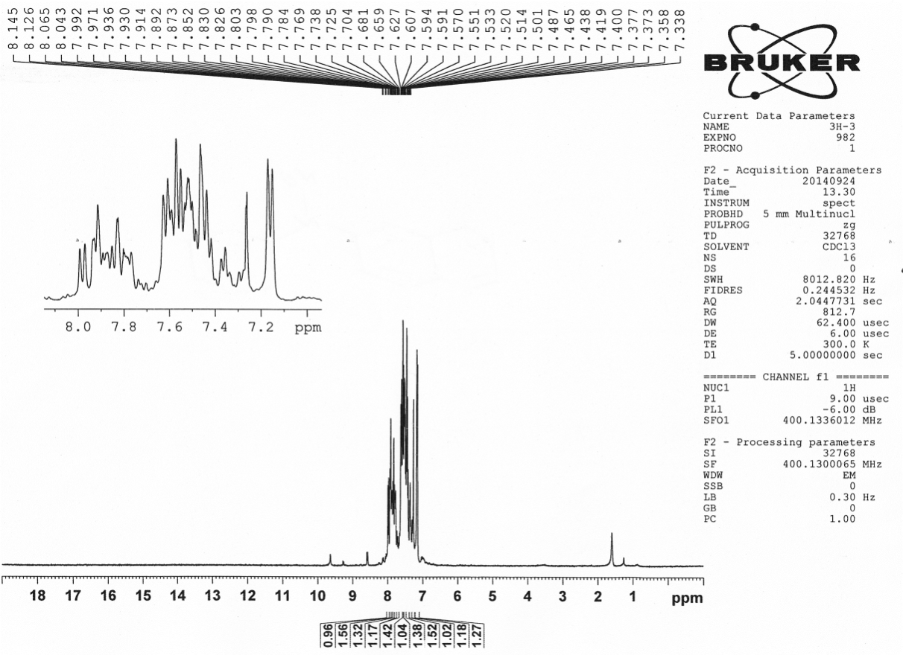
¹H NMR spectrum of compound 8 (CDCl₃)/ppm
N-nitroso 1,2,3,4-tetrahydro quinoline (9: a mixture of E and Z isomers): ῡ_{max} (KBr)/cm⁻¹: 3060 (=C-H), 2945 (-C-H), 1600-1400 (C=C and N=N), 1000-1350 (C=O and C-N),757 (=C-H bending OOP of ortho-disubstituted phenyl ring). ¹H NMR (CDCl₃, 400 MHz)/δ ppm: Z isomer (80%): δ_{H}= 8.07 (“t”, 1H, ³J = 8 Hz), 7.28 (m, 3H), 3.90 (t, 2H, ³J = 6.4 Hz), 2.77 (t, 2H, ³J = 6 Hz), 2.01 (quin, 2H, ³J = 6 Hz). E isomer (20%): δ_{H}= 6.94 (m, 2H), 6.6 (“t”, 1H, ³J = 6.4 Hz), 6.47 (d, 1H, ³J = 8 Hz), 3.28 (t, 2H, ³J = 6.4 Hz), 2.75 (t, 2H, ³J = 6 Hz), 1.99 (quin, 2H, ³J = 6 Hz).
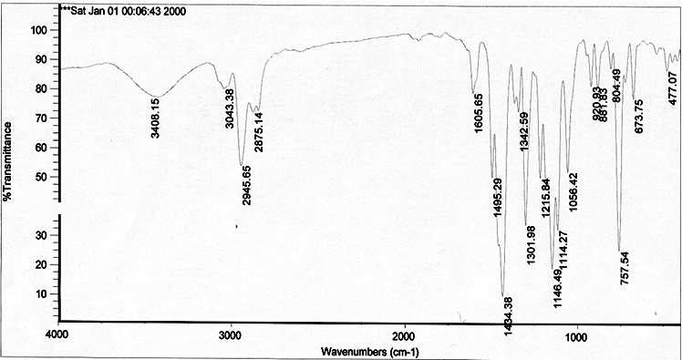
FT–IR spectrum of compound 9
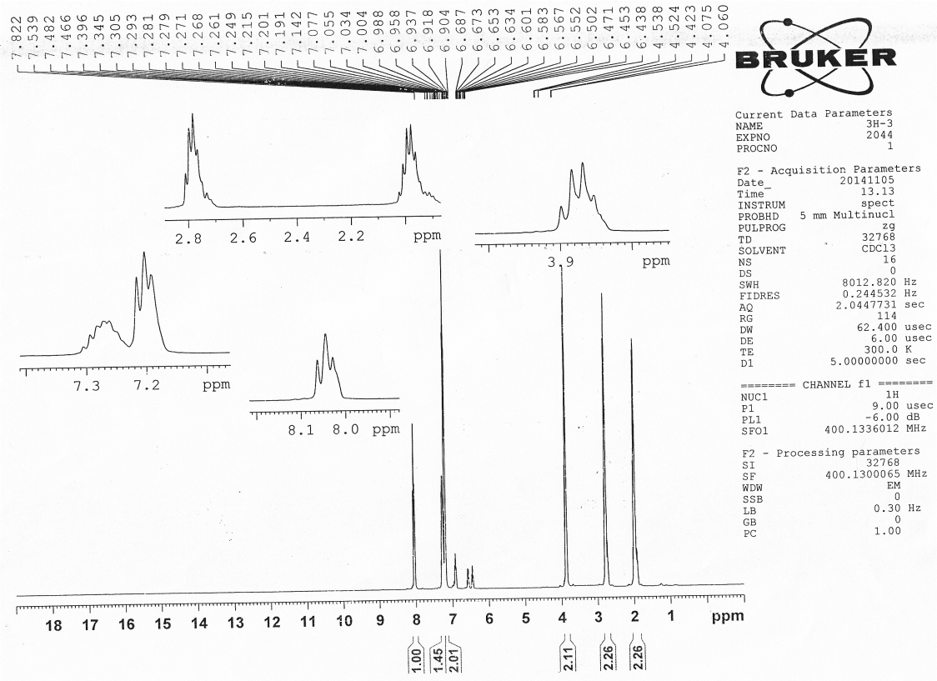
¹H NMR spectrum of compound 9 (CDCl₃)/ppm
N-nitroso 1,2,3,4-tetrahydro isoquinoline (10: a mixture of E and Z isomers): ῡ_{max} (KBr)/cm⁻¹: 3069 (=C-H), 2935 (-C-H), 1600-1400 (C=C and N=N), 1000-1350 (C=O and C-N),770 (=C-H bending OOP of ortho-disubstituted phenyl ring). ¹H NMR (CDCl₃, 400 MHz)/δ ppm: E isomer (27%): δ_{H}= 7.28 (m, 4H), 4.85 (s, 2H), 4.67 (t, 2H, ³J = 6 Hz), 3.10 (t, 2H, ³J = 6 Hz). Z isomer (73%): δ_{H}= 7.28 (m, 2H), 5.41 (s, 2H), 3.91 (t, 2H, ³J = 6 Hz), 2.95 (t, 2H, ³J = 6 Hz).
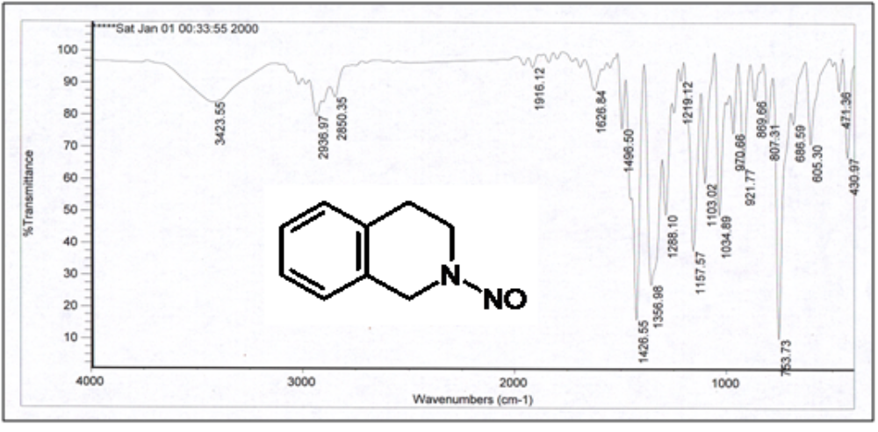
FT–IR spectrum of compound 10
¹H NMR spectrum of compound 10 (CDCl₃)/ppm
N-nitroso-3-carboxyl-1,2,3,4-tetrahydro isoquinoline (11: a mixture of E and Z isomers): ¹H NMR (CDCl₃, 400 MHz)/δ ppm: Z isomer (60%): δ_{H}= 7.28 (m, 4H), 5.90 (m, 1H), 5.1 (AB quartet, 1H, ²J = 14 Hz), 4.65 (AB quartet, 1H, ²J = 14 Hz), 3.50 (m, 2H). E isomer (40%): δ_{H}= 7.28 (m, 4H), 5.68 (AB quartet, 1H, ²J = 14 Hz), 5.31 (AB quartet, 1H, ²J = 14 Hz), 4.90 (m, 1H), 3.20 (m, 2H).
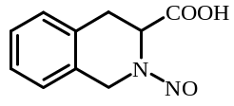
¹H NMR spectrum of compound 11 (CDCl₃)/ppm
N-nitroso indoline (12): ῡ_{max} (KBr)/cm⁻¹: 3069 (=C-H), 2945 (-C-H), 1600-1400 (C=C and N=N), 1000-1350 (C=O and C-N),758 (=C-H bending OOP of ortho-disubstituted phenyl ring). ¹H NMR (CDCl₃, 400 MHz)/δ ppm: E isomer (100%): δ_{H}= 7.84 (d, 1H, ³J = 8 Hz), 7.33 (m, 2H), 7.25 (“t”, 1H, ³J = 8 Hz), 4.15 (t, 2H, ³J = 8 Hz), 3.22 (t, 2H, ³J = 8 Hz).
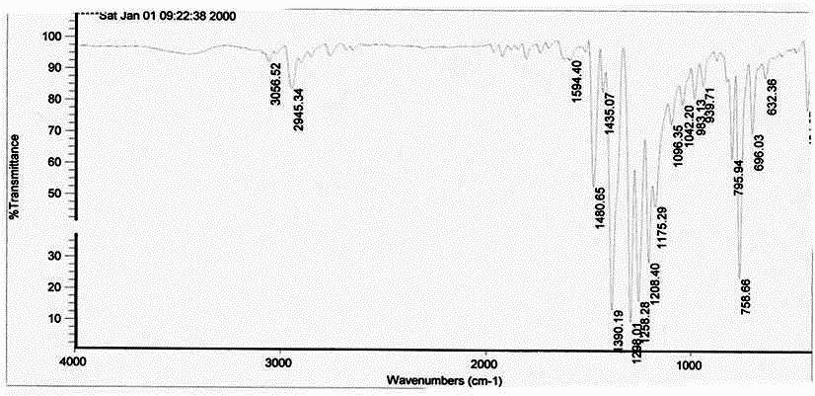
FT–IR spectrum of compound 12
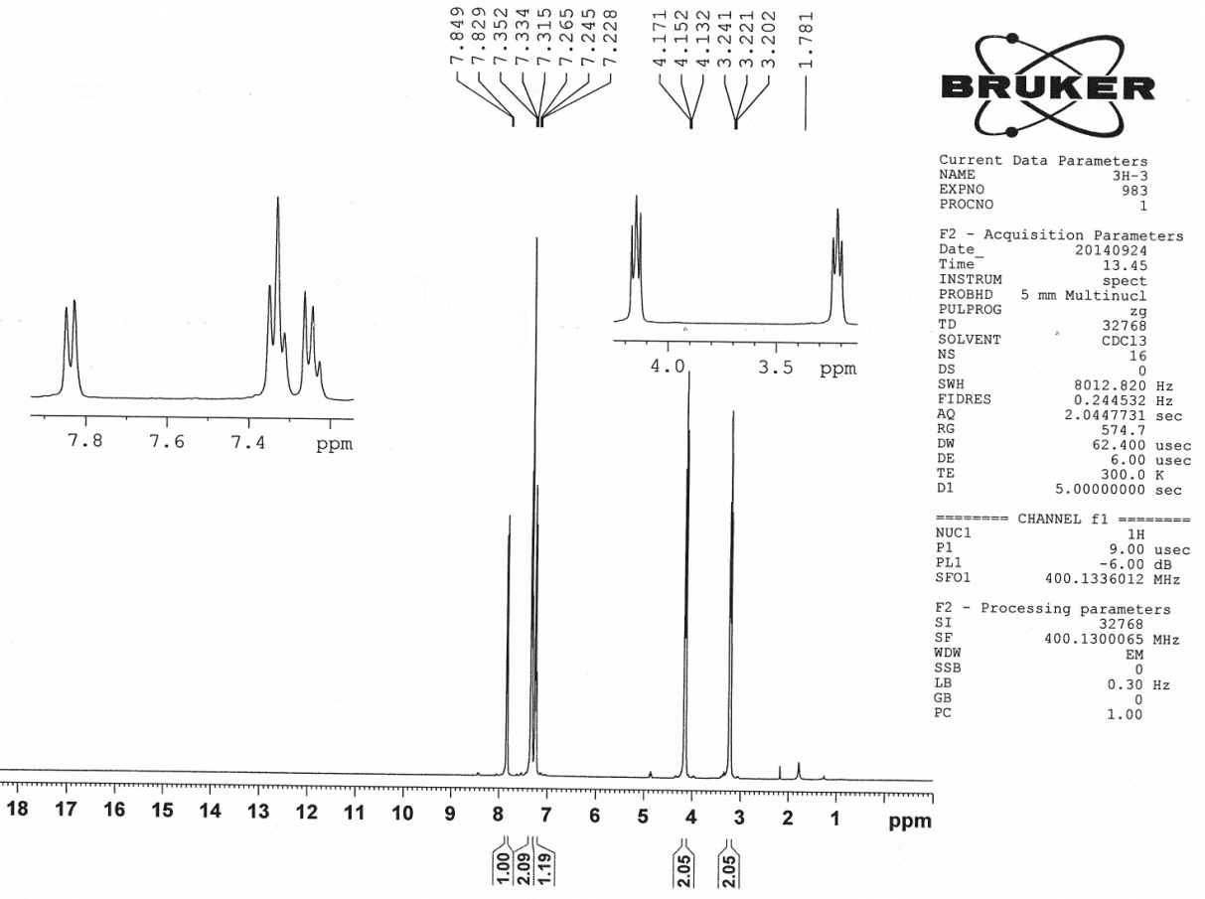
¹H NMR spectrum of compound 12 (CDCl₃)/ppm

N-nitroso morpholine (13 and 14): ῡ_{max} (KBr)/cm⁻¹: 2923 (-C-H), 1600-1400 (C=C and N=N), 1000-1350 (C=O and C-N). ¹H NMR (CDCl₃, 400 MHz)/δ ppm: δ_{H}= 3.02 (m, 2H), 2.62 (m, 6H).
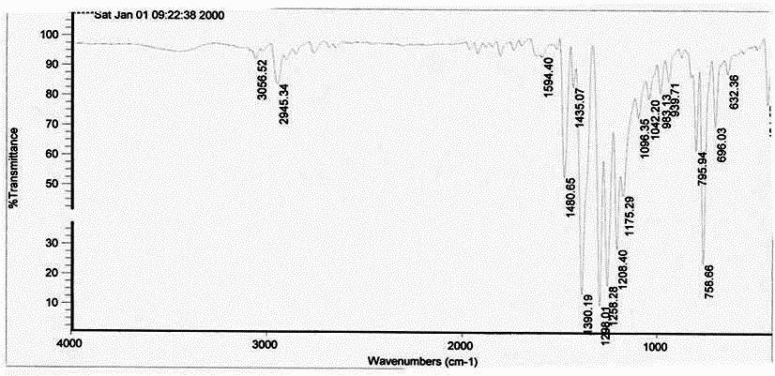
FT–IR spectrum of compound 13 and 14
¹H NMR spectrum of compound 13 and 14(CDCl₃)/ppm
N-nitroso piperidine-4-ol (15): ῡ_{max} (KBr)/cm⁻¹: 3370 (OH), 2936 (-C-H), 1600-1400 (C=C and N=N), 1000-1350 (C=O and C-N). ¹H NMR (CDCl₃, 400 MHz)/δ ppm: δ_{H}= 4.45 (m, 1H), 4.16 (m, 2H), 3.97 (m, 1H) 3.80 (m, 1H), 2.18 (brs, 1H, OH).
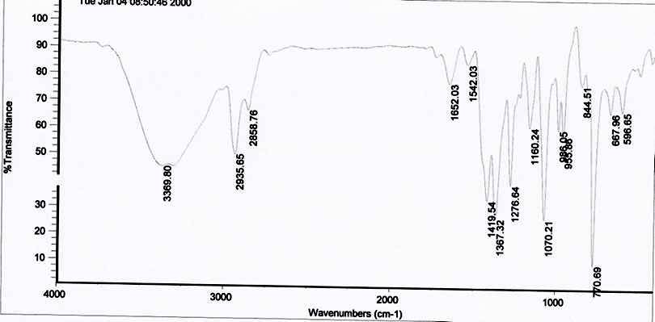
FT–IR spectrum of compound 15
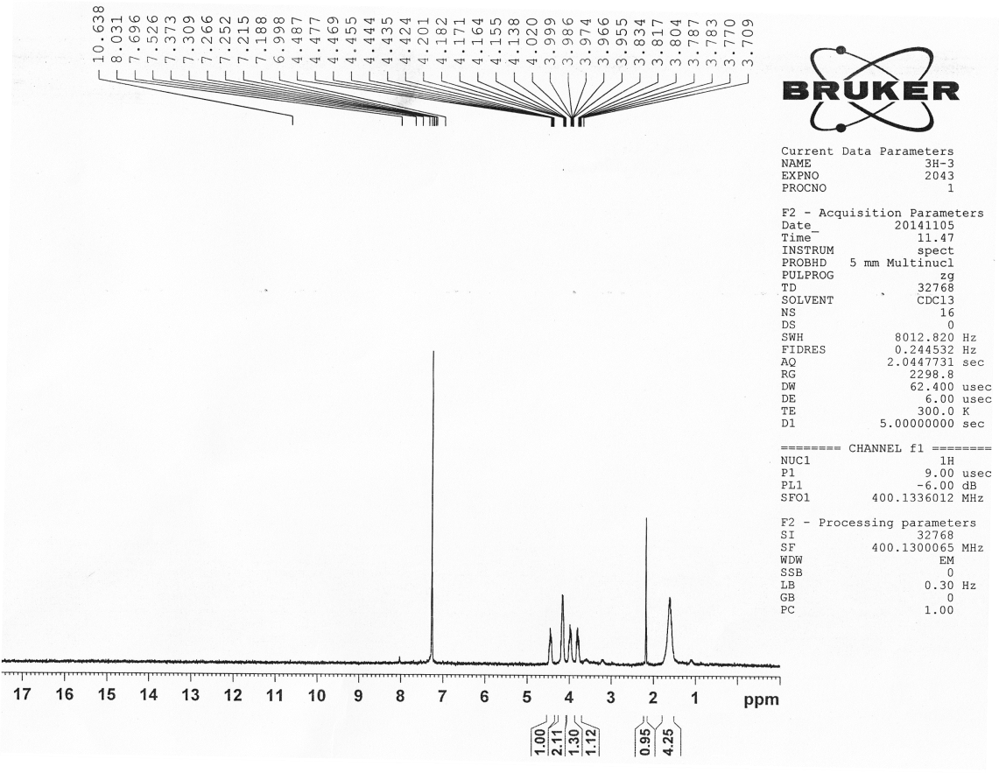
¹H NMR spectrum of compound 15 (CDCl₃)/ppm
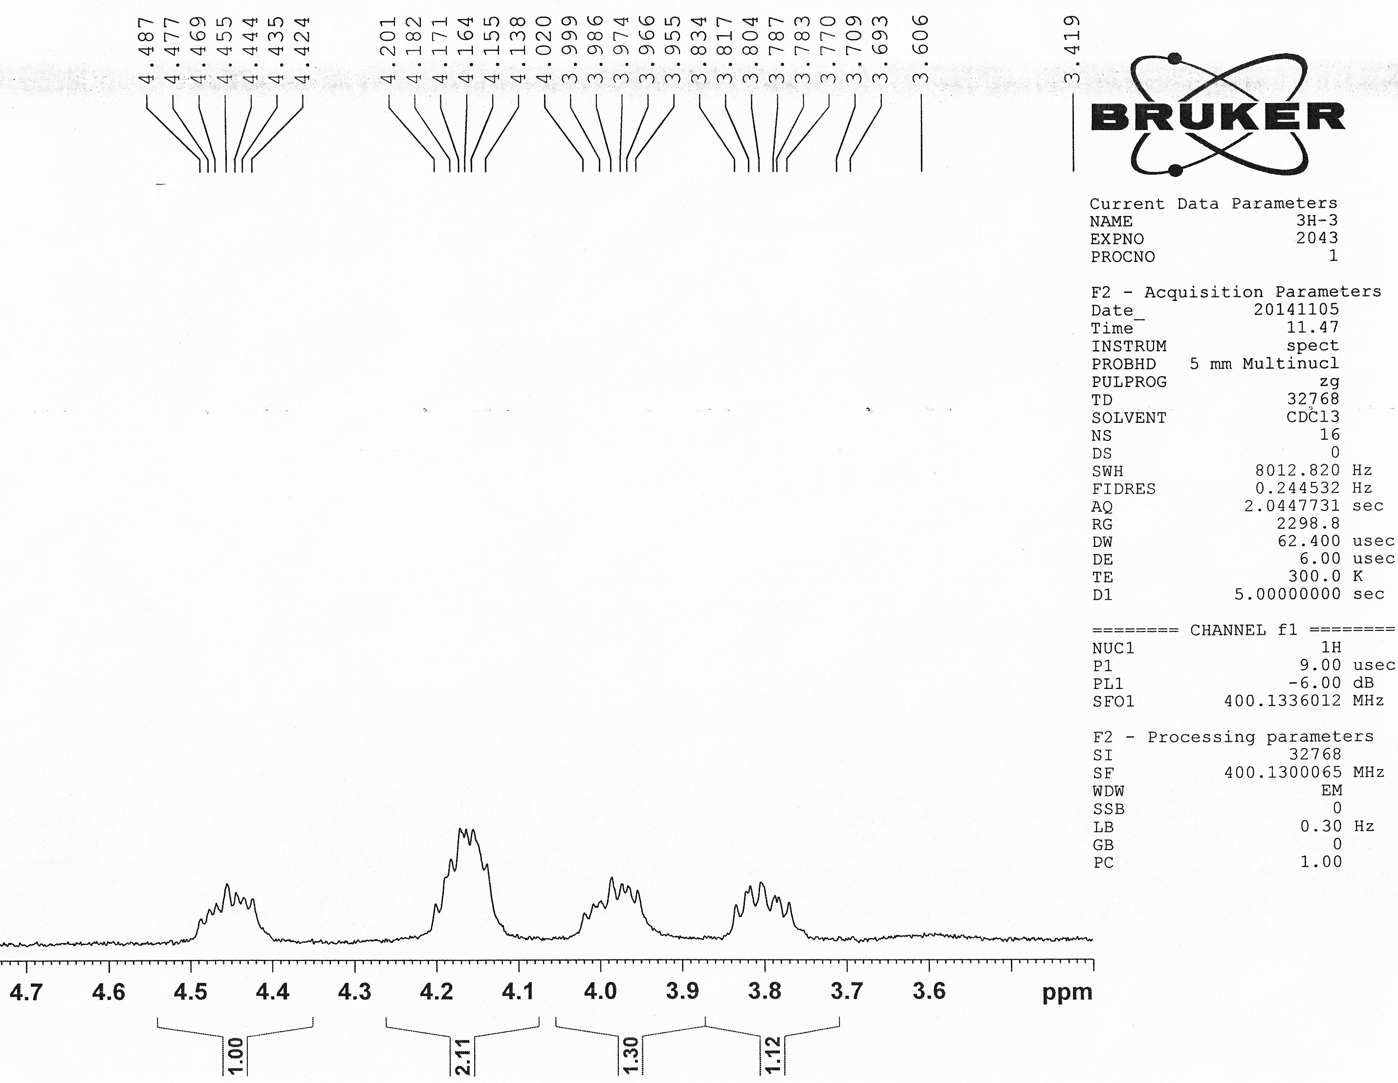
Expanded of ¹H NMR spectrum of compound 14 (CDCl₃)/ppm
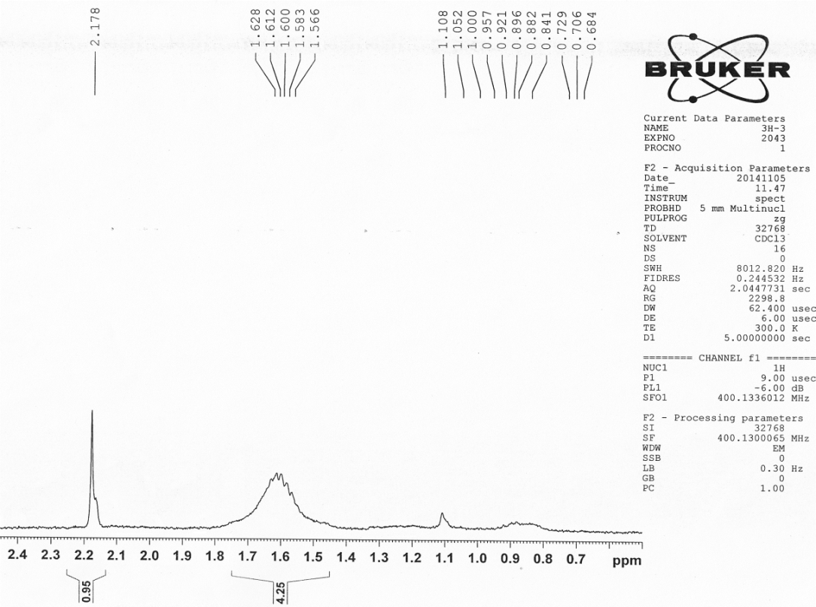
Expanded of ¹H NMR spectrum of compound 14 (CDCl₃)/ppm
4-nitrosopepiridine-1-yl-ethanole (16): ῡ_{max} (KBr)/cm⁻¹: 3410 (OH), 2932 (-C-H), 1600-1400 (C=C and N=N), 1000-1350 (C=O and C-N). ¹H NMR (CDCl₃, 400 MHz)/δ ppm: δ_{H}= 4.3 (t, 2H, ³J = 6 Hz), 3.86 (m, 2H, ³J = 2.4 Hz), 3.68 (m, 2H, ³J = 2.8 Hz), 2.75 (m, 2H, ³J = 5.6 Hz), 2.63 (m, 2H, ³J = 2.8 Hz), 2.52 (t, 2H, ³J = 2.8 Hz), 2.35 (brs, 1H, OH).
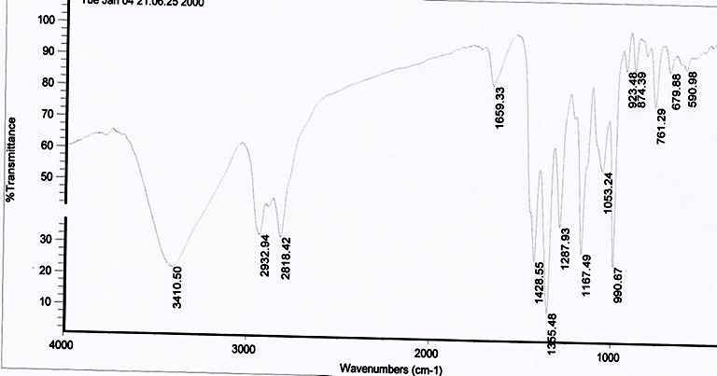
FT–IR spectrum of compound 16
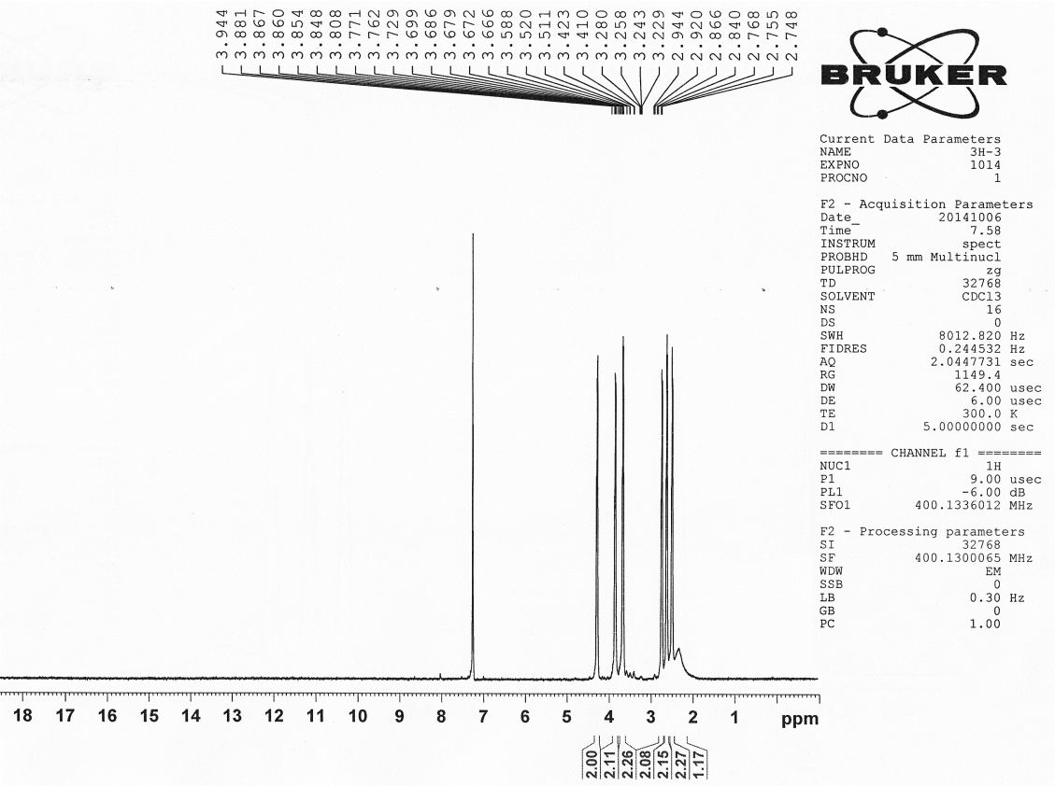
¹H NMR spectrum of compound 16 (CDCl₃)/ppm
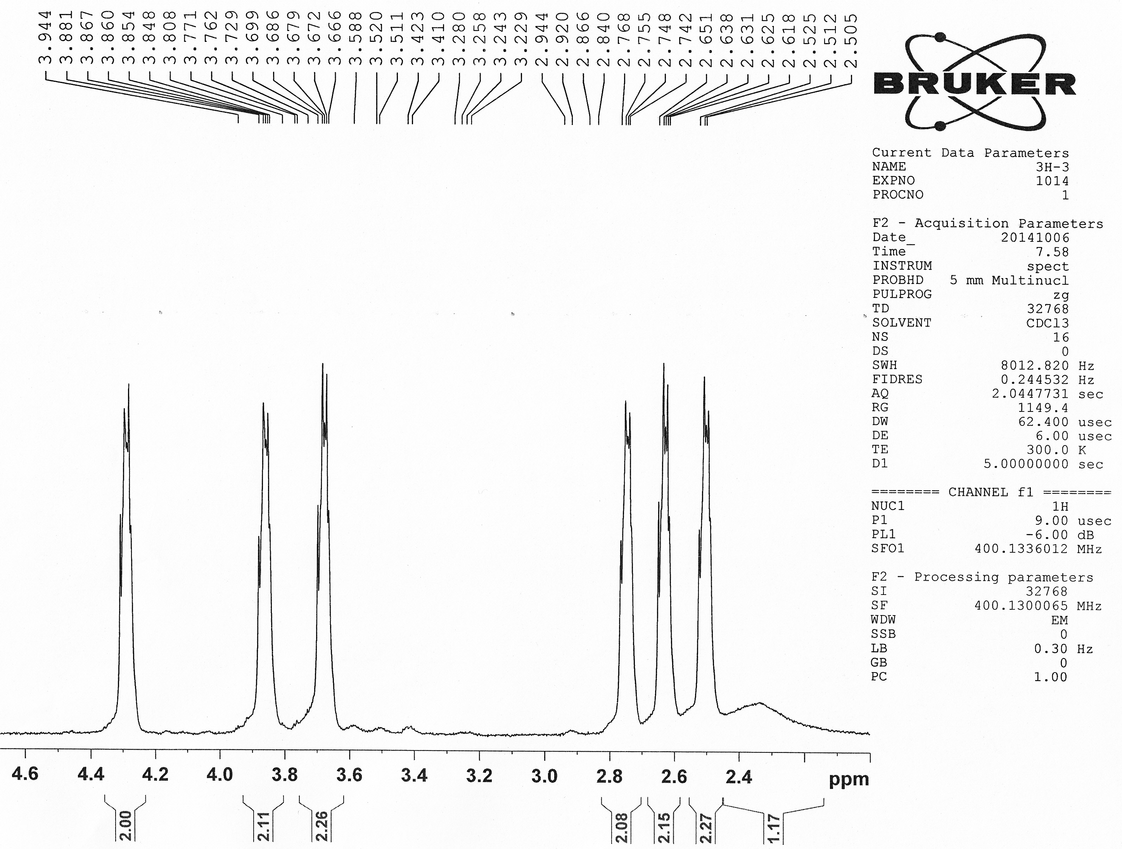
Expanded of ¹H NMR spectrum of compound 16 (CDCl₃)/ppm

N-benziyl-N-phenyl-nitrosamine (17): ῡ_{max} (KBr)/cm⁻¹: 3032 (=C-H), 2932 (-C-H), 1600-1400 (C=C and N=N), 1000-1350 (C=O and C-N). ¹H NMR (CDCl₃, 400 MHz)/δ ppm: Z isomer (100%): δ_{H}=8.2-7.9 (m, 1H), 7.7-7.5 (br. d, 2H, ³J = 8), 7.5-7.4 (m, 2H, Ar–H), 7.4-7.15 (br. m, 4H, Ar–H), 7.15-7.05 (d, 1H, ³J = 7.2 Hz), 5.3 (s, 2H).
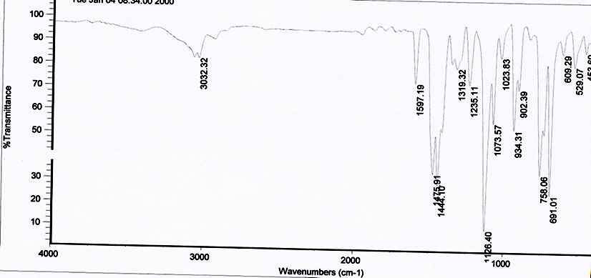
FT–IR spectrum of compound 17
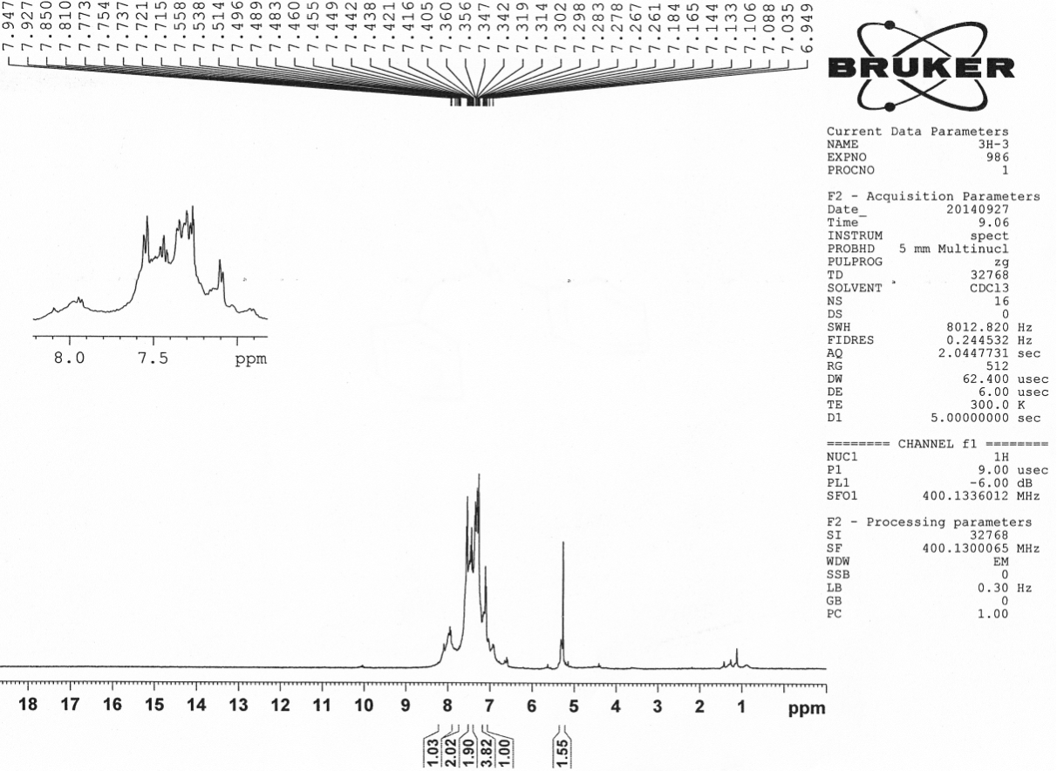
¹H NMR spectrum of compound 17 (CDCl₃)/ppm

N,N-dibenziyl nitrosamine (18): ῡ_{max} (KBr)/cm⁻¹: 3032 (=C-H), 2933 (-C-H), 1600-1400 (C=C and N=N), 1000-1350 (C=O and C-N). ¹H NMR (CDCl₃, 400 MHz)/δ ppm: δ_{H}=7.42-7.36 (“t”, 4H, ³J = 7.2 Hz), 7.33-7.28 (“t”, 3H, ³J = 6.8 Hz), 7.27-7.23 (“t”, 1H), 7.08-7.03 (“t”, 1H), 5.21 (s, 1H), 4.67 (s, 1H), 3.86 (s, 2H).
FT–IR spectrum of compound 18
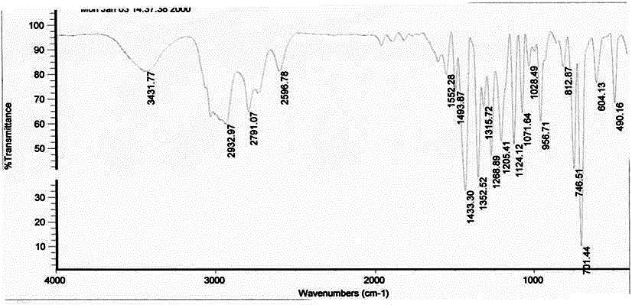
¹H NMR spectrum of compound 18 (CDCl₃)/ppm
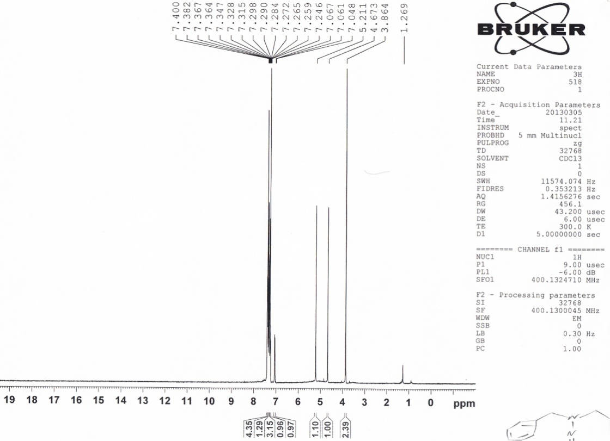
N,N-disyclohexyl nitrosamine (19): ῡ_{max} (KBr)/cm⁻¹: 2934 (-C-H), 1600-1400 (C=C and N=N), 1000-1350 (C=O and C-N). ¹H NMR (CDCl₃, 400 MHz)/δ ppm: δ_{H}= 4.88 (m, 1H), 3.72 (m, 1H), 2-1 (m, 20H).
FT–IR spectrum of compound 19
¹H NMR spectrum of compound 19 (CDCl₃)/ppm
1,4-dinitroso piperazine (20): ῡ_{max} (KBr)/cm⁻¹: 2926 (-C-H), 1600-1400 (C=C and N=N), 1000-1350 (C=O and C-N). ¹H NMR (CDCl₃, 400 MHz)/δ ppm: Anti isomer (51.5%): δ_{H}= 4.4 (“t”, 1H, ³J = 6 Hz), 4.04 (“t”, 1H, ³J = 6 Hz). Cin isomer (48.5%): δ_{H}= 4.56 (s, 1H), 3.81 (s, 1H).
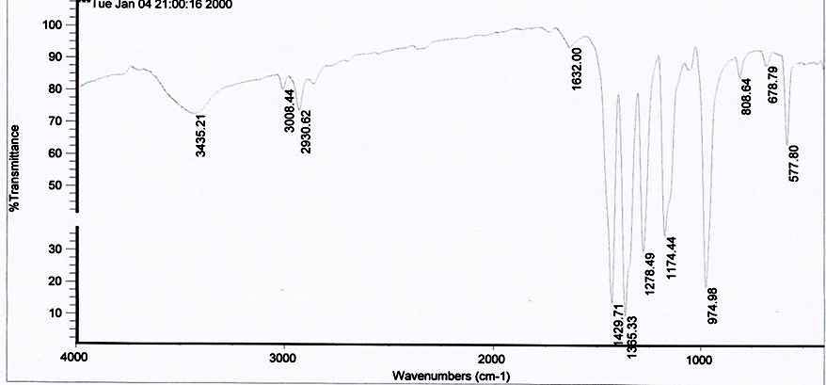
FT–IR spectrum of compound 20
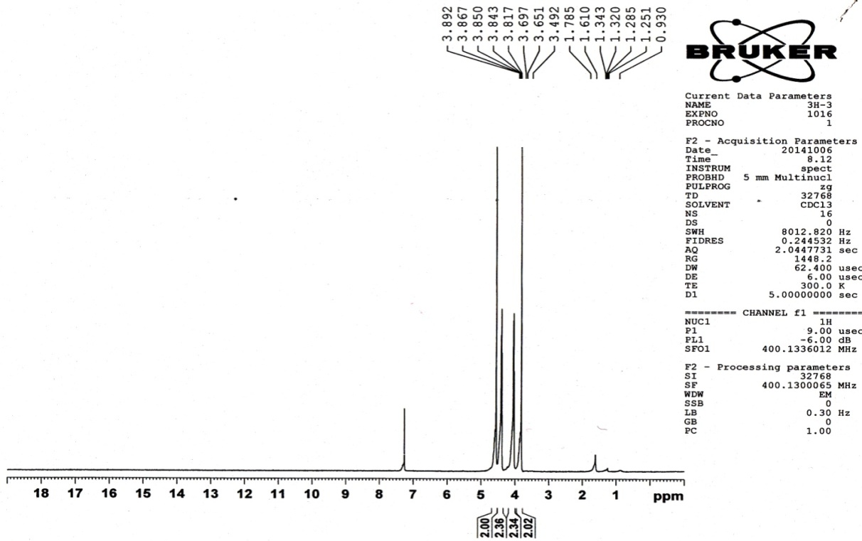
¹H NMR spectrum of compound 20 (CDCl₃)/ppm

