CT acquisition protocol
The coronary CTA scans were performed on a spectral detector CT scanner (IQon, Philips Healthcare, Best, The Netherlands) with prospective ECG gating technique. Using an 18-gauge catheter dual-tube high pressure syringe (Ulrich REF XD 2051), contrast media (Visipaque) (Iodixanol 270; GE Healthcare, Ireland) was injected into the antecubital vein with a flow rate of 4.5 ml/s (<80 kg body weight) or 5 ml/s (≥80 kg body weight) followed by a 20-40 ml saline flush. The total amount of contrast media was based on patient weight (patient weight × 0.8 ml / kg body weight), with the coronary CTA scan acquired 6 seconds after a threshold of 110 Hounsfield Unit (HU) had been reached in the descending aorta. The scans were performed with the following parameters: he tube voltage was 120 kVp; tube current-automatic exposure control (dose right index =13) was used to provide a balance between image quality and radiation dose; field of view =250 mm; tube rotation time =0.27 s; detector collimation =64 × 0.625 mm; matrix =512 × 512; slice thickness =0.9 mm; and increment =0.45 mm. The scan trigger was centered around 78% of the R-R interval, with a ±3% buffer used. Ahead of CT examination, patients with heart rate (HR) >70 bpm were given 25-50 mg of ß-receptor blocker (Metoprolol Succinate sustained-release tablets, AstraZeneca, Sweden) orally to reduce the HR to below 70 bpm.

Supplementary Table 1. The number of HRPC of patients stratified according to TyG index categories.
The number of HRPC | Group
The number of HRPC | T1(n= 67) | T2(n=66) | T3(n=68)
No HRPC, n (%) | 36(53.73) | 31(46.97) | 15(22.06)
1 HRPC, n (%) | 22(32.84) | 22(33.33) | 32(47.06)
2 HRPC, n (%) | 9(13.43) | 11(16.67) | 19(27.94)
≥3 HRPC, n (%) | 0 | 2(3.03) | 2(2.94)
HRPC, High-risk plaque characteristics

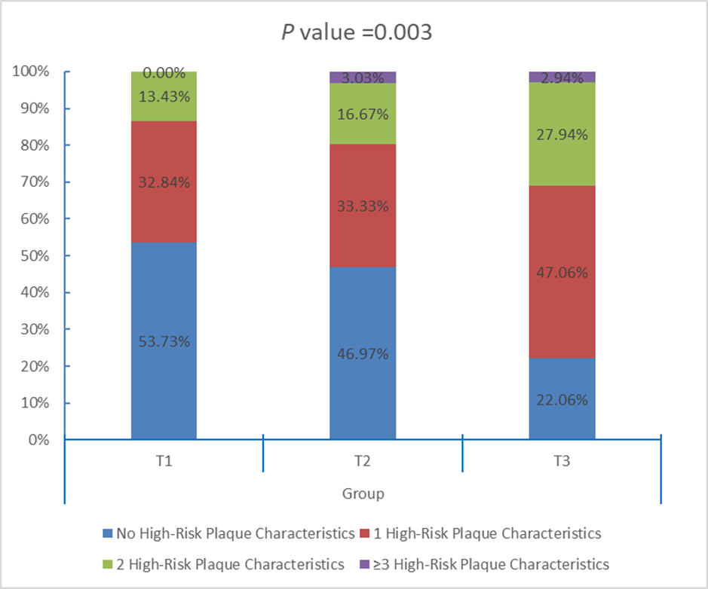
Supplementary Figure 1. Distribution of HRPC According to TyG index Categories. The number of HRPC was significantly different among different TyG index categories (Group T1 [TyG tertile 1≤8.42], Group T2 [TyG tertile 2：8.43~9.12] and Group T3 [TyG tertile 3≥9.13]).
HRPC, high-risk plaque characteristics.

