Supplementary material 1- Flowchart performed to obtain the 63 articles of this systematic bibliographic review.
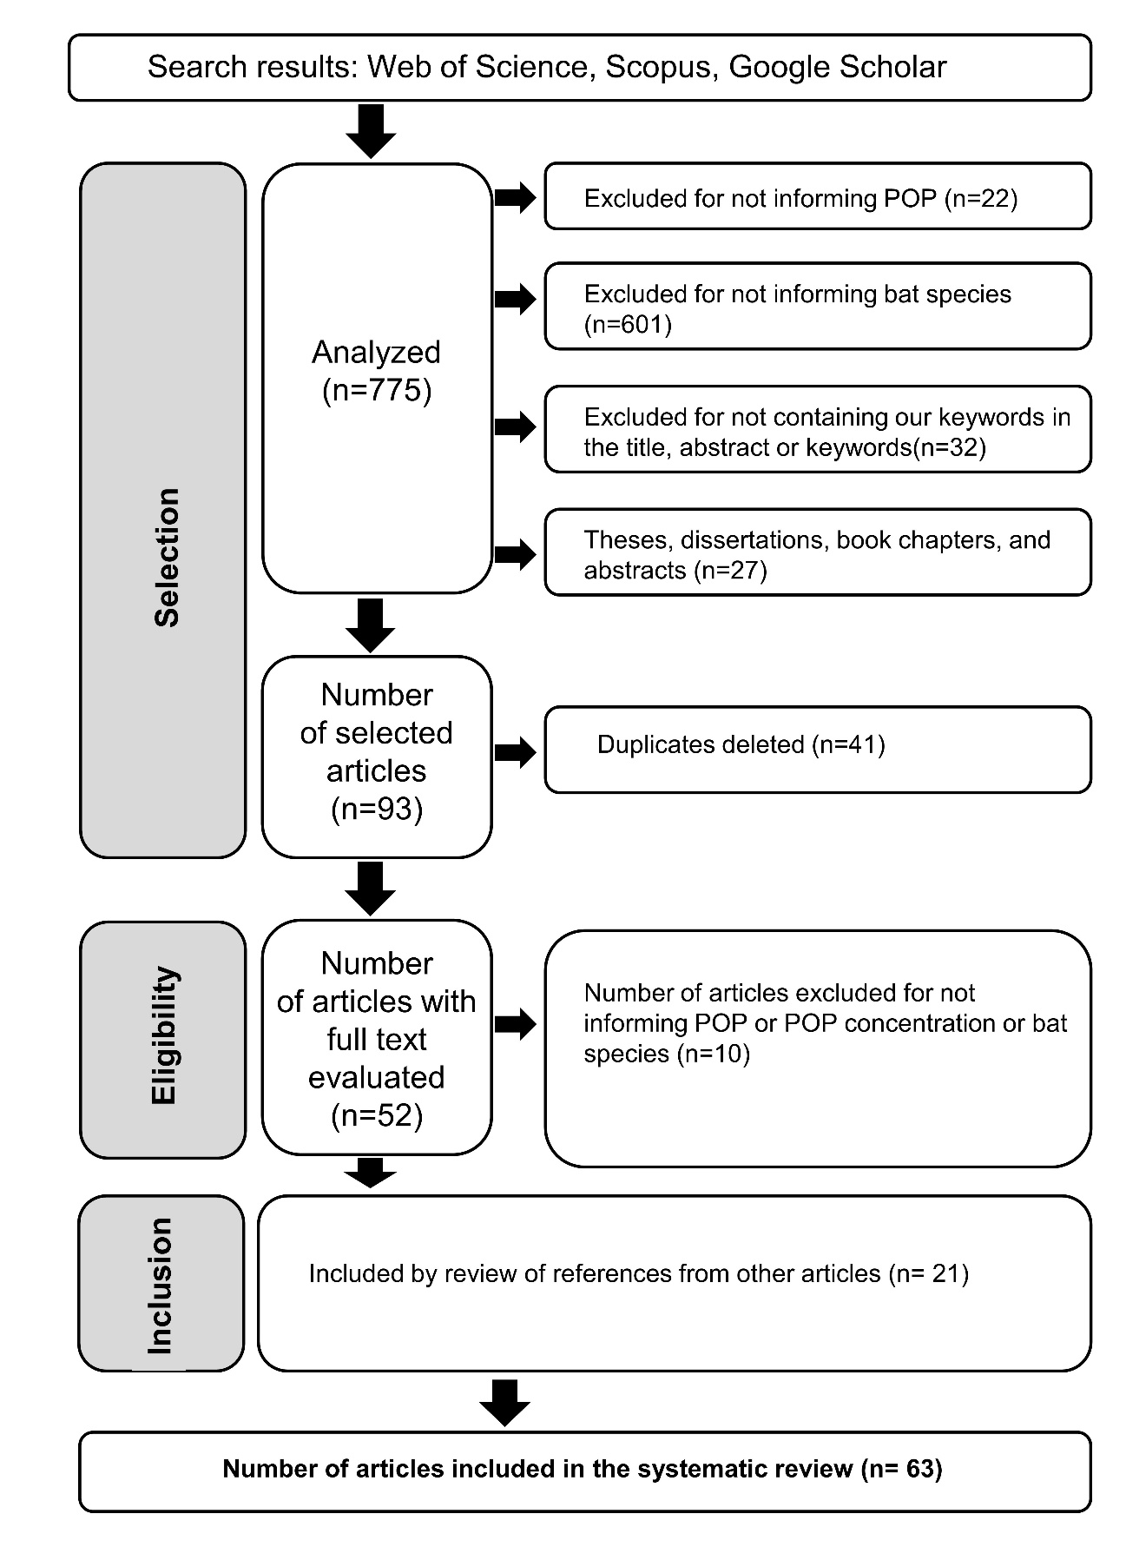
Supplementary material 2- List of 63 articles found in the qualitative systematic review. Articles are listed in alphabetical order by author.

Allinson, G., Mispagel, C., Kajiwara, N., Anan, Y., Hashimoto, J., Laurenson, L., Allinson, M., Tanabe, S., 2006. Organochlorine and trace metal residues in adult southern bent-wing bat (Miniopterus schreibersii bassanii) in southeastern Australia. Chemosphere, 64(9),1464-14710.
Bennett, B. S., & Thies, M. L. 2007. Organochlorine pesticide residues in guano of Brazilian free-tailed bats, Tadarida brasiliensis Saint-Hilaire, from East Texas. Bulletin of environmental contamination and toxicology, 78(3), 191-194.
Best, S. M. 1973. Some organochlorine pesticide residues in wildlife of the Northern Territory, Australia, 1970-71. Australian journal of biological sciences, 26(5), 1161-1170.
Boyd, I. L., Myhill, D. G., Mitchell-Jones, A. J. 1988. Uptake of gamma-HCH (Lindane) by pipistrelle bats and its effect on survival. Environmental Pollution, 51(2), 95-111.
Brinati, A., Oliveira, J. M., Oliveira, V. S., Barros, M. S., Carvalho, B. M., Oliveira, L. S., Queiroz, M. E. L., Matta, S.L.P., Freitas, M. B. 2016. Low, chronic exposure to endosulfan induces bioaccumulation and decreased carcass total fatty acids in neotropical fruit bats. Bulletin of Environmental Contamination and Toxicology, 97(5), 626-631.
Buchweitz, J. P., Carson, K., Rebolloso, S., Lehner, A. 2018. DDT poisoning of big brown bats, Eptesicus fuscus, in Hamilton, Montana. Chemosphere, 201, 1-5.
Clark Jr, D. R. 2001. DDT and the decline of free-tailed bats (Tadarida brasiliensis) at Carlsbad Cavern, New Mexico. Archives of environmental contamination and toxicology, 40(4), 537-543.
Clark Jr, D. R., Bagley, F. M., Johnson, W. W. 1988. Northern Alabama colonies of the endangered grey bat Myotis grisescens: Organochlorine contamination and mortality. Biological Conservation, 43(3), 213-225.
Clark Jr, D. R., Bunck, C. M., Cromartie, E., Laval, R. K. 1983. Year and age effects on residues of dieldrin and heptachlor in dead gray bats, Franklin County, Missouri—1976, 1977, and 1978. Environmental Toxicology and Chemistry: An International Journal, 2(4), 387-393.
Clark, D. R., Clawson, R. L., Stafford, C. J. 1983. Gray bats killed by dieldrin at two additional Missouri caves: aquatic macroinvertebrates found dead. Bulletin of Environmental Contamination and Toxicology, 30(1), 214-218.
Clark Jr, D. R., Kroll, J. C. 1977. Effects of DDE on experimentally poisoned free‐tailed bats (Tadarida brasiliensis): lethal brain concentrations. Journal of Toxicology and Environmental Health, Part A Current Issues, 3(5-6), 893-901.
Clark Jr, D. R., Krynitsky, A. J. 1983. DDE in brown and white fat of hibernating bats. Environmental Pollution Series A, Ecological and Biological, 31(4), 287-299.
Clark Jr, D. R., Kunz, T. H., Kaiser, T. E. 1978. Insecticides applied to a nursery colony of little brown bats (Myotis lucifugus): lethal concentrations in brain tissues. Journal of Mammalogy, 59(1), 84-91.
Clark Jr, D. R., Lamont, T. G. 1976. Organochlorine residues and reproduction in the big brown bat. The Journal of Wildlife Management, 249-254.
Clark Jr, D. R., LaVal, R. K., Krynitsky, A. J. 1980. Dieldrin and heptachlor residues in dead gray bats, Franklin County, Missouri--1976 versus 1977. Pesticides Monitoring Journal, 13(4), 137-140.
Clark Jr, D. R., LaVal, R. K., Swineford, D. M. 1978. Dieldrin-induced mortality in an endangered species, the gray bat (Myotis grisescens). Science, 199(4335), 1357-1359.
Clark, D. R., LaVal, R. K., Tuttle, M. D. 1982. Estimating pesticide burdens of bats from guano analyses. Bulletin of Environmental Contamination and Toxicology, 29(2), 214-220.
Clark Jr, D. R., Martin, C. O., Swineford, D. M. 1975. Organochlorine insecticide residues in the free-tailed bat (Tadarida brasiliensis) at Bracken Cave, Texas. Journal of mammalogy, 56(2), 429-443.
Clark, D. R., Moreno-Valdez, A., Mora, M. A. 1995. Organochlorine residues in bat guano from nine Mexican caves, 1991. Ecotoxicology, 4(4), 258-265.
Clark, D. R., Prouty, R. M. 1984. Disposition of dietary dieldrin in the little brown bat and correlation of skin levels with body burden. Bulletin of environmental contamination and toxicology, 33(1), 177-183.
Clark Jr, D. R., Prouty, R. M. 1977. Experimental feeding of DDE and PCB to female big brown bats (Eptesicus fuscus). Journal of Toxicology and Environmental Health, Part A Current Issues, 2(4), 917-928.
Clark Jr, D. R., Stafford, C. J. 1981. Effects of DDE and PCB (Aroclor 1260) on experimentally poisoned female little brown bats (Myotis lucifugus): lethal brain concentrations. Journal of Toxicology and Environmental Health, Part A Current Issues, 7(6), 925-934.
Clawson, R. L., Clark Jr, D. R. 1989. Pesticide contamination of endangered gray bats and their food base in Boone County, Missouri, 1982. Bulletin of Environmental Contamination and Toxicology, 42(3), 431-437.
Corrao, A., Catalano, E., Zava, B. 1985. Destructive effects of chlorinated pesticides on a bats colony (Chiroptera).
Eidels, R. R., Whitaker Jr, J. O., Sparks, D. W. 2007. Insecticide residues in bats and guano from Indiana. In Proceedings of the Indiana Academy of Science (Vol. 116, No. 1, pp. 50-57).
Eidels, R. R., Whitaker Jr, J. O., Lydy, M. J., Sparks, D. W. 2012. Screening of insecticides in bats from Indiana. In Proceedings of the Indiana Academy of Science (Vol. 121, No. 2, pp. 133-142).
Fernández, M. A., Hernández, L. M., Ibánñez, C., González, M. J., Guillén, A., Pérez, J. L. 1993. Congeners of PCBs in three bat species from Spain. Chemosphere, 26(6), 1085-1097.
Geluso, K. N., Altenbach, J. S., Wilson, D. E. 1976. Bat mortality: pesticide poisoning and migratory stress. Science, 194(4261), 184-186.
Gerell, R., Lunderg, K. G. 1993. Decline of a bat Pipistrellus pipistrellus population in an industrialized area in south Sweden. Biological Conservation, 65(2), 153-157.
Grilliot, M. E., Hunt, J. L., Sims, C. G. 2018. Organochloride pesticides present in animal fur, soil, and streambed in an agricultural region of southeastern Arkansas. Journal of the Arkansas Academy of Science, 72(1), 106-108.
Guillén, A., Ibáñez, C., Pérez, J. L., Hernández, L. M., González, M. J., Fernández, M. A., Fernández, R. 1994. Organochlorine residues in Spanish common pipistrelle bats (Pipistrellus pipistrellus). Bulletin of environmental contamination and toxicology, 52(2), 231-237.
Henny, C. J., Maser, C., Whitaker Jr, J. O., Kaiser, T. E. 1982. Organochlorine residues in bats after a forest spraying with DDT. Northwest Science, 56(4), 329-335.
Hernández, L. M., Ibáñez, C., Fernández, M. A., Guillén, A., González, M. J., Pérez, J. L. 1993. Organochlorine insecticide and PCB residues in two bat species from four localities in Spain. Bulletin of environmental contamination and toxicology, 50(6), 871-877.
Jefferies1, D. J. 1972. Organochlorine insecticide residues in British bats and their significance. Journal of Zoology, 166(2), 245-263.
Kannan, K., Yun, S. H., Rudd, R. J., Behr, M. 2010. High concentrations of persistent organic pollutants including PCBs, DDT, PBDEs and PFOS in little brown bats with white-nose syndrome in New York, USA. Chemosphere, 80(6), 613-618.
Koeman, J. H., Rijksen, H. D., Smies, M., Na'Isa, B. K., Mac-lennan, K. J. R. 1971. Faunal changes in a swamp habitat in Nigeria sprayed with insecticide to exterminate Glossina. Netherlands Journal of Zoology, 21(4), 434-63.
Land, T. A., Clark Jr, D. R., Pekins, C. E., Lacher Jr, T. E. 2019. Seasonal emergence and historical contaminant exposure of cave myotis (Myotis velifer) in central Texas and current status of the population. Environments, 6(12), 121.
Leeuwangh, P., Voûte, A. M. 1985. Bats and woodpreservatives. Pesticide residues in the Dutch Pond bat (Myotis dasycneme) and its implications.
Mansour, S. A., Soliman, S. S., Soliman, K. M. 2017. Biomonitoring of persistent organic pollutants in Egypt using Taphozous perforatus (Chiroptera: Emballonuridae). Lynx, series nova, 48.
Matthiessen, P. 1985. Contamination of wildlife with DDT insecticide residues in relation to tsetse fly control operations in Zimbabwe. Environmental Pollution Series B, Chemical and Physical, 10(3), 189-211.
Mispagel, C., Allinson, M., Allinson, G., Iseki, N., Grant, C., Morita, M. 2004. DDT and metabolites residues in the southern bent-wing bat (Miniopterus schreibersii bassanii) of south-eastern Australia. Chemosphere, 55(7), 997-1003.
Müller, P., Nagel, P., Flacke, W. 1981. Ecological side effects of dieldrin application against tsetse flies in Adamaoua, Cameroon. Oecologia, 187-194.
O’Shea, T. J., Clark Jr, D. R. 2002. An overview of contaminants and bats, with special reference to insecticides and the Indiana bat. The Indiana bat: biology and management of an endangered species. Bat Conservation International, Austin, TX, 237-253.
Oliveira, J. M., Brinati, A., Miranda, L. D. L., Morais, D. B., Zanuncio, J. C., Gonçalves, R. V., Peluzio, M.C.G., Freitas, M. B. 2017. Exposure to the insecticide endosulfan induces liver morphology alterations and oxidative stress in fruit‐eating bats (Artibeus lituratus). International Journal of Experimental Pathology, 98(1), 17-25.
O'shea, T. J., Everette, A. L., Ellison, L. E. 2001. Cyclodiene insecticide, DDE, DDT, arsenic, and mercury contamination of big brown bats (Eptesicus fuscus) foraging at a Colorado Superfund site. Archives of Environmental Contamination and Toxicology, 40(1), 112-120.
Reidinger Jr, R. F. 1976. Organochlorine residues in adults of six southwestern bat species. The Journal of Wildlife Management, 677-680.
Reinhold, J. O., Hendriks, A. J., Slager, L. K., Ohm, M. 1999. Transfer of microcontaminants from sediment to chironomids, and the risk for the Pond bat Myotis dasycneme (Chiroptera) preying on them. Aquatic Ecology, 33(4), 363-376.
Sasse, D. B. 2005. Pesticide residues in guano of gray bats (Myotis grisecens) in Arkansas. Journal of the Arkansas Academy of Science, 59(1), 214-217.
Secord, A. L., Patnode, K. A., Carter, C., Redman, E., Gefell, D. J., Major, A. R., Sparks, D. W. 2015. Contaminants of emerging concern in bats from the northeastern United States. Archives of environmental contamination and toxicology, 69(4), 411-421.
Senthilkumar, K., Watanabe, M., Kannan, K., Subramanian, A., Tanabe, S. 1999. Isomer‐specific patterns and toxic assessment of polychlorinated biphenyls in resident, wintering migrant birds and bat collected from South India. Toxicological & Environmental Chemistry, 71(1-2), 221-239.
Senthilkumar, K., Kannan, K., Subramanian, A., Tanabe, S. 2001. Accumulation of organochlorine pesticides and polychlorinated biphenyls in sediments, aquatic organisms, birds, bird eggs and bat collected from South India. Environmental Science and Pollution Research, 8(1), 35-47.
Shore, R. F., Myhill, D. G., Wright, J. 1996. A comparison of the toxicity to laboratory mice and pipistrelle bats Pipistrellus pipistrellus of exposure to remedially-treated timber. Environmental toxicology and pharmacology, 2(2-3), 125-129.
Shore, R. F., Myhill, D. G., French, M. C., Leach, D. V., Stebbings, R. E. 1991. Toxicity and tissue distribution of pentachlorophenol and permethrin in pipistrelle bats experimentally exposed to treated timber. Environmental pollution, 73(2), 101-118.
Stansley, W., Roscoe, D. E., Hawthorne, E., Meyer, R. 2001. Food chain aspects of chlordane poisoning in birds and bats. Archives of Environmental Contamination and Toxicology, 40(2), 285-291.
Stechert, C., Kolb, M., Bahadir, M., Djossa, B. A., Fahr, J. 2014. Insecticide residues in bats along a land use-gradient dominated by cotton cultivation in northern Benin, West Africa. Environmental Science and Pollution Research, 21(14), 8812-8821.
Streit, B., Winter, S., Nagel, A. 1995. Bioaccumulation of selected organochlorines in bats and tits: Influence of chemistry and biology. Environmental Science and Pollution Research, 2(4), 194-199.
Swanepoel, R. E., Racey, P. A., Shore, R. F., Speakman, J. R. 1999. Energetic effects of sublethal exposure to lindane on pipistrelle bats (Pipistrellus pipistrellus). Environmental Pollution, 104(2), 169-177.
Thies, M. L., Thies, K. M. 1997. Organochlorine residues in bats from Eckert James river cave, Texas. Bulletin of environmental contamination and toxicology, 58(4), 673-680.
Thies, M. L., Thies, K., McBee, K. 1996. Organochlorine pesticide accumulation and genotoxicity in Mexican free-tailed bats from Oklahoma and New Mexico. Archives of environmental contamination and toxicology, 30(2), 178-187.
Thies, M. L., McBee, K. 1994. Cross-placental transfer of organochlorine pesticides in Mexican free-tailed bats from Oklahoma and New Mexico. Archives of Environmental Contamination and Toxicology, 27(2), 239-242.
Valdespino, C., Sosa, V. J. 2017. Effect of landscape tree cover, sex and season on the bioaccumulation of persistent organochlorine pesticides in fruit bats of riparian corridors in eastern Mexico. Chemosphere, 175, 373-382.
White, D. H., Krynitsky, A. J. 1986. Wildlife in some areas of New Mexico and Texas accumulate elevated DDE residues, 1983. Archives of Environmental Contamination and Toxicology, 15(2), 149-157.

Supplementary material 3- List of 15 articles where 65 concentrations of organochlorine POPs were extracted: DDT and its isomer DDE, Dieldrin, Chlordane and PCBs, due to the greater number of studies with these pollutants.

POP | Banishment | Article | Tissue and/or product
DDE, Dieldrin, CHLs●  PCBs♦ | Elimination,  Restriction and Not intentional | Eidels et al., 2007 | Carcass
DDD, DDE, Dieldrin, CHLs● PCBs♦ | Elimination,  Restriction and Not intentional | Clark et al., 1988 | Brain. Carcass, Guano and Breast milk
DDE, Dieldrin● | Elimination  and Restriction | Sasse, 2005 | Guano
DDT, DDE, CHLs, Dieldrin● | Elimination,  Restriction and Not intentional | Land et al., 2019 | Carcass
DDT● PCBs | Elimination,  Restriction and Not intentional | Kannan et al., 2010 | Brain and Fat
DDT, DDE, DDD, CHLs ● | Elimination  and Restriction | Clark et al., 1978(a) | Brain
DDE, Dieldrin● PCBs♦ | Elimination,  Restriction and Not intentional | Clark et al., 1983 (a) | Brain. Carcass and Breast milk
DDE, Dieldrin● | Elimination  and Restriction | O’Shea and Clark, 2002 | Brain, Carcass and Guano
DDE● | Restriction | Clark and Krynitsky, 1983 | Fat
DDE● | Restriction | Thies and Thies, 1997 | Brain and carcass
DDT, DDE, DDD● | Restriction | Henny et al., 1982 | Carcass
Dieldrin, CHLs● | Elimination | Stansley et al., 2001 | Brain
Dieldrin● | Elimination | Clark et al., 1978 (b) | Brain and carcass
Dieldrin● | Elimination | Clark et al., 1983(b) | Brain and carcass
Dieldrin● | Elimination | Clark and Prouty, 1984 | Guano
LEGEND: DDT=Dichlorodiphenyltrichloroethane; CHLs=Chlordane compounds; DDE=Dichlorodiphenyldichlorethylene; PCBs=Polychlorinated biphenyls;
● Pesticides / ♦ Industrial chemicalsls

