sCLC: a Clustering Linear Combination (CLC) Method for Multiple Phenotype Association Studies Based on GWAS Summary Statistics
Meida Wang¹, Xuewei Cao¹, Shuanglin Zhang¹, Qiuying Sha^{1*}
¹ Mathematical Sciences, Michigan Technological University, Houghton, MI, USA.
* Corresponding author

E-mail: qsha@mtu.edu

Table S1 The estimated Type I error rates for different significance levels of the six methods with phenotypic matrix $\hat{R}({10}^{-5})$.
$$α$$ | $${1×10}^{-3}$$ | $$1×{10}^{-4}$$ | $$1×{10}^{-5}$$ | $$1×{10}^{-6}$$ | $$1×{10}^{-7}$$
SSU | $$1.04×{10}^{-3}$$ | $$1.12×{10}^{-4}$$ | $$1.26×{10}^{-5}$$ | $$1.43×{10}^{-6}$$ | $$2.29×{10}^{-7}$$
sCLC | $$1.07×{10}^{-3}$$ | $$1.05×{10}^{-4}$$ | $$1.06×{10}^{-5}$$ | $$1.03×{10}^{-6}$$ | $$8.98×{10}^{-8}$$
Hom | $$9.97×{10}^{-4}$$ | $$1.00×{10}^{-4}$$ | $$9.72×{10}^{-6}$$ | $$8.81×{10}^{-7}$$ | $$8.98×{10}^{-8}$$
Wald | $$1.00×{10}^{-3}$$ | $$9.90×{10}^{-5}$$ | $$1.01×{10}^{-5}$$ | $$1.04×{10}^{-6}$$ | $$1.01×{10}^{-7}$$
aMAT | $$9.96×{10}^{-4}$$ | $$1.00×{10}^{-4}$$ | $$1.02×{10}^{-5}$$ | $$9.87×{10}^{-7}$$ | $$1.10×{10}^{-7}$$
PCFisher | $$1.00×{10}^{-3}$$ | $$1.00×{10}^{-4}$$ | $$9.54×{10}^{-6}$$ | $$9.87×{10}^{-7}$$ | $$9.12×{10}^{-8}$$
Notes: bold faced values indicate that the type I error rates cannot be controlled.

Table S2 The estimated Type I error rates for different significance levels of the six methods with the phenotypic matrix $\hat{R}({10}^{-4})$.
$$α$$ | $${1×10}^{-3}$$ | $$1×{10}^{-4}$$ | $$1×{10}^{-5}$$ | $$1×{10}^{-6}$$ | $$1×{10}^{-7}$$
SSU | $$1.05×{10}^{-3}$$ | $$1.13×{10}^{-4}$$ | $$1.22×{10}^{-5}$$ | $$1.42×{10}^{-6}$$ | $$1.59×{10}^{-7}$$
sCLC | $$1.07×{10}^{-3}$$ | $$1.06×{10}^{-4}$$ | $$1.02×{10}^{-5}$$ | $$8.92×{10}^{-7}$$ | $$8.94×{10}^{-8}$$
Hom | $$1.00×{10}^{-3}$$ | $$9.96×{10}^{-5}$$ | $$9.83×{10}^{-6}$$ | $$8.92×{10}^{-7}$$ | $$9.91×{10}^{-8}$$
Wald | $$9.94×{10}^{-4}$$ | $$9.91×{10}^{-5}$$ | $$1.03×{10}^{-5}$$ | $$1.04×{10}^{-6}$$ | $$1.09×{10}^{-7}$$
aMAT | $$9.90×{10}^{-4}$$ | $$9.94×{10}^{-5}$$ | $$1.00×{10}^{-5}$$ | $$1.04×{10}^{-6}$$ | $$9.92×{10}^{-8}$$
PCFisher | $$1.00×{10}^{-3}$$ | $$1.01×{10}^{-4}$$ | $$1.02×{10}^{-5}$$ | $$1.14×{10}^{-6}$$ | $$8.94×{10}^{-8}$$
Notes: bold faced values indicate that the type I error rates cannot be controlled.

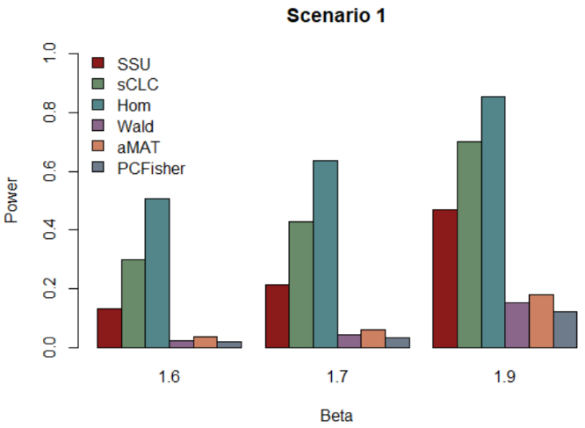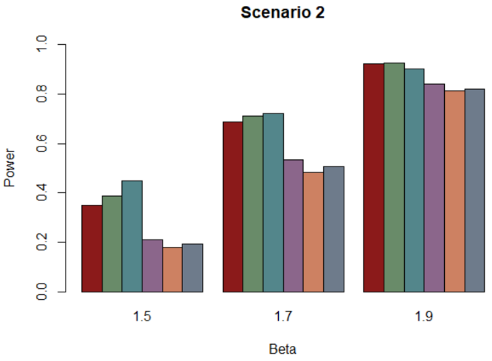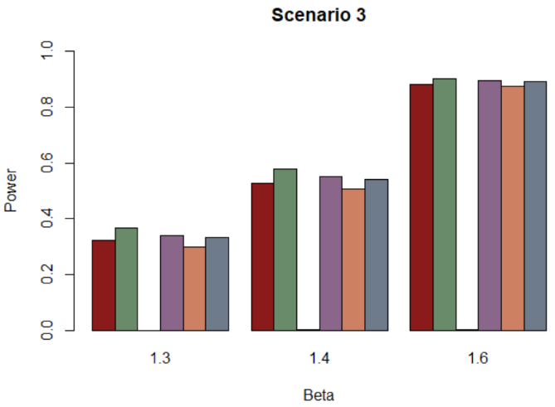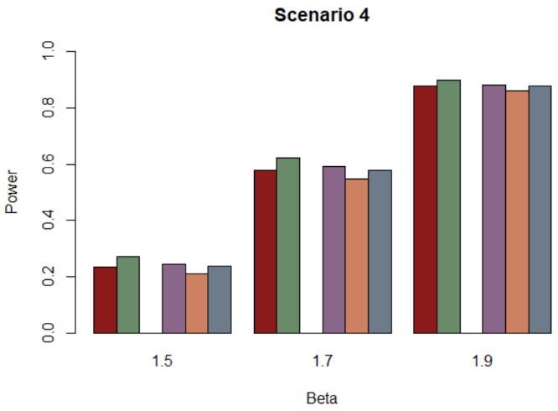

Figure S1 Power comparisons of the six methods, SSU, sCLC, Hom, Wald, aMAT, and PCFisher for the phenotypic matrix $\hat{R}({10}^{-5})$ at a significant level of $5×{10}^{-8}.$

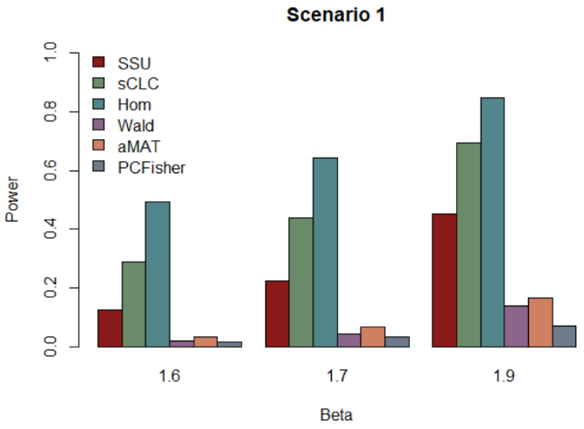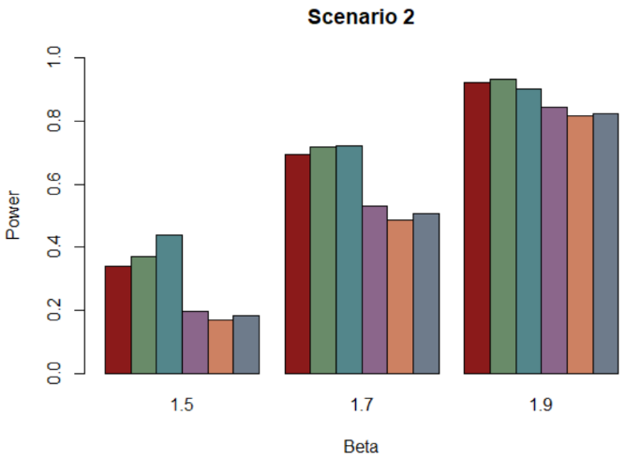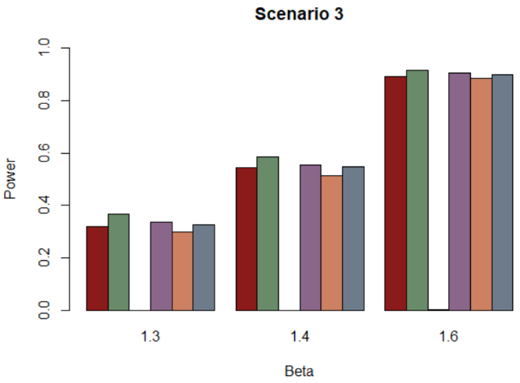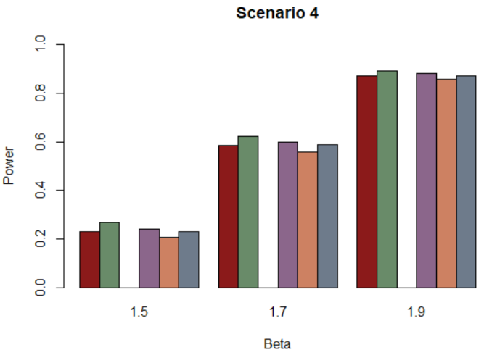

Figure S2 Power comparisons of the six methods, SSU, sCLC, Hom, Wald, aMAT, and PCFisher for the phenotypic matrix $\hat{R}({10}^{-4})$ at a significant level of $5×{10}^{-8}.$

