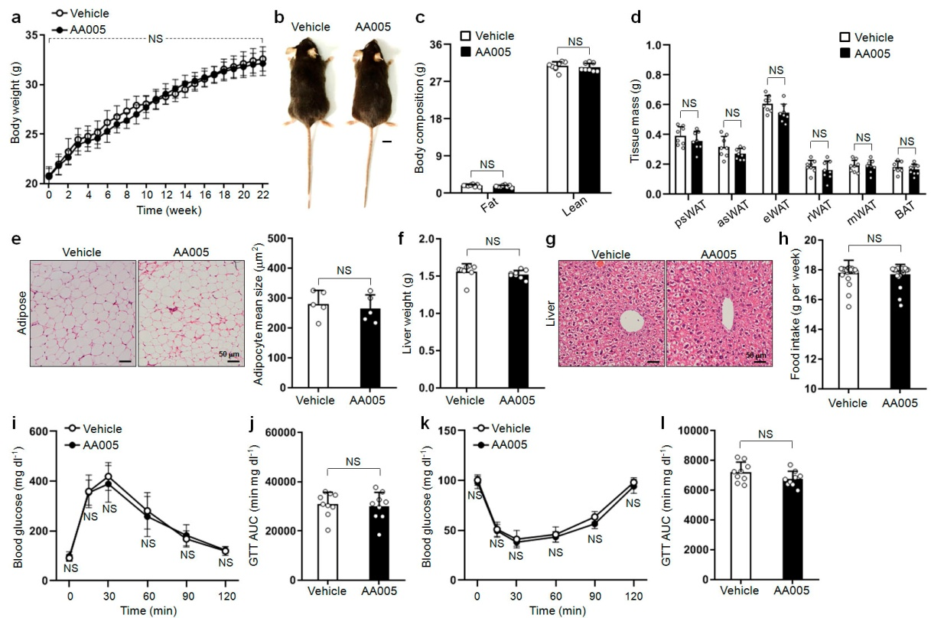

Extended Data Figure 1. AA005 does not create toxic effect in mice. a, Weight gain of male littermates fed CD without or with AA005 (12mg/kg contained in CD) was recorded for 22 weeks (n=8). b, A representative photograph of 7-month-old vehicle and AA005-treated mice fed CD. Scale bar, 1 cm. c, Fat and lean mass were recorded after 22 weeks treatment (n=8). d, Fat weight of psWAT, asWAT, eWAT, rWAT, mWAT and BAT in vehicle and AA005-treated mice fed CD (n=8). e, Representative images of H&E stained of white adipose tissue. Image J software was used to quantify the adipocyte size (n=5). f, Weights of liver in vehicle and AA005-treated mice fed CD (n=8). g, Representative images of H&E-stained liver tissues. h, The average food intake of each mouse for 1 week was recorded (n=22). i-l, Glucose tolerance test (GTT) (i), area under the curve (AUC) of GTT (j), insulin tolerance test (ITT) (k) and AUC of ITT (l) in vehicle and AA005-treated mice fed CD (n=9). Data are mean ± S.D. NS, not significant.

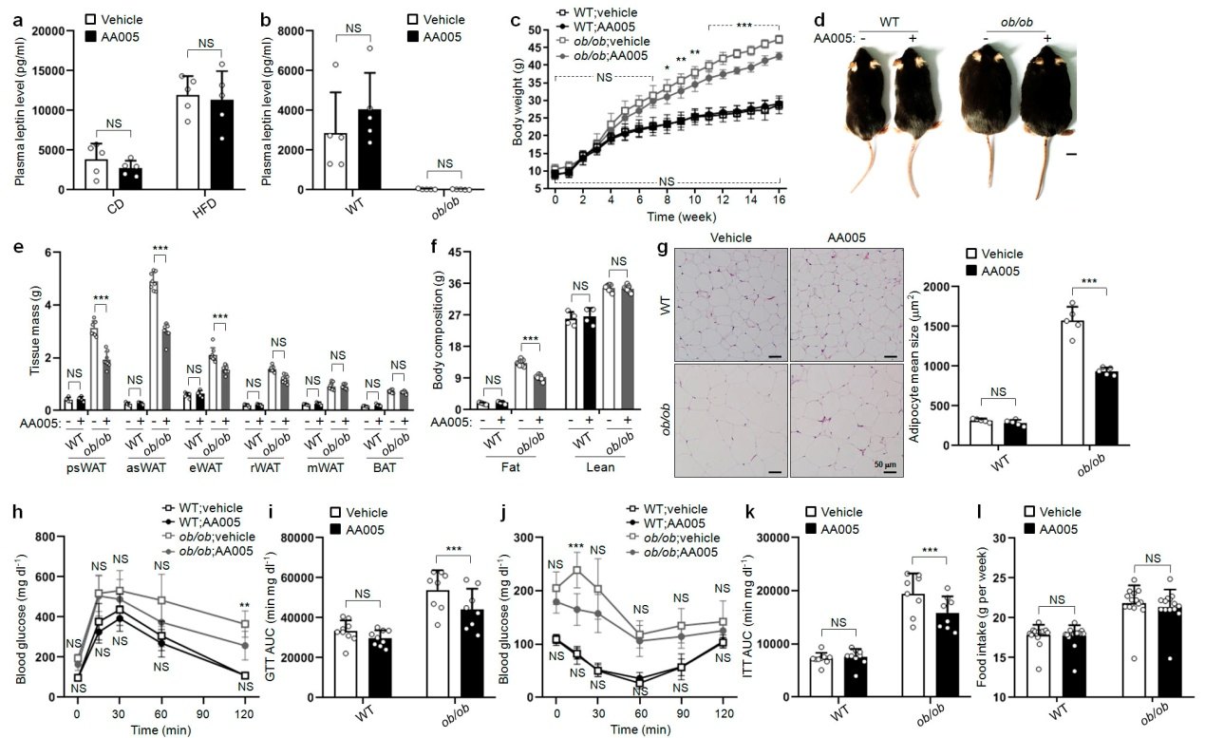
Extended Data Figure 2. AA005 ameliorates obesity independent of leptin. a, Plasma leptin levels were compared between vehicle and AA005-treated mice fed CD or HFD (n=5). b, Comparison of plasma leptin levels in wild-type (WT) and ob/ob mice treated with vehicle or AA005 (n=5). c, Weight gains of WT and ob/ob male littermates treated with vehicle or AA005 (12mg/kg contained in CD) were recorded for 16 weeks (n=8-9 for each group). d, A representative photograph of 5-month-old WT and ob/ob mice treated with vehicle or AA005. Scale bar, 1 cm. e, Fat weight of psWAT, asWAT, eWAT, rWAT, mWAT and BAT in WT and ob/ob mice treated with vehicle or AA005 (n=4 for WT mice, n=8 for ob/ob mice). f, Fat and lean mass were recorded after 16 weeks treatment (n=4 for WT mice, n=8 for ob/ob mice). g, Representative images of H&E stained of white adipose tissue. Image J software was used to quantify the adipocyte size (n=5). h-k, Glucose tolerance test (GTT) (h), area under the curve (AUC) of GTT (i), insulin tolerance test (ITT) (j) and AUC of ITT (k) in vehicle and AA005-treated WT and ob/ob mice (n=8-9 for each group). l, The average food intake of each mouse for 1 week was recorded (n=14). Data are mean ± S.D. NS, not significant.

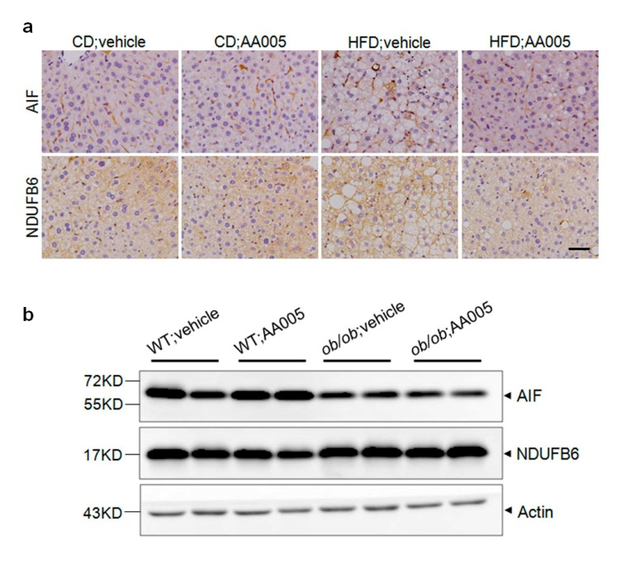
Extended Data Figure 3. AA005 hardly affects the expression of mitochondrial AIF and NDUFB6 in HFD-induced obese mice and ob/ob mice. a, Representative images of Immunohistonchemistry (IHC) staining of AIF and NDUFB6 in liver tissue derived from vehicle- or AA005-treated mice fed CD or HFD. b, Western blots for the protein levels of AIF and NDUFB6 in psWAT of WT and ob/ob mice treated with vehicle or AA005. Actin was used as the loading control.

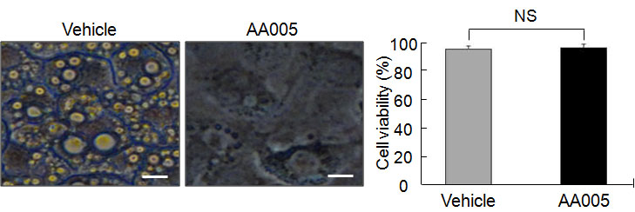

Extended Data Figure 4. AA005 does not create toxic effect in 3T3-L1 cells. The cell viability of 3T3-L1 on the day 8 after adipogenic cocktail accompanied with or without 300 nM AA005 induction was detected by CCK-8 assay. Images were viewed using an Olympus BX-51 fluorescence microscope, Scale bar, 10 μm. Right: cell viability. Each column represents the mean ± S.D. of triplicate runs in an independent experiment. NS, not significant.

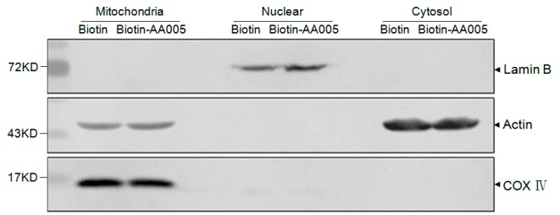
Extended Data Figure 5. Purification of subcellular organelle components of 3T3-L1 cells. Western blot results for three marker proteins to determine the purity of the isolated subcellular fractionations. COX IV (mitochondrial fractions), Lamin B (nuclear extracts), and actin (cytosolic fractions) were used to ensure equivalent loading.

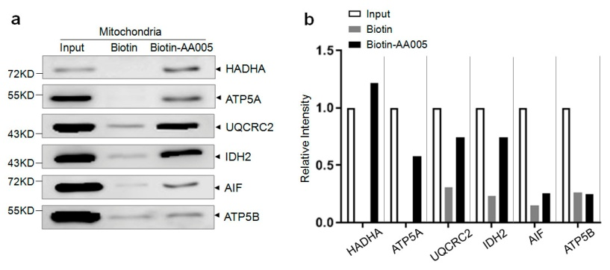
Extended Data Figure 6. Target proteins of AA005 are verified. a, The mitochondria was isolated from 3T3-L1 cells, and the mitochondrial fractions lysates were incubated with biotin or biotin-AA005, followed by pull-down with streptavidin-agarose. The precipitates were detected by western blotting for the proteins as indicated. b, Image J software was used to quantify the intensity of the indicated proteins in biotin or biotin-AA005 group relative to the input group.

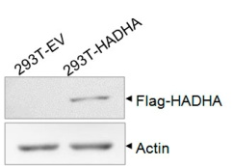
Extended Data Figure 7. HADHA overexpression cell line is constructed. Human embryonic kidney cells (HEK-293 cells) were transfected with plasmid pFLAG-CMV4 as empty negative control (293T-EV) or plasmid pFLAG-CMV4-HADHA (293T-HADHA) respectively. FLAG expression representing for transfection of HADHA proteins was detected by western blotting with anti-FLAG antibody, standardized to actin.

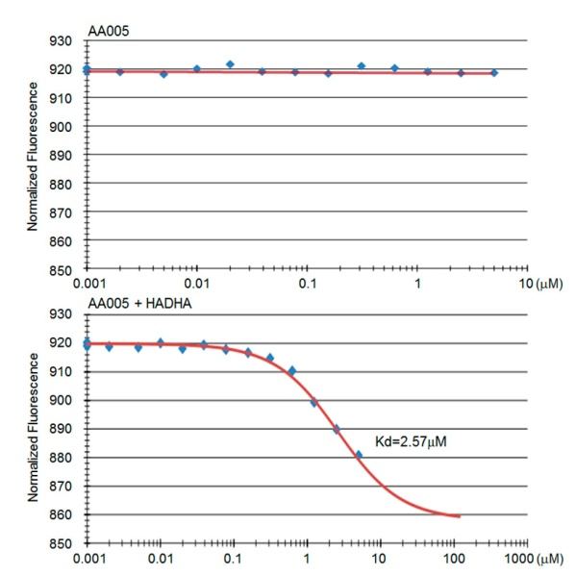
Extended Data Figure 8. HADHA is validated as target of AA005. HEK-293 cells were transfected with empty vector pFLAG-CMV4 (293T-EV) or plasmid pFLAG-CMV4-HADHA (293T-HADHA) respectively. The two group cell lysates were kept equal of total proteins and AA005 was titrated from 0.001 μM to 1000 μM. The difference in normalized fluorescence was plotted for analysis of MST T-Jump. The affinity was determined to be 2.57 μM.
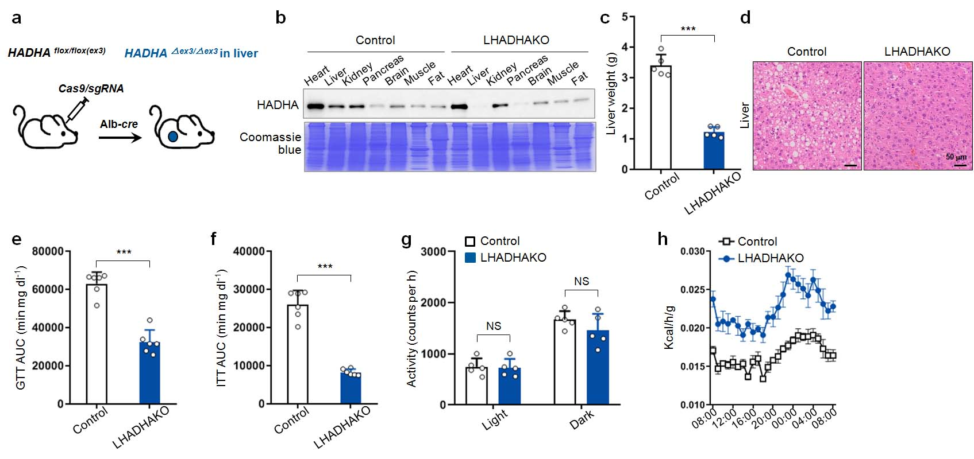
Extended Data Figure 9. LHADHAKO mice are resistant to diet-induced obesity. a,b, Targeting strategy for the introduction of the mutation in exon 3 of the HADHA locus with the CRISPR-Cas9 genome editing system. Deletion of loxP of the HADHA-allele (HADHA^{ﬂox}) by Alb-driven transgenic cre recombinase resulted in liver-speciﬁc HADHA deletion (LHADHAKO) (a), conﬁrmed here by Western blot (b). c, Weights of liver in control and LHADHAKO mice fed HFD (n=5). d, Representative images of H&E-stained liver tissues. e, f, AUC of GTT (e) and AUC of ITT (f) in HFD induced control and LHADHAKO mice (n=6). g, The average quantitation of physical activity in HFD induced control and LHADHAKO mice for 12 h light and12 h dark period. (n=5). h, Energy expenditure were assessed. Mice were monitored over a 3-day period (1 day of acclimatisation followed by 2 days of measurements). ***P＜0.001. NS, not significant.

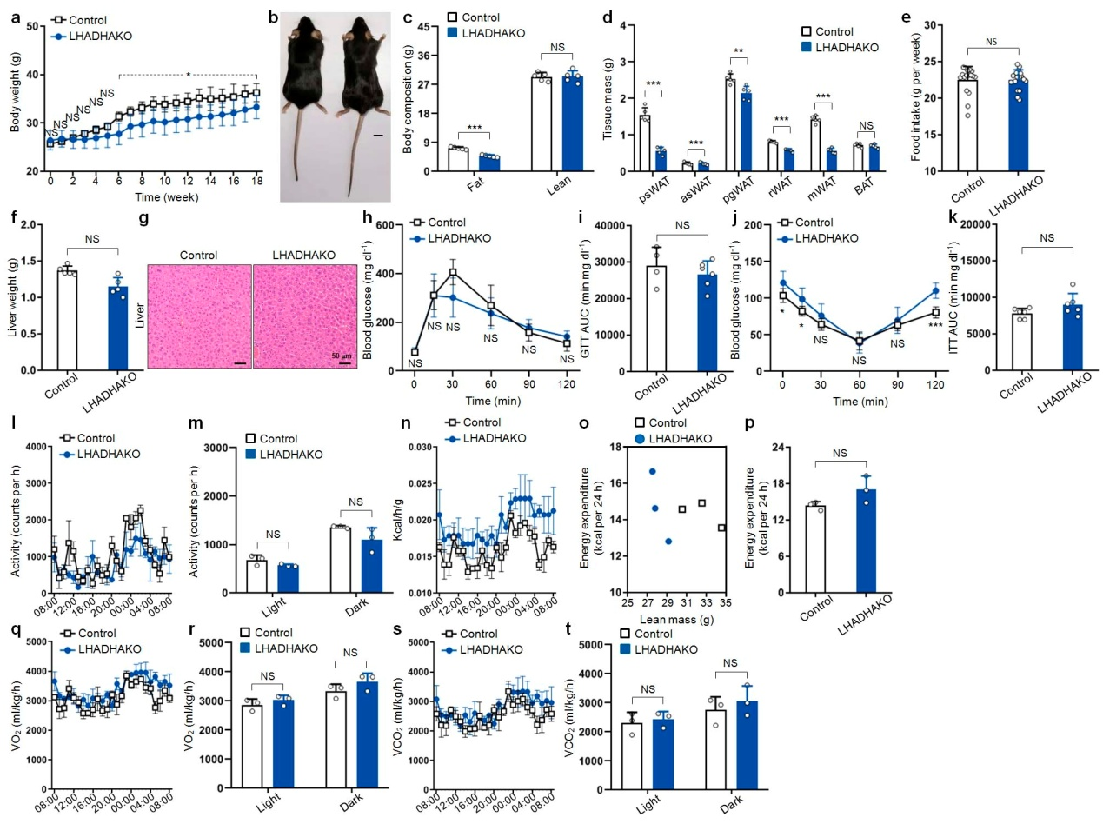
Extended Data Figure 10. AA005 does not create toxic effect in LHADHAKO mice. a, Weight gains of male littermates in control and LHADHAKO mice fed CD were recorded for 18 weeks (n=6-7 for each group). b, A representative photograph of 6-month-old control and LHADHAKO mice fed CD. Scale bar, 1 cm. c, Fat and lean mass were recorded after 18 weeks treatment (n=5). d, Fat weight of psWAT, asWAT, eWAT, rWAT, mWAT and BAT in control and LHADHAKO mice fed CD (n=5). e, The average food intake of each mouse for 1 week was recorded (n=17). f, Weights of liver in control and LHADHAKO mice fed CD (n=5). g, Representative images of H&E-stained liver tissues. h-k, Glucose tolerance test (GTT) (h), area under the curve (AUC) of GTT (i), insulin tolerance test (ITT) (j) and AUC of ITT (k) in control and LHADHAKO mice fed CD (n=6). l, Physical activity of male littermates in control and LHADHAKO mice fed CD for a 24h recording period (n=5). m, The average quantitation of physical activity in control and LHADHAKO mice fed CD for 12 h light and12 h dark period. n, Energy expenditure were assessed. Mice were monitored over a 3-day period (1 day of acclimatisation followed by 2 days of measurements). o, p, 24h energy expenditure was compared between control and LHADHAKO mice. Energy expenditure per mouse was plotted against lean mass (o). The means of energy expenditure in the two groups adjusted with lean mass (p) (n=3). q-t, O₂ consumption (q, r) and CO₂ production (s, t) were recorded during a 24 h period. 24 h period (q, s). Average of light and dark period, respectively (r, t) (n=3). Data are mean ± S.D. *P＜0.05, **P＜0.01, ***P＜0.001, NS means not significant.
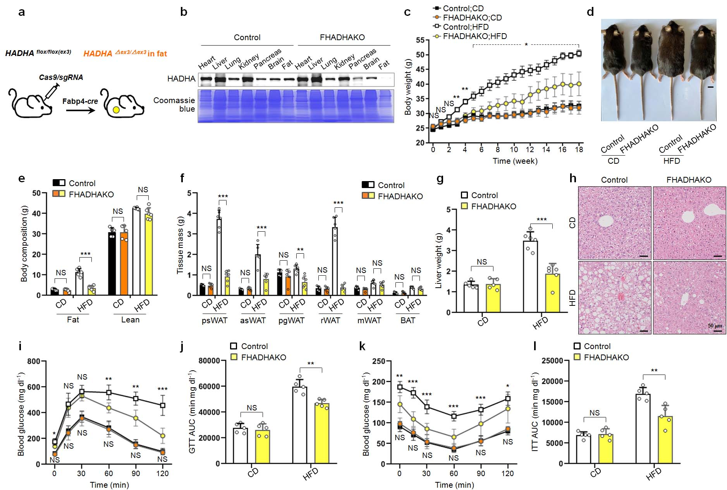
Extended Data Figure 11. FHADHAKO mice are resistant to diet-induced obesity. a,b, Targeting strategy for the introduction of the mutation in exon 3 of the HADHA locus with the CRISPR-Cas9 genome editing system. Deletion of loxP of the HADHA-allele (HADHA^{ﬂox}) by Fabp4-driven transgenic cre recombinase resulted in fat-speciﬁc HADHA deletion (FHADHAKO) (a), conﬁrmed here by Western blot (b). c, Weight gains of male littermates fed CD or HFD in control and FHADHAKO mice were recorded for 18 weeks (n=5). d, A representative photograph of 6-month-old control and FHADHAKO mice fed CD or HFD. Scale bar, 1 cm. e, Fat and lean mass were recorded after 18 weeks treatment (n=5 or 6). f, Fat weight of psWAT, asWAT, eWAT, rWAT, mWAT and BAT in control and FHADHAKO mice fed CD or HFD (n=5 or 6). g, Weights of liver in control and FHADHAKO mice fed CD or HFD (n=5 or 6). h, Representative images of H&E-stained liver tissues. i-l, Glucose tolerance test (GTT) (i), area under the curve (AUC) of GTT (j), insulin tolerance test (ITT) (k) and AUC of ITT (l) in control and FHADHAKO mice fed CD or HFD (n=5). Data are mean ± S.D. *P＜0.05, **P＜0.01, ***P＜0.001, NS means not significant.

Extended Data Table 1. Interacting proteins of AA005 identified by chemical proteomics.
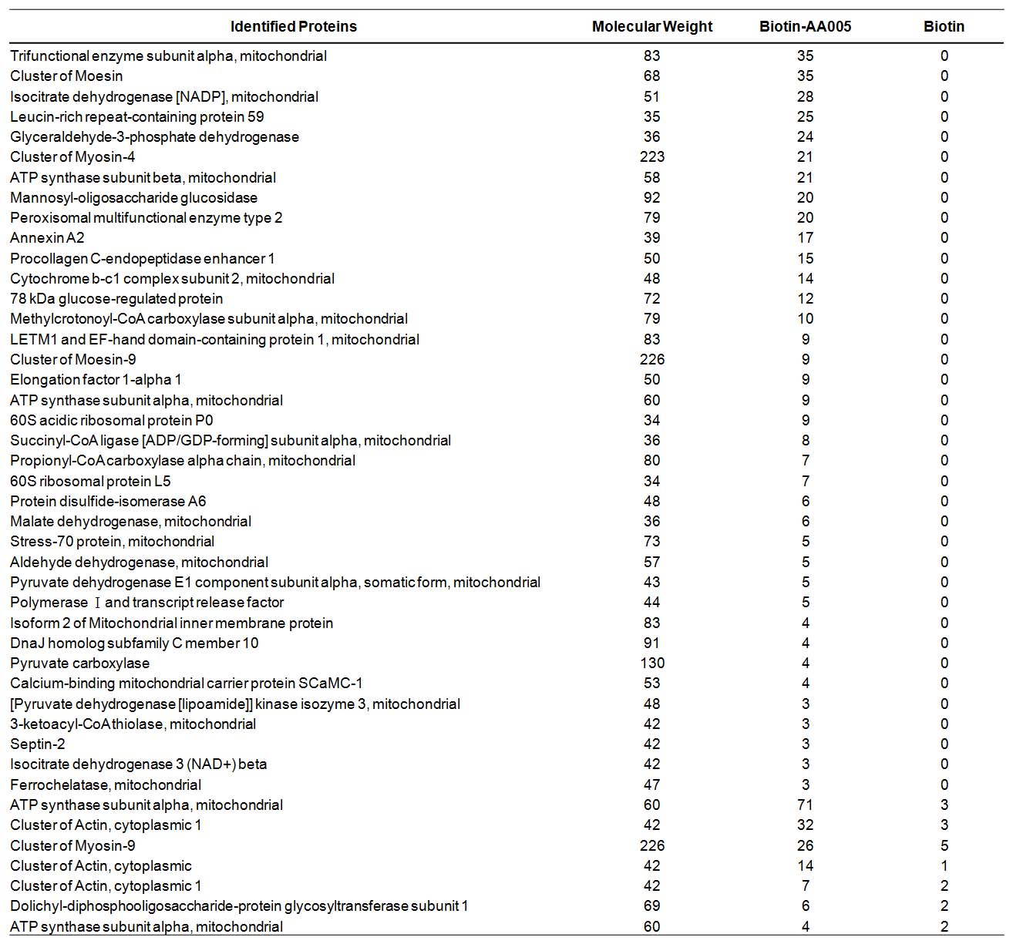
3T3-L1 cells mitochondrial fraction lysates were incubated with equivalent dose of biotin or biotin-AA005, and after affinity purification by beads with streptavidin, the proteins were preliminarily separated by SDS-PAGE. The relative level of tryptic peptides abundances from each group were compared using label-free spectral count-based quantitation. 44 proteins were identified to be significantly enriched by biotin-AA005.

